Supplement 2 – Thoracic impedance pneumography comparisons
Thoracic impedance pneumography reference data
A total of 26,668 reference pneumography-viQtor® RR measurement pairs were available for analysis. The overall ARMS was 4.98 BRPM, with a bias of 0.18 BRPM and wide LoA of –9.69 to 10.04 BRPM (Fig. S2a). Additionally, a Bland-Altman analysis comparing capnography and thoracic impedance pneumography showed an overall ARMS of 5.39 BRPM, with a bias of 0.84 BRPM and wide LoA of -9.81 to 11.50 (Fig. S2b). For illustration purposes, Fig. S3 shows a representative example in which impedance deviations are clearly visible across all three RR modalities.
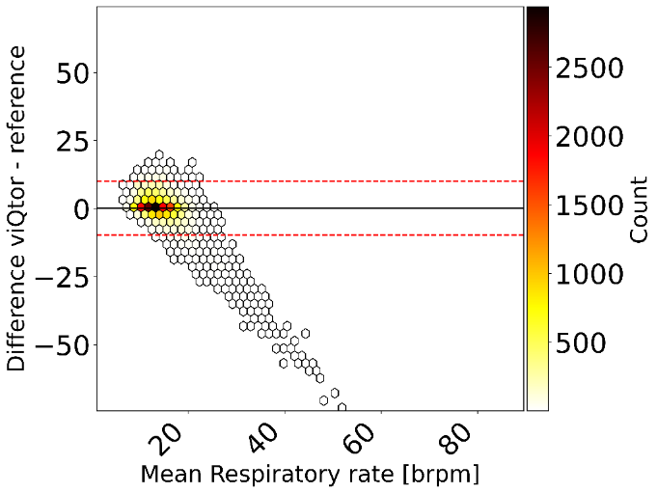
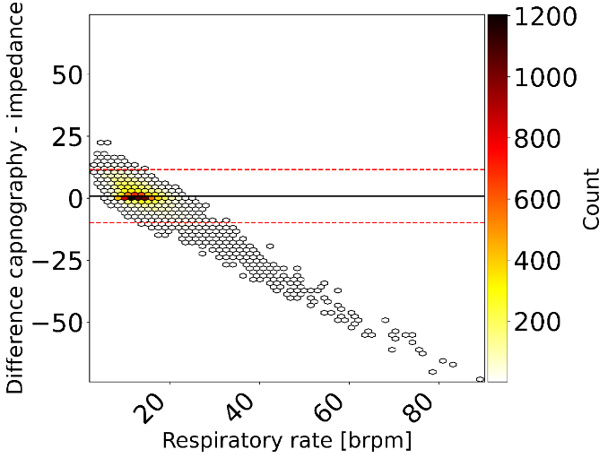
a.
b.

Fig. S2 Bland-Altman plots of the pooled analysis comparing respiratory rate measurements from (a): viQtor and
thoracic impedance pneumography and (b): capnography and thoracic impedance pneumography, with color
indicating the number of measurement pairs (white = low, black = high). The solid black line represents the pooled
bias and the dashed red line the pooled limits of agreement
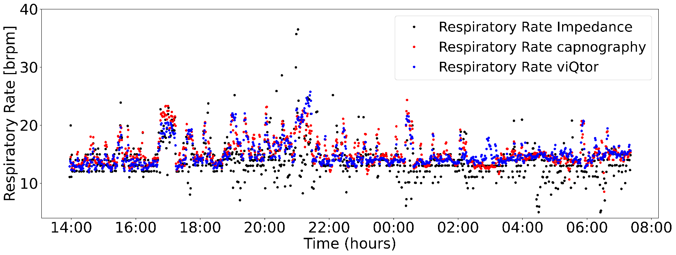

Fig. S3 Example of the difference between thoracic impedance pneumography-based (black), capnography-based (red), and viQtor® (blue) respiratory rate measurements

