Supplement 1 – Error plots individual patients
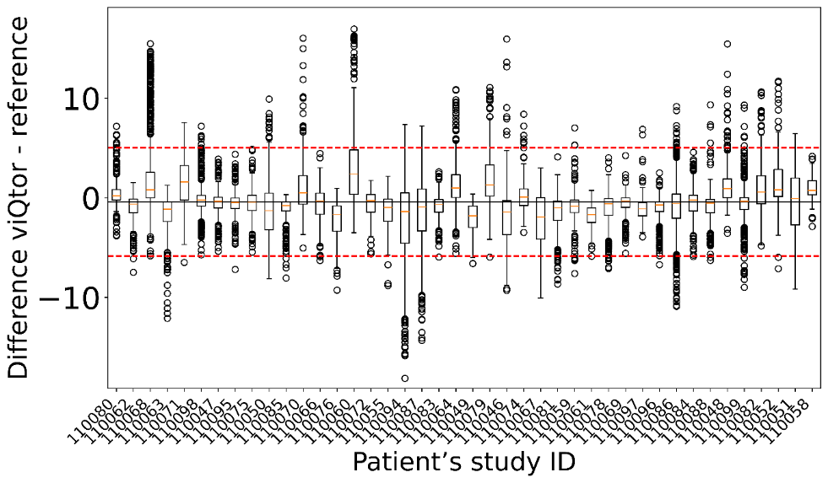
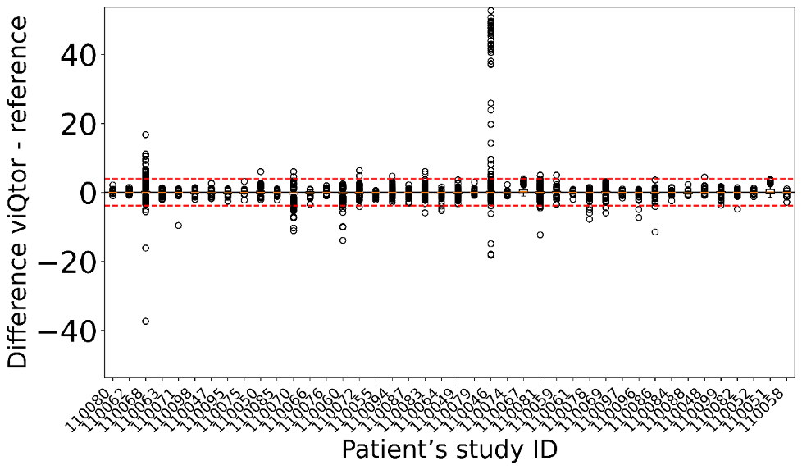
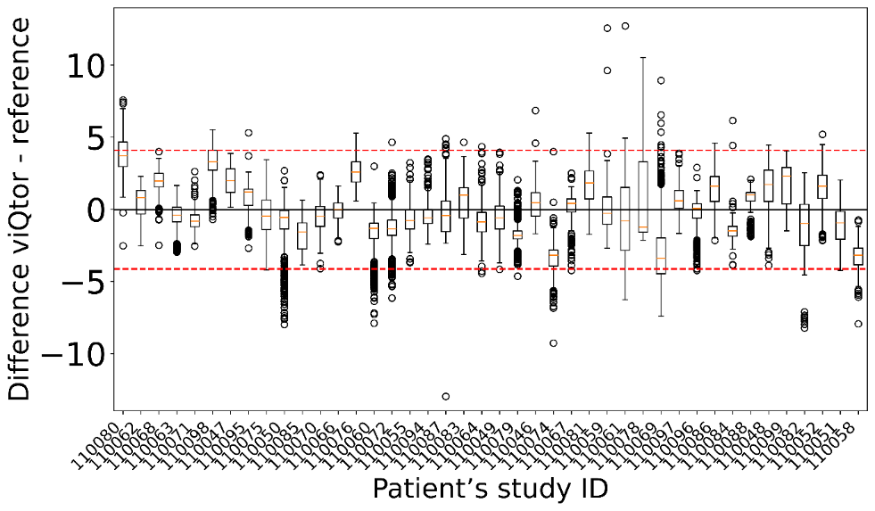
a.
b.
c.

Fig. S1 Error plots of individual patient results comparing viQtor® measurements to the reference monitor. (a): Respiratory rate (capnography reference), (b): Heart rate, and (c): SpO₂. The solid black line represents the pooled bias and the dashed red line the pooled limits of agreement

