Morphometric Analysis of Sectors 1, 2, and 3
The morphometric analysis of the parameters at Sector 1, 2, and 3 reveals distinct differences between the two MIS 5 seacliff types: paleo-seacliffs and polycyclic seacliffs. The most notable differences are found in elevation, roughness, slope, and dissection, which likely reflect ongoing processes of erosion and landform evolution along the Cilento coast. These differences are illustrated through density plots, which depict the distribution of each parameter, and summarized in tables, highlighting central tendencies and variability within each dataset. The following sections focus on these key differences, offering a basis for discussion to better understand how erosion, landform evolution, and geological context have shaped the present-day morphology of this coastal sector.
SECTOR 1 – Licosa Cape
In the paleo-seacliffs of Punta Licosa (Figure S1, Table S1), the elevation distribution is relatively tight, with a median of 58.2 m and a long upper tail reaching up to 188.6 m, indicative of headland features. Roughness is subdued (median of 13.3), and slope values cluster around 24°, reflecting a gently dissected scarp. In contrast, the polycyclic seacliffs show a higher median elevation (73.1 m) and increased roughness variability (Q3 ~31), with both steeper faces (up to 33.9°) and flatter zones. Additionally, the distance metric collapses to a median of ~152 m, suggesting that the polycyclic cliffs extend up to the coastline.
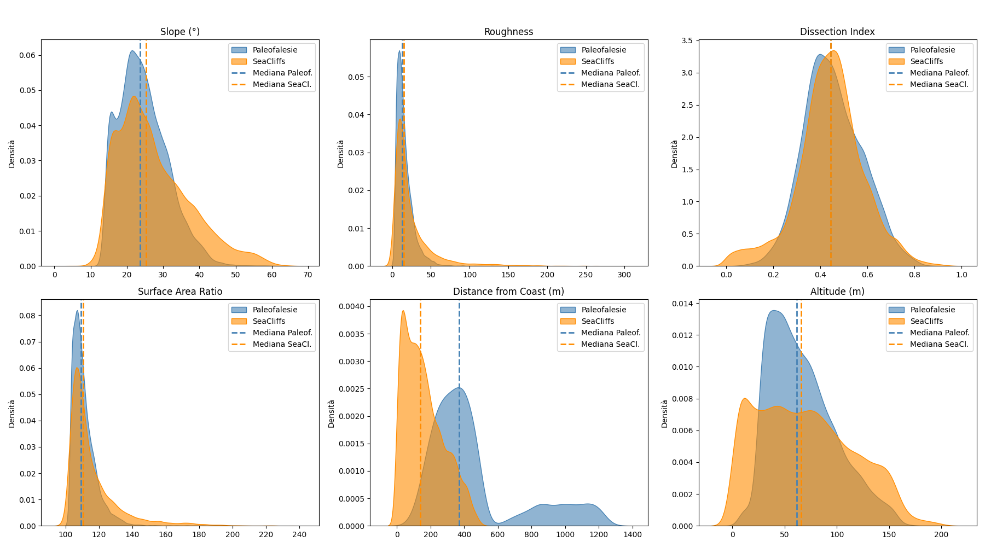Figure S1 – Density plots of key morphometric parameters (elevation, roughness, slope, dissection, surface area, distance from the coast) for Sector 1, highlighting the differences between the two MIS 5 seacliff types: paleo-seacliffs and polycyclic seacliffs.
SECTOR 2 – Palinuro-Marina di Camerota
In the sector between Palinuro and Marina di Camerota (Figure S2, Table S1), paleo-seacliffs show significant heterogeneity, with roughness ranging from 4.2 to 1,043 and slopes reaching 75.8°. Elevations peak at 158.7 m, with a median of 90 m. In contrast, polycyclic seacliffs display a narrowed range of roughness (~85) and reduced slope values (maximum 49°). The dissection index increases from 0.51 in paleo to 0.59 in polycyclic cliffs, indicating the exposure of more subtle features. Furthermore, the paleo-seacliffs are located hundreds of meters offshore (min ~79 m), while polycyclic forms reach much closer to the coastline (min 0 m).
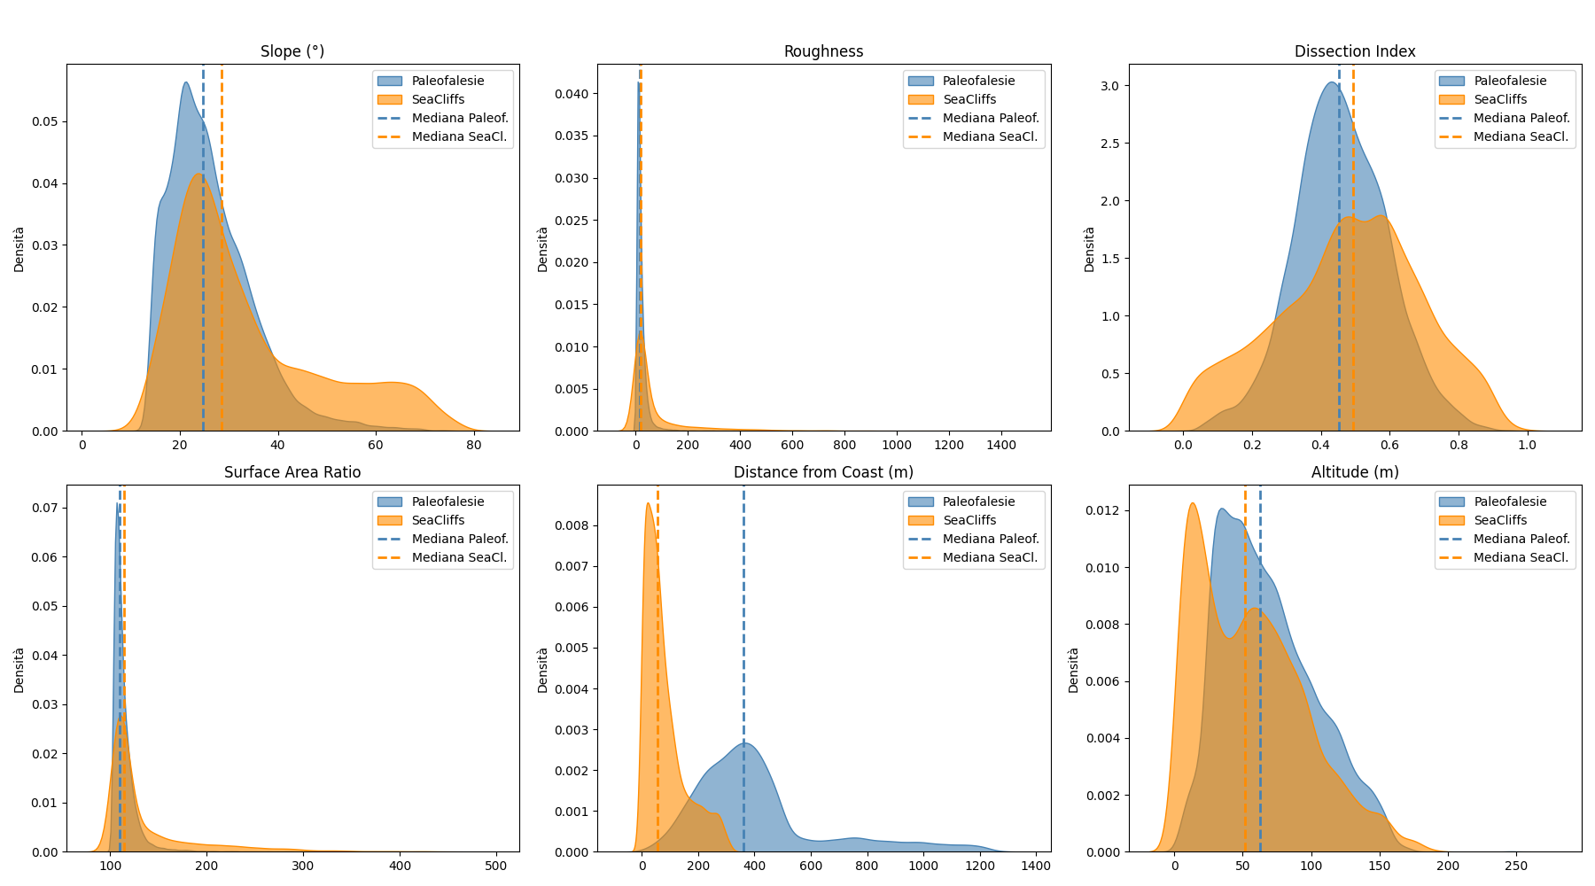Figure S2 – Density plots of key morphometric parameters (elevation, roughness, slope, dissection, surface area, distance from the coast) for Sector 2, highlighting the differences between the two MIS 5 seacliff types: paleo-seacliffs and polycyclic seacliffs.

SECTOR 3 – Acciaroli
Paleo-seacliffs in Acciaroli (Figure S3, Table S1) exhibit moderate elevation (~58 m) and roughness (~14.4), with slopes clustering around 25°. The dissection index is also relatively low (0.44). In contrast, the polycyclic seacliffs show a compression in the elevation range (median ~40.9 m) and slightly higher roughness (median ~14.6). The dissection index increases to 0.59, indicating the presence of more pronounced fractures. The slope distribution remains stable at around 24.7°.

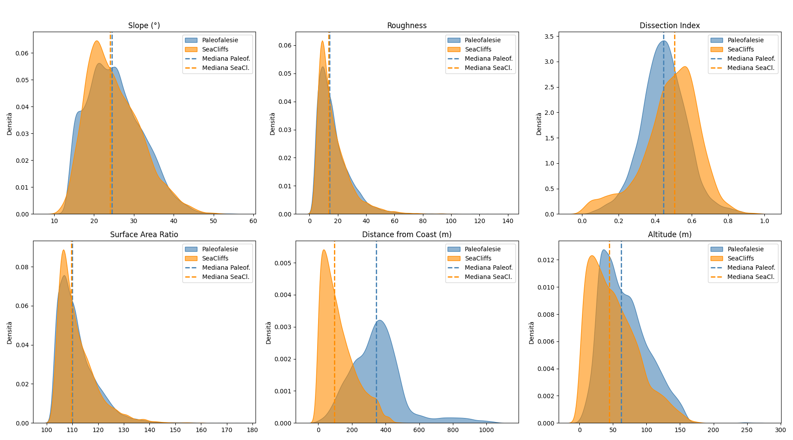Figure S3 – Density plots of key morphometric parameters (elevation, roughness, slope, dissection, surface area, distance from the coast) for Sector 3, highlighting the differences between the two MIS 5 seacliff types: paleo-seacliffs and polycyclic seacliffs.

Table S1
Sector 1
Feature | Min | Q1 | Mediana | Q3 | Max | Media | Std | Dataset
DTM_elevat | 5,85 | 39,94 | 58,15 | 84,28 | 188,55 | 64,64 | 31,37 | Paleo-seacliff
roughness | 4,08 | 8,72 | 13,34 | 20,47 | 77,84 | 15,80 | 9,89 | Paleo-seacliff
slope | 13,92 | 19,81 | 24,01 | 28,93 | 47,37 | 24,56 | 6,37 | Paleo-seacliff
dissection | 0,08 | 0,37 | 0,44 | 0,54 | 0,83 | 0,46 | 0,12 | Paleo-seacliff
surfacearea | 103,03 | 106,29 | 109,48 | 114,26 | 147,66 | 110,97 | 6,43 | Paleo-seacliff
distance | 108,89 | 279,00 | 360,28 | 421,30 | 521,46 | 348,17 | 93,06 | Paleo-seacliff
DTM_elevat | 0,25 | 39,19 | 73,14 | 107,49 | 199,01 | 74,90 | 43,38 | Policyclic seacliff
roughness | 0,38 | 9,28 | 15,56 | 30,95 | 301,06 | 25,91 | 29,15 | Policyclic seacliff
slope | 4,32 | 20,24 | 25,62 | 33,93 | 65,07 | 27,77 | 10,08 | Policyclic seacliff
dissection | 0,00 | 0,37 | 0,45 | 0,53 | 0,95 | 0,45 | 0,14 | Policyclic seacliff
surfacearea | 100,01 | 106,54 | 110,86 | 120,48 | 237,20 | 116,47 | 15,96 | Policyclic seacliff
distance | 0,00 | 76,36 | 152,16 | 252,54 | 502,73 | 170,23 | 113,92 | Policyclic seacliff
Sector 2
Feature | Min | Q1 | Mediana | Q3 | Max | Media | Std | Dataset
DTM_elevat | 2,27 | 50,54 | 90,23 | 126,45 | 158,71 | 88,52 | 42,78 | Paleo-seacliff
roughness | 4,20 | 18,23 | 34,02 | 62,58 | 1043,20 | 55,58 | 74,18 | Paleo-seacliff
slope | 12,42 | 27,04 | 35,29 | 43,68 | 75,82 | 36,16 | 11,89 | Paleo-seacliff
dissection | 0,02 | 0,37 | 0,51 | 0,59 | 0,89 | 0,48 | 0,17 | Paleo-seacliff
surfacearea | 102,40 | 112,27 | 122,51 | 138,27 | 408,25 | 131,14 | 30,07 | Paleo-seacliff
distance | 79,32 | 283,74 | 335,63 | 390,48 | 496,45 | 335,10 | 73,98 | Paleo-seacliff
DTM_elevat | 0,73 | 26,05 | 45,91 | 63,46 | 121,83 | 46,05 | 24,91 | Policyclic seacliff
roughness | 3,58 | 9,90 | 16,16 | 26,90 | 85,13 | 20,50 | 14,48 | Policyclic seacliff
slope | 11,55 | 20,98 | 25,97 | 32,20 | 49,20 | 26,97 | 7,41 | Policyclic seacliff
dissection | 0,00 | 0,43 | 0,59 | 0,66 | 0,81 | 0,54 | 0,16 | Policyclic seacliff
surfacearea | 102,48 | 107,12 | 111,41 | 118,20 | 153,05 | 113,91 | 9,01 | Policyclic seacliff
distance | 0,00 | 39,25 | 72,29 | 106,05 | 273,00 | 76,28 | 50,89 | Policyclic seacliff
Sector 3
Feature | Min | Q1 | Mediana | Q3 | Max | Media | Std | Dataset
DTM_elevat | 2,88 | 39,40 | 58,77 | 84,68 | 149,47 | 63,53 | 29,89 | Paleo-seacliff
roughness | 4,04 | 8,89 | 14,41 | 21,37 | 87,00 | 16,58 | 10,33 | Paleo-seacliff
slope | 13,30 | 19,88 | 24,72 | 29,35 | 49,24 | 24,99 | 6,56 | Paleo-seacliff
dissection | 0,06 | 0,37 | 0,44 | 0,52 | 0,96 | 0,45 | 0,12 | Paleo-seacliff
surfacearea | 102,76 | 106,34 | 110,09 | 114,72 | 153,17 | 111,43 | 6,70 | Paleo-seacliff
distance | 43,42 | 271,84 | 346,19 | 407,67 | 521,35 | 334,82 | 95,21 | Paleo-seacliff
DTM_elevat | 0,52 | 21,26 | 40,94 | 65,96 | 147,28 | 45,64 | 30,11 | Policyclic seacliff
roughness | 3,97 | 9,78 | 14,55 | 22,90 | 85,18 | 18,09 | 11,68 | Policyclic seacliff
slope | 11,64 | 20,61 | 24,70 | 30,22 | 49,00 | 25,75 | 6,74 | Policyclic seacliff
dissection | 0,00 | 0,41 | 0,52 | 0,60 | 0,93 | 0,49 | 0,16 | Policyclic seacliff
surfacearea | 102,67 | 107,17 | 110,69 | 115,75 | 152,43 | 112,51 | 7,35 | Policyclic seacliff
distance | 0,00 | 36,01 | 76,22 | 127,25 | 308,29 | 87,67 | 63,78 | Policyclic seacliff

By comparing the morphometric analysis between the three sectors, the following must be noted.
Slope values in the Punta Licosa sector (Sector 1), where the seacliffs are predominantly composed of well-cemented sandstone (Litho 10), are moderate (median ~24°, see supplementary material 2) and so does the roughness (median ~13.3) due to the balance between resistance to erosion and joint-controlled detachment processes. The Palinuro–Marina di Camerota sector (Sector 2) exposes resistant carbonatic formations (Litho 4), resulting in steep, irregular scarp faces (up to 33.9° slope and Q3 roughness ~31) maintained under persistent wave attack. Conversely, Acciaroli seacliffs (Sector 3) rest on Litho 1 and Litho 7, which correspond to highly variable morphometric responses (slope clustering around 25° but with higher dispersion and roughness variability) own to the alternation of erodible and more competent layers.
However, polycyclic seacliffs in the three sectors exhibit systematically higher dissection indices compared to their paleo counterparts, with increases from 0.51 to 0.59 in Sector 2 and similar trends in Sectors 1 and 3. This rise in dissection corresponds to intensified fracturing and secondary incision on the cliff face resulting from retrogressive erosion and gravitational mass-wasting processes.
The distance from the coast parameter further illustrates the RSL dynamics and the different lithological response: paleo-seacliffs in the northern sector lie hundreds of meters inland (median distance ~335 m in Sector 3), indicative of extensive alluvial fan deposition that masks original footslopes and part of the related wave-cut platform. In contrast, polycyclic forms display minima of 0 m in all sectors, confirming their direct contact with the present shoreline.
Regarding the influence of lithology on the development of coastal landforms, harder substrates like limestone (LITHO 4) often formed steep cliffs with narrow tidal notches created by lateral erosion during high tides, and small shore platforms may develop beneath these notches as wave action gradually undercuts the cliff base. In contrast, softer lithologies (LITHO 10 and 7) are eroded more rapidly, producing wider shore platforms often backed by lower seacliffs. Furthermore, In particular, we measured the differences between the morphometric parameters (Dissection Index, Roughness, Slope, Surface Area Ratio), comparing the two seaciff typologies, LIG paleo-seacliffs (T1) and polycyclic seacliffs (T2).

