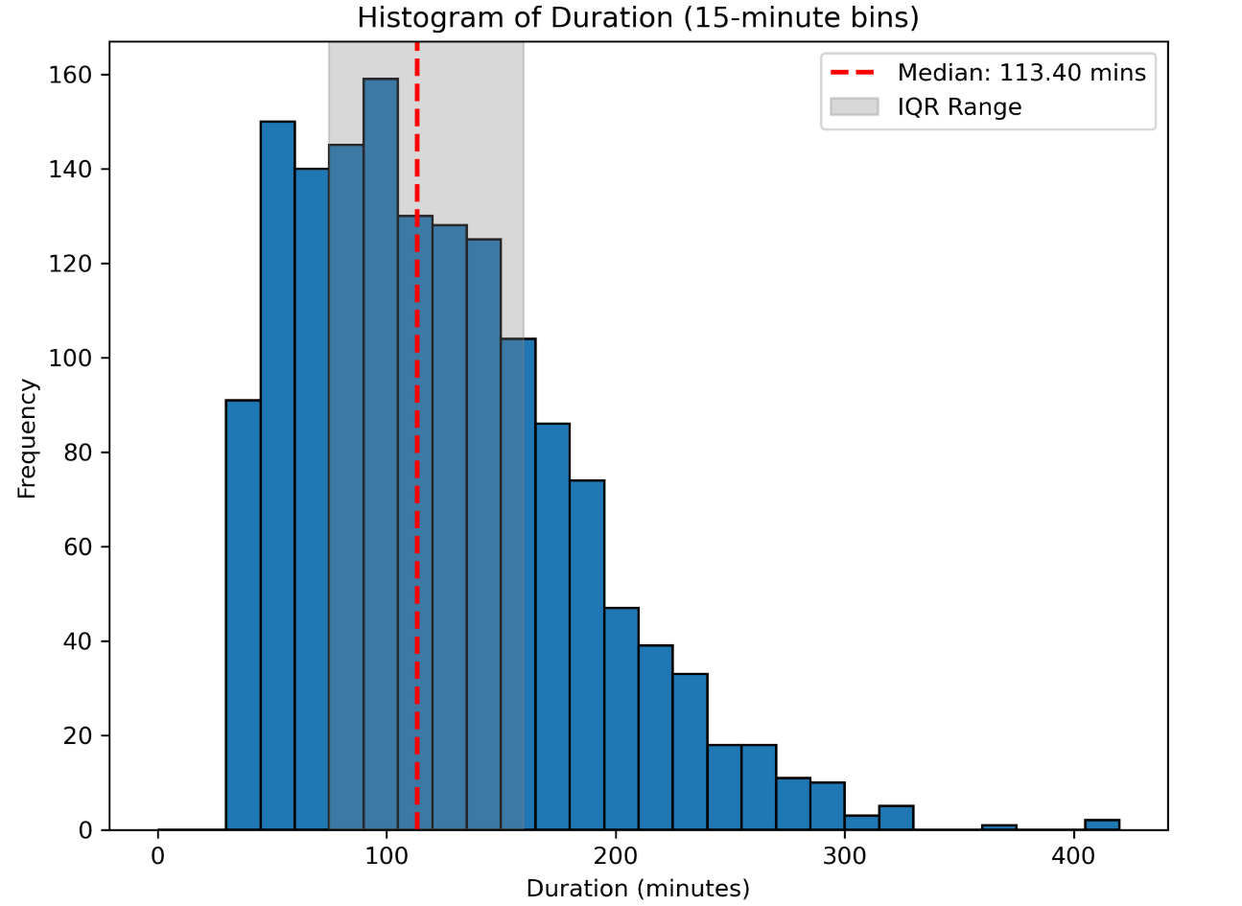
Supplementary Figure 1: Histogram of duration of each of the 1519 included transport episodes. The dashed red line marks the median duration with the grey shaded region marking the inter-quartile range (IQR: 75-160 minutes).

Model Name | Model Description | Input Features | Architecture details | Schematic Reference
Baseline-Only FF | Baseline Features Only | All pre-transport baseline features present in Table 2: patient demographics, transport details, diagnosis (vector-embedded), interventions by the local team prior to transport, intra-transport respiratory and cardiovascular support commenced prior to transport | Two-armed architecture: One feed-forward branch handles baseline features, and a second feed-forward branch separately processes the diagnosis embedding. The outputs from both branches are then merged and passed through a final feed-forward network to generate the prediction. | Supplementary Figure 2
Combined FF | Combined features: Simple Neural Network | Vital signs, associated adverse events and reduced subset of baseline features present in Table 2: age, weight, sex, PIM3, destination care area, diagnosis (vector-embedded), pre-existing medical conditions, intra-transport respiratory and cardiovascular support commenced prior to transport | Three-armed architecture: One feed-forward branch process vital signs, a second feed-forward branch handles baseline features, and a third feed-forward branch separately processes the diagnosis embedding. The outputs from all three branches are then merged and passed through a final feed-forward network to generate the prediction. | Supplementary Figure 3
Vitals-Only Transformer | Vital signs only | Vital signs and pre-occurring adverse events | Transformer-based architecture: Time-series data is first processed by a transformer network, and the resulting outputs are passed through a simple feed-forward layer to generate the final prediction. | Supplementary Figure 4
Combined Transformer (One-Hot Diagnosis, Reduced Baseline) | Combined features: Transformer processing of vital signs, one-hot encoded diagnosis group, reduced subset baseline features | Vital signs, associated adverse events and reduced subset of baseline features present in Table 2: age, weight, sex, PIM3, destination care area, diagnosis (one-hot encoded), pre-existing medical conditions, intra-transport respiratory and cardiovascular support commenced prior to transport | Dual-armed architecture: One branch uses a transformer to process time-series vital signs, while a separate feed-forward branch handles baseline features. The outputs of both branches are merged and passed through a final feed-forward network to produce the prediction. | Supplementary Figure 5
Combined Transformer (Vector Diagnosis, Reduced Baseline) | Combined features: Transformer processing of vital signs, vector embedded diagnosis group, reduced subset baseline features | Vital signs, associated adverse events and reduced subset of baseline features present in Table 2: age, weight, sex, PIM3, destination care area, diagnosis (vector-embedded), pre-existing medical conditions, intra-transport respiratory and cardiovascular support commenced prior to transport | Three-armed architecture: One branch uses a transformer to process time-series vital signs, a second feed-forward branch handles baseline features, and a third feed-forward branch separately processes the diagnosis embedding. The outputs from all three branches are then merged and passed through a final feed-forward network to generate the prediction. | Supplementary Figure 6
Combined Transformer (Vector Diagnosis, Full Baseline) | Combined features: Transformer processing of vital signs, vector embedded diagnosis group, full baseline features | Vital signs, associated adverse events and all baseline features present in Table 2: patient demographics, transport details, diagnosis (vector-embedded), interventions by the local team prior to transport, intra-transport respiratory and cardiovascular support commenced prior to transport | Three-armed architecture: One branch uses a transformer to process time-series vital signs, a second feed-forward branch handles baseline features, and a third feed-forward branch separately processes the diagnosis embedding. The outputs from all three branches are then merged and passed through a final feed-forward network to generate the prediction. | Supplementary Figure 7
Supplementary Table1: Description of the models developed for predicting adverse respiratory and cardiovascular events
Supplementary Table 1: Summary of the key characteristics of the predictive models developed to independently forecast adverse respiratory and cardiovascular events within a 15-minute window. The table descends in order of first computational complexity and then feature complexity. Transformer blocks were implemented rotary positional embeddings, and a decoder-only setup that ensures one-directional (causal) attention for time-series data. The table is ordered to follow incremental progression in model complexity and input feature detail.

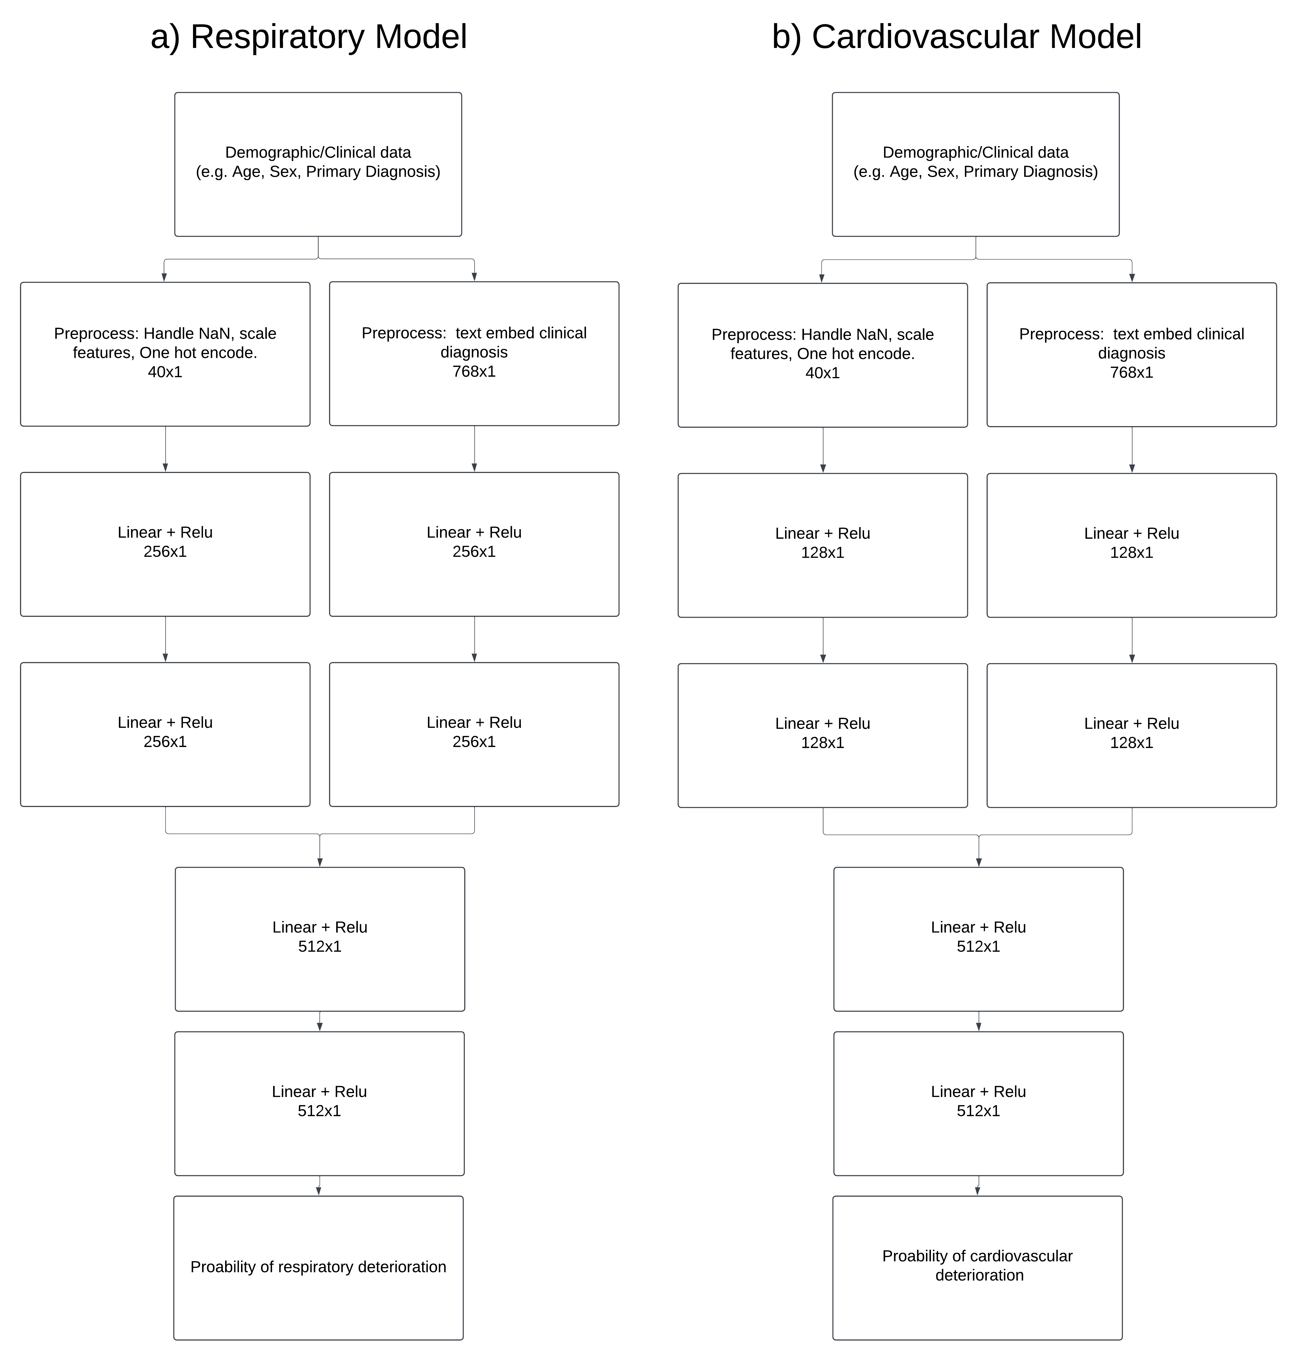
Supplementary Figure 2: Architecture of the Baseline-Only Feed-Forward model. a) Architecture for respiratory model. b) Architecture for cardiovascular model. Each model consists of two parallel feed-forward branches: one processes all pre-transport baseline features (including patient demographics, transport details, pre-transport interventions, and intra-transport support), while the other processes the vector-embedded primary diagnosis. The outputs of both branches are concatenated and passed through a final feed-forward network to generate the prediction.

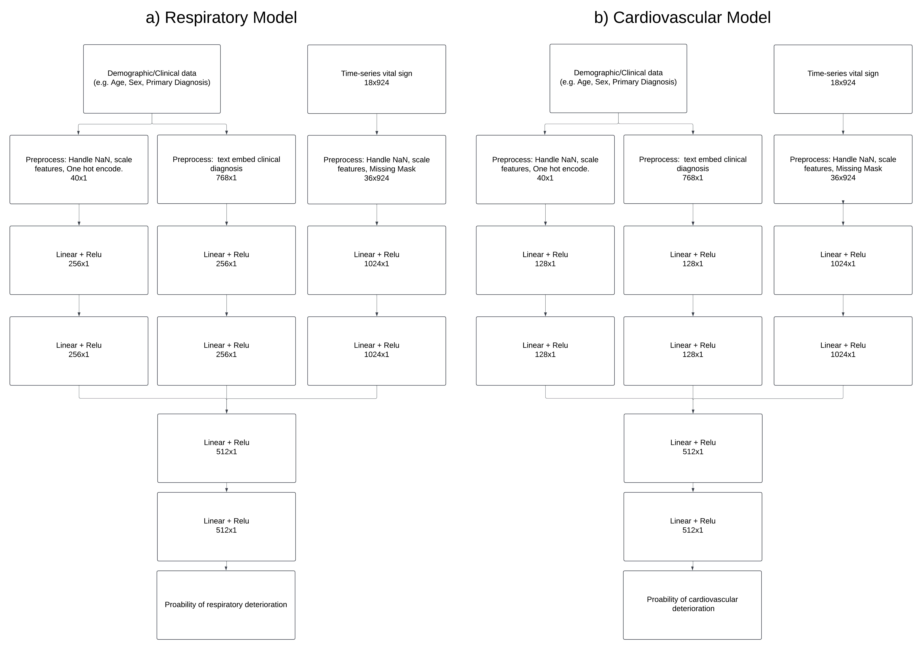
Supplementary Figure 3: Architecture of the Combined Feed-Forward model. a) Architecture for respiratory model. b) Architecture for cardiovascular model.
Each model comprises three parallel feed-forward branches: one processes vital signs and pre-occurring adverse events, another handles a reduced subset of baseline features (including age, weight, sex, PIM3 score, destination care area, pre-existing medical conditions, and intra-transport support), and the third processes the vector-embedded primary diagnosis. Outputs from all three branches are concatenated and passed through a final feed-forward network to generate the prediction.

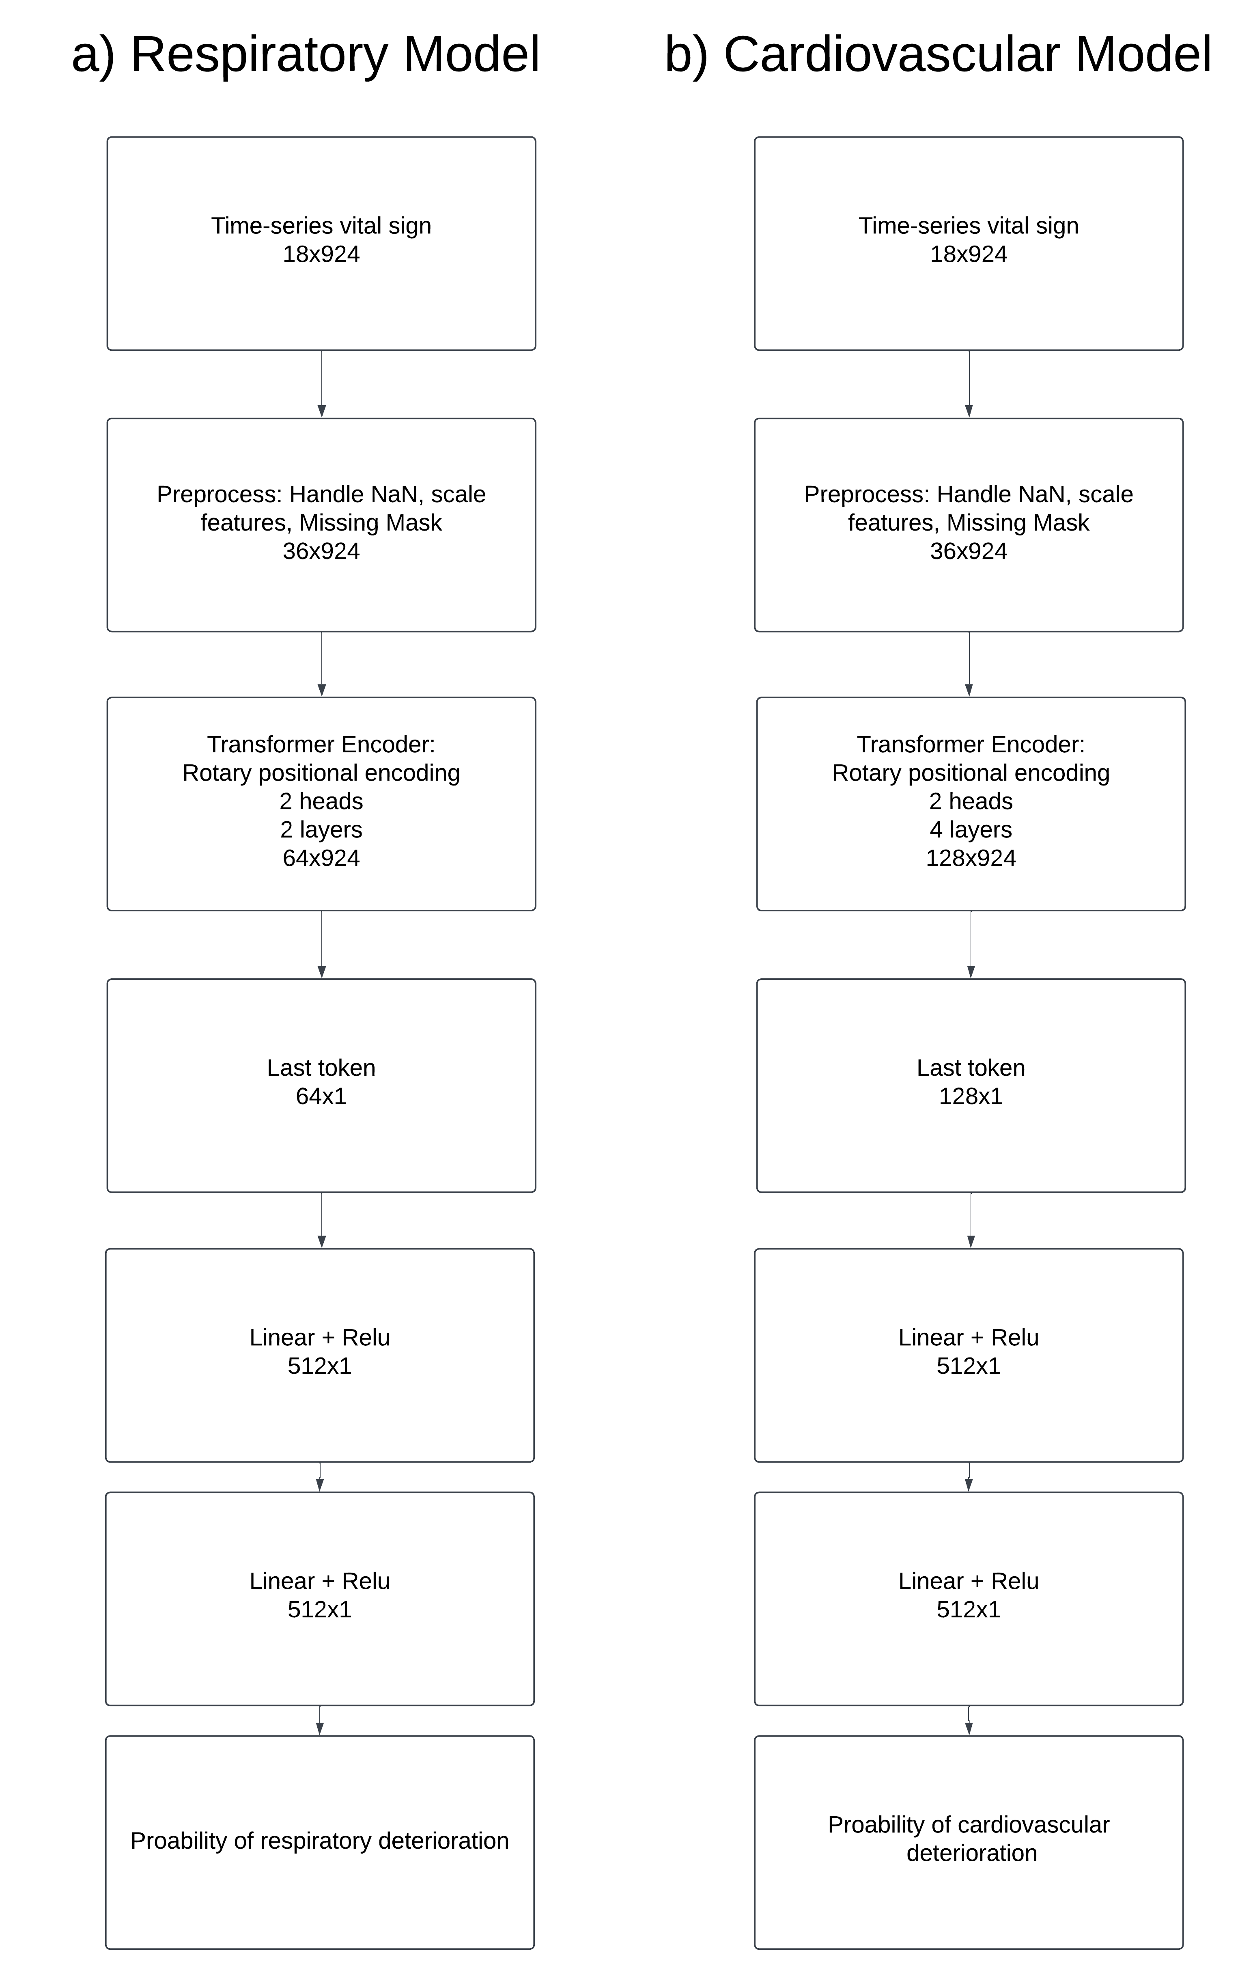

Supplementary Figure 4: Architecture of the Vitals-Only Transformer model. a) Architecture for respiratory model. b) Architecture for cardiovascular model. Each model consists of a single transformer branch that processes time-series vital signs and any pre-occurring adverse events. The output of the transformer is passed through a final feed-forward layer to generate the prediction. No baseline demographic or diagnostic information is included.

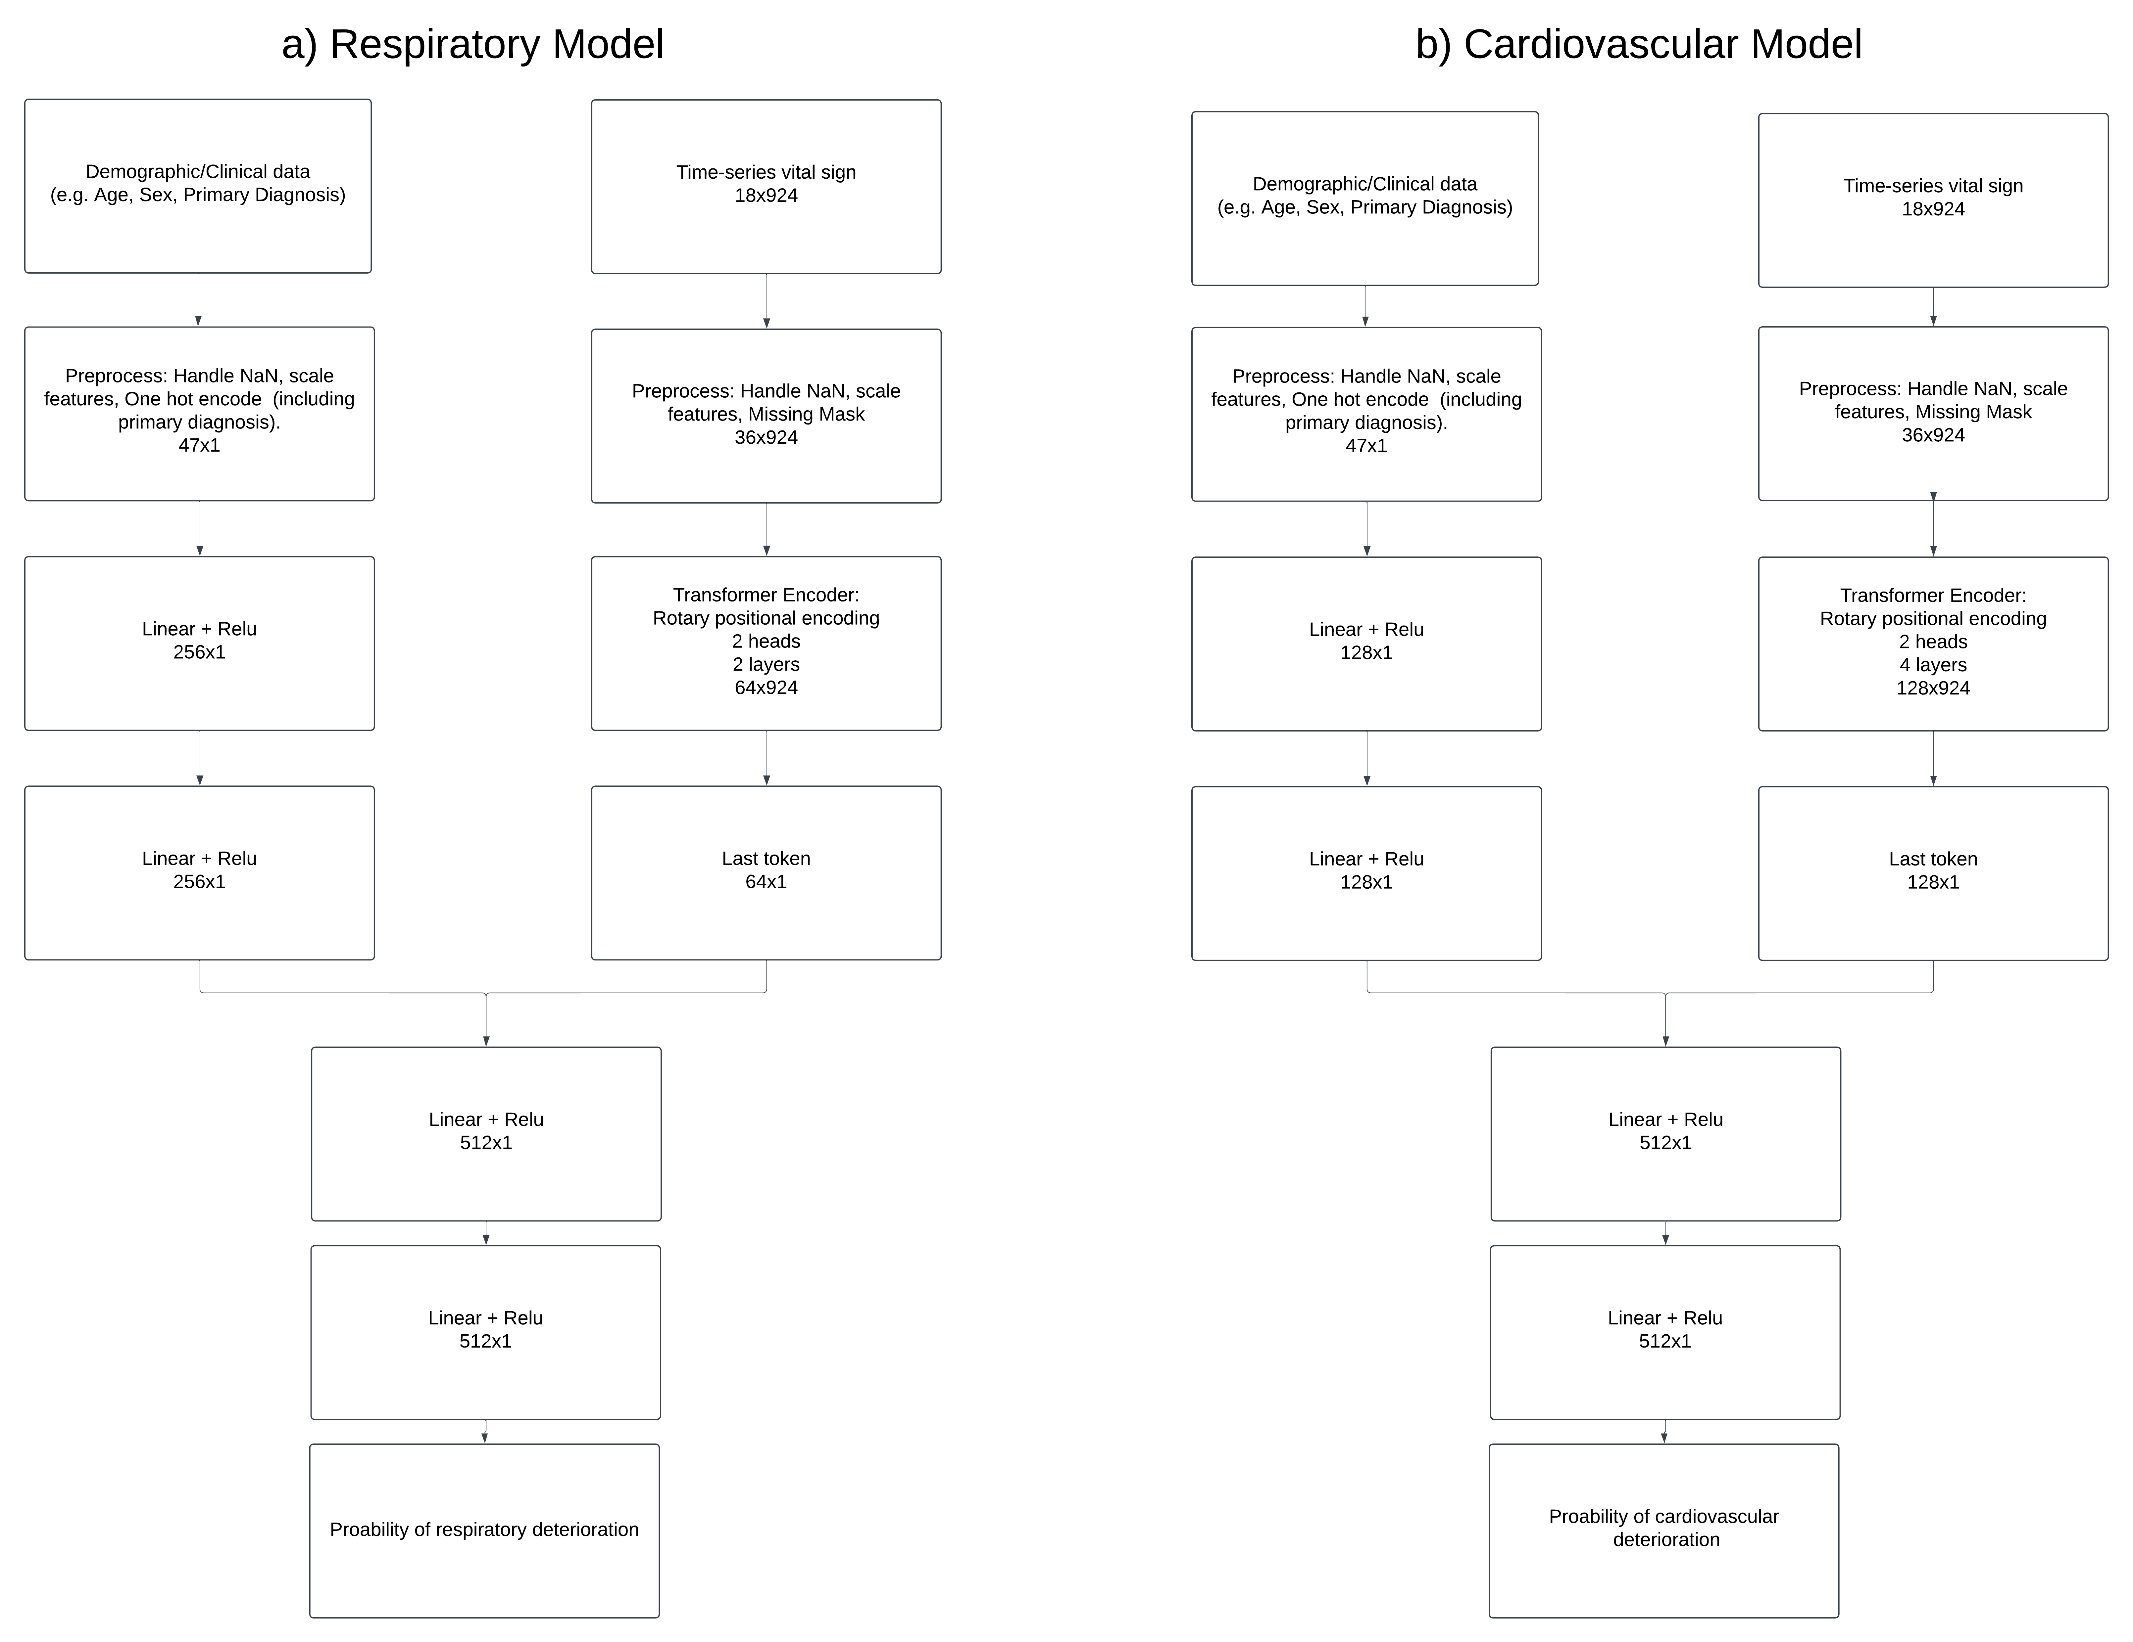
Supplementary Figure 5: Architecture of the Combined Transformer (One-Hot Diagnosis, Reduced Baseline) model. a) Architecture for respiratory model. b) Architecture for cardiovascular model. Each model integrates two branches: a transformer for processing time-series vital signs, and a feed-forward network for a reduced subset of baseline features (including age, weight, sex, PIM3 score, destination care area, pre-existing medical conditions, intra-transport support, and one-hot encoded primary diagnosis). Outputs from both branches are concatenated and passed through a final feed-forward network to generate the prediction.
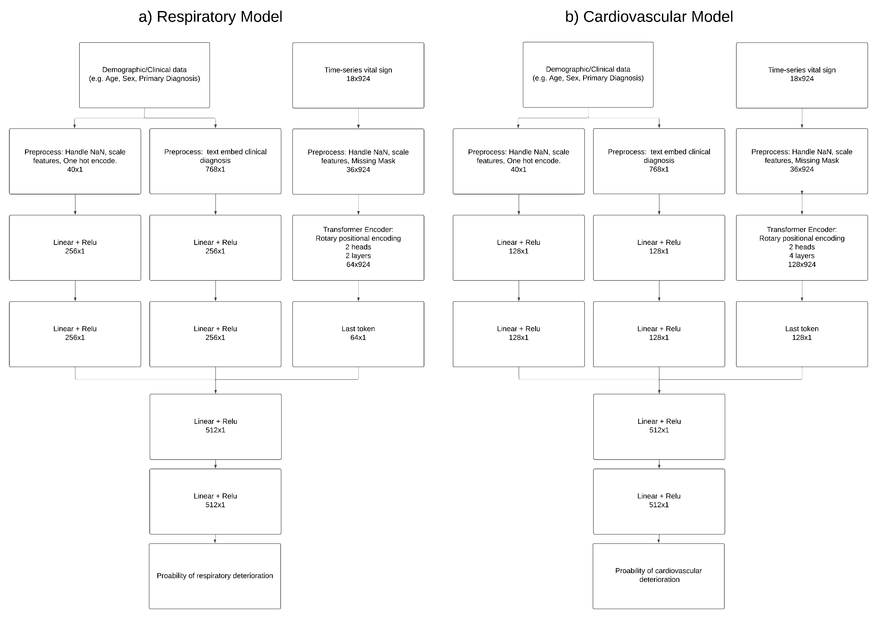
Supplementary Figure 6: Architecture of the Combined Transformer (Vector Diagnosis, Reduced Baseline) model. a) Architecture for respiratory model. b) Architecture for cardiovascular model. Each model integrates three branches: a transformer for processing time-series vital signs, a feed-forward network for a reduced subset of baseline features (including age, weight, sex, PIM3 score, destination care area, pre-existing medical conditions, and intra-transport support), and a separate feed-forward network for the vector-embedded primary diagnosis. Outputs from all branches are concatenated and passed through a final feed-forward network to generate the prediction.

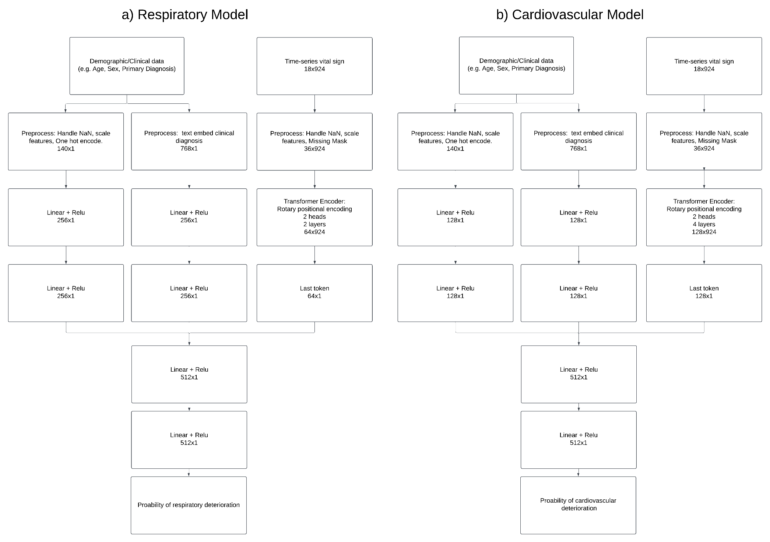
Supplementary Figure 7: Architecture of the Combined Transformer (Vector Diagnosis, Full Baseline) model. a) Architecture for respiratory model. b) Architecture for cardiovascular model. Each model integrates three branches: a transformer for processing time-series vital signs, a feed-forward network for the full set of baseline features (including age, weight, sex, ethnicity, pre-transport interventions, and intra-transport support), and a separate feed-forward network for vector-embedded primary diagnosis. Outputs from all branches are concatenated and passed through a final feed-forward network to generate the prediction.

