Golgi apparatus-targeted AIEgens for effective photodynamic therapy through the crosstalk of Golgi apparatus and mitochondria
Minglun Liu, Yuncong Chen*, Yan Guo, Hao Yuan, Shankun Yao, Suxing Jin, Huanhuan Fan, Chengjun Wang, Weijiang He*, Zijian Guo*
Table of Contents
Experimental section
Materials and methods
Scheme S1. Syntheses routes of AIEgens
Figure S1. ¹H and ¹³C NMR spectra of compound 1
Figure S2. HR-MS spectrum of compound 1.
Figure S3. ¹H and ¹³C NMR spectra of compound 2
Figure S4. HR-MS spectrum of compound 2.
Figure S5. ¹H and ¹³C NMR spectra of TPE-PyT-CP
Figure S6. HR-MS spectrum of TPE-PyT-CP.
Figure S7. ¹H and ¹³C NMR spectra of TPE-PyT-CPS
Figure S8. HR-MS spectrum of TPE-PyT-CPS.
Figure S9. ¹H and ¹³C NMR spectra of TPE-PyT-PS
Figure S10. HR-MS spectrum of TPE-PyT-PS.
Figure S11. ¹H and ¹³C NMR spectra of compound.
Figure S12. HR-MS spectrum of compound 3.
Figure S13. ¹H and ¹³C NMR spectra of 4
Figure S14. HR-MS spectrum of compound 4.
Figure S15. ¹H and ¹³C NMR spectra of TPE-T-CPS.
Figure S16. HR-MS spectrum of TPE-T-CPS.
Table S1. Optical properties of AIEgens.
Table S2. Data of Density functional theory calculations
Figure S17. Absorption and emission spectra of different AIEgens
Figure S18. AIE curves of AIEgens
Figure S19. ROS generation measurement of AIEgens
Figure S20. Lipophilicity of AIEgens.
Figure S21. Subcellular organelle imaging of TPE-T-CPS
Figure S22. Subcellular organelle imaging of TPE-PyT-CP.
Figure S23. Subcellular organelle imaging of TPE-PyT-PS.
Figure S24. Apoptosis of HeLa cells measured by flow cytometry.
Figure S25 Biodistribution of TPE-PyT-CPS in HeLa-tumor-bearing mice
Figure S26. Images of H&E and TUNEL staining of tumor
Figure S27. Images of H&E-stained tumor and various organ slices.

Experimental section
Synthesis and characterization parts
Scheme S1. Syntheses routes of TPE-PyT-CPS, TPE-PyT-CP, TPE-T-CPS and TPE-PyT-PS.
Syntheses of compound 1.
Under N₂ atmosphere, to a mixture of 1,6-dibromopyrene (5.0 g, 13.90 mmol), 5-(4,4,5,5-tetramethyl-1,3,2-dioxaborolan-2-yl)thiophene-2-carbaldehyde (3.33 g, 14.0 mmol) and potassium carbonate (4.14 g) in toluene (90 mL) and water (15 mL) was added Tetrakis(triphenylphosphine)palladium (0.81 g, 0.70 mmol) in one portion, then the mixture was heated to 85 ºC for over 18 hours. After completion, the mixture was cooled to room temperature and removal of the solvent. The resulting residue was extracted with dichloromethane and the crude product was purified by column chromatography using DCM and petroleum ether (1/1, R_{f} = 0.4) as the eluent to give a brown solid (2.3 g, 42.3 %). ¹H NMR (400 MHz, Chloroform-d) δ 10.02 (s, 1H), 8.49 (d, J = 9.2 Hz, 1H), 8.42 (d, J = 9.2 Hz, 1H), 8.27 (d, J = 8.2 Hz, 1H), 8.24 (d, J = 7.9 Hz, 1H), 8.17 (d, J = 9.3 Hz, 1H), 8.11 (d, J = 7.9 Hz, 1H), 8.06 (d, J = 9.3 Hz, 1H), 8.03 (d, J = 8.2 Hz, 1H), 7.92 (d, J = 3.8 Hz, 1H), 7.47 (d, J = 3.8 Hz, 1H). ¹³C NMR (101 MHz, Chloroform-d) δ 182.90, 152.61, 144.21, 136.68, 131.68, 130.65, 130.20, 129.88, 129.30, 128.97, 128.88, 128.80, 128.68, 128.35, 127.06, 125.99, 125.77, 125.20, 124.49, 124.35, 120.87, 29.70. HR-MS (ESI, positive mode, m/z): calcd for C₂₁H₁₁BrOS [M+H] ⁺:390.9787, found: 390.9779.
Syntheses of compound 2.
Under N₂ atmosphere, to a mixture of compound 1 (0.942 g, 2.0 mmol), 2-(4-(1,2-bis(4-methoxyphenyl)-2-phenylvinyl)phenyl)-4,4,5,5-tetramethyl-1,3,2-dioxaborolane (1.10g, 2.1 mmol), potassium carbonate (0.55 g) in toluene (15 mL) and water (3 mL) was added Tetrakis(triphenylphosphine)palladium (0.115 g, 0.095 mmol) in one portion, then the mixture was heated to 85 ºC for over 18 hours. After completion, the mixture was cooled to room temperature and removal of the solvent. The resulting residue was extracted with dichloromethane and the crude product was purified by column chromatography using petroleum ether and DCM (1/1, R_{f} = 0.3) as the eluent to give a brown solid (0.38 g, 27.1 %). ¹H NMR (400 MHz, Chloroform-d) δ 10.02 (s, 1H), 8.44 (d, J = 9.2 Hz, 1H), 8.24 (d, J = 7.9 Hz, 1H), 8.21 (d, J = 4.5 Hz, 1H), 8.19 (d, J = 3.2 Hz, 1H), 8.14 (d, J = 9.3 Hz, 1H), 8.10 (d, J = 7.9 Hz, 1H), 8.02 (t, J = 8.7 Hz, 2H), 7.93 (d, J = 3.9 Hz, 1H), 7.51 (d, J = 3.8 Hz, 1H), 7.38 (d, J = 8.1 Hz, 2H), 7.24 – 7.13 (m, 7H), 7.07 (d, J = 8.7 Hz, 2H), 7.01 (d, J = 8.7 Hz, 2H), 6.74 (d, J =8.7 Hz, 2H), 6.68 (d, J = 8.7 Hz, 2H), 3.81 (s, 3H), 3.77 (s, 3H). ¹³C NMR (101 MHz, Chloroform-d) δ 182.92, 171.99, 158.15, 156.79, 153.26, 144.18, 143.96, 143.56, 140.65, 136.75, 136.44, 132.77, 132.64, 131.80, 131.50, 131.41, 130.06, 129.95, 129.14, 128.74, 128.21, 128.13, 127.82, 127.14, 126.58, 126.25, 125.19, 124.45, 124.05, 113.08, 113.05, 55.20, 55.12. HR-MS (ESI, positive mode, m/z): calcd for C₄₉H₃₄O₃S [M+H] ⁺:703.2301, found: 703.2296.
Syntheses of TPE-PyT-CP.
Compound 2 (147 mg, 0.228 mmol) and 2-(pyridin-4-yl)acetonitrile (34 mg, 0.228 mmol) were added to 50 ml flasks under nitrogen protection, then 15 ml ethanol and 4 drops of piperidine were added. The mixture was heated to 80 ºC and stirred for 24 hours. After the reaction, dichloromethane was used to extract and then anhydrous magnesium sulfate was used to dry. Further separation using column to separate the crude products with DCM (R_{f} = 0.4) yielded 120 mg red solid with a yield of 65.3%. ¹H NMR (400 MHz, Chloroform-d) δ 8.72 (d, J = 5.5 Hz, 2H), 8.48 (d, J = 9.2 Hz, 1H), 8.27 – 8.18 (m, 3H), 8.18 – 8.12 (m, 2H), 8.07 – 7.99 (m, 3H), 7.94 (d, J = 3.8 Hz, 1H), 7.76 (d, J = 5.0 Hz, 2H), 7.55 (d, J = 3.8 Hz, 1H), 7.38 (d, J = 8.1 Hz, 2H), 7.25 – 7.13 (m, 7H), 7.07 (d, J = 8.8 Hz, 2H), 7.01 (d, J = 8.6 Hz, 2H), 6.75 (d, J = 8.8 Hz, 2H), 6.68 (d, J = 8.7 Hz, 2H), 3.81 (s, 3H), 3.77 (s, 3H). ¹³C NMR (101 MHz, Chloroform-d) δ 158.27, 158.15, 148.72, 148.71, 144.17, 143.57, 140.66, 138.88, 138.71, 138.46, 137.85, 137.52, 136.44, 136.26, 136.05, 132.76, 132.64, 131.80, 131.80, 131.50, 131.42, 130.07, 129.95, 129.31, 129.25, 128.82, 128.73, 128.34, 128.16, 127.84, 127.82, 128.73, 127.17, 126.61, 126.25, 125.32, 125.21, 124.98, 124.51, 124.04, 119.97, 117.05, 113.09, 113.05, 55.20, 55.12. HR-MS (ESI, positive mode, m/z): calcd for C₅₆H₃₈N₂O₂S [M+H] ⁺: 803.2727, found: 803.2757.
Syntheses of TPE-PyT-CPS.
A mixture of TPE-PyT-CP (105 mg, 0.13 mmol) and CH₃I (300 mg, 2.12 mmol) in CH₃CN (10 ml) was refluxed at 90°C for 4 h under nitrogen protection. After cooling to room temperature, Et₂O (15 mL) was added into the solution to form a solid. The solid was filtered off and dried under vacuum, then the obtained solid was dissolved in acetone (10 mL), and a solution of KPF₆ (915 mg, 5 mmol) in 2 mL H₂O was added. The mixture was stirred at room temperature for 6 h. Acetone was removed under reduced pressure, and the residue was purified by silica gel chromatography using DCM/MeOH (30:1, R_{f} = 0.5) as the eluent to give TPE-PyT-CPS as a dark red solid (103 mg, 82.2 %). ¹H NMR (400 MHz, DMSO-d6) δ 9.12 (s, 1H), 9.01 (d, J = 6.9 Hz, 2H), 8.51 (d, J = 9.3 Hz, 1H), 8.42 (dd, J = 8.2, 2.6 Hz, 2H), 8.40 – 8.33 (m, 3H), 8.27 (dd, J = 14.1, 8.7 Hz, 2H), 8.20 (d, J = 4.0 Hz, 1H), 8.09 (dd, J = 17.9, 8.6 Hz, 2H), 7.87 (d, J = 3.9 Hz, 1H), 7.44 (d, J = 8.1 Hz, 2H), 7.20 (dq, J = 16.0, 7.4 Hz, 5H), 7.11 (d, J = 7.0 Hz, 2H), 7.00 (d, J = 8.7 Hz, 2H), 6.94 (d, J = 8.6 Hz, 2H), 6.81 (d, J = 8.7 Hz, 2H), 6.73 (d, J = 8.7 Hz, 2H), 4.33 (s, 3H), 3.75 (s, 3H), 3.70 (s, 3H). ¹³C NMR (101 MHz, DMSO-d6) δ 157.94, 157.80, 151.99, 148.77, 145.61, 143.81, 143.67, 143.20, 140.51, 140.50, 140.43, 138.35, 137.90, 137.75, 137.36, 135.66, 135.54, 132.22, 132.09, 131.37, 130.98, 130.85, 130.41, 129.85, 129.69, 129.61, 129.15, 128.48, 128.42, 128.24, 128.02, 127.90, 127.56, 127.50, 126.40, 125.85, 125.66, 125.11, 124.48, 124.14, 123.85, 122.39, 116.50, 113.26, 113.21, 100.78, 55.04, 54.94, 47.19, 29.04. HR-MS (ESI, positive mode, m/z): calcd for C₅₇H₄₁N₂O₂S⁺[M-PF₆⁻] ⁺: 817.2883, found: 817.2894.
Syntheses of TPE-PyT-PS.
A mixture of TPE-PyT-CP (120 mg, 0.17 mmol) and 1,4-dimethylpyridin-1-ium bromide (300 mg, 2.12 mmol) were added to 50 ml flasks under nitrogen protection, then 20 ml ethanol and 6 drops of piperidine were added. The mixture was heated to 80 ºC and stirred for 24 hours. After cooling to room temperature, Et₂O (20 ml) was added into the solution to form a solid. The solid was filtered off and dried under vacuum, then the obtained solid was dissolved in acetone (10 ml), and a solution of KPF₆ (915 mg, 5 mmol) in 2 mL H₂O was added. The mixture was stirred at room temperature for 6 h. Acetone was removed under reduced pressure, and the residue was purified by silica gel chromatography using CH₂Cl₂/MeOH (40:1, R_{f} = 0.5) as the eluent to give TPE-PyT-CPS as a brown solid (80 mg, 50.2 %). ¹H NMR (400 MHz, DMSO-d6) δ 8.85 (d, J = 6.4 Hz, 2H), 8.55 (d, J = 9.2 Hz, 1H), 8.45 – 8.37 (m, 2H), 8.34 (dd, J = 12.7, 2.9 Hz, 2H), 8.28 – 8.15 (m, 4H), 8.07 (dd, J = 14.3, 8.5 Hz, 2H), 7.72 (d, J = 3.5 Hz, 1H), 7.63 (d, J = 3.5 Hz, 1H), 7.43 (d, J = 7.9 Hz, 2H), 7.31 (d, J = 16.0 Hz, 1H), 7.20 (dq, J = 14.9, 7.1 Hz, 5H), 7.11 (d, J = 7.2 Hz, 2H), 7.00 (d, J = 8.5 Hz, 2H), 6.94 (d, J = 8.4 Hz, 2H), 6.81 (d, J = 8.5 Hz, 2H), 6.73 (d, J = 8.5 Hz, 2H), 4.25 (s, 3H), 3.75 (s, 3H), 3.71 (s, 3H). ¹³C NMR (101 MHz, DMSO-d6) δ 157.83, 157.70, 152.04, 145.11, 144.88, 143.57, 143.07, 141.34, 140.32, 138.27, 137.73, 137.55, 135.57, 135.44, 133.42, 132.61, 132.10, 131.97, 130.87, 130.74, 129.97, 129.72, 129.53, 128.61, 128.31, 128.23, 128.02, 127.91, 127.46, 126.29, 125.30, 124.92, 124.42, 124.13, 123.85, 123.08, 122.07, 113.16, 54.83, 46.74, 28.92. HR-MS (ESI, positive mode, m/z): calcd for C₅₆H₄₂NO₂S⁺ [M] ⁺:792.2931, found: 792.2903.
Syntheses of ompound 3.
Under N₂ atmosphere, to a mixture of 4,4'-(2-(4-bromophenyl)-2-phenylethene-1,1-diyl)bis(methoxybenzene) (4.71g, 10.0 mmol), 5-(4,4,5,5-tetramethyl-1,3,2-dioxaborolan-2-yl)thiophene-2-carbaldehyde (3.33 g, 14.0 mmol) and potassium carbonate (4.14 g) in toluene (90 ml) and water (15 ml) was added Tetrakis(triphenylphosphine)palladium (0.81 g, 0.70 mmol) in one portion, then the mixture was heated to 85 ºC for over 18 hours. After completion, the mixture was cooled to room temperature and removal of the solvent. The resulting residue was extracted with dichloromethane and the crude product was purified by column chromatography using DCM and petroleum ether (1/1, R_{f} = 0.3) as the eluent to give a brown solid (3.8 g, 75.6 %). ¹H NMR (400 MHz, Chloroform-d) δ 9.86 (s, 1H), 7.70 (d, J = 3.9 Hz, 1H), 7.42 (d, J = 8.4 Hz, 2H), 7.34 (d, J = 3.9 Hz, 1H), 7.16 – 7.09 (m, 3H), 7.07 (d, J = 8.4 Hz, 2H), 7.03 (dd, J = 7.6, 1.9 Hz, 2H), 6.97 (d, J = 8.8 Hz, 2H), 6.93 (d, J = 8.8 Hz, 2H), 6.67 (d, J = 8.8 Hz, 2H), 6.64 (d, J = 8.8 Hz, 2H), 3.75 (s, 3H), 3.74 (s, 3H). ¹³C NMR (101 MHz, Chloroform-d) δ 182.71, 158.36, 158.23, 154.37, 145.95, 143.83, 141.96, 141.20, 138.16, 137.46, 135.99, 132.62, 132.59, 132.16, 131.39, 130.46, 127.86, 126.35, 125.63, 123.72, 113.22, 113.02, 55.12, 55.09. HR-MS (ESI, positive mode, m/z): calcd for C₃₃H₂₆O₃S⁺ [M] ⁺:503.1675, found: 503.1665.
Syntheses of compound 4
Compound 3 (251 mg, 0.50 mmol) and 2-(pyridin-4-yl)acetonitrile (88 mg, 0.60 mmol) were added to 50 ml flasks under nitrogen protection, then 20 ml ethanol and 10 drops of piperidine were added. The mixture was heated to 80 ºC and stirred for 24 hours. After the reaction, dichloromethane was used to extract and then anhydrous magnesium sulfate was used to dry. Further separation using column to separate the crude products with DCM (R_{f} = 0.35) as the eluent to give a red solid (210 mg, 69.7%). ¹H NMR (400 MHz, Chloroform-d) δ 8.66 (d, J = 5.3 Hz, 2H), 7.84 (s, 1H), 7.65 (d, J = 4.0 Hz, 1H), 7.58 (d, J = 6.1 Hz, 2H), 7.44 (d, J = 8.4 Hz, 2H), 7.34 (d, J = 4.0 Hz, 1H), 7.13 (d, J = 7.2 Hz, 3H), 7.06 (dd, J = 10.5, 8.1 Hz, 4H), 6.98 (d, J = 8.7 Hz, 2H), 6.94 (d, J = 8.7 Hz, 2H), 6.68 (d, J = 8.8 Hz, 2H), 6.64 (d, J = 8.8 Hz, 2H), 3.76 (s, 3H), 3.74 (s, 3H). ¹³C NMR (101 MHz, Chloroform-d) δ 158.40, 158.25, 152.07, 149.41, 145.83, 143.84, 142.66, 141.25, 138.20, 137.43, 136.62, 136.02, 135.81, 132.62, 132.60, 132.20, 131.42, 130.36, 127.86, 126.37, 125.57, 123.78, 119.68, 117.18, 113.25, 113.03, 103.72, 55.13, 55.10. HR-MS (ESI, positive mode, m/z): calcd for C₄₀H₃₀N₂O₂S⁺[M+H] ⁺:603.2101, found: 603.2082
Syntheses of TPE-T-CPS
A mixture of compound 4 (200 mg, 0.33 mmol) and CH₃I (300 mg, 2.12 mmol) in CH₃CN (15 ml) was refluxed at 90 °C for 4 h under nitrogen protection. After cooling to room temperature, Et₂O (15 mL) was added into the solution to form a solid. The solid was filtered off and dried under vacuum, then the obtained solid was dissolved in acetone (10 ml), and a solution of KPF₆ (915 mg, 5 mmol) in 2 ml H₂O was added. The mixture was stirred at room temperature for 6 h. Acetone was removed under reduced pressure, and the residue was purified by silica gel chromatography using CH₂Cl₂/MeOH (30:1, R_{f} = 0.5) as the eluent to give TPE-PyT-CPS as a dark red solid (150 mg, 59.6 %). ¹H NMR (400 MHz, DMSO-d6) δ 8.97 (s, 1H), 8.96 (s, 2H), 8.30 (d, J = 6.9 Hz, 2H), 7.98 (d, J = 4.1 Hz, 1H), 7.80 (d, J = 4.0 Hz, 1H), 7.63 (d, J = 8.3 Hz, 2H), 7.15 (dq, J = 14.2, 7.0 Hz, 3H), 7.07 (d, J = 8.3 Hz, 2H), 7.00 (d, J = 6.8 Hz, 2H), 6.93 (d, J = 8.6 Hz, 2H), 6.88 (d, J = 8.6 Hz, 2H), 6.75 (d, J = 8.7 Hz, 2H), 6.70 (d, J = 8.7 Hz, 2H), 4.30 (s, 3H), 3.69 (d, J = 2.5 Hz, 6H). ¹³C NMR (101 MHz, DMSO-d6) δ 157.92, 157.78, 153.18, 148.78, 145.69, 145.40, 143.58, 143.30, 141.27, 140.88, 137.71, 135.42, 135.28, 132.03, 131.96, 131.79, 130.74, 129.70, 129.50, 127.91, 126.40, 125.66, 125.44, 122.14, 116.38, 113.30, 113.09, 99.92, 54.84, 47.02. HR-MS (ESI, positive mode, m/z): calcd for C₄₁H₃₃N₂O₂S⁺[M] ⁺:617.2257, found: 617.2243.

Figure S1. ¹H and ¹³C NMR spectra of compound 1 in CDCl₃.
Figure S2. HR-MS spectrum of compound 1.
Figure S3. ¹H and ¹³C NMR spectra of compound 2 in CDCl₃.
Figure S4. HR-MS spectrum of compound 2.
Figure S5. ¹H and ¹³C NMR spectra of TPE-PyT-CP in CDCl₃.

Figure S6. HR-MS spectrum of TPE-PyT-CP.
Figure S7. ¹H and ¹³C NMR spectra of TPE-PyT-CPS in DMSO-d6.
Figure S8. HR-MS spectrum of TPE-PyT-CPS.
Figure S9. ¹H and ¹³C NMR spectra of TPE-PyT-PS in DMSO-d6.
Figure S10. HR-MS spectrum of TPE-PyT-PS.
Figure S11. ¹H and ¹³C NMR spectra of compound 3 in CDCl₃.
Figure S12. HR-MS spectrum of compound 3.
Figure S13. ¹H and ¹³C NMR spectra of 4 in CDCl₃.
F Figure S14. HR-MS spectrum of compound 4.
Figure S15. ¹H and ¹³C NMR spectra of TPE-T-CPS in DMSO-d6.

Figure S16. HR-MS spectrum of TPE-T-CPS.

Table S1. Optical properties of AIEgens TPE-PyT-CP, TPE-PyT-PS, TPE-T-CPS, TPE-PyT-CPS.
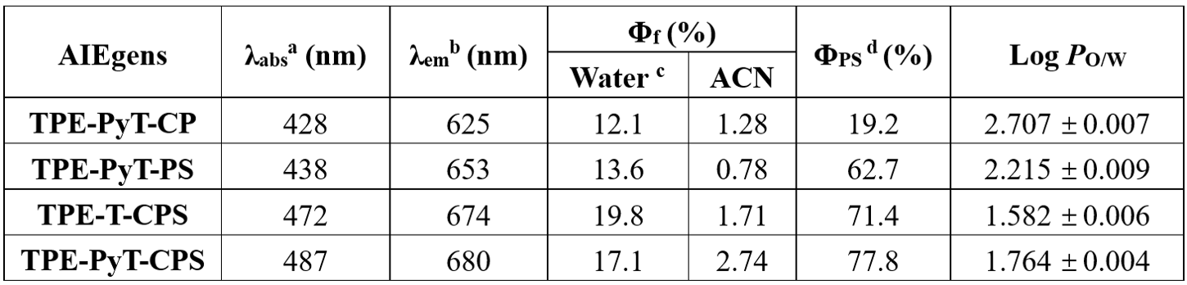
a) Absorption maximum in water (containing 1% acetonitrile). b) Emission maximum in water (containing 1% acetonitrile). c) The ¹O₂ quantum yield of AIEgens in aqueous solution.
Table S2. Selected parametersª for the calculated singlet state energy level and triplet state energy level of TPE-T-CPS and TPE-PyT-CPS.
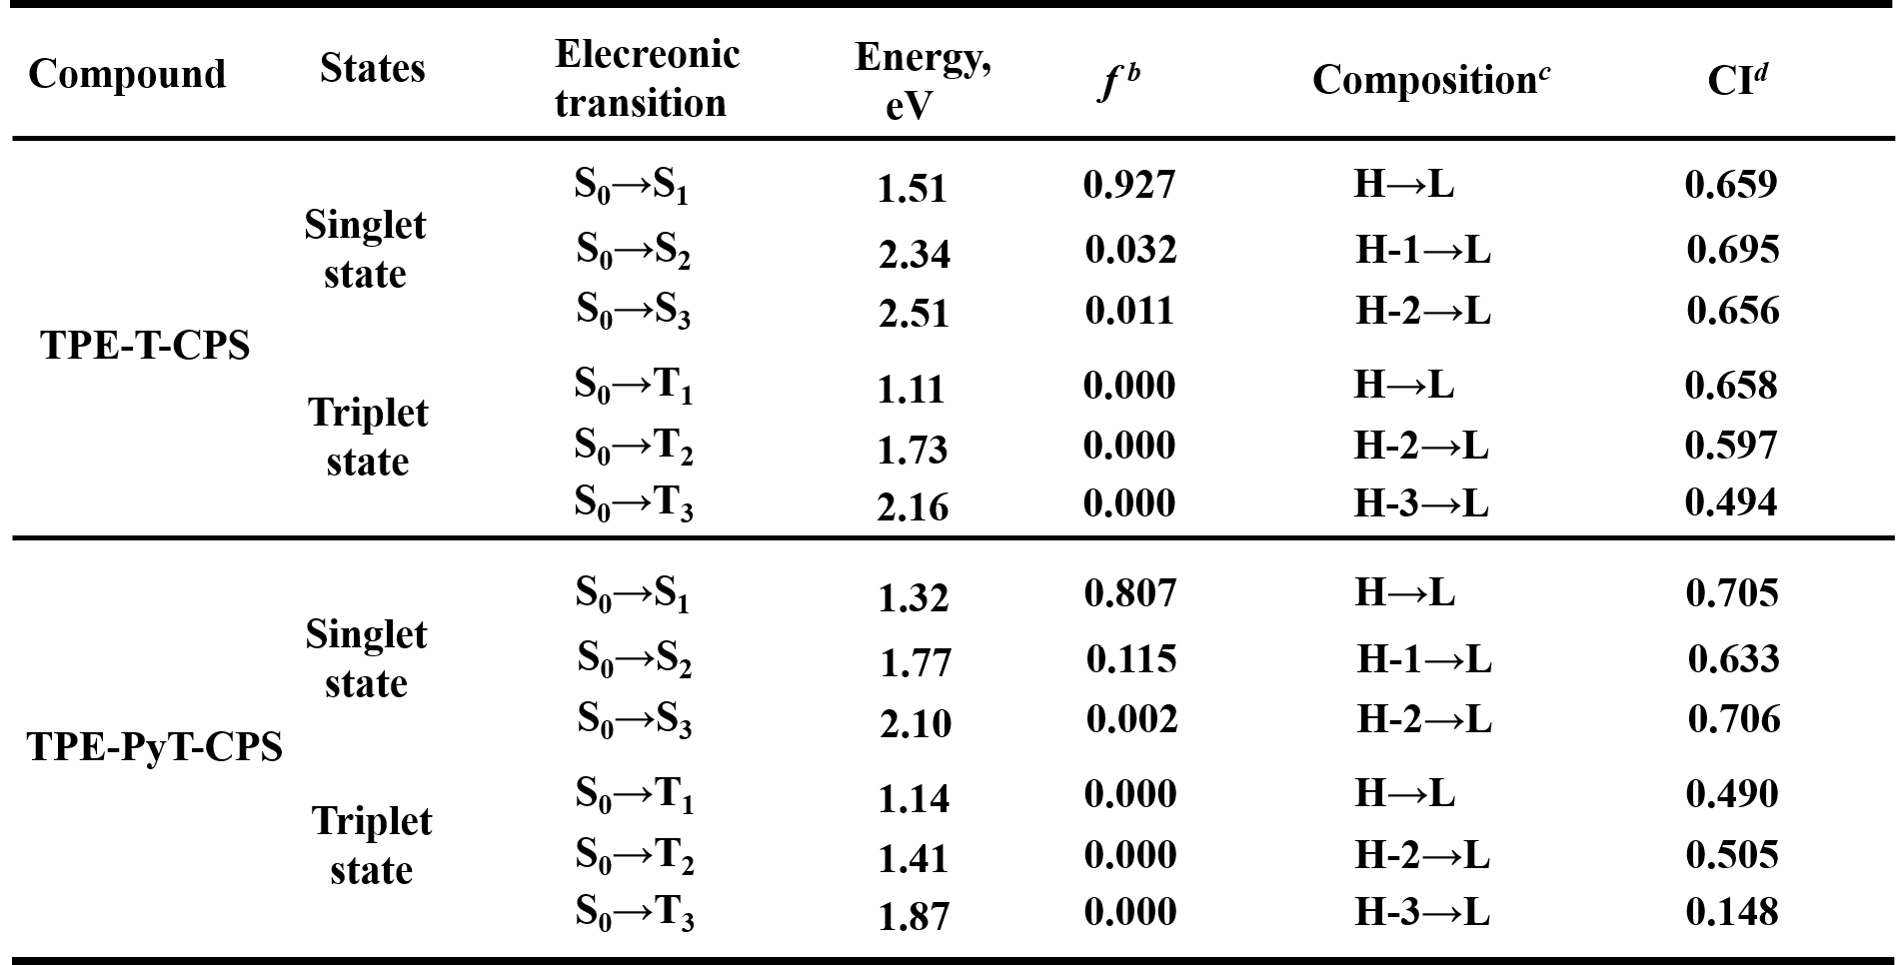
ªParameters were calculated by TD-DFT//B3LYP/6-31G(d), based on the optimized ground-state geometries using the method DFT//B3LYP/6-31G(d). ^{b}Oscillator strength. ^{c}H, HOMO (highest occupied molecular orbital) and L, LUMO (lowest unoccupied molecular orbital). ^{d}Coefficient of the wavefunction for each excitation.
Absorption and fluorescence spectra
The stock solution of those compounds (1 mM) was prepared in acetonitrile and stored at 4 ºC. All spectroscopic study of the compounds were carried out in test solution (10 μM) in 3 mL water.
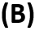

Figure S17. (A) Absorption and (B) emission spectra of TPE-PyT-CPS, TPE-PyT-CP, TPE-PyT-PS, TPE-T-CPS (10 μM) were recorded in water (containing 1% acetonitrile, v/v).
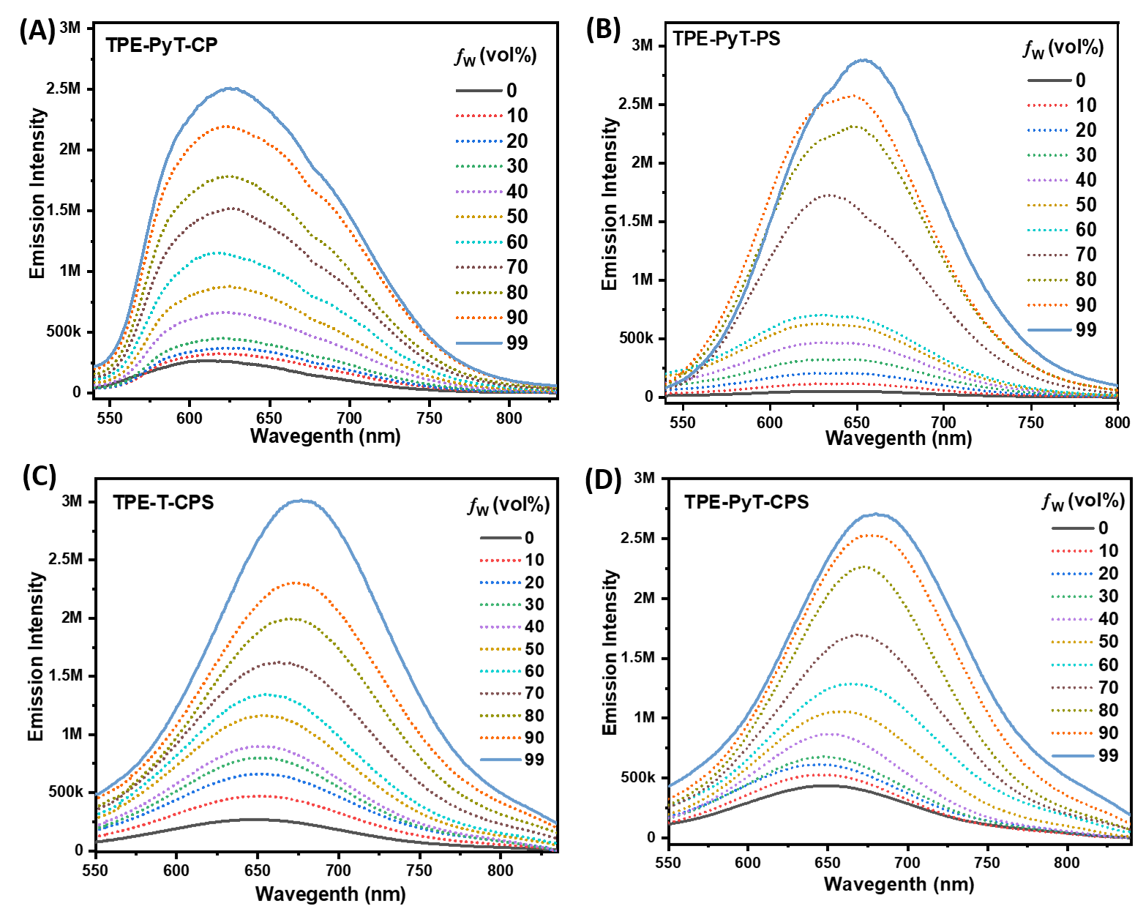
Figure S18. Emission spectra of different AIEgens in acetonitrile/Water mixtures with varied water fractions (ƒ_{w}).
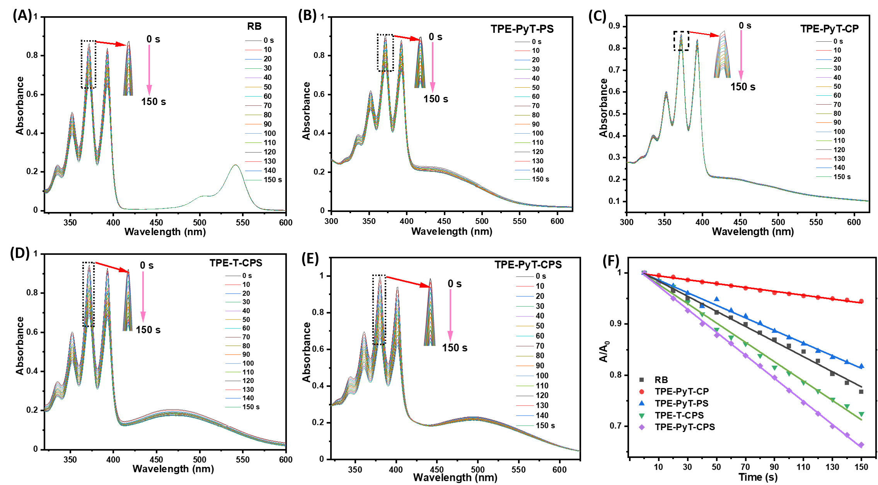
Figure S19. The ¹O₂ generation ability of RB (A), TPE-PyT-PS (B), TPE-PyT-CP (C), TPE-T-CPS (D), TPE-PyT-CPS (E) and (F) Plot of ln(A/A₀) against light exposure time for different AIEgens in water (containing 1% acetonitrile, v/v), where A₀ and A are the ABDA absorbance (378 nm) before and after irradiation, respectively.
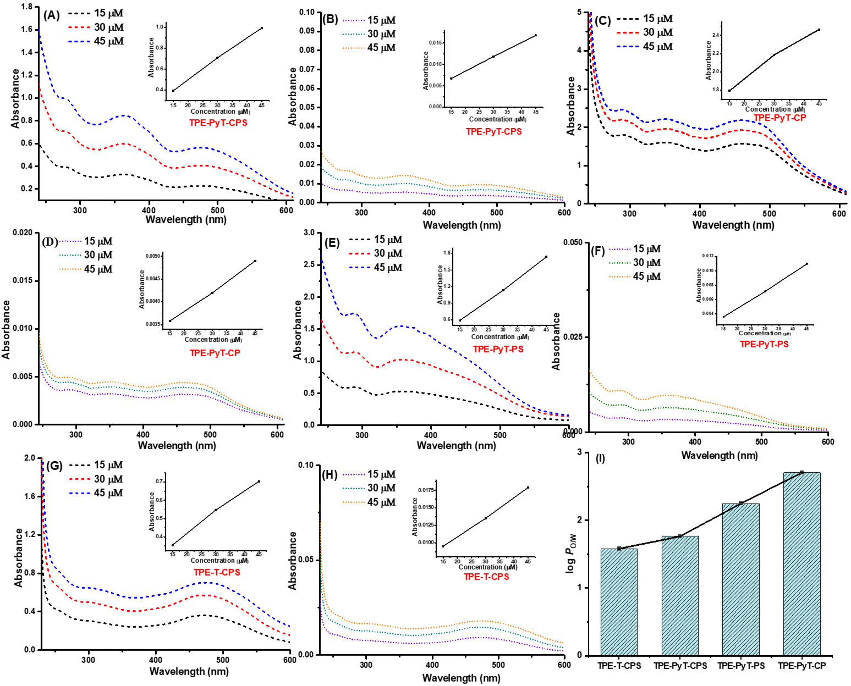
Figure S20. UV spectra of TPE-PyT-CPS, TPE-PyT-CP, TPE-PyT-PS, TPE-T-CPS in phosphate buffer and 1-octanol at different concentrations: (A), (C), (E) (G)) before shaking; (B), (D), (F) (H) after shaking. (I) The log P_{O/W} value of different AIEgens.
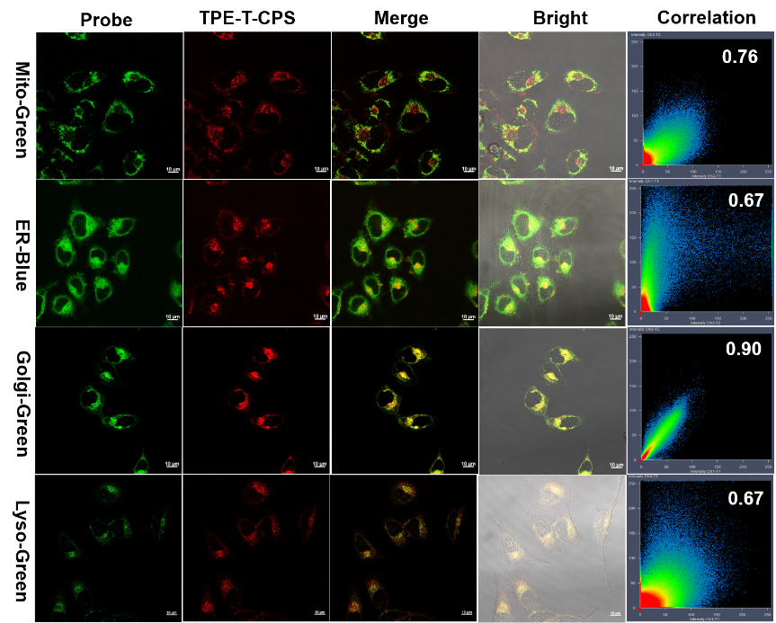
Figure S21. CLSM of HeLa cells stained with different commercial probes (Mito-Green, ER-Blue, Golgi-Green, Lyso-Green) and TPE-T-CPS (10 μM) (scale bar: 10 μm).
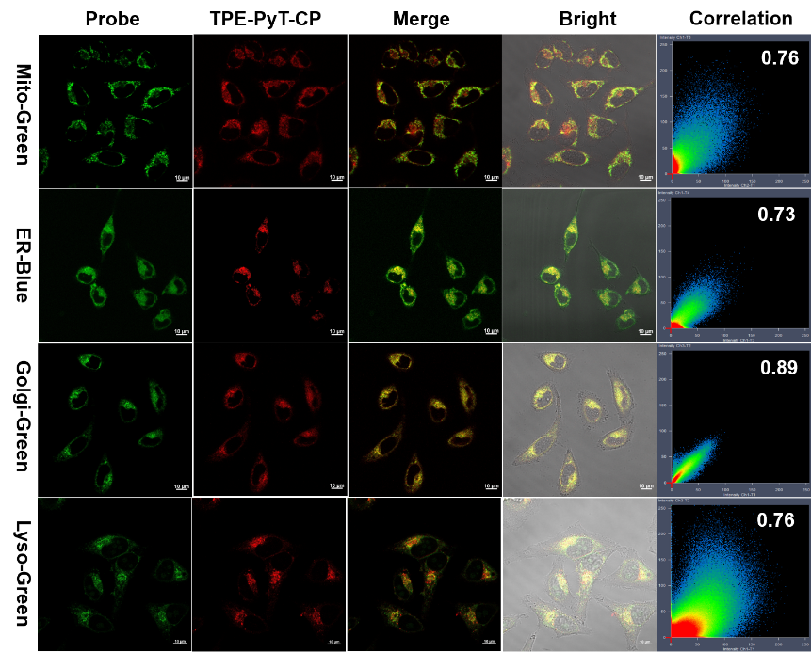
Figure S22. CLSM of HeLa cells stained with different commercial probes (Mito-Green, ER-Blue, Golgi-Green, Lyso-Green) and TPE-PyT-CP (10 μM) (scale bar: 10 μm).
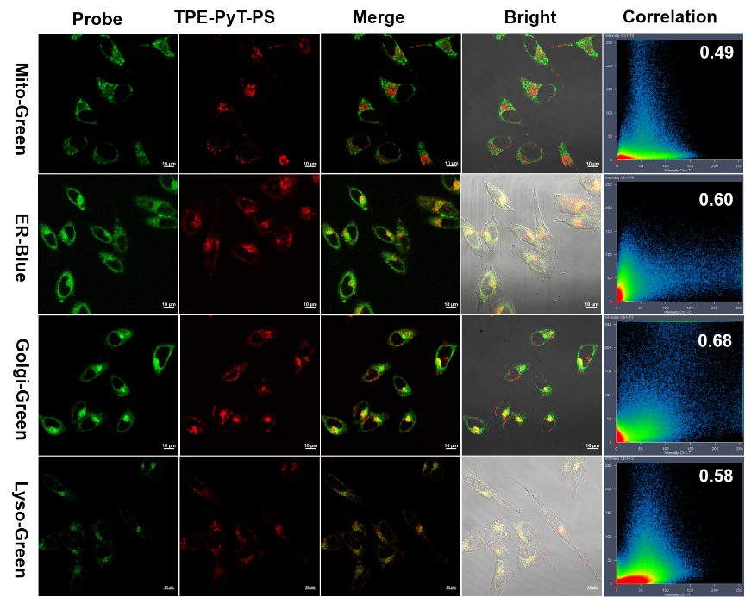
Figure S23. CLSM of HeLa cells stained with different commercial probes (Mito-Green, ER-Blue, Golgi-Green, Lyso-Green) and TPE-PyT-PS (10 μM) (scale bar: 10 μm).
Flow cytometry analysis
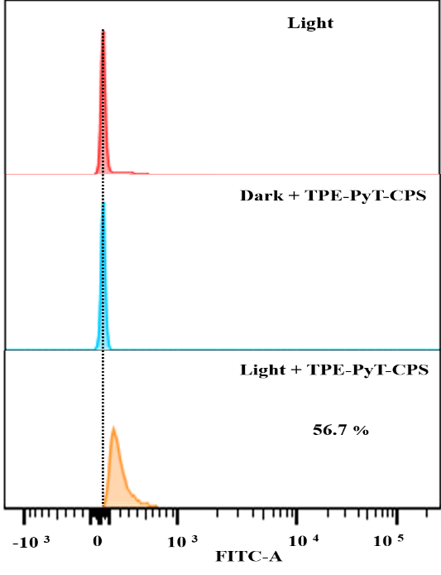
Figure S24. Apoptosis of HeLa cells after treatment with TPE-PyT-CPS (0.2 μM) under light irradiation (65 mW cm⁻², 2 min) and measured by using Annexin V in combination with flow cytometry.
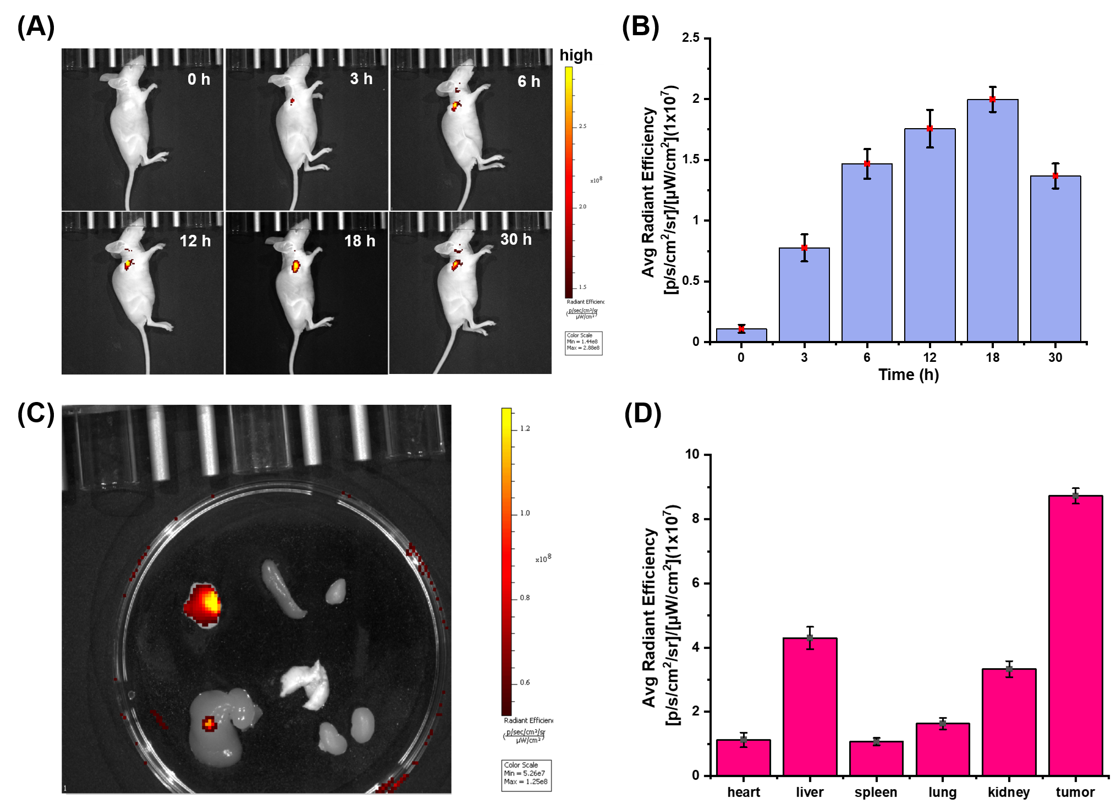
Figure S25 (A) Biodistribution of TPE-PyT-CPS in HeLa-tumor-bearing mice after intratumoral injection of TPE-PyT-CPS (100 μM, 120 μL) at different time. (B) Time-dependent fluorescence intensity changes of TPE-PyT-CPS in mice. (C) Fluorescence intensity analysis of anatomic organs. (D) Photographs of excised tumors on the 22 th day.
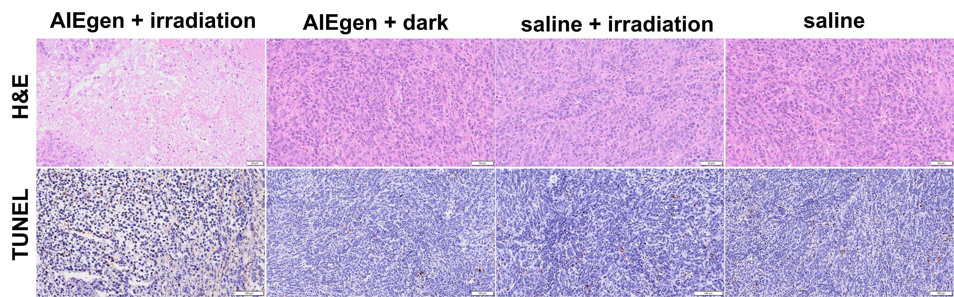
Figure S26. Images of various H&E-stained organ slices from mice after different treatments (scale bar: 50 μm) and apoptotic analysis of TUNEL stained tumor tissues after treatment with saline and TPE-PyT-CPS (scale bar: 100 μm).
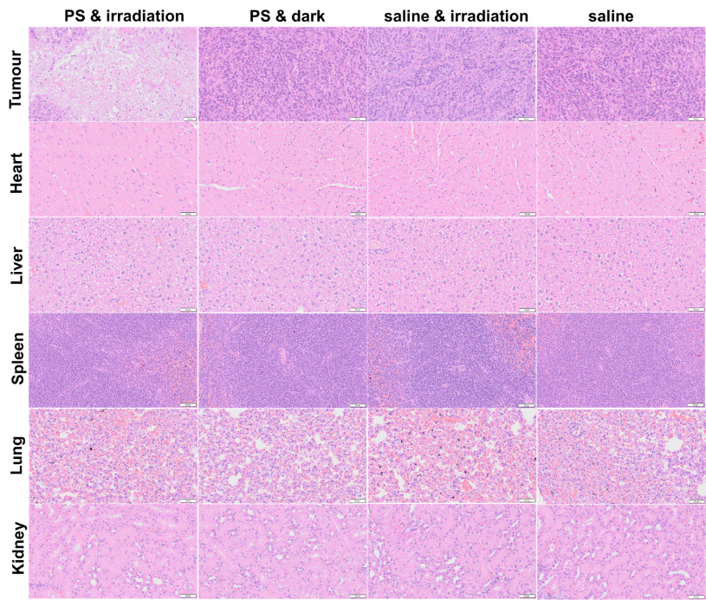
Figure S27. Images of various H&E-stained tumor and organ slices from mice after different treatments (scale bar: 50 μm).
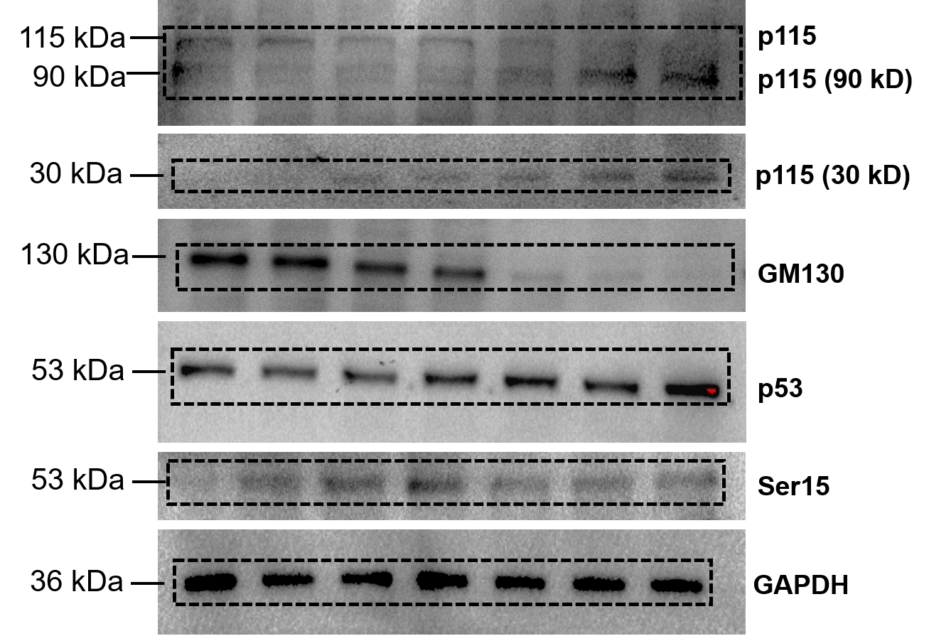
Figure S28. Uncropped scans of western blot with molecular weight markers, and it is related with Figure 7A and B.
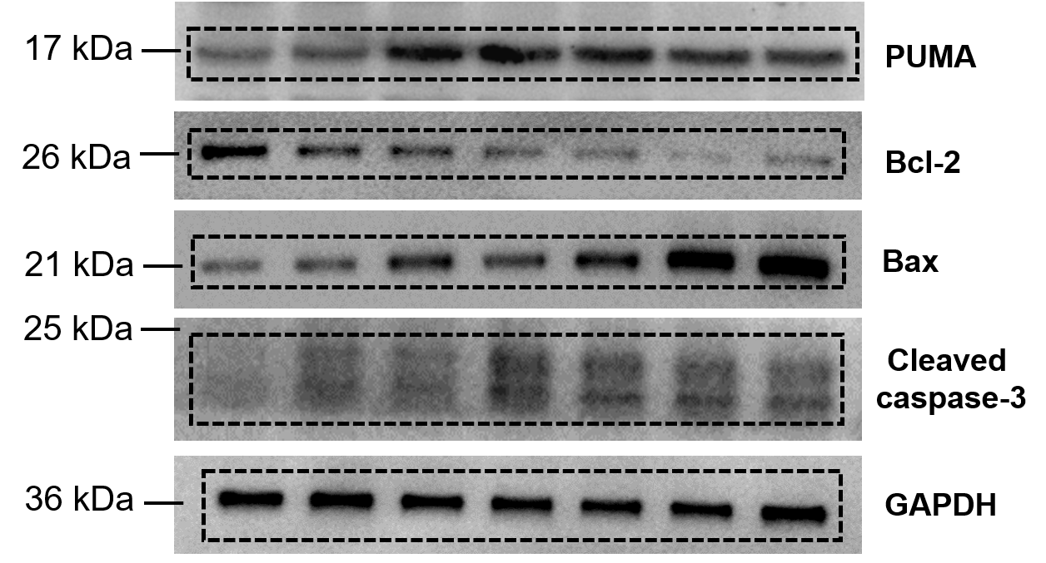
Figure S29. Uncropped scans of western blot with molecular weight markers, and it is related with Figure 7C and D.

