Supporting Information
MOCVD Growth of Covalent and 2D Ga–Se: A Raman Microscopy-Based Phase Validation
Nils Fritjof Langlotz^{1,2}, Robin Günkel^{1,2}, Dominik Muth^{1,2}, Imad Limame³, Naghmeh Ghadghooni^{1,2}, Max Bergmann^{1,2}, Marcel Kröner^{1,2}, Jürgen Belz^{1,2}, Andreas Beyer^{1,2}, Stephan Reizenstein³, Marina Gerhard^{1,2}, Kerstin Volz^{1,2*}

¹mar.quest | Marburg Center for Quantum Materials and Sustainable and Technologies, Philipps-Universität Marburg, 35032 Marburg, Germany

²Department of Physics, Philipps-Universität Marburg, Hans Meerwein Str. 6, 35032 Marburg, Germany

³Institute of Physics and Astronomy, Technical University of, Hardenbergstraße 36, 10623 Berlin, Germany

*kerstin.volz@physik.uni-marburg.de

Table of contents:
S1. Evaluation of GaSe on Sapphire Substrates at 450 °C
S2. Evaluation of GaSe on Sapphire Substrates at 500–550 °C
S3. Evaluation of Ga₂Se₃ on Sapphire Substrates
S4. Evaluation of Ga₂Se₃ on GaP/Si Substrates
S5. Comparison of GaP/Si and Sapphire Substrates
S6. EDX Analysis of the Ga₂Se₃ Layer on GaP/Si (Figure 2e)
S7. EDX Analysis of GaSe on GaP/Si (Figure 3a,c)
S8. MOCVD Reactor Setup

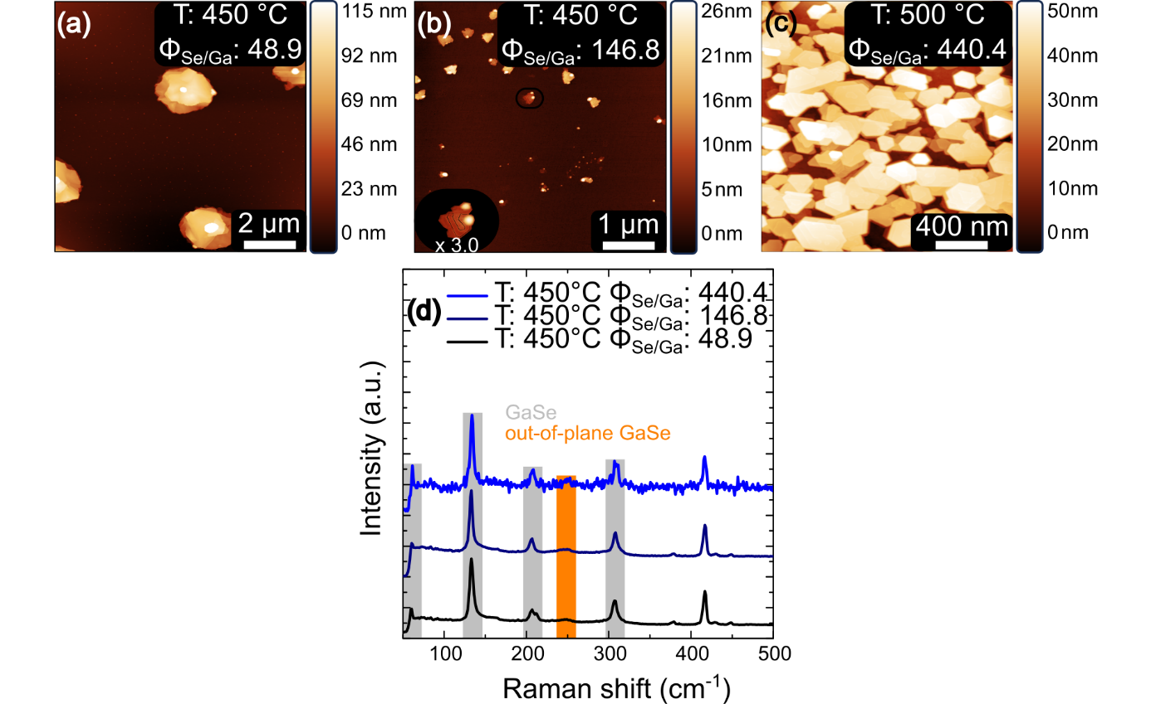
Figure S1: Morphology and spectroscopic characterization of GaSe grown at 450 °C on sapphire:
(a) AFM image of a cluster consisting of a central grain with layered flakes growing outward.
(b) AFM image showing a grain from which an in-plane layered structure grows, featuring visible screw dislocations, with a 3.0× magnified inset of an individual screw dislocation.
(c) AFM image of hexagonal flakes that are still not coalesced.
(d) Raman spectra corresponding to (a–c), showing only GaSe- and substrate-related Raman modes.^{[1–7]}

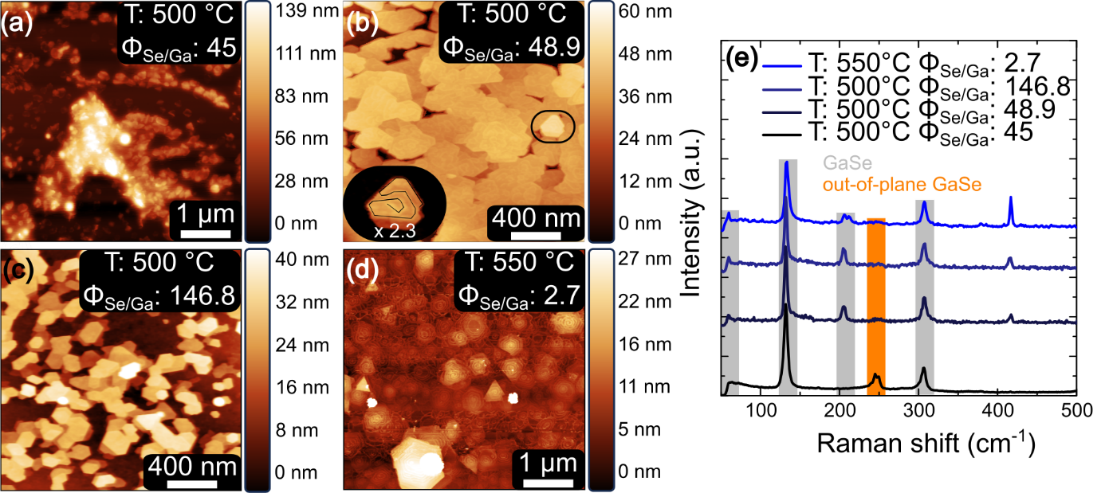
Figure S2: Morphology and spectroscopic characterization of GaSe grown at 500 and 550 °C on sapphire:
(a) AFM image of out-of-plane flakes.
(b) AFM image of non-coalesced hexagonal and trigonal flakes showing screw dislocations, with a 2.3× magnified inset of an individual screw dislocation.
(c) AFM image of hexagonal flakes that are still not coalesced.
(d) AFM image of screw dislocations in hexagonal and trigonal flakes with a fully coalesced underlying layer.
(e) Raman spectra corresponding to (a–d), showing only GaSe- and substrate-related Raman modes.^{[1–7]}

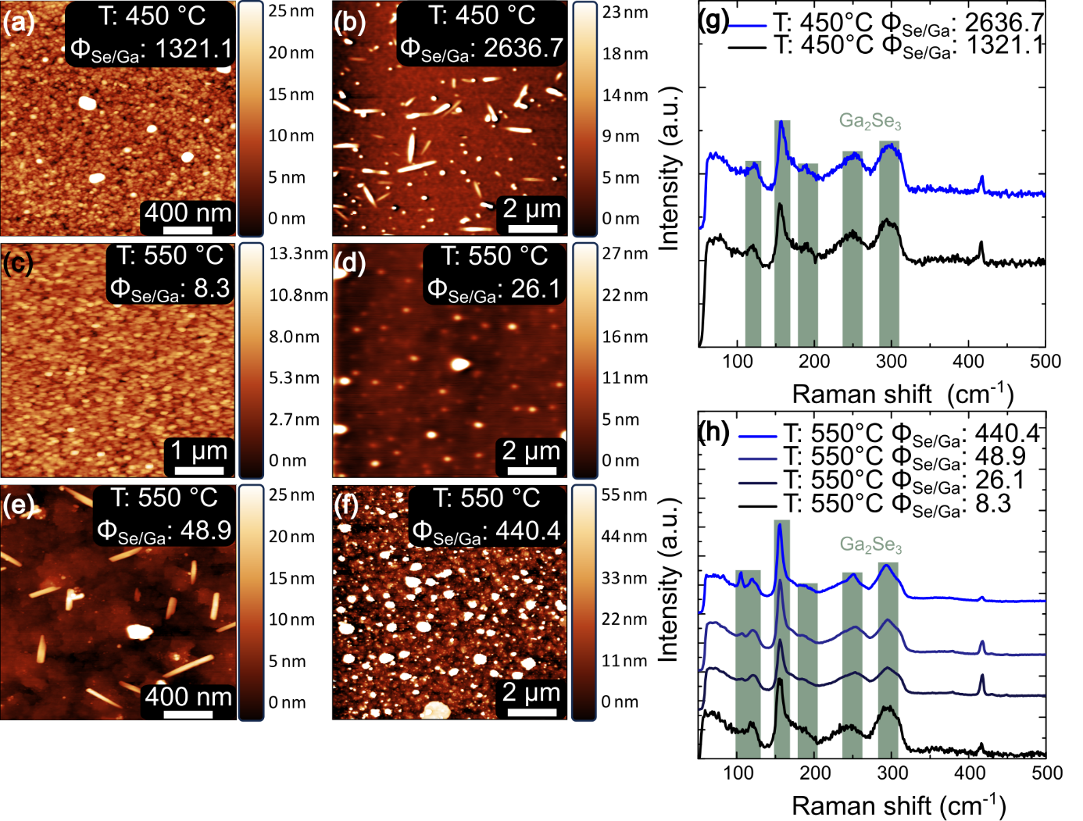
Figure S3: Morphology and spectroscopic characterization of Ga₂Se₃ grown at 450 and 550 °C on sapphire:
(a) AFM image of Ga₂Se₃ clusters.
(b) AFM image of a coalesced layer with clusters and rod-like structures on it.
(c) AFM image of Ga₂Se₃ clusters.
(d) AFM image of Ga₂Se₃ clusters.
(e) AFM image of layered Ga₂Se₃ and rod-like structures.
(f) AFM image of layered and clustered Ga₂Se₃ structures.
(g) Raman spectra corresponding to (a) and (b), showing only Ga₂Se₃- and substrate-related Raman modes.^{[2,3,8–11]}
(h) Raman spectra corresponding to (c–f), showing only Ga₂Se₃- and substrate-related Raman modes.^{[2,3,8–11]}

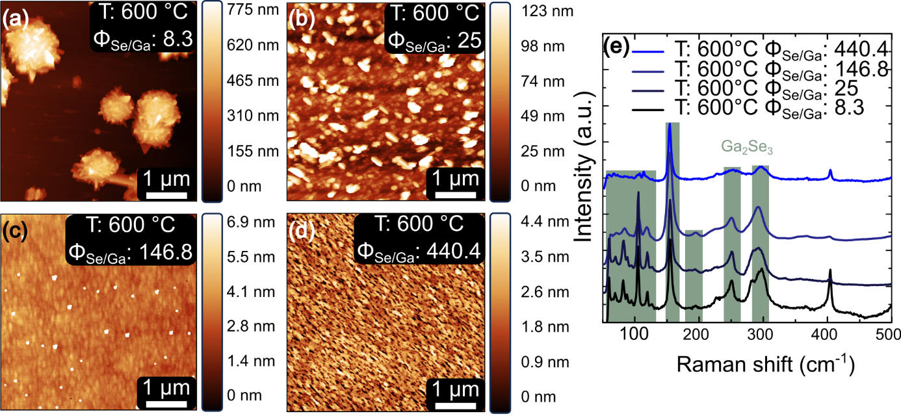
Figure S4. Morphology and spectroscopic characterization of Ga₂Se₃ grown at 600 °C on GaP/Si:
(a) AFM image of Ga₂Se₃ clusters with rod-like features.
(b) AFM image of Ga₂Se₃ clusters with rod-like features oriented in two perpendicular directions.
(c) AFM image of coalesced Ga₂Se₃ layers and clusters.
(d) AFM of small Ga₂Se₃ patches.
(e) Raman spectra corresponding to (a–d), showing only Ga₂Se₃- and substrate-related Raman modes.^{[8–15]}

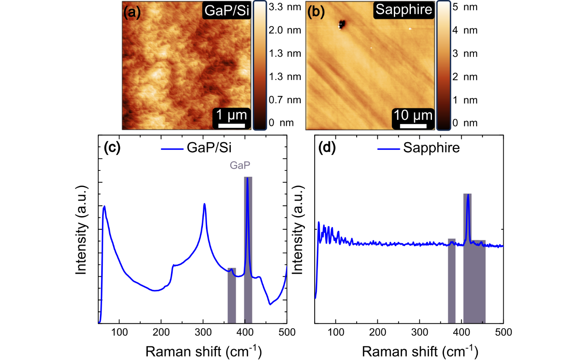
Figure S5: Morphology and spectroscopic characterization of GaP/Si and sapphire substrates:
(a) AFM image of GaP steps on the GaP/Si substrate.
(b) AFM image of the sapphire substrate showing polishing lines and a localized surface contamination.
(c) Raman spectra of the GaP/Si substrate, showing GaP peaks (marked) and additional signals from Si.^{[12–15]}
(d) Raman spectra of sapphire, showing four characteristic sapphire-related Raman peaks (marked).^{[2,3]}

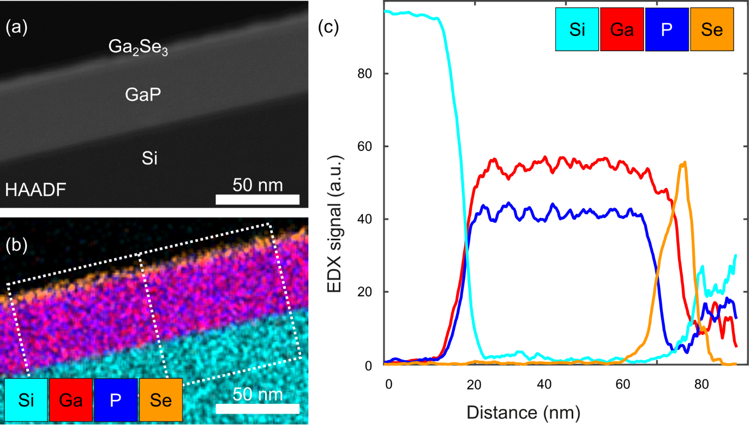
Figure S6: EDX Analysis of the Covalently bonded Ga₂Se₃ Layer on GaP/Si:
(a) Zoomed-out HAADF image of the Ga₂Se₃ layer from Figure 2(e) of thin Ga₂Se₃ layer.
(b) EDX map corresponding to (a).
(c) Averaged EDX line profile across the Ga₂Se₃, GaP, and Si interface extracted from the EDX map shown in (b), illustrating the 2:3 ratio of Ga and Se in the covalently bonded layer.

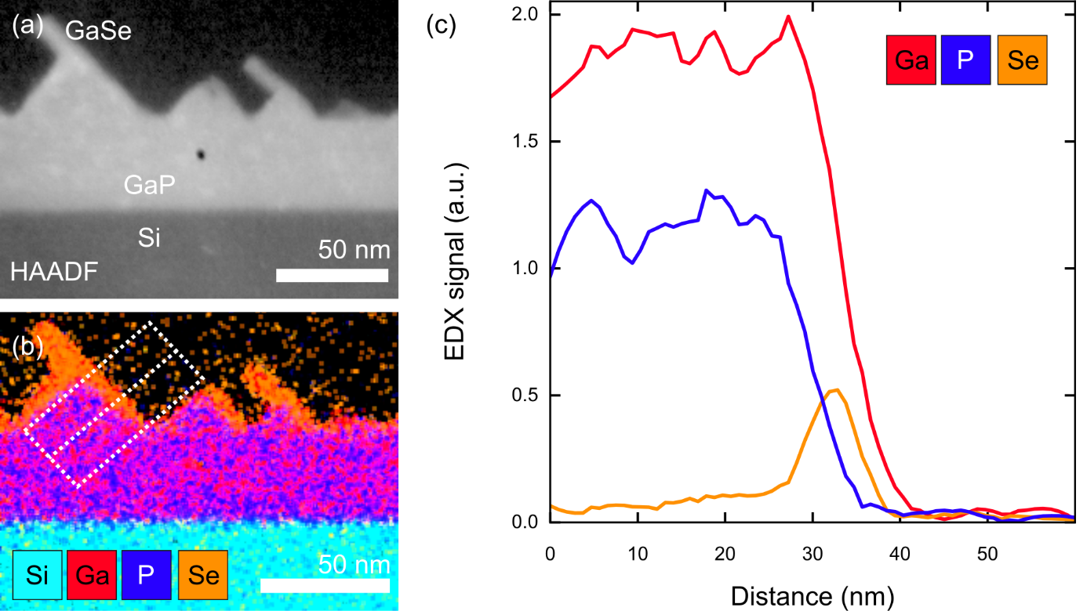
Figure S7: EDX Analysis of the 2D GaSe on GaP/Si:
(a) HAADF image of GaSe on GaP/Si from Figure 3(a,c)
(b) EDX map corresponding to (a).
(c) Averaged EDX line profile across the GaSe and GaP interface extracted from the EDX map shown in (b), illustrating a 1:1 ratio of Ga and Se in the van der Waals bonded layeres.
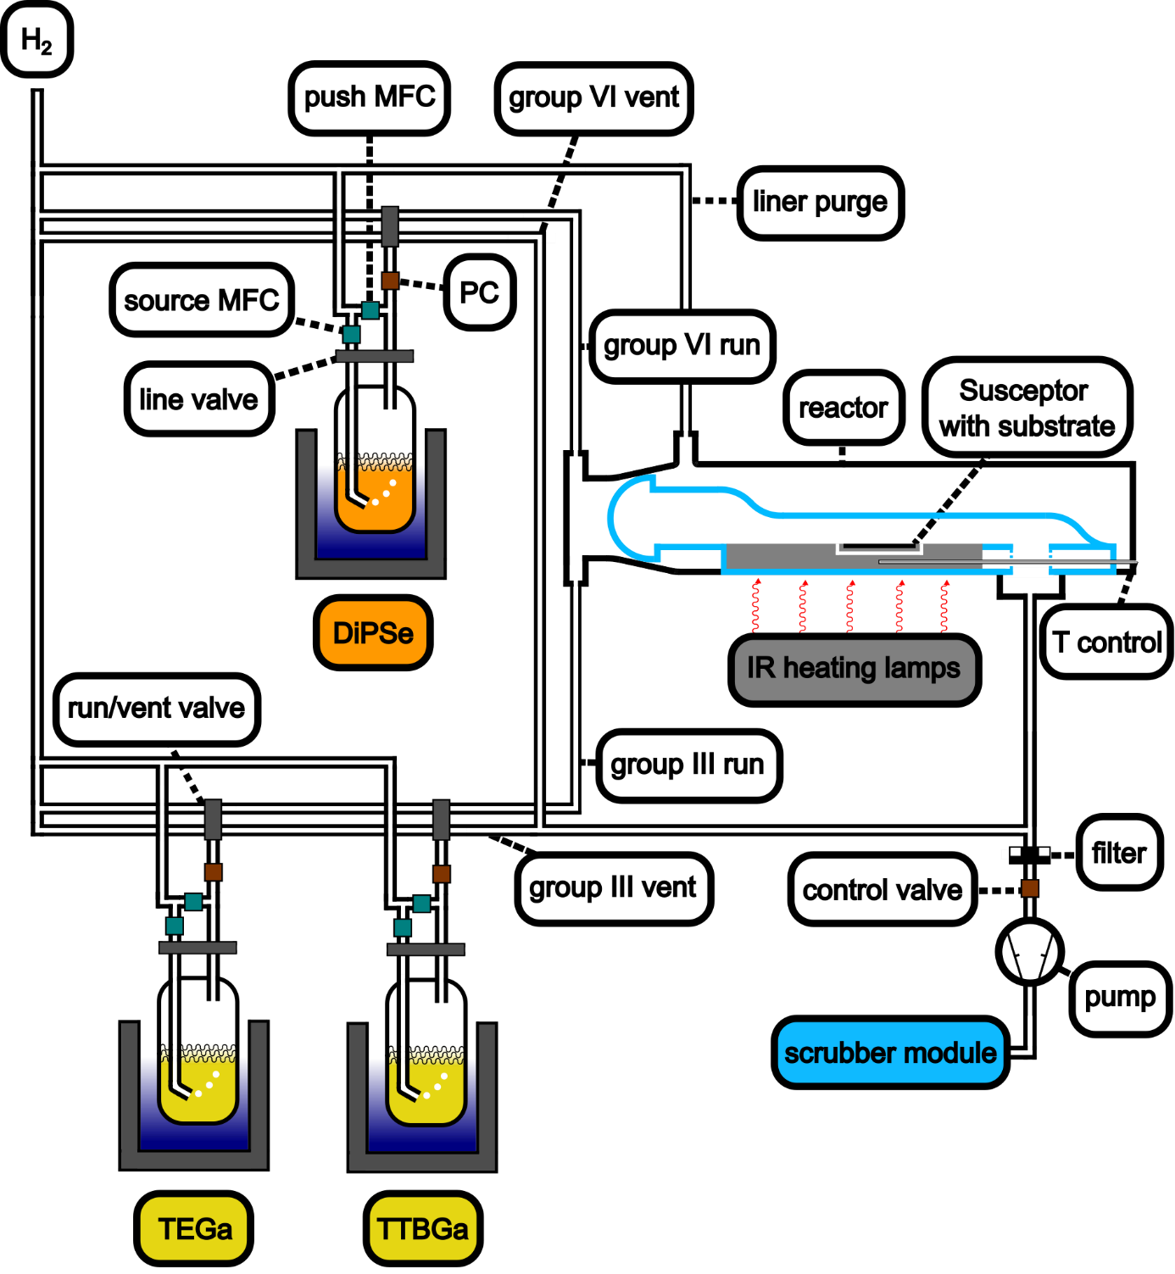
Figure S8: MOCVD reactor setup

References
1. Rodriguez, R. D. et al. Selective Raman modes and strong photoluminescence of gallium selenide flakes on sp2 carbon. Journal of Vacuum Science & Technology B, Nanotechnology and Microelectronics: Materials, Processing, Measurement, and Phenomena 32; 10.1116/1.4881995 (2014).
2. Vural, S. & Sari, Ö. Synthesis and characterization of SDS assistant α-alumina structures and investigation of the effect of the calcination time on the morphology. Colloid Polym Sci 297, 107–114; 10.1007/s00396-018-4442-4 (2019).
3. Kadleı́ková, M., Breza, J. & Veselý, M. Raman spectra of synthetic sapphire. Microelectronics Journal 32, 955–958; 10.1016/S0026-2692(01)00087-8 (2001).
4. Grzonka, J., Claro, M. S., Molina‐Sánchez, A., Sadewasser, S. & Ferreira, P. J. Novel Polymorph of GaSe. Adv Funct Materials 31; 10.1002/adfm.202104965 (2021).
5. Diep, N. Q. et al. Growth Mode Transition in Two-Dimensional GaSe on Three-Dimensional GaN/Sapphire Platform: Implication for Self-Powered Photodetection. ACS Appl. Nano Mater. 7, 3042–3049; 10.1021/acsanm.3c05343 (2024).
6. Avdienko, P. et al. Structural and Optical Properties of GaSe/GaAs(001) Layers Grown by Molecular Beam Epitaxy. Acta Phys. Pol. A 136, 608–612; 10.12693/APhysPolA.136.608 (2019).
7. Diep, N. Q. et al. Screw-Dislocation-Driven Growth Mode in Two Dimensional GaSe on GaAs(001) Substrates Grown by Molecular Beam Epitaxy. Scientific reports 9, 17781; 10.1038/s41598-019-54406-5 (2019).
8. Bletskan, D. I., Kabatsii, V. N. & Kranjčec, M. Photoelectric properties of ordered-vacancy Ga2Se3 single crystals. Inorg Mater 46, 1290–1295; 10.1134/S0020168510120034 (2010).
9. Emde, M. von der et al. MOCVD growth of Ga2Se3 on GaAs(100) and GaP(100): a Raman study. Applied Surface Science 104-105, 575–579; 10.1016/S0169-4332(96)00205-X (1996).
10. Märkl, A., Emde, M. von der, Nowak, C., Richter, W. & Zahn, D. Investigation of Se capping of epitaxial Ga 2 Se 3 layers. Surface Science 331-333, 631–635; 10.1016/0039-6028(95)00356-8 (1995).
11. Finkman, E., Tauc, J., Kershaw, R. & Wold, A. Lattice dynamics of tetrahedrally bonded semiconductors containing ordered vacant sites. Phys. Rev. B 11, 3785–3794; 10.1103/PhysRevB.11.3785 (1975).
12. Seo, H. W., Bae, S. Y., Park, J., Yang, H. & Kim, S. Synthesis of gallium phosphide nanowires via sublimation method. Chem. Commun., 2564–2565; 10.1039/B207995J (2002).
13. Dubey, R. L., Dubey, S. K., Yadav, A. D., Sulania, I. & Kanjilal, D. Raman scattering and FTIR studies of 100 MeV Fe 9+ ion-irradiated gallium phosphide. Radiation Effects and Defects in Solids 166, 743–748; 10.1080/10420150.2011.578633 (2011).
14. Abdullayeva, S. H. et al. GaInPN/Si heterostructure growth by metal-organic vapour phase epitaxy. Fizika (Baku) 15, 18–23 (2009).
15. Lee, W.-J. & Chang, Y.-H. Growth without Postannealing of Monoclinic VO2 Thin Film by Atomic Layer Deposition Using VCl4 as Precursor. Coatings 8, 431; 10.3390/coatings8120431 (2018).

