Table S1. List of ‘common’ differentially expressed genes (DEGs) which showed a common pattern of expression changes in both radish leaves and roots at 28 and 42 days after germination (DAG) under the red light (RL) in comparison with far-red light (FRL)*.

ID of protein product (NCBI) | Function of protein product  (NCBI) | log2 fold change
ID of protein product (NCBI) | Function of protein product  (NCBI) | leaf |  | root
ID of protein product (NCBI) | Function of protein product  (NCBI) | 14 DAG | 28 DAG | 14 DAG | 28 DAG
Downregulated under RL (13 genes total)
KAJ4887868.1 | Pseudo-response regulator APRR5 | -2.5261825183565 | -1.0140043121755 | -1.6406116213069 | -1.4550644855772
KAJ4906650.1 | MADS-box protein SOC1 | -5.2622803220849 | -2.4812987476026 | -9.8076595531523 | -6.4464590164298
KAJ4870594.1 | MADS-box protein SOC1 | -2.5784701487719 | -2.0889691325272 | -2.3417979517550 | -7.9712641057570
KAJ4911149.1 | Protein CONSTANS-LIKE5 | -4.1853867341983 | -2.1863289415179 | -2.7276134530199 | -1.6265456869011
KAJ4880546.1 | Xyloglucan endotransglucosylase/hydrolase | -3.1911331872392 | 0 | -3.1270545484161 | -1.5838549856894
KAJ4901395.1 | Tonoplast dicarboxylate transporter | -4.5209908499064 | 0 | -4.9542433984130 | 0
KAJ4874343.1 | Vacuolar membrane proton pump | -1.3445558495921 | 0 | -2.5590331964105 | -2.3093047861529
KAJ4884228.1 | Putative carboxylesterase | -1.0613655605887 | 0 | -1.7883564988240 | -2.3921912858641
Upregulated under RL (4 genes total)
KAJ4879121.1 | Two-component response regulator ARR4 | 1.19102447737697 | 3.57139246675224 | 1.61379171504291 | 2.05062510794951
KAJ4871578.1 | Myrosinase 1 | 1.29636461429848 | 10.1413888649609 | 1.78618057142299 | 1.18670983342403
KAJ4881196.1 | Myrosinase 1 | 1.96032909846856 | 14.0744433470567 | 3.13288265524729 | 1.48919143962641
KAJ4910175.1 | Myrosinase 1 | 1.15607238819137 | 8.82178991488416 | 1.9163683609008 | 1.43982407122758
* The table only shows genes with known function.

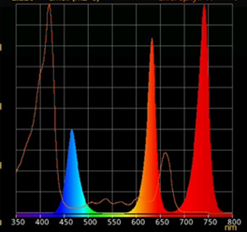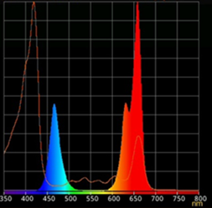

A B

Figure S1. Light treatment spectra, relative portion of R₆₆₀ and FR₇₃₀ in their combination: Treatment A– 0% R₆₆₀ + 100% FR₇₃₀; Treatment B – 100% R₆₆₀ + 0% FR_{730.}

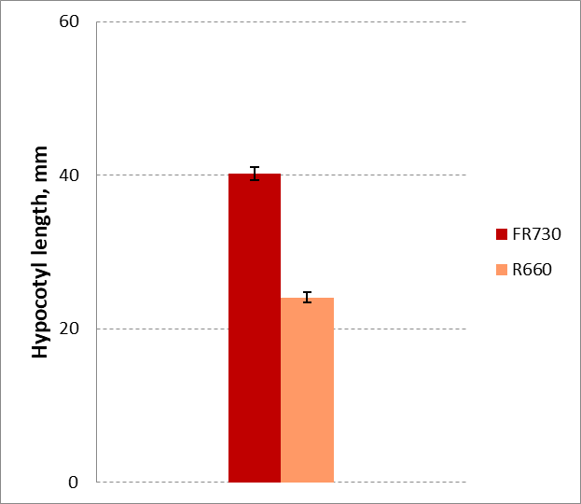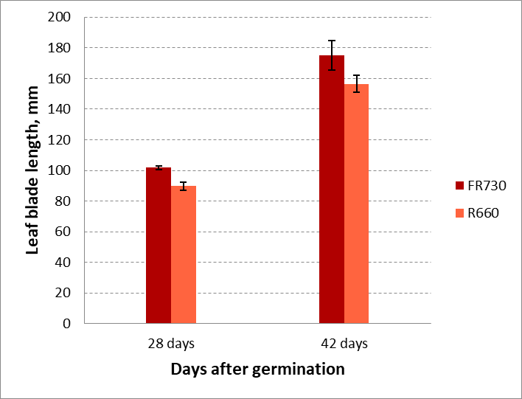
A B
Figure S2. Shade avoidance response in radish plants treated with FR₇₃₀ . A – hypocotyl elongation, 11 days after germination, mm; B – the biggest leaf length, mm. Means ±standard error (SE).

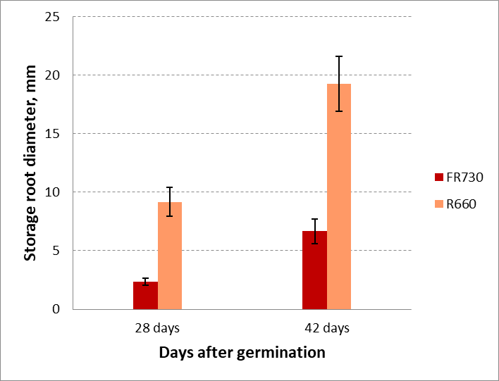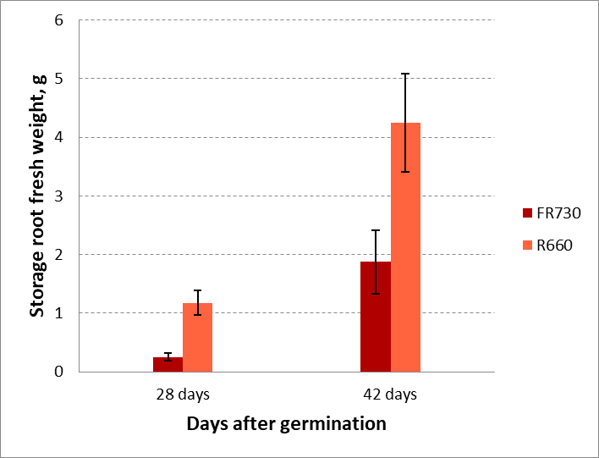
A B
Figure S3. Storage root formation in radish plants as affected by FR₇₃₀ or R₆₆₀ light treatment. A – storage root diameter, mm; B – storage root fresh weight. Means ± SE.

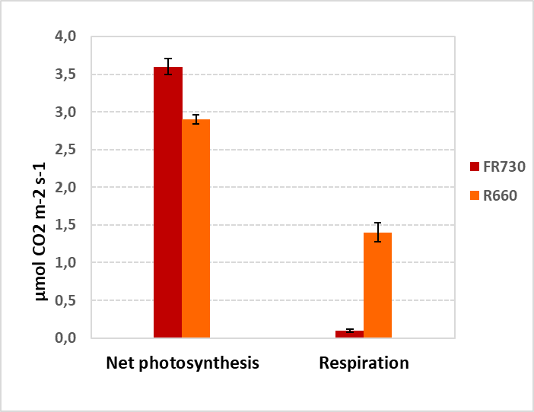
Figure S4. CO₂ exchange in the leaves of radish plants as affected by FR₇₃₀ or R₆₆₀ light treatment, 33 DAG. Means ± SE.

Figure S5. Transverse sections through the lower part of the storage root of R. sativus corresponding to the primary root (A), middle part of the storage root corresponding to the hypocotyl (B, D – F) and the stem internode (C). D, E, storage root transverse section of R. sativus grown on R (28 DAG). Proliferation of apotracheal and vasicentric parenchyma is observed both in central part of the stele (D) and in secondary xylem (E); F, Storage root transverse section of R. sativus grown on RL (42 DAG). “Halo” of the apotracheal proliferating parenchyma is shown. app, apotracheal proliferating parenchyma; cor, cortex; cz, cambial zone; lr, lateral root; mxv, metaxylem vessel; pxv, protoxylem vessel; sc, sclerenchyma; sxv, secondary xylem vessel, vpp, vasicentric proliferating parenchyma. Scale bars, A-E 100 µm, F 50 µm.

