Table 1. Colour coordinates of jelly candies prepared at different pH levels using R. poinciana flower dye extracted via ultrasonic water bath
Extraction method of flower dye | pH | Appearance | Color coordinates |  |  | Molds | Yeasts
Ultrasonic water bath (USB) | pH | Appearance | L* | a* | b* | CFU g ⁻¹ | CFU g ⁻¹
Ultrasonic water bath (USB) | 3 | 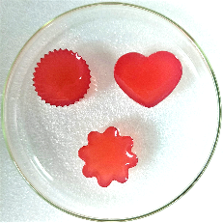 | 54.08±0.04 | 21.33±0.07 | 9.04± 0.07 | 00.00±0.00 | 00.00±0.00
Ultrasonic water bath (USB) | 4 | 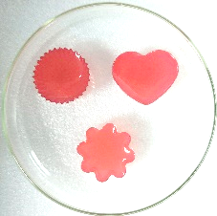 | 52.09±0.01 | 19.57±0.95 | 6.22± 0.07 | 00.00±0.00 | 00.00±0.00
Ultrasonic water bath (USB) | 5 | 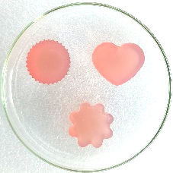 | 49.01±0.22 | 17.29±0.05 | 5.08± 0.89 | 00.00±0.00 | 00.00±0.00
Ultrasonic water bath (USB) | 6 | 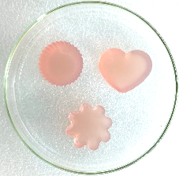 | 48.55±0.86 | 16.30±0.26 | 4.22± 0.55 | 00.00±0.00 | 00.00±0.00
Ultrasonic water bath (USB) | 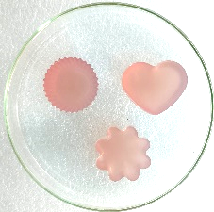  7 |  | 48.02±0.04 | 16.33±0.07 | 4.02± 0.01 | 00.00±0.00 | 00.00±0.00
Ultrasonic water bath (USB) | 8 | 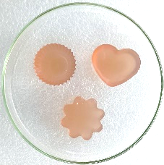 | 46.09±0.88 | 15.21±0.99 | 10.04± 0.58 | 00.00±0.00 | 00.00±0.00
Ultrasonic water bath (USB) | 9 | 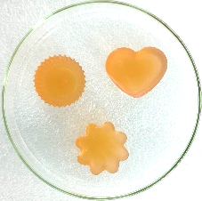 | 44.89±0.03 | 14.23±0.59 | 11.08± 0.87 | 00.00±0.00 | 00.00±0.00
Ultrasonic water bath (USB) | 10 | 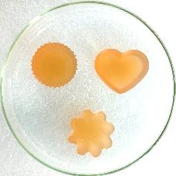 | 43.99±0.09 | 13.98±0.01 | 13.08± 0.13 | 00.00±0.00 | 00.00±0.00

Table 2. Colour coordinates of jelly candies prepared at different pH levels using R. poinciana flower dye extracted via ultrasonic probe
Extraction method of flower dye | pH | Appearance | Color coordinates |  |  | Molds | Yeasts
Ultrasonic Probe (USP) | pH | Appearance | L* | a* | b* | CFU g ⁻¹ | CFU g ⁻¹
Ultrasonic Probe (USP) | 3 | 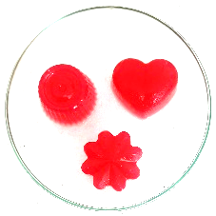 | 53.09±0.01 | 18.97±0.05 | 6.02± 0.09 | 00.00±0.00 | 00.00±0.00
Ultrasonic Probe (USP) | 4 |  | 49.81±0.32 | 17.09±0.22 | 5.98± 0.01 | 00.00±0.00 | 00.00±0.00
Ultrasonic Probe (USP) | 5 | 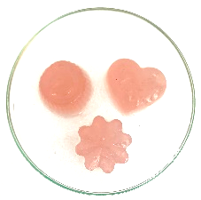  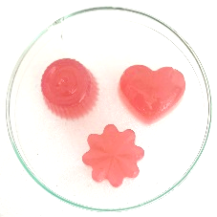 | 47.28±0.07 | 15.98±0.24 | 4.32± 0.08 | 00.00±0.00 | 00.00±0.00
Ultrasonic Probe (USP) | 6 | 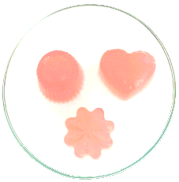 | 45.89±0.01 | 14.61±0.04 | 11.09± 0.06 | 00.00±0.00 | 00.00±0.00
Ultrasonic Probe (USP) | 7 | 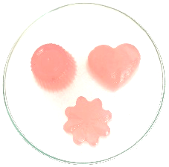 | 45.02±0.88 | 14.00±0.05 | 12.03± 0.66 | 00.00±0.00 | 00.00±0.00
Ultrasonic Probe (USP) | 8 | 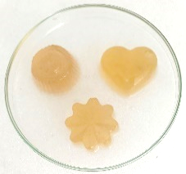  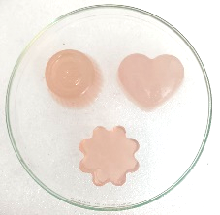 | 42.08±0.33 | 11.08±0.21 | 13.88± 0.32 | 00.00±0.00 | 00.00±0.00
Ultrasonic Probe (USP) | 9 |  | 38.11±0.51 | 15.01±0.54 | 16.02± 0.82 | 00.00±0.00 | 00.00±0.00
Ultrasonic Probe (USP) | 10 | 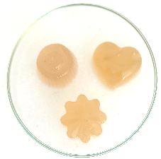 | 36.41±0.14 | 17.02±0.78 | 18.05± 0.81 | 00.00±0.00 | 00.00±0.00

Table 3. Colour coordinates of jelly candies prepared at different pH levels using R. poinciana flower dye extracted via direct heating with magnetic stirring
Extraction method of flower dye | pH | Appearance | Color coordinates |  |  | Molds | Yeasts
Direct heating with magnetic stirring (DH) | pH | Appearance | L* | a* | b* | CFU g ⁻¹ | CFU g ⁻¹
Direct heating with magnetic stirring (DH) | 3 | 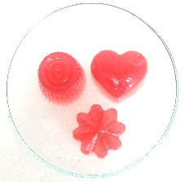 | 53.01±0.23 | 17.02±0.52 | 7.28± 0.01 | 00.00±0.00 | 00.00±0.00
Direct heating with magnetic stirring (DH) | 4 | 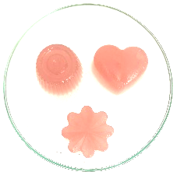 | 47.62±0.23 | 16.08±0.05 | 6.65± 0.71 | 00.00±0.00 | 00.00±0.00
Direct heating with magnetic stirring (DH) | 5 | 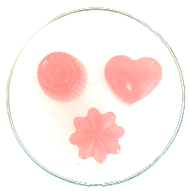 | 46.01±0.47 | 18.05±0.21 | 7.03± 0.41 | 00.00±0.00 | 00.00±0.00
Direct heating with magnetic stirring (DH) | 6 | 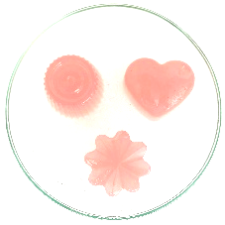 | 44.55±0.86 | 15.03±0.60 | 9.20± 0.08 | 00.00±0.00 | 00.00±0.00
Direct heating with magnetic stirring (DH) | 7 |  | 44.01±0.01 | 15.98±0.03 | 10.09± 0.99 | 00.00±0.00 | 00.00±0.00
Direct heating with magnetic stirring (DH) | 8 | 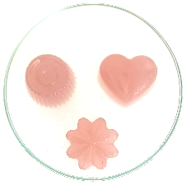 | 43.80±0.79 | 16.28±0.62 | 13.39± 0.16 | 00.00±0.00 | 00.00±0.00
Direct heating with magnetic stirring (DH) | 9 | 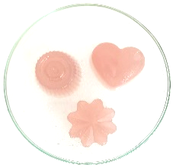 | 42.49±0.14 | 16.02±0.11 | 16.12± 0.78 | 00.00±0.00 | 00.00±0.00
Direct heating with magnetic stirring (DH) | 10 | 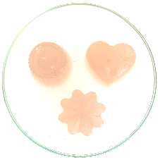  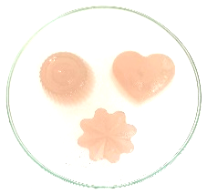 | 40.16±0.93 | 16.89±0.37 | 17.12± 0.29 | 00.00±0.00 | 00.00±0.00

