Table 2. Concerns on reporting in institutions that return secondary findings (n=28) vs. do not return secondary findings (n=10). The same set of concerns was presented to both groups as a multi-answer item with free text option. The two columns show the absolute numbers of participants that chose each concern on the list. Multiple answers were possible. Abbreviation: SF: secondary findings.
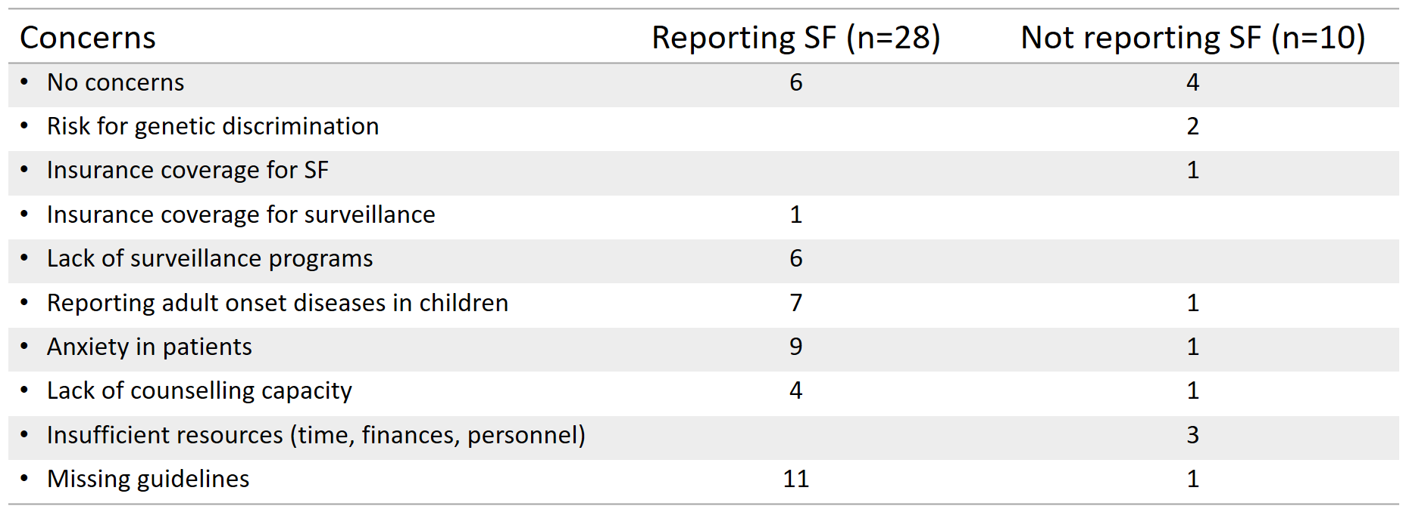
(Table 2. Editable version)
Concerns | Reporting SF  (n=28) | Not Reporting SF (n=10)
- No concerns | 6 | 4
- Risk for genetic discrimination |  | 2
- Insurance coverage for SF |  | 1
- Insurance coverage for surveillance | 1
- Lack of surveillance programs | 6
- Reporting adult onset diseases in children | 7 | 1
- Anxiety in patients | 9 | 1
- Lack of counselling capacity | 4 | 1
- Insufficient resources (time, finances, personnel) |  | 3
- Missing guidelines | 11 | 1

