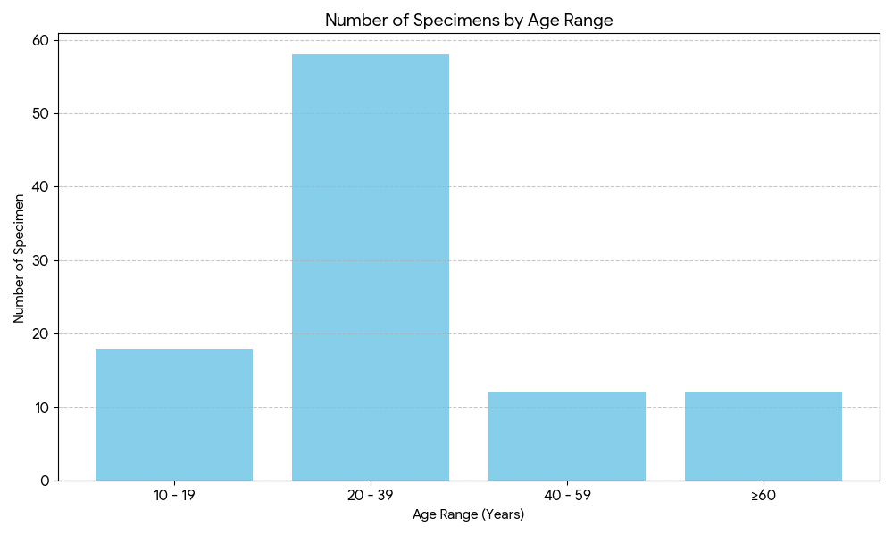
Age Group | Age Range | N | Left Kidney Mean ± SD (gm) | Left Kidney 95% CI (gm) | Right Kidney Mean ± SD (gm) | Right Kidney 95% CI (gm)
A | 10–19 | 9 | 85.04 ± 2.30 | 83.27 – 86.81 | 84.88 ± 2.03 | 83.32 – 86.45
B | 20–39 | 29 | 98.67 ± 3.95 | 97.17 – 100.17 | 95.80 ± 7.05 | 89.31 – 102.29
C | 40–59 | 6 | 94.75 ± 0.95 | 93.76 – 95.75 | 94.84 ± 1.47 | 93.28 – 96.39
D | ≥60 | 6 | 85.33 ± 2.48 | 82.72 – 87.95 | 85.19 ± 2.64 | 82.41 – 87.97
Table 1: Kidney Weights (gm) Across Different Age Groups
Kidney | F-value | p-value | Interpretation
Left Kidney | 3.604 | 0.001 | Statistically significant difference (p<0.001)
Right Kidney | 95.871 | 0.001 | Statistically significant difference (p<0.001)
*ANOVA Test Results
Age Group | Age Range | N | Left Kidney Mean ± SD (cm) | Left Kidney 95% CI (cm) | Right Kidney Mean ± SD (cm) | Right Kidney 95% CI (cm)
A | 10–19 | 9 | 8.44 ± 0.87 | 8.11 – 8.78 | 8.45 ± 0.40 | 8.14 – 8.76
B | 20–39 | 29 | 9.56 ± 0.98 | 8.63 – 9.70 | 9.41 ± 1.03 | 8.33 – 9.50
C | 40–59 | 6 | 8.55 ± 0.50 | 8.01 – 9.08 | 8.70 ± 0.40 | 8.27 – 9.12
D | ≥60 | 6 | 8.42 ± 0.27 | 8.21 – 8.63 | 8.38 ± 1.08 | 7.96 – 8.79
Table 2: Kidney Lengths (cm) Across Different Age Groups
Age Group | Age Range | N | Left Kidney Breadth<br>Mean ± SD (cm) | 95% CI Left Kidney (cm) | Right Kidney Breadth<br>Mean ± SD (cm) | 95% CI Right Kidney (cm)
A | 10–19 | 9 | 4.06 ± 0.37 | 3.77 – 4.35 | 3.82 ± 0.28 | 3.60 – 4.04
B | 20–39 | 29 | 4.16 ± 0.44 | 3.99 – 4.33 | 3.95 ± 0.57 | 3.73 – 4.16
C | 40–59 | 6 | 4.05 ± 0.36 | 3.66 – 4.43 | 3.76 ± 0.21 | 3.54 – 3.99
D | ≥60 | 6 | 3.88 ± 0.62 | 3.22 – 4.53 | 3.65 ± 0.34 | 3.50 – 3.80
Table 3: Kidney Breadth (cm) Across Different Age Groups
Age Group | Age Range | N | Left Kidney Thickness<br>Mean ± SD (cm) | 95% CI Left Kidney (cm) | Right Kidney Thickness<br>Mean ± SD (cm) | 95% CI Right Kidney (cm)
A | 10–19 | 9 | 3.04 ± 0.46 | 2.86 – 3.21 | 3.02 ± 0.36 | 2.66 – 3.20
B | 20–39 | 29 | 3.28 ± 0.40 | 2.98 – 3.59 | 3.27 ± 0.30 | 3.04 – 3.51
C | 40–59 | 6 | 3.07 ± 0.16 | 2.60 – 3.50 | 3.06 ± 0.58 | 2.45 – 3.68
D | ≥60 | 6 | 2.73 ± 0.36 | 2.34 – 3.11 | 2.76 ± 0.44 | 2.29 – 3.23
Table 4: Kidney Thickness (cm) Across Different Age Groups
Age Group | Age Range | N | Left Kidney Volume (Mean ± SD) | 95% CI Left Kidney (cm³) | Right Kidney Volume (Mean ± SD) | 95% CI Right Kidney (cm³)
A | 10–19 | 9 | 58.07 ± 17.53 | 51.40 – 64.74 | 55.04 ± 6.63 | 49.93 – 60.14
B | 20–39 | 29 | 58.18 ± 9.35 | 50.99 – 65.37 | 57.67 ± 17.86 | 50.88 – 64.47
C | 40–59 | 6 | 58.17 ± 19.46 | 37.75 – 78.60 | 53.56 ± 20.43 | 28.19 – 78.93
D | ≥60 | 6 | 47.72 ± 3.20 | 33.85 – 61.58 | 50.73 ± 8.16 | 42.17 – 59.29
Table 5: Kidney Volume (cm³) Across Age Groups
Age Group | Age Range | N | Left Kidney Glomeruli (Mean ± SD) | 95% CI Left Kidney | Right Kidney Glomeruli (Mean ± SD) | 95% CI Right Kidney
A | 10–19 | 5 | 8.48 ± 0.18 | 8.24 – 8.71 | 8.35 ± 0.20 | 8.10 – 8.61
B | 20–39 | 5 | 9.33 ± 0.46 | 9.00 – 9.66 | 9.27 ± 0.44 | 8.95 – 9.59
C | 40–59 | 5 | 8.20 ± 0.39 | 7.71 – 8.68 | 8.27 ± 0.42 | 7.74 – 8.79
D | ≥60 | 5 | 7.85 ± 0.15 | 7.69 – 8.00 | 7.78 ± 0.19 | 7.57 – 7.98
Table 6: Number of Glomeruli per mm² in Kidneys Across Age Groups

