Contrasting bioavailability of iron in glacial vs. groundwater to Antarctic phytoplankton: Linking iron uptake to geochemistry
Jasmin Stimpfle, Florian Koch, Berenice Ebner, Christian Völkner, Rebecca Zitoun, Camila F. Sukekava, Sylvia G. Sander, Susann Henkel, Randelle M. Bundy, Angel Ruacho, Sabine Kasten, Scarlett Trimborn

Supplementary Material

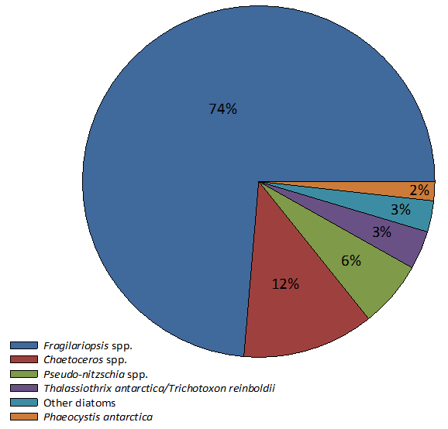
Supplementary Fig. 1. Taxonomic composition of the collected and concentrated natural phytoplankton community, consisting of various diatom genera and Phaeocystis antarctica. Please note that unidentified flagellates accounted for 7% of this community, but are not shown in this figure.

Supplementary Table 1. In-situ conditions at the sampling sites of the LCW and HCW: Macronutrients (nitrate (NO₃⁻), phosphate (PO₄), silicate (SiOH₄), chlorophyll a (Chl a), particulate organic carbon (POC), primary production (PP), photosynthetic efficiency (Fv/Fm), heterotrophic bacteria (HB). Values represent the mean ± SD (n = 3).
 | NO₃⁻ (µmol L⁻¹) | PO₄ (µmol L⁻¹) | SiOH₄ (µmol L⁻¹) | Chl. a (µg L⁻¹) | POC (mg L⁻¹) | PP (mg C m⁻³ d⁻¹) | Fv/Fm | HB  (cells mL⁻¹)
LCW (unfiltered) | 19.02 ± 0.03 | 1.30 ± 0.00 | 12.56 ± 0.03 | 0.33 ± 0.01 | 0.14 ± 0.00 | 27.85 ± 0.58 | 0.28 ± 0.01 | 217352 ± 6500
HCW (unfiltered) | 16.90 ± 0.07 | 1.09 ± 0.00 | 9.54 ± 0.01 | 3.78 ± 0.24 | 0.37 ± 0.00 | 139.10 ± 11.11 | 0.43 ± 0.01 | 383049 ± 54642

Supplementary Table 2. Fe speciation, dissolved organic matter (DOC) and Fe uptake rates in the HCW. Dissolved Fe concentration (dFe), total ligand concentration (L_{T}), excess ligand concentration (L*), conditional stability constants ($logK_{FeL,Fe'}^{cond}$), complexation capacity (α = L_{T} x 10^ $logK_{FeL,Fe'}^{cond}$, where L_{T} is in mol L⁻¹), concentration of free inorganic Fe (Fe’). For L_{T}, $logK_{FeL,Fe'}^{cond}$, α and Fe’, values are represented ± the uncertainty of the fitting method. Statistically significant differences in uptake rates (p < 0.05) are indicated by small letters (n = 3). Fe speciation parameters and DOC were taken before the addition of the pre-concentrated phytoplankton community (see methods section).
 | dFe (nM) | L_{T} (nM) | L* (nM) | $$logK_{FeL,Fe'}^{cond}$$ | α | Fe’ (pM) | DOC (µmol L⁻¹) | Fe uptake (pmol L⁻¹ d⁻¹)
abiotic | 0.116 ± 0.009 | 1.10 ± 0.48 | 0.98 | 10.49 ± 0.45 | 33.98 | 2.80 ± 3.12 | 73.52 ± 0.76 | 17.96 ± 4.03 a
biotic |  |  |  |  |  |  |  | 22.53 ± 1.48 a
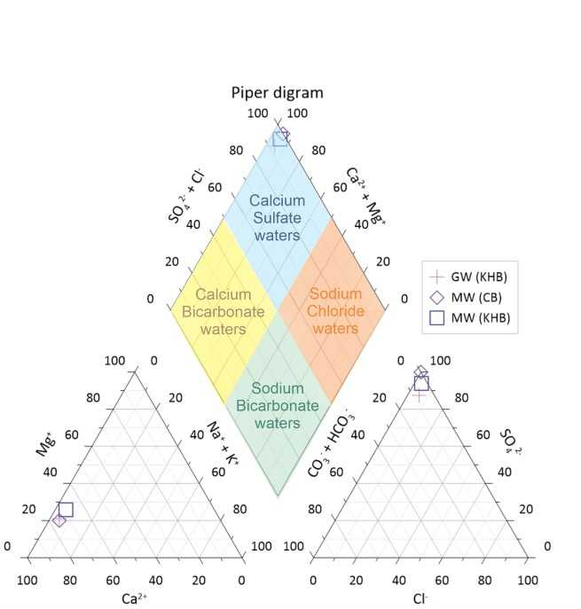
Supplementary Figure 2. Piper diagram ¹. Illustration of the major ion chemistry of the natural Fe sources. All samples are within the calcium sulfate type (blue).

Supplementary Table 3. Sampling time and locations and auxiliary data. Fe concentrations were measured in 0.2µm filtered samples via ICP-MS.
 | Date | Latitude | Longitude | dFe (nM) | Salinity
LCW | 24.11.2022 | -54.6013 | -43.9022 | 0.42 | 32.2
HCW | 30.11.2022 | -54.4135 | -37.5876 | 0.12 | 33.6
Phytoplankton community | 9.12.2022 | -53.3890 | -29.1840 | - | -
GW (KHB) | 29.11.2022 | -54.1447 | -37.2786 | 370.20 | 0.00
MW (KHB) | 29.11.2022 | -54.1453 | -37.2758 | 71.06 | 0.20
MW (CB) | 4.12.2022 | -54.3692 | -36.4939 | 477.20 | 0.00
EW (CB) | 4.12.2022 | -54.3691 | -36.4942 | 9.85 | 25.40

Supplementary Table 4. Concentrations of humic like substances (HS) in incubations 24h after the addition of different Fe sources. Suwannee River Fulvic Acid (SRFA), limit of detection (LOD) >0.04 nM.
 | HS (nM)
LCW | 0.15 ± 0.04
+ GW (KHB) | ≤ LOD
+ MW (KHB) | ≤ LOD
+MW (CB) | ≤ LOD
+ EW (CB) | 0.40 ± 0.06
+ FeCl₃ | ≤ LOD
HCW | ≤ LOD
+ GW (KHB) | ≤ LOD
+ MW (KHB) | ≤ LOD
+MW (CB) | ≤ LOD
+ EW (CB) | 0.20 ± 0.04
+ FeCl₃ | ≤ LOD

References
1. Piper, A. M. A graphic procedure in the geochemical interpretation of water‐analyses. Eos, Transactions American Geophysical Union 25, 914–928 (1944).

