Supporting Information for
Synthesis and Antimicrobial Evaluation of Novel Naringenin-Based Isopropanolamine Hybrid Derivatives

ª School of Chemistry and Chemical Engineerin, Guangdong Pharmaceutical University, Zhongshan 528458, P. R. of China.

* Corresponding author.
E-mail: caohua@gdpu.edu.cn, xiangzm@live.com

Contents
- ¹H NMR, ¹³C NMR and ¹⁹F NMR spectra for the intermediates and new compounds (Figures S1 to S41)...............................................................................2

- 1H NMR, 13C NMR and 19F NMR spectra the intermediate and new compounds
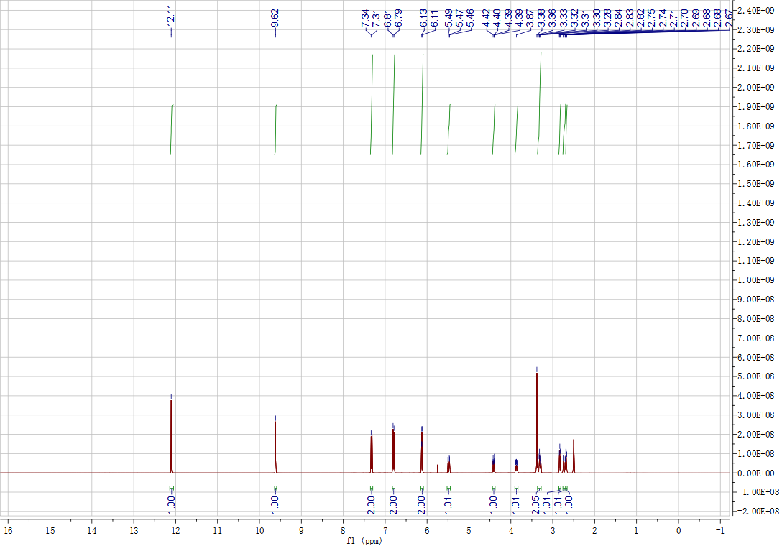
Figure S1. ¹H NMR Spectrum (DMSO, 400 MHz) of intermediate
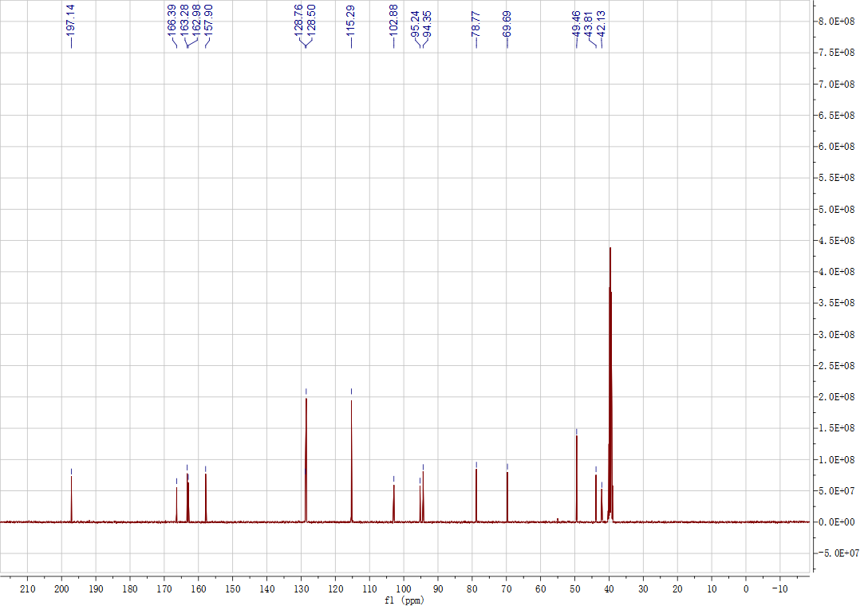
Figure S2. ¹³C NMR Spectrum (DMSO, 101 MHz) of intermediate.
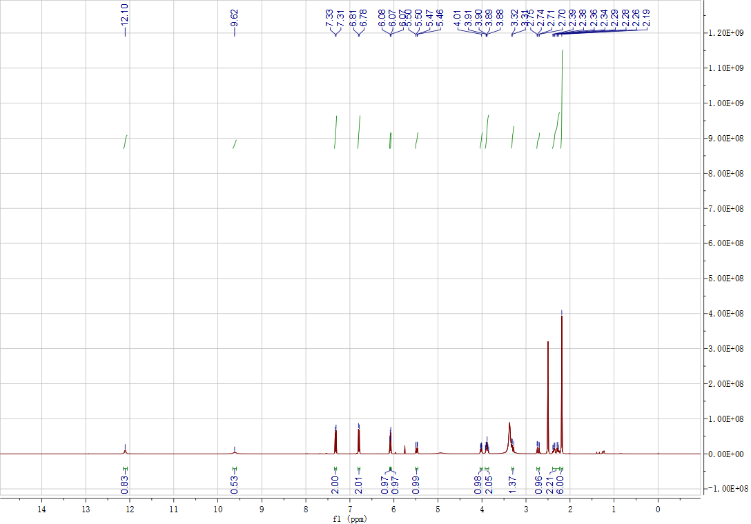
Figure S3. ¹H NMR Spectrum (DMSO, 400 MHz) of A₁.
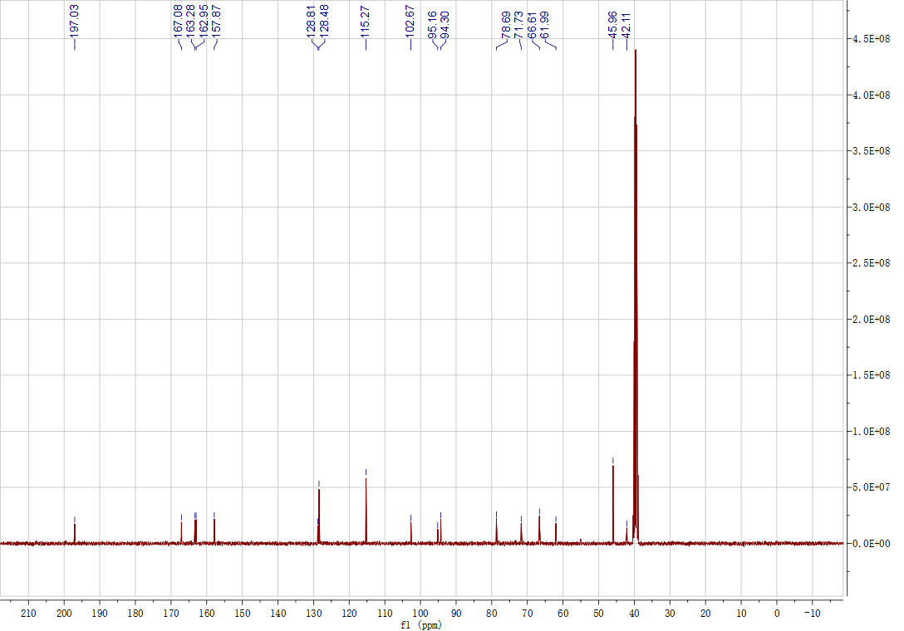
Figure S4. ¹³C NMR Spectrum (DMSO, 101 MHz) of A₁.
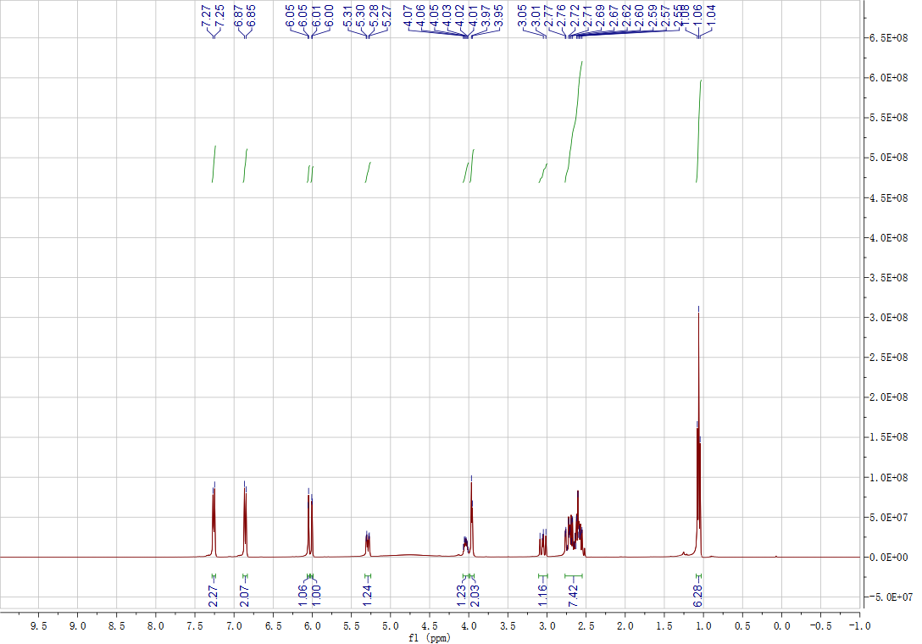
Figure S5. ¹H NMR Spectrum (DMSO, 400 MHz) of A₂.
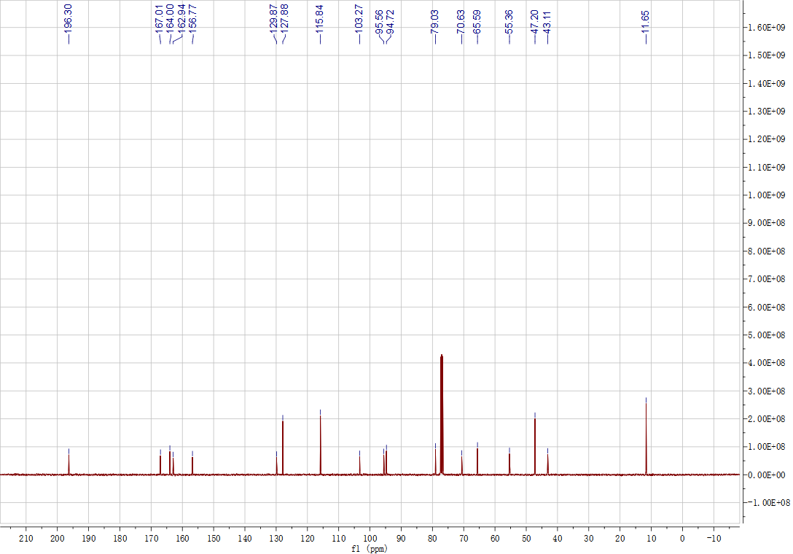
Figure S6. ¹³C NMR Spectrum (DMSO, 101 MHz) of A₂.
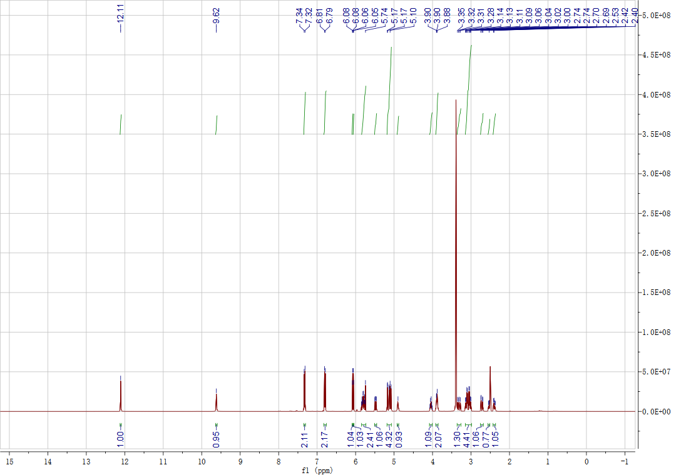
Figure S7. ¹H NMR Spectrum (DMSO, 400 MHz) of A₃.
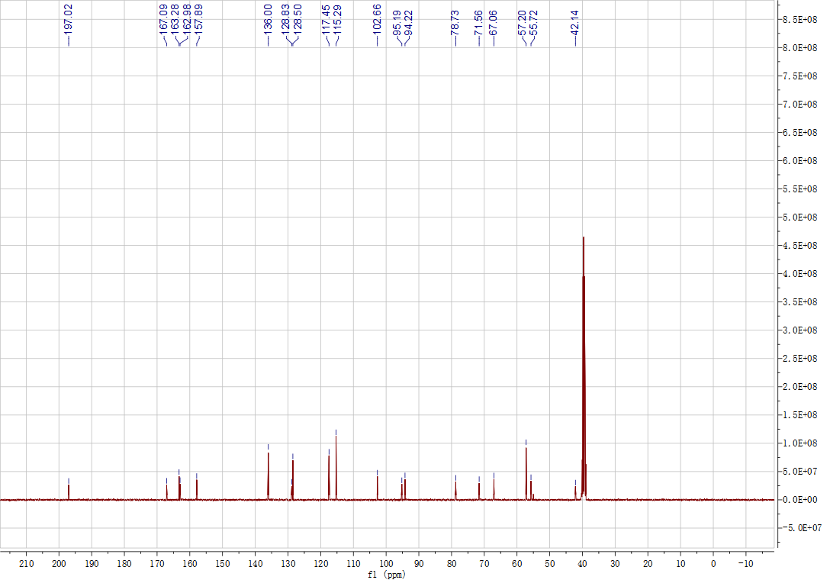
Figure S8. ¹³C NMR Spectrum (DMSO, 101 MHz) of A₃.
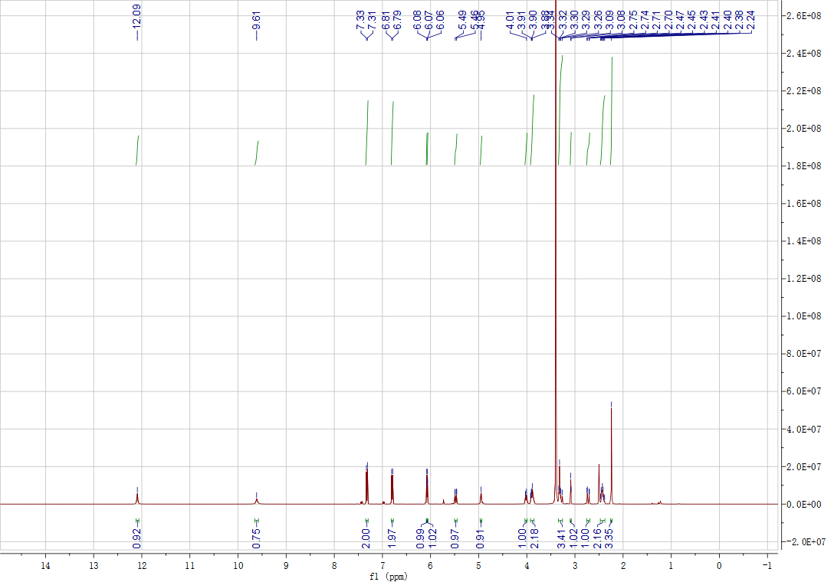
Figure S9. ¹H NMR Spectrum (DMSO, 400 MHz) of A₄.
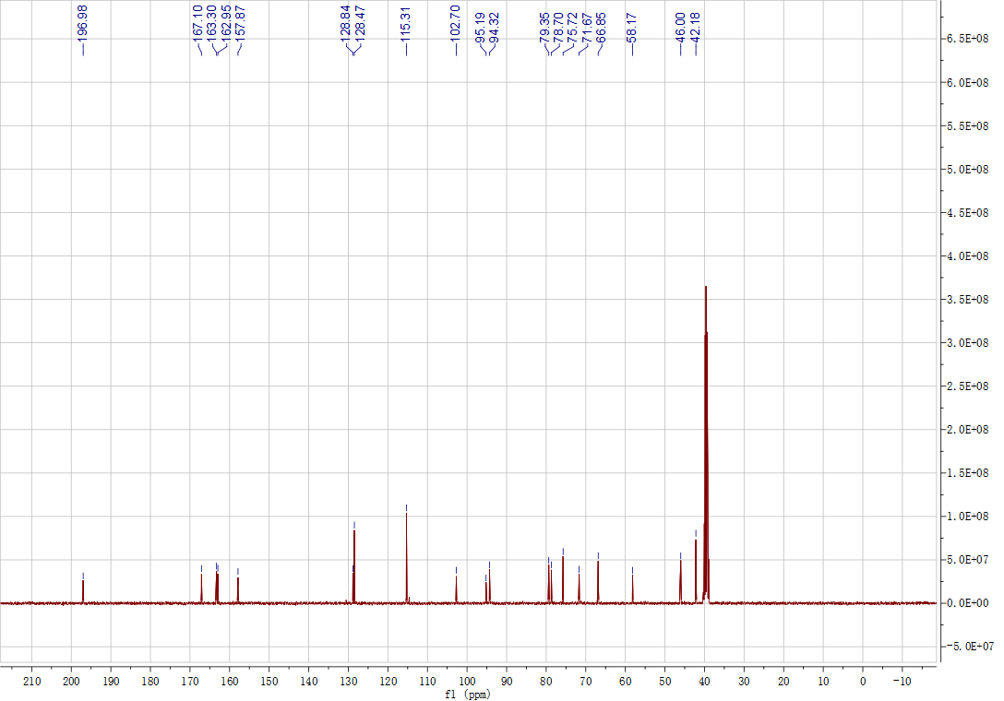
Figure S10. ¹³C NMR Spectrum (DMSO, 101 MHz) of A₄.
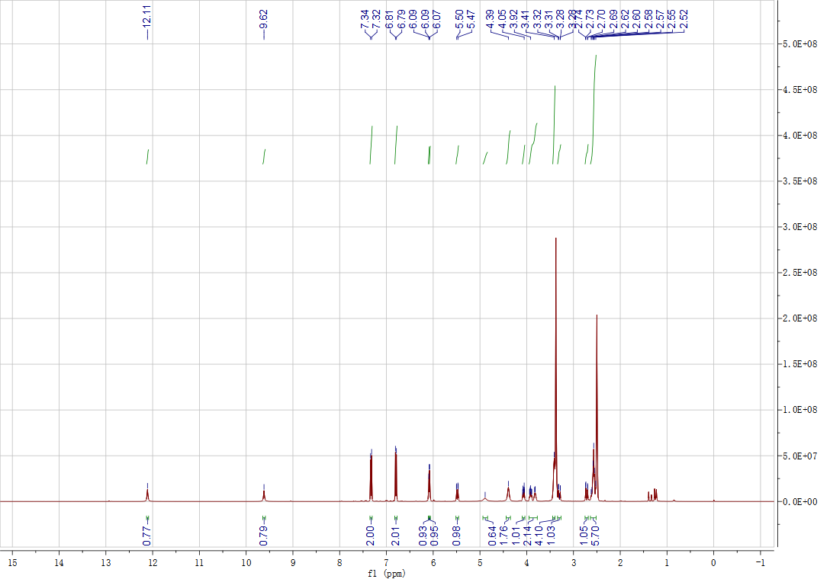
Figure S11. ¹H NMR Spectrum (DMSO, 400 MHz) of A₅.
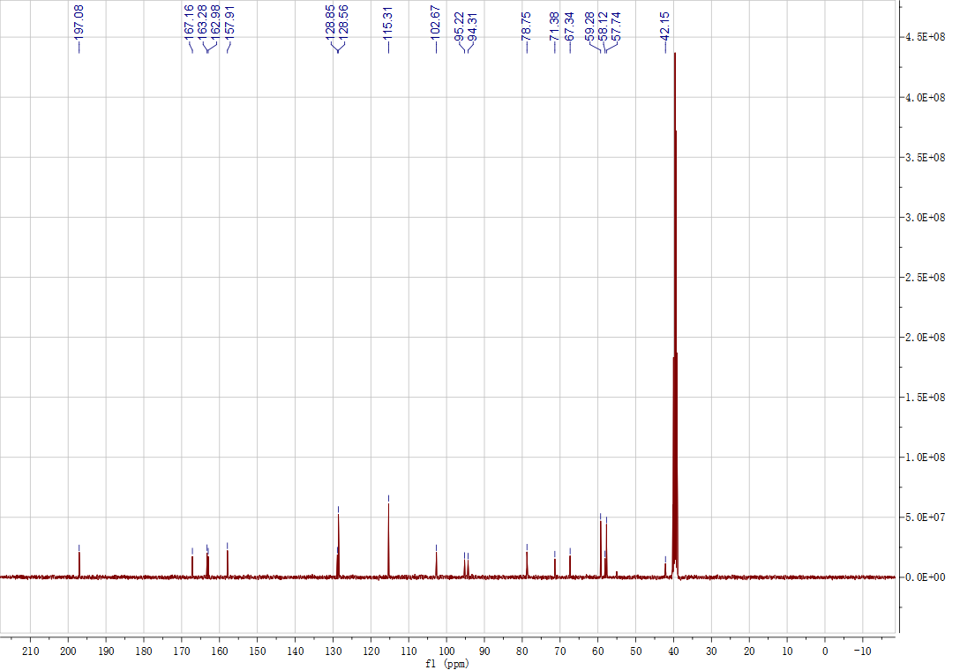
Figure S12. ¹³C NMR Spectrum (DMSO, 101 MHz) of A₅.
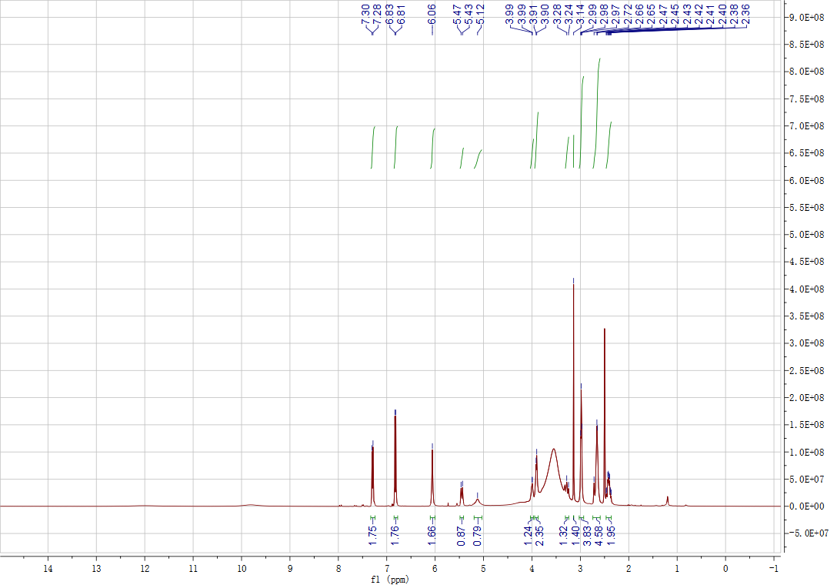
Figure S13. ¹H NMR Spectrum (DMSO, 400 MHz) of A₆.
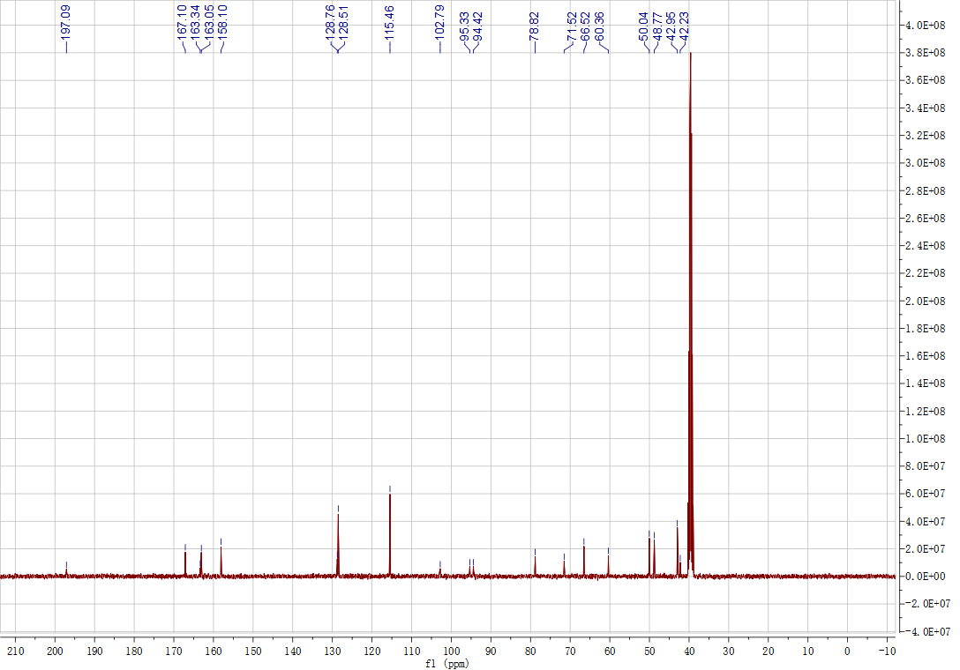
Figure S14. ¹³C NMR Spectrum (DMSO, 101 MHz) of A₆.
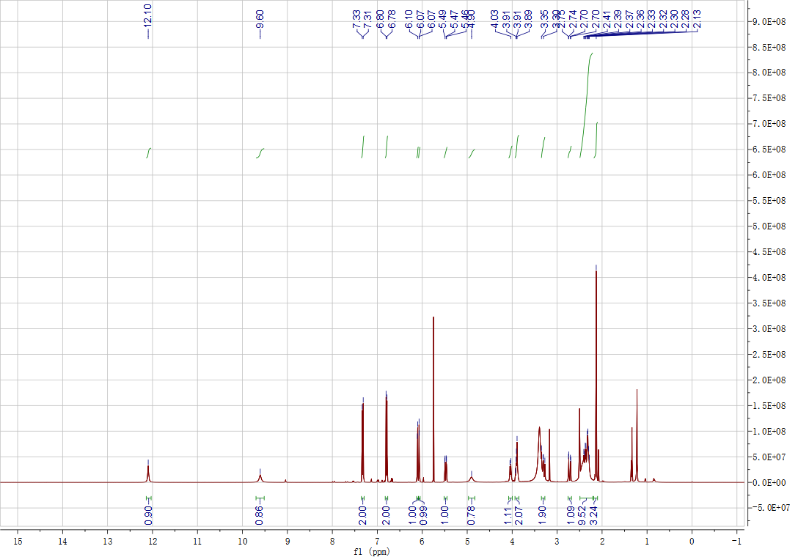
Figure S15. ¹H NMR Spectrum (DMSO, 400 MHz) of A₇.
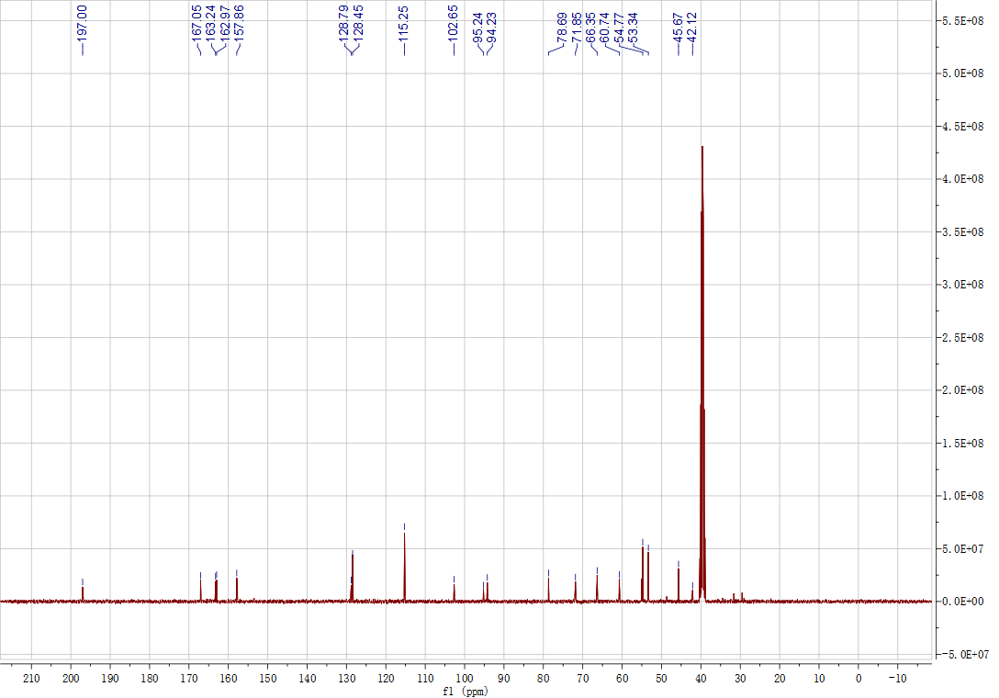
Figure S16. ¹³C NMR Spectrum (DMSO, 101 MHz) of A₇.
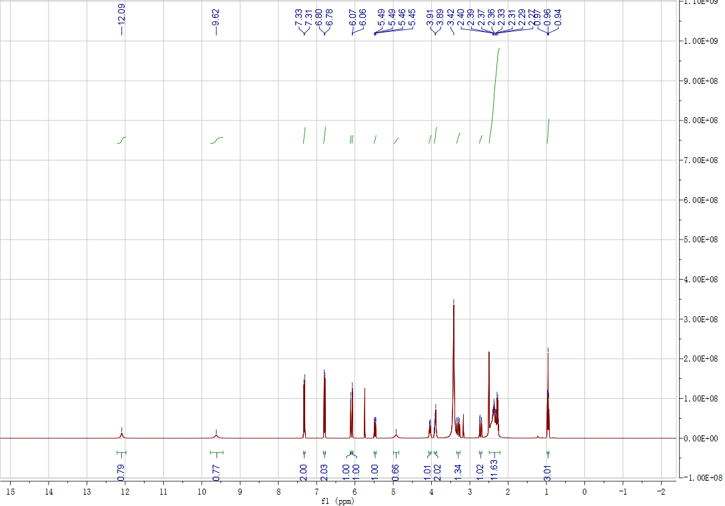
Figure S17. ¹H NMR Spectrum (DMSO, 400 MHz) of B₁.
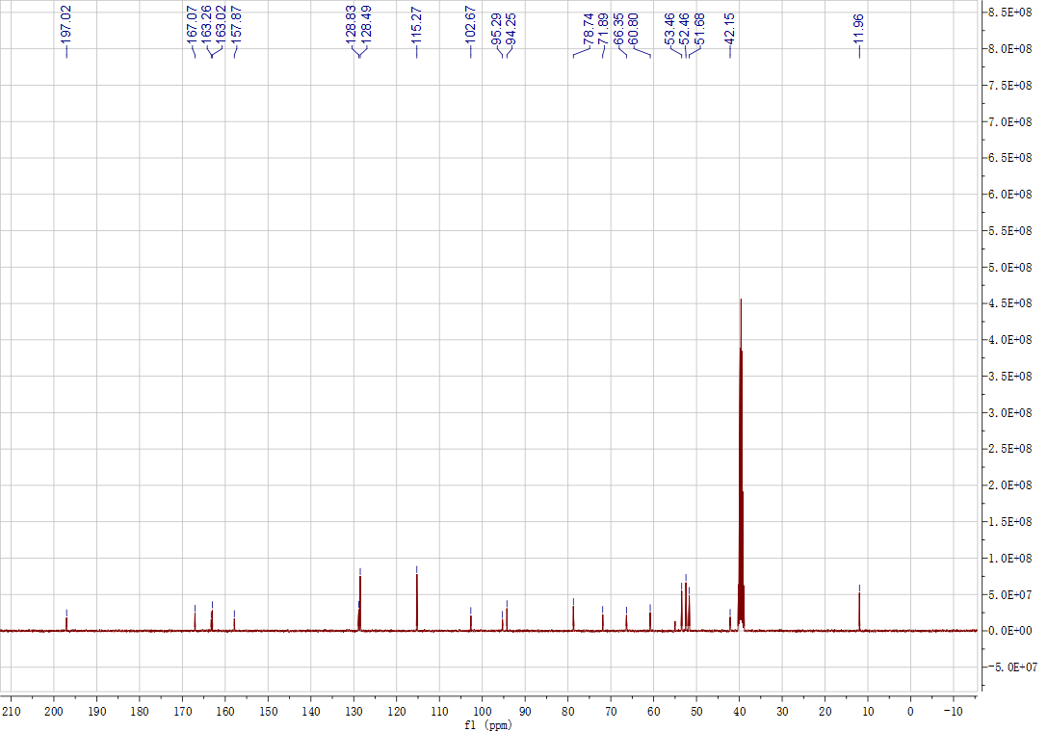
Figure S18. ¹³C NMR Spectrum (DMSO, 101 MHz) of B₁.
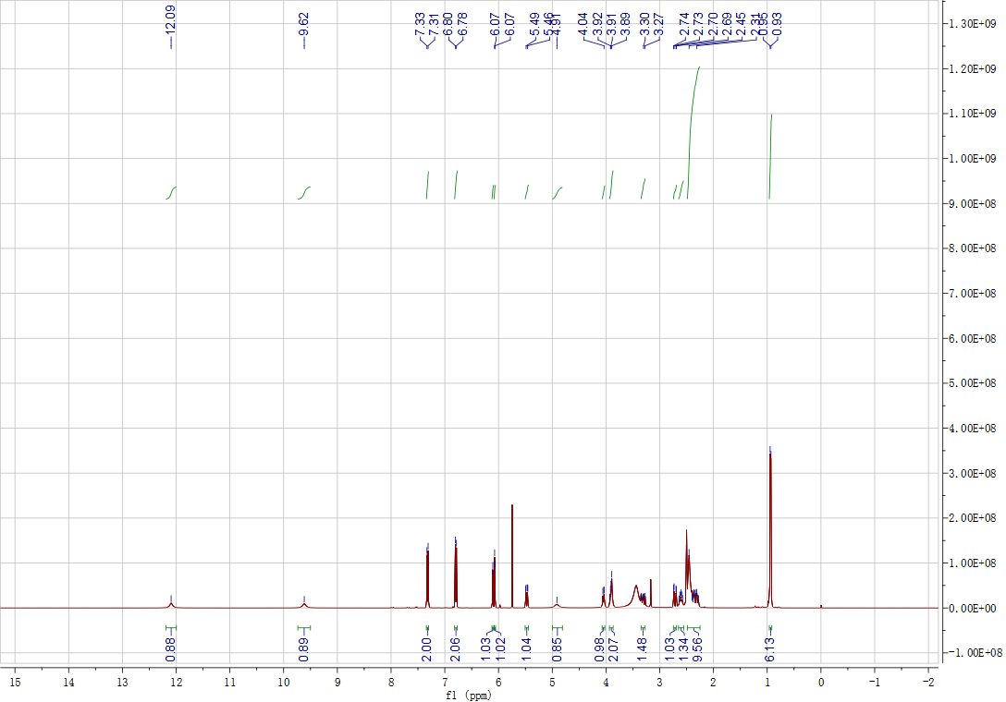
Figure S19. ¹H NMR Spectrum (DMSO, 400 MHz) of B₂.
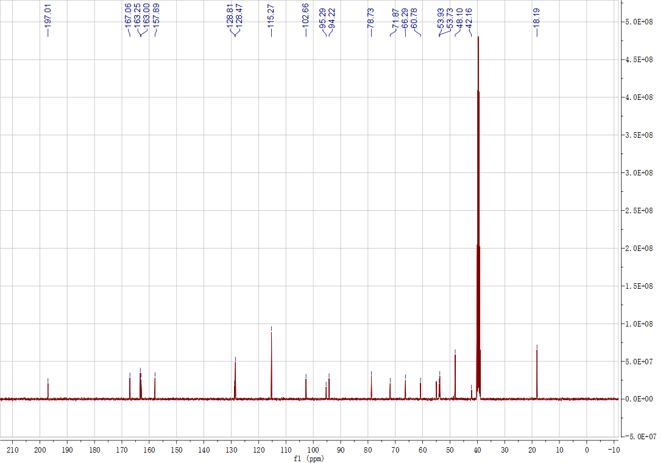
Figure S20. ¹³C NMR Spectrum (DMSO, 101 MHz) of B₂.
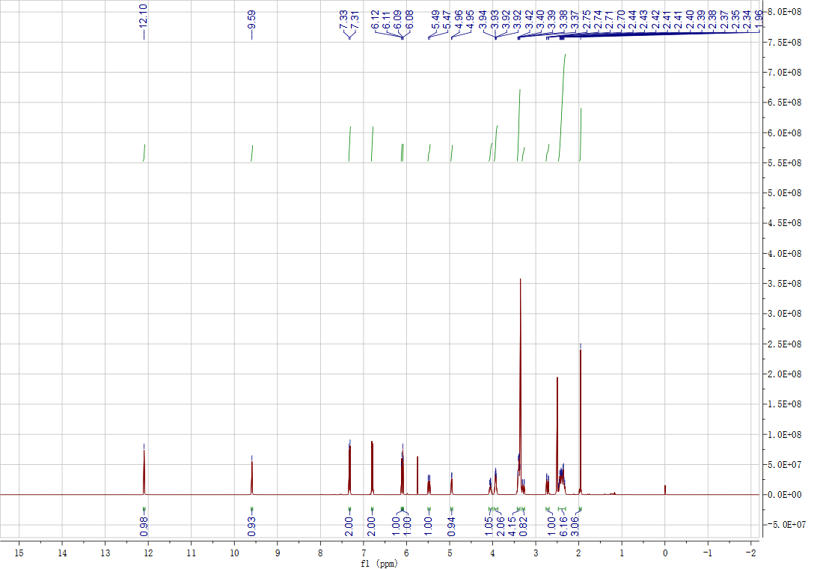
Figure S21. ¹H NMR Spectrum (DMSO, 400 MHz) of B₃.
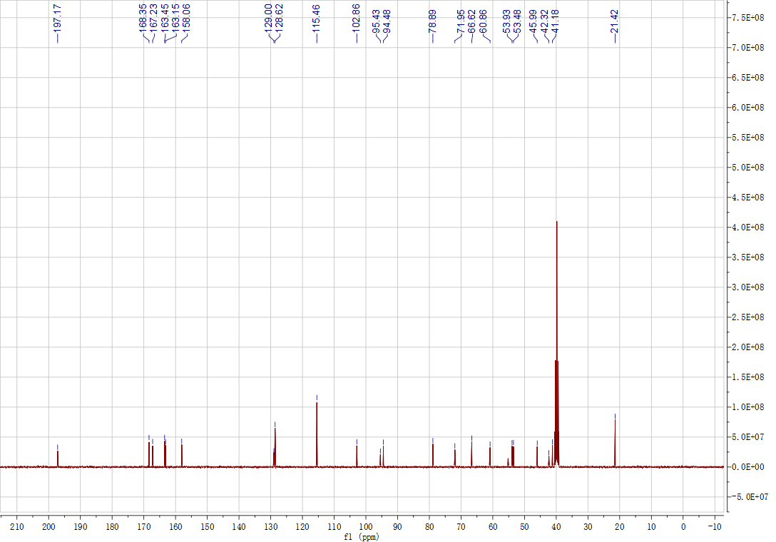
Figure S22. ¹³C NMR Spectrum (DMSO, 101 MHz) of B₃.
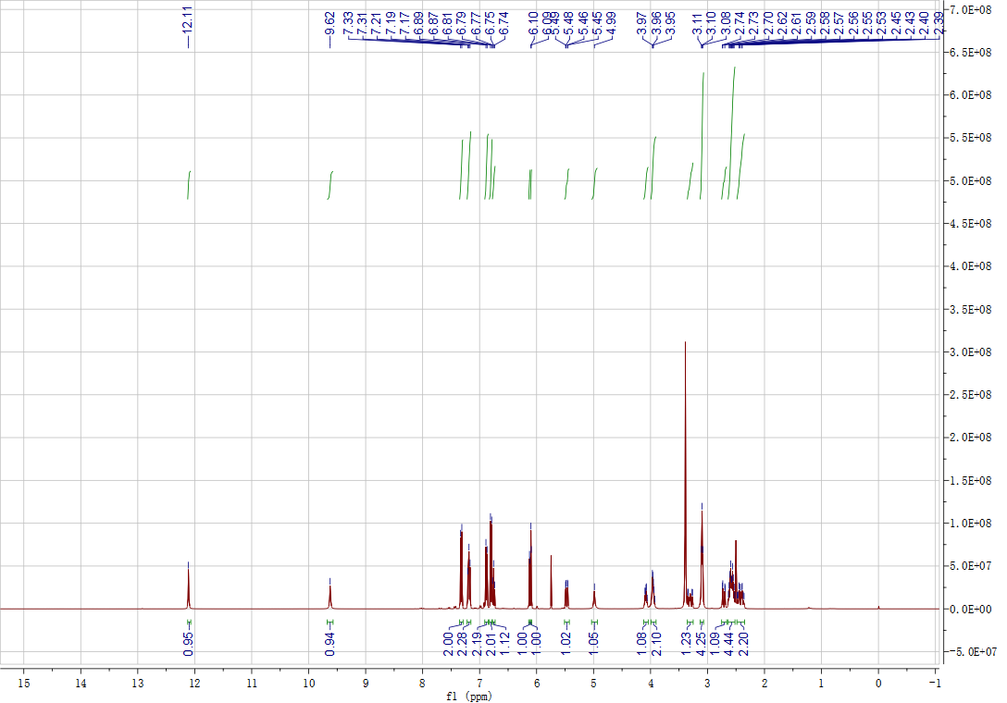
Figure S23. ¹H NMR Spectrum (DMSO, 400 MHz) of B₄.
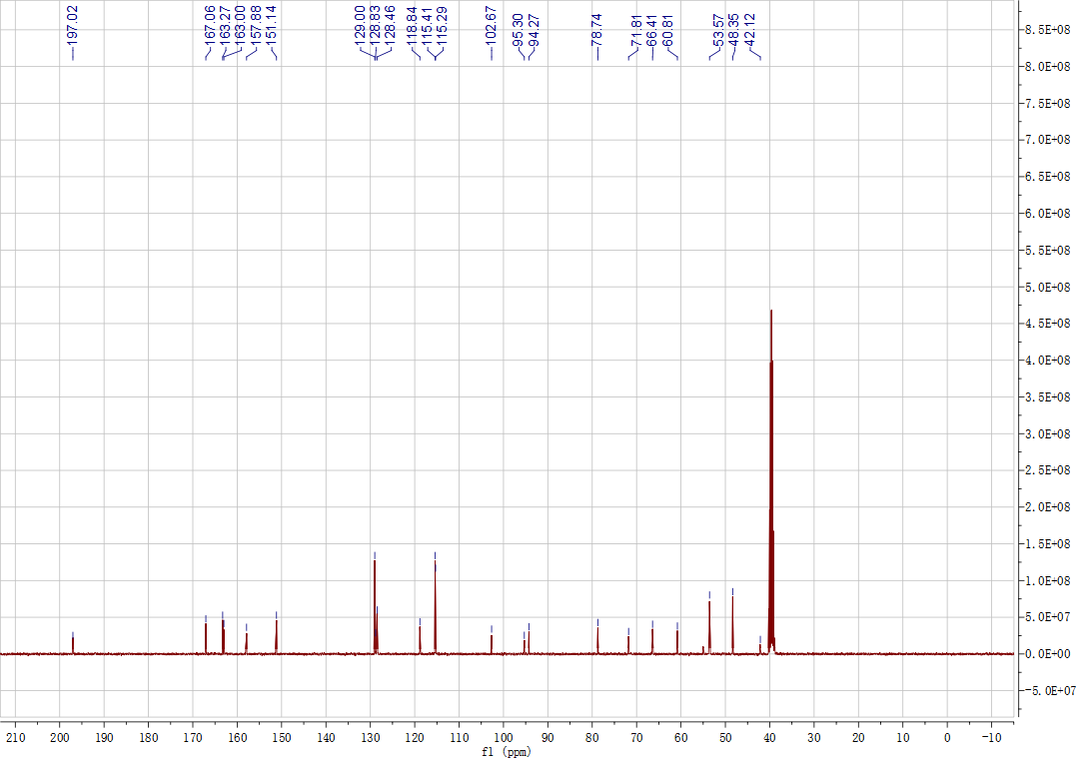
Figure S24. ¹³C NMR Spectrum (DMSO, 101 MHz) of B₄.
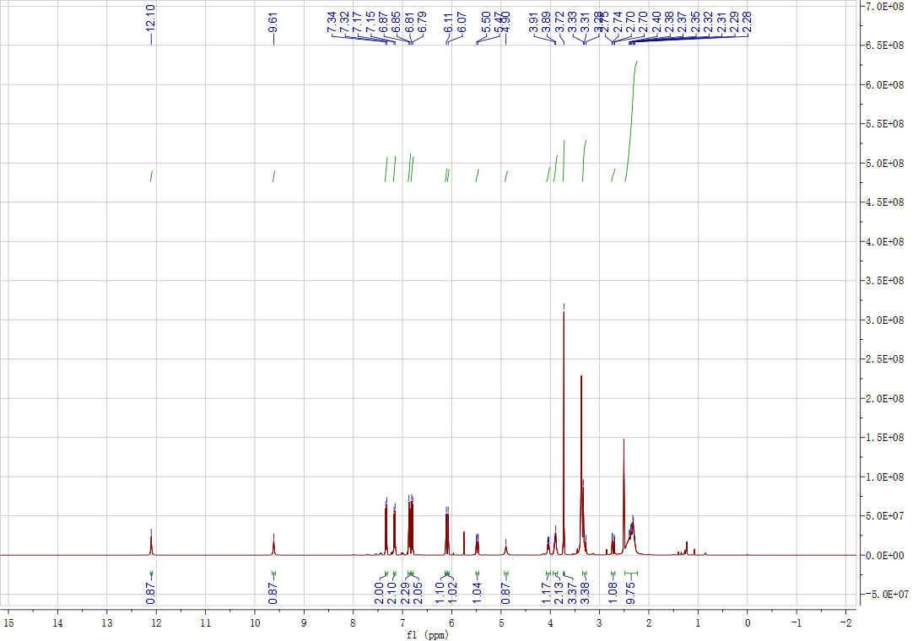
Figure S25. ¹H NMR Spectrum (DMSO, 400 MHz) of B₅.
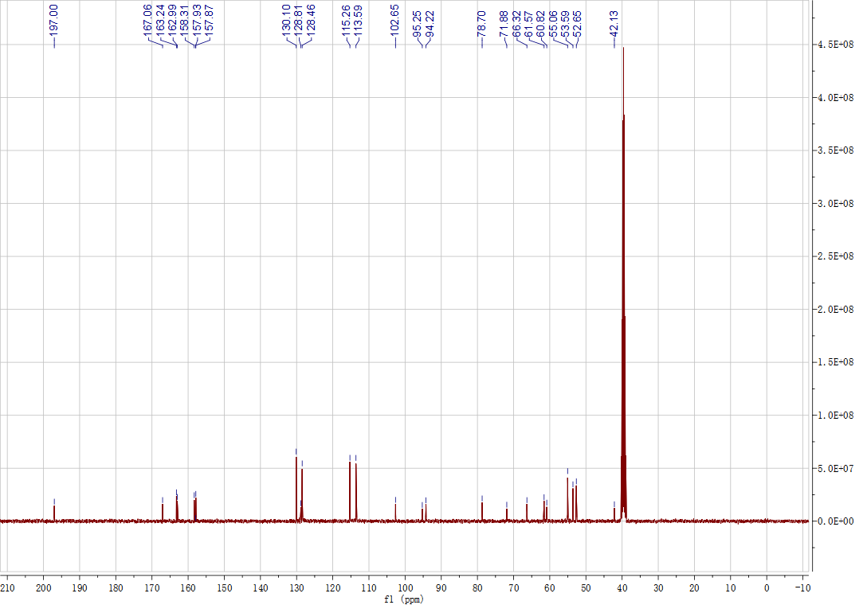
Figure S26. ¹³C NMR Spectrum (DMSO, 101 MHz) of B₅.
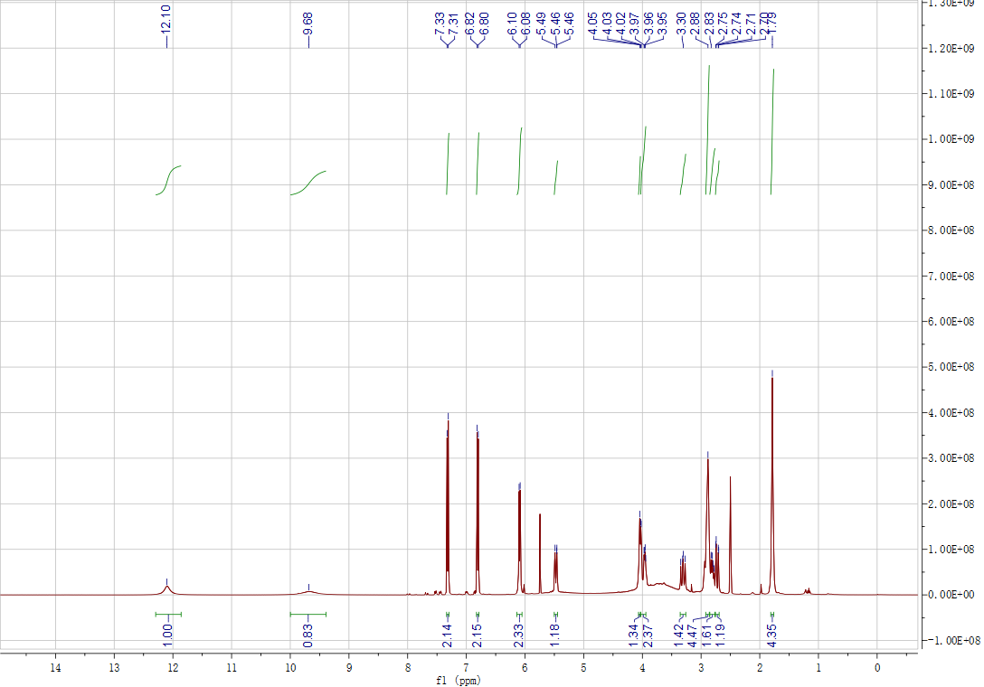
Figure S27. ¹H NMR Spectrum (DMSO, 400 MHz) of B₆.
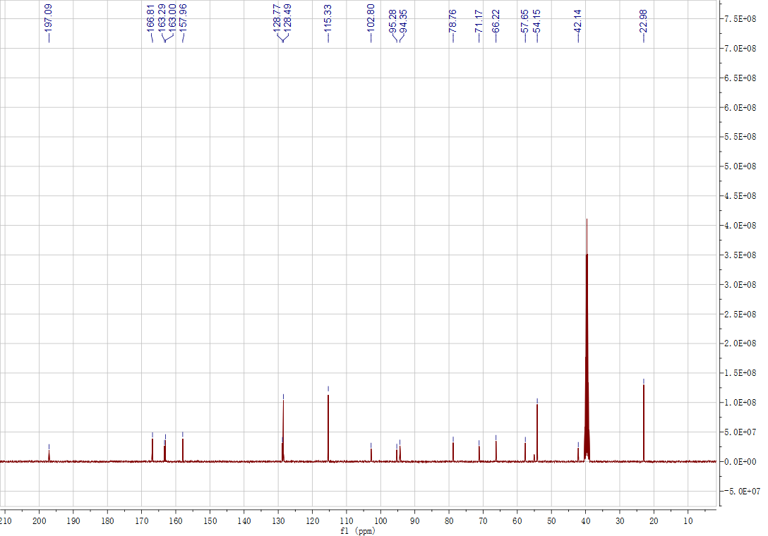
Figure S28. ¹³C NMR Spectrum (DMSO, 101 MHz) of B₆.
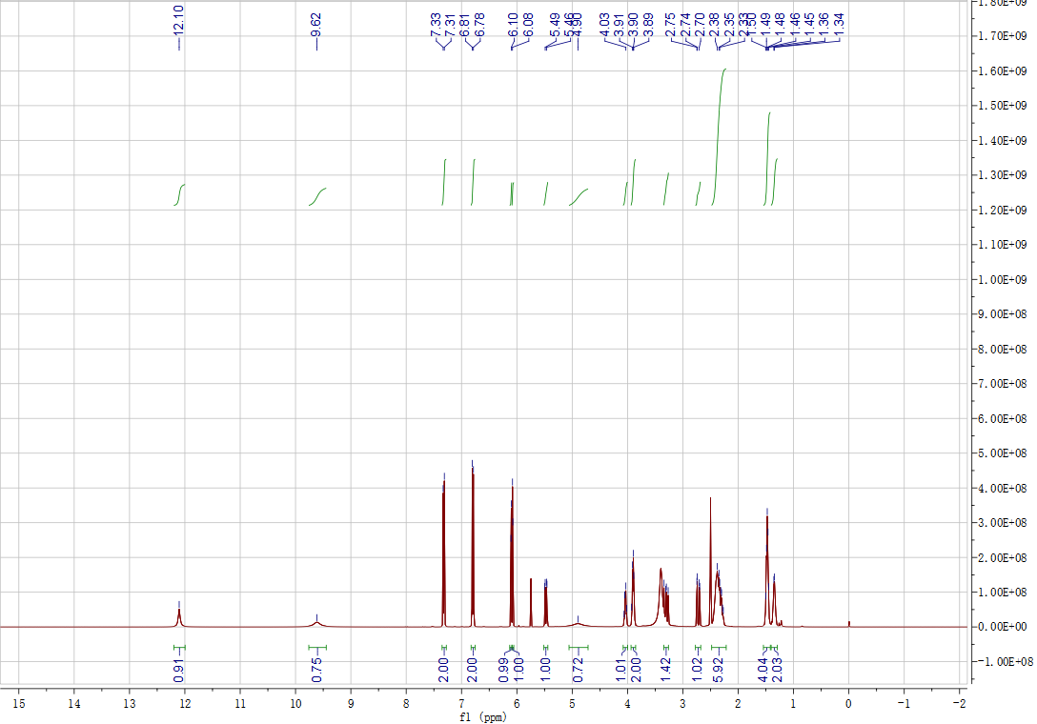
Figure S29. ¹H NMR Spectrum (DMSO, 400 MHz) of C₁.
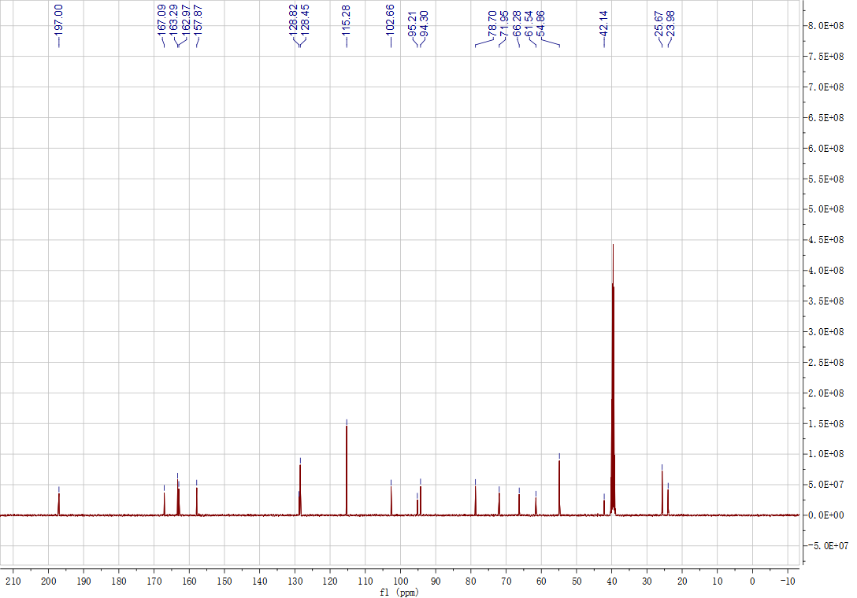
Figure S30. ¹³C NMR Spectrum (DMSO, 101 MHz) of C₁.
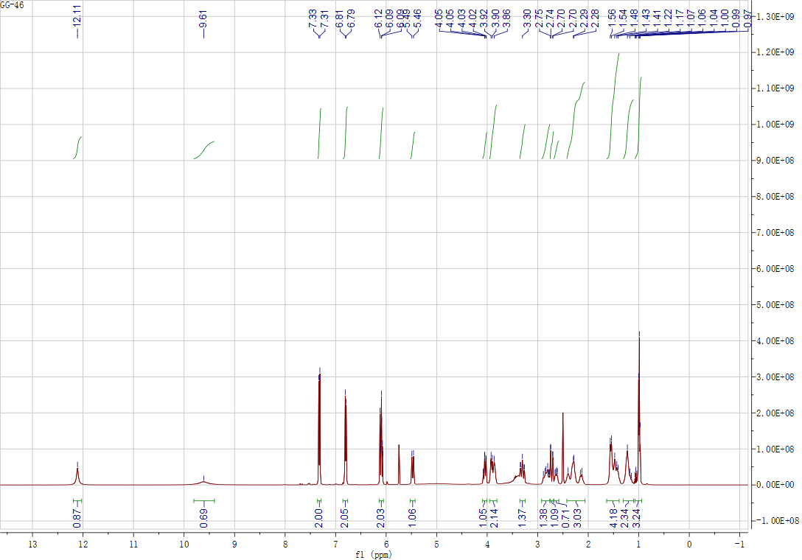
Figure S31. ¹H NMR Spectrum (DMSO, 400 MHz) of C₂.
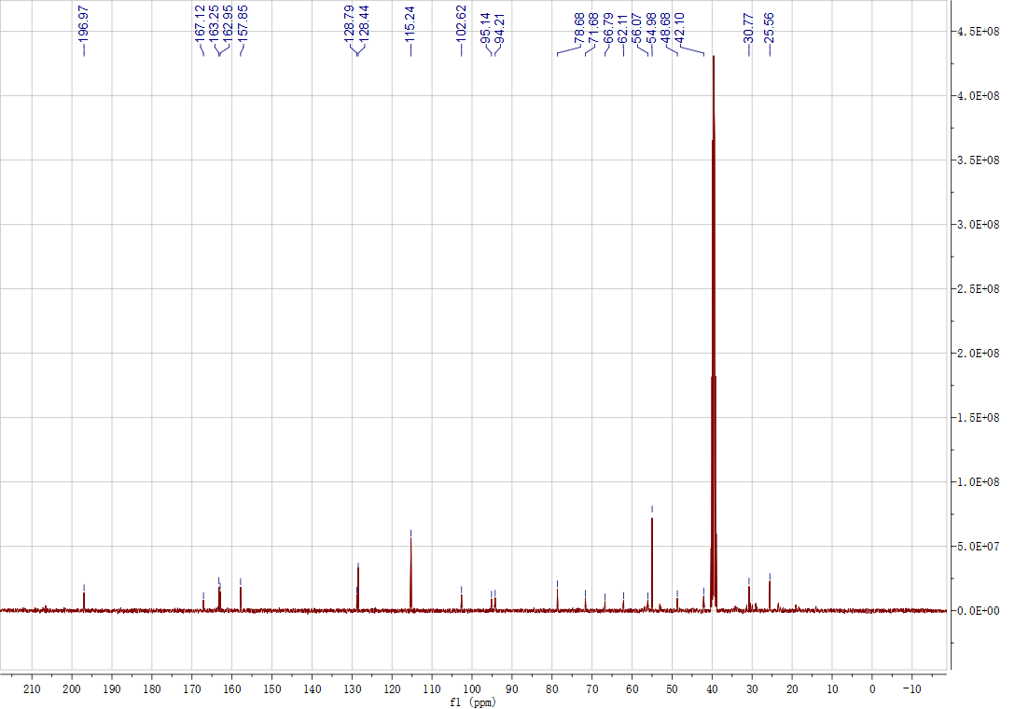
Figure S32. ¹³C NMR Spectrum (DMSO, 101 MHz) of C₂.
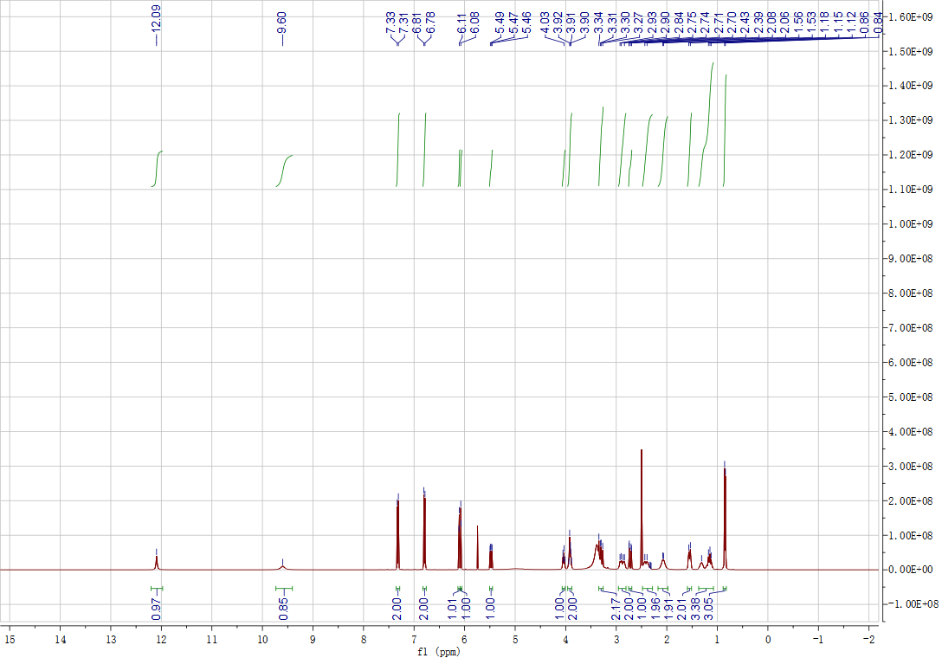
Figure S33. ¹H NMR Spectrum (DMSO, 400 MHz) of C₃.
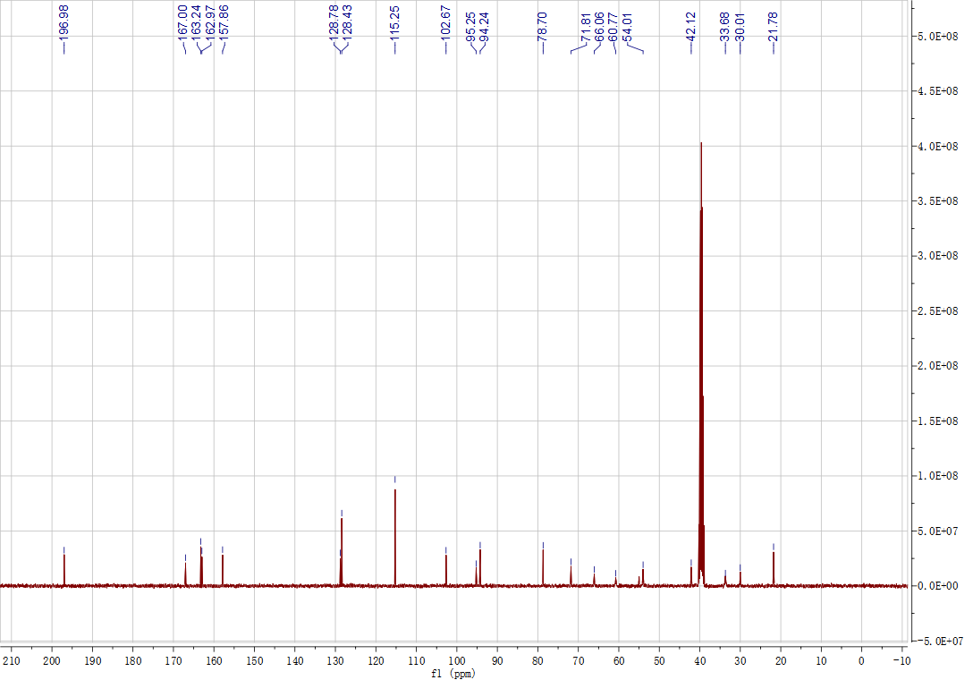
Figure S34. ¹³C NMR Spectrum (DMSO, 101 MHz) of C₃.
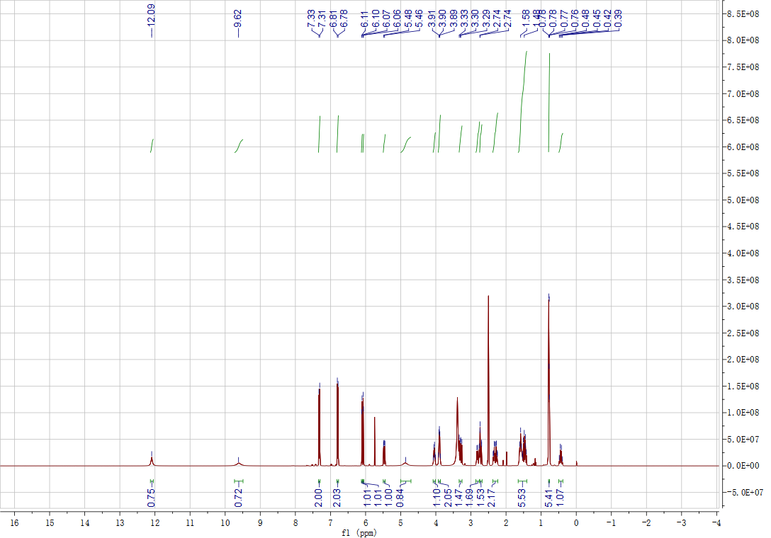
Figure S35. ¹H NMR Spectrum (DMSO, 400 MHz) of C₄.
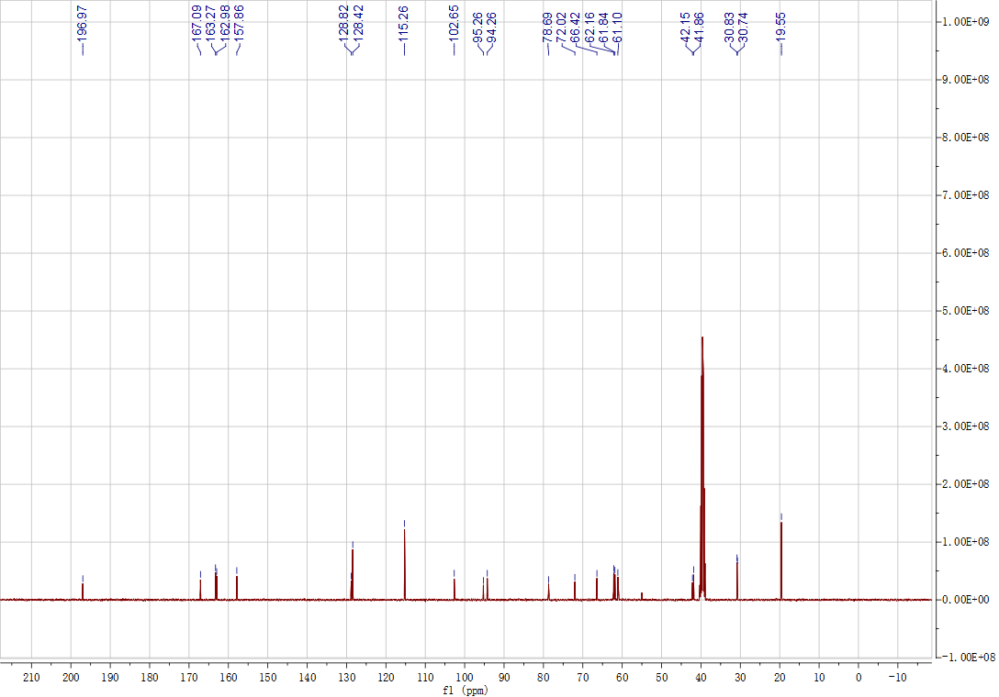
Figure S36. ¹³C NMR Spectrum (DMSO, 101 MHz) of C₄.
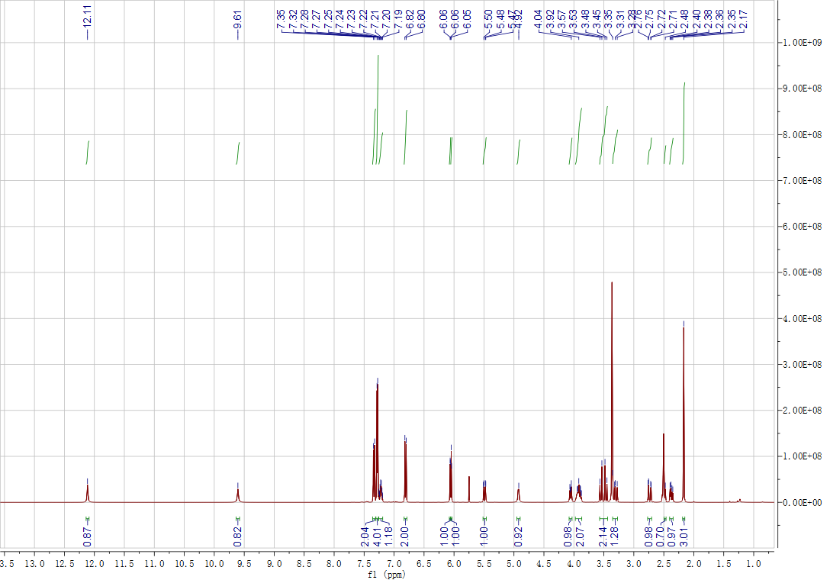
Figure S37. ¹H NMR Spectrum (DMSO, 400 MHz) of C₅.
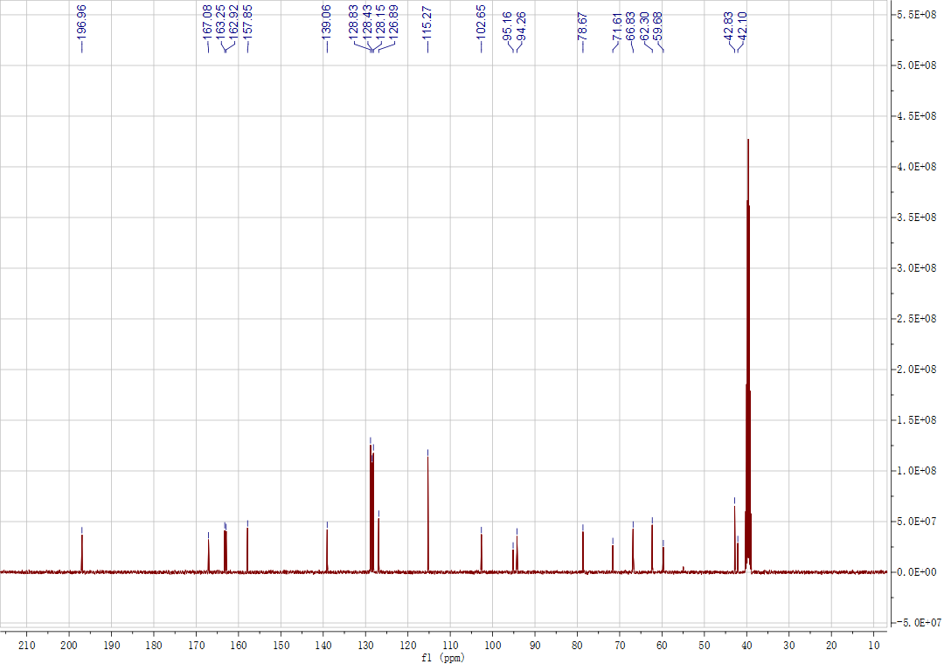
Figure S38. ¹³C NMR Spectrum (DMSO, 101 MHz) of C₅.
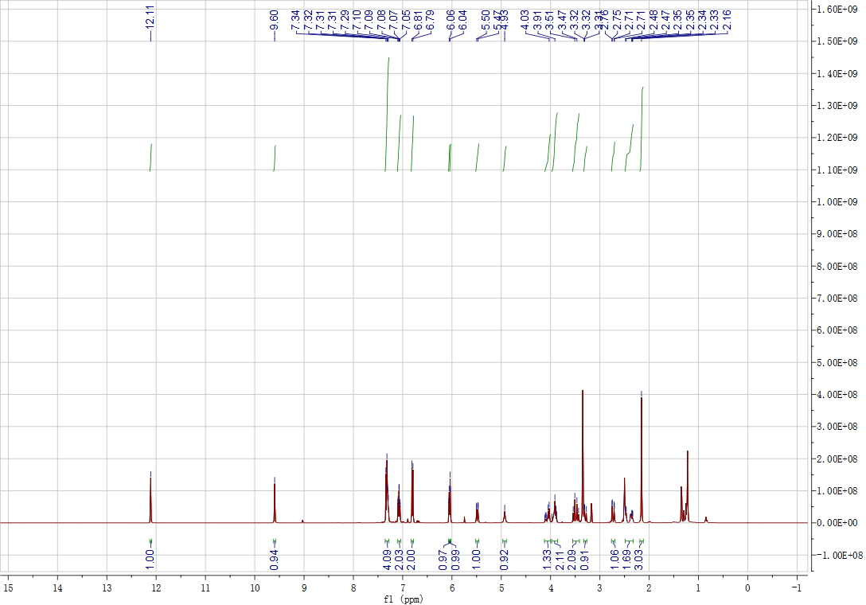
Figure S39. ¹H NMR Spectrum (DMSO, 400 MHz) of C₆.
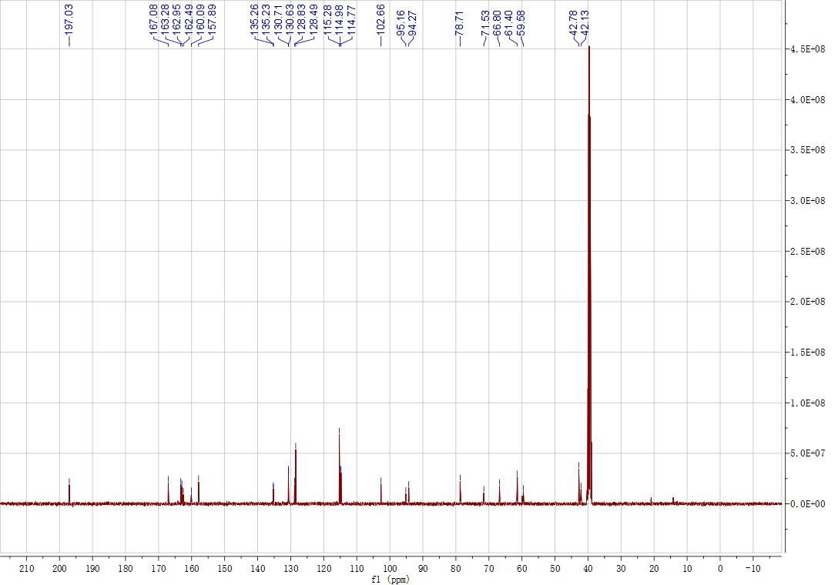
Figure S40. ¹³C NMR Spectrum (DMSO, 101 MHz) of C₆.
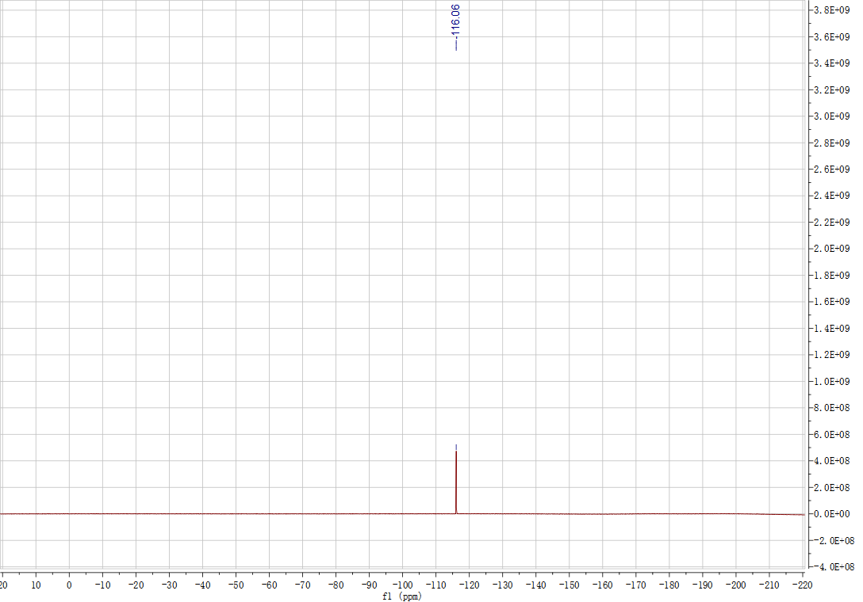
Figure S41. ¹⁹F NMR Spectrum (DMSO, 101 MHz) of C₆.

