Cryo-EM Structure of the LARS1-IARS1 Complex Reveals A Nutrient-Responsive Switch Controlling mTORC1 Signaling

Supplementary Method
Molecular Dynamics Simulation
Hydrogen atoms were added to the LARS1:IARS1 structure using the MolProbity web server (version 4.5.1)¹. All-atom molecular dynamics simulations were performed using the GROMACS 2023 software². Topologies for the UNE-L protein, IARS1, and UNE-L:IARS1 complex were generated with gmx pdb2gmx module and AMBER ff14SB forcefield³ with Joung-Cheatham parameters for monovalent ions⁴. The structures were solvated with TIP3P water molecules in a dodecahedron box with a padding distance of 2.0 nm, using the gmx solvate module. The solvation shells were charge-neutralized with sodium chloride under a physiological ionic strength of 0.15 M via the gmx genion module. Then, systems were energy minimized without constraints under the steepest descent algorithm with a step size of 0.01 nm. For the equilibration steps, non-hydrogen atoms were position-restrained by a harmonic constraint with a force constant of 1000 kJ/mol/nm. The Verlet cutoff scheme and the cutoff distance of 1.0 nm were used. The overall structures were NVT equilibrated with a time step of 2 fs and a velocity-rescaled modified Berendsen thermostat at 310 K. Two temperature coupling groups were used, one with the protein and the other with the surrounding water and sodium chloride ions. After a 500 ps NVT equilibration step, the system was subjected to a 500 ps NPT equilibrium with an exponential relaxation isotropic pressure coupling at 1.0 bar and a time constant of 2.0 ps. Finally, a 100 ns production run was made with Parrinello-Rahman isotropic pressure coupling, where bonds to hydrogen atoms were constrained using the LINCS holonomic constraint algorithm. With a 2 fs time step, energies and coordinates were saved every 10 ps. The resulting trajectory was centered at IARS1, and periodic boundary conditions were lifted using the gmx trjconv module. Hydrogen bonding analysis was conducted using the gmx hbond module. Per-residue binding energy decomposition via MM/GBSA was performed using the gmx_MMPBSA 1.6.3 tool⁵. Generalized Born model 2 (igb=5)⁶ with mbondi2 radii set and analytical linearized Poisson-Boltzmann approximation (ALPB) was employed. C2 entropy approximation⁷ was used to calculate the entropic term. The relative dielectric constants ε_{internal} and ε_{external} were set as 1.0 and 78.5, respectively. The ionic strength of 0.15 M, solvent probe radius of 1.4 Å, and surface tension of 0.0072 kcal/mol/Å² were used. The results were analyzed by the gmx_MMPBSA_ana module.

Supplementary Tables
Supplementary Table 1. LARS1:IARS1 interface summary measured using ePISA
 | IARS1 |  | LARS1_UNE-L
Selection range | B |  | A
class | Protein |  | Protein
symmetry operation | x,y,z |  | x,y,z
symmetry ID | 1_555 |  | 0_555
Number of atoms
interface | 134 | 2.0% | 107 | 12.4%
surface | 3701 | 55.7% | 579 | 66.9%
total | 6644 | 100.0% | 865 | 100.0%
Number of residues
interface | 40 | 4.9% | 28 | 25.7%
surface | 776 | 95.9% | 108 | 99.1%
total | 809 | 100.0% | 109 | 100.0%
Solvent-accessible area, Å
interface | 1084.4 | 3.0% | 1191.5 | 16.3%
total | 36621.7 | 100.0% | 7302.2 | 100.0%
Solvation energy, kcal/mol
isolated structure | -859.5 | 100.0% | -95.7 | 100.0%
gain on complex formation | -0.1 | 0.0% | -4.0 | 4.2%
average gain | -1.3 | 0.2% | -2.8 | 2.9%
P-value | 0.643 |  | 0.385
Supplementary Table 2. Hydrogen bonds
 | IARS1 | Distance [Å] | LARS1_UNE-L
1 | B:LYS 169 [NZ] | 2.95 | A:GLN1075 [O]
2 | B:LYS 169 [NZ] | 2.83 | A:ASN1078 [OD1]
3 | B:LYS 169 [NZ] | 3.34 | A:HIS1080 [O]
4 | B:VAL 478 [N] | 3.54 | A:ARG1126 [O]
5 | B:ARG 511 [NH2] | 3.19 | A:ASP1169 [OD2]
6 | B:THR 576 [O] | 3.58 | A:SER1077 [OG]
7 | B:LEU 578 [O] | 3.56 | A:ASN1078 [N]
8 | B:LEU 578 [O] | 3.61 | A:GLY1079 [N]
9 | B:GLN 165 [OE1] | 3.30 | A:SER1082 [N]
10 | B:GLN 165 [OE1] | 3.55 | A:SER1082 [OG]
11 | B:PRO 509 [O] | 3.07 | A:ARG1126 [NH1]
12 | B:GLU 477 [OE1] | 3.18 | A:ARG1126 [NH1]

Supplementary Table 3. Salt bridges
 | IARS1 | Distance [Å] | LARS1_UNE-L
1 | B:ARG 511 [NH2] | 3.62 | A:ASP1169 [OD1]
2 | B:ARG 511 [NH1] | 3.98 | A:ASP1169 [OD1]
3 | B:ARG 511 [NH2] | 3.19 | A:ASP1169 [OD2]
4 | B:GLU 477 [OE1] | 3.18 | A:ARG1126 [NH1]

Supplementary Table 4. Hydrophobic core
 | IARS1 | LARS1_UNE-L
1 | B:TRP141, B:PHE579, B:TYR540, B:TYR535, B:PHE548, B:PHE552, B:PHE542 | A:TYR1831
2 | B:LEU171, B:ARG418, B:ARG478, B:TYR167 | A:VAL1128, A:LEU1131, A:VAL1130
3 | B:TRP161, B:VAL162, B:PHE579, B:VAL578, B:TYR535 | A:PHE1081

Supplementary Figures

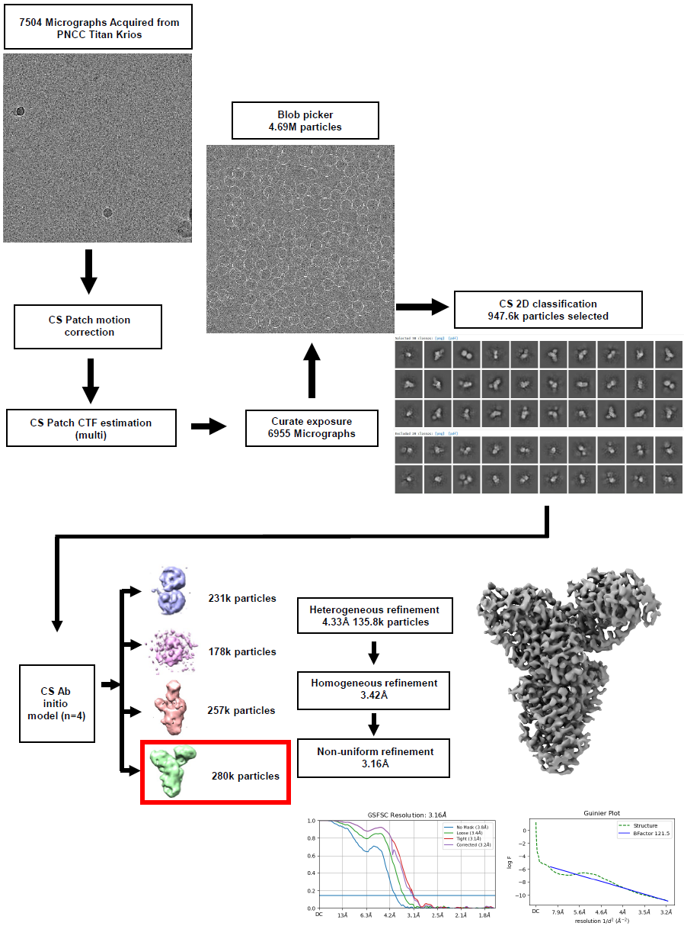
Supplementary Figure 1. Cryo-EM data processing workflow for LARS1:IARS1 complex structure determination
Comprehensive data processing pipeline for cryo-EM structure determination of the human LARS1:IARS1 complex. Starting with 7,504 micrographs acquired from the PNCC Titan Krios, the workflow includes cryoSPARC Patch motion correction, cryoSPARC Patch CTF estimation (multi), followed by particle picking with the blob picker (4.69 million particles). After exposure curation (6,955 micrographs), cryoSPARC 2D classification yielded 947.6k selected particles. cryoSPARC Ab initio reconstruction (n=4) generated four initial models with 231k, 178k, 257k, and 280k particles respectively. The selected model (red box, 280,000 particles) underwent heterogeneous refinement (n = 4, 4.33 Å, 135,800 particles selected), followed by homogeneous refinement (3.42 Å), and final non-uniform refinement, achieving a 3.16 Å resolution. Bottom panels show gold-standard FSC resolution curves and Guinier plot, validating the final reconstruction quality. The final 3D density map shows clear secondary structure features of the LARS1:IARS1 complex.

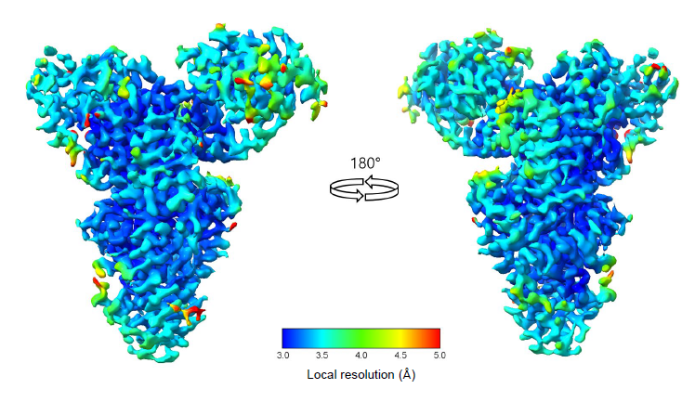
Supplementary Figure 2. Local resolution estimation of the LARS1:IARS1 complex cryo-EM map
Local resolution analysis of the final 3.16 Å cryo-EM reconstruction of the human LARS1:IARS1 complex calculated using cryoSPARC local resolution estimation. The map is colored according to local resolution values ranging from 3.0 Å (blue) to 5.0 Å (red) as indicated by the color scale. Two orthogonal views (180° rotation) demonstrate that the core regions of both IARS1 and the LARS1 UNE-L domain achieve high resolution (predominantly blue, ~3.0-3.5 Å), while peripheral regions and the IARS1 editing domain show lower resolution (green to red, ~4.0-5.0 Å). The well-resolved central interface region between IARS1 and LARS1 UNE-L domain validates the quality of the reconstruction for detailed structural analysis of the protein-protein interaction.

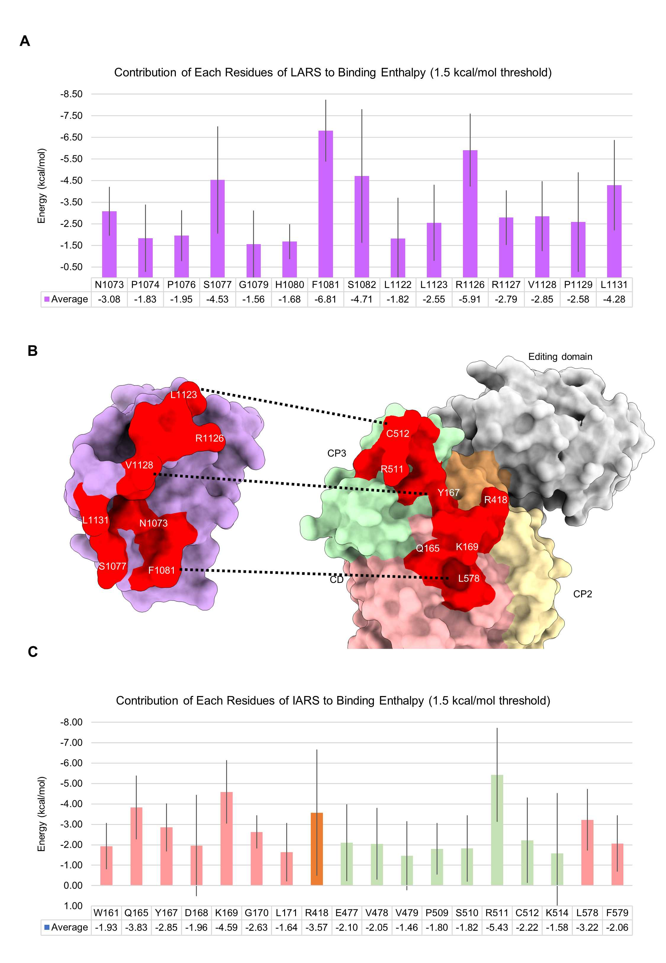
Supplementary Figure 3. MM/GBSA analysis of LARS1:IARS1 interface.
(a) Binding enthalpy contribution of individual LARS1 UNE-L domain residues to the LARS1-IARS1 interaction calculated using the MM/GBSA method. Residues contributing more than a 1.5 kcal/mol threshold are shown. Key residues include Phe1081 (-6.81 kcal/mol), Arg1126 (-5.91 kcal/mol), Ser1082 (-4.71 kcal/mol), and Ser1077 (-4.53 kcal/mol), highlighting their critical roles in complex stability. (b) Surface representation of the LARS1-IARS1 interface with key interacting residues highlighted in red. The LARS1 UNE-L domain is shown in purple, with dotted lines indicating major interaction networks between the proteins. IARS1 domains are colored as: CD (pink), CP core (orange), CP2 (yellow), CP3 (green), and editing domain (gray). (c) Binding enthalpy contribution of individual IARS1 residues to the complex formation. Notable contributors include Arg511 (-5.43 kcal/mol), Lys169 (-4.59 kcal/mol), and Gln165 (-3.83 kcal/mol).

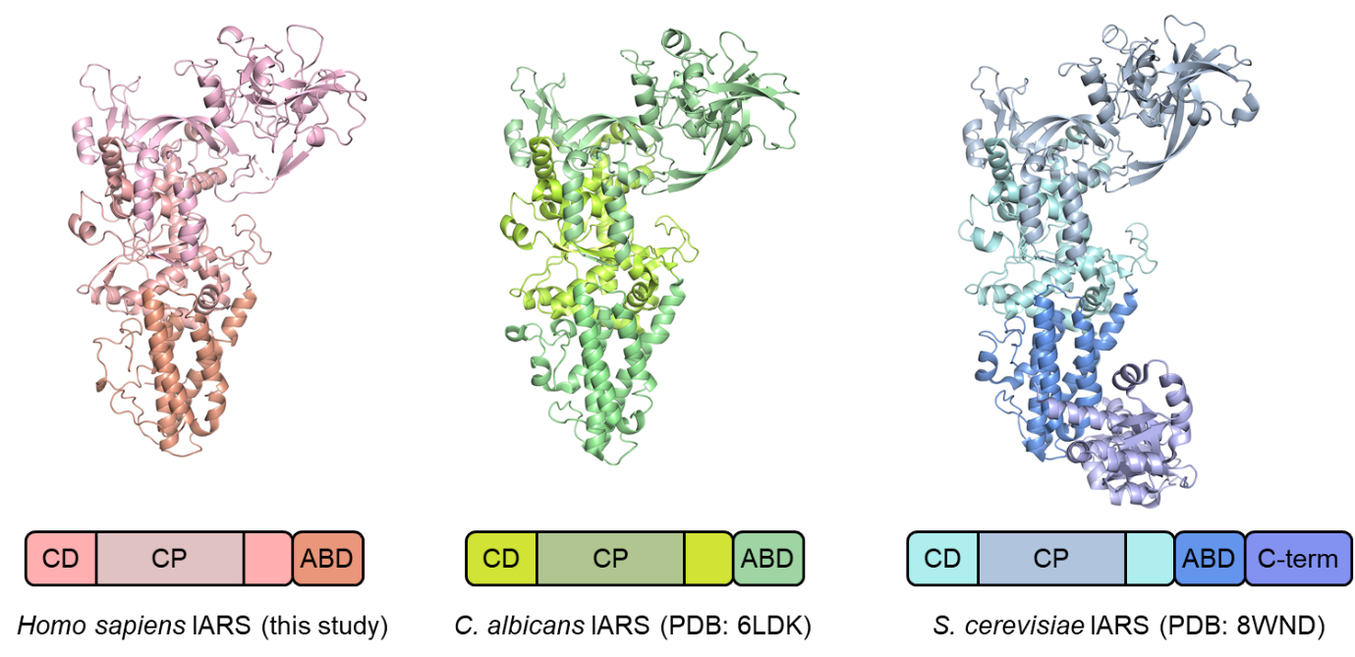
Supplementary Figure 4. Structural comparison of human IARS1 with other eukaryotic IARS1.
Comparison of the human IARS1 structure (left, from this study) with previously determined structures of IARS1 from C. albicans (center, PDB: 6LDK) and S. cerevisiae (right, PDB: 8WND). The structural comparison reveals a high degree of conservation in overall fold and domain organization across species, particularly within the catalytic core and anticodon-binding domains.

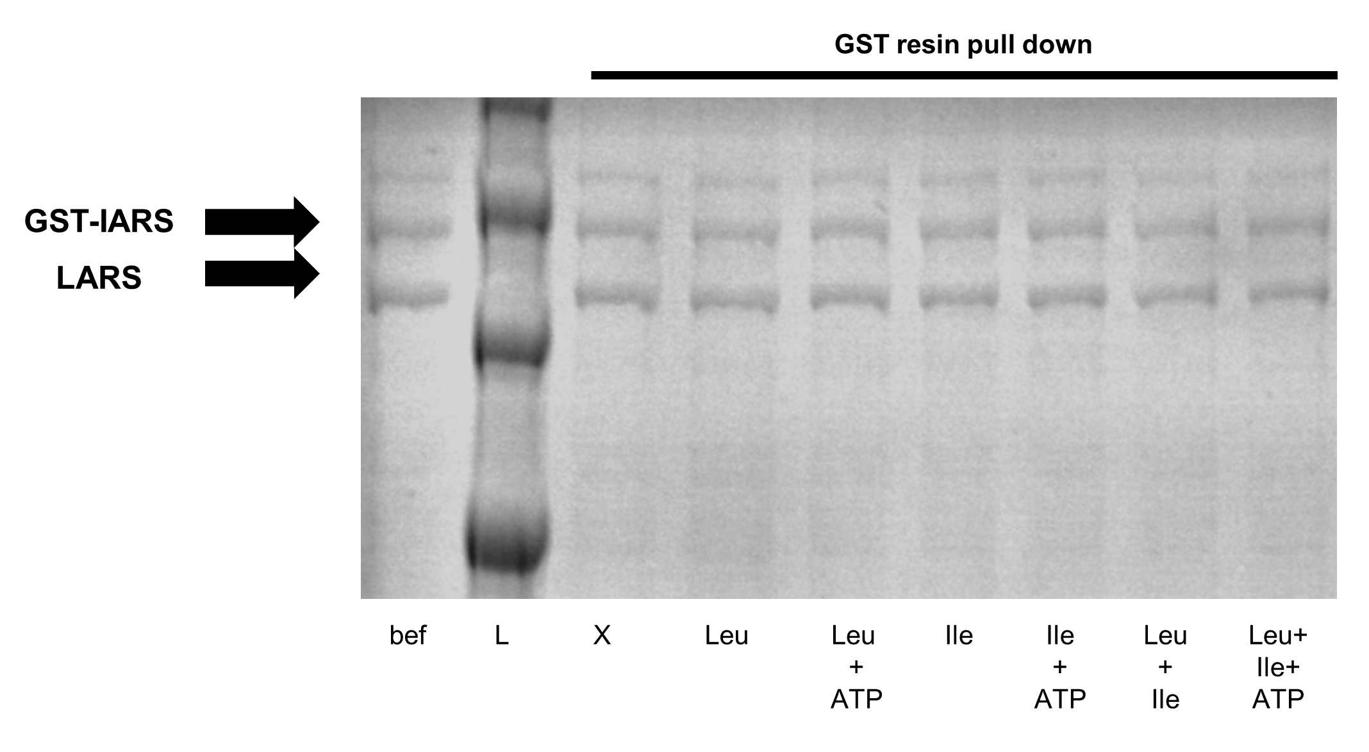
Supplementary Figure 5. Effect of amino acids and ATP on LARS1:IARS1 complex stability
GST pull-down assay examining the stability of LARS1:GST-IARS1 complex under various amino acid and ATP conditions. Purified LARS1:GST-IARS1 protein complex was incubated with different combinations of leucine (1 mM), isoleucine (1 mM), and ATP (1 mM) as indicated. After incubation, a GST pull-down was performed using glutathione-Sepharose resin. The results show that the LARS1:IARS1 complex remains stable under all tested conditions, indicating that amino acid or ATP binding events are not sufficient to disrupt the complex in vitro.
bef: before incubation control, L: Ladder, X: control condition.

Supplementary Figure 6. Validation of mTORC1 activation and LARS1 immunoprecipitation for MS/MS analysis
(a) Western blot analysis of whole cell lysates (WCL) from HEK293T cells transfected with FLAG-tagged LARS1. Cells were subjected to 24-hour amino acid starvation followed by stimulation with 2 mM leucine or complete amino acids (whole AA) as indicated. mTORC1 activation was monitored by phospho-S6K1 (Thr389) levels, with total S6K1, FLAG-LARS1 expression, and GAPDH shown as controls. N/A: non-transfected control, (-): starvation condition. (b) SDS-PAGE analysis of FLAG-LARS1 immunoprecipitated using anti-FLAG resin. The red dashed box indicates the FLAG-tagged LARS1 protein band (approximately 100-130 kDa) that was excised for in-gel digestion and subsequent LC-MS/MS analysis. The band near 48 kDa is the heavy chain of anti-flag antibody.
L : protein ladder marker.

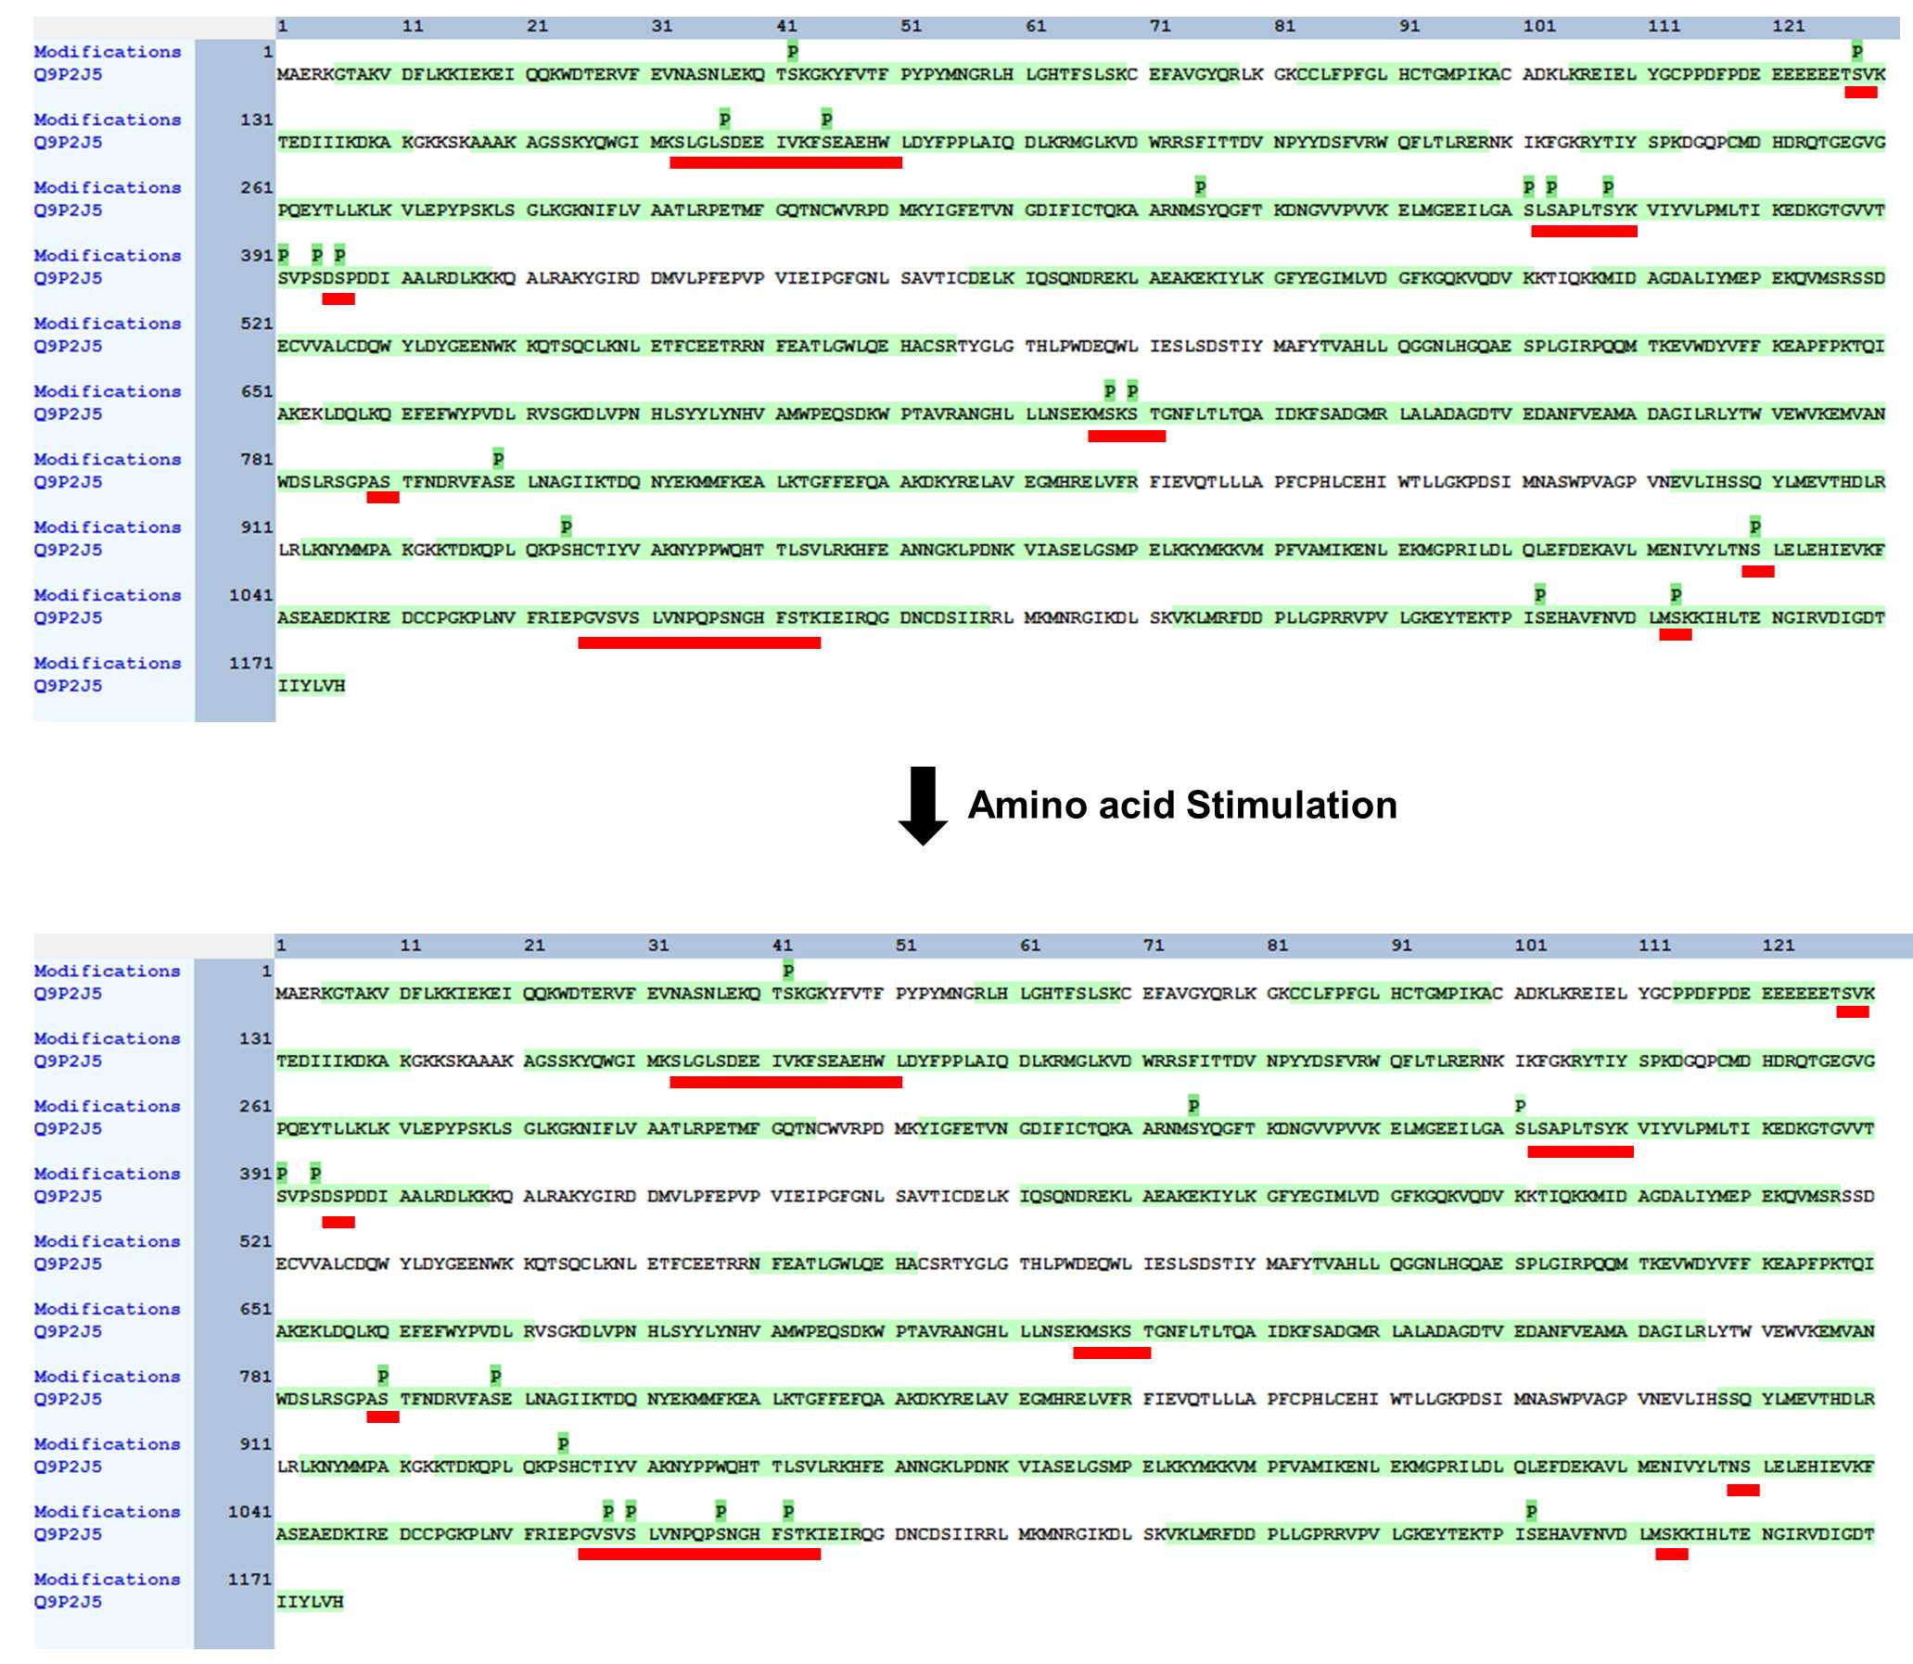
Supplementary Figure 7. LC-MS/MS identification of LARS1 phosphorylation sites.
Phosphorylation profile of FLAG-LARS1 immunoprecipitated from HEK293T cells under amino acid starvation (upper) or stimulation (lower) conditions. Green 'S' indicates detected phosphoserine residues. Red underlines highlight regions with differential phosphorylation between conditions. MS analysis was performed using Proteome Discoverer (Thermo Fisher Scientific) with Sequest HT (precursor tolerance: 0.1 Da, fragment tolerance: 0.03 Da).
Supplementary Figure 8. Validation of phosphoserine incorporation in UNE-L domain by MALDI-TOF mass spectrometry.
(a) SDS-PAGE analysis of genetic code expansion-produced proteins used for mass spectrometry analysis. GST-IARS1 (~100 kDa) and UNE-L domain variants (~17 kDa) with wild-type or phosphoserine incorporation at positions 1070, 1077, or 1082 were separated by SDS-PAGE. The UNE-L bands (red arrow) were excised for in-gel digestion and subsequent MALDI-TOF analysis. (b) MALDI-TOF intact protein mass spectra confirming phosphoserine incorporation. Sinapic acid (SA) was used as a matrix. Top panel shows wild-type UNE-L (expected mass: 13721.063 Da) with a characteristic +80 Da shift, indicating successful phosphoserine incorporation. Subsequent panels show individual phosphoserine variants: Ser1070Sep (13722.235 -> 13795.800 Da), Ser1077Sep (13724.107 -> 13799.453 Da), and Ser1082Sep (13730.776 -> 13798.606 Da). The +80 Da mass shift corresponds to the replacement of serine (87 Da) with phosphoserine (167 Da), providing direct evidence for site-specific phosphoserine incorporation using genetic code expansion technology.

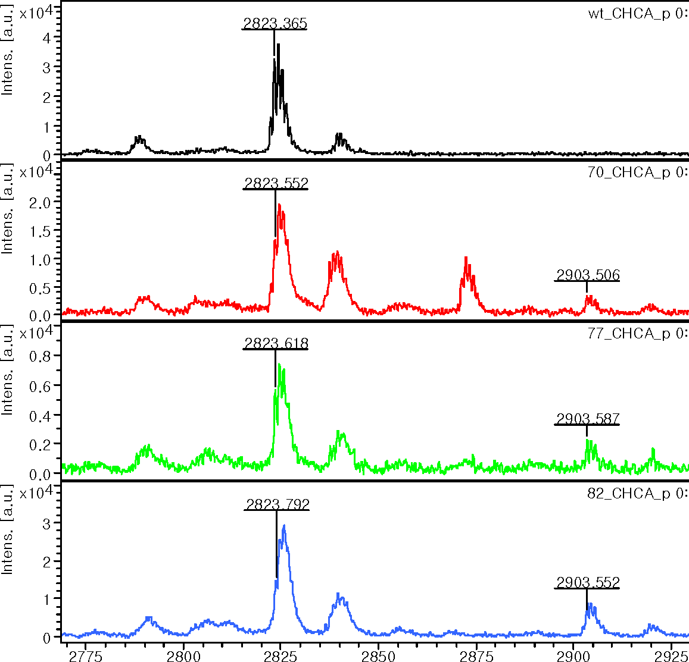
+ 80 da
UNE-L wt
UNE-L S1082Sep
UNE-L S1077Sep
UNE-L S1070Sep
Supplementary Figure 9. MALDI-TOF analysis of phosphoserine-incorporated UNE-L variants
MALDI-TOF mass spectrometry analysis of tryptic peptides derived from in-gel digested UNE-L domain proteins following genetic code expansion. The top panel shows the wild-type UNE-L peptide with a mass of 2823.365 Da. The characteristic +80 Da mass shift (black arrow) indicates successful incorporation of phosphoserine. The +80 Da mass shifts (black boxes) correspond to the mass difference between serine and phosphoserine, providing peptide-level confirmation of site-specific phosphoserine incorporation at the designated positions. This analysis validates the successful genetic code expansion and confirms the presence of phosphoserine in the UNE-L domain at the intended sites.

Supplementary Figure 10. MS/MS fragmentation analysis of phosphoserine-containing peptides
MALDI-TOF/TOF MS/MS analysis using LIFT technology to confirm phosphoserine incorporation at specific sites in UNE-L domain peptides. (a) Fragmentation spectrum of UNE-L Ser1070Sep. (b) Fragmentation spectrum of UNE-L Ser1077Sep. (c) Fragmentation spectrum of UNE-L Ser1082Sep. In all spectra, S* denotes the phosphoserine residue, and the fragmentation patterns provide unambiguous confirmation of successful genetic code expansion-mediated phosphoserine incorporation at the designated serine positions. The comprehensive b-ion and y-ion series validate the sequence and confirm the precise location of phosphoserine modifications in each peptide variant.

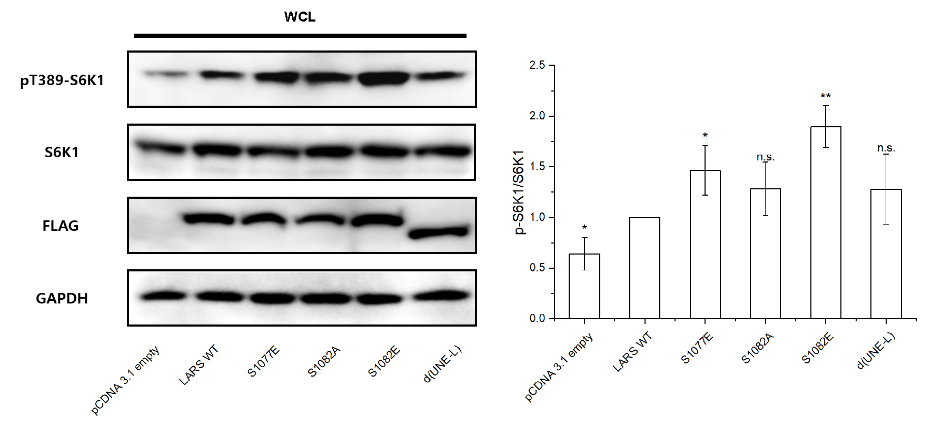
Supplementary Figure 11. mTORC1 activation by various LARS1 constructs and controls.
Western blot analysis and quantification of mTORC1 activity in HEK293T cells transfected with different LARS1 constructs. Left panel shows representative Western blots for phospho-S6K1 (Thr389), total S6K1, FLAG-LARS1, and GAPDH. The right panel shows quantification of the phospho-S6K1/S6K1 ratio normalized to wild-type LARS1 (set as 1.0). Data are presented as mean ± SD from three independent experiments (n=3). Wild-type LARS1 activity was set as the reference (1.0). Statistical significance was determined by an unpaired Student's t-test. The empty vector showed significantly lower activity compared to wild type (0.64-fold, p < 0.05), while the Ser1077Glu mutant (1.46-fold, p < 0.05) and Ser1082Glu (1.90-fold, p < 0.01) exhibited significantly increased activity. The Ser1082Ala mutant and ∆UNE-L deletion showed intermediate activities that were not statistically significant compared to the wild type, although both showed trends toward increased activation. *p < 0.05, **p < 0.01, n.s. = not significant. Quantification performed using ImageJ software⁸.
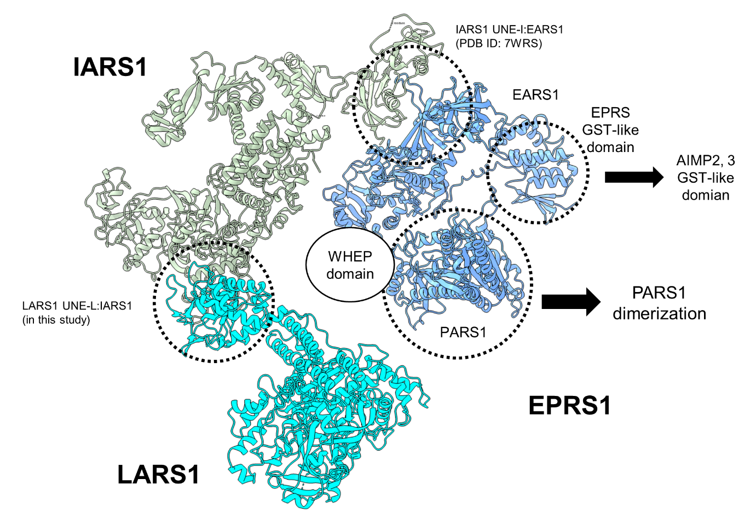
Supplementary Figure 12. Structural model of MSC Subcomplex III
Structural model of MSC subcomplex III, derived from experimental structures and AlphaFold3 predictions, showing the structural organization of LARS1 (cyan), IARS1 (green), and EPRS1 (magenta). EPRS1 contains a WHEP domain that connects EARS1 and PARS1. The LARS1 UNE-L:IARS1 region (highlighted in a dotted circle, left) represents the interface examined in this work. The IARS1 UNE-I:EARS1 interaction (dotted circle, top; PDB ID: 7WRS) illustrates the experimentally resolved structural interface between these domains. The GST-like domain of EPRS1 (dotted circle, top right) interacts with GST-like domains of AIMP2 and AIMP3, mediating the linkage between MSC Subcomplex III and Subcomplexes I and II. PARS1 (dotted circle, bottom right) forms a homodimer.

Supplementary References
1. Williams, C. J. et al. MolProbity: More and better reference data for improved all-atom structure validation. Protein Science 27, 293–315 (2018).
2. Abraham, M. J. et al. Gromacs: High performance molecular simulations through multi-level parallelism from laptops to supercomputers. SoftwareX 1–2, 19–25 (2015).
3. Maier, J. A. et al. ff14SB: Improving the Accuracy of Protein Side Chain and Backbone Parameters from ff99SB. J Chem Theory Comput 11, 3696–3713 (2015).
4. Joung, I. S. & Cheatham, T. E. Determination of alkali and halide monovalent ion parameters for use in explicitly solvated biomolecular simulations. Journal of Physical Chemistry B 112, 9020–9041 (2008).
5. Valdés-Tresanco, M. S., Valdés-Tresanco, M. E., Valiente, P. A. & Moreno, E. Gmx_MMPBSA: A New Tool to Perform End-State Free Energy Calculations with GROMACS. J Chem Theory Comput 17, 6281–6291 (2021).
6. Onufriev, A., Bashford, D. & Case, D. A. Exploring Protein Native States and Large-Scale Conformational Changes with a Modified Generalized Born Model. Proteins: Structure, Function and Genetics 55, 383–394 (2004).
7. Menzer, W. M., Li, C., Sun, W., Xie, B. & Minh, D. D. L. Simple Entropy Terms for End-Point Binding Free Energy Calculations. J Chem Theory Comput 14, 6035–6049 (2018).
8. Abràmoff, M. D., Magalhães, P. J. & Ram, S. J. Image processing with imageJ. Biophotonics International vol. 11 36–42 Preprint at https://doi.org/10.1201/9781420005615.ax4 (2004).

