Appendix 1:
A rigorous validation process is essential for any LLM-based classification to ensure the accuracy and consistency of the output data. The validation process of the pipeline of this paper has been carried out by a team of experts in the QT job market and data scientists, who have iteratively honed each of the prompts of the steps in order to reach a satisfactory classification accuracy. The validation framework utilized in this study is inspired by the works of Shah [50] and Pangakis et al., [51] and has been customized to meet the specific objectives and resource constraints of our project.

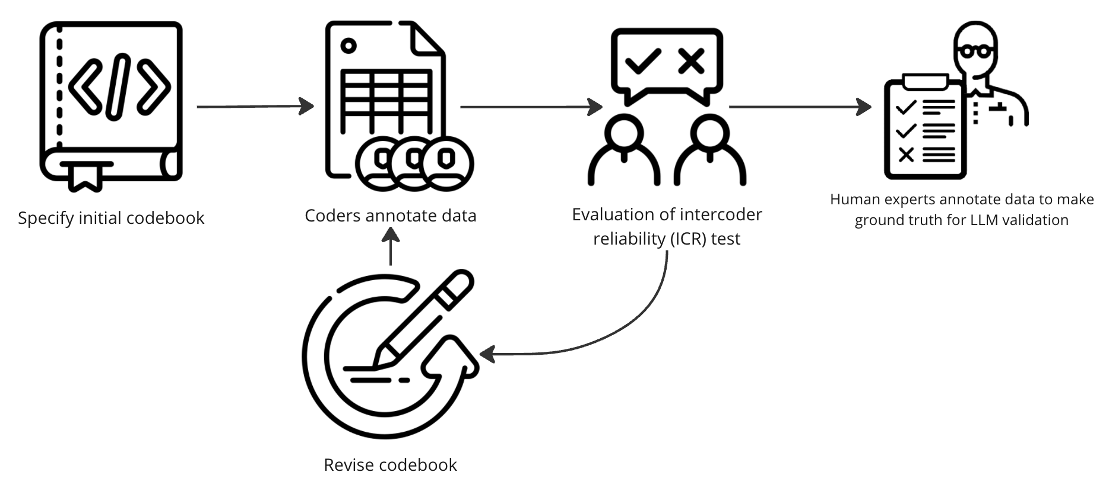

Figure 17. Initial phase of the validation framework. The figure illustrates the different steps involved in composing a codebook that the prompt used for classification is based on. The process is iterative and continues until the codebook has passed an intercoder reliability test.
The validation process of a classification step begins by formulating an initial codebook like any traditional coding task [52-53]. Human coders then annotate the data based on the instructions of the codebook; in our framework, three non-expert coders each had to label a subset of the data (25 job posts) whereafter the labelled data was compared against each other in an intercoder reliability (ICR) test [54]. The purpose of performing the ICR test is to ensure that the codebook is interpreted as intended and to catch any potential edge cases that were not accounted for in the initial codebook specification. Discordant labels formed the basis for revising the codebook, such as using more concise wording or expanding the codebook to encompass previously unforeseen cases. Once the codebook had been revised, the coders would once again label the data so a new ICR test could be conducted. This iterative flow would continue until there was at least 90% agreement between the coders. Once the codebook has passed the test, a human expert (i.e. a person well-acquainted with the QT job market) uses it to annotate 200 job posts in order to create ground truth that can be used in the assessment of the LLM-classification performance. This represents over 5% of the database and is in line with recommendations for LLM-classification validation from prior studies [51]. The next phase of the validation process involves converting the codebook into a prompt for the LLM. Although LLMs are trained on and adept at handling natural language, adjustments are made to ensure the output adheres to a format that the codebase can process correctly.

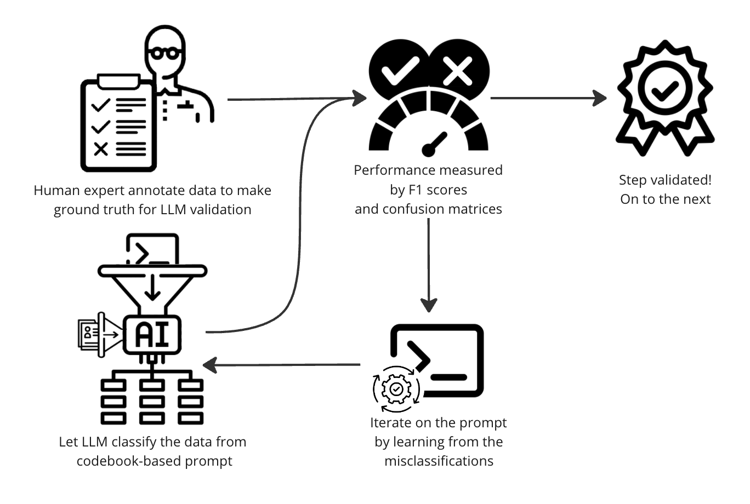

Figure 18. Second phase of the validation framework. The figure shows the process of comparing the ground truth in the form of annotations by a human expert with the classifications of the LLM. If the classification performance is unsatisfactory, the prompt is iterated upon and the LLM classifies the data anew. This is repeated until the performance is adequate.

Once the first version of the prompt for classification has been made, the same 200 job posts, where the true classifications have been defined, are classified by the LLM using the prompt. The classifications made by the LLM are then compared to the ground truth and the performance is evaluated using the weighted average of the F1-scores for the labels along with the associated confusion matrix. The weighted average of the F1-scores was selected as the performance metric for the classification task, as it offers a more robust assessment for datasets with imbalanced label distributions [55]. Since there is no conventional threshold for F1-scores—unlike p-values, which typically indicates significance if below 0.05 [56] — the scores were assessed on an ad hoc basis, using the general rule of thumb that a score of 0.7 or higher is regarded as good [57]. Following this guideline, the prompt was iteratively refined based on insights from misclassifications; the confusion matrix concisely highlighted any potential biases in the classification, thereby aiding in accurately adjusting the prompt. The process involved letting the LLM reclassify the data using the newly refined prompts, and subsequently generating the new F1-score and confusion matrix. This cycle was repeated until the score was deemed satisfactory. Consequently, the lowest weighted average F1-score achieved across all steps was 89%; below is an example of the classification performance for step 4 of the pipeline, on the job posts labeled 'Corporate' in the previous step.

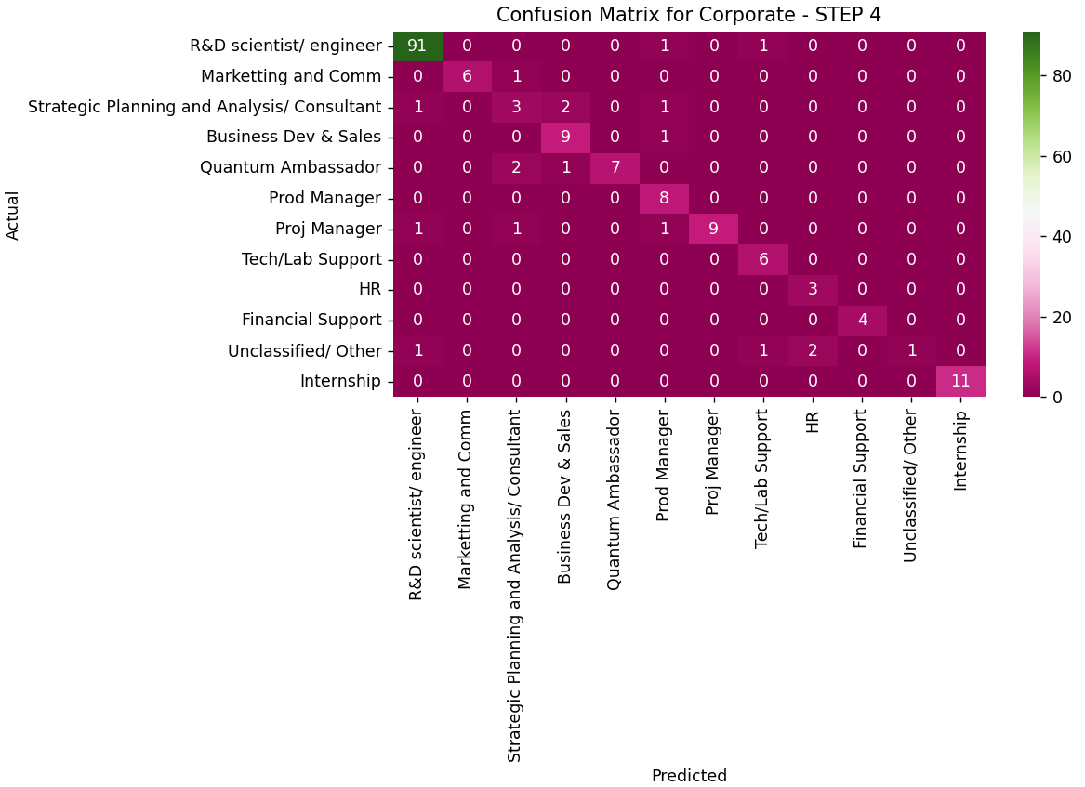

Figure 19. The confusion matrix provides an overview of the LLM's classification performance across different labels. Notably, the label 'R&D Scientist/Engineer' shows a high proportion of correctly classified job posts, likely due to it being well-defined and easy to delineate. Other roles, such as “Strategic Planning and Analysis / Consultant” may be more difficult to classify accurately, indicated by the off-diagonal components. Overall though, the LLM-classification performs quite well, as seen by the distinctly outlined diagonal of the matrix and quantified by the F1-score.

The majority of the steps of the pipeline were validated using the LLM-model gpt-3.5-turbo-0125 from OpenAI, while the remaining was done using gpt-4o-mini-2024-07-18, also from OpenAI [33]. The models were chosen by balancing cost and performance – the common denominator between the two models is, that they both are the affordable version of their correspondent flagship models. Due to the longevity of the development of the pipeline, gpt-4o-mini was chosen for the later steps, since this model has become available at this point in the process and that it “cheaper, more capable, multimodal, and just as fast as gpt-3.5-turbo” [58].

