Supplementary Information for

Illumination-Induced Transparency in 2D Layered Perovskites via Lattice Energy Reservoirs

Chunhua Zhou¹, Junlin Lu², Mehri Ghasemi², Zhixing Gan³, Fang Wang¹, Wenjie Wang¹, Shaoding Liu¹, Baohua Jia^{2*}, Xiaoming Wen^{2*}

- College of Physics and Optoelectronics, Taiyuan University of Technology, Taiyuan 030024, People’s Republic of China.
- Centre for Atomaterials and Nanomanufacturing, RMIT University, Melbourne VIC 3000, Australia
- Center for Future Optoelectronic Functional Materials, School of Computer and Electronic Information/School of Artificial Intelligence, Nanjing Normal University, Nanjing 210023, People’s Republic of China

Experimental section
Material Preparation: Lead (II) iodide (PbI₂) powder (1.152g) was dissolved in a mixed solution with 5 mL of 57% w/w aqueous hydroiodic acid (HI) and 0.85 mL hypophosphorous acid (H₃PO₂) at room temperature under constant magnetic stirring, which formed a bright yellow solution. Meanwhile, in another bottle, n-CH₃(CH₂)₃NH₂ (0.5 mL) was slowly neutralized with 3 mL of HI 57% w/w in an ice bath. Then, the n-CH₃(CH₂)₃NH₃I solution was dropwise added to the lead solution under 120 °C and stirring, which initially produced an orange precipitate and subsequently dissolved under heating the combined solution to boiling. The stirring was then stopped, and the solution was left to cool to room temperature during which time orange plate shaped crystals can be obtained. The precipitation was deemed to be complete after about 2 h. The crystals were isolated by filtration and washed by diethyl ether thoroughly dried under reduced pressure.

Experimental samples for this investigation
Samples in this experiment could not be reused within a short period of time, because the IIT effect is a time-accumulating process. During irradiation, LERs form and may persist for hours, even after samples are stored in darkness. As shown in Figure S3e, PL spectra retain characteristics of LER activation even after 15 minutes post-recovery. Additionally, determining the exact zero-time point in the experiment is challenging, as any unintended prior light exposure (e.g. alignment) must be accounted for. These cumulative effects—combined with the inability to reset the lattice to its pristine state—necessitate the use of fresh samples or previously untested regions for each experimental trial.

Material Characterization: The powder XRD pattern of the crystal was recorded on Bruker D8 diffractometer at a scanning rate of 1° min⁻¹, using Cu Kα radiation (λ = 1.5406 Å). The scanning electron microscope images was carried out by Zeiss Ultra 55 thermal FESEM system.

Spectroscopic Characterizations: A custom-built system was employed for PL measurements. A pulsed laser (355 nm wavelength, 5 ns pulse width, 20 Hz repetition rate) was directed onto the sample through an objective lens. The pump power was controlled using neutral density filters. The emitted PL signal was collected via an optical fiber and guided to a spectrometer (Horiba 320). In reflection mode, the laser was focused on the sample surface using a 40x objective lens, and the PL signal was collected through the same lens. In transmission mode, the laser was incident on the sample from the left side through a 20x objective lens, while the PL signal was collected with the 40x objective lens. White light was introduced along the same optical path as in the transmission mode to enable absorption detection.

Note1: Transient spectroscopic techniques in current investigation
Transient spectroscopic techniques, such as time-resolved PL (TRPL) and transient absorption spectroscopy (TAS), have been widely employed as powerful tools for investigating carrier dynamics, providing valuable insights into photogenerated carrier and phonon behaviors. However, these techniques can provide only limited information for the current investigation due to the long measurement time required to obtain signals for reasonable quality.

Transient spectroscopic techniques typically capture dynamic processes occurring on femtosecond timescales. For example, femtosecond transient absorption (fs-TAS) probes dynamics from sub-picoseconds to nanoseconds, while time-correlated single photon counting (TCSPC) is generally used for sub-nanosecond to microsecond timescales. Despite their utility, these techniques require relatively long experimental acquisition times. For instance, TCSPC measurements under high repetition rate excitation typically take tens of seconds, and fs-TAS measurements often require even longer durations. As a result, the transient spectroscopic data collected represent an average over the entire acquisition period. This limitation is also inherent in other time-resolved spectroscopic techniques.

In our attempt to observe transient spectroscopic information during the dynamic IIT process in 2D RP samples using TCSPC and TAS, the measurements did not provide insights into the IIT processes. By the time the measurements were taken, the IIT effect had already fully developed, meaning the collected data only reflect an averaged representation of the variation processes. Additionally, experiments using alternative laser sources to irradiate the crystal did not yield observable IIT effects. For instance, when excited by a 375 nm laser (10MHz), the PL spectra remained stable, with only Peak-II detected.
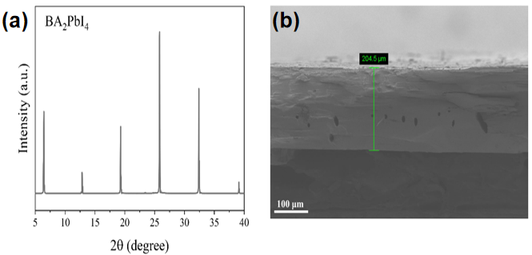
Figure S1. (a) XRD pattern and (b) SEM cross-sectional image of a (BA)₂PbI₄ crystal.

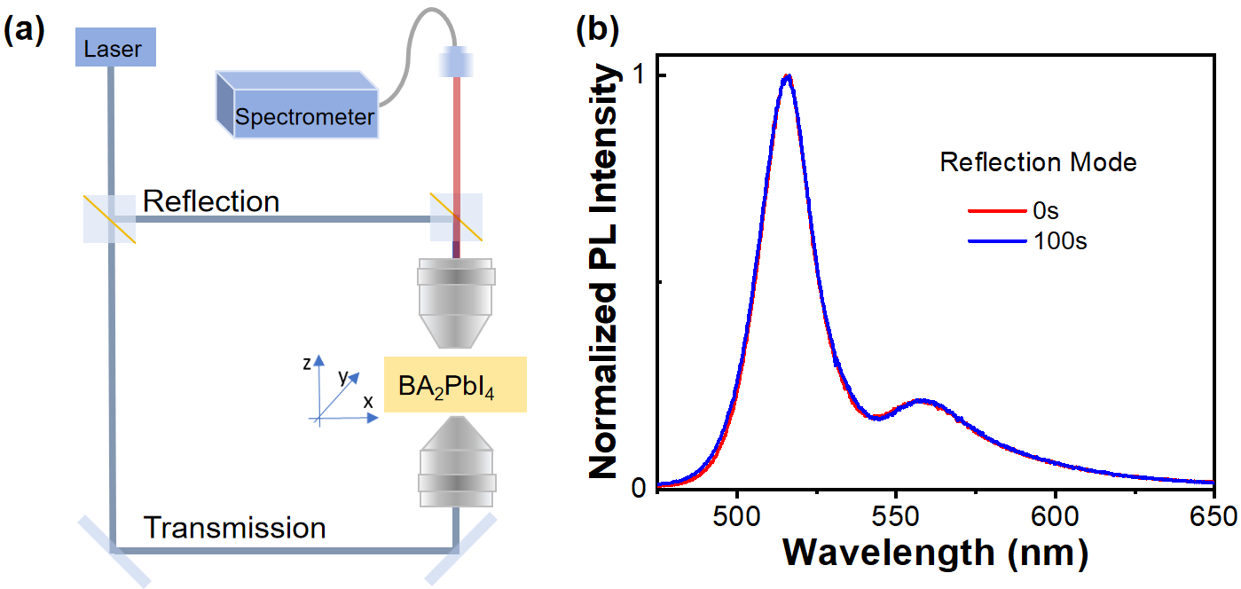

Figure S2. (a) Diagram of the PL collection setup in both reflection and transmission mode; (b) PL spectra under continuous laser excitation in the reflection mode.

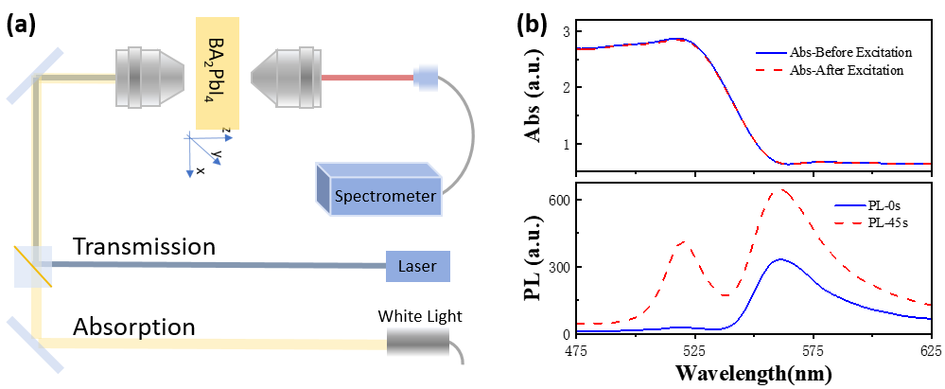

Figure S3. (a) Schematic of the PL and absorption measurement setup; (b) PL spectra of a single crystal under continuous laser excitation, along with the absorbance before and after laser irradiation.

