HBK-15 bypasses BDNF via ERK1/2-biased 5-HT_{1A} signaling to deliver a rapid antidepressant-like effect

Kinga Sałaciak¹, Angelika Jagielska^{1,2}, Klaudia Lustyk¹, Monika Głuch-Lutwin³, Barbara Mordyl³, Elżbieta Żmudzka⁴, Anna Janus^{1,2}, Aleksandra Koszałka^{1,2}, Jan Detka⁵, Alicja Skórkowska^{6,7}, Weronika Krzyżanowska^{6,7}, Bartosz Pomierny^{6,7}, Jorge Valero Gómez-Lobo^{8,9,10}, Bila Abdoul Fatahou Kabore¹¹, Séverine Morisset-Lopez¹¹, Karolina Pytka^{1*}

¹Laboratory of Experimental Neuropharmacology, Department of Pharmacodynamics, Faculty of Pharmacy, Jagiellonian University Medical College, 9 Medyczna St, 30-688 Krakow, Poland
²Doctoral School of Medical and Health Sciences, Jagiellonian University Medical College, 16 Św. Łazarza St, 31-530 Krakow, Poland
³Department of Pharmacobiology, Jagiellonian University Medical College, 9 Medyczna St, 30-688 Krakow, Poland
⁴Department of Social Pharmacy, Faculty of Pharmacy, Jagiellonian University Medical College, 9 Medyczna St, Krakow, Poland
⁵Department of Pharmacodynamics, Faculty of Pharmacy, Jagiellonian University Medical College, 9 Medyczna St, 30-688 Krakow, Poland
⁶Department of Toxicological Biochemistry, Faculty of Pharmacy, Jagiellonian University Medical College, 9 Medyczna St, Krakow, Poland
⁷Imaging Laboratory, Center for the Development of Therapies for Civilization and Age-Related Diseases, Jagiellonian University Medical College, Poland
⁸Department of Cell Biology and Pathology, Universidad de Salamanca. Facultad de Medicina. Avd. Campus Miguel de Unamuno. 37007 Salamanca, Spain
⁹Laboratory of Neuronal Plasticity and Neurorrepair. Institute for Neuroscience of Castilla y León, Univesidad de Salamanca. C/ Pintor Fernando Gallego, 1, 37007, Salamanca, Spain
¹⁰TGYC-03-Laboratory of Neuronal Plasticity and Neurorrepair, Institute of Biomedical Research of Salamanca. Edificio Virgen de la Vega, 10.ª planta
Pº de San Vicente, 58-182. 37007 Salamanca, Spain

¹¹Centre de Biophysique Moléculaire, CNRS UPR 4301, Université d’Orléans, rue Charles Sadron, 45071 Orléans Cedex 2, France

*Corresponding Author:
Karolina Pytka
Laboratory of Experimental Neuropharmacology, Department of Pharmacodynamics, Faculty of Pharmacy, Jagiellonian University Medical College, 9 Medyczna St, 30-688 Krakow, Poland
Phone number: +48 (12) 620-55-38, e-mail: karolina.pytka@uj.edu.pl

Table S1. Cellular functional activity of HBK-15 at the 5-HT_{2B} receptor.

 | Agonist mode |  |  | Antagonist mode
 | E_{max} | EC₅₀  [nM] | pEC₅₀ | I_{max} | IC₅₀  [nM] | pIC₅₀ | pKb
serotonin | 100% | 4.9 | 8.31 | - | - | - | -
HBK-15 | 2% | n.c. | n.c. | 82% | 180 | 6.74 | 7.55
SB 206553 | - | - | - | 21% | 18 | 7.74 | 8.56

Functional studies on the 5-HT_{2B} receptor were performed commercially at Eurofins Laboratories (Poitiers, France). In agonist mode, responses were normalized to the maximal effect of the reference agonist (serotonin at 10⁻⁶ M), with E_{max} defined as the maximum achievable stimulation. Effects below 25% are not considered significant. Responses from 25% to 70% are interpreted as a partial agonist. A response higher than 70% is characterized as a full agonist. The concentration–response curve for HBK-15 showed less than 25% efficacy at the highest concentration, indicating a lack of agonist activity. In antagonist mode, responses were normalized to the maximal response obtained without the antagonist. HBK-15 exhibited weak antagonist activity. The Iₘₐₓ, defined as the maximum observed inhibition, EC₅₀ and IC₅₀ values (expressed as pEC₅₀ or pIC₅₀, the negative logarithm of the concentration producing 50% of the maximal effect/inhibition) are presented as mean from three separate experiments. Kb values represent the equilibrium dissociation constant of a competitive antagonist, calculated using the Cheng–Prusoff equation. n.c.- not calculable.

Figure S1. Microinjection cannula positions. a: Arrow indicates the placement of the cannula. b: Coronal section of brain showing the cannula placement (scale bar – 1 mm).

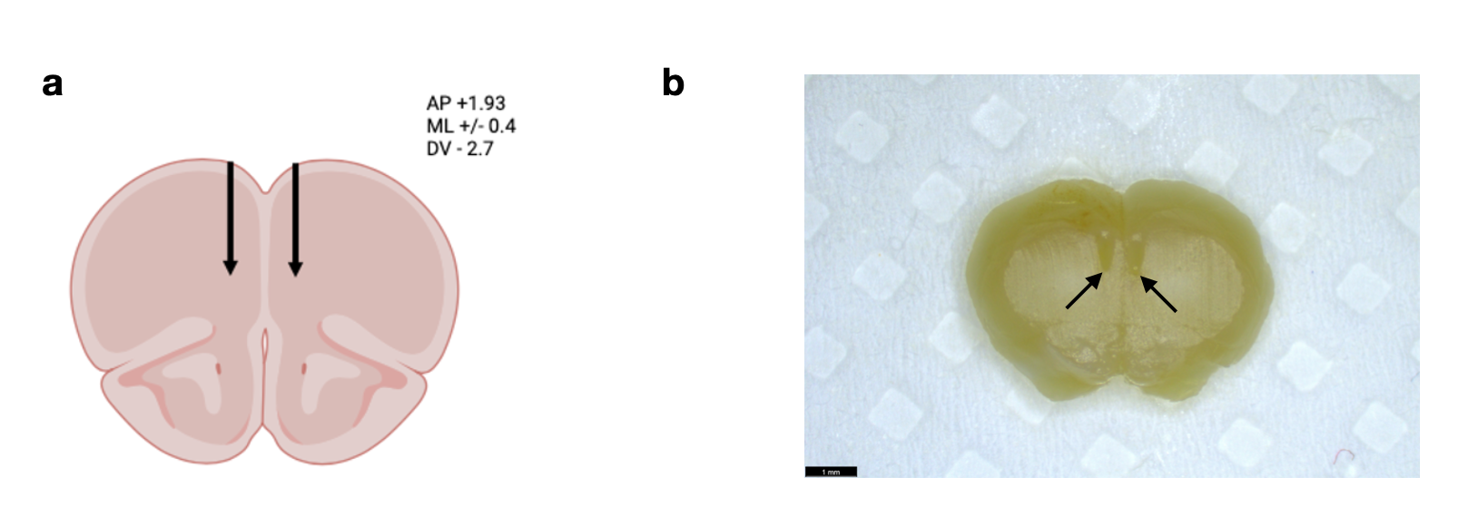
Figure S2. (complementary to Figure 2) Immunofluorescent detection of pERK1/2 and pPKA in non-stressed, stressed, HBK-15- and ketamine-treated neurons
a-b: Representative confocal images (maximum intensity projection Z-stacks spanning 5 μm in depth) showing in cyan phosphorylated ERK1/2 (pERK1/2; a) and phosphorylated PKA (pPKA; b) immunostainings in the prelimbic cortex of mice subjected to the unpredictable chronic mild stress (UCMS) and treated with HBK-15 or ketamine, along with stressed and non-stressed controls. DAPI was used for nuclear staining (gray), and MAP2 (microtubule-associated protein 2) for neuron identification (magenta). Scale bar = 50 μm.

Figure S3. (complementary to Figure 2) HBK-15 does not alter the expression of plasticity-related genes in the prefrontal cortex of chronically stressed mice.
a–f: HBK-15 and ketamine did not significantly alter the mRNA expression of Mapk1 (F_{3,24}=4.581, p=0.0113; a), Mapk3 (H_{4,28}=2.375, p=0.4983; b), Riiad1 (F_{3,24}=1.567, p=0.2233; c), Camk4 (F_{3,24}=1.605, p=0.2143; d), Creb (F_{3,24}=0.3206, p=0.8104; e), or Bdnf (H_{4,27}=5.977, p=0.1127; f) in the prefrontal cortex of chronically stressed mice, as measured by qPCR.
Data are presented as mean ± SD (a,c,d,e) or median with interquartile range (b,f). Statistical analysis: one-way ANOVA (Bonferroni post hoc; a,c,d,e) and Kruskal–Wallis (Dunn’s post hoc; b,f); *p < 0.05, n = 6–7. Doses are expressed in milligrams per kilogram of body weight (mg/kg).

Figure S4 (complementary to Figure 3) HBK-15 moderately modulates PKC protein without altering CaMKII and RSK2 gene expression
a–b: Relative mRNA expression of Rps6ka3 (F_{3,24}=1.107, p=0.3657; a) and Camk2a (H_{4,28}=1.37, p=0.7125; b), measured by qPCR, showed no significant changes following HBK-15 or ketamine treatment in mice subjected to the unpredictable chronic mild stress.
c–d: HBK-15 increased phosphorylated PKC (F_{5,29}=3.154, p=0.0215; c) but not PKC (F_{5,24}=2.809, p=0.0391; d) protein levels in the prefrontal cortex compared to stressed control mice.
The data are presented as means ± SD (a,c,d) or medians with interquartile range (b). Statistical analysis: one-way ANOVA (Bonferroni post hoc; a,c,d) and Kruskal-Wallis (Dunn’s post hoc; b); *p<0.05, n=5-7. Doses are expressed in milligrams per kilogram of body weight (mg/kg).

