Supplementary information (SI)

Article Type: Research Article

Title:
Combined Geospatial, Geophysical and Geochemical Studies on Coastal Aquifer at Muttom-Mandaikadu Area, Tamilnadu, India
Journal name: Environmental Science and Pollution Research
Authors name and affiliations:
Rajkumar Stanlyª, Srinivas Yasalaª*, Nithya. C. Nair^{b}, Arunbose Subashª
ª Centre for Geo-Technology, Manonmaniam Sundaranar University, Abishekapatti, Tirunelveli – 627012, Tamil Nadu, India.
^{b} Department of Marine Geology and Geophysics School of Marine Sciences, Cochin University of Science and Technology Cochin - 682016, Kerala, India.

Corresponding author:
Srinivas Yasala
Email: drysv@yahoo.co.in

SI 1. Field photos of the study area
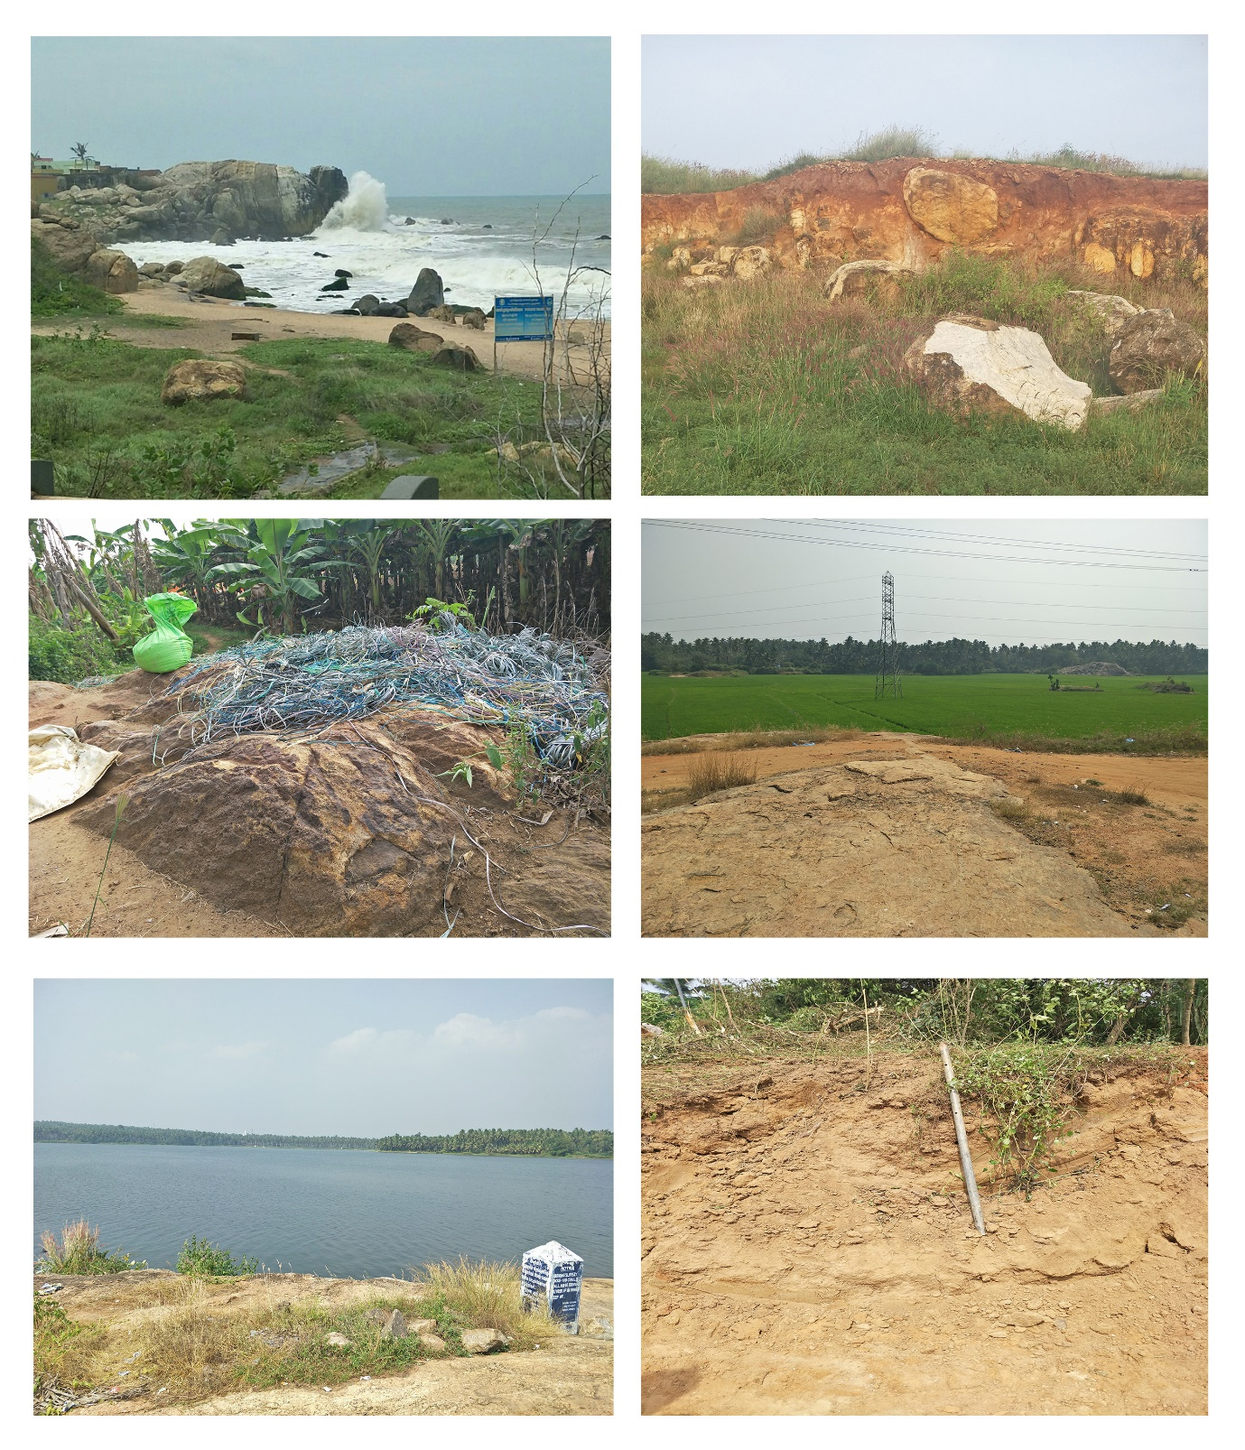

SI 2. Some interpreted VES curves with layer parameters.
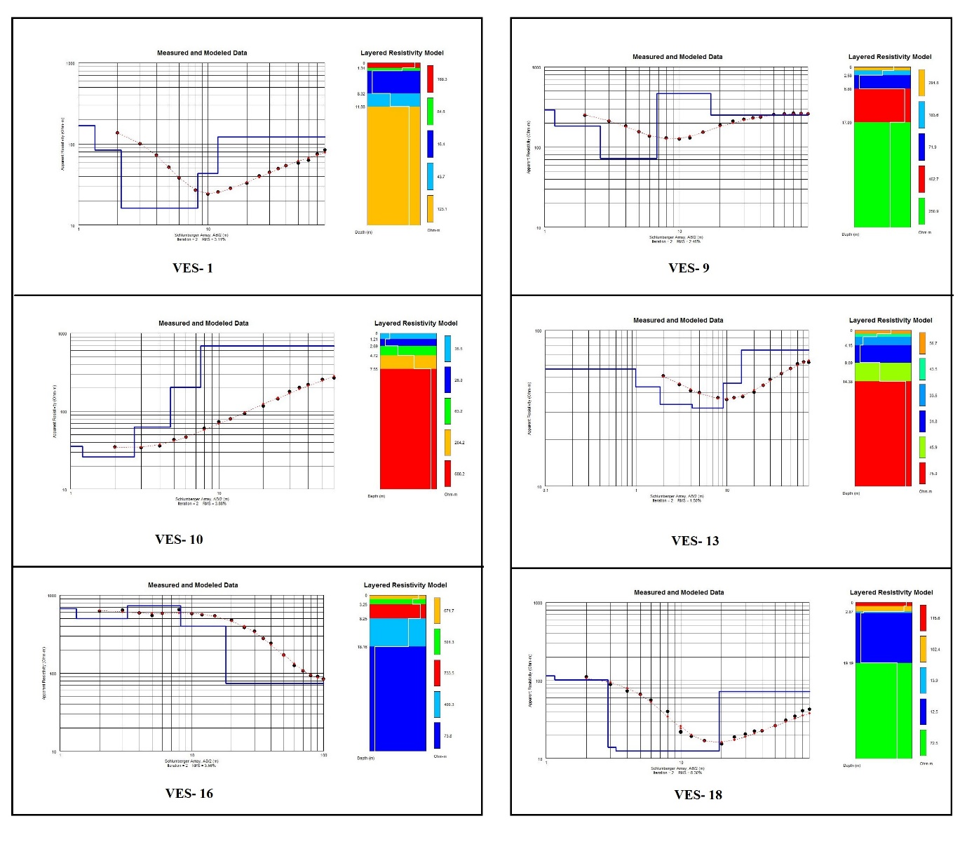

SI 3. Graphical plot of aquifer resistivity, chloride concentration of the water sample and EC
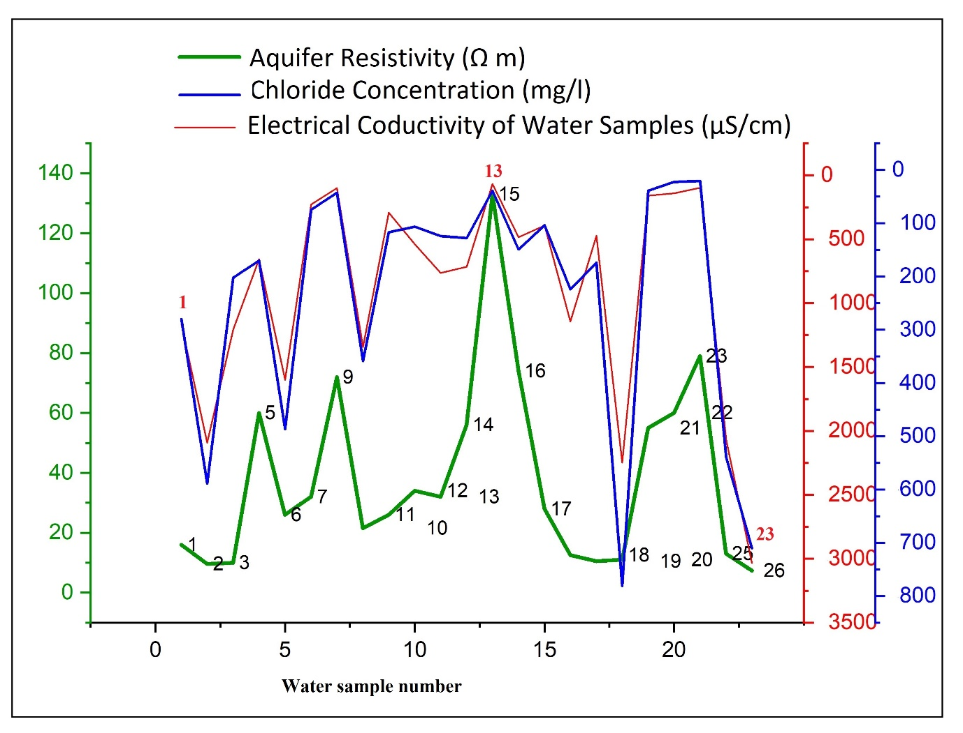

SI 4. Geochemical analysis data for Physico-chemical parameters in the study area
S.no | Longitude | Latitude | pH | EC  mS/cm | TDS mg/l | Ca²⁺  mg/l | Mg²⁺  mg/l | Na⁺ mg/l | K⁺  mg/l | HCO₃⁻mg/l | Cl⁻ mg/l | SO₄²⁻ mg/l | TH  mg/l | WQI
WS1 | 77.3074 | 8.14061 | 7.41 | 1166 | 746.2 | 56.1 | 65.7 | 154 | 3 | 225.7 | 280.5 | 9.3 | 410.3 | 77
WS2 | 77.30433 | 8.14584 | 6.45 | 2093 | 1339.5 | 104.2 | 51.0 | 320 | 4 | 215.9 | 588.6 | 57.6 | 470.2 | 52
WS3 | 77.29715 | 8.15143 | 6.8 | 1207 | 772.5 | 72.1 | 65.7 | 135 | 40 | 280.6 | 202.4 | 9.3 | 450.4 | 66
WS4 | 77.2977 | 8.15943 | 5.78 | 656 | 419.8 | 36.0 | 11.6 | 118 | 16 | 167.1 | 170.4 | 9.3 | 137.8 | 85
WS5 | 77.27627 | 8.16378 | 5.82 | 1600 | 1024.0 | 54.0 | 28.4 | 190 | 86 | 136.6 | 486.4 | 4.8 | 251.7 | 59
WS6 | 77.28279 | 8.16632 | 5.11 | 229 | 146.6 | 12.0 | 9.7 | 46 | 1 | 103.7 | 74.6 | 6.1 | 70.1 | 92
WS7 | 77.281 | 8.174 | 5.4 | 100 | 64.0 | 20.0 | 12.2 | 15 | 1 | 128.1 | 42.6 | 17 | 100.1 | 93
WS8 | 77.31583 | 8.124 | 6.57 | 1343 | 859.5 | 40.1 | 58.4 | 195 | 8 | 384.3 | 358.6 | 8.9 | 340.3 | 76
WS9 | 77.31806 | 8.12975 | 6.54 | 292 | 186.9 | 24.0 | 19.5 | 52 | 6 | 109.8 | 117.2 | 18 | 140.1 | 100
WS10 | 77.302 | 8.154 | 7.3 | 540 | 345.6 | 42.1 | 13.3 | 76 | 3 | 166.4 | 106.5 | 8.9 | 160.0 | 100
WS11 | 77.30239 | 8.15607 | 7.07 | 763 | 488.3 | 52.1 | 19.5 | 108 | 36 | 305 | 124.3 | 16.8 | 210.2 | 86
WS12 | 77.29832 | 8.165022 | 7.42 | 716 | 458.2 | 52.1 | 34.0 | 90 | 2 | 134.2 | 127.8 | 10.1 | 270.2 | 100
WS13 | 77.29433 | 8.16764 | 6.14 | 68 | 43.5 | 20.0 | 7.3 | 9 | 2 | 97.6 | 39.1 | 1.1 | 80.1 | 100
WS14 | 77.29411 | 8.16117 | 6.22 | 484 | 309.8 | 24.0 | 11.0 | 81 | 1 | 68.6 | 149.1 | 6.5 | 105.5 | 93
WS15 | 77.28929 | 8.15766 | 6.02 | 393 | 251.5 | 24.0 | 9.7 | 71 | 6 | 108.8 | 103.6 | 10.8 | 100.1 | 93
WS16 | 77.30895 | 8.14481 | 5.86 | 1145 | 732.8 | 60.1 | 31.6 | 116 | 21 | 176 | 224.0 | 36 | 280.2 | 69
WS17 | 77.31499 | 8.14462 | 6.55 | 474 | 303.4 | 8.0 | 34.0 | 95 | 5 | 103.7 | 174.0 | 11.2 | 160.1 | 100
WS18 | 77.24072 | 8.181079 | 5.41 | 2249 | 1439.4 | 88.2 | 54.6 | 380 | 18 | 148.8 | 781.0 | 7.3 | 444.7 | 43
WS19 | 77.28066 | 8.16919 | 5.78 | 160 | 102.4 | 10.0 | 4.3 | 26 | 2 | 42.7 | 39.1 | 6.7 | 42.7 | 93
WS20 | 77.28947 | 8.17325 | 5.21 | 142 | 90.9 | 8.0 | 2.3 | 26 | 6 | 56.6 | 22.6 | 9.4 | 29.5 | 93
WS21 | 77.29638 | 8.17302 | 6.5 | 98 | 62.7 | 11.0 | 2.5 | 17 | 4 | 48.5 | 20.5 | 8.9 | 37.7 | 100
WS22 | 77.30826 | 8.14356 | 6.61 | 2070 | 1324.8 | 136.3 | 95.6 | 194 | 6 | 390.2 | 539.6 | 6.4 | 733.9 | 64
WS23 | 77.314 | 8.15968 | 7.21 | 3034 | 1941.8 | 112.2 | 150.8 | 340 | 170 | 591.7 | 710.0 | 8.8 | 900.7 | 22
WS24 | 77.31302 | 8.13347 | 5.9 | 365 | 233.0 | 16.0 | 7.0 | 58 | 5 | 54 | 89.0 | 12 | 68.8 | 92

