Adaphostin-Induced Oxidative Stress in Oesophageal Neuroendocrine Carcinoma: A Potential Therapeutic Strategy
Supplementary Material

Table S1. Primary and secondary antibodies used for western blotting
Antibody Type | Target | Host species | Dilution used* | Supplier and catalogue number
Primary | Anti-DNA PKcs (phospho S2056) antibody [EPR5670] | Rabbit mAb | 1:2000* | Abcam #ab124918
Primary | Anti-DNA PKcs antibody [Y393] | Rabbit mAb | 1:5000* | Abcam #ab32566
Primary | Cleaved PARP (Asp214) | Rabbit | 1:2000 | Cell Signaling Technology #9541
Primary | Phospho-Histone H2A.X (Ser139) | Mouse mAb | 1:1000* | Invitrogen #14-9865-82
Primary | GAPDH | Mouse mAb | 1:10,000* | Sigma #G8795
Secondary | Goat Anti-Rabbit IgG, HRP-linked | Goat | 1:5000* | Cell Signaling Technology #7074
Secondary | Goat Anti-Mouse IgG HRP-linked | Goat | 1:5000* | Abcam #ab205719
* Diluted in 2% (w/v) skim milk powder in Tris-buffered saline solution

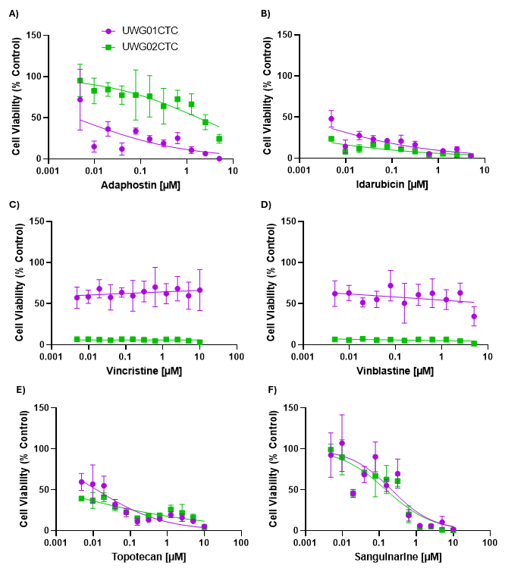
Figure S1. Example top compound hits identified via the LOPAC1280 compound library under 21% O₂ and 5% CO₂ conditions. Dose responsiveness of the UWG01CTC (purple) and UWG02CTC (green) lines towards treatment with A) adaphostin, B) idarubicin, C) vincristine, D) vinblastine, E) topotecan, and F) sanguinarine. Values shown are mean ± SEM, n= 3.

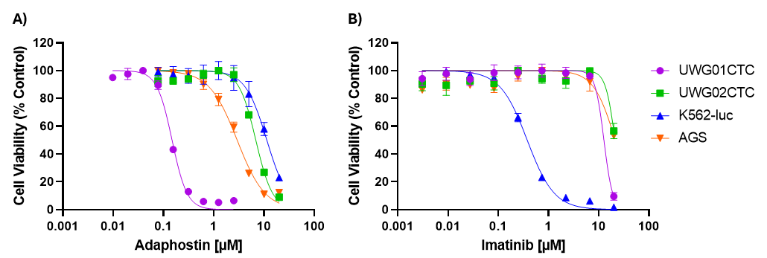
Figure S2. Representative dose-response curves for UWG01CTC, UWG02CTC, AGS, and K562-luc cell lines treated with A) adaphostin and B) imatinib. Values shown are mean ± SEM, n= 4.

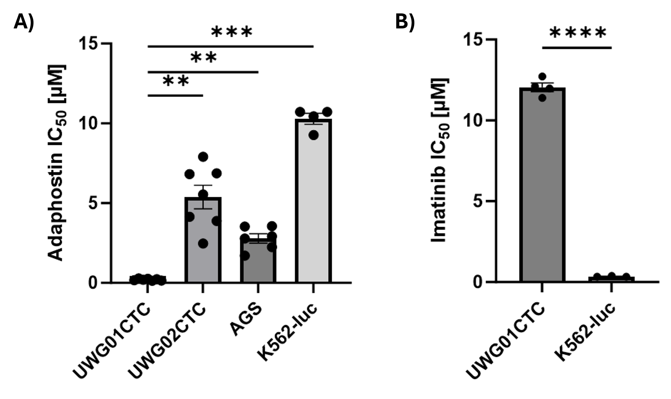
Figure S3. Statistical analyses confirmed a significant difference in IC₅₀ values between cell lines and the UWG01CTCs treated with adaphostin and imatinib. A) Brown Forsythe and Welch’s ANOVA tests were performed to assess the significance between IC₅₀ values obtained for the UWG01CTC, UWG02CTC, AGS, and K562-luc cell lines treated with adaphostin. The UWG01CTC IC₅₀ value was significantly lower than the reported values of all the other cell lines, with UWG01CTC vs UWG02CTC P=0.0021, UWG01CTC vs AGS P=0.0016, and UWG01CTC vs K562-luc P=0.0003. B) An unpaired T test with Welch’s correction was used to assess the significance between the UWG01CTC and K562-luc cell lines treated with imatinib. The UWG01CTC IC50 value obtained was significantly higher than the value obtained for the K562-luc cell line, with P<0.0001.

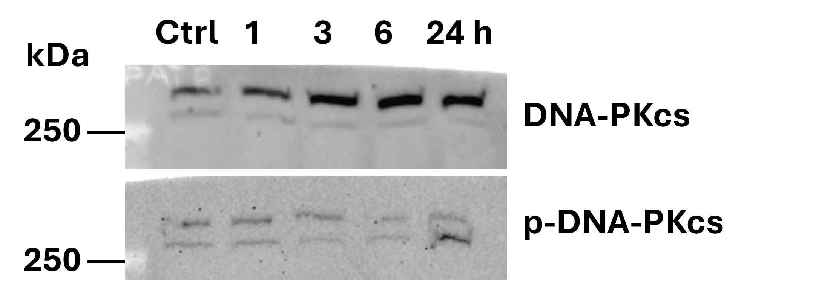
Figure S4. Adaphostin induces DNA damage and apoptosis in UWG01CTCs observed via western blot analysis. Representative western blotting images of UWG01CTCs treated with 0.5 µM adaphostin for 0, 1, 3, 6, and 24 h, depicting the expression of DNA-PKcs and p-DNA-PKcs. Uniform GAPDH expression for this experiment is shown in Figure 2B, confirming equal protein loading.

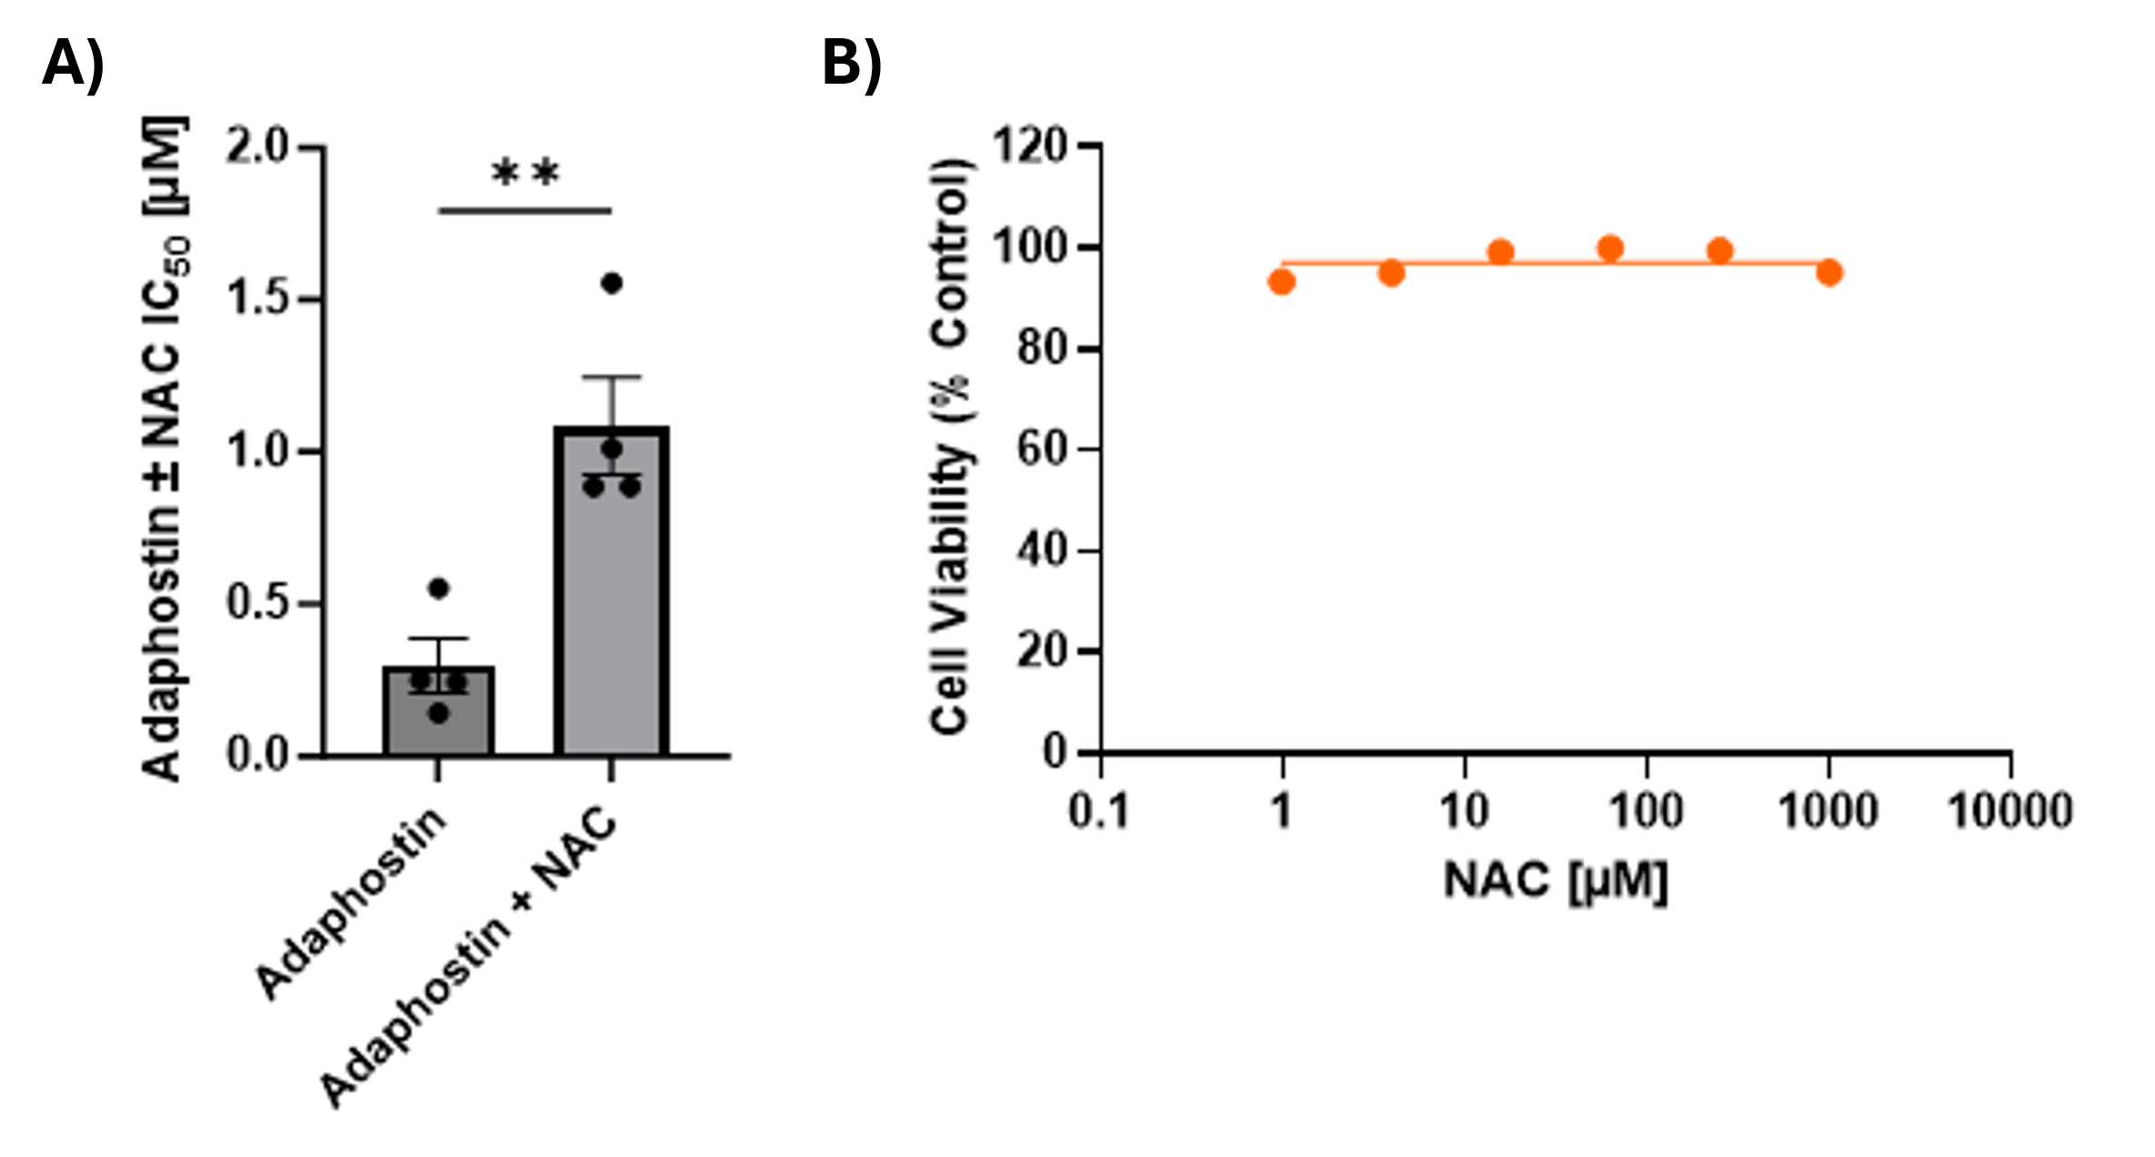Figure S5. Effect of NAC on adaphostin treatment of UWG01CTCs. A) Bar graphs showing IC₅₀ values obtained for UWG01CTCs treated with adaphostin alone versus adaphostin + 1 mM NAC. Values shown are means ± SD of 4 separate experiments each performed in triplicate. Unpaired T test with Welch’s correction, ** P=0.0088. B) Representative dose response curve of the UWG01CTCs treated with NAC for 72 h. Values shown are mean ± SEM, n= 3.

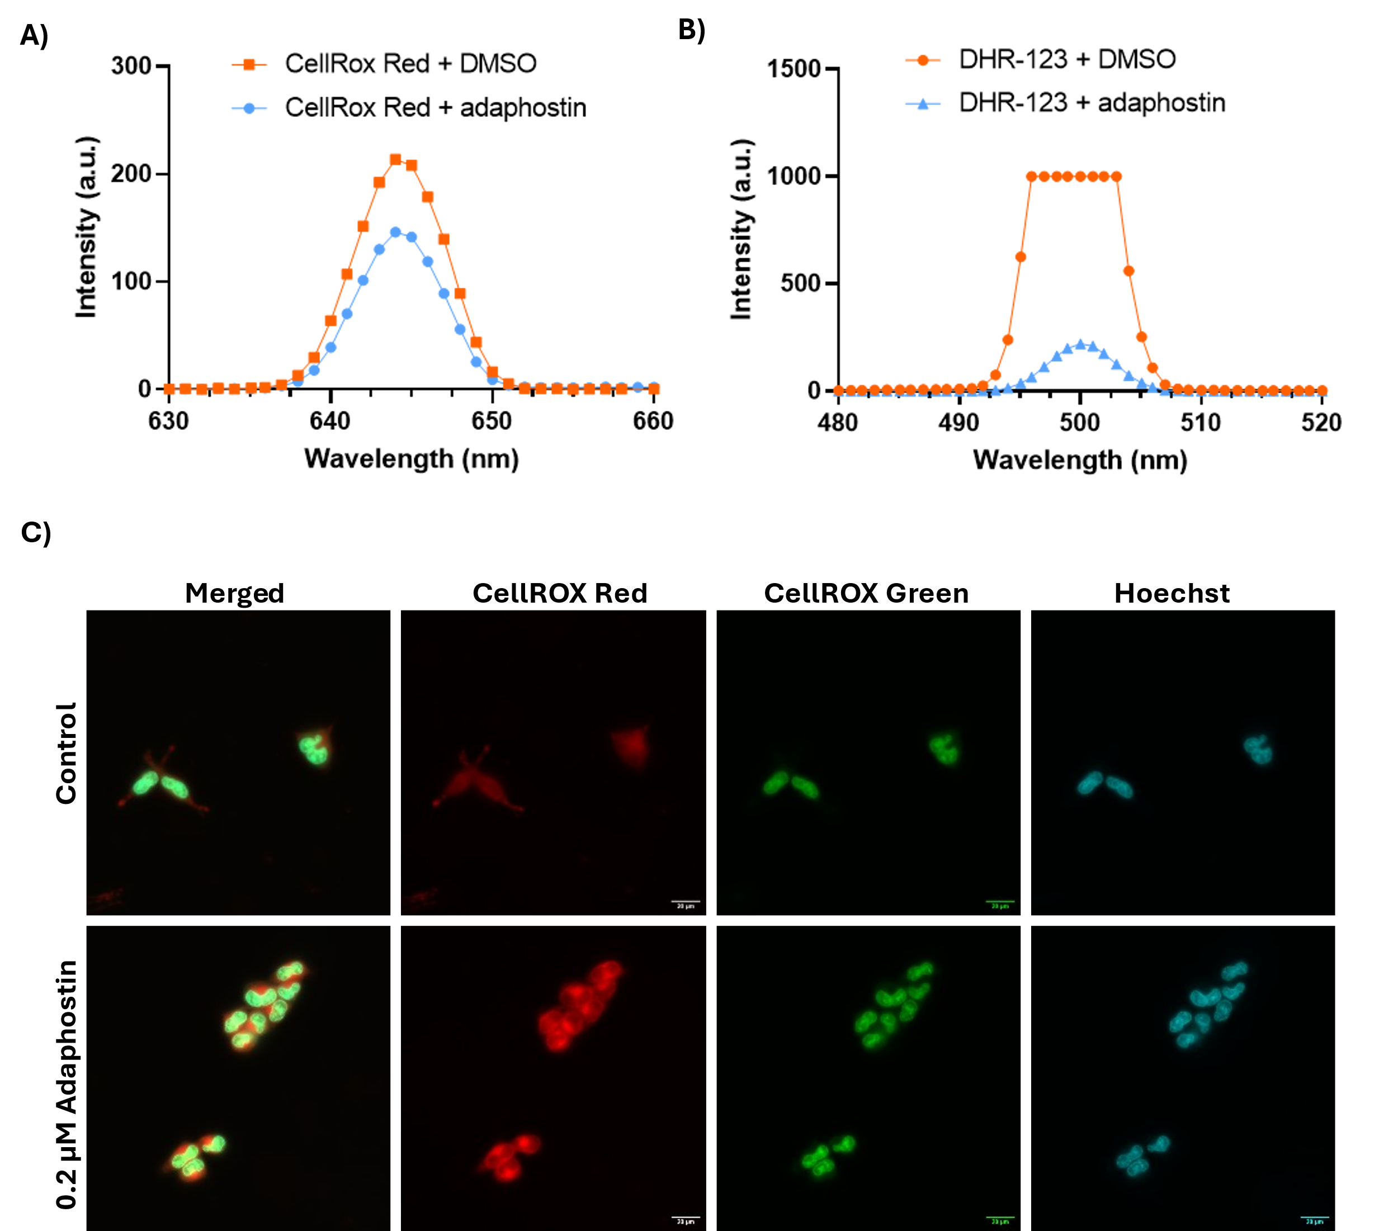
Figure S6. Fluorometric analysis using ROS dyes. A,B) Fluorescence intensity of PBS samples containing either A) 2.5 µM CellRox Deep Red (ThermoFisher Scientific) + 5 µM adaphostin or DMSO vehicle control, and B) 1 µM Dihydrorhodamine 123 (DHR 123; ThermoFisher Scientific) + 10 µM adaphostin or DMSO vehicle control, measured using the Cary Eclipse Fluorescence Spectrophotometer (Agilent Technologies). The reduction in fluorescence intensity of the ROS dyes CellRox Deep Red and, in particular, DHR-123 in the presence of high concentrations of adaphostin confirmed the quenching ability of the drug. C) Representative fluorescent images of UWG01CTCs exposed to 0.1% DMSO vehicle control (top row) or 0.2 µM adaphostin (bottom row) treatment for 1 h under low O₂ (3%) conditions. Following treatment, the cells were washed with PBS and then incubated for 30 min with CellROX Deep Red (cytoplasmic ROS) + CellROX Green (nuclear and mitochondrial DNA) + Hoechst 33342 (nuclear DNA). Cells were then washed with Hanks buffered salt solution and imaged at 63x using a DMi8 inverted light microscope (Leica). Images show increased fluorescence intensity for cytoplasmic ROS (CellRox Deep Red staining) in adaphostin treated cells compared to vehicle control cells.

