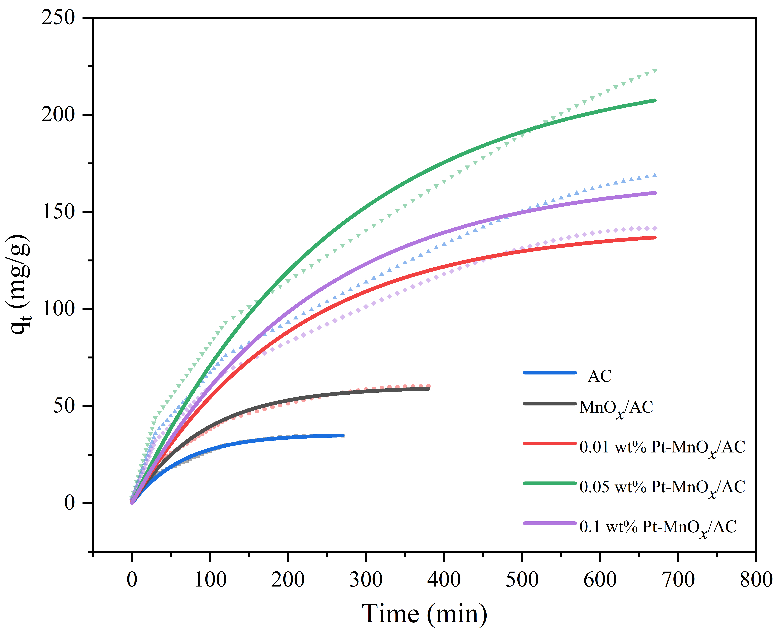
Figure S1 Fitting results of pseudo-first-order kinetic model for dynamic experimental data

Table S1 Fitting parameters values of pseudo-first-order kinetic model
Catalysts | K₁ (min⁻¹) | q_{e} (mg/g) | R²
AC | 0.0150±0.00035 | 35.5034±0.3145 | 0.9945
MnO_{x}/AC | 0.0107±0.00028 | 59.9489±0.5661 | 0.9917
0.01 wt% Pt-MnO_{x}/AC | 0.0048±0.00019 | 142.4533±2.1111 | 0.9797
0.05 wt% Pt-MnO_{x}/AC | 0.0038±0.00020 | 225.4634±5.1506 | 0.9734
0.1 wt% Pt-MnO_{x}/AC | 0.0044±0.00019 | 168.8455±3.0087 | 0.9769

