Supplementary Figures
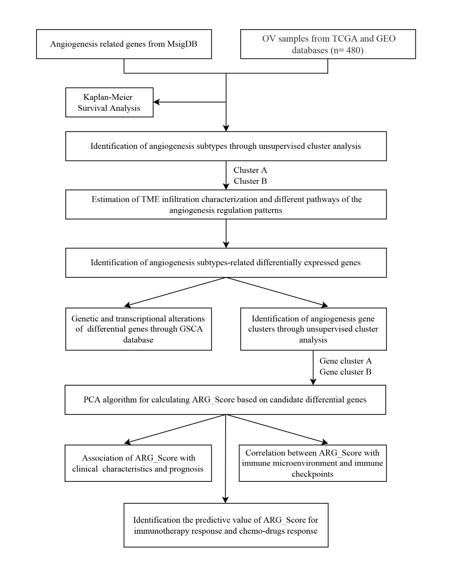
Figure S1 The entire analytical process of the study.

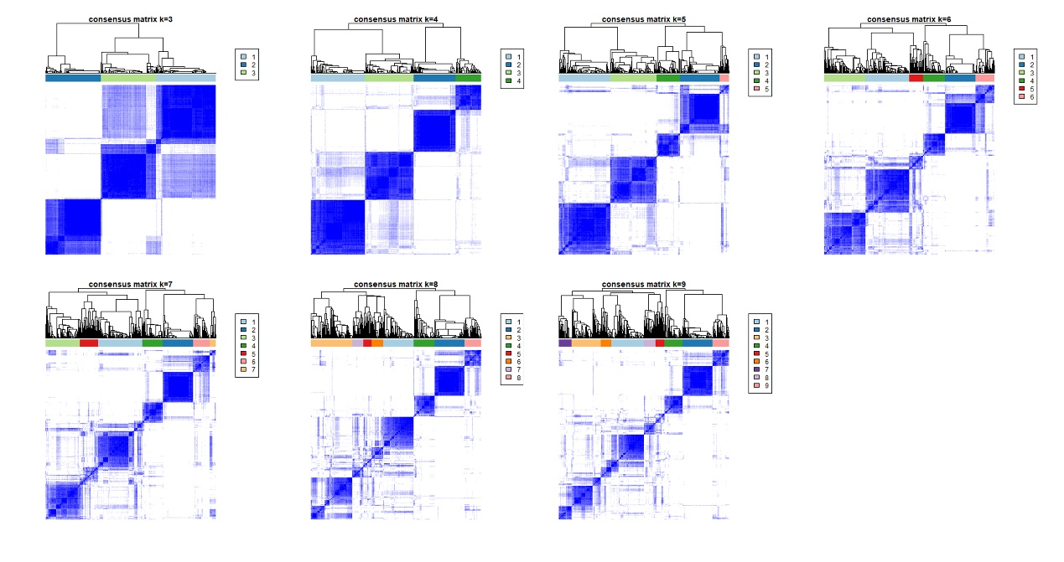
Figure S2 Unsupervised clustering of pyroptosis-related genes and Consensus matrix heatmaps for k = 3-9.

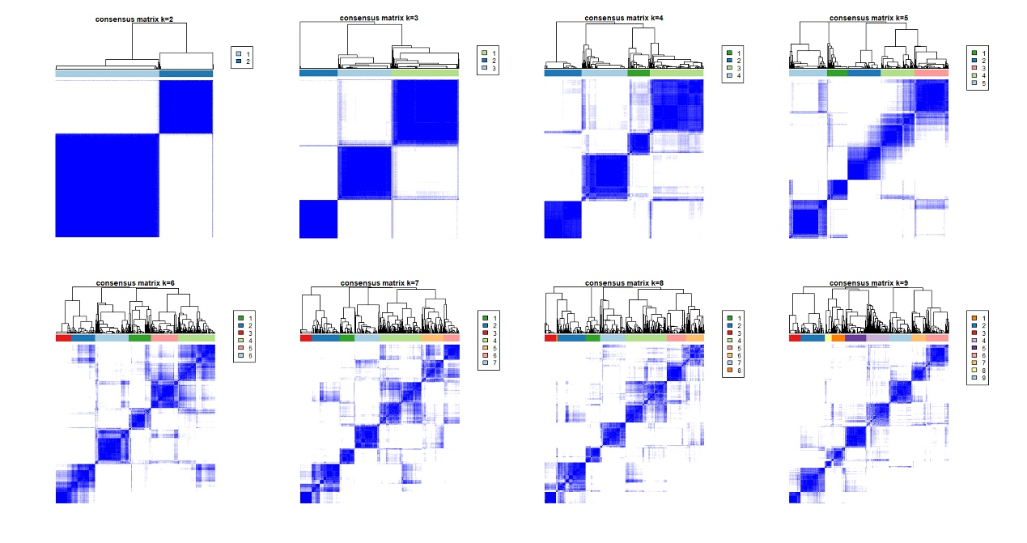
Figure S3 Unsupervised clustering of pyroptosis-related genes and Consensus matrix heatmaps for k =2-9.

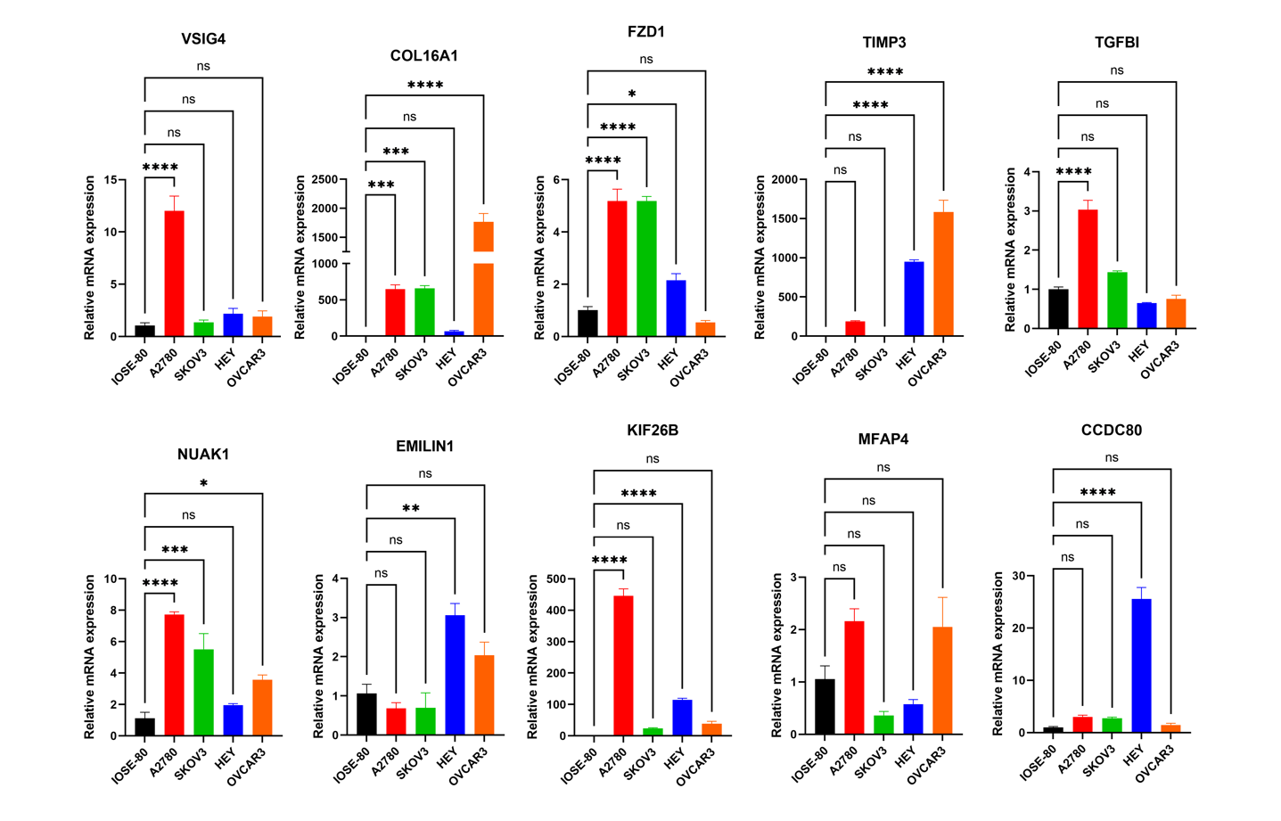
Figure S4 Relative mRNA levels of the 10 key genes shown in normal cell compared with tumor cells.

