Raw Western blots data

OVCAR3
nc si-1 si-2 si-3
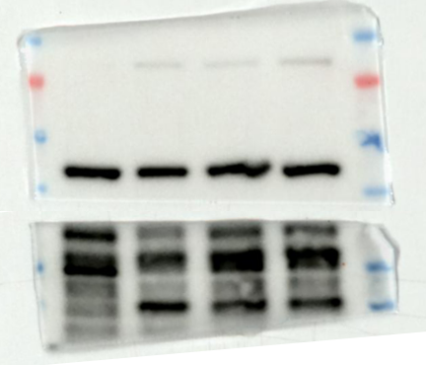
55kDa
40kDa
35kDa
25kDa
70kDa

β-actin

GAS1

SKOV3
nc Vector GAS1
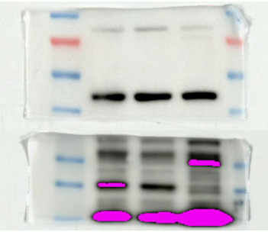
70kDa
55kDa
40kDa
35kDa
25kDa

β-actin
GAS1

HEY
Nc Vector GAS1
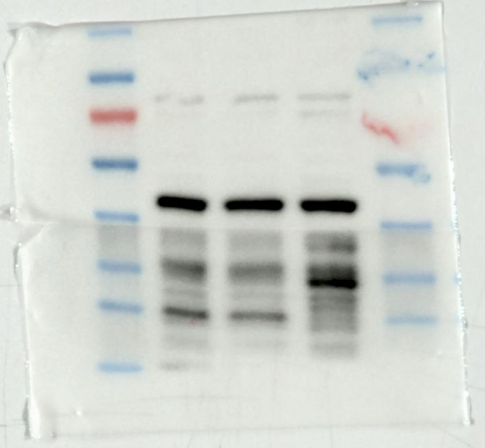
GAS1
β-actin
70kDa
55kDa
40kDa
35kDa
25kDa

