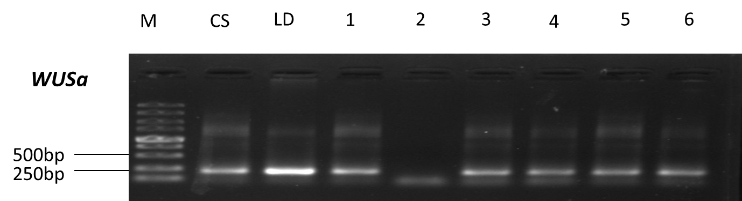
Gel electrophoresis of specific fragments of TaWUSa. M, DNA molecular marker; CS, PCR product of Chinese Spring (T. aestivum); LD, PCR product of Langdon (T. durum); samples 1-6 were: substitution lines 2D(2B), 2D(2A), 1D(1A), 3D(3A), 4D(4A), and 5D(5A).
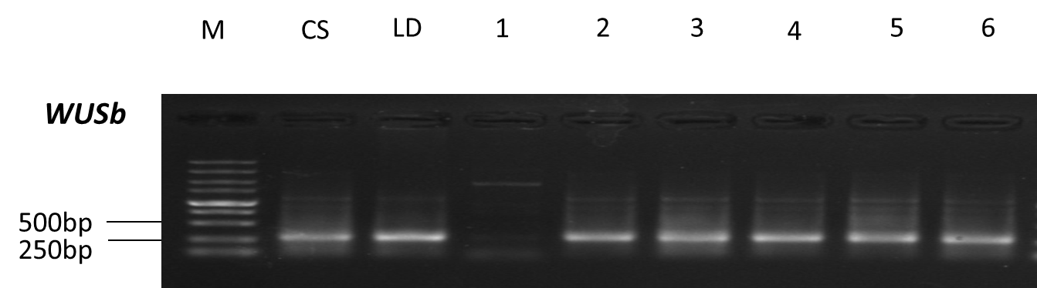
Gel electrophoresis of specific fragments of TaWUSb. M, DNA molecular marker; CS, PCR product of Chinese Spring (T. aestivum); LD, PCR product of Langdon (T. durum); samples 1-6 were: substitution lines 2D(2B), 2D(2A), 1D(1B), 3D(3B), 4D(4B), and 5D(5B).
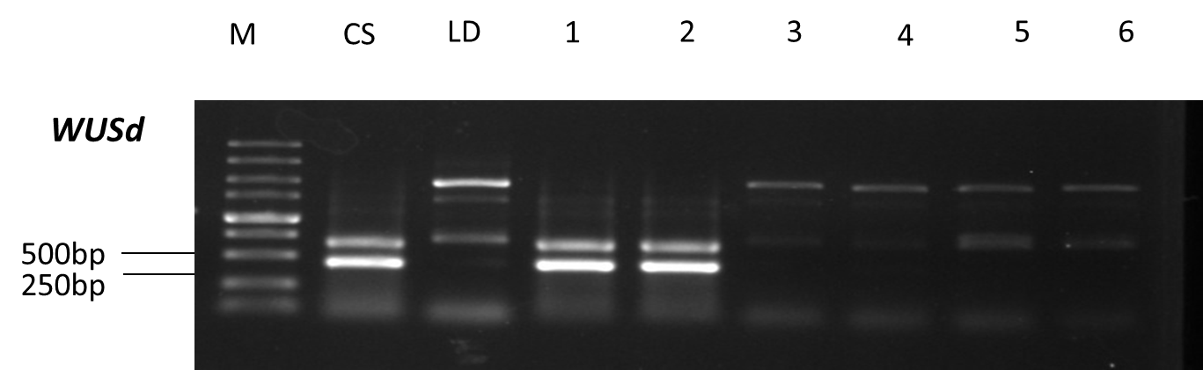
Gel electrophoresis of specific fragments of TaWUSd. M, DNA molecular marker; CS, PCR product of Chinese Spring (T. aestivum); LD, PCR product of Langdon (T. durum); samples 1-6 were: substitution lines 2D(2B), 2D(2A), 1D(1A) and 1D(1B), 3D(3A) and 3D(3B), 4D(4A) and 4D(4B), and 5D(5A) and 5D(5B).
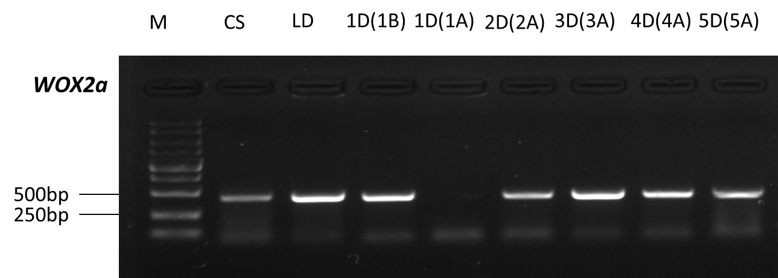
Gel electrophoresis of specific fragments of TaWOX2a. M, DNA molecular marker; CS, PCR product of Chinese Spring (T. aestivum); LD, PCR product of Langdon (T. durum); samples 1-6 were substitution lines 1D(1B), 1D(1A), 2D(2A), 3D(3A), 4D(4A), and 5D(5A).
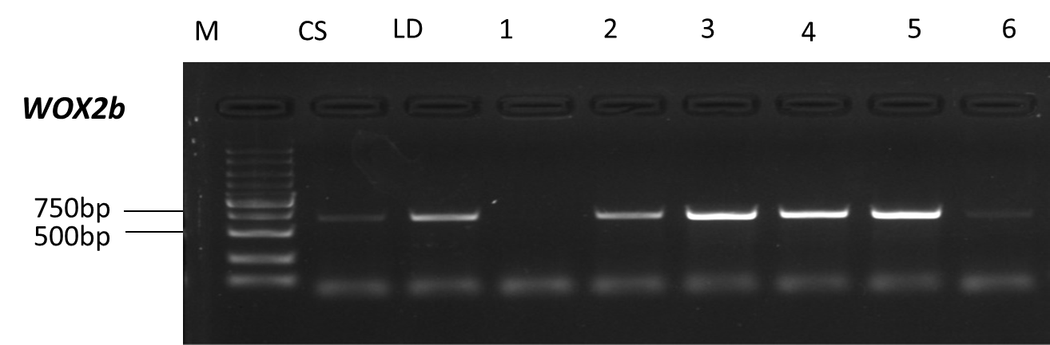
Gel electrophoresis of specific fragments of TaWOX2b. M, DNA molecular marker; CS, PCR product of Chinese Spring (T. aestivum); LD, PCR product of Langdon (T. durum); samples 1-6 were substitution lines 1D(1B), 1D(1A), 2D(2B), 3D(3B), 4D(4B), and 5D(5B).
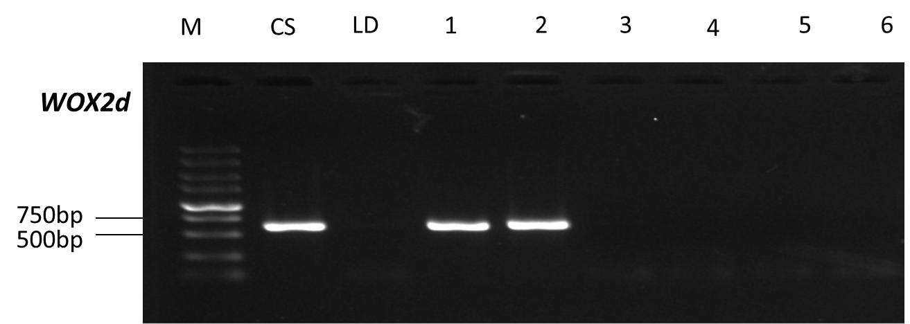
Gel electrophoresis of specific fragments of TaWOX2d. M, DNA molecular marker; CS, PCR product of Chinese Spring (T. aestivum); LD, PCR product of Langdon (T. durum); samples 1-6 were substitution lines 1D(1B), 1D(1A), 2D(2A) and 2D(2B), 3D(3A) and 3D(3B), 4D(4A) and 4D(4B), and 5D(5A) and 5D(5B).
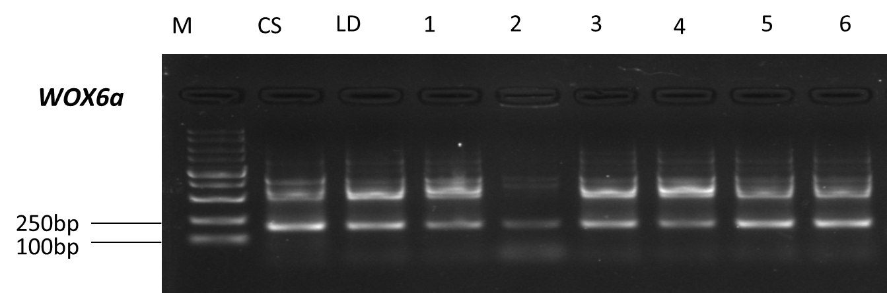
Gel electrophoresis of specific fragments of TaWOX6a. M, DNA molecular marker; CS, PCR product of Chinese Spring (T. aestivum); LD, PCR product of Langdon (T. durum); samples 1-6 were substitution lines 4D(4B), 4D(4A), 1D(1A), 2D(2A), 3D(3A), and 5D(5A).

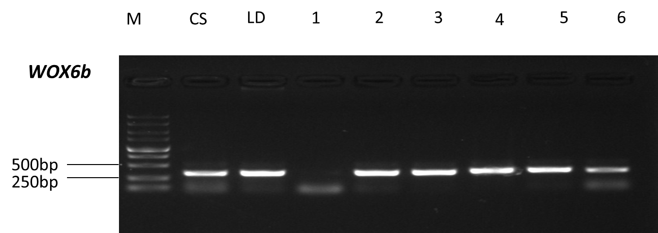
Gel electrophoresis of specific fragments of TaWOX6b. M, DNA molecular marker; CS, PCR product of Chinese Spring (T. aestivum); LD, PCR product of Langdon (T. durum); samples 1-6 were substitution lines 4D(4B), 4D(4A), 1D(1B), 2D(2B), 3D(3B), and 5D(5B).
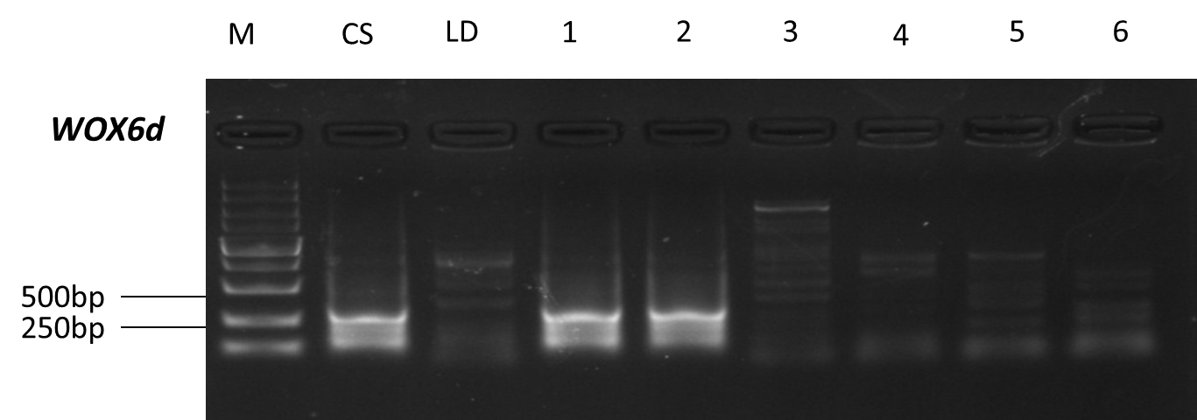
Gel electrophoresis of specific fragments of TaWOX6d. M, DNA molecular marker; CS, PCR product of Chinese Spring (T. aestivum); LD, PCR product of Langdon (T. durum); samples 1-6 were substitution lines 4D(4B), 4D(4A), 1D(1A) and 1D(1B), 2D(2A) and 2D(2B), 3D(3A) and 3D(3B), and 5D(5A) and 5D(5B).

Fig. 3 Verification of chromosomal locations of several TaWOX alleles by specific PCR amplification.

