Supplementary information for

“Diversity of resident plant communities weakens their allelopathic resistance against alien and native invaders”
Ling Yuan¹, Junmin Li¹, Mark van Kleunen^{1,2*}

Allelopath species | Family | Number of  Chinese  regions | Multi-species diversity level
Allelopath species | Family | Number of  Chinese  regions | 3 |  |  |  |  |  |  |  |  |  |  |  | 6 |  |  |  |  |  |  |  |  |  |  |  | 12
Rumex dentatus L.^{†1,2} | Polygonaceae | 21
Chenopodium album L.^{†3,4} | Amaranthaceae | 34
Polygonum chinense L. | Polygonaceae | 17
Eclipta prostrata (L.) L.* | Asteraceae | 29
Patrinia scabiosifolia Link^{†5} | Caprifoliaceae | 28
Rostellularia procumbens (L.) Nees | Acanthaceae | 19
Carpesium abrotanoides L.^{†6} | Asteraceae | 18
Perilla frutescens (L.) Britton^{†7} | Lamiaceae | 14
Polygonum lapathifolium (L.) Delarbre | Polygonaceae | 28
Adenostemma lavenia (L.) Kuntze* | Asteraceae | 20
Antenoron filiforme (Thunb.) Roberty & Vautier | Polygonaceae | 17
Physalis angulata L.* | Solanaceae | 30
Table S1 Composition of the 25 multi-species mixtures of aqueous plant leachates used in the experiment to test for potential allelopathic effects of germination of alien and native test species. In total we had 37 leachates, but the 12 single-species ones are not shown in the table. Using 12 resident species (allelopaths) of a plant community in Taizhou, China, we created mixtures of aqueous plant leachates of four different diversity levels (1, 3, 6 and 12 allelopath species). Grey indicates that the species is present in the respective mixture. The three species marked with an asterisk (*) are not native to China, but are alien resident species co-occurring with the native ones. The five species marked with a dagger (†) have previously been shown to have allelopathic effects.
Information on the number of Chinese regions (n = 34) in which a species occurs is from Yan et al. (2019) for alien species, and from the Flora of China (http://www.efloras.org/flora_page.aspx?flora_id=2) for native species.
References
(1) Anwar, T. et al. 2013. Allelopathic suppression of Aven fatua and Rumex dentatus in associated crops. Pakistan J. Weed Sci. Research 1(19): 31-43.
(2) Zhu, Q. et al. 2014. Allelopathic effect of Rumex dentatua aqueous extract on four groups. Guizhou Agricultural Sci. 42(7): 53-56.
(3) Dmitrovic, S. et al. 2015. Hairy root exudates of allelopathic weed Chenopodium murale L. induce oxidative stress and down-regulate core cell cycle genes in Arabidopsis and wheat seedlings. Plant Growth Regul. 75(1): 365-382.
(4) Zhang, X. et al. 2008. Preliminary determination on allelopathy of several Chenopodiaceae weeds. J. Anhui Agricultural Sci. 36(35): 15562-15563.
(5) Zorikova, O. et al. 2017. Allelopathic Activity of Patrinia scabiosifolia and Patrinia rupestris. Biomed. Pharmacology J. 10(2): 651-658.
(6) Li, Y. et al. 2003. Bio-activities of extracts from 25 species compositae plants against three kinds of pathogens. J. Northwest Sci-tech Univ. Agric. Forest.(Nat. Sci. Ed) 4(31): 123-125.
(7) Wang, Y. et al. 2005. Effects of Perilla frutescens and Coix lacryma-jobi L. root exudates on radicle growth of Panax quinquefolium. Chinese Society for plant protection. Proceedings of the second symposium on allelopathy in China and the founding meeting of allelopathy Committee of Chinese Society for plant protection.

Table S2 Information on the six alien and six native herbaceous species used to test the potential allelopathic effects of the aqueous plant leachate mixtures on germination.
Species | Family | Number of  Chinese  regions | Status in eastern China (year of first record) | Region of origin | Life cycle | Seed source
Amaranthus tricolor L. | Amaranthaceae | 34 | Alien-3 (1909) | Tropical Asia | Annual | Junjie Nursery Stock Company (Jiangsu,Suqian)
Rudbeckia laciniata L. | Asteraceae | 20 | Alien-5 (1916) | North America | Annual/biennial | Jiangsu Qixiu Seed Industry Co., Ltd (Jiangsu,Suqian)
Trifolium repens L. | Fabaceae | 31 | Alien-2 (1908) | Europe, and parts of Asia and Africa | Perennial | Junjie Nursery Stock Company (Jiangsu, Suqian)
Lolium perenne L. | Poaceae | 32 | Alien-4 (1905) | Europe | Perennial | Jiangsu Daxin Ecological Technology Co., Ltd (Jiangsu,Suqian)
Capsella bursa-pastoris (L.) Medik. | Brassicaceae | 34 | Alien-4 (1906) | Europe, and parts of Asia and Africa | Annual | Field in Taizhou
Crotalaria pallida Aiton | Fabaceae | 19 | Alien-3 (1913) | Tropical Africa and Tropical Asia | Perennial | Junjie Nursery Stock Company (Jiangsu, Suqian )
Achyranthes bidentata Blume | Amaranthaceae | 14 | Native | Eastern and Tropical Asia | Perennial | Thousand Green Seed Company (Jjiangsu,Suqian)
Crepidiastrum sonchifolium (Maxim.) Pak & Kawano | Asteraceae | 19 | Native | Eastern Asia | Annual/biennial | Thousand Green Seed Company (Jjiangsu,Suqian)
Orychophragmus violaceus (L.) O.E.Schul | Brassicaceae | 15 | Native | N.&E. China to N. Korea | Annual/biennial | Jiangsu huazhiyin seed industry (Jiangsu,Suqian)
Arthraxon hispidus | Poaceae | 20 | Native | Tropical Africa, W. Indian Ocean,Asia to E. Australia | Annual | Field in Taizhou
Aeschynomene indica Linn. | Fabaceae | 21 | Native | Tropical & Subtropical old world | Annual | Thousand Green Seed Company (Jjiangsu,Suqian)
Zoysia sinica Hance | Poaceae | 10 | Native | - China to Temp.& Asia | Perennial | Wancao Seed Industry (Hebei, Baoding)
Information on the number of Chinese regions (n = 34) in which a species occurs is from Yan et al. (2019) for alien species, and from the Flora of China (http://www.efloras.org/flora_page.aspx?flora_id=2) for native species. Information on the alien status and its invasiveness grade in China is from Yan et al. (2014): Alien-2 = serious invasive plant (i.e. alien species having obvious impact on the economy or environment), Alien-3 = local invasive plant (i.e. alien species having local impacts), Alien-4 = alien plant that is common but does not have obvious impacts). Alien-5 = alien plant without known impacts. Information on the year of first record of alien species is from the Chinese Virtual Herbarium (https://www.cvh.ac.cn/). Information on the region of origin is from POWO (2019). Information on life cycle is from the Flora of China.

Figure S1 Boxplots of the osmolality of the 12 single species leachates, the 12 three-species, the 12 six-species and one 12-species leachate mixtures used in our experiment. The red horizontal line indicates the osmolality of the PEG-control treatment. Boxes show the interquartile range around the median (thick horizontal line), whiskers extend to 1.5× the interquartile range, and circles indicate outliers. The diversity effect was not statistically significant (χ² = 0.844, P = 0.358) .

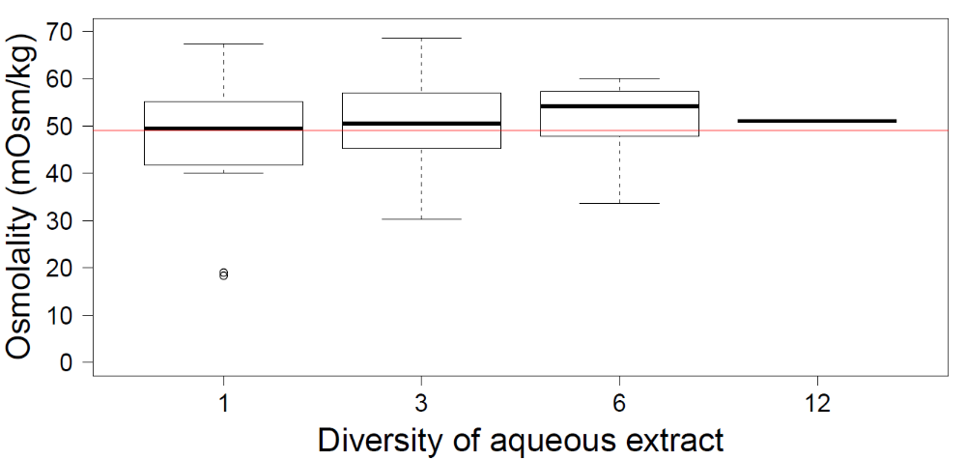
Appendix 1 | Hierarchical diversity-interaction modeling analysis
Methods
To estimate the contributions of the allelopath species identities and their interactions to the allelopath diversity effect on the proportion of germinated seeds, we used the hierarchical diversity-interaction modeling framework of Kirwan et al. (2009). For these analyses, we excluded the PEG control Petri-dishes. We basically ran five hierarchical models (Fig. S2): 1) The null model only included the intercept as fixed term. 2) The species-identity model included each of the species identities (their proportions in the allelopath mixture) as fixed effects. 3) The separate-pairwise-interactions model included in addition to the allelopath-species identities all of the available pairwise interactions between the allelopath species. 4) The eveness model included in addition to the allelopath-species identities a single average interaction effect (i.e. it assumes that all available pairwise interactions between allelopath species are the same). 5) The additive-species-specific-interaction-contributions model included in addition to the allelopath-species identities average interaction effects for each of the allelopath species (i.e. it assumes that an allelopath species’ pairwise interaction is the same for all other allelopath species it interacts with). The average interaction effect and the average species-specific interaction effects were calculated according to the equations in Kirwan et al. (2009). Each of the five hierarchical models was run once without considering the origin of the test species, and once with considering the main effect of the origin only, the main effect and the interaction of origin with allelopath-species identity and the main effect, and all interactions of origin with allelopath-species identity and pairwise allelopath-species interactions. As some of these models are the same, we ended up with 17 instead of 20 models. Test-species identity and allelopath-mixture identity were included as random effects. To find the model with the best fit, we used the AIC values (Kirwan et al. 2009).
Figure S2 Hierarchy of diversity-interaction models, following the framework of Kirwan et al. (2009). Comparisons between the models provide insight into whether the allelopath species differ in their individual effects and whether interactions between allelopath species contribute to the diversity effect. The blue box and question in blue refers to the models in which we added interactions with the origin of the test species (native vs alien).

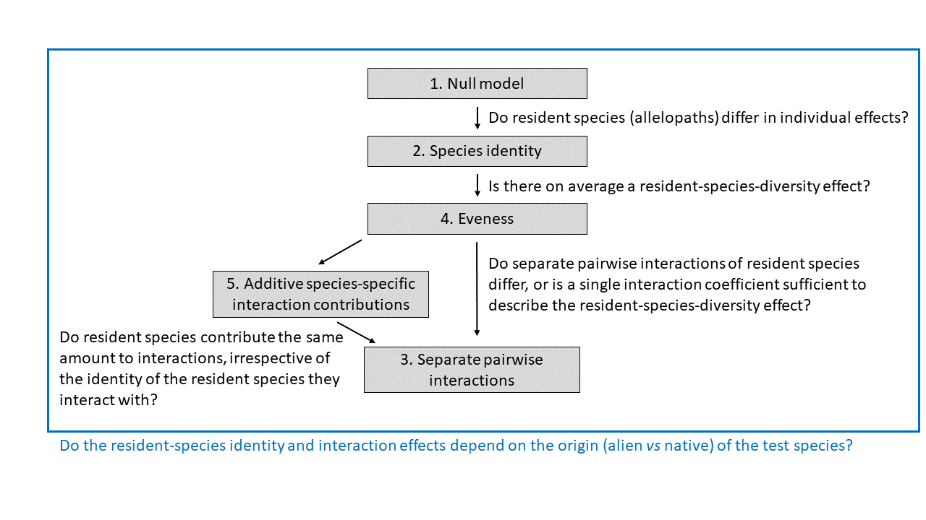

Results
For the proportion of germinated seeds, using the hierarchy of diversity-interaction modeling approach, we found that, compared to the null model, the species-identity model did not have a better fit (Table S3). The eveness model, however, improved model fit (Table S3), reflecting the positive resident-species-diversity effect on the proportion of germinated seeds (Fig. 2a in main manuscript). When not considering the origin of the test species, the additive-species-specific-interaction-contributions model had the lowest AIC (6829.4; Table S3). However, when also adding interactions with origin of the test species, the separate-pairwise-interactions model with all possible interactions of origin had the lowest AIC (6794.8; Table S3). This suggests that separate pairwise interactions of the resident species differ for the proportion of germinated seeds and depend on the origin of the test species.
For the number of days to first germination, we found that, compared to the null model, the species-identity model and eveness model did not have better fits (Table S3). This was, however, only true when we did not consider the origin of the test species. When we considered the latter, the best fitting models were those in which we included origin of the test species in combination with species-identity interactions (Table S3). The lowest AIC was for the separate-pairwise-interactions model (5527.9) but both the species-identity model and eveness model were within two AIC points (Table S3). This suggests that the simpler species-identity model with origin interaction suffices in explaining the variation in the number of days to first germination, and thus that the resident species differ in their individual effects and that those depend on the origin of the test species.

Table S3 AIC values of the individual models of the diversity-interaction modeling approach according to Kirwan et al. (2009) for the proportion of germinated seeds. Models 1 to 5 correspond to the model numbers in Kirwan et al. (2009). Each of those was run without considering origin (native vs alien) of the test species, with origin as main effect, with origin as main effect and in interaction with the species identities, and with origin as main effect and in interaction with species identies and interactions.

 | Without  Origin | With Origin main effect | With Origin × Species-iden  tities | With Origin and all its interactions
1. Null model | 6902.6 | 6904.5 | - | -
2. Species identity | 6905.4 | 6907.3 | 6880.3 | -
3. Separate pairwise interactions | 6834.1 | 6836.0 | 6809.2 | 6794.8
4. Eveness | 6894.7 | 6896.6 | 6869.520 | 6870.6
- Additive species-specific  interaction contributions | 6829.4 | 6831.3 | 6804.7 | 6800.1
The lowest AIC values (i.e. best fitting models) is in bold.

References
Kirwan, L., Connolly, J., Finn, J. A., Brophy, C., Lüscher, A., Nyfeler, D., & Sebastia, M. T. (2009) Diversity-interaction modeling: estimating contributions of species identities and interactions to ecosystem function. Ecology, 90, 2032-2038.

