Overconsumption Gravely Threatens Water Security in the Binational Rio Grande-Bravo Basin

Supplemental Information

Table SI-1. Consumptive water uses by sub-basin. Summary of the average annual consumptive use volumes over recent decades for each sub-basin and the entire basin as shown in Figure 2, in acre-feet per year.

Table SI-2. Reservoir evaporation. Listing of 37 reservoirs included in estimation of reservoir evaporation for each sub-basin.
RGB_Subbasin | Lake_name
Rio Grande Colorado | Continental Reservoir
Rio Grande Colorado | Santa Maria Reservoir
Rio Grande Colorado | Farmers Union Reservoir
Rio Grande Colorado | Platoro Reservoir
Rio Grande Colorado | La Jara Reservoir
Rio Grande Colorado | Sanchez Reservoir
Rio Grande Colorado | Mountain Home Reservoir
Rio Grande Colorado | Terrace Reservoir
Rio Grande Northern New Mexico | Heron Lake
Rio Grande Northern New Mexico | El Vado Reservoir
Rio Grande Northern New Mexico | Abiquiu Reservoir
Rio Grande Northern New Mexico | Costilla Reservoir
Rio Grande Northern New Mexico | Stone Lake
Rio Grande Middle New Mexico | Cochiti Lake
Rio Grande Middle New Mexico | Jemez Canyon Reservoir
Rio Grande Southern New Mexico | Elephant Butte Reservoir
Rio Grande Southern New Mexico | Caballo Reservoir
RGB El Paso to Fort Quitman | Hudspeth Reservoir
Rio Conchos | Presa Luis L. Leon
Rio Conchos | Lago Las Virgenes
Rio Conchos | Presa La Boquilla
Rio Conchos | Presa Chihuahua
Rio Conchos | Presa Pico de Aguila
Rio Conchos | Presa Federalismo Mexicano
Rio Conchos | Lago Rosetilla
Pecos River New Mexico | Santa Rosa Lake
Pecos River New Mexico | Storrie Lake
Pecos River New Mexico | Lake Sumner
Pecos River New Mexico | Brantley Lake
Pecos River Texas | Red Bluff Reservoir
RGB Amistad Dam to Gulf | Amistad Reservoir
RGB Amistad Dam to Gulf | Falcon Reservoir
RGB Amistad Dam to Gulf | Lake Casa Blanca
Rio Salado MX | Presa Venustiano Carranza
Rio San Juan MX | Presa Marte R.Gomez
Rio San Juan MX | Lago El Cuchillo
Rio San Juan MX | Presa Rodrigo Gomez
Figure SI-1. Crop Water Trends and Averages

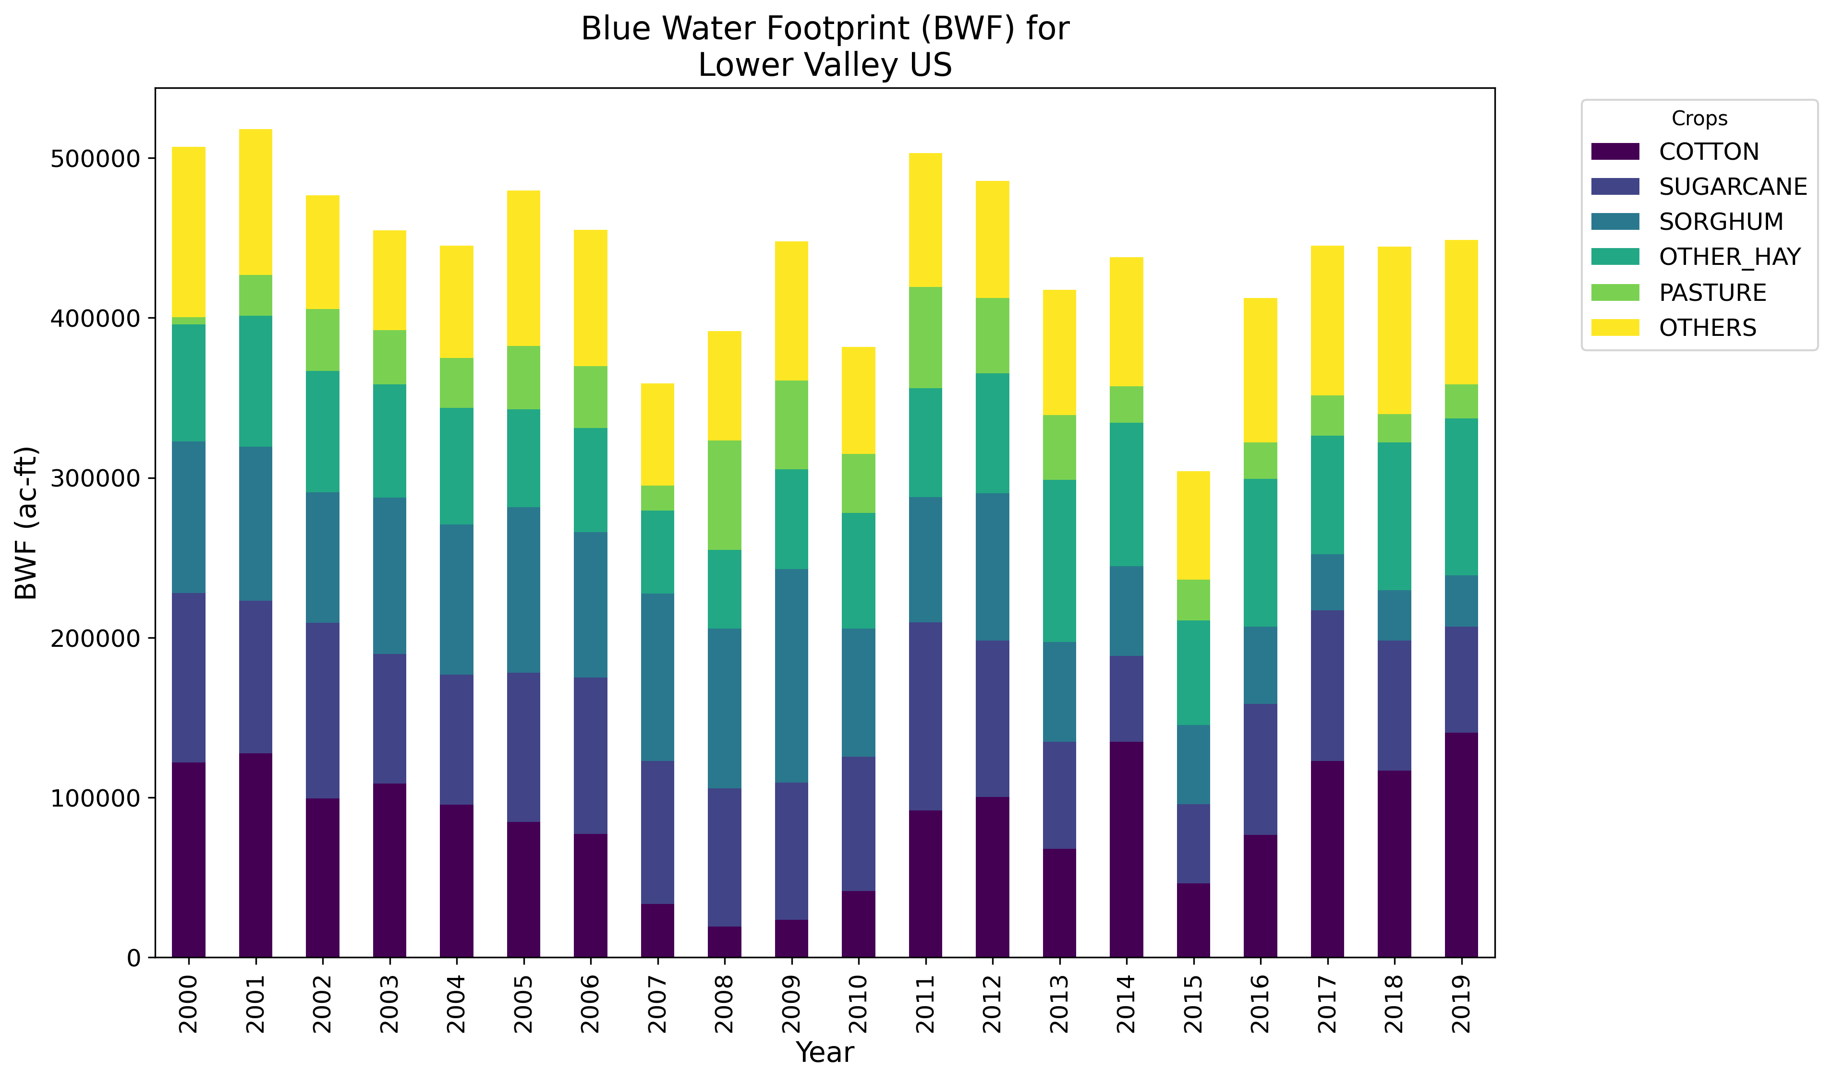
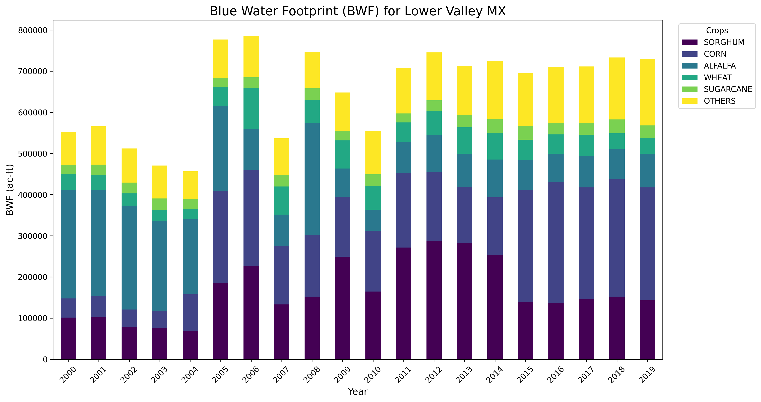
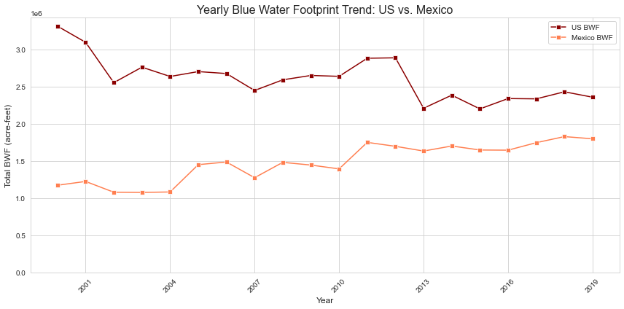
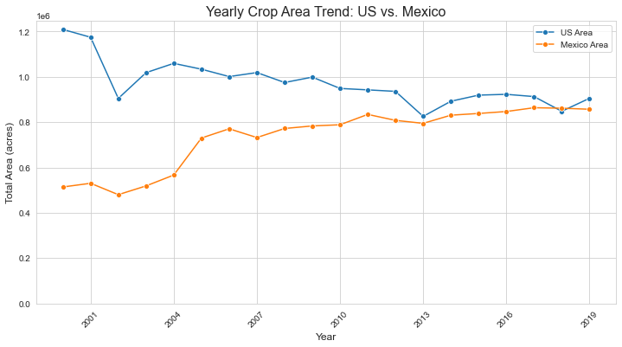

Figure SI-2. Changes in water storage during 2002-2024. TWS = total water storage; GWS = ground water storage; SWRS = surface water storage (reservoirs); SMS = soil moisture storage.
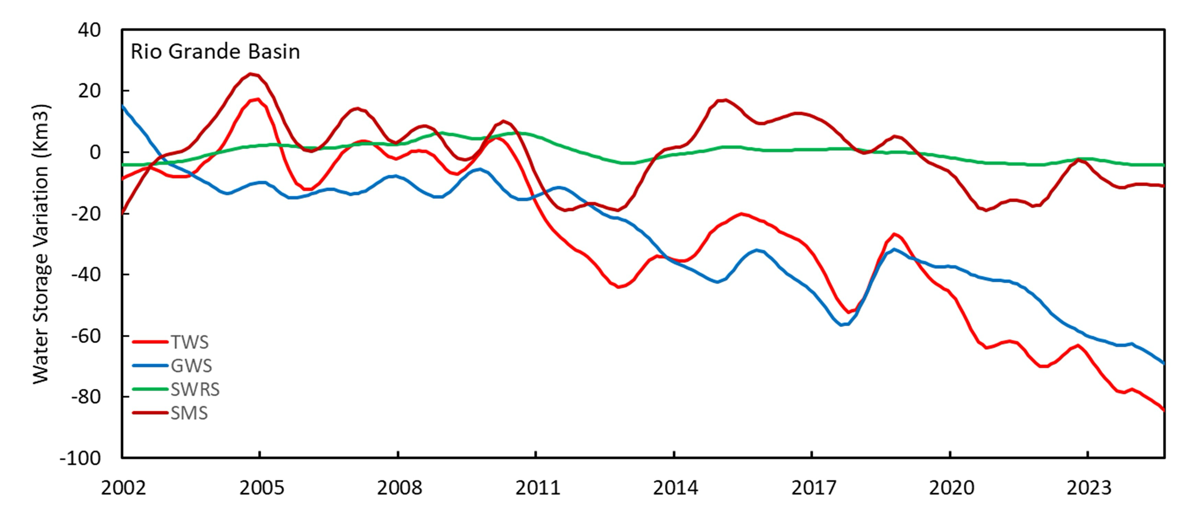
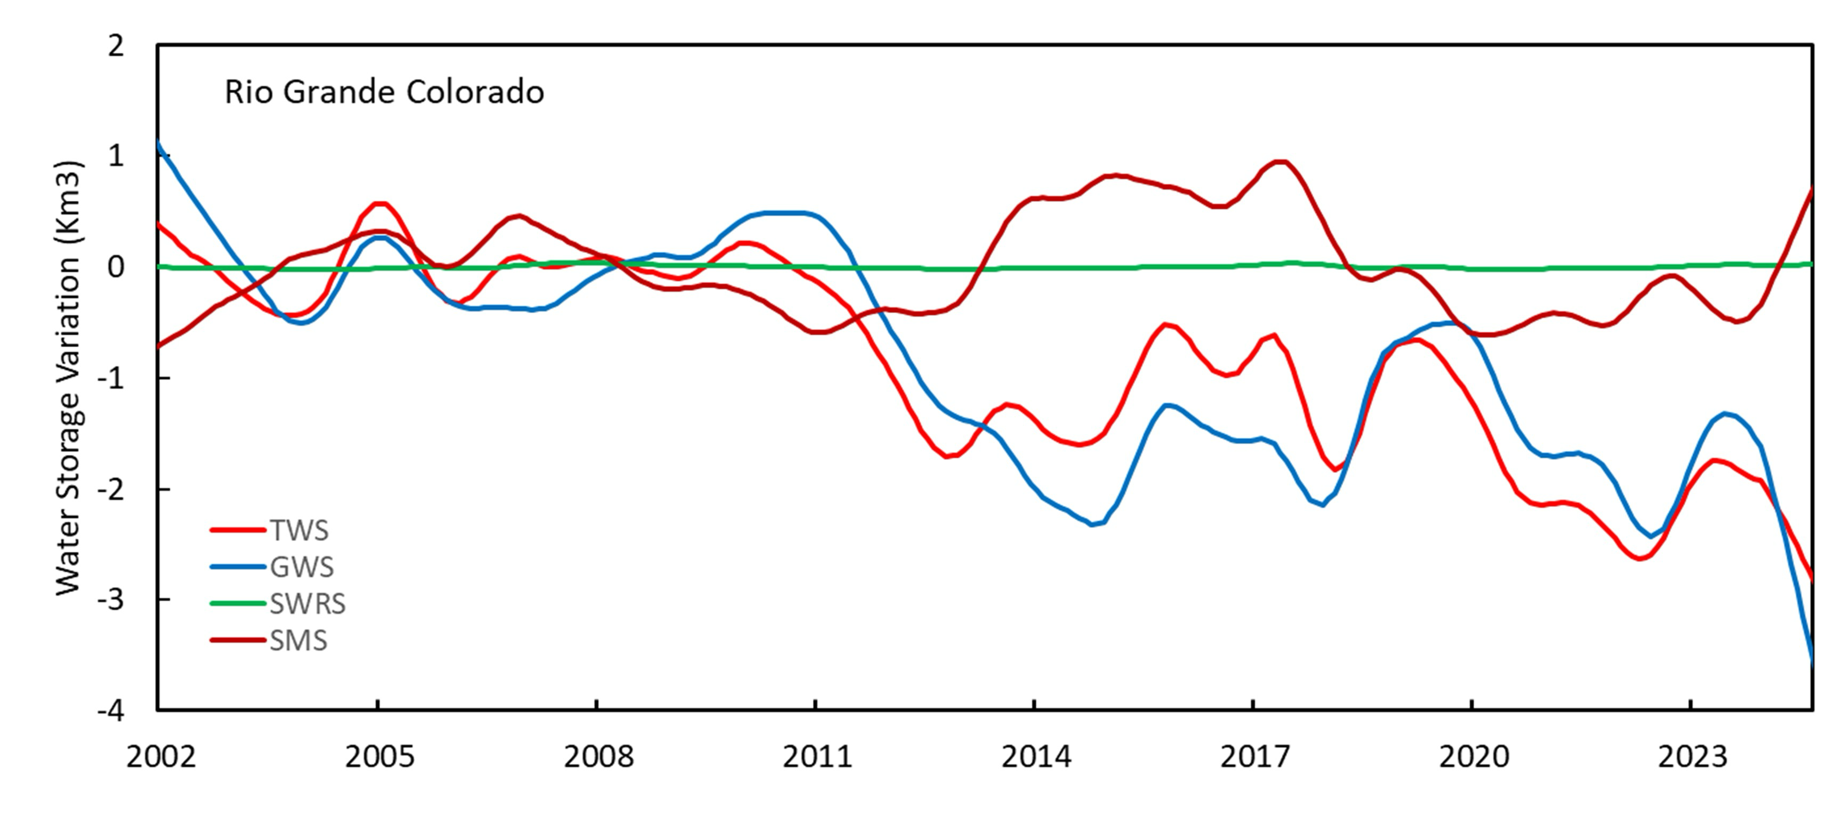
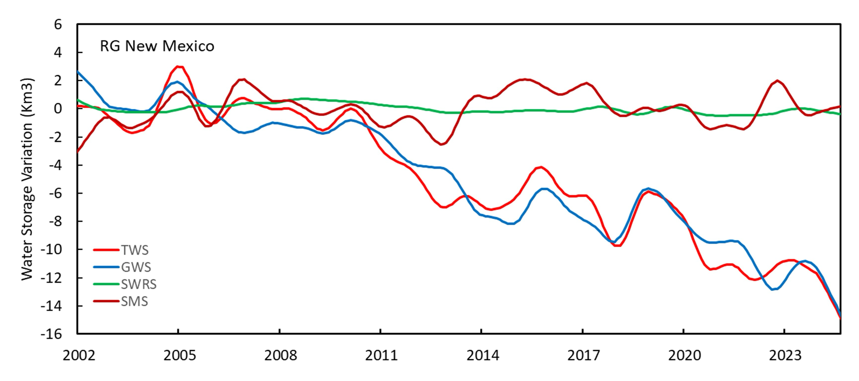
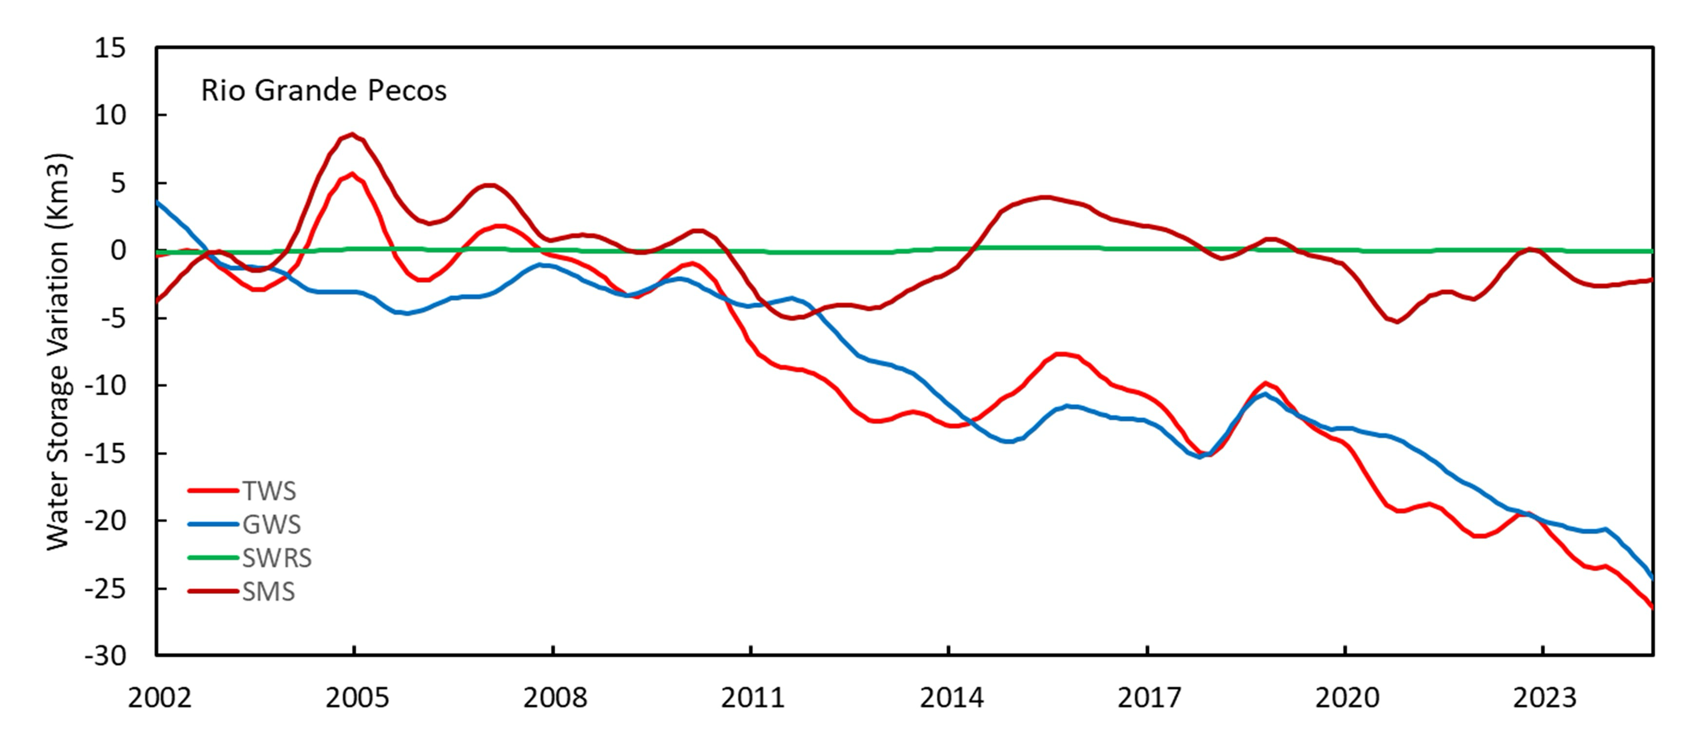
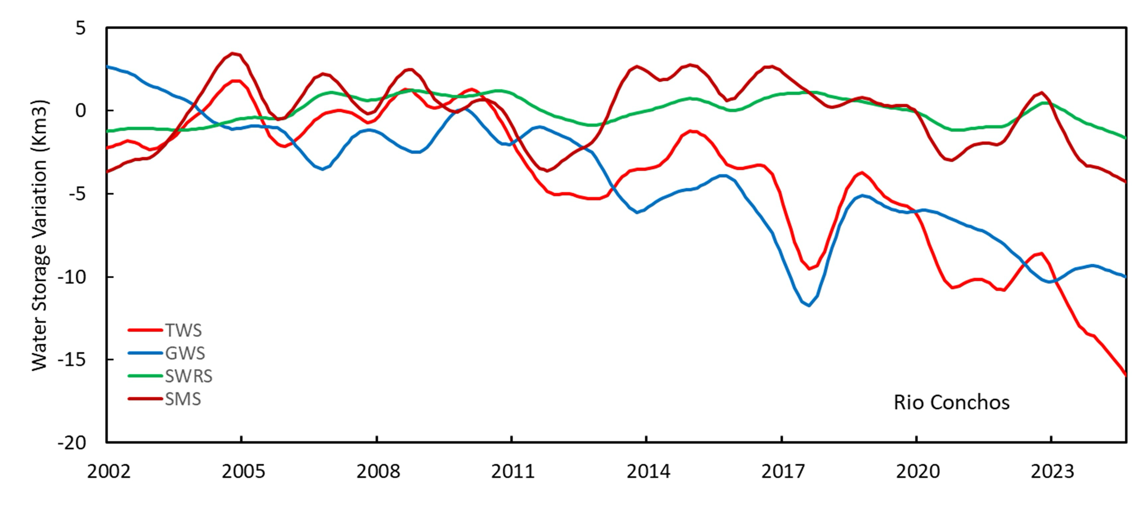

Fire Impacts on Water Availability in the Rio Grande-Bravo basin

In this paper we have presented findings on the historical water budget of the RGB. However, we must also recognize the uncertainty faced by basin inhabitants and how elements of the water budget may change in the future. Fires across Intermountain West, including the headwater areas of the RGB, are becoming more frequent and larger in size (Iglesias, et al., 2022). The burn scars left by these fires affect the water budget in a multitude of ways. Studies in New Mexico and Colorado have found that snowpacks in burned areas hold less water, melt earlier, and melt faster (Harpold et al. 2014, Kampf et al., 2022). Confounding the impacts that fires may have on snowpacks, increased dust emissions from land use disturbances can lead to the accumulation of dust-on-snow (Neff et al., 2008). Studies have found aeolian deposition of dust on snowpacks in the San Jaun Mountains and Wasatch Valley to be a contributor to earlier and quicker snowpack melting due to increased energy absorption (Reynolds et al., 2020). Fire further complicates the future RGB water budget by forcing changes to evapotranspiration. A study of ET changes pre- and post-fire found an increase in post-fire ET across ten NM fire locations (Joshi et al., 2024). While the Joshi et al. (2024) study notes that other studies have found a decrease in post-fire ET compared to pre-fire ET, other regional pre-, post-fire ET studies have found increases in ET post-fire (Poulos et al, 2021). Further, while streamflow may increase post-fire, accompanying water quality issues present new challenges to utilize the temporary increase in streamflow (Williams et al., 2022). Increased fire risk in the RGB is not constrained to the headwaters in southern Colorado and northern New Mexico. Galván and Magaña (2020) identified fire risk hotspot areas in northeastern Mexico in the RGB. With the increased frequency of fire in the RGB, future water governance strategies must tightly couple with wildfire planning and governance (Morgan et al., 2023)

References Cited

Iglesias, V., Balch, J. K., & Travis, W. R. (2022). US fires became larger, more frequent, and more widespread in the 2000s. Science advances, 8(11), eabc0020.

Harpold, A. A., Biederman, J. A., Condon, K., Merino, M., Korgaonkar, Y., Nan, T., ... & Brooks, P. D. (2014). Changes in snow accumulation and ablation following the Las Conchas Forest Fire, New Mexico, USA. Ecohydrology, 7(2), 440-452.

Kampf, S. K., McGrath, D., Sears, M. G., Fassnacht, S. R., Kiewiet, L., & Hammond, J. C. (2022). Increasing wildfire impacts on snowpack in the western US. Proceedings of the National Academy of Sciences, 119(39), e2200333119.

Reynolds, R. L., Goldstein, H. L., Moskowitz, B. M., Kokaly, R. F., Munson, S. M., Solheid, P., ... & Derry, J. (2020). Dust deposited on snow cover in the San Juan Mountains, Colorado, 2011–2016: Compositional variability bearing on snow‐melt effects. Journal of Geophysical Research: Atmospheres, 125(7), e2019JD032210.

Neff, J. C., et al. (2008), Increasing eolian dust deposition in the western United States linked to human activity, Nat. Geosci., 1(3), 189–195, doi:10.1038/ngeo133.

Joshi, R. C., Jensen, A., Pascolini-Campbell, M., & Fisher, J. B. (2024). Coupling between evapotranspiration, water use efficiency, and evaporative stress index strengthens after wildfires in New Mexico, USA. International Journal of Applied Earth Observation and Geoinformation, 135, 104238.

Poulos, H. M., Barton, A. M., Koch, G. W., Kolb, T. E., & Thode, A. E. (2021). Wildfire severity and vegetation recovery drive post‐fire evapotranspiration in a southwestern pine‐oak forest, Arizona, USA. Remote Sensing in Ecology and Conservation, 7(4), 579-591.

Galván, L., & Magaña, V. (2020). Forest fires in Mexico: an approach to estimate fire probabilities. International Journal of Wildland Fire, 29(9), 753-763.

Williams, A. P., Livneh, B., McKinnon, K. A., Hansen, W. D., Mankin, J. S., Cook, B. I., ... & Lettenmaier, D. P. (2022). Growing impact of wildfire on western US water supply. Proceedings of the National Academy of Sciences, 119(10), e2114069119.

Morgan, M., Webster, A., Piccarello, M., Jones, K., Chermak, J., McCarthy, L., & Srinivasan, J. (2023). Adaptive governance strategies to address wildfire and watershed resilience in New Mexico's upper Rio Grande watershed. Frontiers in Climate, 5, 1062320.

Backcasting USGS Thermoelectric Power Plant Consumption

An AutoRegressive Integrated Moving Average (ARIMA) model is a widely used statistical method for analyzing and forecasting time series data by capturing trends, lags, and past errors (Equation 1; Box et al., 2015).

$ARIMA(p, d, q)$ (Equation 1)

Here, each ARIMA parameter captures a different aspect of the time series behavior. The autoregressive component (p) refers to the number of past observations used to predict future values, effectively modeling the influence of previous time steps. The differencing order (d) represents the number of times the original time series must be differenced to achieve stationarity, meaning the mean and variance remain constant over time. Finally, the moving average component (q) captures the relationship between the current observation and past forecast errors, smoothing out short-term fluctuations. The Seasonal AutoRegressive Integrated Moving Average (SARIMA) model extends the traditional ARIMA framework to account for recurring seasonal patterns in time series data (Equation 2; Box et al., 2015).

$SARIMA\left(p,d,q\right)×\left(P,D,Q,m\right)$ (Equation 2)

The first set of parameters - p, d, and q - represent the non-seasonal components: the number of autoregressive terms, the order of differencing to remove trends, and the number of moving average terms, respectively. The second set - P, D, and Q - captures the seasonal behavior of the series: P denotes the number of seasonal autoregressive terms, D is the number of seasonal differences required for stationarity, and Q refers to the number of seasonal moving average terms. The m parameter defines the length of the seasonal cycle (e.g., 12 for monthly data with yearly seasonality). SARIMA models are particularly useful when a time series shows short-term dependencies and seasonal patterns, such as temperature, precipitation, or water use that fluctuates annually (Miauo, 1990; Jones & Hulme, 1996).
A SARIMA model can backcast missing historical values by leveraging past observations, trends, and seasonal fluctuations when applied to thermoelectric power plant withdrawal and consumption data. Backcasting in time series analysis uses a statistical or machine learning model to estimate past values of a dataset when historical data is missing or incomplete (Sibeijn & Pequito, 2022). It works similarly to forecasting but in reverse—instead of predicting future values, the model reconstructs past trends using known patterns, seasonality, and relationships in the existing data. This is particularly useful when older data is incomplete, as the model can estimate missing values based on known patterns in more recent data, improving the continuity and reliability of long-term water use records (Sibeijn & Pequito, 2022).

It is important to acknowledge that time series models often face challenges due to the inherent noise, data quality, and complexity in real-world data (Kim et al., 2024; Tawakuli et al., 2024). High noise levels can obscure underlying trends and seasonal patterns, making identifying true signals within the data difficult. Complex data structures can lead to issues such as overfitting, where the model captures noise instead of meaningful patterns, resulting in poor predictive performance on new data (Kim et al., 2024). Additionally, the quality of the input data plays a critical role in model performance, as poor, unreliable data can lead to unreliable forecasts and misguided decision-making (Tawakuli et al., 2024). These factors contribute to the difficulty in achieving perfect forecasting results, as models may struggle to distinguish between genuine patterns and random fluctuations.

In time series modeling, choosing the best model means balancing two key goals: how well the model fits the historical data and how accurately it can predict future values. A model that perfectly fits past data may not perform well on unseen data if it captures noise instead of real patterns. To help assess model performance, we use a mix of statistical and error-based metrics. The Akaike Information Criterion (AIC; Equation 3; Akaike, 1974) and Bayesian Information Criterion (BIC; Equation 4; Schwarz, 1978) evaluate how well a model fits the data while penalizing unnecessary complexity. Meanwhile, Mean Absolute Error (MAE; Equation 5) and Root Mean Square Error (RMSE; Equation 6) measure how far off predictions are from actual values. Using these metrics together gives a more complete picture of a model's accuracy and reliability in forecasting real-world data.

AIC is a model selection criterion that balances the model's goodness of fit and complexity (Equation 3; Akaike, 1974). A low AIC score indicates a better-fitting model but penalizes models with many parameters to dissuade overfitting. It is important to note that the absolute value of AIC scores is not directly interpreted; it is only the difference between AIC scores that matters.

$AIC=2k-2ln⁡(\hat{L})$ (Equation 3)

Here, k is the number of estimated parameters in the model and $\hat{L}$ is the maximum value of the model’s likelihood function. BIC similarly balances model fit and complexity but instead penalizes model complexity more strongly as the sample size increases (Equation 4; Schwarz, 1978). Just like AIC, BIC tends to favor simpler models.
$BIC=Kln\left(n\right)-2ln⁡(\hat{L})$ (Equation 4)

For BIC, k remains as the number of estimated parameters alongside $\hat{L}$ being the maximum value of the model’s likelihood function. The added n represents the number of observations used in the model. For model error verification, we first used MAE because it is good at interpreting forecasting errors of time series models. MAE measures the average magnitude of errors in a set of predictors without considering whether they are negative or positive (Equation 5). This model's average error size is a million gallons per day units.

$MAE= \frac{1}{n}\sum_{i=1}^{n}{|y_{i}-{\hat{y}}_{i}|}$ (Equation 5)

Here, $y_{i}$ represents the actual values, ${\hat{y}}_{i}$ the predicted values, and n being the number of predictions. RMSE is the square root of the average squared error (Equation 6). RMSE is a similar error metric to MAE but penalizes larger errors more harshly than MAE due to its squaring, however, it is more sensitive to value inflation to outliers. RMSE also uses the same parameters as MAE (Equation 5).

$RMSE= \sqrt{\frac{1}{n}\sum_{i=1}^{n}{{(y_{i}-{\hat{y}}_{i})}^{2}}}$ (Equation 6)

To fill missing monthly water consumption data (units of million gallons per day – Mgal/day) for 2000–2007, individual SARIMA models were trained on observed monthly values from 2008–2020 for each HUC12 sub-watershed (Galanter et al., 2023). The goal was not to generate high-precision forecasts but to approximate plausible monthly values consistent with recent historical trends. Each model was fit individually per HUC12 and selected based on its ability to capture seasonal structure and minimize residual autocorrelation, heteroskedasticity, and extreme non-normality. Model diagnostics (shown in Figure S3-S10), including Ljung-Box tests (Ljung & Box, 1978), Jarque-Bera normality checks (Jarque & Bera, 1980), and heteroskedasticity tests (Breusch & Pagan, 1979), confirmed that most models had white noise residuals with stable variance and moderate deviations from normality which are acceptable given the approximate nature of the backcasting task (Sibeijn & Pequito, 2022). Verification was performed using standard error metrics: MAE and RMSE. These were computed by comparing model predictions against actual observed values from 2008 to 2020 (the in-sample period). The MAE and RMSE values ranged from 0.11 to 2.51 and 0.15 to 4.78, respectively (Table SI-3), indicating that the models generally performed well for approximating monthly water consumption values at the sub-watershed level. While error levels varied depending on the water use patterns and variability within each HUC12, the models provided reliable estimates suitable for backcasting.

Table SI-3. Summary of SARIMA model configurations, evaluation statistics, and data coverage for each Rio Grande HUC-12 sub-watershed containing a reported U.S. thermoelectric power plant. The HUC-12 130700071102 (Permian Basin power plant) includes only 36 monthly observations from 2008 to 2010, as the facility ceased operation in 2011. The final row corresponds to Laredo power station in HUC-12 130800022802, which was operational only in 2008, based on reported Energy Information Administration (EIA) records and the USGS dataset (Galanter et al., 2023;EIA, 2025).
HUC12 | Data count (n) | SARIMA Model | AIC | BIC | MAE | RMSE | Notes
130202030302 | 156 | (1,0,0)x(2,1,0,12) | -111.4 | -100.3 | 0.17 | 0.28 | Log transformed
130202070105 | 156 | (1,0,0)x(0,1,1,12) | 193.7 | 205.2 | 2.51 | 4.78 | Log transformed
130301020903 | 156 | (1,0,0)x(2,1,0,12) | -161.1 | -149.9 | 0.11 | 0.15
130301020906 | 156 | (1,0,0)x(0,1,0,12) | 194.3 | 200.2 | 0.11 | 0.15 | Log transformed
130302020608 | 156 | (1,0,0)x(2,1,0,12) | 104.4 | 115.5 | 0.41 | 0.58
130401000101 | 156 | (1,0,0)x(0,1,1,12) | 239.8 | 248.4 | 0.54 | 0.7
130700070102 | 156 | (1,0,0)x(1,0,2,12) | 151.8 | 166.2 | 0.37 | 0.48
130700071102 | 36 | (0,0,0)x(1,1,0,12) | 11.7 | 12.7 | 0.45 | 0.63
130800022802 | 12 | N/A | N/A | N/A | N/A | N/A | Only operated in 2008 per EIA data

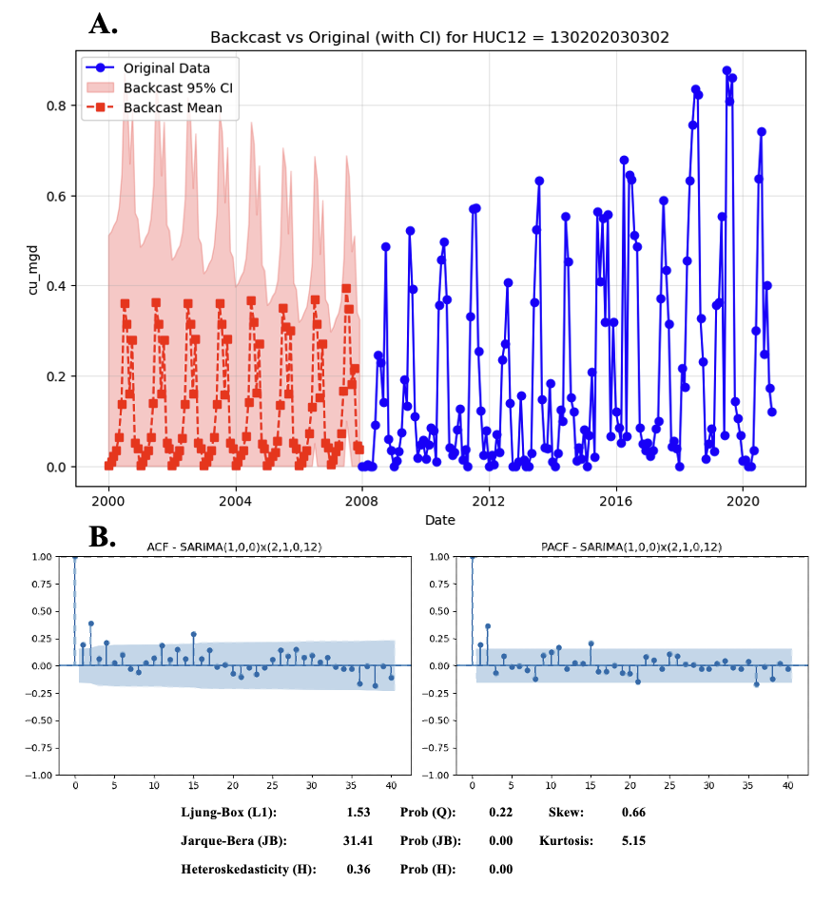
Figure SI-3. A) Monthly thermoelectric water consumption (cu_mgd) for HUC-12 130202030302, showing observed data from 2008–2020 (blue points and lines) and SARIMA-based backcast estimates from 2000–2007 (red dashed line = backcast mean; shaded area = 95% confidence interval). The model used was SARIMA(1,0,0)x(2,1,0,12), applied to log-transformed data to stabilize variance. (B) Model residual diagnostics, including autocorrelation function (ACF) and partial autocorrelation function (PACF) plots with 95% confidence bands, and summary statistics. The Ljung-Box test indicates no significant autocorrelation (p = 0.22), while the Jarque-Bera test (p = 0.00) and elevated kurtosis (5.15) suggest slight departures from normality. No significant heteroskedasticity was detected (p = 0.36).
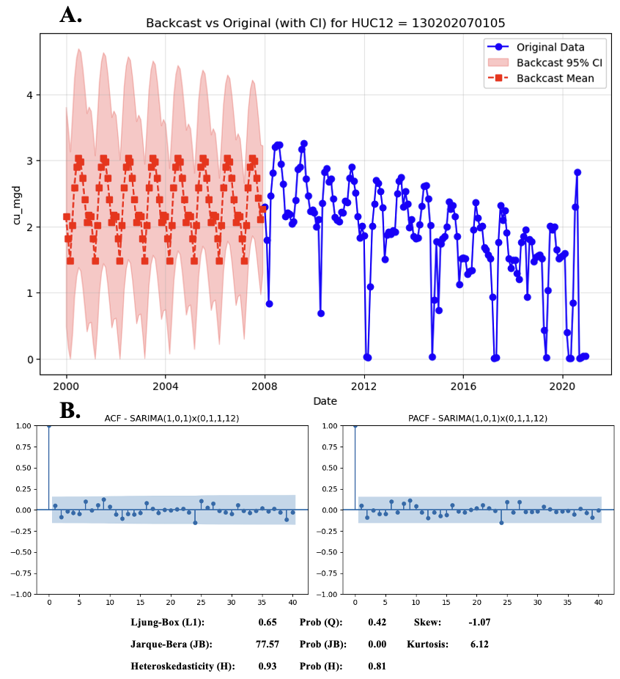
Figure SI-4. (A) Monthly thermoelectric water consumption (cu_mgd) for HUC-12 130202070105, showing observed data from 2008–2020 (blue points and lines) and SARIMA-based backcast estimates for 2000–2007 (red dashed line = backcast mean; shaded area = 95% confidence interval). The model used was SARIMA(1,0,0)x(1,1,0,12), applied to log-transformed data to stabilize variance. (B) Residual diagnostics include autocorrelation function (ACF) and partial autocorrelation function (PACF) plots with 95% confidence bands, and summary statistics. The Ljung-Box test (p = 0.42) suggests no significant autocorrelation, and the heteroskedasticity test (p = 0.81) indicates constant variance. However, the Jarque-Bera test (p = 0.00), skewness (–1.07), and high kurtosis (6.12) reveal strong left skew and heavy-tailed residuals, indicating deviations from normality.
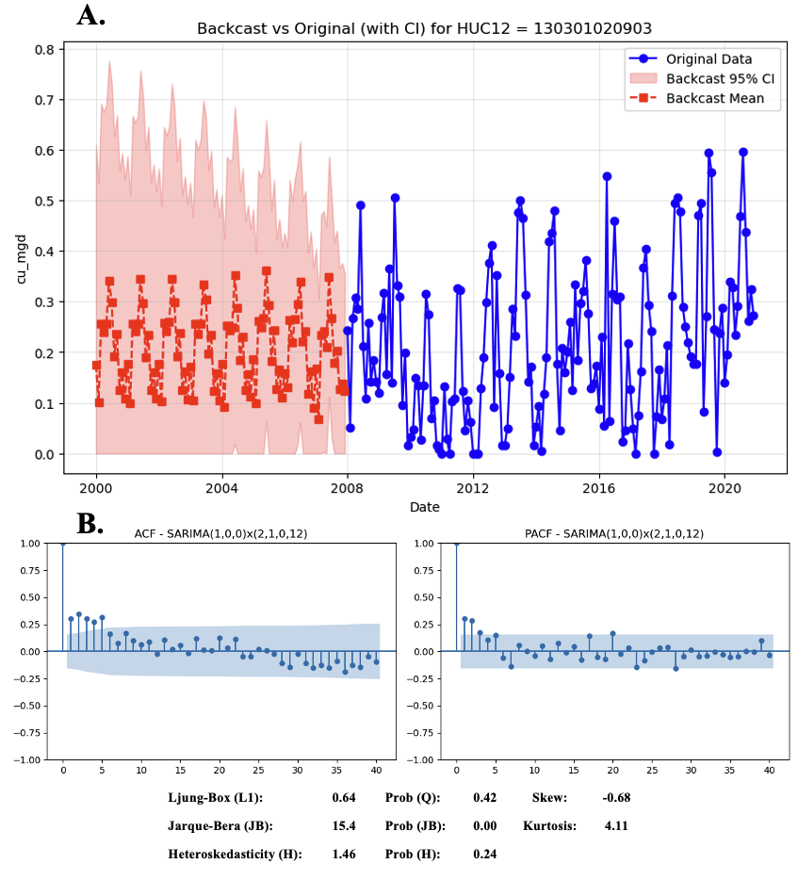
Figure SI-5. (A) Monthly thermoelectric water consumption (cu_mgd) for HUC-12 130301020903, displaying observed data from 2008–2020 (blue points and lines) and SARIMA-based backcast estimates for 2000–2007 (red dashed line = backcast mean; shaded area = 95% confidence interval). The selected model was SARIMA(1,0,0)x(2,1,0,12}, fit to untransformed data. (B) Residual diagnostics include autocorrelation function (ACF) and partial autocorrelation function (PACF) plots with 95% confidence intervals, along with statistical tests. The Ljung-Box test (p = 0.42) indicates no significant autocorrelation, and the heteroskedasticity test (p = 0.24) suggests constant variance. The Jarque-Bera test (p = 0.00), skewness (–0.58), and kurtosis (4.11) point to mild residual non-normality with slight left skew and heavier tails.
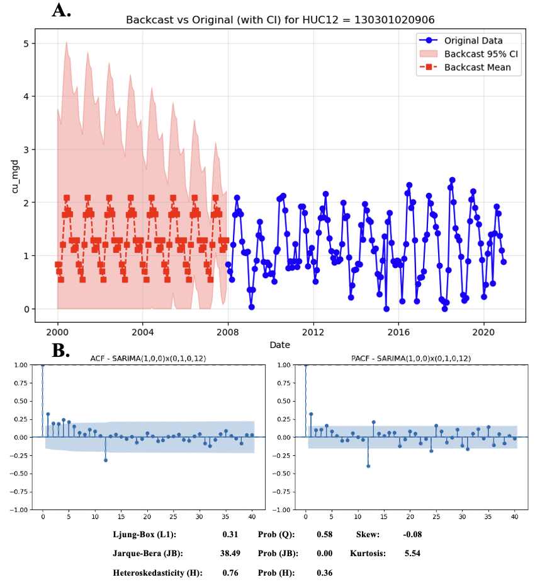
Figure SI-6. (A) Monthly thermoelectric water consumption (cu_mgd) for HUC-12 130301020906, showing observed data from 2008–2020 (blue points and lines) and SARIMA-based backcast estimates for 2000–2007 (red dashed line = backcast mean; shaded area = 95% confidence interval). The model used was SARIMA(1,0,0)x(0,1,0,12}, applied to log-transformed data to account for variance heterogeneity. (B) Residual diagnostics include autocorrelation function (ACF) and partial autocorrelation function (PACF) plots with 95% confidence intervals and summary statistics. The Ljung-Box test (p = 0.58) suggests no significant autocorrelation, and the heteroskedasticity test (p = 0.36) confirms stable residual variance. However, the Jarque-Bera test (p = 0.00), skewness (–0.08), and kurtosis (5.54) indicate moderate deviations from normality, primarily due to fat-tailed residuals.
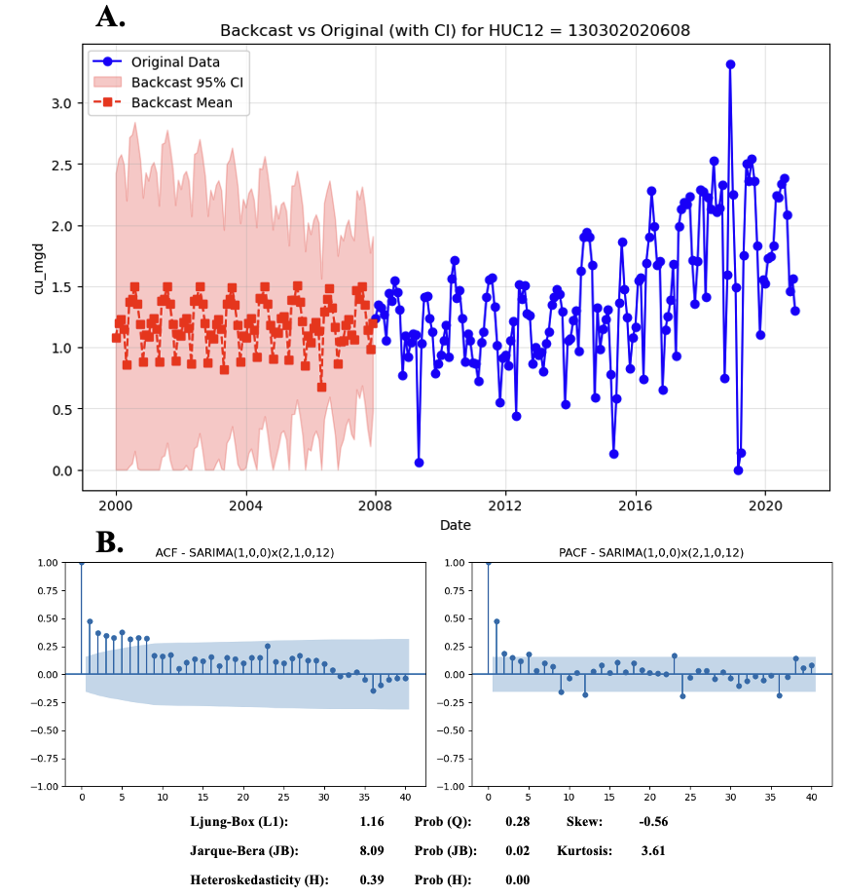
Figure SI-7. (A) Monthly thermoelectric water consumption (cu_mgd) for HUC-12 130302020608, showing observed data from 2008–2020 (blue points and lines) and SARIMA-based backcast estimates for 2000–2007 (red dashed line = backcast mean; shaded area = 95% confidence interval). The selected model was SARIMA(1,0,0)x(2,1,0,12}, applied to untransformed data. (B) Residual diagnostics include autocorrelation function (ACF) and partial autocorrelation function (PACF) plots with 95% confidence intervals, as well as statistical test summaries. The Ljung-Box test (p = 0.28) suggests no significant autocorrelation. Residual variance appears stable (heteroskedasticity test p = 0.13), though the Jarque-Bera test (p = 0.02), skewness (–0.56), and kurtosis (3.61) indicate mild left skew and modest tail heaviness, reflecting slight deviations from normality.
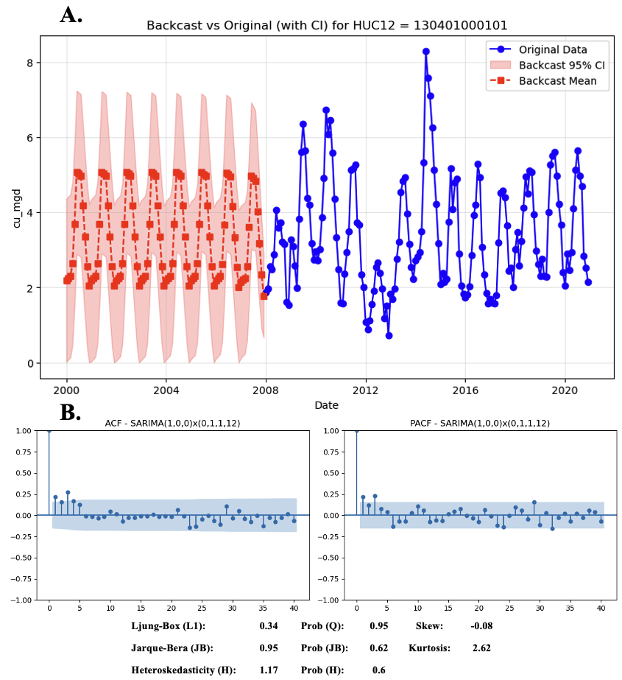
Figure SI-8. (A) Monthly thermoelectric water consumption (cu_mgd) for HUC-12 130401000101, showing observed data from 2008–2020 (blue points and lines) and SARIMA-based backcast estimates for 2000–2007 (red dashed line = backcast mean; shaded area = 95% confidence interval). The selected model was SARIMA(1,0,0)x(0,1,1,12}, applied to untransformed data. (B) Residual diagnostics include autocorrelation function (ACF) and partial autocorrelation function (PACF) plots with 95% confidence intervals and summary statistics. The Ljung-Box test (p = 0.36) indicates no significant autocorrelation, and the heteroskedasticity test (p = 0.60) confirms constant residual variance. The Jarque-Bera test (p = 0.95), skewness (0.08), and kurtosis (2.62) suggest that residuals are approximately normal, with minimal skew or tail deviation.
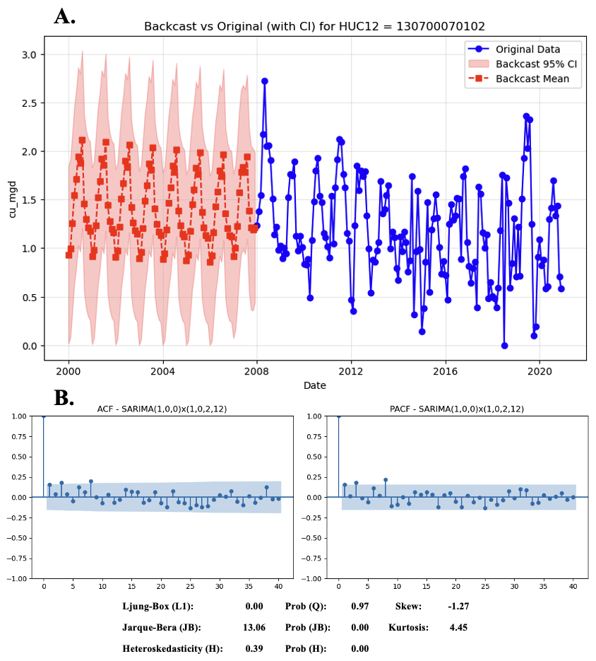
Figure SI-9. (A) Monthly thermoelectric water consumption (cu_mgd) for HUC-12 130700070102, displaying observed data from 2008–2020 (blue points and lines) and SARIMA-based backcast estimates for 2000–2007 (red dashed line = backcast mean; shaded area = 95% confidence interval). The selected model was SARIMA(1,0,0)x(1,0,2,12), applied to untransformed data. (B) Residual diagnostics include autocorrelation function (ACF) and partial autocorrelation function (PACF) plots with 95% confidence intervals and key summary statistics. The Ljung-Box test (p = 0.97) indicates no evidence of autocorrelation, and the heteroskedasticity test (p = 0.00) suggests variance is not constant. The Jarque-Bera test (p = 0.00), skewness (–1.27), and kurtosis (4.45) highlight substantial left skew and moderately heavy tails, indicating notable deviations from normality.
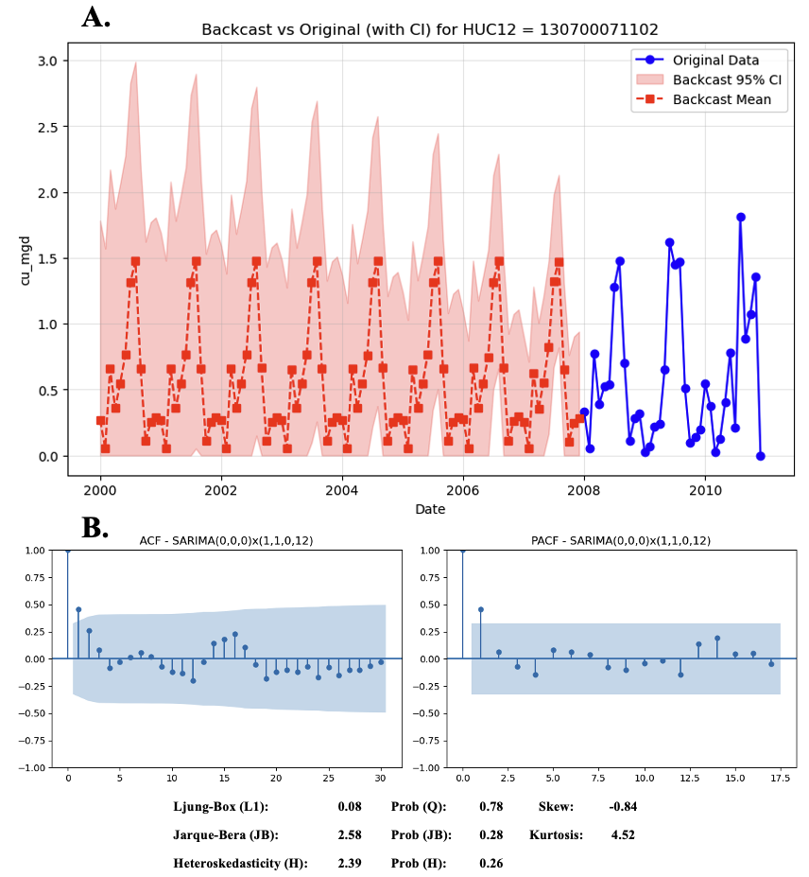
Figure SI-10. (A) Monthly thermoelectric water consumption (cu_mgd) for HUC-12 130700071102, displaying observed data from 2008–2010 (blue points and lines) and SARIMA-based backcast estimates for 2000–2007 (red dashed line = backcast mean; shaded area = 95% confidence interval). The model used was SARIMA(0,0,0)x(1,1,0,12), fit to untransformed data. This plant ceased operation in 2011, resulting in a shorter observed time series. (B) Residual diagnostics include autocorrelation function (ACF) and partial autocorrelation function (PACF) plots with 95% confidence intervals and key statistical test results. The Ljung-Box test (p = 0.78) and heteroskedasticity test (p = 0.26) show no significant autocorrelation or variance instability. However, the Jarque-Bera test (p = 0.28), skewness (–0.54), and kurtosis (4.52) suggest moderate deviations from normality, primarily due to tail heaviness and mild left skew.

Linearly Interpolating Mexico Thermoelectric Power Plant Values
Annual estimates of Mexican thermoelectric power plant water consumption for the Rio Bravo portion of the Rio Grande/Rio Bravo basin between 2000 and 2020 were obtained from the Estadísticas del Agua en México annual reports published by the Sistema Nacional de Información del Agua (2025). However, two data gaps were present in the collected data. First, annual reports were missing for 2000, 2001, 2002, and 2020. Second, there were partial reports in 2004, 2005, 2008, 2009, and 2013 where thermoelectric power plant water withdrawal was reported, but water consumption was not.
To address these data gaps, we constructed a complete time series of annual thermoelectric water consumption values (in hm³) for the Rio Bravo basin using a multi-step strategy. For 2000 to 2002, which lacked any reported data, we assumed the same consumptive use value as in 2003 (30.55 hm³), the first year with available data. This conservative approach avoids extrapolating into a period with no established baseline trend, as no annual reports were available prior to 2003. We applied linear interpolation based on adjacent known values for years with partially reported or missing data - 2004, 2005, 2008, 2009, 2013, and 2020. To interpolate a value for 2020, we included the reported consumptive value from the 2021 annual report to provide an adjacent value. Interpolation was performed strictly between observed data points to preserve the long-term trend and avoid introducing artificial seasonality or curvature. This approach provides plausible and consistent estimates for missing years. A side-by-side comparison of the pre-interpolation and post-interpolation values is presented in Table S2.

Table SI-4. Annual Mexican thermoelectric water consumption values (in cubic hectometers - hm³) for a U.S. power plant site along the Rio Grande/Rio Bravo basin, shown before and after linear interpolation. Missing values were filled using linear interpolation where possible. Years prior to 2003 lack official reported data; therefore, values for 2000–2002 were held constant at the 2003 level (30.55 hm³) and are marked with an asterisk (*). For years where both pre- and post-interpolation values exist, no adjustments were made. The interpolation was performed to ensure a continuous dataset for modeling and trend analysis between 2000 and 2021.
Year | Pre-Interpolation  Consumption Value (hm3) | Post-Interpolation  Consumption Value (hm3)
2000 | N/A | 30.55*
2001 | N/A | 30.55*
2002 | N/A | 30.55*
2003 | 30.55 | 30.55
2004 | N/A | 56.7
2005 | N/A | 86.85
2006 | 115 | 115
2007 | 115 | 115
2008 | N/A | 114
2009 | N/A | 113
2010 | 112 | 112
2011 | 112 | 112
2012 | 111.5 | 111.5
2013 | N/A | 111.25
2014 | 111 | 111
2015 | 111 | 111
2016 | 111 | 111
2017 | 111 | 111
2018 | 111 | 111
2019 | 111 | 111
2020 | N/A | 87
2021 | 63 | 63

After constructing the gap-filled time series of annual thermoelectric water consumption for the Rio Bravo basin, we proportionally allocated basin-wide values to individual Mexican HUC-8 sub-basins based on thermoelectric power plant infrastructure characteristics. This disaggregation was designed to reflect spatial heterogeneity in water use by incorporating facility-level information. Allocation weights were derived from two primary attributes: the total installed generation capacity (in megawatts, MW) of thermoelectric power plants within each sub-basin and the operational start year of each plant, which determined its contribution to water use each year.
To implement this, we first compiled detailed facility-level data, including plant name, fuel type, generation technology, installed capacity, and operational year for all known thermoelectric units operating between 2000 and 2020 within the Rio Bravo basin. This data was sourced from the Global Energy Monitor Wiki (GEM, 2025) and cross-referenced with the World Resource Institute’s Global Power Plant Database (Table S3; Byers et al., 2018). We constructed capacity profiles for each year by identifying operational units within each HUC-8 and summing their total installed capacities to reflect the sub-basin's annual generation capacity. Annual allocation weights were then calculated by dividing each HUC-8’s capacity by the total operational capacity across all HUC-8s in that year (Equation 7):

$w_{h,t}=\frac{C_{h,t}}{\sum_{i=1}^{n}{C_{i,t}}}$ (Equation 7)

where $w_{h,t}$ is the weight for HUC-8 h in year t, ${CU}_{h,t}$ is the total installed capacity in HUC-8 h in year t, and $C_{i,t}$ is the capacity of for sub-basin i in year t, with n representing the number of active sub-basins in year t. These weights were then multiplied by the total basin-wide consumptive use value for each year to estimate the annual thermoelectric water use for each sub-basin (Equation 8):

${CU}_{h,t}=w_{h,t} × {CU}_{B,t}$ (Equation 8)

where ${CU}_{h,t}$ is the consumptive use assigned to HUC-8 h in year t, and ${CU}_{B,t}$ is the total Rio Bravo basin thermoelectric consumption, B, in year t. This approach assumes that water use scales linearly with installed capacity and that plants within a given HUC-8 are otherwise homogeneous in operational characteristics such as cooling technology and water use intensity. While simplified, this method offers a transparent and reproducible means of spatially disaggregating aggregate water use values in the absence of detailed plant-level consumption data and plant operational characteristics.

Table SI-5. List of Mexican thermoelectric power generation units located within the Rio Grande/Río Bravo (RGRB) basin in Mexico, including plant name, unit number, fuel type, generation technology, installed capacity (MW), operational start year, and associated RGRB sub-basin. The dataset covers facilities using a range of generator technologies and fuels. Several facilities consist of multiple units commissioned in different years. Sub-basin classification reflects the geographic location of each plant relative to major hydrologic divisions of the Rio Grande/Río Bravo. This data was manually collected using the Global Energy Monitor Wiki (GEM, 2025).
Plant Name | Unit | Fuel | Technology | Capacity  (MW) | Start Year | RGRB Subbasin
CCC Norte-III power station | 1 | Natural Gas | Combined Cycle | 453 | 2020 | RGRB El Paso to Fort Quitman
CCC Norte-III power station | 2 | Natural Gas | Combined Cycle | 453 | 2020 | RGRB El Paso to Fort Quitman
Chihuahua II (El Encino) power station | 1 | Natural Gas | Combined Cycle | 619 | 2003 | Rio Conchos
Chihuahua III power station | 1 | Natural Gas | Combined Cycle | 327 | 2003 | Rio Conchos
Norte II power station | 1 | Natural Gas | Combined Cycle | 433 | 2014 | Rio Conchos
Francisco Villa power station | 4 | Natural Gas, Heavy Fuel Oil | Steam Turbine | 150 | 1981 | Rio Conchos
Francisco Villa power station | 5 | Natural Gas, Heavy Fuel Oil | Stream Turbine | 150 | 1981 | Rio Conchos
Ramos cogeneration power station | 1 | Natural Gas | Combined Cycle | 52 | 2016 | Rio San Juan Mex Tributary
Saltillo power station | 1 | Natural Gas | Combined Cycle | 247.5 | 2001 | Rio San Juan Mex Tributary
Tractebel Monterrey power station | 1 | Natural Gas | Combined Cycle | 284 | 2003 | Rio San Juan Mex Tributary
Deacero power station | 1 | Natural Gas | Gas Turbine | 200 | 2015 | Rio San Juan Mex Tributary
Huinalá CC power station | 1 | Natural Gas | Combined Cycle | 378 | 1981 | Rio San Juan Mex Tributary
Dulces Nombres (Monterrey) power station | 2 | Natural Gas | Combined Cycle | 459 | 2000 | Rio San Juan Mex Tributary
Dulces Nombres (Monterrey) power station | 1 | Natural Gas | Combined Cycle | 252 | 2002 | Rio San Juan Mex Tributary
Dulces Nombres (Monterrey) power station | 2 | Natural Gas | Combined Cycle | 252 | 2002 | Rio San Juan Mex Tributary
Dulces Nombres (Monterrey) power station | 3 | Natural Gas | Combined Cycle | 252 | 2002 | Rio San Juan Mex Tributary
Dulces Nombres II power station | 4 | Natural Gas | Combined Cycle | 252 | 2002 | Rio San Juan Mex Tributary
Noreste (Escobedo) power station | 1 | Natural Gas | Combined Cycle | 300 | 2016 | Rio San Juan Mex Tributary
Ternium Monterrey power station | 1 | Natural Gas | Combined Cycle | 878 | 2019 | Rio San Juan Mex Tributary
El Carmen Nuevo Leon power station | 1 | Natural Gas | Gas Turbine | 50 | 1992 | Rio San Juan Mex Tributary
Pemcorp Energy power station | 1 | Natural Gas | Combined Cycle | 866 | 2019 | Rio San Juan Mex Tributary
Pesquería power station | 1 | Natural Gas | Internal Combustion | 130.9 | 2018 | Rio San Juan Mex Tributary
Refinería Hector Lara Sosa power station | 1 | Natural Gas | Combined Cycle | 900 | 2016 | Rio San Juan Mex Tributary
Los Ramones power station | 1 | Natural Gas, Fuel Oil | Steam Turbine | 79 | 2007 | Rio San Juan Mex Tributary
Los Ramones power station | 1 | Natural Gas | Gas Turbine | 277 | 2020 | Rio San Juan Mex Tributary
José López Portillo power station | 2 | Natural Gas | Gas Turbine | 277 | 2020 | Rio San Juan Mex Tributary
José López Portillo power station | 1 | Coal | Subcritical | 300 | 1982 | RGRB Amistad dam to Gulf of Mexico
José López Portillo power station | 2 | Coal | Subcritical | 300 | 1983 | RGRB Amistad dam to Gulf of Mexico
José López Portillo power station | 3 | Coal | Subcritical | 300 | 1985 | RGRB Amistad dam to Gulf of Mexico
Carbón II power station | 4 | Coal | Subcritical | 300 | 1987 | RGRB Amistad dam to Gulf of Mexico
Carbón II power station | 1 | Coal | Subcritical | 350 | 1993 | RGRB Amistad dam to Gulf of Mexico
Carbón II power station | 2 | Coal | Subcritical | 350 | 1993 | RGRB Amistad dam to Gulf of Mexico
Carbón II power station | 3 | Coal | Subcritical | 350 | 1995 | RGRB Amistad dam to Gulf of Mexico
Río Bravo III (Lomas del Real) power station | 4 | Coal | Subcritical | 350 | 1996 | RGRB Amistad dam to Gulf of Mexico
Río Bravo IV (Valle Hermoso) power station | 3 | Natural Gas | Combined Cycle | 495 | 2004 | RGRB Amistad dam to Gulf of Mexico
Río Bravo II (Anahuac) power station | 4 | Natural Gas | Combined Cycle | 500 | 2005 | RGRB Amistad dam to Gulf of Mexico
Emilio Portes Gil power station | 2 | Natural Gas | Combined Cycle | 495 | 2002 | RGRB Amistad dam to Gulf of Mexico
Emilio Portes Gil power station | 3 | Natural Gas | Steam Turbine | 300 | 1982 | RGRB Amistad dam to Gulf of Mexico
Dulces Nombres (Monterrey) power station | 4 | Natural Gas | Combined Cycle | 211 | 2007 | RGRB Amistad dam to Gulf of Mexico
Dulces Nombres (Monterrey) power station | 1 | Natural Gas | Combined Cycle | 453 | 2020 | RGRB El Paso to Fort Quitman
Dulces Nombres (Monterrey) power station | 2 | Natural Gas | Combined Cycle | 453 | 2020 | RGRB El Paso to Fort Quitman
Dulces Nombres (Monterrey) power station | 1 | Natural Gas | Combined Cycle | 619 | 2003 | Rio Conchos
Dulces Nombres II power station | 1 | Natural Gas | Combined Cycle | 327 | 2003 | Rio Conchos
Noreste (Escobedo) power station | 1 | Natural Gas | Combined Cycle | 433 | 2014 | Rio Conchos

Supplemental Information References
- Akaike, H., 1974. A new look at the statistical model identification. IEEE Transactions on Automatic Control, 19(6), pp.716–723.
- Box, G.E., Jenkins, G.M., Reinsel, G.C. and Ljung, G.M., 2015. Time Series Analysis: Forecasting and Control. John Wiley & Sons.
- Byers, L., Friedrich, J., Hennig, R., Kressig, A., Li, X., McCormick, C.O.L.I.N. and Valeri, L.M., 2018. A global database of power plants. World Resources Institute, 18.
- Breusch, T.S. and Pagan, A.R., 1979. A simple test for heteroscedasticity and random coefficient variation. Econometrica: Journal of the Econometric Society, pp.1287–1294.
- Energy Information Administration (EIA). 2025. Form EIA-923 detailed data with previous form data (EIA-906/920). Accessible from: https://www.eia.gov/electricity/data/eia923/ (Accessed on 11.15.2024)
- Jarque, C.M. and Bera, A.K., 1980. Efficient tests for normality, homoscedasticity and serial independence of regression residuals. Economics Letters, 6(3), pp.255–259.
- Jones, P.D. and Hulme, M., 1996. Calculating regional climatic time series for temperature and precipitation: methods and illustrations. International Journal of Climatology: A Journal of the Royal Meteorological Society, 16(4), pp.361–377.
- Kim, J., Kim, H., Kim, H., Lee, D. and Yoon, S., 2024. A Comprehensive Survey of Time Series Forecasting: Architectural Diversity and Open Challenges. arXiv preprint arXiv:2411.05793.
- Ljung, G.M. and Box, G.E., 1978. On a measure of lack of fit in time series models. Biometrika, 65(2), pp.297–303.
- Miaou, S.P., 1990. A class of time series urban water demand models with nonlinear climatic effects. Water Resources Research, 26(2), pp.169–178.
- Schwarz, G., 1978. Estimating the dimension of a model. The Annals of Statistics, pp.461–464.
- Sibeijn, M. and Pequito, S., 2022. A time-reversed model selection approach to time series forecasting. Scientific Reports, 12(1), p.10912.
- Sistema Nacional de Información del Agua. 2025. Portal de Publicaciones. Accessible from: https://sinav30.conagua.gob.mx:8080/port_publicaciones.html (Accessed on 01.10.2025)
- Tawakuli, A., Havers, B., Gulisano, V., Kaiser, D. and Engel, T., 2024. Survey: Time-series data preprocessing: A survey and an empirical analysis. Journal of Engineering Research.
- The Global Energy Monitor (GEM). 2025. Global Energy Monitor Wiki. Accessible from: https://www.gem.wiki/Main_Page (Accessed on 01.10.2025)

