Supplementary File
Index
Supplementary Table 1: Search strategies used in different electronic databases
Supplementary Table 2: Newcastle Ottawa Scale for the quality assessment of the non-randomized studies
Supplementary Figure 1: Functional independence funnel plot
Supplementary Figure 2: Independent ambulation funnel plot
Supplementary Figure 3: Successful recanalization funnel plot
Supplementary Figure 4: Mortality funnel plot
Supplementary Figure 5: Spontaneous intracerebral hemorrhage funnel plot
Supplementary Figure 6: Functional independence, Egger’s regression test
Supplementary Figure 7: Independent ambulation, Egger’s regression test
Supplementary Figure 8: Successful recanalization, Egger’s regression test
Supplementary Figure 9: Mortality, Egger’s regression test
Supplementary Figure 10: Spontaneous intracerebral hemorrhage, Egger’s regression test

Supplementary Table 1: Search strategies used in different electronic databases
Databases | Search string | Articles retrieved
PubMed | ("Stroke"[MeSH Terms] OR "Ischemic Stroke"[All Fields] OR "Ischaemic Stroke"[All Fields] OR "Cryptogenic Stroke"[All Fields] OR "Acute Ischemic Stroke"[All Fields] OR "Wake-up Stroke"[All Fields] OR "Cerebrovascular Accident"[All Fields] OR "Apoplexy"[All Fields] OR "Cerebral Stroke"[All Fields] OR "Thrombotic Stroke"[All Fields] OR "Brain Attack"[All Fields] OR "Cerebral Insult"[All Fields] OR "Cerebrovascular Occlusion"[All Fields] OR "Ischemic Seizure"[All Fields] OR (("thrombose"[All Fields] OR "thrombosing"[All Fields] OR "thrombosis"[MeSH Terms] OR "thrombosis"[All Fields] OR "thrombosed"[All Fields] OR "thromboses"[All Fields]) AND "cerebrovascular"[All Fields])) AND ("Basilar Artery"[MeSH Terms] OR "Basilar Artery"[All Fields] OR "Basilar Arteries"[All Fields]) AND ("Thrombolytic Therapy"[MeSH Terms] OR "Thrombolysis"[All Fields] OR "Therapeutic Thrombolysis"[All Fields] OR "Fibrinolytic Therapy"[All Fields] OR "Intravenous Alteplase"[All Fields]) AND ("Thrombectomy"[MeSH Terms] OR "Thrombectomy"[All Fields] OR "Endovascular Therapy"[All Fields] OR "Percutaneous Aspiration Thrombectomy"[All Fields]) | 278
Cochrane Central | ("Stroke" OR "Ischemic Stroke" OR "Ischaemic Stroke" OR "Cryptogenic Stroke" OR "Acute Ischemic Stroke" OR "Wake-up Stroke" OR "Cerebrovascular Accident" OR "Apoplexy" OR "Cerebral Stroke" OR "Thrombotic Stroke" OR "Brain Attack" OR "Cerebral Insult" OR "Cerebrovascular Occlusion" OR "Ischemic Seizure" OR "Thrombosis, Cerebrovascular") AND ("Basilar Artery" OR "Basilar Artery" OR "Basilar Arteries") AND ("Thrombolytic Therapy" OR "Thrombolysis" OR "Therapeutic Thrombolysis" OR "Fibrinolytic Therapy" OR "Intravenous Alteplase") AND ("Thrombectomy" OR "Thrombectomy" OR "Endovascular Therapy" OR "Percutaneous Aspiration Thrombectomy") | 57
ScienceDirect | ("Stroke" OR "Ischemic Stroke" OR "Ischaemic Stroke" OR "Cerebrovascular Occlusion") AND ("Basilar Artery") AND ("Thrombolytic Therapy" OR "Thrombolysis") AND ("Thrombectomy" OR "Endovascular Therapy") | 1,331

Study | Item & score
Study | Selection |  |  |  | Comparability | Outcome
Study | Representativeness  of the exposed cohort（1） | Selection of the  non-exposed cohort（1) | Ascertainment of exposure  （1） | Demonstration that outcome of interest was not present at start of  study（1） | Compare ability of cohorts based on the design or analysis  （2） | Assessment of outcome  （1） | Was follow up long enough for outcomes to  occur（1） | Adequacy of  follow up of cohorts（1） | Total
Knapen et al. 2024 | * | * | * | * | ** | - | * | - | 7
Feil et al. 2023 | * | - | * | * | ** | - | * | * | 7
Guo et al. 2024 | * | * | * | * | ** | * | * | * | 9
Kaneko et al.  2019 | * | * | * | * | * | - | - | * | 6
Singer et al.  2015 | * | * | * | * | * | - | * | * | 7
Uno et al.  2017 | * | - | * | * | * | - | * | * | 6
Siow et al.  2022 | * | * | * | * | ** | - | * | - | 7
Nappini et al.  2021 | * | * | * | * | ** | - | * | * | 8
Nie et al.  2022 | * | * | * | * | ** | * | * | * | 9
Yang et al.  2024 | * | * | * | * | ** | - | * | * | 8
Maier et al. 2023 | * | * | * | * | * | * | * | - | 7
Supplementary Table 2: Newcastle Ottawa Scale for the quality assessment
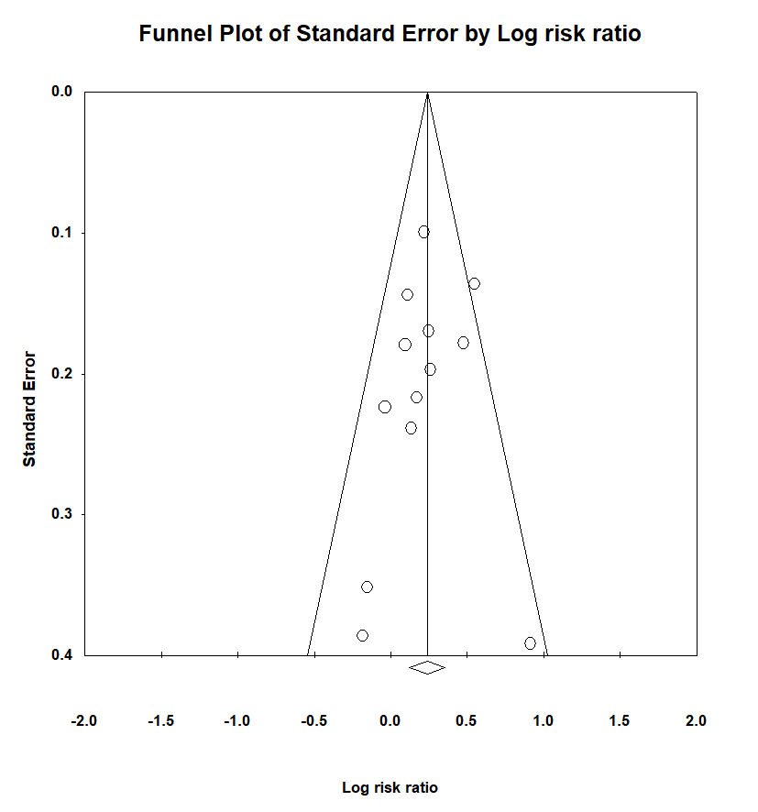

Supplementary Figure 1: Functional independence funnel plot
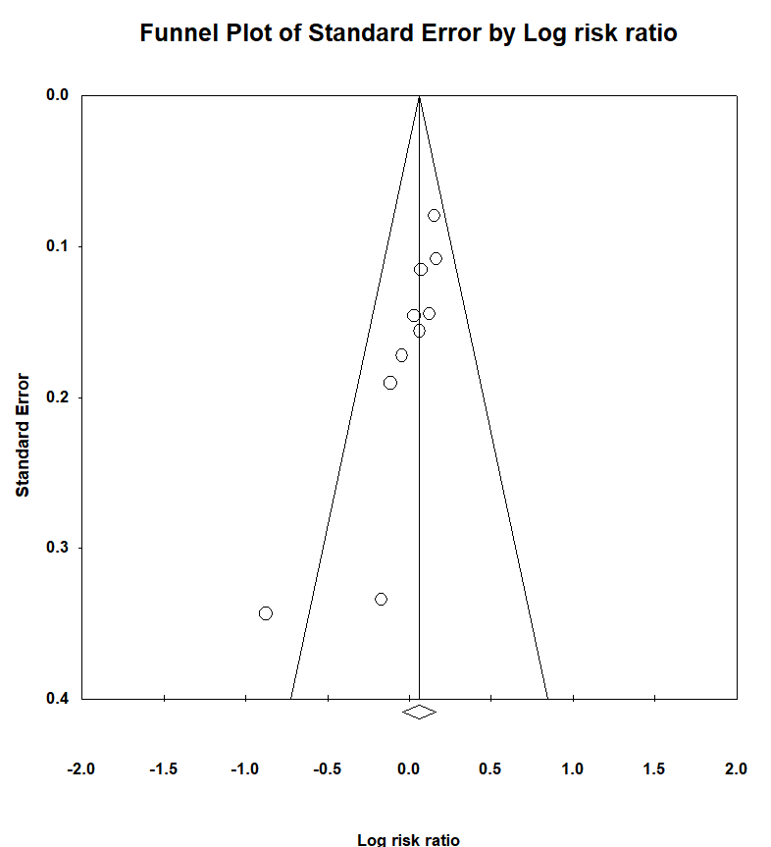

Supplementary Figure 2: Independent ambulation funnel plot
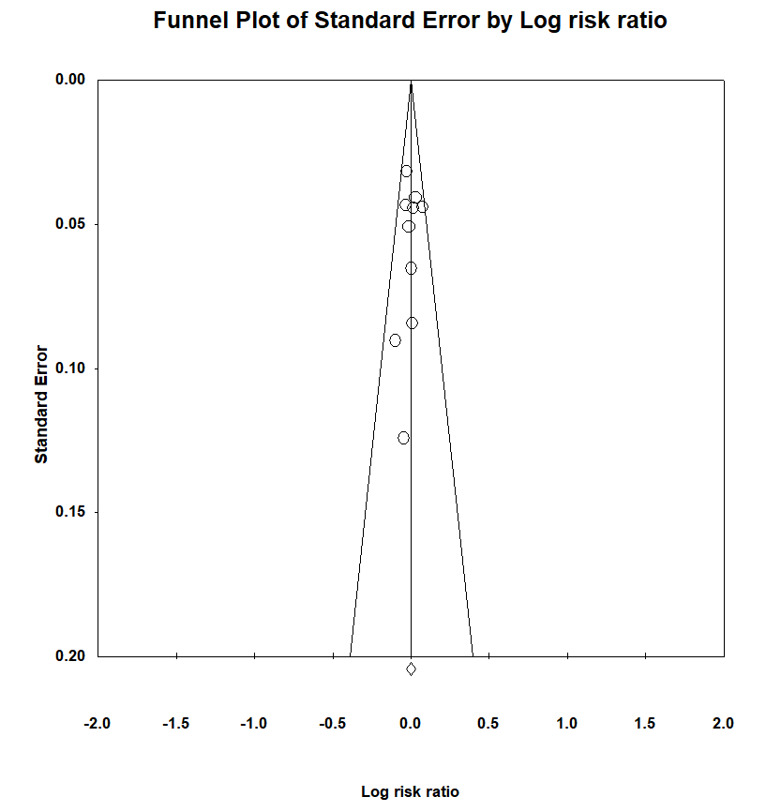

Supplementary Figure 3: Successful recanalization funnel plot
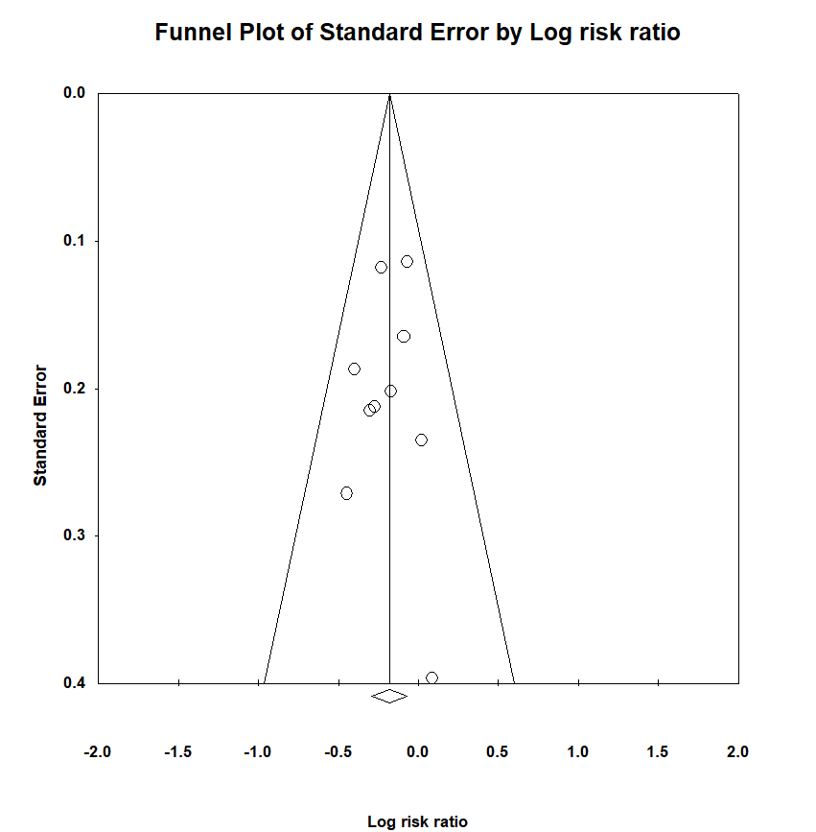

Supplementary Figure 4: Mortality funnel plot
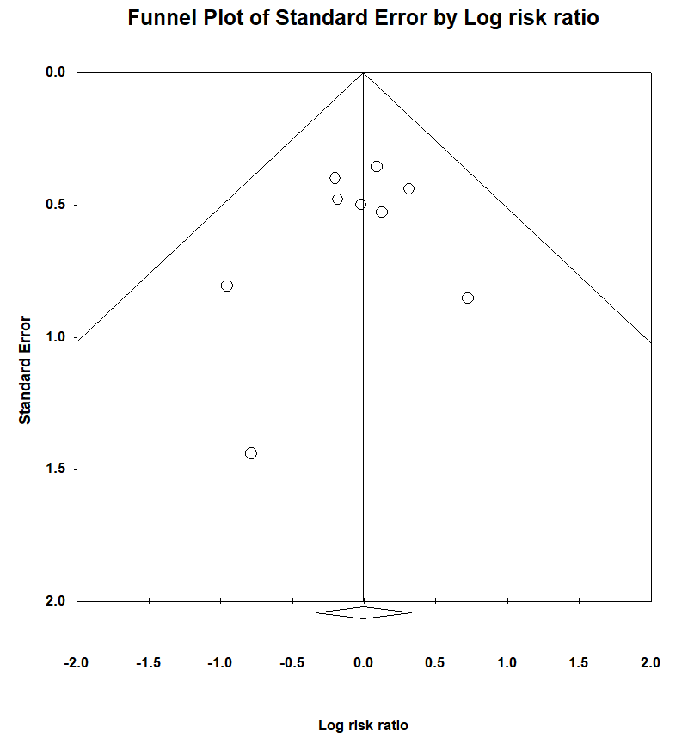

Supplementary Figure 5: Spontaneous intracerebral hemorrhage funnel plot
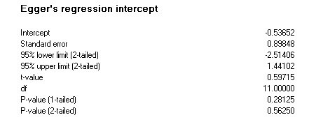

Supplementary Figure 6: Functional independence, Egger’s regression test
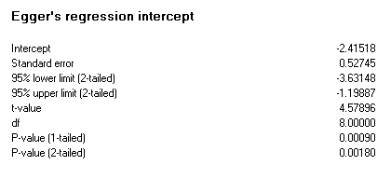

Supplementary Figure 7: Independent ambulation, Egger’s regression test
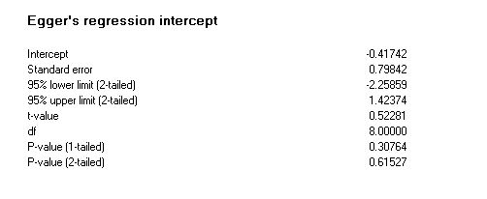

Supplementary Figure 8: Successful recanalization, Egger’s regression test
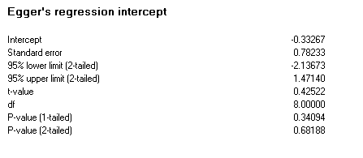

Supplementary Figure 9: Mortality, Egger’s regression test
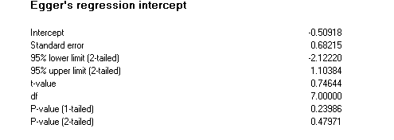

Supplementary Figure 10: Spontaneous intracerebral hemorrhage, Egger’s regression test

