Supplementary Material for:

On-Chip Ultrafast Electrons in Asymmetric Nanogaps: a Scalable Platform for Time-Resolved Spectroscopy of Individual Nanosystems

Haoqing Ning¹, Marios Maimaris¹, Longren Li¹, Jiewen Wei¹, Emilie Gérouville², Evangelos Moutoulas², Vladimir Shilovskikh^{6,7}, Oliver Burman³, Zhu Meng¹, Clement Ferchaud⁴, Dmitry Maslennikov¹, Navendu Mondal¹, Tong Wang¹, Colin Chow¹, Aleksandar P. Ivanov³, Joshua B. Edel³, Saif A. Haque¹, Misha Ivanov⁵, Fabian Paulus⁶, Yana Vaynzof^{6,7}, Jon P. Marangos⁴, Dimitra G. Georgiadou², Artem A. Bakulin¹

¹ Department of Chemistry and Centre for Processible Electronics, Imperial College London, UK
² Electronics and Computer Science & Optoelectronics Research Centre, University of Southampton, UK
³ Department of Chemistry, Imperial College London, UK
⁴ Department of Physics, Blackett Laboratory, Imperial College London, UK
⁵ Max Born Institute, Berlin, Germany
⁶ Leibniz Institute for Solid State and Materials Research Dresden, Dresden, Germany
⁷ Chair for Emerging Electronic Technologies, Technical University of Dresden, Dresden, Germany

Contents
Note 1. Fabrication of asymmetric Al/Au nanogaps 4
Note 2. Reproducibility of nanogap size on PANs 5
Note 3. CW illumination control experiment 7
Note 4. High Electron Yields achievable with PANs 8
Note 5. Improved Signal-to-Noise Performance under Bias-Free Conditions 9
Note 6. Evidence of negligible optically induced current in the glass substrate 10
Note 7. Representative experimental setup - Laser systems used 11
Note 8. Numerical simulation of possible optical-pulse-induced thermal expansion effects with/without bias 13
Note 9. Alternative mechanism check: photon-assisted tunneling/emission (PAT/PAE) 15
Note 10. I-V and photocurrent characteristics modelling using two-electrode Fowler-Nordheim emission theory 18
Note 11. Fowler-Nordheim modelling of PANs photocurrent under different wavelengths irradiation [Fig. 2 of the main text] 21
Note 12. Keldysh parameter estimation 24
Note 13. Modelling of bias-dependent nonlinearity 25
Note 14. Modelling photocurrent generation based on F-N tunneling and classic trajectories of electrons 26
Note 15. Characterisation of 800 nm chirped pulses using PANs 29
Note 16. Spectrum retrieved from MIR autocorrelation 30
Note 17. 400 nm autocorrelation 31
Note 18. Simulation of autocorrelation in PAN 32
Note 19. Fabrication of QD and ZnO devices based on PANs 33
Note 20. Tunneling photocurrent map on dark quantum dots 37
Note 21. Transient absorption of drop-cast nanocrystal film 39
Note 22. Sub-15 fs pump-probe tunneling photocurrent on PANs 42

Fabrication of asymmetric Al/Au nanogaps
Asymmetric Al/Au nanogaps fabrication:
The Al-Au asymmetric nanogaps are fabricated using adhesion lithography. Initially, a 40 nm thick Al electrode is thermally evaporated onto a glass substrate. Photolithography, followed by wet etching, is then employed to establish the initial pattern. Subsequently, the substrate is immersed in a 1 mM solution of the self-assembled monolayer (SAM) octadecylphosphonic acid in 2-propanol to generate a hydrophobic layer on the aluminium surface. A 5 nm Al layer followed by a 35 nm thick layer of Au is subsequently deposited. Following the deposition of gold, an adhesive film (from Photonic Cleaning Technologies) is applied to the wafer, left to dry, and later peeled off manually, removing the Al/Au part in contact with the SAM-functionalised aluminium. Finally, the organic SAM layer can be removed through UV-ozone treatment, resulting in a 10-20 nm nanogap.

Reproducibility of nanogap size on PANs
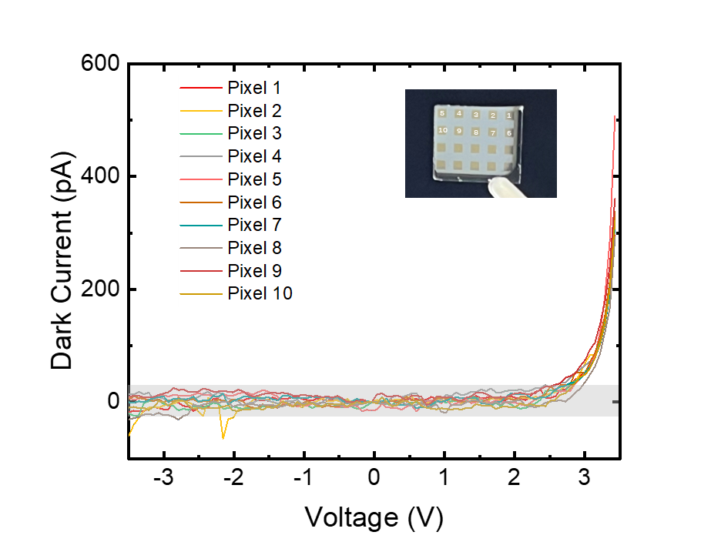
Supplementary Figure 1. I-V characteristic of 10 distinct pixels of the same chip. All tests are under no illumination. The turning point (~3 V) shows gap size variation is controlled. The shaded current range is within the instrumental limitation of the amplifier under 0 Hz.

The dark current level on the order of 0.2 nA at 3 V allows lock-in detection of optically induced currents with accuracy below 1pA. Notably, the bias DC current contribution stemmed from the entire PAN diode with a total working area of 4000 μm (Au perimeter) x 40 nm (thickness). In comparison, conventional tunnel junctions with smaller effective areas possess typical widths in the ~nm range, resulting in current levels of 1 nA / 0.1 V. This difference in the level of current rules out the presence of any <2 nm spaced hotspots in PANs.
J-V measurements from multiple PANs confirm the consistency of photocurrent distribution along the nanogap. To validate the size reproducibility of the nanogap size on PAN, we tested and compared the gap size variation on 10 distinct devices. The slope and current level could indicate the homogeneity of PAN due to the distance-field strength relationship on Fowler-Nordheim (F-N) tunneling. Therefore, we perform the J-V sweeps of different PAN samples within the voltage range of -3.5 V to 3.5 V. Through analysis of the consistency in current magnitude, we conclude that the size repeatability of the nanostructures is ensured.

CW illumination control experiment
As a control experiment, we irradiated samples with a 670 nm CW laser of average power 2 mW using a lens of 10 mm focus. The CW laser was modulated at 1 kHz through an optical chopper. Due to the absence of voltage bias requirements and the relatively small length variation dZ/Z resulting from larger gaps (~10 nm), no observable thermal flow was generated by the CW laser (Supplementary Fig. 2). In contrast, plasmonic heating induces thermal expansion on nm-spaced nanowires or nano junctions formed between the STM tip and sample plane, which is more prominent.
Supplementary Figure 2. Photocurrent test under CW illumination. On-off test under 670 nm CW laser, chopped at 1 kHz.

High Electron Yields achievable with PANs
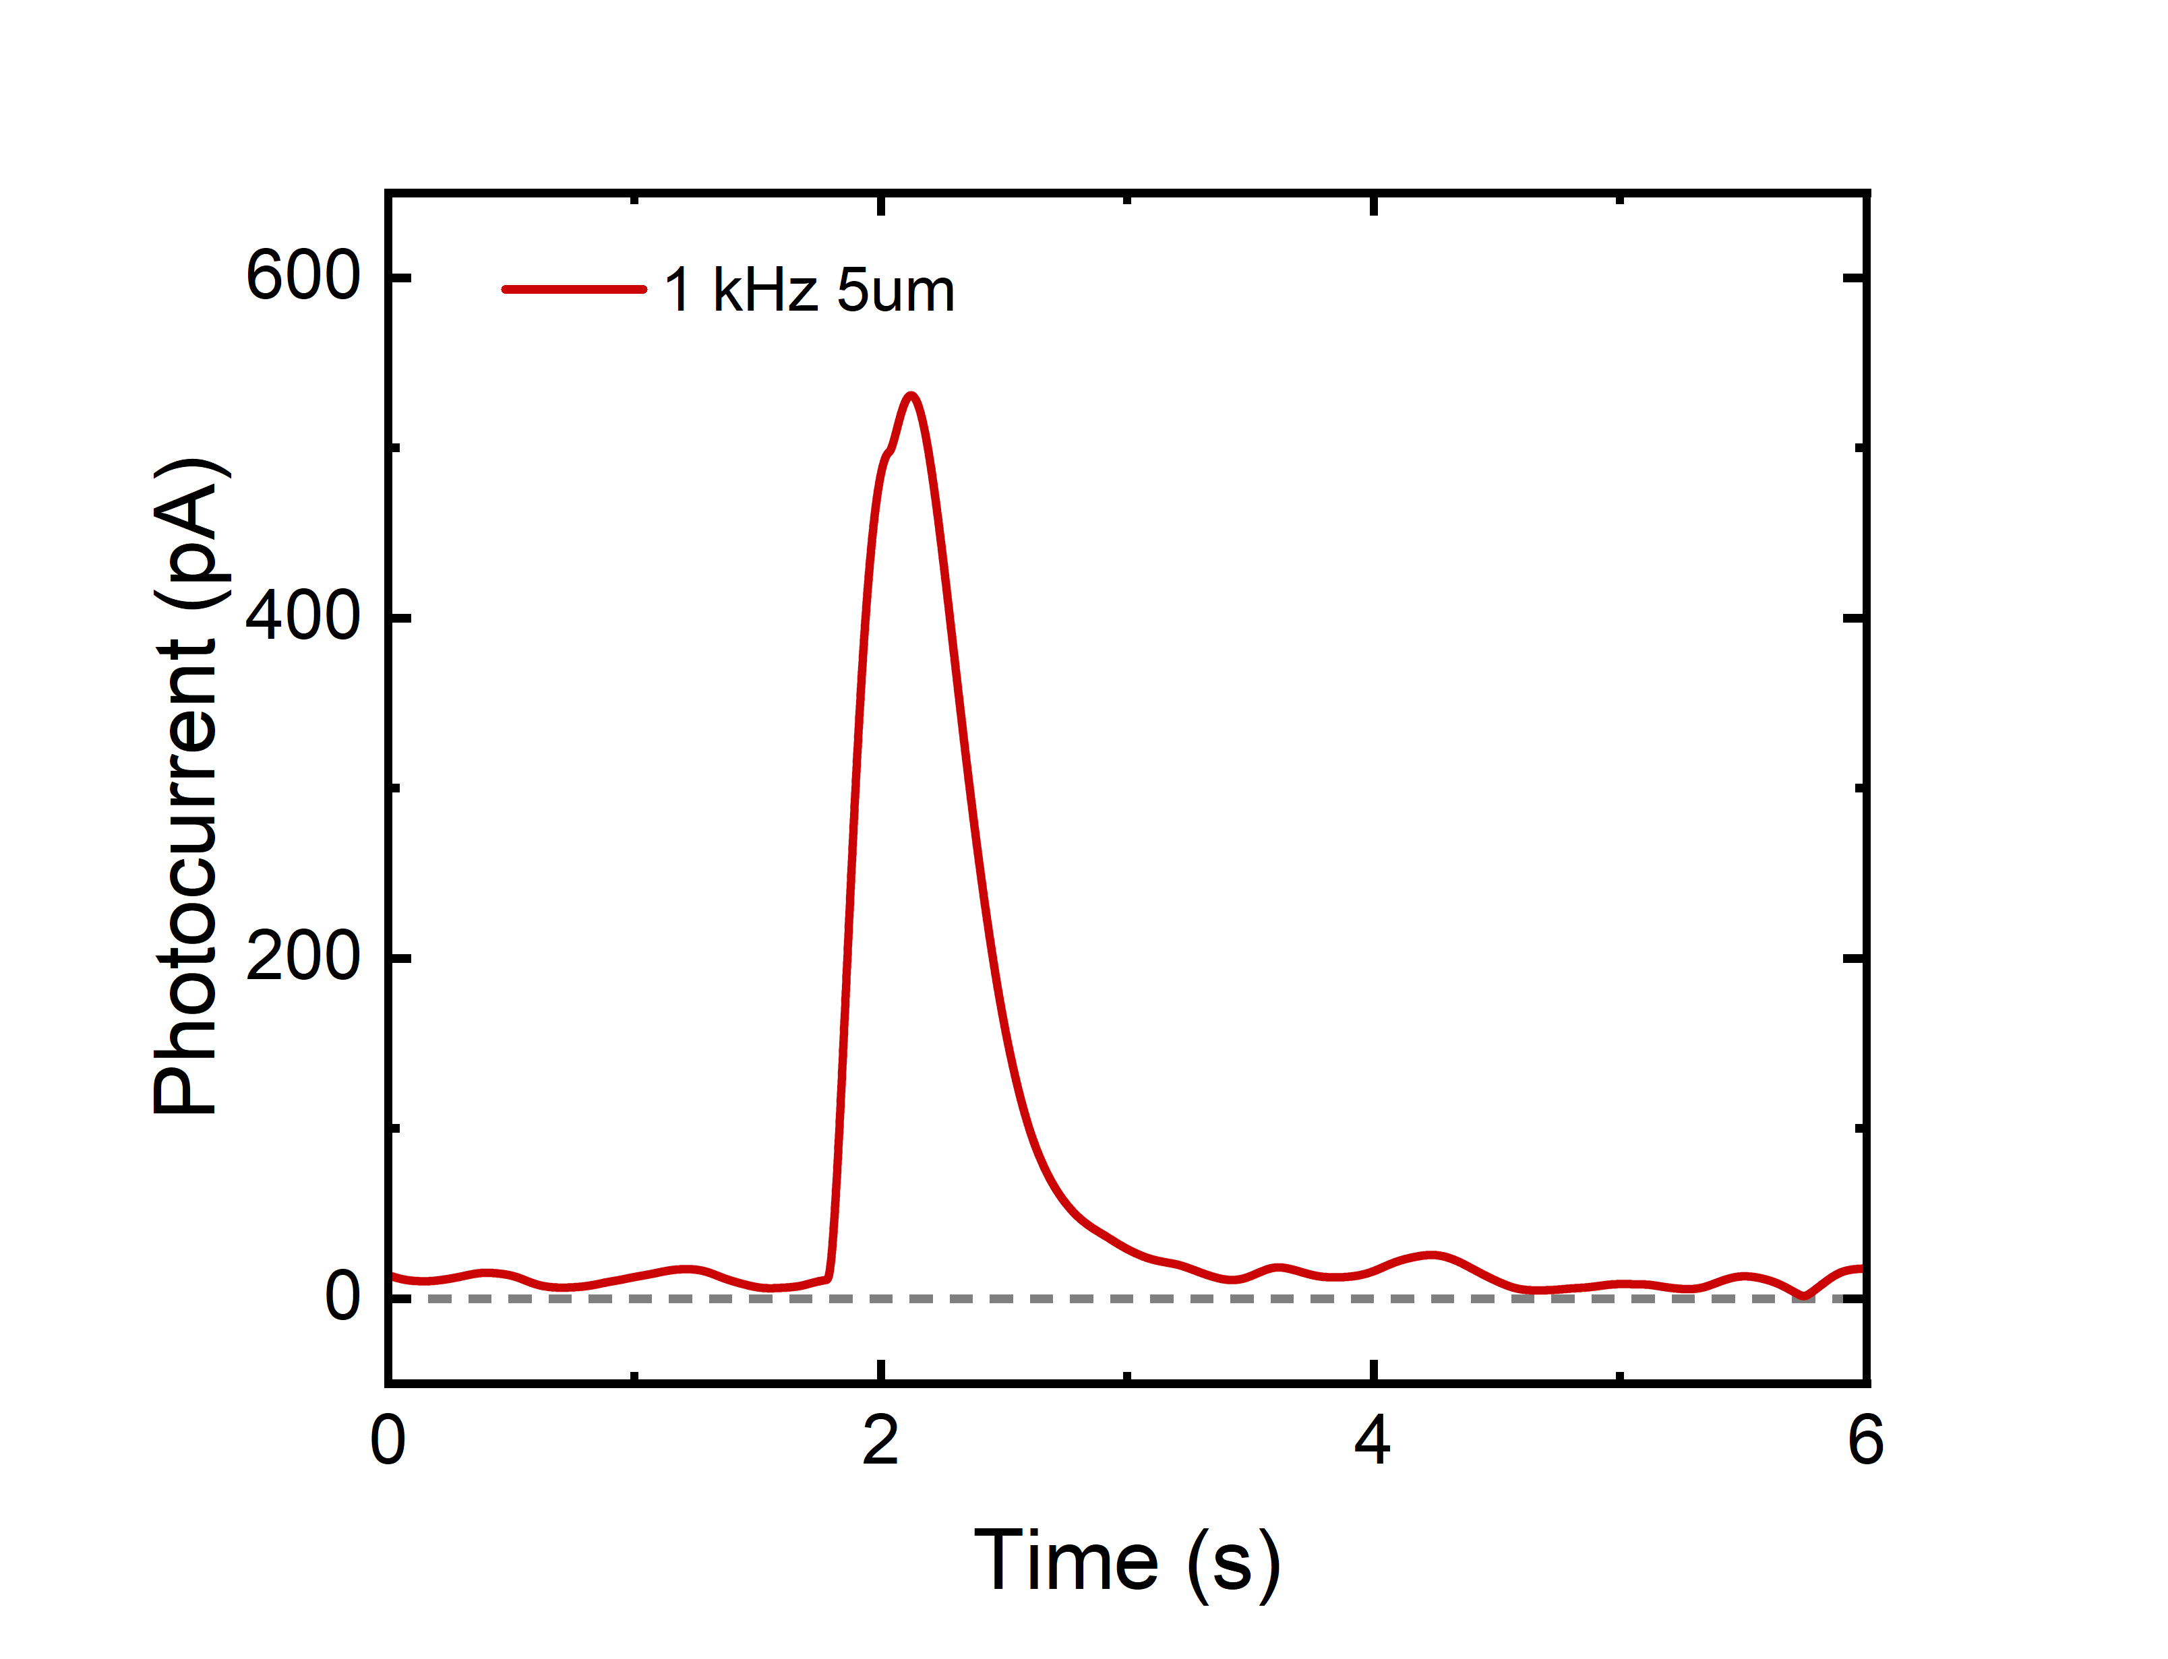
Supplementary Figure 3. On-off modulation measurement at high illumination - ultrafast tunneling photocurrent and electron yield characterization. The photocurrent limit was characterized near the damage threshold using 5 µm wavelength excitation with ~200 fs pulse duration at repetition rates of 1 kHz. The average photocurrent under illumination reached approximately 600 pA, corresponding to ~3,700 electrons emitted per optical pulse. Rise and fall are limited by lock-in time constant.

Improved Signal-to-Noise Performance under Bias-Free Conditions
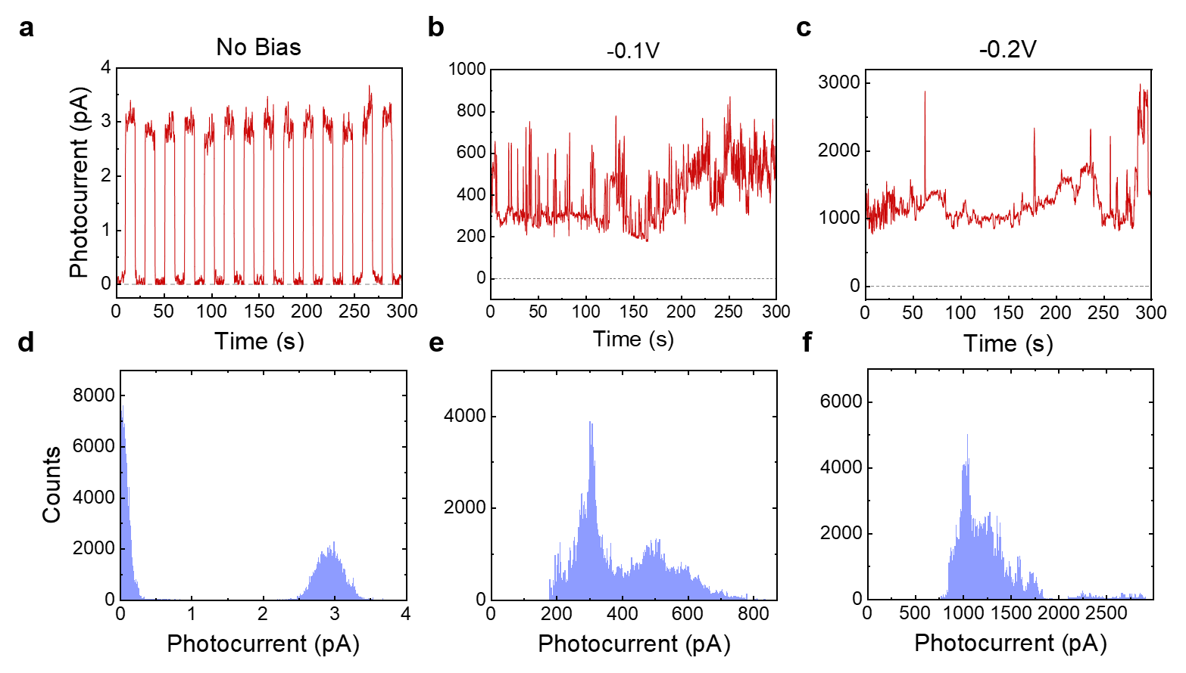
Supplementary Figure 4 On-off modulation under different bias for signal to noise characterization. Influence of applied bias on the photocurrent signal and signal-to-noise ratio, measured under 200 µW excitation at 515 nm (~200 fs pulse duration, 5 kHz repetition rate) using a 10× objective. a) Single-shot photocurrent measurement under bias-free operation, showing clear on-off modulation with low dark current and high signal-to-noise ratio. Under a) No bias b) -0.1 V c) -0.2 V applied bias voltage, the overall photocurrent amplitude increases; however, from histogram, unlike bias free condition d) the on-off contrast e) f) becomes less stable due to enhanced dark current and associated noise fluctuations. These results indicate that applying bias, while increasing average current, can induce large fluctuations in the number of electrons per pulse and reduce the effective signal-to-noise ratio in time-resolved measurements.

Evidence of negligible optically induced current in the glass substrate
It has been demonstrated that carriers can be injected from the dielectric material to the electrode to generate photocurrent ¹. Therefore, apart from carrier generation via F-N emission, carrier injection from the glass substrate in PANs can be a second origin of photocurrent under a strong field. However, our results show that the F-N emission mechanism is the dominant pathway of photocurrent generation in PANs for the following reasons.
Most measurements are performed under a peak field strength around 0.1 V/Å, which is 20 times smaller than the working peak field strength (400 times smaller on fluence) to inject electrons from the dielectric (2 V/Å). Therefore, the peak field strength in our measurements is insufficient to inject electrons from the glass substrate. Also, the dielectric between two electrodes in PAN is only 10nm, which further reduces the possible injected electrons.
In the traditional symmetrical device structure, both electrodes have the same work function without applied voltage. Although the threshold of electron ionization from the metal (gold, ~5.1 eV) is smaller than the dielectric (e.g. for silica is ~11 eV), the electrons in both metal electrodes are ionized with a similar possibility, resulting in similar photocurrent canceling throughout full optical cycles. Therefore, the major contribution to the detectable photocurrent is obtained from electron injection from the dielectric material rather than the electrons ionized from the metal electrode. However, in PANs, we use asymmetrical device structures (Al-Au) with different work functions ($∅_{Al}≈4.3 eV$ and $∅_{Au}≈5.2 eV$) to enable different possibilities of electron ionization from the two different metal electrodes without the assistance of an applied voltage. This asymmetric electrode design allows us to observe detectable photocurrent with a small peak field strength (i.e., fluence).

Representative experimental setup - Laser systems used
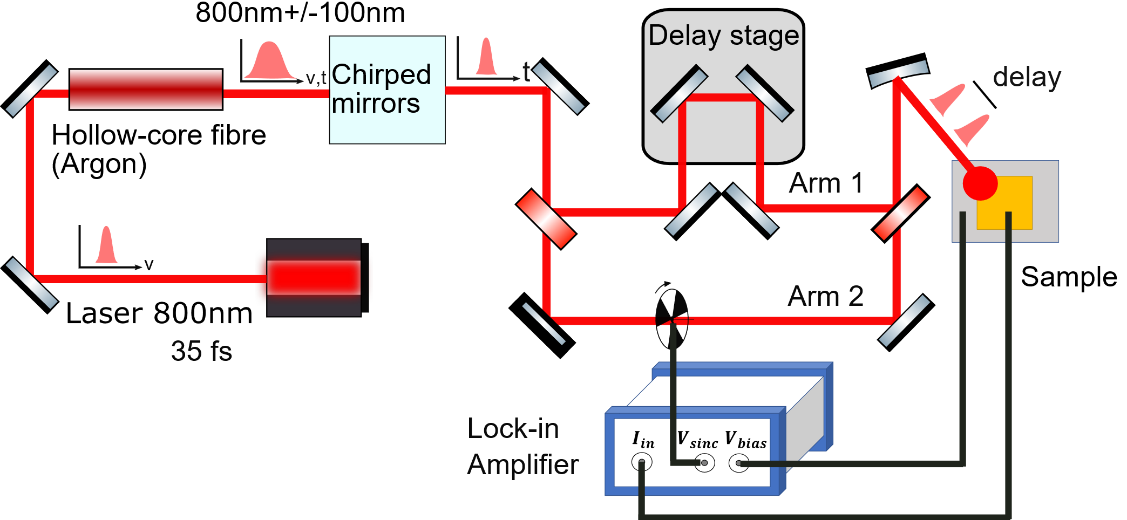
Supplementary Figure 5. Schematic representation of the Autocorrelation setup with photocurrent detection. The laser system here is Astrella (Coherent) 4 kHz and the pulse compression is done via hollow-core fiber and a pair of chirped mirrors (800 nm 10 fs).

Table S1. Wavelength, pulse duration and generation methods under working systems.
Wavelength | Pulse duration | Generation
266nm | ~8.5 fs | Red Dragon (KM labs) at 1kHz + Optical Parametric Amplifier + Hollow Core Fibers
400nm | ~100 fs | Astrella (Coherent) at 4kHz + BBO crystal for SHG
800nm | ~35 fs | Astrella (Coherent) at 4kHz Fundamental pulse
800nm few cycle | ~10 fs | Astrella (Coherent) at 4kHz +Hollow Core Fiber
1030nm | ~200 fs | Pharos (Light conversion) at 200 kHz
1.45um | ~10 fs | Red Dragon (KM labs) at 1kHz + Optical Parametric Amplifier + Hollow Core Fiber
5 um | ~170fs | Pharos + ORPHEUS +Lyra (Light conversion) at 10kHz
6.7um | ~100 fs | Astrella (Coherent) at 4kHz + TOPAS OPA + AgGaS₂ for DFG
We carried out photocurrent measurements using different laser sources to achieve broadband coverage of the spectrum spanning from DUV 266 nm up to MIR 6.7 μm. A hollow core fiber filled with Argon is used to generate ultrafast pulses. The pulse duration and the laser system used for each wavelength are shown in Table S1 above. For example, Supplementary Fig. 5 shows the photocurrent measurement performed for the case of 800 nm with a 10 fs pulse duration. For this case, Astrella (Coherent) at 4 kHz is used along with hollow-core fiber pumped differentially with Argon and a pair of chirped mirrors. For all wavelengths, the delay between the two pulses is controlled by the translation stage. The device is mounted in a commercial two-electrode probe stage (Linkham Scientific); the metallic stage can also work as a Faraday cage, which cancels external electric field interference. Laser pulses irradiated the nanogap chip. For current and photocurrent recording, we use a 500 kHz digital lock-in amplifier (MFLI, Zurich Instruments) with built-in auxiliary bias output. The demodulator frequency is selected to 0Hz for DC current recording and selected for external synchronization (1 kHz or 4 kHz) for photocurrent recording. For both current and photocurrent measurement, we choose 10 MV/A for the transimpedance gain, which gives a noise level of 150 $fA/\sqrt{Hz}$ at 1 kHz.

Numerical simulation of possible optical-pulse-induced thermal expansion effects with/without bias
When the focused laser pulse irradiates the metallic nanostructures, the electron-phonon coupling ultimately induces lattice heating, leading to nano-size changes that may impact the level of electrical current. Here, we illustrate that, under unbiased conditions, the changes in the signal due to thermal expansion can be neglected, as depicted in Supplementary Fig. 6.
When no DC bias is applied (Supplementary Fig. 6a), if we consider thermal expansion as a signal on the microsecond scale, its temporal product with the original voltage signal will influence the final shape of the electrical pulse. However, the photo-voltage, being the sole voltage signal, does not contribute to any signal beyond the duration of the optical pulse. In the presence of bias (Supplementary Fig. 6b), the direct current (DC) signal, treated as a continuously existing signal, continuously convolves with the thermal expansion signal in the time domain. Assuming a constant length of thermal expansion at the same power, as the nanostructure dimensions decrease, the impact of this signal becomes more pronounced. This slow signal may also result in the temporal resolution of electronic pulses under bias influenced not only by the optical pulse itself but also by the continuous presence of the DC signal.
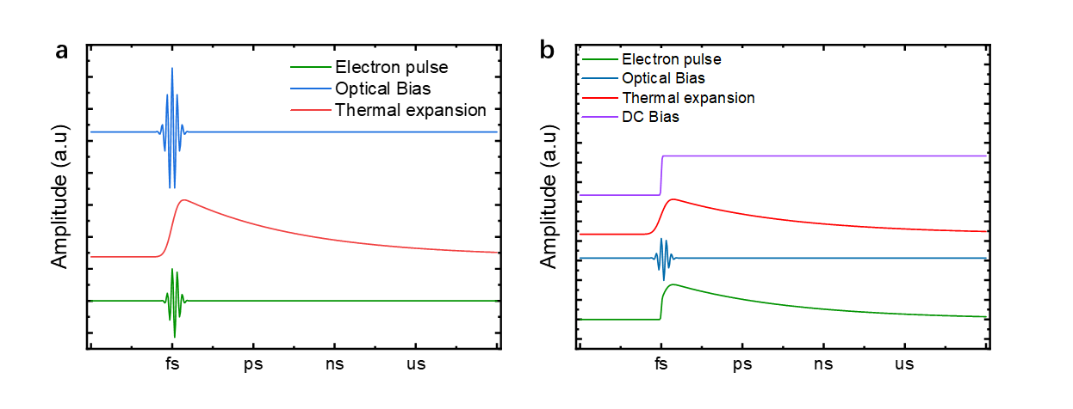
Supplementary Figure 6. Electron pulse duration (green) when a slow thermal expansion is present. a) When no bias is applied, the tail part of the expansion will not induce any slow current b) When bias (purple) is applied, the ns to $μ$s tail will generate a slow and strong electron pulse.

Alternative mechanism check: photon-assisted tunneling/emission (PAT/PAE)
Photon-assisted tunneling was discovered by Tien-Gorden and Tucker. This theoretical framework describes the relationship between the rectified current and the original DC current in the quantum picture of the AC field, and how variations in photon energy and light field intensity can influence the rectified current. As detailed by the following formula:
$$\begin{aligned}I\left(ω\right)\sim \frac{e}{ℏ}Σ{\left|J_{n}\left(\frac{V_{ac}}{nℏω}\right)\right|}^{2}I\left(nℏω\right),\#\left(S11\right)\end{aligned}$$
where $ℏω$ is the photon energy, e is electron mass, Jn is the Bessel function of nth kind. Vac is the field strength.
First, we check the scenario of $nℏω<φ$. we observed that the rectified photocurrent decreases as field strength increases (5). This results from the overall Bessel function value (J_{n}) for all orders, which decreases as the field strength increases. This is shown in Supplementary Fig. 7b and Fig. 7c for the cases of low and high field strength, respectively. For a photon energy of 0.2 eV (MIR), we limited the photon order to 20 to set the Vac below 4 eV, which is still below the work function value of Aluminum. Therefore, we can exclude any PAT mechanism below the barrier as we experimentally observe that the rectified photocurrent increases within a field strength range of V/nm.
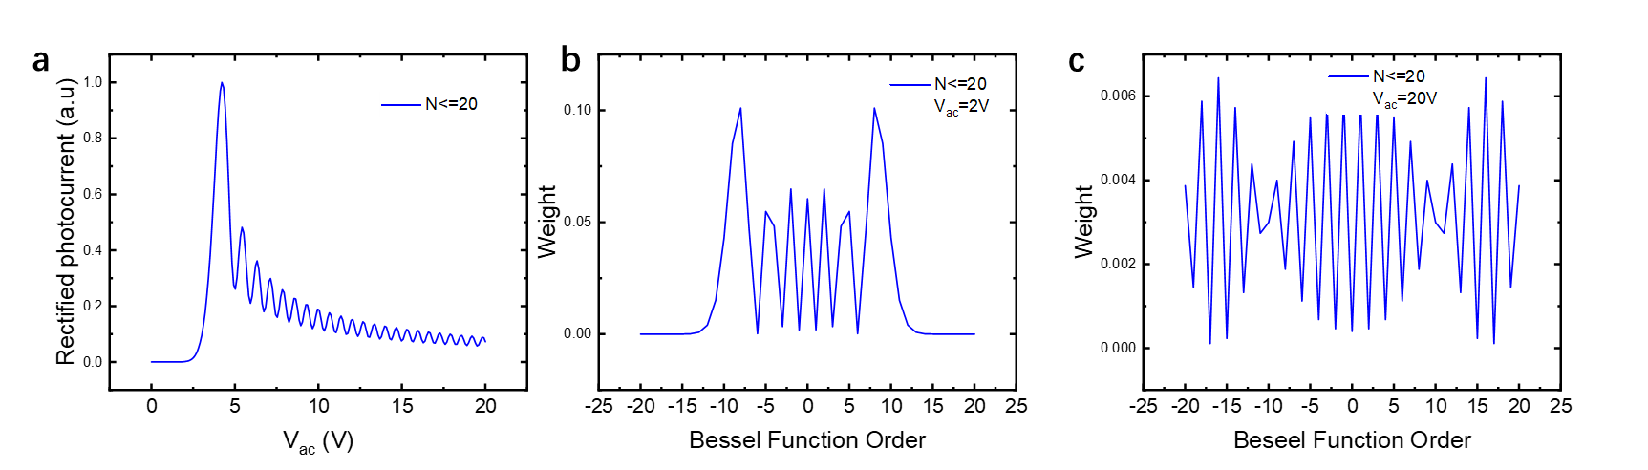
Supplementary Figure 7 Photon assisted tunneling with photon-number limitation (below barrier). a) Photocurrent variation with field strength b) Weight of contribution from different photon orders.

Second, we examine the regime of $nℏω>φ$ where PAE is realized. As shown on Supplementary Fig. 8a there is an increase in photocurrent as field strength increases. This results from the higher overall Bessel function value (Jn) as higher orders are activated.
We plot the total photocurrent as a function of the field strength for both regimes (PAT plus PAE), as shown in Supplementary Fig. 9. As the graph shows, the slope change is more dramatic for lower energy photons, and as we reach high peak field strengths, the slope becomes independent of the energy photon. None of these are observed in our case. Notably, for the 0.2 eV photon (mid-IR pulse) Supplementary Fig. 9 illustrates a power order of ~8 for the field strengths utilized in the experiment, significantly exceeding the order which has been experimentally measured, as shown in Fig. 2 and Supplementary Fig. 11 below.
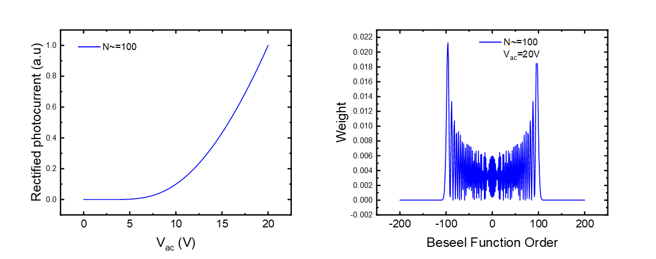
Supplementary Figure 8. Photon-assisted tunneling with no photon-order limitation (above barrier). a) Photocurrent variation with field strength b) Weight of contribution from different photon orders.

Supplementary Figure 9. Simulation of Photon-Assisted Tunneling yield for various photon energies. The dark red line covers the field strengths used in our experiments. PAT predicts a higher slope than the one experimentally measured (see Supplementary Fig. 11 for the mid-IR pulse) and simulated by the F-E model.

I-V and photocurrent characteristics modelling using two-electrode Fowler-Nordheim emission theory

In Fowler-Nordheim (F-N) tunneling, electrons overcome ionization potential under a strong electric field, tunnel through a thinned barrier and accelerate through an insulating medium. F-N tunneling requires an extremely strong electric field (on the order of 10 ⁸ V/m, requiring laser intensities > 10⁹ W cm²), which corresponds precisely to the field strength across nanogap in our experiments. Considering the configuration of our double Schottky barrier diode devices, we describe the electron emission process in two F-N tunneling terms as shown below. The first term corresponds to electron emission from Aluminum to gold and the second term corresponds to electron emission from gold to Aluminum. For the case of external bias being applied, this means that the first term and second term are assigned to positive and negative bias. For the case of the laser-induced field, the two terms are assigned to the opposite directions of the electric field, the positive and negative part of field cycles.
$$\begin{aligned}j\left(F\right)∝Θ\left(-F\right){\left|F\right|}^{2}\exp\left(-\frac{4\sqrt{2m_{e}}Φ_{1}^{\frac{3}{2}}}{3ℏeβ\left|F\right|}\right)-Θ\left(F\left(t\right)\right){\left|F\left(t\right)\right|}^{2}\exp\left(-\frac{4\sqrt{2m_{e}}Φ_{2}^{\frac{3}{2}}}{3ℏeβ\left|F\right|}\right)\#\left(S1\right)\end{aligned}$$
where $e$ is the elementary charge, $m_{e}$ is the electron mass, $j$ is the instantaneous current density crossing the nanoscale junction, $β$ is the enhancement factor, F is the field strength, $Φ_{1}^{ }$(4.12eV) is the work function of Al and $Φ_{2}^{ }$ (5.2eV) is the work function of Au. $Θ$ is the Heaviside function and is used here to differentiate between negative and positive bias or the opposite directions of laser electric field during its cycles. Therefore, $Θ\left(-F\right)=1$and $Θ\left(F\left(t\right)\right)=0$, when bias or laser electric field has direction from Al to Au, and $Θ\left(-F\right)=0$and $Θ\left(F\left(t\right)\right)=1$, when bias or laser electric field has direction from Au to Al. In the case of biased (no optical field) experiments, the effective area of the current is proportional to the entire 4mmx40nm nanochannel. In experiments with optical fields, the photocurrent only originates from the illuminated spot area. For a single pair of Al-Au emitters, the current term from Al to Au is determined by work function $Φ_{1}^{ }$, and the current term from Au to Al is determined by the work function $Φ_{2}^{ }$. For barriers $Φ_{1}^{ }$ and $Φ_{2}^{ }$, to simplify the model, we only consider the dominant processes and we do not consider the spatial variation of the barriers, such as bending at the interface.
The field strength F is the sum of the optical field and the DC electric field,
$$\begin{aligned}F=E_{opt}+\frac{V_{DC}}{d}\#\left(S2\right)\end{aligned}$$
where $E_{opt}$ is the laser electric field, $d$ is the nanogap distance, and $V_{DC}$ is the DC bias. The optical field, $E_{opt}$, is kept independent of the distance for simplification. For the case of no light:
$$\begin{aligned}F=\frac{V_{DC}}{d}\#\left(S3\right)\end{aligned}$$

For the I-V curve fitting (no light), it is necessary to include the enhancement factor $β$ between 10-100. $β$ varies with changes in emitter material and geometry² and cathode-anode distances. Therefore, a fixed factor from I-V fitting for different devices is extracted. In the optical measurement analysis shown below, a fixed $β$ value is used for all wavelength fitting. We did not induce a wavelength dependence on $β$ due to plasmonic enhancement for optical measurement, because Aluminium plasmonic resonance is supposed to be strong in DUV and will not be a dominant varying parameter within a wider spectrum span.
However, if the impact of large gaps on different kinetic energy electrons, such as the Simple man's mode³ , or effects like plasmonic enhancement, needs correction, the distance will also affect the optical field. The field strength of the DC electric field is directly related to the bias voltage $V_{Dc}$ and gap length d. The simulated and experimental I-V characteristic of the nanogap without applying an optical field is shown in Supplementary Fig. 10.
Supplementary Figure. 10. Measured dark current (red dot) and simulated J-V characteristic (dark blue line) in Fowler-Nordheim regime. They show good agreement when only DC bias is applied.

Fowler-Nordheim modelling of PANs photocurrent under different wavelengths irradiation [Fig. 2 of the main text]
Supplementary Figure 11. Model (lines) compared to measured experimental data for photocurrent (points) for different wavelengths and fluences (see Fig. 2a of the main text).

When laser pulse is present, and there is no applied DC biased then the field strength is,
$$\begin{aligned}F=E_{opt}\#\left(S4\right)\end{aligned}$$
But laser electric field is a function of time and space:
$$\begin{aligned}F\left(r,t\right)=E_{opt}\left(r,t\right)\#\left(S5\right)\end{aligned}$$
Thus, the F-N expression becomes:
$$\begin{aligned}j\left(r,t\right)∝Θ\left(-F\right){\left|F\right|}^{2}\exp\left(-\frac{4\sqrt{2m_{e}}Φ_{1}^{\frac{3}{2}}}{3ℏeβ\left|F\right|}\right)-Θ\left(F\left(t\right)\right){\left|F\left(t\right)\right|}^{2}\exp\left(-\frac{4\sqrt{2m_{e}}Φ_{2}^{\frac{3}{2}}}{3ℏeβ\left|F\right|}\right)\#\left(S6\right)\end{aligned}$$
Then, the average photocurrent readout J from the measurement experiment is:
$$\begin{aligned}J=\frac{Q}{τ_{rep}}=A_{eff}\int_{R_{focus}}^{ }{\int_{τ_{pulse}}^{ }{j(F\left(r,t\right))drdt }}\#\left(S7\right)\end{aligned}$$
where $Q$ is the charge readout by lock-in amplifier, $τ_{rep}$ is inverse of laser repetition rate, $R_{focus}$ is the measured beam waist on focal position and $τ_{pulse}$ is pulse duration. $A_{eff}$ is a fitted pre-factor to match the amplitude of measured photocurrent, it is positively correlated effective number of emitters and it further varies at different mediums (e.g. vacuum to air) - more detailed in Table S2. j($r,t$) is the instant current flow scale with the probability determined by F-E emission. $F(r,t)$ is the instant field strength and it is calculated as follows:
$$\begin{aligned}F\left(r,t\right)=E_{opt}+\frac{V_{dc}}{d}=\sqrt{\frac{{2I}_{opt}\left(r,t\right)}{cϵ_{0}}}+V_{dc}\#(S8)\end{aligned}$$
$$\begin{aligned}I_{opt}\left(r,t\right)=I_{center}\exp\left(-4\ln{2}\left(\frac{t^{2}}{τ_{FWHM}^{2}}+\frac{r^{2}}{{\left({2R}_{focus}\right)}^{2} }\right)\right)\exp\left(iωt+ϕ\right)\#(S9)\#\end{aligned}$$

$$\begin{aligned}I_{center}=\frac{2P_{avg}}{f_{Rep}*0.94τ_{pulse}* πR_{focus}^{2}}\#(S10)\end{aligned}$$

When $V_{dc}=0$, $F(r,t)$ scale with intensity on position $r$ and at instant time $t$ (we put beam center as $r=0$, and temporal peak position as $t=0$). Here, the $τ_{FWHM}$, pulse duration FHWM, was taken from autocorrelation measurements (Fig. 2, Supplementary Fig. 17 , Supplementary Fig. 18, Supplementary Fig. 19). $P_{avg}$ is the measured average power. F(r,t) rapidly oscillates on every optical-cycle with a frequency $ω$, but current direction is secured by the device asymmetry and the fact that we are working with multi-cycle pulses CEP will only have an influence on sub-cycle part of the pulse.

The fitting process is as follows: The F-E emission characteristic for PAN is determined by fitting the DC measurement to j(F), as shown in the previous section. It is worth noting that we didn't use a varied system ($β and d)$ for different wavelengths. We mainly fit A to match the measured current to the model, but at the same time, we give a tolerable range to $R_{focus}$ considering radius changing due to the z position of the sample and the mismatch from ellipticity, which is detailed in Table S2.
The parameter A remained consistent within one order of magnitude except for the 6570nm measurement. For the MIR pulse dry air is used during the experiment to minimize MIR absorption by water molecules. This change of environment is suggested to cause this one-order difference, this is also reflected in the photocurrent as a function of fluence graph, where MIR pulse achieves high photocurrents in relatively low fluences (low field strengths).

Table S2. Fitted A_{eff} and Radius for all wavelengths. The bracket value is from the estimation of beam diameter and focus.
Central wavelength | A_{eff} | Radius (um)
266nm | 3.82e6 | 57.53 (~50/100 on x/y axis)
400nm | 9.70e6 | 86.72 (~50)
800nm | 1.61e6 | 141.68 (~100)
800nm + HCF | 1.64e6 | 124.12(~100)
1450nm | 5.02e6 | 138.95(~175)
6570nm | 8.71e7 | - ~100)

Keldysh parameter estimation
The Keldysh parameter is defined as a function of ionization potential $I_{p}$ over ponderomotive kinetic energy $U_{p}$.
$$\begin{aligned}γ=\sqrt{\frac{I_{p}}{2U_{p}}}\#(S12)\end{aligned}$$

in which we calculate $U_{p}$ as follows:[17]
$$\begin{aligned}U_{p}=\frac{e^{2}β^{2}E^{2}}{4m_{e}ω^{2}}\#\left(S13\right)\end{aligned}$$

To demonstrate most of our experiment is performed under the field-driven ($γ$>1) condition. We calculated $γ$ under a fixed focus spot size and pulse duration, as shown in Supplementary Fig. 12.
Supplementary Figure 12. Keldysh parameter versus peak fluence for various photon energies. For 400 nm (blue square dot), the maximum (left) of γ is 2.54.

Modelling of bias-dependent nonlinearity
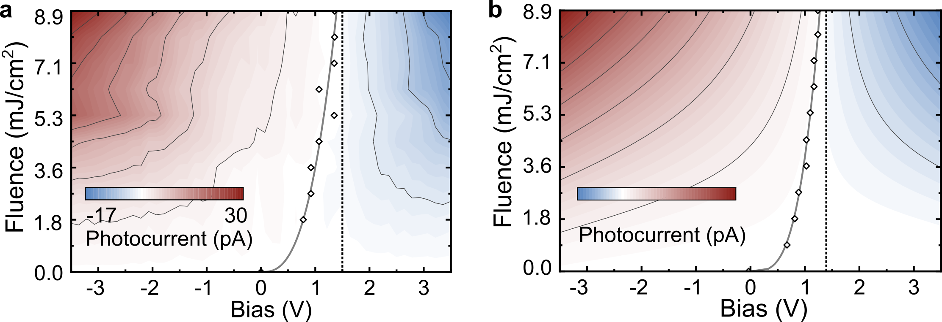

Supplementary Figure 13. Modeling of Biased Photocurrent. a) Measured 2D map of photocurrent as a function of bias voltage and pump fluence (same as Fig. 2d).b) Simulated photocurrent map based on a photoemission model.
Supplementary Figure 14. Power-photocurrent relationship under different bias. Comparing to peak optical field, DC field is relatively weak (~0.01 V/A), however, a slight slope change could be observed. We averaged 2.5 V-3 V and 0-0.5 V photocurrent-power slope, and the experimental data showed a predicted trend from F-E model.

Modelling photocurrent generation based on F-N tunneling and classic trajectories of electrons
In PAN, electron pulse trains are generated by the optical field, with electrons emitted at various moments within the optical cycle exhibiting different kinetic energies. As the electron beam travels from one electrode to another, it experiences time delays and stretching. While precise measurements are required to determine the electron pulse shape, methods such as electron-photon cross-correlation techniques are applicable. However, the severity of delays and deformations can be estimated through calculations of electron trajectories. These methods include the Time-Dependent Schrödinger Equation (TDSE) and the classical Simple-Man Model (SMM), both of which have been successful in predicting the shape of the kinetic spectrum (34). Computational estimates indicate that, due to the relatively small nanogap distance, the pulse delays are on the order of femtoseconds, and the electron pulses do not exhibit significant broadening. The rate of electron emission is calculated using Fowler-Nordheim (F-N) emission, and their trajectory is determined using classical kinetics:
$$a(t)=-\frac{eγE}{m_{e}}$$
Taking a similar form from tip enhancement on one-electrode field emission, we put exponential decay on both sides of the electrode with the following form:
$$γ=\sum_{i=1}^{2}{\left(α-1\right)*{\left(\frac{r_{i}}{r_{0}+x}\right)}^{3}+exp⁡(-2ln2*\frac{{(x-x_{center})}^{2}}{d_{focus}^{2}})}$$

Supplementary Fig. 15 illustrates the density of electrons emitted at various phases of the optical field. Electrons emitted during the tail of the pulse or at times when the optical field strength within a cycle is weak exhibit a "quiver motion." This occurs because the field strength is insufficient to propel the electrons across to the opposite electrode within half a cycle. Nonetheless, due to the enhancement profile, the electrons do not decelerate as much as they accelerate, allowing most of them to continue moving forward when the next positive half-cycle begins. A small portion of the electrons will return to the same electrode, where they are considered to be absorbed. We did not account for elastic collisions in this process. This dynamic can lead to pulse distortion. Due to relatively short gap distances, it is possible to maintain the duration of the electron pulse at a level comparable to that of the optical pulse, as depicted in Supplementary Fig. 16.
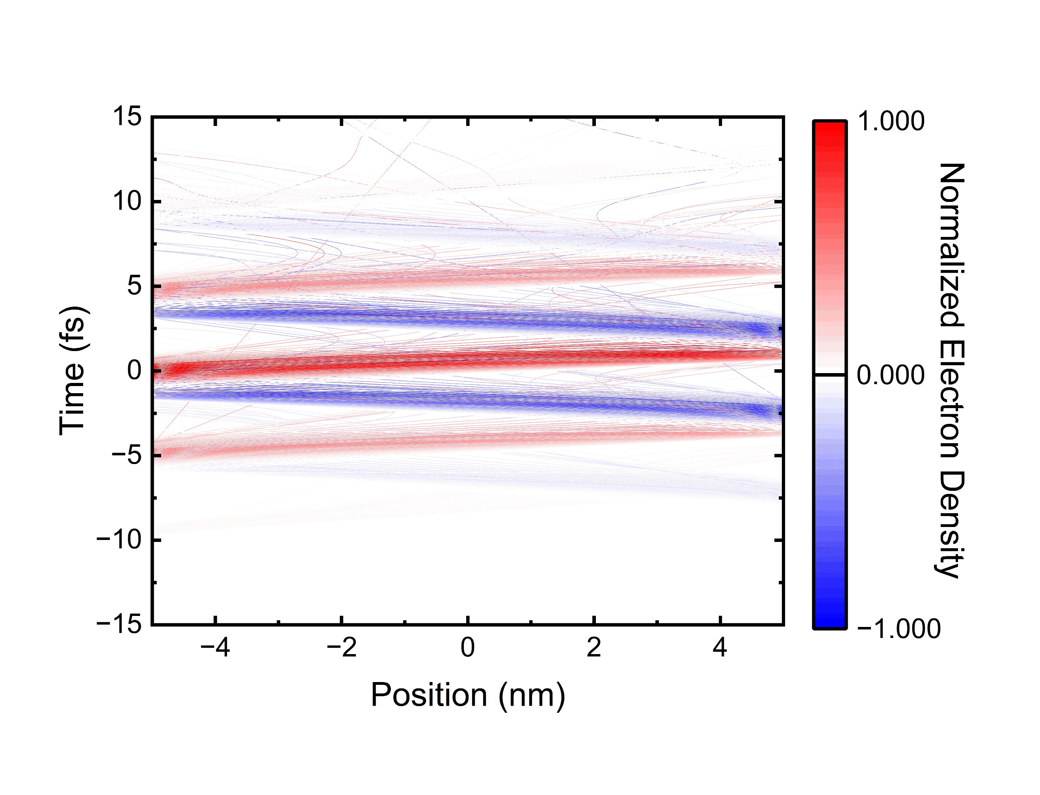
Supplementary Figure 15. Electron trajectory analysis under 1450 nm, 10 fs illumination reveals the maximum electron density emitted from aluminium (red) and gold (blue). Most electrons arrive at the opposite electrode after a short delay. Depending on the phase in the optical-cycle, several electrons exhibit quiver motion, and some return to the emitting electrode.
Supplementary Figure 16. Deformation of the electron pulse occurs under 1450 nm, 10 fs illumination. We analyzed the initial temporal profile of electrons emitted from aluminium (red) and the final temporal profile upon arrival at the gold electrode (blue). This delay increases as the ionization wavelength shifts to shorter wavelengths, corresponding to shorter optical cycles.

Characterisation of 800 nm chirped pulses using PANs
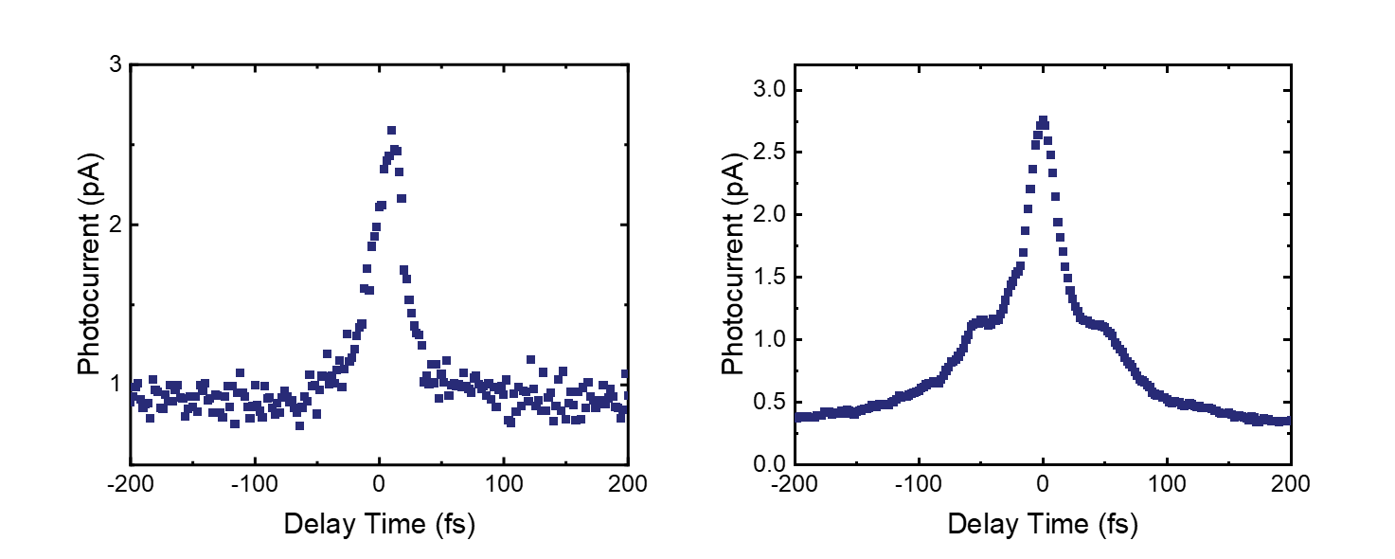
Supplementary Figure 17. Characterization of 800nm chirped pulses using nanogap. a) without chirping and b) with chirping.

Intensity autocorrelation is performed on a compressed 800 nm pulse by changing its compression. Nanogap autocorrelation can clearly follow the distortion of the pulse shape introduced by the intentional chirping.

Spectrum retrieved from MIR autocorrelation
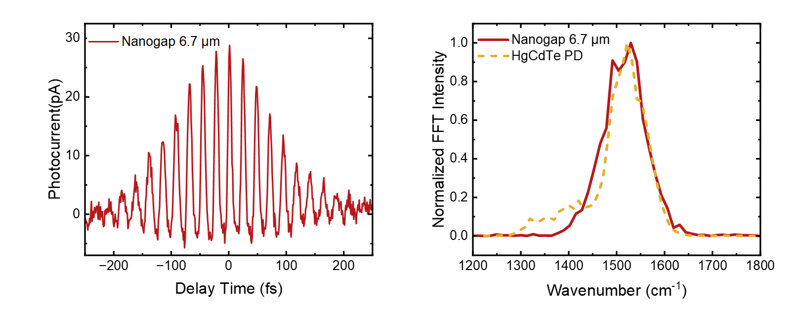
Supplementary Figure 18. MIR photocurrent autocorrelation from PAN. Left, interferometric photocurrent for collinear autocorrelation with 6.7 μm pulses. Right, Retrieved spectrum comparison between Pan autocorrelation and linear response of HgCdTe detector.

The collinear autocorrelation for the case of MIR 6.7 μm gives interferometric fringes, allowing Fourier Transform to extract the MIR spectrum. The spectrum extracted from the PAN is compared with the spectrum extracted from the MIR linear response of HgCdTe detector.

400 nm autocorrelation
Supplementary Figure 19. Autocorrelation photocurrent on PAN for 400 nm pulse.

Simulation of autocorrelation in PAN
In an n^{th} order autocorrelation, Intensity of an n-photon response crystal/photodetector gives a photocurrent according to:
$$\begin{aligned}I\left(τ\right)=\int_{-∞}^{∞}{{|\left[E+E\left(t-τ\right)\right]}^{2}{\left.​\right|}^{n}dt}\#\left(S14\right)\end{aligned}$$
In PAN, we could have a correlation according to instant nonlinear response from a similar term:
$$\begin{aligned}J\left(τ\right)=\int_{-∞}^{∞}{j(E+E\left(t-τ\right) dt}\#\left(S15\right)\end{aligned}$$
With a sufficiently strong field strength where the slope is slowly varying, it has a feature similar to fixed order autocorrelation, which is compared in Supplementary Fig. 20.
Supplementary Figure 20. Comparison of calculated nanogap autocorrelation and various order of nonlinear response. Interferometric autocorrelation is calculated with a center wavelength of 6.7μm.

Fabrication of QD and ZnO devices based on PANs
Chemicals:
Cesium Bromide (CsBr, 99.999%), Lead bromide (PbBr₂, 99.999%), 1-octadecene (ODE, technical grade, 90 %), bis(trimethylsilyl) sulfide ((TMS)₂S, synthesis grade), dibenzo-21-crown-[7] (DB21C7, 97%), N,N-dimethylformamide (DMF, anhydrous, ≥99.9%) , Toluene (anhydrous, ≥99.5%), oleic acid (OA, ≥99%), octylamine (OctAm, ≥98%), n-butanol (anhydrous, ≥99.8%), octadecylphosphonic acid (ODPA, 97%), zinc oxide (ZnO, 99.99% trace-metal basis), ammonium hydroxide (50% v/v aqueous) were purchased from Sigma-Aldrich. Acetone (99.8%), hexane (95%) were purchased from Fisher Scientific. Bismuth (III) acetate (Bi(OAc)3, 99%) was obtained from Thermo Scientific. Silver acetate (Ag(OAc), 99%, anhydrous was purchased from Alfa Aesar. All chemicals were used as received.

Synthesis of CsPbBr₃ QD Nanocubes:
Precursor solutions were prepared by adding 0.1 mmol of CsBr, 0.1 mmol of DB₂₁C₇, 0.1 mmol of PbBr₂, and 1 ml of DMF in a 7 ml vial under stirring until all chemicals were dissolved. Subsequently, 150 μl of the precursor was added dropwise into a vigorous stirring solution containing 5 ml of toluene, 0.3 ml of OA, 25 μl of OctAm, and 2 ml of n-butanol for 1 min. Following this, the crude reaction solution was purified using two centrifuge steps.
In the first step, the crude reaction solution was centrifuged at 8500 rpm for 10 mins. The precipitant was collected and redispersed in 1 ml toluene. The dispersion was then centrifuged at 3000 rpm for 1 min. The supernatant was collected and filtered through a 0.22 um filter before deposition onto the nanogap electrode chip.
To confirm that the synthesized quantum dots meet the expected size and are sufficiently small to enter nanogaps, we characterized them through both transmission electron microscopy (TEM) and UV-VIS absorption/PL spectroscopy. We analysed the size statistics from TEM (Supplementary Fig. 21) and the position of the PL peaks (Supplementary Fig. 23). Both results indicated that the size of the majority of quantum dots meets the requirements for entry into nanogaps.
Synthesis of AgBiS2 QDs:
Synthesis of AgBiS2 QDs followed the hot-injection method as described previously⁴.
In short, Ag(OAc) (133.5 mg, 0.8 mmol), Bi(OAc)3 (386,1 mg, 1 mmol), OlAc (6 mL, 19.2 mmol) and 4 ml of ODE were loaded in a 50 mL flask and heated up to 100 °C for 2h under vacuum. Then, the system was filled with N2 and (TMS)2S (1 mmol, 210 µL) diluted in 1 mL of ODE was swiftly injected into the reaction vessel. The heating was removed and the reaction mixture was quickly cooled with a water bath. The reaction mixture was stirred at room temperature for ca. 60 min. For purification, AgBiS2 QDs were precipitated from the crude solution acetone and subsequent centrifugation. The supernatant was discarded, and the precipitate was dispersed in 6 mL of hexane and stirred overnight. The solution was centrifuged for 3 min at 10000 rpm (10956 RCF). The precipitate was discarded and acetone was added to the solution in small portions until the solution became turbid and the QDs were precipitated with centrifugation. Purified QDs were dispersed in toluene for further use. The QDs exhibit a typical size of 4.5nm in average.

Preparation of ZnO solution:
Precursor solution of ZnO was prepared by dissolving zinc oxide powder in ammonium hydroxide at a concentration of 10 mg ml⁻¹.

Deposition of ZnO ,CsPbBr₃ QDs and AgBiS₂ QDs into the nanogap:

ZnO:
The ZnO solution was spin-coated onto the nanogap electrodes at 4000 rpm for 40 s, followed by 35 min thermal annealing at 180 °C in air. A second layer of the same solution was spin-coated, following exactly the same procedure to yield a film thickness of around 40 nm.

CsPbBr₃ QDs and AgBiS₂ QDs:
CsPbBr₃ QDs and AgBiS₂ QDs were introduced into the ~10 nm PAN nanogaps via an air‑brush spray deposition technique combined with dielectrophoretic (DEP) trapping. The QD colloidal solutions were prepared by diluting 1 mL of the as‑synthesized QDs solution with 10 mL of toluene. Subsequently, 100 µL of this diluted solution and 1 mL of toluene were added into a 7 mL vial for deposition. The QD solutions were atomized using a precision air‑brush under a controlled compressed‑air flow (~0.5 L min⁻¹) and directed toward the nanogap surface from a distance of ~10 cm to ensure uniform coverage. Simultaneously, an AC electric field (100 kHz, 2 Vpp​) was applied across the nanogap electrodes using a Zurich lock‑in amplifier, generating a sufficiently high field gradient to induce DEP trapping and selectively drive QDs into the gap region. The trapping process was maintained for ~60 s, after which the devices were rinsed with toluene to remove excess QDs outside the nanogap and gently dried under a N₂ stream. The degree of nanogap filling was reproducibly controlled by adjusting the initial QD solution concentration, enabling systematic studies of QD occupancy effects.(Supplementary Fig. 24, Supplementary Fig. 25).

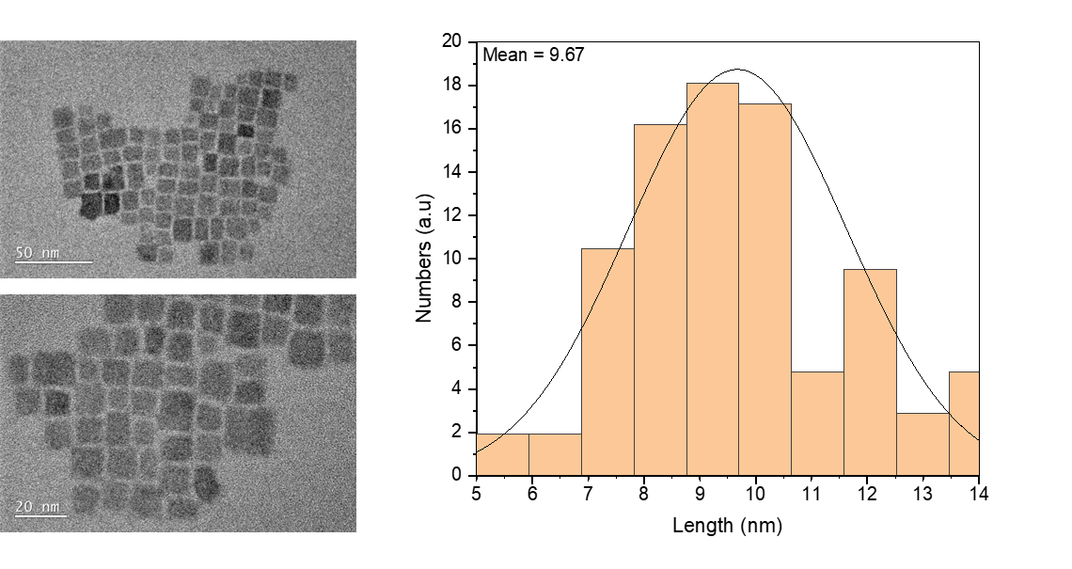
Supplementary Figure 21. TEM images of synthesized CsPbBr₃ nanocrystals and the size statistics.

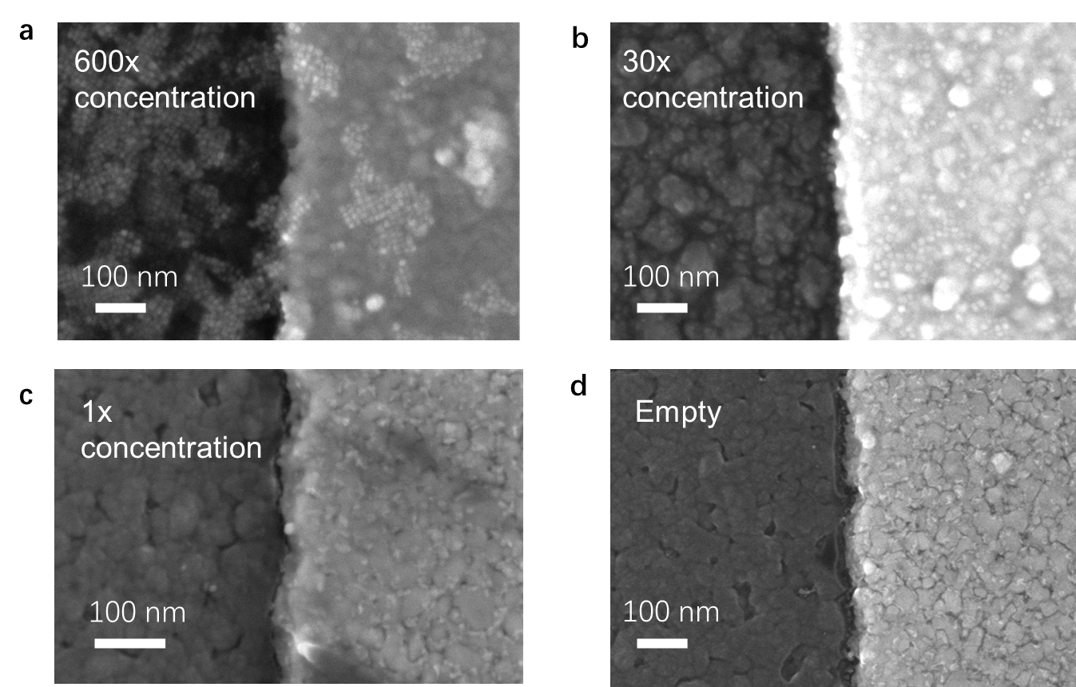
Supplementary Figure 22. SEM images of PAN nanogaps after drop-casting CsPbBr₃ quantum dot solutions with varying concentrations: (a) 600×, (b) 30×, (c) 1×, and (d) empty gap (no QDs). Increasing QD solution concentration results in progressively denser QD deposition within the ~10 nm nanogap, whereas low-concentration solutions lead to sparse filling, and the empty control shows no QD occupancy.

Supplementary Figure 23. Absorption and PL spectra of CsPbBr₃ nanocrystals with <10nm average size. The excitonic feature is seen in the absorption part, and the PL peak position indicates the average size is between 9 nm~10 nm. FWHM of PL peak is around 90 meV.
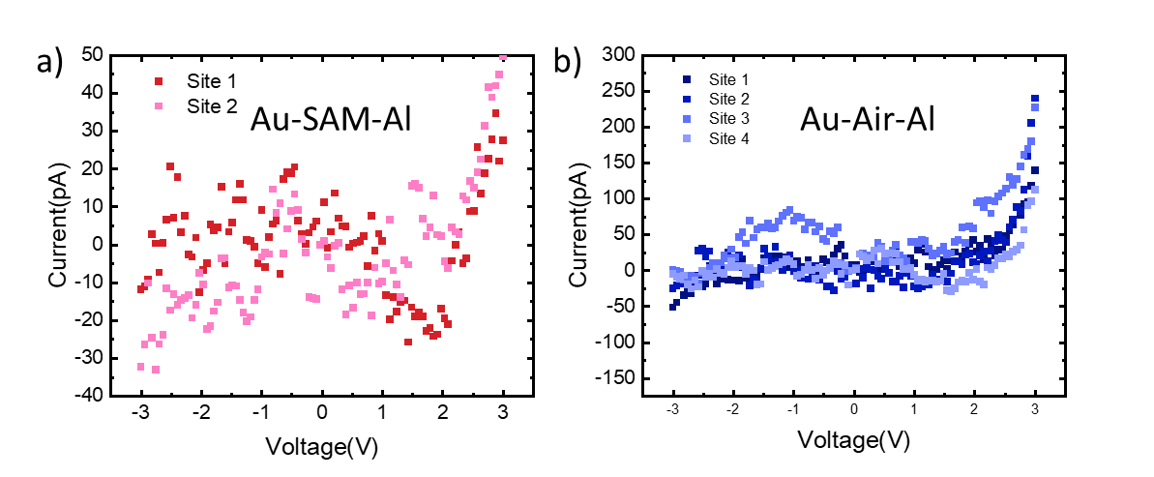
Supplementary Figure 24. Implementation of perovskite QDs into the nanogap. I-V characteristic curves for various states of the nanogap: a) air, including the SAM-layer on the Al electrode, b) air, after removing the SAM.

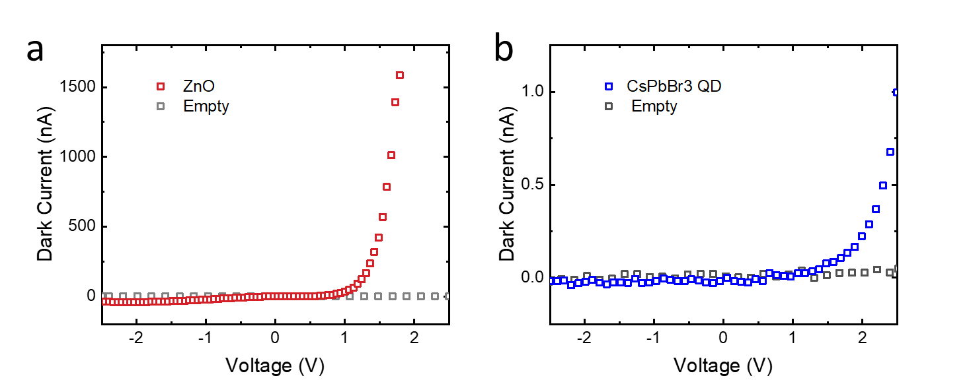
Supplementary Figure 25. I-V characteristics of different materials within the nanogap. Black dots indicate a reference from the air gap. a) ZnO. b) CsPbBr₃ QD. ZnO shows a much higher current due to its very low conduction band, which is closer to the work function of the Al electrode.

Tunneling photocurrent map on dark quantum dots
To demonstrate the capability of PANs for probing non-emissive nanosystems, we also deposited AgBiS₂ quantum dots (QDs) into the nanogap and performed spatially resolved tunneling photocurrent mapping under dark conditions. Supplementary Fig. 26 shows a large-area scan of photocurrent signals recorded in the absence of optical excitation. Clear photocurrent hotspots appear along the nanogap edges after deposition, suggesting the incorporation of AgBiS₂ QDs within the nanogap. These findings highlight the sensitivity of PAN-based tunneling detection for identifying dark or non-emissive nanosystems at the single-particle level. In contrast to fluorescence-based techniques, this method does not rely on optical emission and can thus be applied to a broader range of materials, including metal chalcogenides and strongly quenched systems.

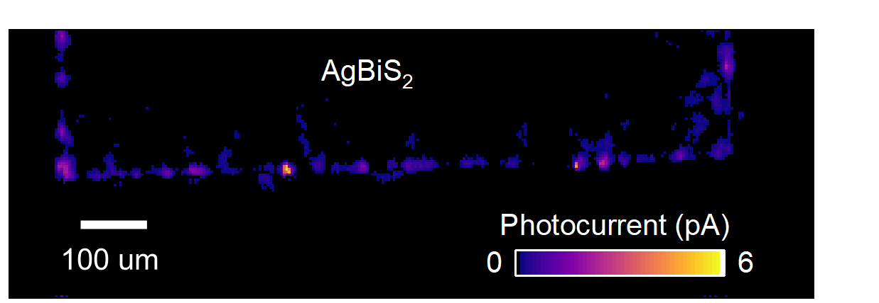

Supplementary Figure 26. Mapping of AgBiS₂ quantum dots in PANs. Tunneling photocurrent map of AgBiS₂ in PANs.

Transient absorption of drop-cast nanocrystal film
We performed transient absorption spectroscopy (TAS) to establish a baseline for the dynamics observed in single quantum dots (QDs) via tunneling photocurrent measurements. To this end, we prepared a drop-cast CsPbBr₃ nanocrystal (NC) film and recorded its carrier dynamics using TAS.
We used a 1 kHz Ti:Sapphire laser (pulse width <100 fs), with a 400 nm pump (via second harmonic generation) and a white-light probe generated in sapphire. Measurements were conducted under multiple excitation fluences to enable comparison with the high-fluence conditions used in our microscope (PAN) setup.
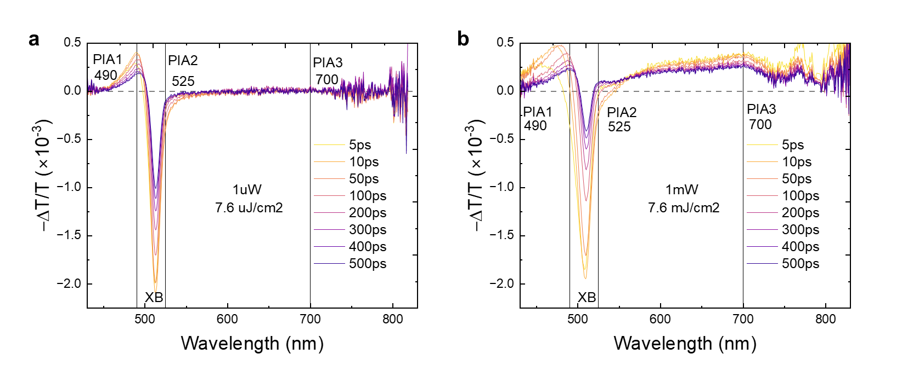
Supplementary Figure 27. Transient absorption spectra and carrier kinetics of drop-casted CsPbBr₃ nanocrystal film. TAS spectra at low (a) and high (b) pump fluences. GSB appears around 510 nm, while PIA features are visible near 490 nm, 525 nm, and above 700 nm.

The TAS spectra are shown in Supplementary Fig. 27. Under both high and low fluence, we observed a strong ground-state bleach (GSB) around 510 nm, along with three photoinduced absorption (PIA) features near 490 nm, 525 nm, and >700 nm. The key difference appears in the high-wavelength PIA region (>700 nm), where the high-fluence condition yields a significantly broader and stronger tail.
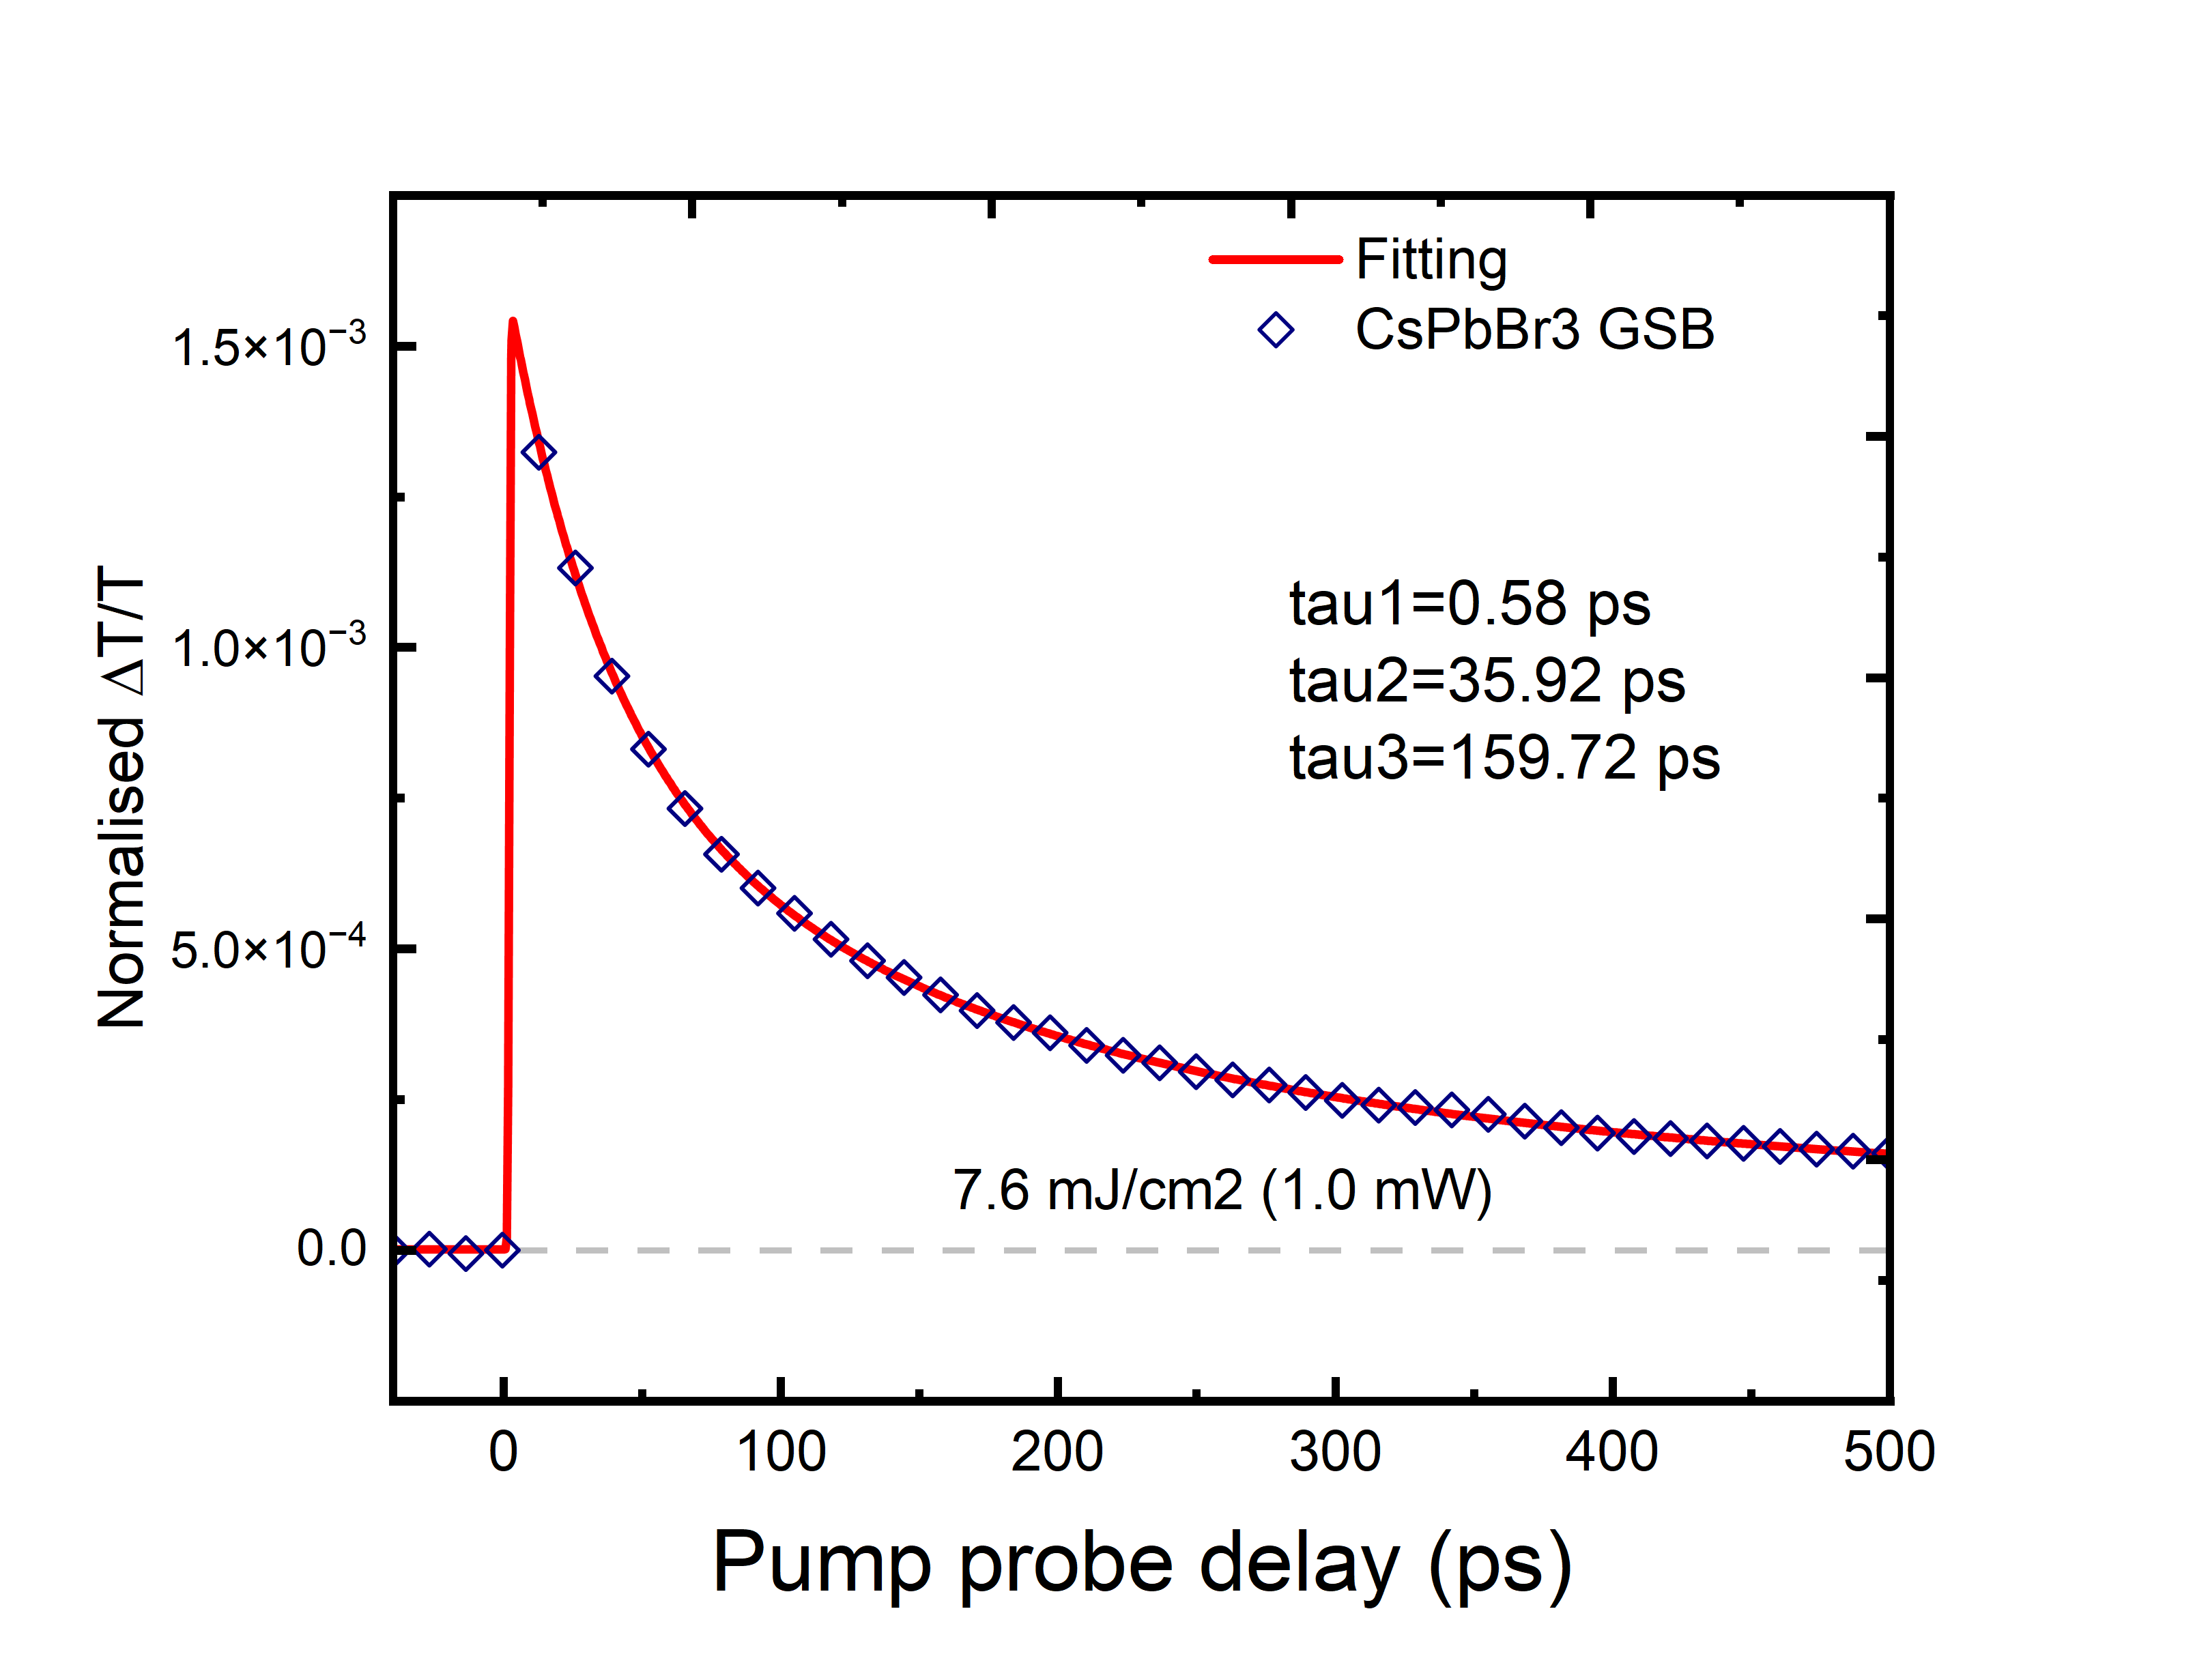
Supplementary Figure 28. Kinetic decay and fitting at the GSB wavelength.

We then compared the extracted exciton dynamics between the TAS (Supplementary Fig. 28) and PAN measurements. In the PAN data, we observe a hot-carrier relaxation component faster than 1 ps, followed by the main decay within ~10–20 ps. In contrast, the TAS of the drop-casted CsPbBr₃ NC film shows a similar initial hot-carrier relaxation component (τ₁ = 0.58 ps), but a much longer exciton lifetime (τ₃ = 158.72 ps), along with an intermediate decay (τ₂ = 35.92 ps) attributed to Auger recombination and rapid trapping.
This difference aligns with prior reports showing that carrier dynamics in nanocavity systems⁵ and STM-based platforms⁶ differ substantially from bare-film systems ⁷. In the PAN measurements, the ~10 nm nanogap could lead to a mode small volume(V) and therefore a large Purcell enhancement factor ($F_{p}\sim Q/V)$ .Purcell-enhanced local photonic density of states, which strongly accelerates the radiative recombination rate—comparable to STM tunneling-induced emission lifetimes.

Sub-15 fs pump-probe tunneling photocurrent on PANs

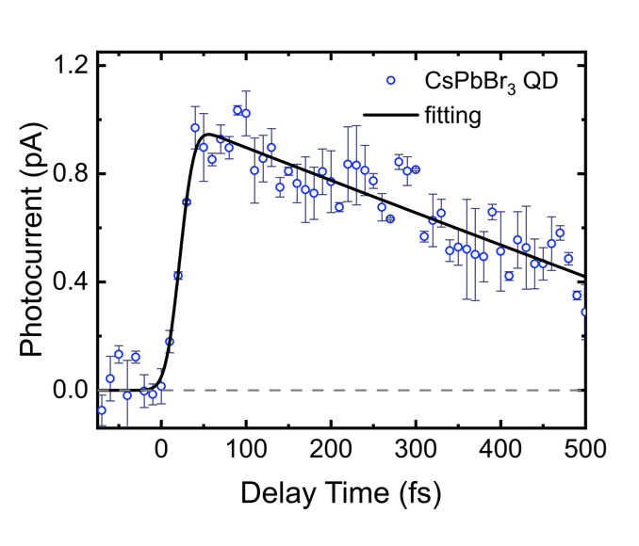
Supplementary Figure 29. Sub-15 fs time resolution tunneling electron probe measurement of electronic dynamics in CsPbBr₃ QD-filled nanogap. A high concentration of QD solution was used during deposition resulting in ~100 QDs within the observation volume. A 10-fs 400 nm pump and ~12-fs tunneling-driving probe 800 nm were utilized in the experiment. The line is an exponential decay function convoluted with a 12-fs Gaussian response function.

1 Schiffrin, A. et al. Optical-field-induced current in dielectrics. Nature 493, 70–74 (2013). https://doi.org/10.1038/nature11567
2 Garg, M. & Kern, K. Attosecond coherent manipulation of electrons in tunneling microscopy. Science 367, 411–415 (2020). https://doi.org/doi:10.1126/science.aaz1098
3 Rybka, T. et al. Sub-cycle optical phase control of nanotunnelling in the single-electron regime. Nature Photonics 10, 667–670 (2016). https://doi.org/10.1038/nphoton.2016.174
4 Albaladejo-Siguan, M. et al. Bis(stearoyl) Sulfide: A Stable, Odor-Free Sulfur Precursor for High-Efficiency Metal Sulfide Quantum Dot Photovoltaics. Advanced Energy Materials 13, 2203965 (2023). https://doi.org/https://doi.org/10.1002/aenm.202203965
5 Hoang, T. B., Akselrod, G. M. & Mikkelsen, M. H. Ultrafast Room-Temperature Single Photon Emission from Quantum Dots Coupled to Plasmonic Nanocavities. Nano Lett 16, 270–275 (2016). https://doi.org/10.1021/acs.nanolett.5b03724
6 Kimura, K. et al. Ultrafast on-demand exciton formation in a single-molecule junction by tailored terahertz pulses. Science 387, 1077–1082 (2025). https://doi.org/10.1126/science.ads2776
7 Jun, S. et al. Ultrafast and Bright Quantum Emitters from the Cavity-Coupled Single Perovskite Nanocrystals. ACS Nano 18, 1396–1403 (2024). https://doi.org/10.1021/acsnano.3c06760

