Supplemental information
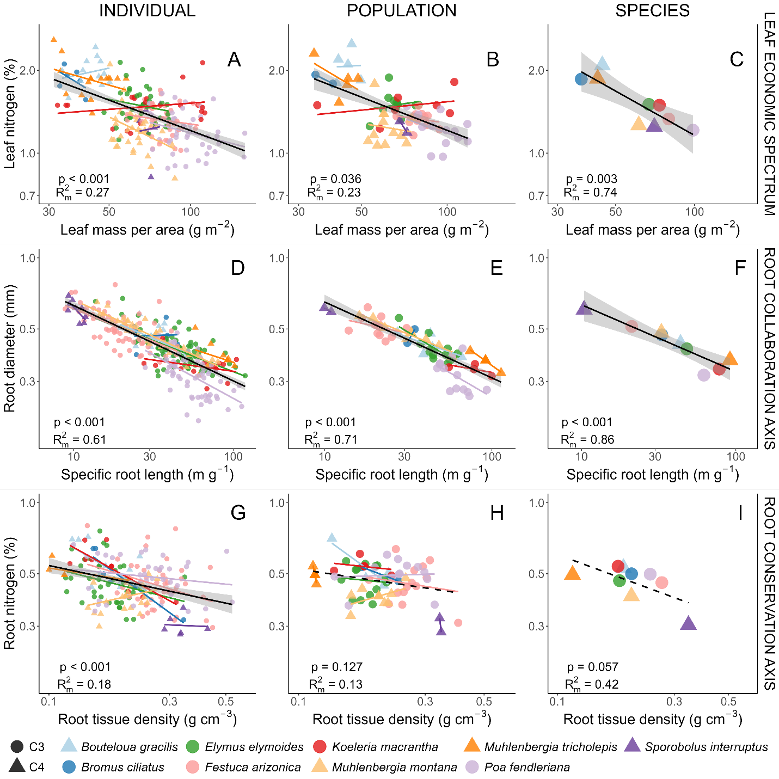
Figure S1. Bivariate trait relationships with Carex geophila excluded from the analysis between plant functional traits associated with the leaf economic spectrum (A-C), root collaboration axis (D-F), and root conservation axis (G-I) among individuals (A, D, G), populations (B, E, H), and species (C, F, I). Main effects are plotted as solid black lines with a gray band representing 95% confidence intervals. Species-level relationships were modelled as random intercepts and are plotted using colored lines. Photosynthetic pathway is indicated by the shape for C3 (circle) and C4 (triangle) species. R² and overall model p-values are reported for each model.

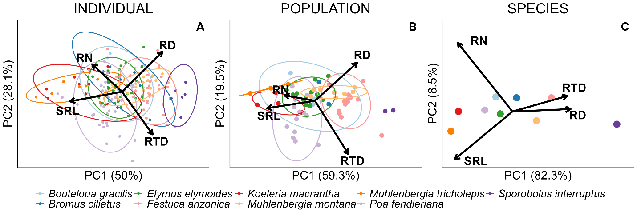

Figure S2. Principal component analyses with Carex geophila excluded from the analysis of traits among individuals, populations, and species. Species ellipses represent 2 standard deviations from the mean centroid.
 | Individual-level (A) |  |  | Population-level (B) |  |  | Species-level (C)
 | PC1 | PC2 | PC3 | PC1 | PC2 | PC3 | PC1 | PC2 | PC3
Eigenvalue: | 1.999 | 1.123 | 0.758 | 2.373 | 0.782 | 0.753 | 3.293 | 0.339 | 0.314
SRL | -0.662 | -0.148 | -0.234 | -0.612 | -0.111 | -0.256 | -0.511 | -0.560 | 0.211
RD | 0.516 | 0.612 | -0.079 | 0.538 | 0.575 | 0.172 | 0.517 | 0.029 | -0.561
RTD | 0.390 | -0.654 | 0.508 | 0.428 | -0.806 | 0.254 | 0.487 | 0.184 | 0.800
RN | -0.379 | 0.419 | 0.825 | -0.390 | 0.084 | 0.917 | -0.484 | 0.807 | -0.016
Table S1. Eigenanalysis of plant functional traits associated with PCAs in Figure S2.

Table S2. Mean, minimum, and maximum functional trait values among individuals, populations, and species.
 | Individual |  |  | Population |  |  | Species
 | Mean | Min. | Max. | Mean | Min. | Max. | Mean | Min. | Max.
Bouteloua gracilis | N=50 |  |  | N=5 |  |  | N=1
LMA | 44.46 | 33.55 | 59.42 | 44.56 | 40.83 | 49.71 | 44.56 | NA | NA
LN | 2.09 | 1.58 | 2.53 | 2.09 | 1.80 | 2.49 | 2.09 | NA | NA
SRL | 43.84 | 19.49 | 147.9 | 43.89 | 27.26 | 66.09 | 43.89 | NA | NA
RD | 0.43 | 0.28 | 0.58 | 0.43 | 0.38 | 0.48 | 0.43 | NA | NA
RTD | 0.19 | 0.11 | 0.29 | 0.19 | 0.13 | 0.22 | 0.19 | NA | NA
RN | 0.53 | 0.40 | 0.72 | 0.52 | 0.45 | 0.70 | 0.52 | NA | NA
Bromus ciliatus | N=20 |  |  | N=2 |  |  | N=1
LMA | 36.97 | 31.77 | 43.35 | 36.97 | 34.37 | 39.57 | 36.97 | NA | NA
LN | 1.86 | 1.56 | 2.11 | 1.86 | 1.79 | 1.93 | 1.86 | NA | NA
SRL | 33.15 | 23.96 | 44.69 | 32.92 | 31.27 | 34.57 | 32.92 | NA | NA
RD | 0.47 | 0.39 | 0.56 | 0.47 | 0.44 | 0.50 | 0.47 | NA | NA
RTD | 0.20 | 0.15 | 0.34 | 0.21 | 0.17 | 0.24 | 0.21 | NA | NA
RN | 0.50 | 0.32 | 0.64 | 0.50 | 0.47 | 0.53 | 0.50 | NA | NA
Carex geophila | N=125 |  |  | N=14 |  |  | N=1
LMA | 73.47 | 30.56 | 128.9 | 73.49 | 60.41 | 80.17 | 73.49 | NA | NA
LN | 1.39 | 1.00 | 1.80 | 1.40 | 1.20 | 1.65 | 1.40 | NA | NA
SRL | 26.13 | 6.22 | 80.91 | 24.85 | 12.51 | 38.18 | 24.85 | NA | NA
RD | 0.39 | 0.24 | 0.58 | 0.39 | 0.29 | 0.45 | 0.39 | NA | NA
RTD | 0.38 | 0.14 | 0.65 | 0.41 | 0.27 | 0.57 | 0.41 | NA | NA
RN | 0.53 | 0.20 | 1.30 | 0.53 | 0.41 | 0.87 | 0.53 | NA | NA
Elymus elymoides | N=94 |  |  | N=14 |  |  | N=1
LMA | 66.91 | 43.92 | 94.30 | 66.28 | 53.40 | 79.41 | 66.28 | NA | NA
LN | 1.50 | 1.12 | 2.14 | 1.50 | 1.25 | 1.88 | 1.50 | NA | NA
SRL | 48.13 | 13.71 | 118.8 | 47.68 | 27.82 | 62.40 | 47.68 | NA | NA
RD | 0.41 | 0.32 | 0.67 | 0.41 | 0.36 | 0.56 | 0.41 | NA | NA
RTD | 0.18 | 0.09 | 0.38 | 0.18 | 0.14 | 0.21 | 0.18 | NA | NA
RN | 0.47 | 0.32 | 0.76 | 0.47 | 0.37 | 0.57 | 0.47 | NA | NA
Festuca arizonica | N=122 |  |  | N=14 |  |  | N=1
LMA | 79.68 | 58.26 | 126.0 | 79.42 | 66.33 | 93.95 | 79.42 | NA | NA
LN | 1.33 | 1.02 | 1.69 | 1.33 | 1.16 | 1.49 | 1.33 | NA | NA
SRL | 21.15 | 8.85 | 44.60 | 21.14 | 13.94 | 30.93 | 21.14 | NA | NA
RD | 0.51 | 0.36 | 0.77 | 0.51 | 0.44 | 0.62 | 0.51 | NA | NA
RTD | 0.27 | 0.09 | 0.44 | 0.27 | 0.18 | 0.40 | 0.27 | NA | NA
RN | 0.46 | 0.30 | 0.80 | 0.46 | 0.31 | 0.64 | 0.46 | NA | NA
Koeleria macrantha | N=56 |  |  | N=7 |  |  | N=1
LMA | 73.48 | 29.56 | 152.2 | 75.09 | 34.88 | 106.0 | 75.09 | NA | NA
LN | 1.49 | 1.18 | 2.13 | 1.49 | 1.23 | 1.81 | 1.49 | NA | NA
SRL | 78.14 | 27.58 | 137.4 | 78.14 | 55.30 | 99.83 | 78.14 | NA | NA
RD | 0.34 | 0.27 | 0.46 | 0.34 | 0.32 | 0.35 | 0.34 | NA | NA
RTD | 0.18 | 0.09 | 0.36 | 0.18 | 0.14 | 0.22 | 0.18 | NA | NA
RN | 0.54 | 0.38 | 0.70 | 0.54 | 0.49 | 0.61 | 0.54 | NA | NA
Muhlenbergia montana | N=126 |  |  | N=12 |  |  | N=1
LMA | 61.27 | 40.98 | 89.60 | 61.87 | 52.70 | 74.83 | 61.87 | NA | NA
LN | 1.26 | 0.81 | 2.10 | 1.24 | 1.07 | 1.78 | 1.24 | NA | NA
SRL | 32.94 | 11.30 | 80.12 | 33.43 | 16.13 | 57.83 | 33.43 | NA | NA
RD | 0.48 | 0.34 | 0.65 | 0.48 | 0.38 | 0.57 | 0.48 | NA | NA
RTD | 0.20 | 0.12 | 0.32 | 0.20 | 0.16 | 0.25 | 0.20 | NA | NA
RN | 0.40 | 0.30 | 0.50 | 0.40 | 0.33 | 0.48 | 0.40 | NA | NA
Muhlenbergia tricholepis | N=50 |  |  | N=5 |  |  | N=1
LMA | 42.67 | 22.51 | 79.14 | 42.67 | 33.98 | 48.57 | 42.67 | NA | NA
LN | 1.87 | 1.39 | 2.58 | 1.87 | 1.53 | 2.30 | 1.87 | NA | NA
SRL | 91.70 | 57.81 | 152.9 | 92.58 | 74.20 | 113.6 | 92.58 | NA | NA
RD | 0.37 | 0.29 | 0.51 | 0.37 | 0.32 | 0.40 | 0.37 | NA | NA
RTD | 0.12 | 0.09 | 0.21 | 0.12 | 0.11 | 0.12 | 0.12 | NA | NA
RN | 0.50 | 0.44 | 0.60 | 0.50 | 0.45 | 0.54 | 0.50 | NA | NA
Poa fendleriana | N=107 |  |  | N=13 |  |  | N=1
LMA | 98.67 | 55.15 | 158.5 | 96.19 | 72.14 | 118.1 | 96.19 | NA | NA
LN | 1.21 | 0.88 | 1.65 | 1.21 | 0.97 | 1.48 | 1.21 | NA | NA
SRL | 62.12 | 28.08 | 150.9 | 62.12 | 47.11 | 93.36 | 62.12 | NA | NA
RD | 0.32 | 0.20 | 0.48 | 0.32 | 0.26 | 0.41 | 0.32 | NA | NA
RTD | 0.24 | 0.10 | 0.53 | 0.24 | 0.14 | 0.33 | 0.24 | NA | NA
RN | 0.50 | 0.35 | 0.66 | 0.50 | 0.37 | 0.60 | 0.50 | NA | NA
Sporobolus interruptus | N=20 |  |  | N=2 |  |  | N=1
LMA | 70.22 | 60.79 | 84.80 | 70.22 | 68.17 | 72.27 | 70.22 | NA | NA
LN | 1.25 | 0.82 | 1.51 | 1.25 | 1.19 | 1.31 | 1.25 | NA | NA
SRL | 10.41 | 9.22 | 11.86 | 10.47 | 9.97 | 10.96 | 10.47 | NA | NA
RD | 0.60 | 0.53 | 0.69 | 0.60 | 0.59 | 0.61 | 0.60 | NA | NA
RTD | 0.34 | 0.29 | 0.42 | 0.34 | 0.34 | 0.34 | 0.34 | NA | NA
RN | 0.30 | 0.28 | 0.36 | 0.30 | 0.28 | 0.32 | 0.30 | NA | NA

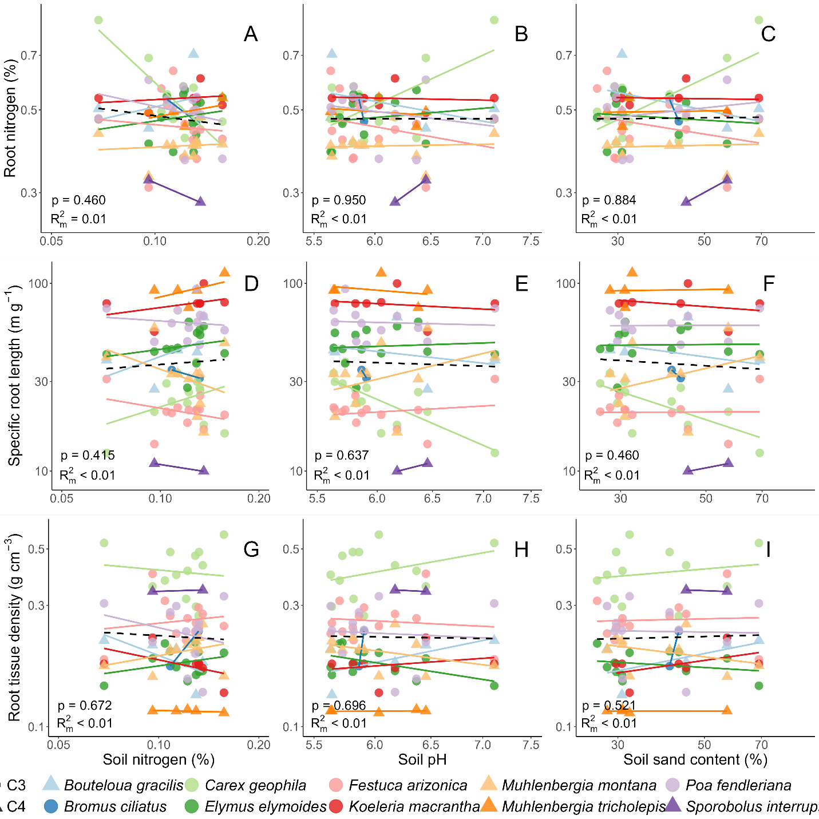
Figure S3. Relationship between root traits and soil properties. This figure shows the relationship between the roots traits RN, SRL, and RN an soil properties soil nitrogen content, soil pH, and soil sand content at the population level. Non-significant main effects are dashed lines without a confidence interval. Species-level relationships are plotted using colored lines. Photosynthetic pathway is indicated by the shape for C3 (circle) and C4 (triangle) species. Marginal R² ($R_{m}^{2})$ and overall model p-values are reported for each model.

