Supplementary Table 1. Patient characteristics for Sub-group analyses
 | Sub-group Analysis 3A |  |  | Sub-group Analysis 3B
 | Post-treatment, normal cyto, n=81 | Control,  n=39 | p value | Post-treatment, Normal cyto, HPV negative,  n=70 | Control,  HPV negative,  n=23 | p value
Age, years |  |  | 0.1144 |  |  | 0.0106
Mean (SD, range) | 31.6 (5.1, 25 – 43) | 30.1 (4.4, 20 – 43) |  | 31.7 (5.2, 25 – 43) | 29.8 (3.3, 24 – 37)
Ethnicity , n/N (%) |  |  | 0.2098 |  |  | 0.0487
Caucasian | 69/81 (86) | 30/39 (77) |  | 59/70 (84) | 15/23 (65)
Asian | 6/81 (7) | 2/39 (5) |  | 6/70 (9) | 2/23 (9)
Black | 6/81 (7) | 7/39 (18) |  | 5/70 (7) | 6/23 (26)
Parity, n/N (%) |  |  | 0.5168 |  |  | 0.2848
Nulliparous | 56/81 (69) | 30/39 (76) |  | 48/70 (69) | 19/23 (80)
Parous | 25/81 (31) | 9/39 (24) |  | 22/70 (31) | 4/23 (20)
Smoking status, n/N (%) |  |  | 0.3447 |  |  | 0.1413
Current smoker | 20/81 (25) | 6/39 (15) |  | 18/70 (25) | 2/23 (9)
Non-smoker | 61/81 (75) | 33/39 (85) |  | 52/70 (75) | 20/23 (91)
Phase of menstrual cycle, n/N (%) |  |  | 0.3257 |  |  | 0.5137
Luteal | 36/81 (45) | 23/39 (58) |  | 31/70 (44) | 13/23 (56)
Follicular | 40/81 (49) | 14/39 (36) |  | 34/70 (49) | 8/23 (35)
Unknown | 5/81 (6) | 2/39 (5) |  | 5/70 (7) | 2/23 (9)
Contraception, n/N (%) |  |  | 0.8009 |  |  | 0.4619
Nil | 28/81 (35) | 19/39 (49) |  | 24/70 (35) | 12/23 (55)
Condoms | 16/81 (20) | 5/39 (13) |  | 15/70 (21) | 2/23 (9)
COCP | 27/81 (33) | 12/39 (31) |  | 22/70 (32) | 7/23 (32)
POP | 3/81 (4) | 1/39 (2) |  | 3/70 (4) | 1/23 (4)
Copper IUD | 1/81 (1) | 0/39 (0) |  | 1/70 (1) | 0/23 (0)
Mirena IUS | 4/81 (5) | 1/39 (2) |  | 3/70 (4) | 0/23 (0)
Contraceptive implant | 2/81 (2) | 1/39 (2) |  | 2/70 (3) | 0/23 (0)
Time since last intercourse, n/N (%) |  |  | 0.3321 |  |  | 0.7044
>48 hours | 72/81 (90) | 34/39 (87) |  | 63/70 (90) | 20/23 (87)
<48 hours | 8/81 (10) | 5/39 (13) |  | 7/70 (10) | 3/23 (13)
HPV status |  |  | 0.0006 |  |  | >0.9999
Negative | 70/81 (86) | 23/39 (59) |  | 70/70 (100) | 23/23 (100)
Positive | 11/81 (14) | 12/39 (31) |  | 0/70 (0) | 0/23 (0)
Unknown | 0/81 (0) | 4/39 (10) |  | 0/70 (0) | 0/23 (0)
Cytology |  |  | >0.9999 |  |  | >0.9999
Negative | 81/81 (100) | 39/39 (100) |  | 70/70 (100) | 23/23 (100)
BNC | 0/81 (0) | 0/39 (0) |  | 0/70 (0) | 0/23 (0)
LSIL | 0/81 (0) | 0/39 (0) |  | 0/70 (0) | 0/23 (0)
HSIL | 0/81 (0) | 0/39 (0) |  | 0/70 (0) | 0/23 (0)
Cytology & HPV status |  |  | 0.0006 |  |  | >0.9999
Normal, HPV -ve | 70/81 (86) | 23/39 (59) |  | 70/70 (100) | 23/23 (100)
Normal, HPV +ve | 11/81 (14) | 12/39 (31) |  | 0/70 (0) | 0/23 (0)
Normal, HPV status unknown | 0/81 (0) | 4/39 (10) |  | 0/70 (0) | 0/23 (0)
BNC, HPV -ve | 0/81 (0) | 0/39 (0) |  | 0/70 (0) | 0/23 (0)
BNC, HPV +ve | 0/81 (0) | 0/39 (0) |  | 0/70 (0) | 0/23 (0)
LSIL, HPV -ve | 0/81 (0) | 0/39 (0) |  | 0/70 (0) | 0/23 (0)
LSIL, HPV +ve | 0/81 (0) | 0/39 (0) |  | 0/70 (0) | 0/23 (0)
HSIL | 0/81 (0) | 0/39 (0) |  | 0/70 (0) | 0/23 (0)
BNC: Borderline nuclear changes; CIN: Cervical intraepithelial neoplasia; COCP: Combined oral contraceptive pill; HSIL: high-grade squamous intraepithelial neoplasia; HPV: Human Papillomavirus; IUD: Intrauterine device; IUS: Intrauterine system; LSIL: low-grade squamous intraepithelial neoplasia; POP: Progesterone-only pill, SD: standard deviation.
Supplementary Table 2. Pre- and post-treatment CST and VMB dynamics according to cone length, proportion of cervical length excised and proportion of cervical length regeneration.
 |  | Cone length(mm)  Median 11.0 mm, range 7.0-22.0mm |  |  | Proportion of cervical length excised (%)  Median 33.2 %, range 22.0-79.6% |  |  | Proportion of cervical length regenerated (%)  Median 73.5 %, range 12.0-98.5%
 |  | Lower 50th percentile,  n=55 | Upper 50th percentile,  n=48 | p value | Lower 50th percentile,  n=52 | Upper 50th percentile,  n=51 | p value | Lower 50th percentile,  n=52 | Upper 50th percentile,  n=51 | p value
Pre-treatment | CST I  (L. crispatus) | 26/55 (47) | 19/48 (40) | 0.7375 | 24/52 (46) | 21/51 (41) | 0.2091 | 22/52 (42) | 23/51 (45) | 0.6000
Pre-treatment | CST III  (L. iners) | 18/55 (33) | 19/48 (40) | 0.7375 | 21/52 (40) | 16/51 (31) | 0.2091 | 21/52 (40) | 16/51 (31) | 0.6000
Pre-treatment | CST IV (Lactobacillus spp. deplete, high diversity) | 11/55 (20) | 10/48 (20) | 0.7375 | 7/52 (14) | 14/51 (28) | 0.2091 | 9/52 (18) | 12/51 (24) | 0.6000
Post-treatment | CST I  (L. crispatus) | 24/55 (44) | 16/48 (34) | 0.5750 | 20/52 (38) | 20/51 (39) | 0.9999 | 23/52 (44) | 17/51 (33) | 0.3527
Post-treatment | CST III  (L. iners) | 22/55 (40) | 22/48 (46) | 0.5750 | 22/52 (42) | 22/51 (43) | 0.9999 | 22/52 (42) | 22/51 (43) | 0.3527
Post-treatment | CST IV (Lactobacillus spp. deplete, high diversity) | 9/55 (16) | 10/48 (20) | 0.5750 | 10/52 (20) | 9/51 (18) | 0.9999 | 7/52 (14) | 12/51 (24) | 0.3527
Dynamics of CST’s | Same CST pre & post treatment | 36/55 (65) | 22/48 (46) | 0.0498 | 31/52 (60) | 27/51 (53) | 0.5539 | 31/52 (60) | 27/51 (53) | 0.5539
Dynamics of CST’s | Changed CST pre & post treatment | 19/55 (35) | 26/48 (54) | 0.0498 | 21/52 (40) | 24/51 (47) | 0.5539 | 21/52 (40) | 24/51 (47) | 0.5539
Dynamics of CST’s | Changed from one Lactobacillus dominant CST to another | 5/19 (26) | 9/26 (35) | 0.7460 | 12/21 (57) | 13/24 (54) | 1.000 | 13/21 (62) | 12/24 (50) | 1.000
Dynamics of CST’s | Changed from Lactobacillus dominant CST to CST IV | 3/19 (16) | 6/26 (23) | 0.7123 | 3/21 (14) | 6/24 (25) | 0.4764 | 3/21 (14) | 6/24 (25) | 0.4764
Dynamics of CST’s | Changed from CST IV to a Lactobacillus dominant CST | 5/19 (26) | 6/26 (23) | 1.000 | 3/21 (14) | 8/24 (33) | 0.1772 | 0/21 (0) | 1/24 (4) | 1.000
CST: Community state type, L.: Lactobacillus

Supplementary table 3. Cervical length regeneration according to pre- and post-treatment CST
Regeneration according to pre-treatment CST
 | Length of cone excised, mm  Average  (range, SD) | Cervical length at follow-up, mm  Average  (range, SD) | Proportional cervical length excised, %  Average  (range, SD) | Proportion cervical length regeneration, %  Average  (range, SD)
CST I,  n = 45 | 11.4  (7 – 22, 3.3) | 29.5  (23 – 42, 6.9) | 33.4  (12 – 80, 12.6) | 62.1  (14 – 98, 24.9)
CST III,  n = 37 | 12.0  (7 – 21, 3.6) | 28.4  (24 – 39, 6.7) | 36.8  (18 – 62, 11.0) | 70.4  (12 – 97, 21.3)
CST IV,  n = 21 | 11.6  (7 – 18, 3.8) | 30.1  (22 – 36, 4.0) | 32.4  (11 – 52, 11.6) | 70.7  (12 – 98, 22.4)
p value | 0.8490 | 0.8253 | 0.7027 | 0.3828
Regeneration according to post-treatment CST
 | Length of cone excised, mm  Average  (range, SD) | Cervical length at follow-up, mm  Average  (range, SD) | Proportional length excised, %  Average  (range, SD) | Proportion length regeneration, %  Average  (range, SD)
CST I,  n = 41 | 10.8  (7 – 21, 3.6) | 30.0  (24 – 42, 8.1) | 31.8  (12 – 62, 11.8) | 67.5  (15 – 94, 22.1)
CST III,  n = 39 | 12.1  (7 – 17, 2.8) | 29.2  (22 – 39, 4.8) | 35,8  (18 – 55, 9.0) | 68,0  (12 – 97, 24.9)
CST IV,  n = 16 | 12.2  (7 – 18, 3.8) | 28.2  (22 – 36, 4.5) | 37.7  (11 – 56, 13.0) | 62.5  (12 – 98, 23.0)
p value | 0.3418 | 0.8679 | 0.3301 | 0.6048
CST: Community state type, SD: standard deviation.

Supplementary Table 4. hBD-1 and SLPI levels per total protein concentration
 | hBD-1:total protein (pg/μg protein)  (median ± IQR) | SLPI:total protein (pg/μg protein)  (median ± IQR)
Analysis 1
Pre-treatment, n=80 | 5651 ± 6284 | 221437 ± 421810
Control, n=34 | 2096 ± 3503 | 86673 ± 97675
p value | 0.0033 | 0.0006
Analysis 2
Pre-treatment, n=80 | 5651 ± 6284 | 221437 ± 421810
Post-treatment, n=80 | 1007 ± 423 | 28392 ± 89230
p value | <0.0001 | <0.0001
Analysis 3
Post-treatment, n=80 | 1007 ± 1552 | 28392 ± 89230
Control, n=34 | 2096 ± 3503 | 86673 ± 97675
p value | 0.0029 | 0.0382
Sub-group analysis 3A
Post-treatment, normal cytology, n=65 | 956 ± 1388 | 36825 ± 70571
Control, n=34 | 2096 ± 3503 | 86673 ± 97675
p value | 0.0003 | 0.0009
Sub-group analysis 3B
Post-treatment, Normal cyto, HPV  negative, n=50 | 1038 ± 1523 | 26298 ± 32916
Control, HPV negative, n=20 | 2625 ± 5042 | 81669 ± 94238
p value | 0.0006 | 0.0016
HPV: Human Papillomavirus; IQR; interquartile range

Supplementary Table 5. Impact of treatment on levels of Levels of IL-1β, IL-8, IFN-γ and TNF-α
 | IL-1β:total protein (pg/μg protein)  (median ± IQR) | IL-8:total protein (pg/μg protein)  (median ± IQR) | Interferon-γ  pg/μg protein)  (median ± IQR) | TNF-α:total protein (pg/μg protein)  (median ± IQR)
Analysis 1
Pre-treatment, n=80 | 463.9 ± 714.2 | 408.8 ± 1085.2 | 13.7 ± 13.3 | 14.9 ± 39.3
Control, n=34 | 177.4 ± 284.3 | 199.9 ± 309.5 | 28.2 ± 74.5 | 13.1 ± 11.4
p value | <0.0001 | 0.0014 | 0.01 | 0.62
Analysis 2
Pre-treatment, n=80 | 463.9 ± 714.2 | 408.8 ± 1085.2 | 13.7 ± 13.3 | 14.9 ± 39.3
Post-treatment, n=80 | 497.8 ± 666.1 | 374.4 ± 1302.3 | 24.7 ± 58.2 | 8.9 ± 13.7
p value | >0.99 | >0.99 | 0.002 | 0.10
Analysis 3
Post-treatment, n=80 | 497.8 ± 666.1 | 374.4 ± 1302.3 | 24.7 ± 58.2 | 8.9 ± 13.7
Control, n=34 | 177.4 ± 284.3 | 199.9 ± 309.5 | 28.2 ± 74.5 | 13.1 ± 11.4
p value | <0.0001 | 0.0035 | >0.99 | >0.99
Sub-group analysis 3A
Post-treatment, normal cytology, n=65 | 421.7 ± 614.3 | 425.7 ± 1378.3 | 23.7 ± 54.6 | 9.6 ± 13.7
Control, n=34 | 177.4 ± 284.3 | 199.9 ± 309.5 | 28.2 ± 74.5 | 13.1 ± 11.4
p value | 0.0002 | 0.0005 | 0.4408 | 0.7102
Sub-group analysis 3B
Post-treatment, Normal cyto, HPV  negative, n=50 | 406.7± 639.7 | 362.6 ± 1358.0 | 23.8 ± 51.5 | 8.9 ± 9.6
Control, HPV negative, n=20 | 264.6 ± 343.2 | 116.6 ± 314.0 | 32.15 ± 58.8 | 13.1 ± 14.9
p value | 0.0097 | 0.0023 | 0.3721 | 0.3156
HPV: Human Papillomavirus; IQR; interquartile range

SUPPLEMENTARY FIGURES
A. Normal controls VS Post-treatment normal cytology (Subgroup Analysis 3A)
i. ii.
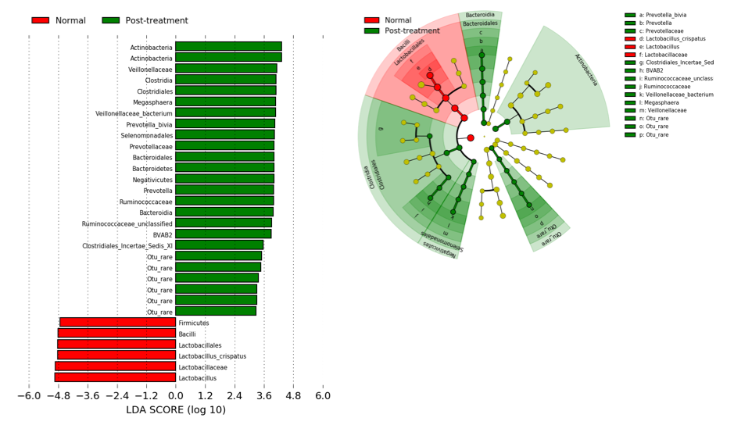

B. Normal HPV negative controls VS Post-treatment cytology & HPV negative (Subgroup Analysis 3B)
i. ii.
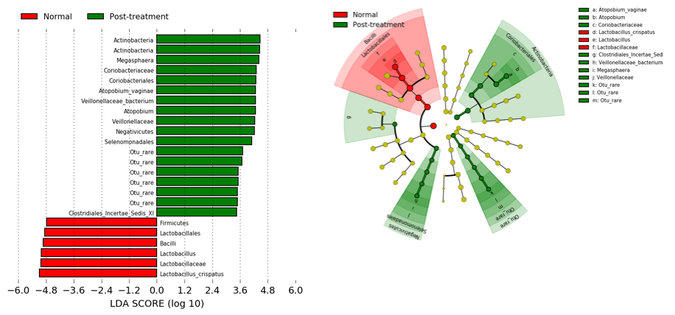
Supplementary Figure 1. LEfSe analysis identified vaginal microbiota differentially abundant taxa in the comparison of women with normal cytology post-treatment versus normal controls (Analysis 3A) and negative HPV and cytology post-treatment versus HPV and cytology negative controls (Analysis 3B).
(A) Analysis 3A: Prevotella bivia and BVAB2 were significant overrepresented at a species level in treated women with normal cytology compared to untreated controls. (B) Analysis 3B: Atopobium vaginae was overrepresented in the subgroup analysis restricted with HPV-negative treated women and HPV-negative treated controls. Lactobacillus crispatus was significantly more abundant in the control groups in both sub-group analyses (A & B).
- Histogram of LDA scores found to differ significantly in abundance between treated women compared to controls.
- Cladogram representing taxa at all phylogenetic levels with significantly different abundance in the compared groups. The size of the circle is proportional to the abundance of taxon represented.
KEY - LDA: linear discriminant analysis. NB. Analysis restricted to top 20 taxa with all remaining taxa denoted as ‘other
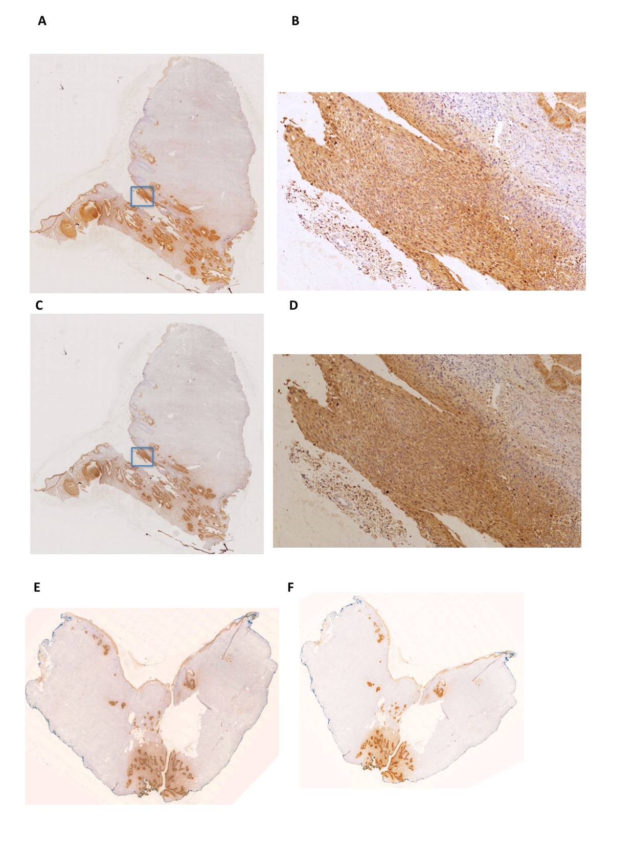
Supplementary Figure 2. Distribution of hBD1 and SLPI in a section from a cervical cone with CIN3 in the whole section and in an area with CIN3 (hBD1: A – B; SLPI: C – D). Distribution of hBD1 (E) and SLPI (F) after the same women after a second cone.
Staining for both peptides was strongest in the glandular epithelium and areas of high-grade CIN with weak staining of the normal squamous epithelium. The scarred epithelium appears to exhibit weak staining for both peptides compared to the untouched cervical and glandular epithelial surfaces.

A. B.
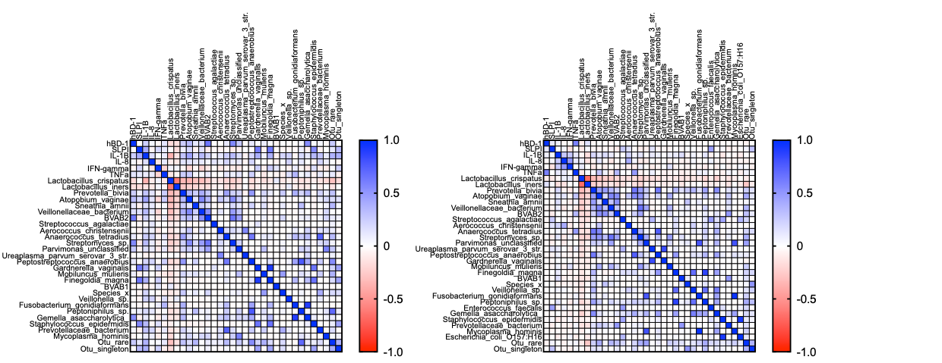

Supplementary Figure 3. Correlation between bacterial species, antimicrobial peptides and cytokines before (A) and after (B) treatment in 80 treated women (Pearson correlation coefficient).
Anaerobes such as Prevotella bivia (p=0.02), Atopobium vaginae (p=0.003), BVAB2 (p<0.001), Gardnerella vaginalis (p<0.001), Streptomyces sp. (p<0.001) & Gemella asaccharolytic (p<0.001)were positively correlated with AMP expression prior to treatment, all of which were also weakly positively correlated with expression of IL-1β and TNF-α. After treatment there is no significant change in bacterial composition, but AMP expression is no longer correlated with these bacterial species.

