Supplementary File
Index
Supplementary Table 1: Detailed search strategies used in different electronic databases
Supplementary Table 2: Newcastle Ottawa Scale for the quality assessment of the non-randomized cohort studies
Supplementary Table S3: Newcastle Ottawa Scale for the quality assessment of the non-randomized case-control studies
Supplementary Figure 1: Visual field normalization leave-out-out sensitivity analysis
Supplementary Figure 2: Good functional outcome leave-out-out sensitivity analysis
Supplementary Figure 3: Early neurological improvement funnel plot
Supplementary Figure 4: Visual field normalization funnel plot
Supplementary Figure 5: Good functional outcome funnel plot
Supplementary Figure 6: Excellent functional outcome funnel plot
Supplementary Figure 7: Symptomatic intracranial hemorrhage funnel plot
Supplementary Figure 8: Mortality at 90 days funnel plot
Supplementary Figure 9: Early neurological improvement, Egger's regression test
Supplementary Figure 10: Visual field normalization, Egger's regression test
Supplementary Figure 11: Good functional outcome, Egger's regression test
Supplementary Figure 12: Excellent functional outcome, Egger's regression test
Supplementary Figure 13: Mortality at 90 days, Egger's regression test
Supplementary Figure 14: Symptomatic intracranial hemorrhage, Egger's regression test
Supplementary Figure 15: Symptomatic intracranial hemorrhage, Begg's rank correlation test

Supplementary Table 1: Detailed search strategies used in different electronic databases
Databases | Search string | Articles retrieved
PubMed | ("Ischemic Stroke"[MeSH Terms] OR "Cerebral Infarction"[MeSH Terms]) AND ("Posterior Cerebral Artery"[MeSH Terms] OR "Proximal posterior Cerebral Artery"[All Fields] OR "infarction, posterior cerebral artery"[MeSH Terms] OR "Posterior cerebral artery occlusion"[All Fields] OR "Posterior cerebral artery stroke"[All Fields] OR (("Posterior Cerebral Artery"[MeSH Terms] OR ("posterior"[All Fields] AND "cerebral"[All Fields] AND "artery"[All Fields]) OR "Posterior Cerebral Artery"[All Fields]) AND ("dental occlusion"[MeSH Terms] OR ("dental"[All Fields] AND "occlusion"[All Fields]) OR "dental occlusion"[All Fields] OR "occlusion"[All Fields] OR "occlused"[All Fields] OR "occlusions"[All Fields] OR "occlusive"[All Fields] OR "occlusives"[All Fields]) AND ("stroke"[MeSH Terms] OR "stroke"[All Fields] OR "strokes"[All Fields] OR "stroke s"[All Fields])) OR "Isolated posterior cerebral artery occlusion"[All Fields] OR "MeVO"[All Fields] OR "MDVO"[All Fields] OR "PCA"[All Fields] OR "p1"[All Fields] OR "p2"[All Fields] OR "p3"[All Fields]) AND ("Embolectomy"[All Fields] OR "Thrombectomy"[MeSH Terms] OR "Endovascular thrombectomy"[All Fields] OR "medium vessel occlusion"[All Fields] OR "mechanical thrombectomy"[All Fields] OR "endovascular procedure"[All Fields] OR "endovascular therapy"[All Fields]) | 174
Cochrane Central | ("Ischemic Stroke" OR "Cerebral Infarction") AND ("Posterior Cerebral Artery" OR "Proximal posterior Cerebral Artery" OR "Infarction, Posterior Cerebral Artery" OR "Posterior cerebral artery occlusion" OR "Posterior cerebral artery stroke" OR "Posterior cerebral artery occlusion Stroke" OR "Isolated posterior cerebral artery occlusion" OR "MeVO" OR "MDVO" OR "PCA" OR "p1" OR "p2" OR "p3") AND ("Embolectomy" OR "Thrombectomy" OR "Endovascular thrombectomy" OR "medium vessel occlusion" OR "mechanical thrombectomy" OR "endovascular procedure" OR "endovascular therapy" ) | 43
ScienceDirect | ("Ischemic Stroke") AND ("Posterior Cerebral Artery" OR "Infarction, Posterior Cerebral Artery" OR "Posterior cerebral artery occlusion" OR "PCA") AND ("Embolectomy" OR "Endovascular thrombectomy" OR "mechanical thrombectomy" ) | 864

Supplementary Table S2: Newcastle Ottawa Scale for the quality assessment of the non-randomized cohort studies
Cohort Studies |  | Selection |  |  |  | Comparability | Exposure |  |  | Total
Author | Year | Representativeness of Exposed Cohort | Selection of the Non exposed cohort | Ascertainment of Exposure | Outcome was not Present at the start of Study | Comparability | Assessment of Outcome | Follow-up long enough for Outcomes to occur | Adequacy of follow-up of Cohorts | Total
Cunha | 2021 | * | * | * |  | ** | * | * |  | 7
Herweh | 2021 | * | * | * | * | * | * | * |  | 7
Maulucci | 2023 | * | * | * | * | ** | * | * | * | 9
Nguyen | 2023 | * | * | * | * | ** | * | * | * | 9
Sabben | 2023 | * | * | * | * | * | * | * |  | 7
Strambo | 2020 | * | * | * | * | * | * | * | * | 8
Salim | 2024 | * | * | * | * | ** | * | * | * | 9
Strambo | 2024 | * | * | * | * | * | * | * | * | 8
Dicpinigaitis | 2024 | * | * | * | * | ** | * | * | * | 9

Supplementary Table S3: Newcastle Ottawa Scale for the quality assessment of the non-randomized case-control studies
Study ID | Case Definition Adequate? | Representativeness of the Cases | Selection of Controls | Definition of Controls | Control for Demographics (eg. Age, Sex, BMI, etc.) | Control for Other Confounding Factors | Ascertainment of Exposure | Same Method of Ascertainment for Cases and Controls | Non-Response Rate | Overall
Meyer 2021 | * | * | * | * | * | * | * | * |  | 8

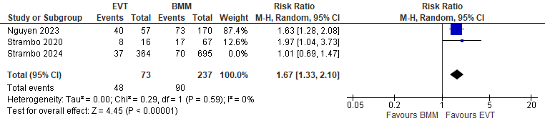
Supplementary Figure 1: Visual field normalization leave-out-out sensitivity analysis
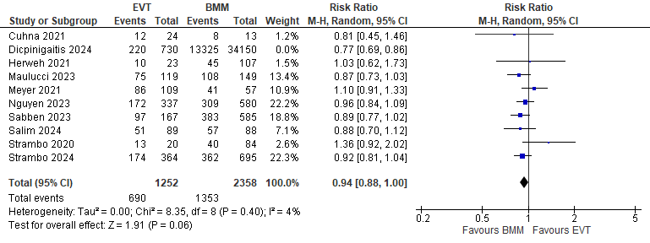
Supplementary Figure 2: Good functional outcome leave-out-out sensitivity analysis
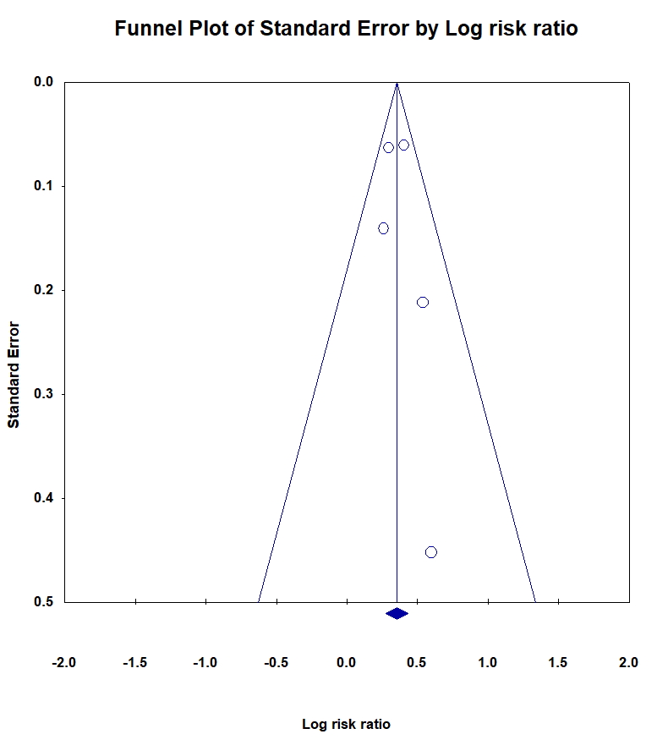

Supplementary Figure 3: Early neurological improvement funnel plot
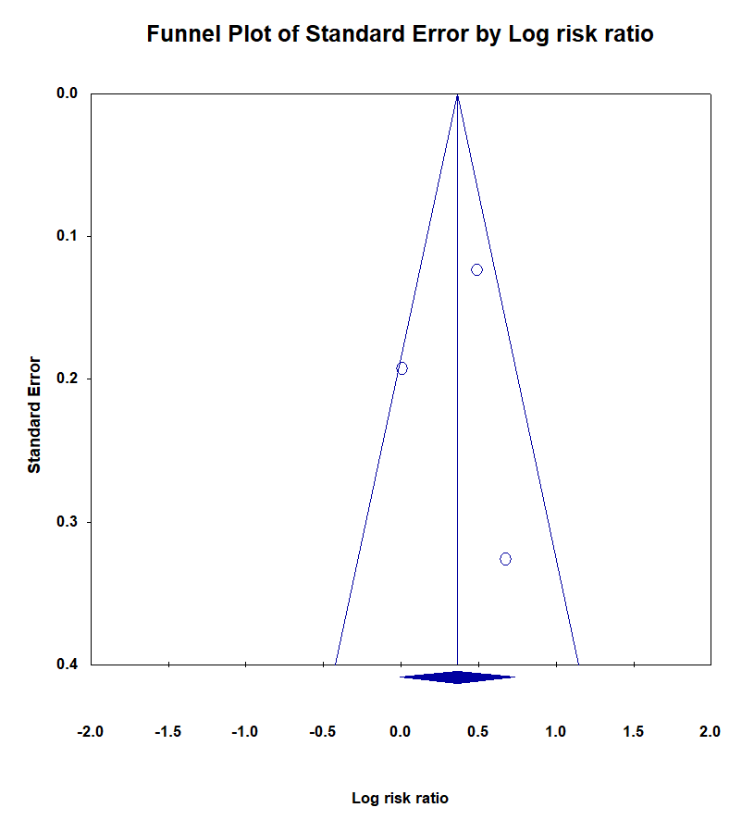

Supplementary Figure 4: Visual field normalization funnel plot
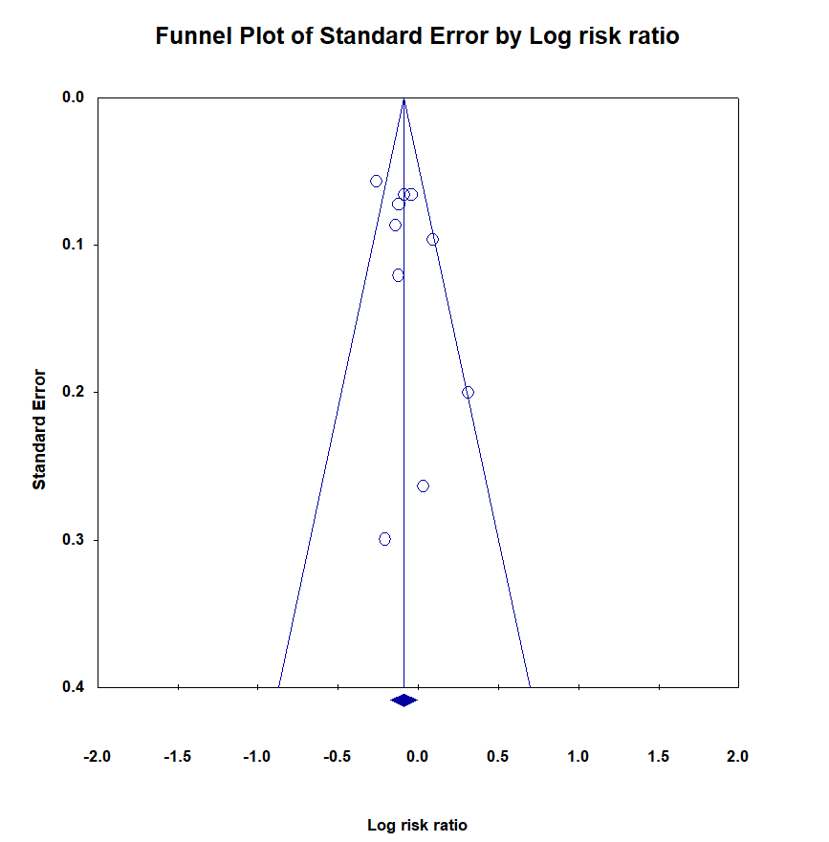

Supplementary Figure 5: Good functional outcome funnel plot
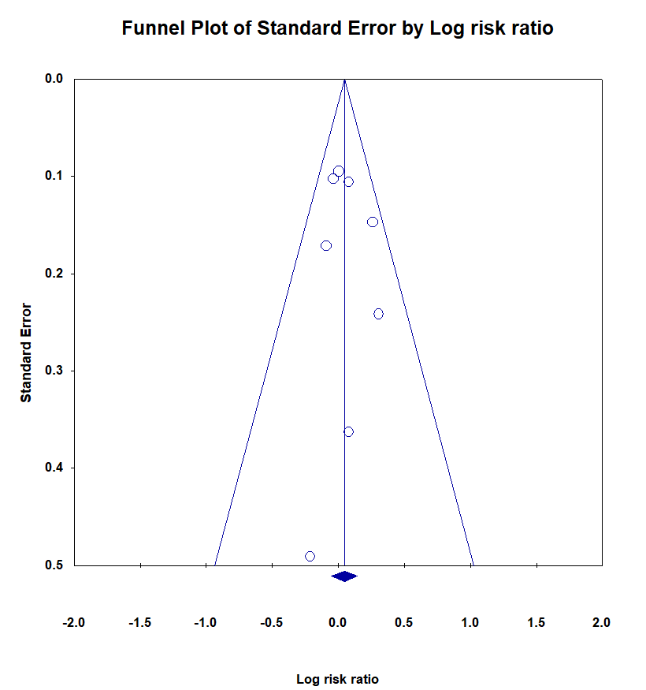

Supplementary Figure 6: Excellent functional outcome funnel plot
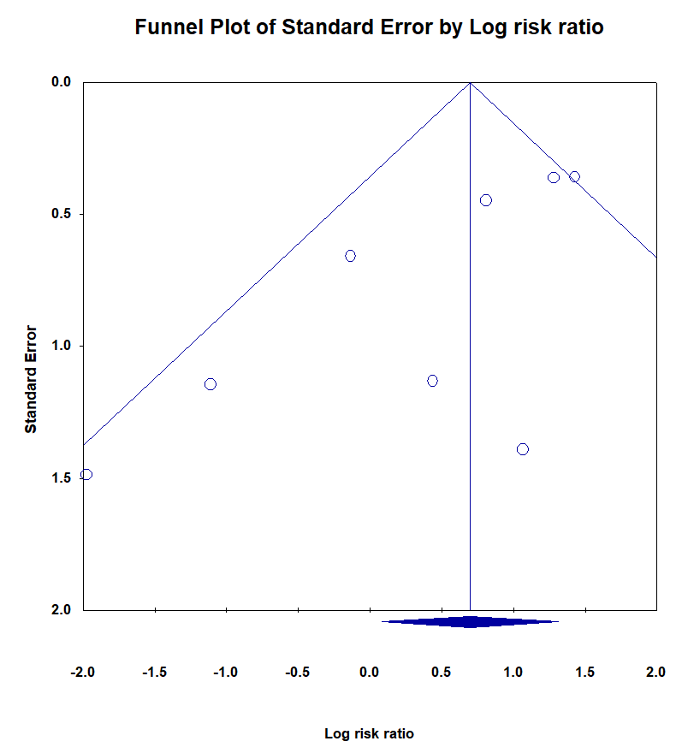

Supplementary Figure 7: Symptomatic intracranial hemorrhage funnel plot
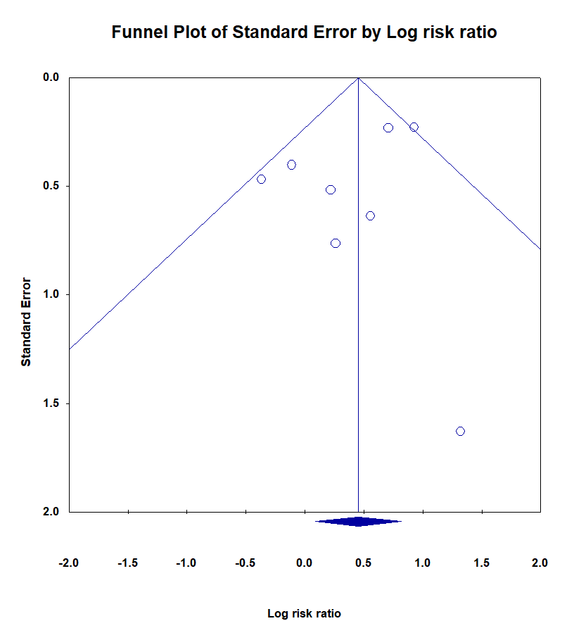

Supplementary Figure 8: Mortality at 90 days funnel plot
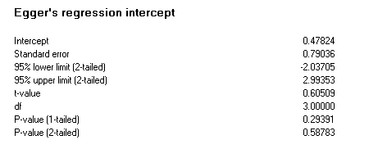

Supplementary Figure 9: Early neurological improvement, Egger's regression test
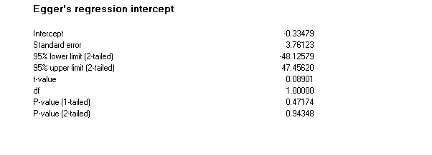

Supplementary Figure 10: Visual field normalization, Egger's regression test
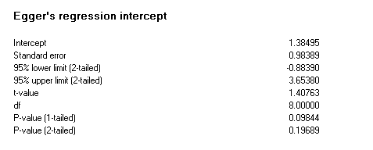

Supplementary Figure 11: Good functional outcome, Egger's regression test
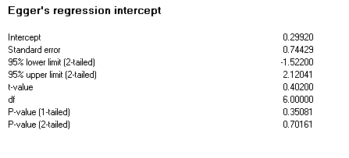

Supplementary Figure 12: Excellent functional outcome, Egger's regression test
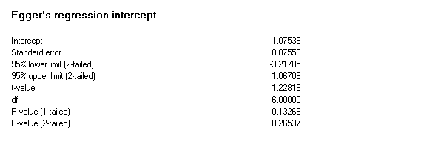

Supplementary Figure 13: Mortality at 90 days, Egger's regression test
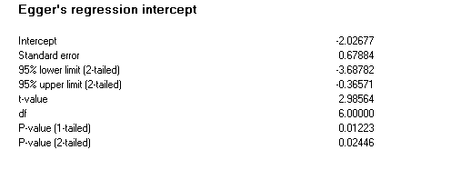

Supplementary Figure 14: Symptomatic intracranial hemorrhage, Egger's regression test
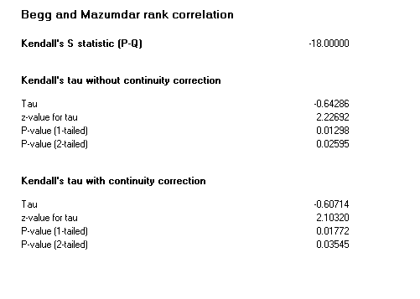

Supplementary Figure 15: Symptomatic intracranial hemorrhage, Begg's rank correlation test

