Supplementary Figure 1. Flowchart of the patients included in the study.
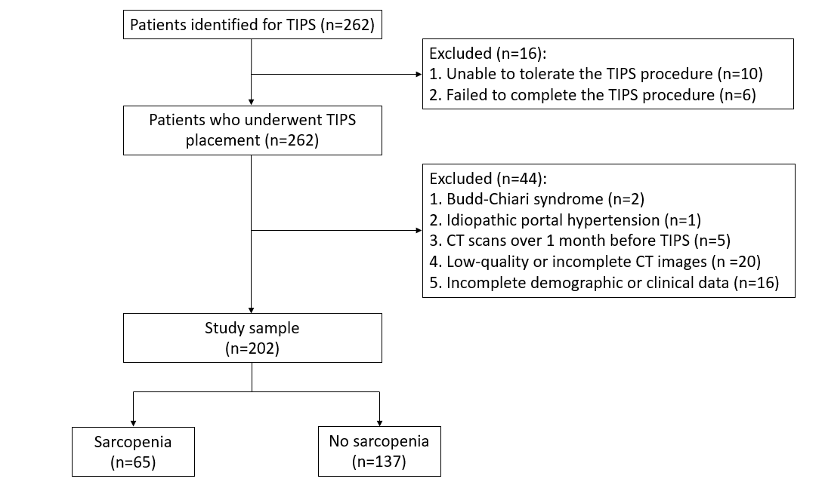

Supplementary Figure 2. Variable selection using the Least Absolute Shrinkage and Selection Operator (LASSO) regression model. A: LASSO coefficient profiles of the 29 variables; B: Ten-fold cross-validation for tuning parameter (λ) selection in the LASSO model. The two vertical dashed lines indicate the optimal λ values determined by the minimum mean squared error criterion and the 1-standard error criterion. Under the 1-standard error criterion, seven variables were selected: Age; gender; drinking; body mass index; etiology; hepatic encephalopathy; and right psoas muscle thickness.

Supplementary Figure 3. The bootstrap receiver operating characteristic curve of the new model for predicting sarcopenia in patients with cirrhosis undergoing transjugular intrahepatic portosystemic shunt.
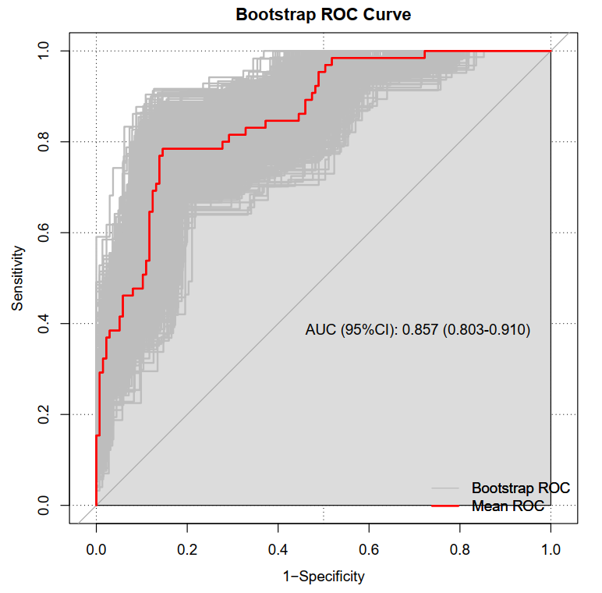

Supplementary Figure 4. Calibration curve (using 1000 bootstrap resamples) of the new model for predicting sarcopenia in patients with cirrhosis undergoing transjugular intrahepatic portosystemic shunt.
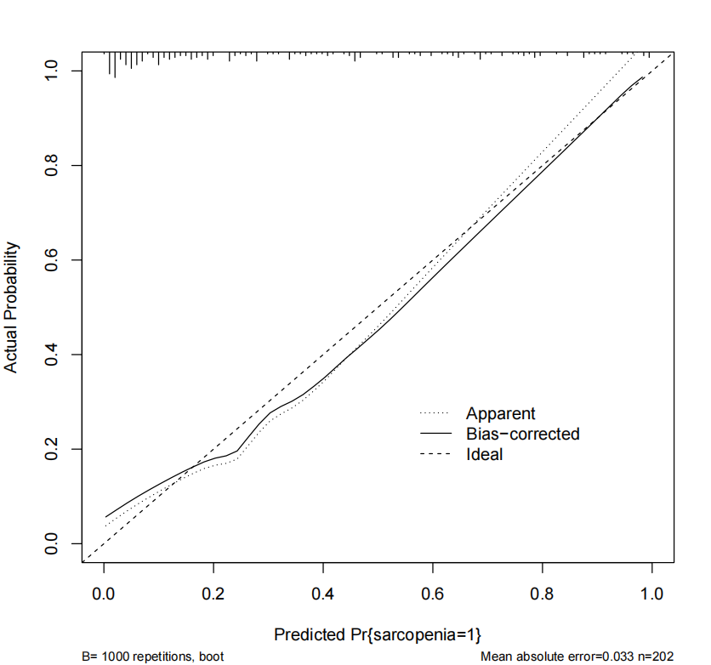

Supplementary Figure 5. The receiver operating characteristic and calibration curve for the sensitivity analysis excluding patients with hepatocellular carcinoma.

Supplementary Figure 6. The calibration curve of the HIBA score (A), the ABCS score (B), PMTH score (C), and the sarcopenia index (D) in patients with cirrhosis undergoing transjugular intrahepatic portosystemic shunt.

