Effect and mechanism of appearance, rheology, in vitro properties of HPC-acrylate blend film forming system with different excipients

Supplemental Table 1 Power law parameters (K, n) of all samples
Film forming solutions | Power law parameters |  |  | Viscoelastic parameters
Film forming solutions | K | n | R² | End of LVR (Pa) | Yield Stress (Pa)
FC1 | 36.23 ± 0.87a | 0.3145 ± 0.0036a | 0.9890 | 68.92 ± 7.31 | 87.74 ± 9.53
FC2 | 33.68 ± 0.34b | 0.3340 ± 0.0026b | 0.9924 | 44.44 ± 3.95 | 63.17 ± 5.24
FMC1 | 32.33 ± 2.00b | 0.3426 ± 0.0106b | 0.9939 | 27.19 ± 7.01 | 54.86 ± 9.44
FMC2 | 25.23 ± 0.41c | 0.3567 ± 0.0029c | 0.9943 | 36.81 ± 4.70 | 57.15 ± 8.39
FP1 | 19.73 ± 0.51d | 0.3618 ± 0.0045d | 0.9898 | 38.74 ± 3.92 | 49.69 ± 4.61
FP2 | 16.79 ± 0.49e | 0.3665 ± 0.0068e | 0.9910 | 45.05 ± 5.02 | 37.65 ± 4.73
FMP1 | 16.53 ± 0.50e | 0.3755 ± 0.0056e | 0.9915 | 34.52 ± 3.42 | 37.59 ± 6.07
FMP2 | 15.06 ± 1.07e | 0.3867 ± 0.0104e,f | 0.9923 | 33.57 ± 6.65 | 44.76 ± 6.12
Different superscript letters (a-f) within the same column indicate significant differences between formulations (p < 0.05).

Supplemental Table 2 Summary of release kinetics function
 | R²
 | Zero order | First order | Higuchi
Commercial Product | 0.8904 | 0.9380 | 0.9186
FC1 | 0.9400 | 0.9391 | 0.9596
FC2 | 0.8947 | 0.9814 | 0.9359
FMC1 | 0.9266 | 0.9986 | 0.9629
FMC2 | 0.9345 | 0.9832 | 0.9657
FP1 | 0.9609 | 0.9671 | 0.9878
FP2 | 0.9314 | 0.9759 | 0.9719
FMP1 | 0.9622 | 0.9959 | 0.9901
FMP2 | 0.9487 | 0.9957 | 0.9837

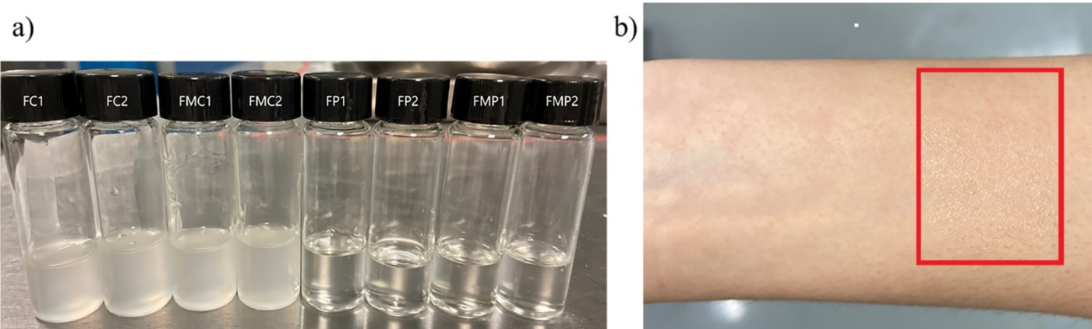
Supplemental Fig. 1 a) Appearance of film forming solution. b) Appearance of film dried in the forearm skin (FP1)

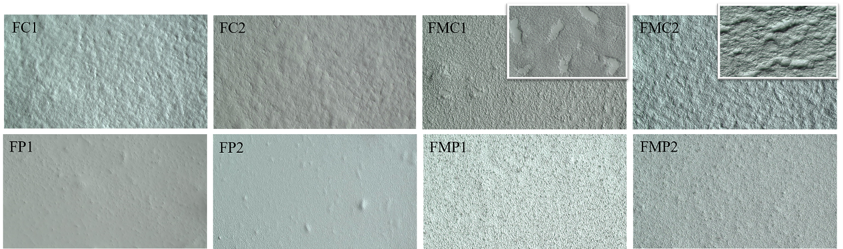
Supplementary Fig. 1. Polarized optical microscopy images of different films surface (100 x)

