Supplementary material
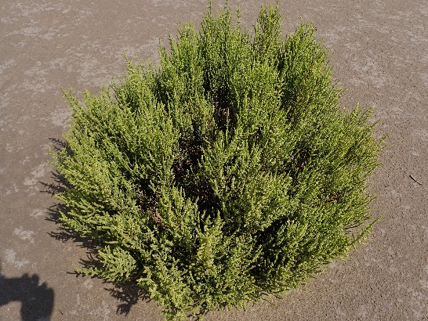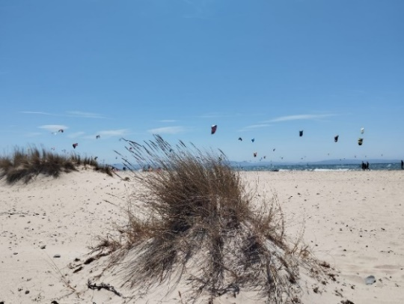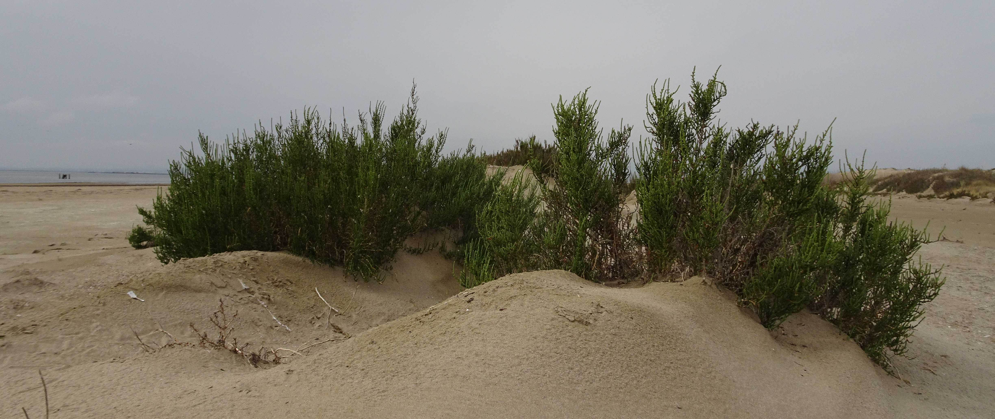
a)
c)
b)
Fig. S1. Sandy systems sampled a) Garxal, Ebro Delta – Protected dunes, Mediterranean coast b) Los Lances, Cádiz – Non-protected dunes, Atlantic coast c) La Marquesa, Ebro Delta – Non-protected dunes, Mediterranean coast.
b)
a)
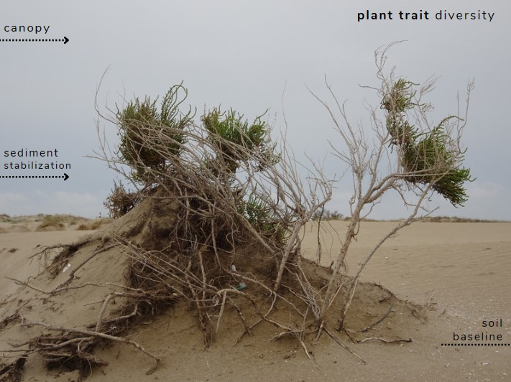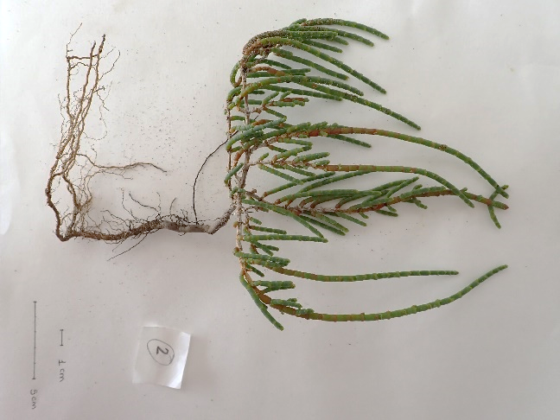
Fig. S2. Sarcocornia fruticosum a) in the field, Ebro Delta, and b) in the laboratory for trait measurements.

Table S1. A total count of dominant species (n=12) across all sampled patches (n=480)
Dominant plant species | n (patch)
Ammophila arenaria | 112
Cakile maritima | 76
Echinophora spinosa | 19
Euphorbia paralias | 23
Limoniastrum monopetalum | 9
Limonium vigoi | 13
Salicornia europaea | 80
Salsola kali | 61
Sarcocornia fruticosum | 51
Sporobolus pungens | 11
Suaeda maritima | 13
Xanthium strumarium | 12

Community type | Strandline | Pioneer dunes | Dunes | Dune depressions and backdunes
Description | Annual halonitrophilous vegetation occupying accumulations of drift material and gravel, exposed to wind action and occasionally to breaking waves. | Pioneer, perennial, and halophilous community of the low embrion dunes, forming the first dunes and usually exposed to wind, salt spray, and occasionally flooding. | Perennial herb community assemblages growing on dunes- stabilized dunes. Communities of the inland side of dunes are dominated by chamaephyte herbaceous and rhizomatous species. | Herbaceous wet communities of the dune slacks. Formations of annuals and ephemeral plants occupying deep sands in dry interdunal depressions, and located in the clearings of perennial vegetation.
Most abundant species | Cakile maritima  Salsola kali | Ammophila arenaria  Euphorbia paralias Sporobolus pungens Polygonum maritimum  Suaeda marítima  C. marítima  S. kali | A. arenaria  Crithmum maritimum  Echinophora spinosa  Medicago marítima  Xanthium strumarium | Salicornia europaea  Sarcocornia fruticosum  Limoniastrum monopetalum  Limonium vigoi
Plot number | 16 | 229 | 156 | 108
Table S2. Description of the four plant communities across habitats used in this study:

Table S3. Functional traits were used to calculate the models and multivariate analysis for 14 psammophilous species. Data represent the means ± SE of 3 replicates.
Plant specie | Family | Phenology | Plant life-form | Total Length (cm) | CAN-H (cm) | Root Spread (cm) | Leaves Spread (cm) | Maximum Root Length (cm) | Mean Root Length (cm) | Total Root Length (cm/m²) | Shoot Density  (m²) | Root Density  (m²)
Ammophila arenaria | Poaceae (Gramineae) | Perenne | hemicryptophyte | 39.90 ± 2.26 | 31.03 ± 0.99 | 15.63 ± 1.32 | 8.20 ± 0.61 | 13.93 ± 1.54 | 35.29 ± 26.54 | 8480.73 ± 3286.94 | 396.12 ± 198.73 | 452.71 ± 142.41
Cakile maritima | Cruciferae (Brassicaceae) | Annual | therophyte | 36.75 ± 8.97 | 25.00 ± 7.82 | 18.38 ± 3.73 | 12.47 ± 4.60 | 17.75 ± 2.99 | 12.00 ± 1.51 | 3706.54 ± 1482.73 | 155.62 ± 42.44 | 325.38 ± 116.37
Echinophora spinosa | Apiaceae | Bienal/  perenne | geophyte | 14.07 ± 5.24 | 8.77 ± 3.60 | 14.80 ± 10.87 | 13.00 ± 1.53 | 23.67 ± 3.71 | 15.49 ± 1.99 | 3755.59 ± 364.64 | 565.88 ± 32.67 | 245.22 ± 18.86
Euphorbia parabis | Euphorbiaceae | Annual | chamaephyte | 59.33 ± 3.84 | 42.33 ± 2.73 | 13.00 ± 0.87 | 14.00 ± 0.58 | 24.50 ± 0.76 | 11.29 ± 1.24 | 2084.34 ± 61.85 | 547.02 ± 37.73 | 188.63 ± 18.86
Limonium vigoi | Plumbaginaceae | Perenne | therophytic | 9.62 ± 1.48 | 1.88 ± 0.31 | 12.75 ± 3.17 | 4.88 ± 1.03 | 11.10 ± 2.43 | 6.41 ± 0.57 | 2225.34 ± 511.41 | 14.15 ± 14.15 | 353.68 ± 87.59
Salicornia europaea | Chenopodiaceae | Annual/  perenne | therophyte | 34.33 ± 2.91 | 18.00 ± 1.73 | 9.17 ±  0.60 | 8.63 ± 0.61 | 16.33 ± 1.20 | 16.33 ± 2.91 | 1339.26 ± 272.04 | 150.90 ± 37.73 | 94.31 ± 37.73
Salsola kali | Amaranthaceae | Annual | therophyte | 36.27 ± 11.44 | 23.50 ± 8.10 | 13.03 ± 3.31 | 17.37 ± 2.58 | 11.73 ± 3.29 | 8.93 ± 1.45 | 4036.64 ± 809.78 | 377.26 ± 49.91 | 471.57 ± 99.81
Sarcocornia fruticosum | Chenopodiaceae | Perenne | therophyte | 25.33 ± 2.96 | 13.67 ± 1.20 | 11.50 ± 3.55 | 11.33 ± 1.76 | 12.40 ± 1.78 | 16.18 ± 5.12 | 1552.41 ± 228.94 | 264.08 ± 37.73 | 113.18 ± 32.67
Sueda maritima | Chenopodiaceae | Annual | therophyte | 12.53 ± 0.76 | 5.47 ± 1.07 | 7.90 ±  0.74 | 11.03 ± 0.97 | 12.80 ± 1.03 | 6.21 ± 1.24 | 1754.24 ± 257.44 | 381.97 ± 48.32 | 297.09 ± 35.60
Plant specie | Specific Root Length  (SRL, cm/g) | Root Length Density  (DLR, cm/cm²) | Root Length Ratio  (RLR, cm/g) | Root Tissue Density  (RTD, g/cm³) | Relative Root Weight  (RWR) | Root to shoot ratio (RS) | Root biomass (g/m²) | Stem biomass (g/m²) | Leaves biomass  (g/m²) | Aboveground biomass  (AGB, g/m²) | Above: Belowground ratio
Ammophila arenaria | 48.69 ± 8.97 | 0.02 ± 0.01 | 21.46 ± 3.47 | 4.33·10⁻⁴ ± 1.46·10⁻⁴ | 0.31 ± 0.04 | 0.56 ± 0.12 | 176.14 ± 60.30 | 190.21 ± 46.41 | 182.61 ± 40.82 | 372.82 ± 86.38 | 2.33 ± 0.42
Cakile maritima | 20.41 ± 6.55 | 0.01 ± 0.00 | 5.28 ± 1.63 | 4.25·10⁻⁴ ± 2.5·10⁻⁵ | 0.22 ± 0.04 | 0.30 ± 0.06 | 168.18 ± 14.90 | 201.78 ± 32.13 | 538.06 ± 205.63 | 739.84 ± 236.32 | 4.24 ± 1.21
Echinophora spinosa | 19.71 ± 6.18 | 0.01 ± 0.00 | 13.05 ± 2.53 | 7.33·10⁻⁴ ±  3.84·10⁻⁵ | 0.43 ± 0.13 | 1.16 ± 0.66 | 287.13 ± 154.08 | 124.27 ± 6.02 | 178.57 ± 45.69 | 302.84 ± 48.29 | 1.79 ± 0.84
Euphorbia parabis | 11.59 ± 0.62 | 0.01 ± 0.00 | 1.94 ± 0.07 | 4.33·10⁻⁴ ± 3.33·10⁻⁵ | 0.14 ± 0.01 | 0.25 ± 0.01 | 180.33 ± 4.99 | 446.25 ± 42.36 | 632.24 ± 24.89 | 1078.49 ± 66.74 | 6.01 ± 0.52
Limonium vigoi | 27.03 ± 3.49 | 0.01 ± 0.00 | 7.17 ± 2.14 | 2.00·10⁻⁴ ±  4.08·10⁻⁵ | 0.20 ± 0.04 | 0.43 ± 0.10 | 80.57 ± 16.99 | 192.20 ± 58.92 | 154.71 ± 50.39 | 346.92 ± 101.24 | 4.48 ± 1.05
Salicornia europaea | 7.00 ± 0.86 | 0.00 ± 0.00 | 2.22 ± 0.43 | 4.33·10⁻⁴ ± 3.33·10⁻⁵ | 0.24 ± 0.01 | 0.42 ± 0.03 | 187.93 ± 15.82 | 437.16 ± 22.25 | 168.69 ± 17.37 | 605.86 ± 32.57 | 3.26 ± 0.25
Salsola kali | 31.14 ± 6.37 | 0.01 ± 0.00 | 4.59 ± 0.34 | 3.00·10⁻⁴ ± 0.00 | 0.13 ± 0.01 | 0.17 ± 0.02 | 129.78 ± 1.05 | 154.30 ± 7.66 | 709.62 ± 121.01 | 863.92 ± 114.59 | 6.66 ± 0.91
Sarcocornia fruticosum | 8.21 ± 1.00 | 0.00 ± 0.00 | 1.75 ± 0.25 | 4.67·10⁻⁴ ± 8.82·10⁻⁵ | 0.18 ± 0.03 | 0.34 ± 0.04 | 194.34 ± 33.12 | 618.27 ± 20.04 | 267.02 ± 25.86 | 885.29 ± 5.95 | 4.87 ± 0.94
Sueda maritima | 9.80 ± 1.35 | 0.00 ± 0.00 | 6.68 ± 1.39 | 4.75·10⁻⁴ ± 4.79·10⁻⁵ | 0.40 ± 0.03 | 0.99 ± 0.08 | 180.42 ± 16.97 | 148.94 ± 26.02 | 128.84 ± 7.81 | 277.78 ± 33.14 | 1.56 ± 0.18

GLMM results:
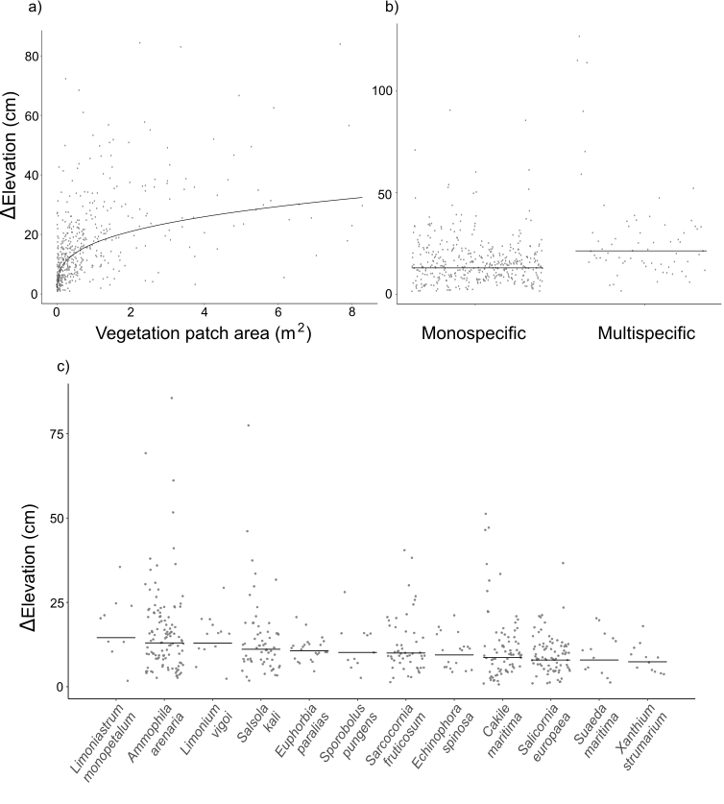
Fig. S3. GLMM results of the relationship between: a) the vegetation patch area (in square meters) and the elevation change (in centimeters); b) vegetation patch composition (monospecific vs. multispecific) and elevation change; c) plant species across vegetation patches and elevation change. Data points represent the distribution of standardized partial residuals of the fitted linear mixed model, where continuous lines represent the model fit through the data. Points represent partial residuals using “visreg”.

Edafic propierties:
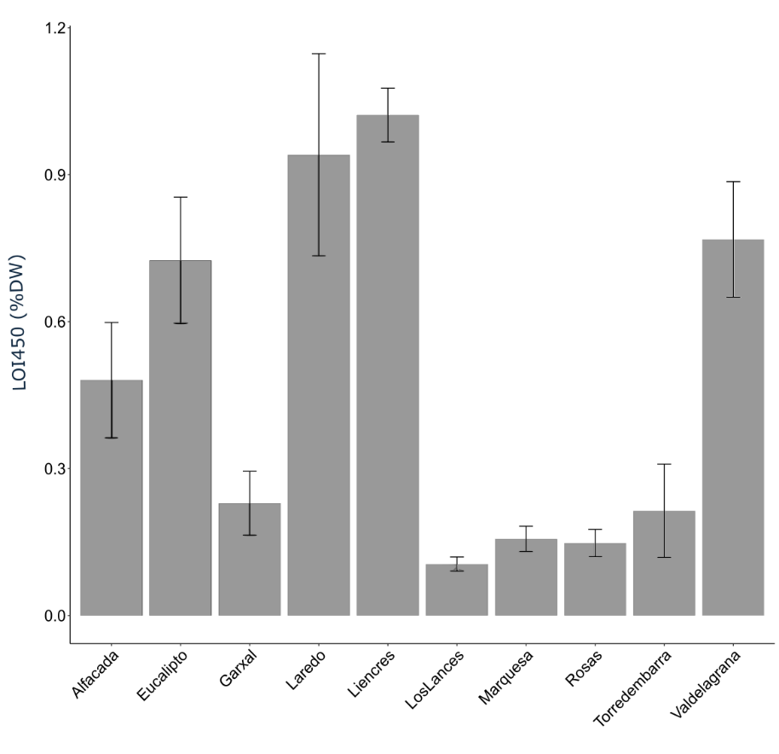
Fig. S4. LOI450 (%DW) in bulk sediment samples.
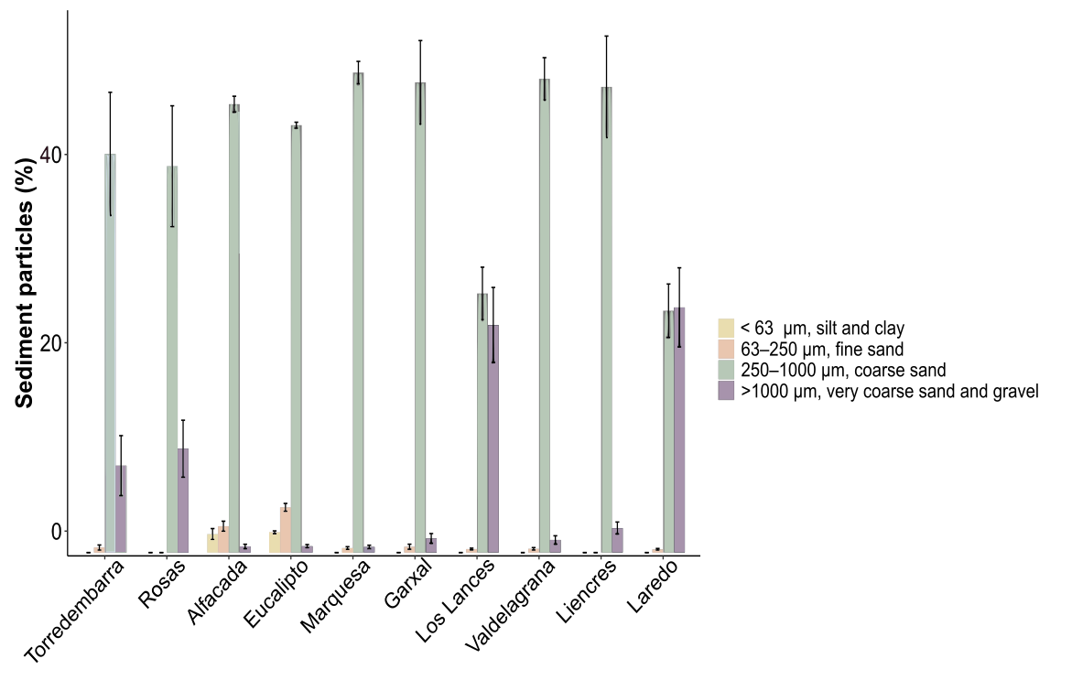
Fig. S5. Sediment grain size distribution across the sampled localities, classified according to the Udden–Wentworth scale: silt and clay (<63 μm), fine sand (63–250 μm), coarse sand (250–1000 μm), and very coarse sand and gravel (>1000 μm).

