Additional Information File

Neuromodulatory roles of dopamine and acetylcholine in mediating agonistic behaviors of boxer shrimps (Stenopus species)
(Submitted to BMC Genomics)

Terance Ho Him Wongª, Lai Him Chow^{a^}, Ziwei Wu^{b^}, Tom Kwok Lun Huiª, Ling Ming Tsangª

ª Simon F.S. Li Marine Science Laboratory, School of Life Sciences, The Chinese University of Hong Kong, Shatin, Hong Kong
^{b} Department of Microbiology and Immunology, The Peter Doherty Institute for Infection and Immunity, University of Melbourne, Victoria, Australia
^ The authors contributed equally

Correspondence author
Email address: lmtsang@cuhk.edu.hk (L.M. Tsang)

Supplementary Information Tables
Table S1 Full list of annotated significantly up- and downregulated differentially expressed genes (DEGs) for each pairwise comparison (i.e., control vs winner, control vs loser, and loser vs winner) for all three organs (antennae + antennules, central nervous system, and eyestalks) of Stenopus hispidus, S. cyanoscelis, and mutually in Stenopus https://docs.google.com/spreadsheets/d/11zV8Ct5iYbfQ7N77nd1zqSCm5Ty2kaiN/edit?usp=drive_link&ouid=114071563695881171971&rtpof=true&sd=true

Table S2 Full list of significantly enriched gene ontologies (GOs) from up- and downregulated differentially expressed genes (DEGs) for each pairwise comparison (i.e., control vs winner, control vs loser, and loser vs winner) for all three organs (antennae + antennules, central nervous system, and eyestalks) of Stenopus hispidus, S. cyanoscelis, and mutually in Stenopus https://docs.google.com/spreadsheets/d/17BryT5ZHLPNCujBO6c5BydKZpeepsmnW/edit?usp=drive_link&ouid=114071563695881171971&rtpof=true&sd=true

Table S3 Full list of significantly enriched Kyoto Encyclopedia of Genes and Genomes (KEGG) pathways from up- and downregulated differentially expressed genes (DEGs) for each pairwise comparison (i.e., control vs winner, control vs loser, and loser vs winner) for all three organs (antennae + antennules, central nervous system, and eyestalks) of Stenopus hispidus, S. cyanoscelis, and mutually in Stenopus https://docs.google.com/spreadsheets/d/1M8c-BtEcLgfaJRVZtccJnnjIRbVWzcOP/edit?usp=drive_link&ouid=114071563695881171971&rtpof=true&sd=true

Table S4 Common aggression-related neuroendocrine regulators identified in the three organs for the three pairwise comparisons in the two studied Stenopus species
 |  | S. hispidus |  |  |  |  |  |  |  |  |  |  |  |  | S. cyanoscelis
 |  | Control VS Winner |  |  |  |  | Control VS Loser |  |  |  | Loser VS Winner |  |  |  | Control VS Winner |  |  |  | Control VS Loser |  |  |  | Loser VS Winner
Neuroendocrine regulators |  | AAª |  | CNS^{b} |  | ES^{c} | AA | CNS | ES | AA |  | CNS | ES | AA |  | CNS | ES | AA |  | CNS | ES | AA |  | CNS | ES
Gene set level^{d} | Dopamine | - |  |  | + |  | - |  | + |  |  |  |  |  |  | - | + | - |  | - | +
Gene set level^{d} | Substance P/Tachykinin^{f} | - |  |  | - |  |  |  | -
Gene set level^{d} | Acetylcholine | + | + |  | - |  |  | + |  |  |  | + | - |  |  | - | - | - |  | + | - | + |  | - | -
Gene set level^{d} | Octopamine |  |  |  |  |  | + | - |  |  |  |  |  |  |  |  |  | + |  | +
Gene set level^{d} | Ecdysteroids | - |  |  | - |  |  | +
Gene set level^{d} | Juvenile hormone/ Methyl farnesoate^{g} |  |  |  |  |  | +
Gene set level^{d} | Nitric oxide |  | - |  | + |  |  |  |  |  |  |  | + |  |  |  |  | +
Gene set level^{d} | Serotonin |  |  |  |  |  |  |  |  | - |  | + | + |  |  |  |  |  |  |  | -
Gene set level^{d} | Glutamate |  | - |  |  |  |  | - |  |  |  | - |  |  |  |  |  |  |  |  |  |  |  | - | -
Gene set level^{d} | GABA^{h} |  | + |  | + |  |  |  |  |  |  | - |  |  |  |  |  | + |  |  |  | -
Gene level^{e} | Crustacean hyperglycemic hormones |  | - |  |  |  |  | -
Gene level^{e} | Crustacean hyperglycemic hormones isoform A |  |  |  |  |  |  | -
Gene level^{e} | Crustacean hyperglycemic hormones isoform B |  |  |  |  |  |  | + |  |  |  |  |  |  |  |  |  | - |  | - |  | +
ªAntennae + Antennules, ^{b}Central nervous system, ^{c}Eyestalks, ^{d}Gene set level refers to the neuroendocrine regulators identified through GO and KEGG enrichment results, ^{e}Gene level refers to the differentially expressed genes that are known to mediate agonistic behaviors in pan-crustaceans but have not been assigned any hormone-related GO or KEGG annotations, ^{f}Substance P homolog, ^{g}Juvenile hormone homolog, ^{h}Gamma-butyric acid. +, neuroendocrine regulator level elevated. -, level reduced.
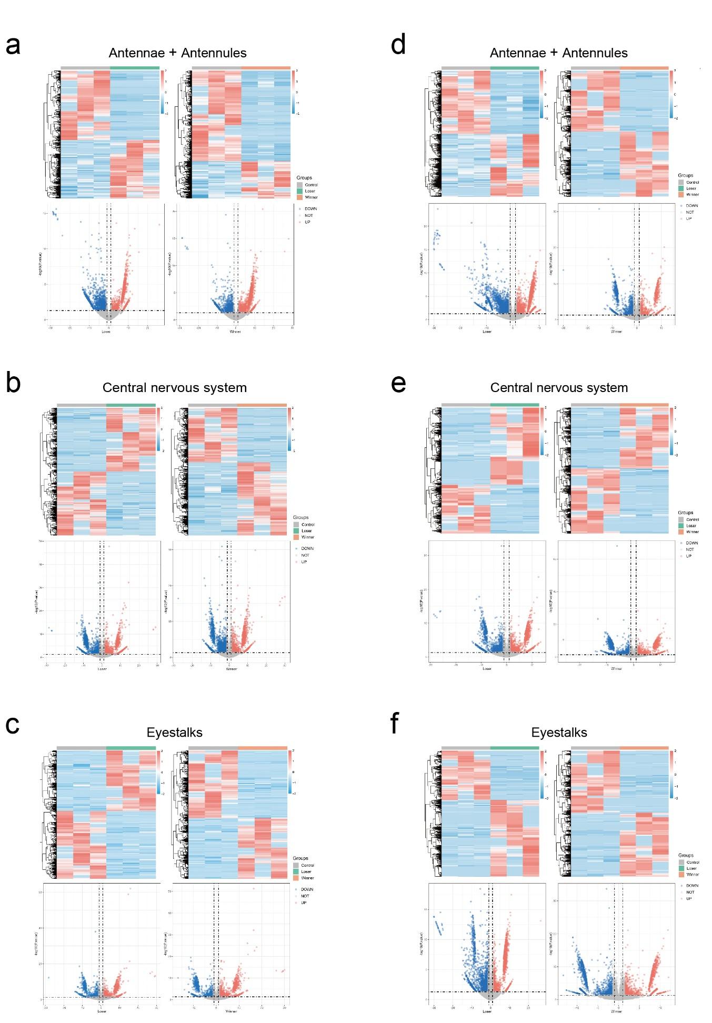
Supplementary Information Figures
Fig. S1 Heatmap and volcano diagram showing the pattern of transcript expression and differentially expressed genes, respectively, for the three target organs (i.e., antennae + antennules, central nervous system, and eyestalks) in the control vs winner and control vs loser comparisons for (a - c) S. hispidus and (d – f) S. cyanoscelis, respectively.

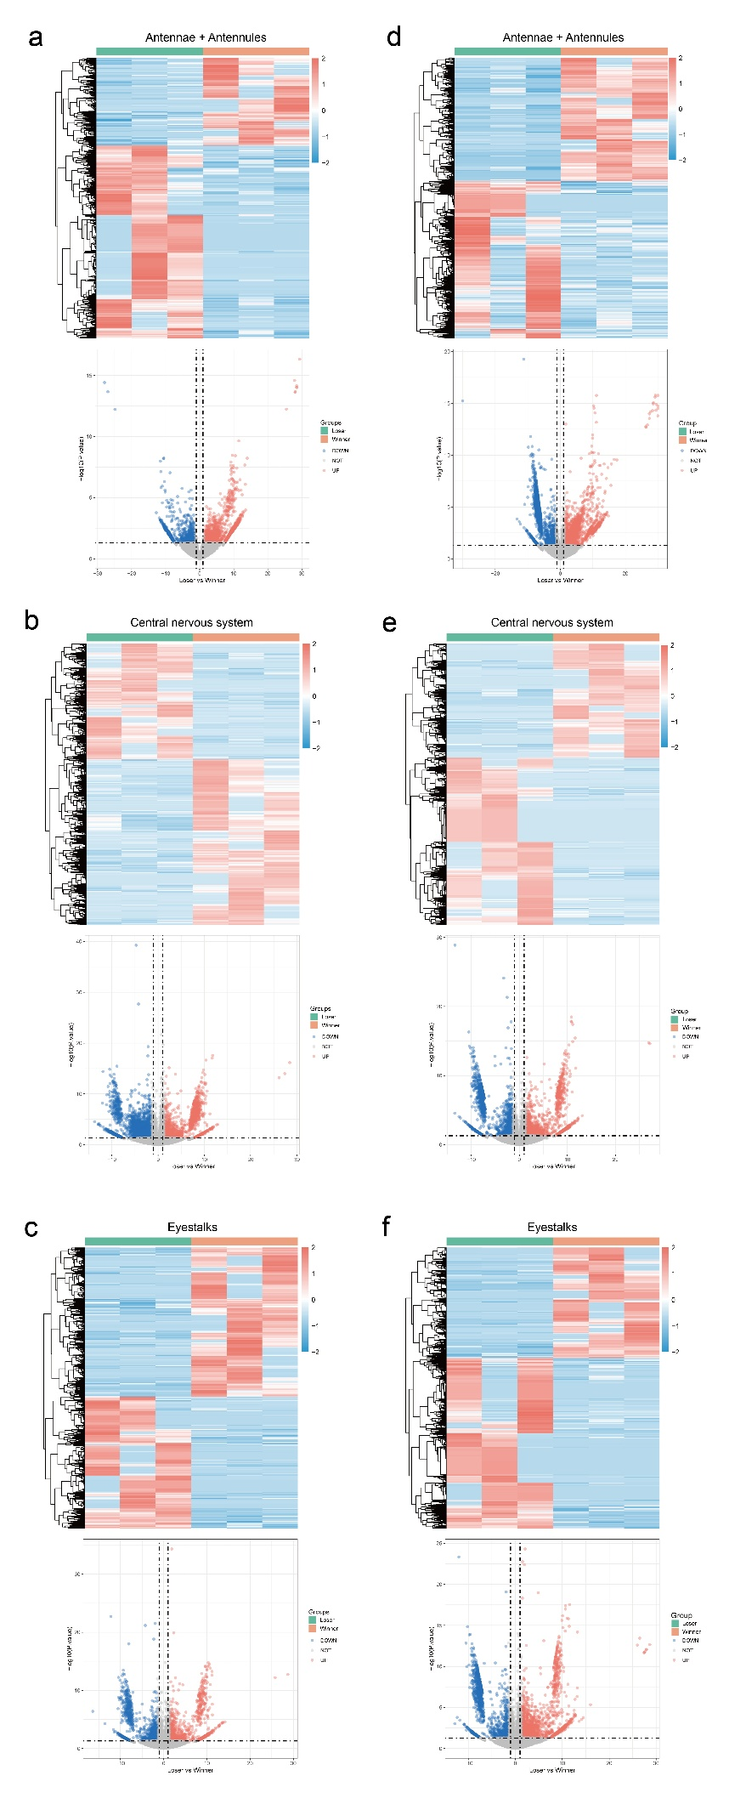

Fig. S2 Heatmap and volcano diagram showing the pattern of transcript expression and differentially expressed genes, respectively, for the three target organs (i.e., antennae + antennules, central nervous system, and eyestalks) of winners compared to losers for (a - c) S. hispidus and (d – f) S. cyanoscelis, respectively.
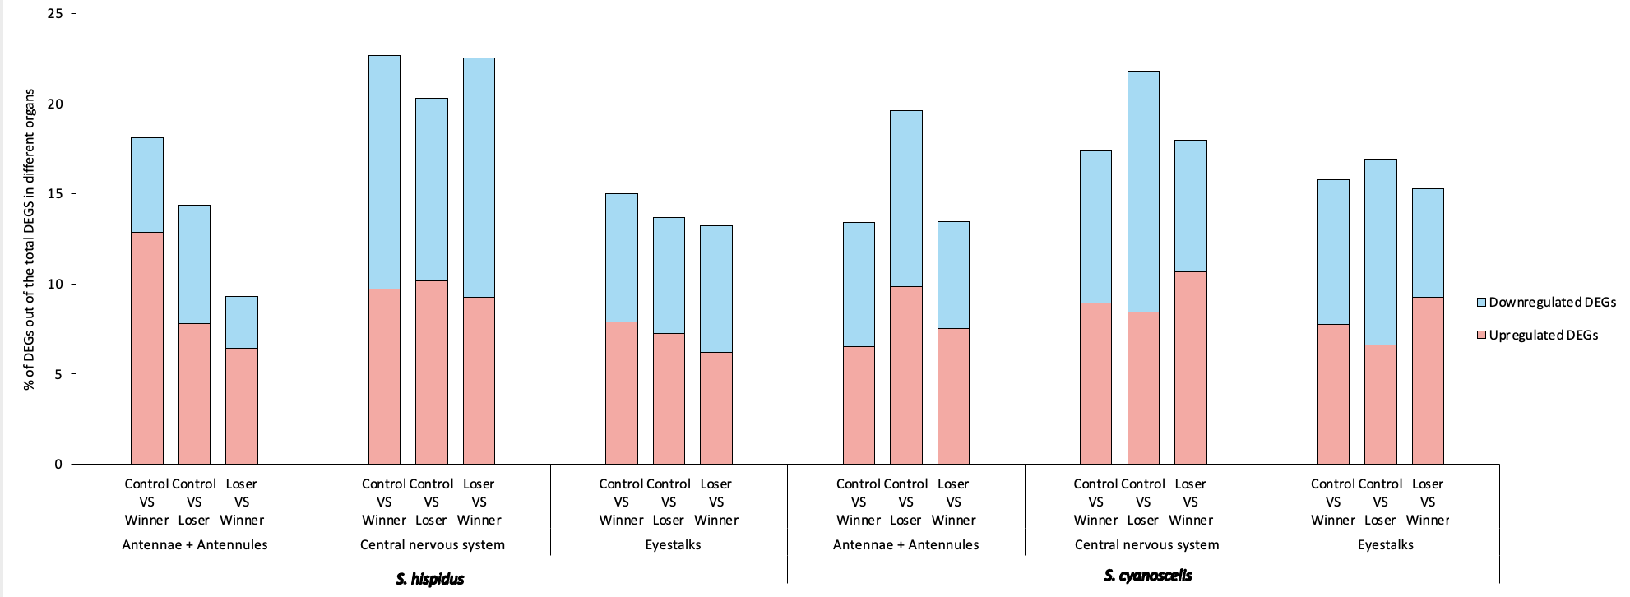
Fig. S3 Percentage of both upregulated and downregulated differentially expressed genes (DEGs) out of the total number of DEGs in the three target organs (i.e., antennae + antennules, central nervous system, and eyestalks) for control vs winner, control vs loser, and loser vs winner comparisons of the two Stenopus species. Red and blue color refers to upregulated and downregulated DEGs, respectively.

Fig. S4 Mutually enriched major GOs from upregulated and downregulated DEGs in the same organ (i.e., antennae + antennules, central nervous system, and eyestalks) of winners when compared to losers of both Stenopus species. All enriched GO terms are statistically significant at p < 0.05 and were grouped according to their typical functions. Individually bolded GOs indicate that their DEGs were statistically significant in at least one control vs treatment comparison. No mutually enriched KEGG pathways were identified in the same organ of winners when compared to losers in Stenopus.

