Spatial distribution of glucose and amino acids within all-aqueous emulsions directs the Maillard reaction and oxidation pathways
Kangni Chen ª, Ashkan Madadlou ^{b}, Sabrina De Pascale ^{c}, Andrea Scaloni ^{c}, Vincenzo Fogliano ª, Antonio Dario Troise ^{c,*}
a Food Quality and Design Group, Wageningen University & Research, Wageningen, the Netherlands
b School of Food and Nutritional Sciences, University College Cork (UCC), Cork, Ireland
c Proteomics, Metabolomics & Mass Spectrometry Laboratory, ISPAAM, National Research Council, Portici, Italy

* Corresponding author: Antonio Dario Troise
antoniodario.troise@cnr.it

Supporting information
PEG_5/ Na₂SO₄_5
Supplementary Figure S1. Volcano plot including the log₂ fold change and log₁₀ p value between PEG_5 vs Na₂SO₄_5 for reactants segregation. Green and red areas indicate compounds over-represented in PEG_5 (n = 33) and Na₂SO₄_5 (n = 42), respectively.
B
A
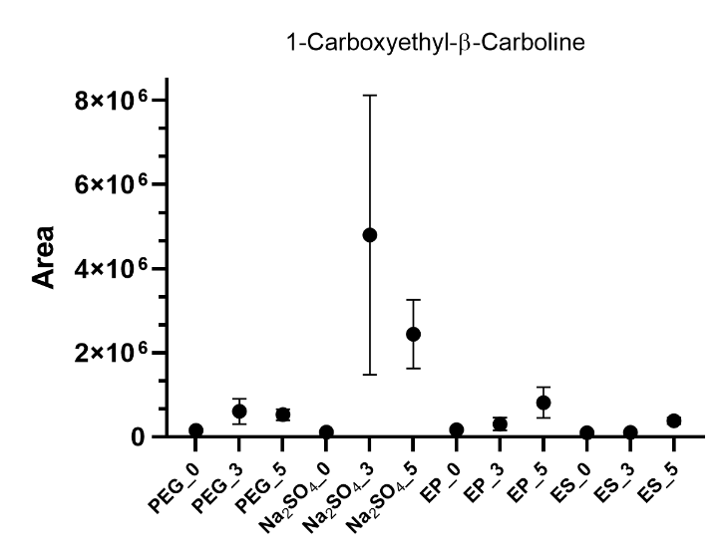
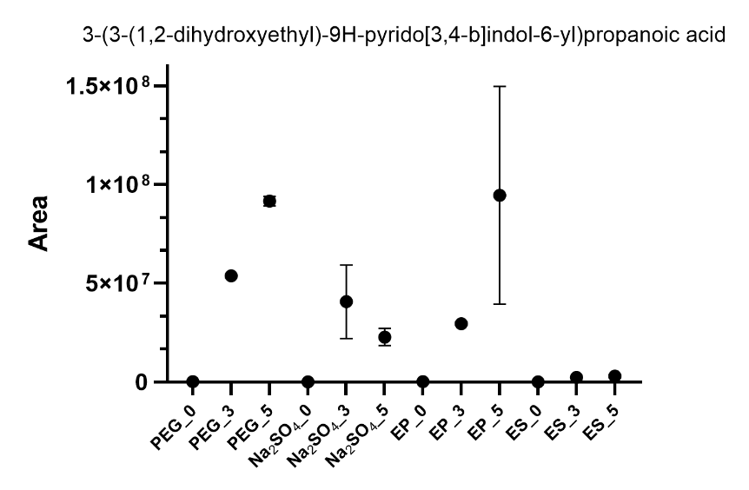
Supplementary Figure S2. (A) Spectral comparison between the reference compound eluting at 4.89 min (bottom spectrum) pointing at m/z 362.1501 and one of its structural isomers eluting at 5.1 min (top spectrum). Both spectra are characterized by the typical tryptophan fragmentation patterns (B) Fragment ion search (FiSH) result indicating the putative chemical structure derived from an oxidation product of tryptophan and tryptophan itself.

Supplementary Figure S3. The normalized areas of 1-carboxyethyl-β-carboline and 3-(3-(1,2-dihydroxyethyl)-9H-pyrido[3,4-b]indol-6-yl)propanoic acid screened in full scan experiments upon annotation and identification of tandem MS spectra.

PEG_5/ Na₂SO₄_5
Supplementary Figure S4. Volcano plot highlighting the log₂ fold change and log₁₀ p value between PEG_5 vs Na₂SO₄_5 for reactants co-encapsulation. Green and red areas indicate compounds over-represented in PEG_5 (n = 38) and Na₂SO₄_5 (n = 29), respectively.
B
A
Supplementary Figure S5. (A) MS/MS spectral comparison between two isomers of asparagine and aspartic acid (a putative oxidation product of asparagine): one eluting at 7.4 min (bottom spectrum) and a structural isomer eluting at 9.1 min (top spectrum). (B) Fragment ion search (FiSH) result showing the putative chemical structure, suggesting the formation of a peptide bond between asparagine and aspartic acid.

Supplementary Table captions
Supplementary Table S1. Annotated compounds according to the Metabolomics standards initiative in tryptophan-supplemented samples. Compounds reported in bold are characterized by an identification level of 1 based on matching with pure reference compounds analyzed in the same conditions. Compounds name was assigned according to publicly available databases, for some compounds the possibility of the same name exists; all the compounds were screened upon the availability of tandem MS spectra, neutral losses and peak rating were reported alongside. Formylkynurenine includes putative structural isomers as dioxyindolylalanine, 3-hydroperoxytryptophan, dioxetane intermediate, dihydroxypyrroloindole and 3-hydroperoxypyrroloindole (all with chemical formula C11H12N2O4). Molecular formula C11H12N2O3 listed as 5-hydroxytryptophan includes putative compounds: hydroxytryptophan isomers, oxindolylalanine and 3-hydroxypyrroloindole carboxylic acid (PIC).

Supplementary Table S2. Annotated compounds according to the Metabolomics standards initiative in asparagine-supplemented samples. Compounds reported in bold are characterized by an identification level of 1 based on matching with pure reference compounds analyzed in the same conditions. Compounds name was assigned according to publicly available databases, for some compounds the possibility of the same name exists; all the compounds were screened upon the availability of tandem MS spectra.

