Supplementary Table 1. HRs comparing CSS and OS between Non-RT group and RT group according to clinicopathologic factors
 | Multivariate Cox analysis |  |  |  |  |  | Weighted multivariable analysis
Variable | CSS |  |  | OS |  |  | CSS |  |  | OS
 | HR | 95% CI | P | HR | 95% CI | P | HR | 95% CI | P | HR | 95% CI | P
Age, y
y≤60 | 1.047 | 0.503-2.184 | 0.901 | 0.599 | 0.332-1.082 | 0.892 | 1.136 | 0.534-2.419 | 0.740 | 0.647 | 0.362-1.157 | 0.142
y>60 | 0.857 | 0.534-1.376 | 0.524 | 0.617 | 0.428-0.888 | 0.009 | 0.904 | 0.570-1.436 | 0.670 | 0.688 | 0.490-0.967 | 0.031
Sex
Male | 0.658 | 0.411-1.055 | 0.082 | 0.462 | 0.320-0.666 | <.001 | 0.752 | 0.479-1.180 | 0.215 | 0.527 | 0.378-0.734 | <.001
Female | 1.571 | 0.696-3.307 | 0.294 | 1.058 | 0.560-1.923 | 0.906 | 1.254 | 0.573-2.744 | 0.571 | 0.921 | 0.502-1.690 | 0.790
Race
White | 0.844 | 0.543-1.313 | 0.452 | 0.595 | 0.422-0.839 | 0.003 | 0.933 | 0.606-1.435 | 0.752 | 0.663 | 0.477-0.920 | 0.014
Others | 0.845 | 0.316-2.255 | 0.736 | 0.522 | 0.243-1.123 | 0.096 | 1.040 | 0.408-2.652 | 0.935 | 0.593 | 0.296-1.189 | 0.141
Stage
I-II | 1.278 | 0.466-3.499 | 0.634 | 0.673 | 0.325-1.395 | 0.287 | 1.346 | 0.506-3.575 | 0.552 | 0.691 | 0.341-1.401 | 0.305
III-IV | 0.766 | 0.500-1.173 | 0.220 | 0.558 | 0.396-0.784 | <.001 | 0.878 | 0.556-1.387 | 0.578 | 0.671 | 0.458-0.984 | 0.041
T stage
T1-T2 | 0.553 | 0.219-1.394 | 0.209 | 0.438 | 0.193-0.993 | 0.048 | 0.583 | 0.245-1.385 | 0.222 | 0.497 | 0.228-1.086 | 0.079
T3-T4 | 0.798 | 0.491-1.297 | 0.363 | 0.554 | 0.379-0.809 | 0.002 | 0.964 | 0.570-1.628 | 0.890 | 0.726 | 0.472-1.119 | 0.147
N stage
N0 | 0.730 | 0.321-1.663 | 0.454 | 0.592 | 0.307-1.139 | 0.117 | 0.818 | 0.360-1.858 | 0.631 | 0.796 | 0.399-1.587 | 0.517
N+ | 0.789 | 0.475-1.311 | 0.360 | 0.534 | 0.354-0.805 | 0.003 | 0.877 | 0.502-1.530 | 0.643 | 0.604 | 0.381-0.958 | 0.032
Grade
I-II | 0.975 | 0.304-3.121 | 0.966 | 0.669 | 0.298-1.500 | 0.329 | 1.013 | 0.336-3.050 | 0.982 | 0.722 | 0.309-1.690 | 0.453
III-IV | 0.736 | 0.463-1.170 | 0.195 | 0.532 | 0.363-0.779 | 0.001 | 0.829 | 0.503-1.366 | 0.461 | 0.621 | 0.408-0.945 | 0.026
Abbreviations: CSS, cancer-specific survival; OS, overall survival; S, surgery; RT, radiotherapy.

Supplementary Table 2. The 5-year CSS and 5-year OS of postoperative patients with parotid adenocarcinoma according to ATNG score.
ATNG risk stratification | ATNG score | No. (%) |  | 5-year CSS |  |  |  | 5-year OS
ATNG risk stratification |  |  |  | % | 95% CI | P |  | % | 95% CI | P
Low risk | 0 | 99 |  | 95.0 | 90.3-99.9 | <.001 |  | 93.7 | 88.5-99.2 | <.001
Low risk | 1 | 88 |  | 98.4 | 95.3-100 |  |  | 90.5 | 83.4-98.3
Medium risk | 2 | 80 |  | 76.5 | 65.8-88.9 |  |  | 74.6 | 63.9-87.0
Medium risk | 3 | 103 |  | 83.8 | 75.9-92.6 |  |  | 72.7 | 63.8-82.9
High risk | 4 | 80 |  | 46.5 | 35.0-61.6 |  |  | 42.6 | 31.5-57.6
 | 5 | 69 |  | 43.0 | 31.6-58.5 |  |  | 31.6 | 21.5-46.6
 | 6 | 83 |  | 43.8 | 32.7-58.7 |  |  | 31.0 | 21.5-44.7

Supplementary Table 3. The C-indel and adjusted C-index of different prognostic model in predicting CSS and OS.
 | CSS |  |  | OS
Model | C-index | Adjusted C-index |  | C-index | Adjusted C-index
AJCC | 0.736 | 0.735 |  | 0.712 | 0.712
SEER | 0.744 | 0.743 |  | 0.719 | 0.719
ATNG | 0.752 | 0.753 |  | 0.750 | 0.746
Abbreviations: CSS, cancer-specific survival; OS, overall survival.

Supplementary Table 4. HRs comparing CSS and OS between Non-RT group and RT group according to ATNG risk stratifications.
 | Multivariate Cox analysis |  |  |  |  |  | Weighted multivariable analysis
ATNG Risk | CSS |  |  | OS |  |  | CSS |  |  | OS
ATNG Risk | HR | 95% CI | P | HR | 95% CI | P | HR | 95% CI | P | HR | 95% CI | P
Low | 2.116 | 0.404-11.10 | 0.375 | 0.544 | 0.179-1.655 | 0.284 | 2.110 | 0.39-11.398 | 0.386 | 0.477 | 0.154-1.476 | 0.199
Medium | 0.748 | 0.319-1.750 | 0.503 | 0.611 | 0.325-1.148 | 0.126 | 0.933 | 0.412-2.114 | 0.868 | 0.682 | 0.370-1.258 | 0.220
High | 0.757 | 0.474-1.210 | 0.245 | 0.542 | 0.368-0.796 | 0.002 | 0.877 | 0.530-1.451 | 0.609 | 0.647 | 0.426-0.983 | 0.041
All | 0.880 | 0.592-1.308 | <.001 | 0.612 | 0.451-0.830 | 0.002 | 0.938 | 0.633-1.391 | 0.750 | 0.656 | 0.487-0.882 | 0.005
Abbreviations: CSS, cancer-specific survival; OS, overall survival.

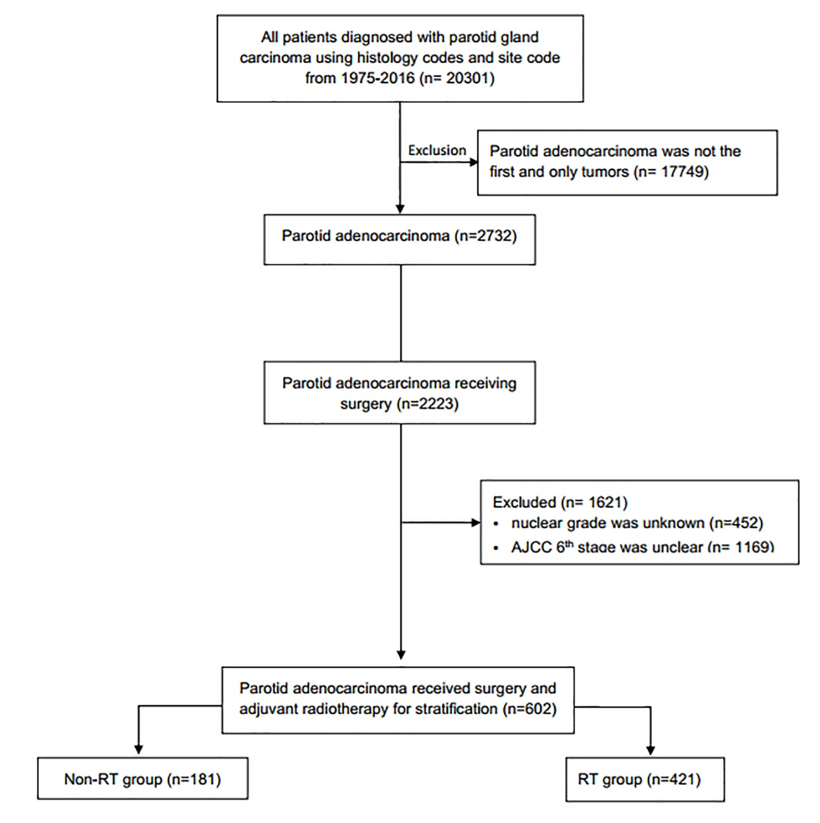

Supplementary Figure 1

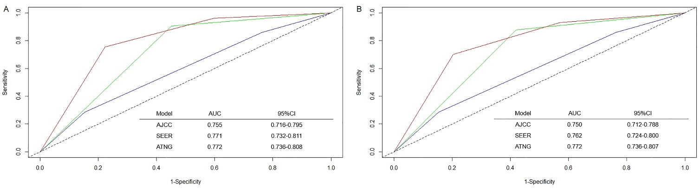

Supplementary Figure 2
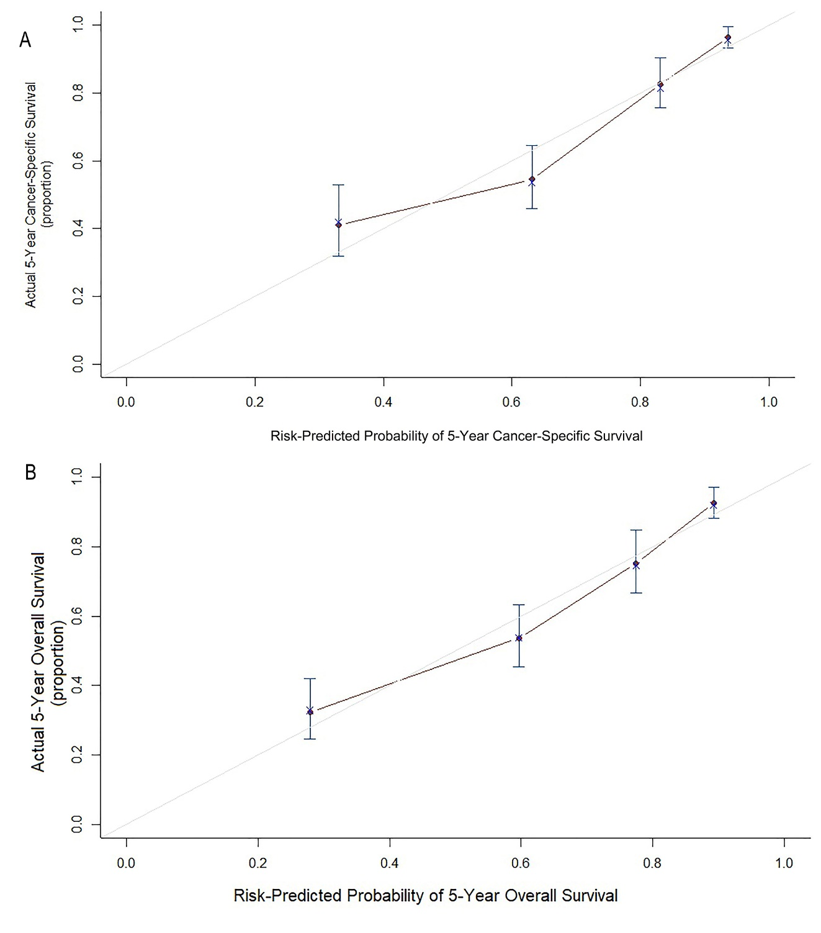
Supplementary Figure 3

