Supplement 1: Growth curves of caterpillars
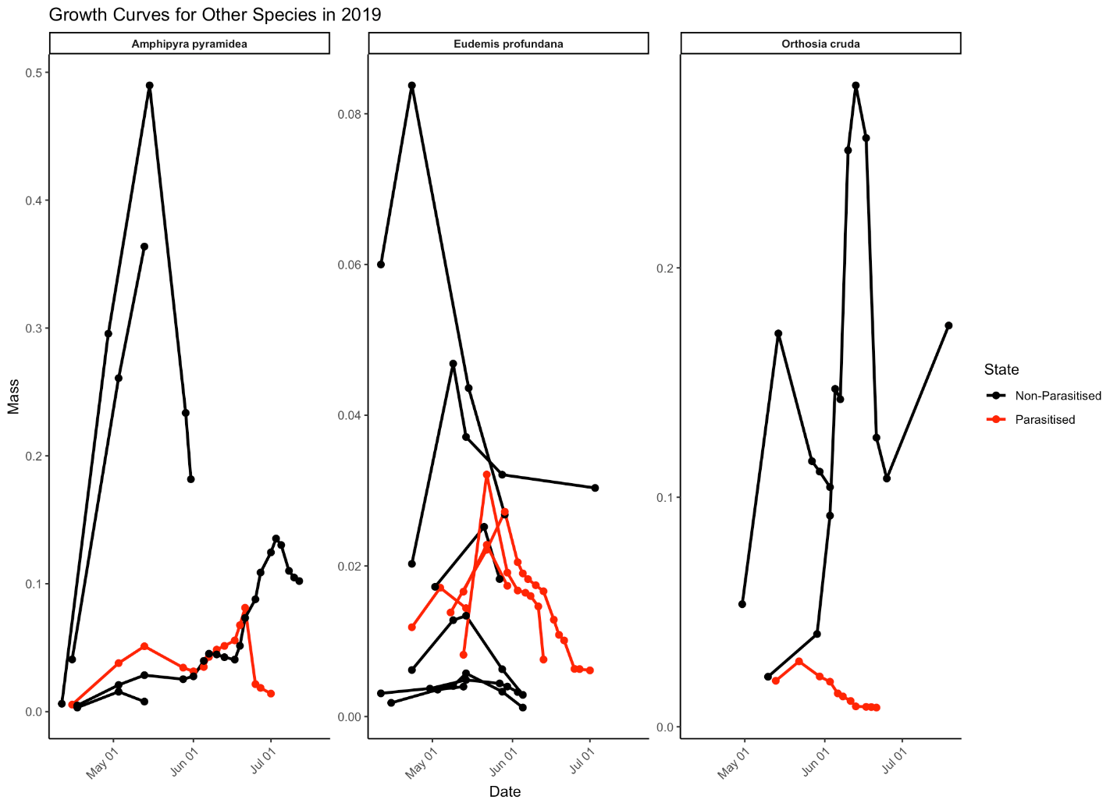
Figure S1.1. Growth trajectories of caterpillars collected in 2019, with mass changes over time for both parasitised (red data points) and non-parasitised individuals (black data points) where consecutive measurements are connected with a straight line. This excludes Operopthera brumata which are shown in the next graph.
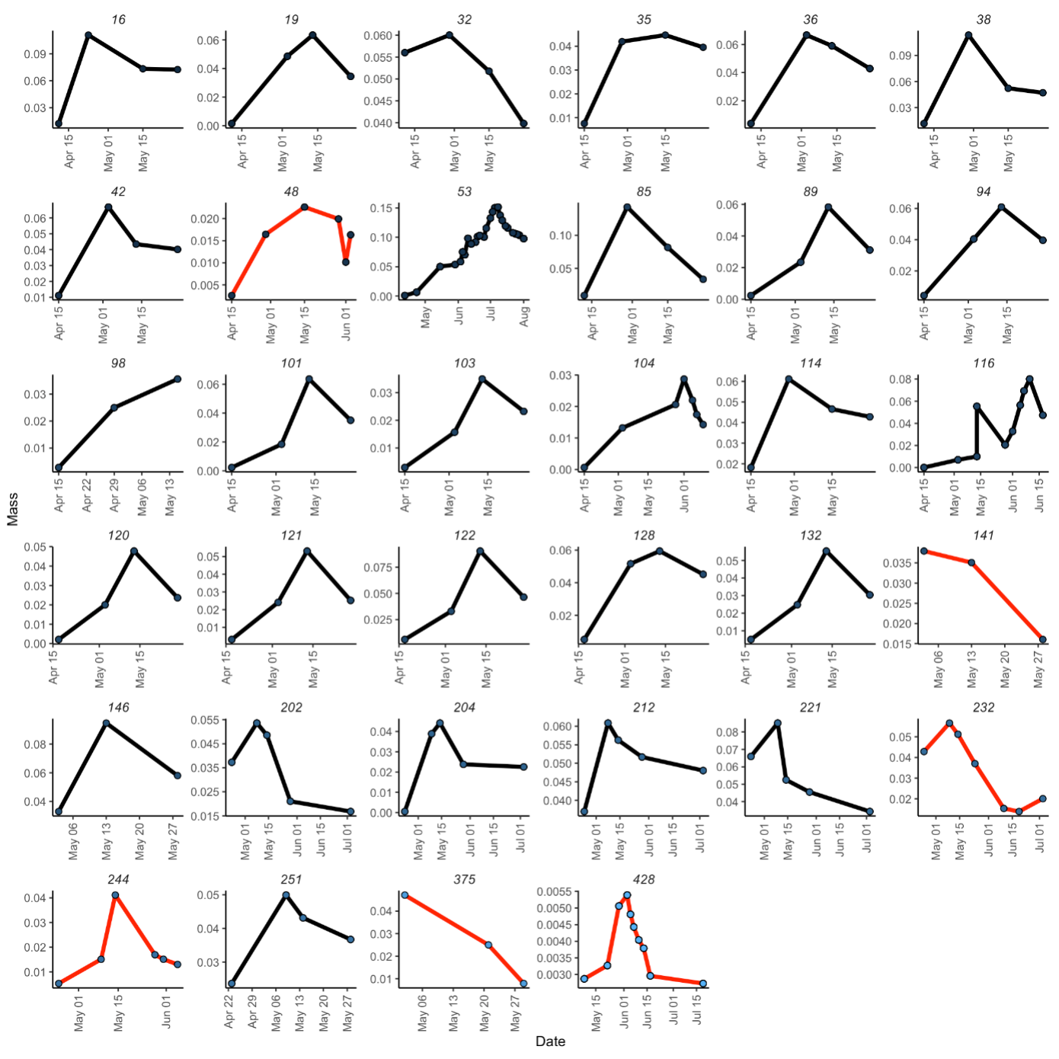
Figure S1.2: Growth curves for the Operophtera brumata individuals reared in 2019, showing mass changes over time for both parasitised (red lines) and non-parasitised (black lines) individuals. The graph includes 34 specimens, with 6 parasitised and 28 non-parasitised individuals. The y-axis represents mass, while the x-axis represents the date. Black lines indicate non-parasitised specimens, and red lines indicate parasitised specimens. The highest mass value for parasitised specimens is approximately 0.06 g, while the highest mass value for non-parasitised specimens reaches around 0.15 g. This visualization highlights the impact of parasitism on the growth patterns of Operophtera brumata caterpillars, showcasing noticeable differences in mass changes between parasitised and non-parasitised states.

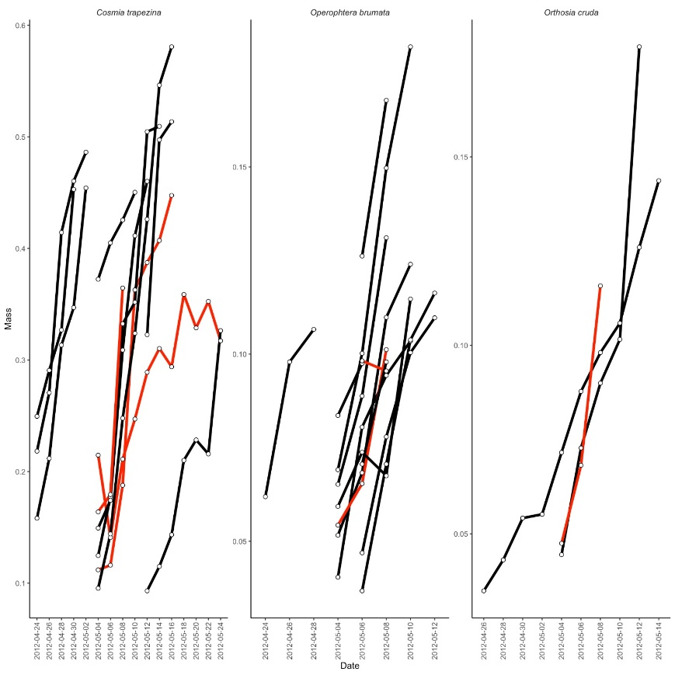

Figure S1.3: Growth curves for the individuals reared in 2012. Black lines indicate non-parasitised specimens, and red lines indicate parasitised specimens. Caterpillar body mass (mg) was inferred from their length.

