Supplementary Materials

Figure S1. Flow diagram of participant selection in the HRS
Table S1. ACEs Measurement
Table S2. The association between number and scores of ACEs with the incidence of PDOA
Table S3. Sensitivity analysis 1: time-varying Cox regression after excluding PDOA cases within the first two years of follow-up (N= 8,584)
Table S4. Sensitivity analysis 2: time-varying Cox regression after excluding PDOA cases in the first follow-up interview (N= 8,436)
Table S5. Sensitivity analysis 3: time-varying Cox regression adjusting for the total number of physical diseases as a time-varying covariate in Model 3 (N= 8,628)
Table S6. Sensitivity analysis 4: associations between ACEs and the incidence of PDOA using traditional Cox regression models with baseline covariates only (N= 8,628)
Table S7. Sensitivity analysis 5: Fine–Gray competing risk analyses of the association between ACEs and the incidence of PDOA accounting for death as a competing event (N=8,628)
Figure S3. Cumulative incidence of PDOA and death by the types and number of ACEs
Table S8. Number and percentage of recorded state transitions among participants with and without ACEs [n (%)]
Table S9. Transition intensity between different states among participants with and without ACEs
Table S10. Associations between ACEs and multi-transient states using univariate Markov model
Table S11. Effects of covariates on state transitions among participants with ACEs (Univariate Markov model)
Figure S4. Transition probability curves for participants with and without ACEs over 22 years

Figure S1. Flow diagram of participant selection in the HRS

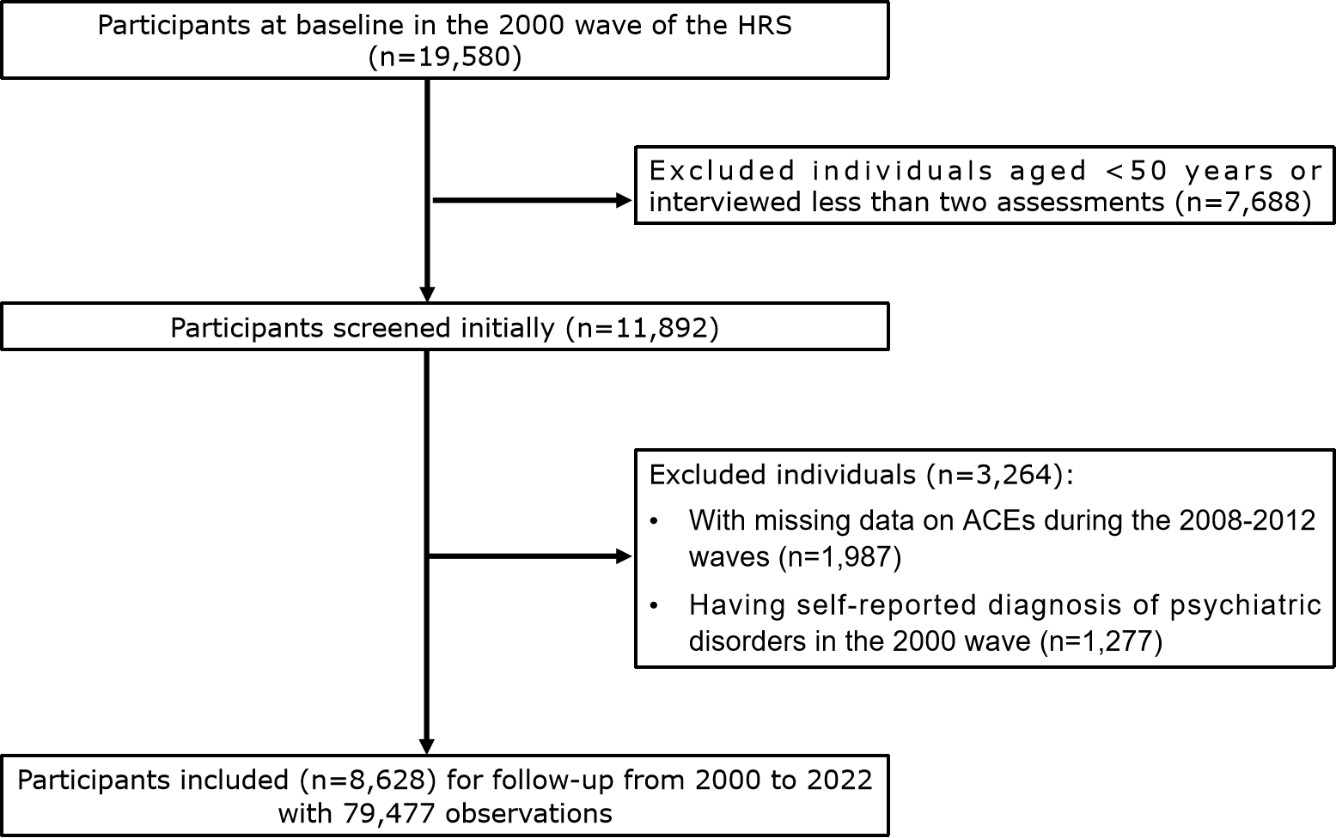
Table S1. ACEs Measurement
ACE types | Survey items | Coding methods
Trauma & violence | Have you ever been in a major fire, flood, earthquake, or other natural disaster? (Choosing before 18 years old) | Binary (1="Yes" and 0= "No")
Trauma & violence | Have you ever fired a weapon in combat or been fired upon in combat? (Choosing before 18 years old) | Binary (1="Yes" and 0= "No")
Trauma & violence | Were you the victim of a serious physical attack or assault in your life? (Choosing before 18 years old) | Binary (1="Yes" and 0= "No")
Trauma & violence | Did you ever have a life-threatening illness or accident? (Choosing before 18 years old) | Binary (1="Yes" and 0= "No")
Family dysfunction | How much time and attention did your mother give you when you needed it? (Choosing before 18 years old) | 4-point Likert scale ranging from 1 (“a lot”) to 4 (“not at all"). Reverse-scored and recoded: "not at all" scored as 1 and all other responses as 0.
Family dysfunction | Before you were 18 years old, did either of your parents drink or use drugs so often that it caused problems in the family? | Binary (1="Yes" and 0= "No")
Family dysfunction | Before you were 18 years old, were you ever physically abused by either of your parents? | Binary (1="Yes" and 0= "No")
Social problems | Before you were 18 years old, did you have to do a year of school over again? | Binary (1="Yes" and 0= "No")
Social problems | Before you were 18 years old, were you ever in trouble with the police? | Binary (1="Yes" and 0= "No")
Note: ACE: adverse childhood experience.

Table S2. The association between the number and scores of ACEs with the incidence of PDOA (N=8,628)
Variables | Cases  N | Incidence rate, per 1000  person-years | Model 1 |  |  | Model 2 |  |  | Model 3
Variables | Cases  N | Incidence rate, per 1000  person-years | HR | 95%CI | P | HR | 95%CI | P | HR | 95%CI | P
No. of ACEs
0 ACE | 5,672 | 8.85 | Reference |  |  | Reference |  |  | Reference
1 ACE | 2,160 | 11.2 | 1.340 | 1.188-1.511 | <0.001 | 1.313 | 1.163-1.482 | <0.001 | 1.185 | 1.051-  1.337 | 0.006
2 ACEs | 608 | 13.0 | 1.608 | 1.336-1.935 | <0.001 | 1.524 | 1.265-1.835 | <0.001 | 1.279 | 1.056-1.549 | 0.012
≥3 ACEs | 188 | 15.0 | 1.845 | 1.357-2.508 | <0.001 | 1.785 | 1.313-2.428 | <0.001 | 1.506 | 1.128-2.011 | 0.005
Continuous ACE score | 1,429 | 9.85 | 1.249 | 1.175- 1.329 | <0.001 | 1.229 | 1.154-1.308 | <0.001 | 1.142 | 1.072- 1.216 | <0.001
Notes: Bolded values indicate P < 0.05. ACE: adverse childhood experience; PDOA: psychiatric disorders in older adults; HR: Hazard ratio; CI: Confidence interval; CESD-8: 8-item Center for Epidemiological Studies Depression Scale; JSS-4: 4-item Jenkins Sleep Scale; TICS-m: modified version of the Telephone Interview for Cognitive Status Scale.
Model 1 was adjusted for age, sex and race/ethnicity.
Model 2 was adjusted for age, sex, race/ethnicity, marital status, living with others, educational level, vigorous activities, smoking, and alcohol use.
Model 3 was adjusted for the same covariates as model 2 plus history of major physical diseases (diabetes, cancer, heart conditions, stroke, hypertension, lung diseases, and arthritis), total CESD-8 score, total JSS-4 score and total TICS-m score.

Figure S2. Kaplan-Meier survival curve by the types and number of ACEs
A B
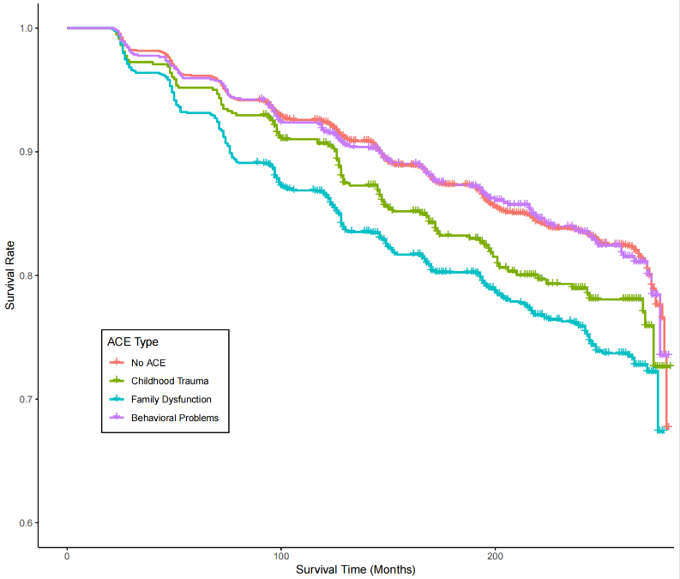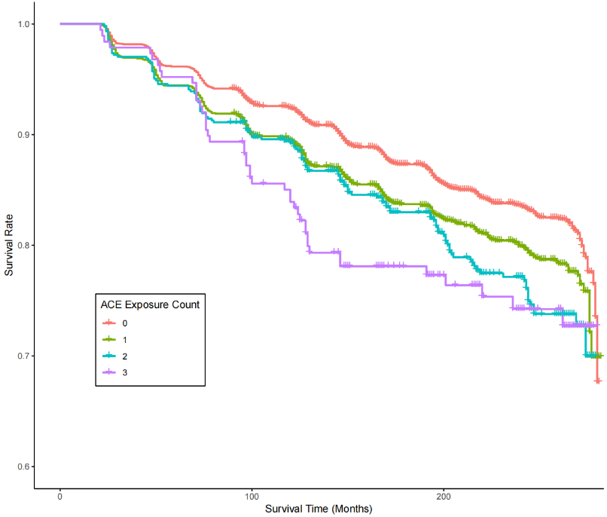

A: Kaplan-Meier survival curve by types of ACEs.
B: Kaplan-Meier survival curve by numbers of ACEs.

Table S3. Sensitivity analysis 1: time-varying Cox regression after excluding PDOA cases within the first two years of follow-up (N= 8,584)
Variables | Model 1 |  |  | Model 2 |  |  | Model 3
Variables | HR | 95%CI | P | HR | 95%CI | P | HR | 95%CI | P
ACE type
No adversity | Reference |  |  | Reference |  |  | Reference
Trauma & violence | 1.349 | 1.099-1.656 | 0.004 | 1.361 | 1.108-1.671 | 0.003 | 1.262 | 1.034-1.541 | 0.022
Family dysfunction | 1.612 | 1.413-1.839 | <0.001 | 1.563 | 1.369-1.785 | <0.001 | 1.364 | 1.194-1.559 | <0.001
Social problems | 1.145 | 0.955-1.372 | 0.143 | 1.093 | 0.910-1.313 | 0.344 | 0.968 | 0.806-1.164 | 0.731
No. of ACEs
0 ACE | Reference |  |  | Reference |  |  | Reference
1 ACE | 1.339 | 1.186-1.513 | <0.001 | 1.313 | 1.161-1.485 | <0.001 | 1.187 | 1.051-1.342 | 0.006
2 ACEs | 1.606 | 1.331-1.938 | <0.001 | 1.523 | 1.261-1.839 | <0.001 | 1.278 | 1.053-1.552 | 0.013
≥3 ACEs | 1.778 | 1.295-2.440 | <0.001 | 1.722 | 1.254-2.365 | <0.001 | 1.458 | 1.082-1.963 | 0.013
Continuous ACE score | 1.243 | 1.168-1.324 | <0.001 | 1.223 | 1.148-1.303 | <0.001 | 1.137 | 1.067-1.212 | <0.001
Notes: Bolded values indicate P < 0.05. ACE: adverse childhood experience; PDOA: psychiatric disorders in older adults; HR: Hazard ratio; CI: Confidence interval; CESD-8: 8-item Center for Epidemiological Studies Depression Scale; JSS-4: 4-item Jenkins Sleep Scale; TICS-m: modified version of the Telephone Interview for Cognitive Status Scale.
Model 1 was adjusted for age, sex and race/ethnicity.
Model 2 was adjusted for age, sex, race/ethnicity, marital status, living with others, educational level, vigorous activities, smoking, and alcohol use.
Model 3 was adjusted for the same covariates as model 2 plus history of major physical diseases (diabetes, cancer, heart conditions, stroke, hypertension, lung diseases, and arthritis), total CESD-8 score, total JSS-4 score and total TICS-m score.

Table S4. Sensitivity analysis 2: time-varying Cox regression after excluding PDOA cases in the first follow-up interview (N= 8,436)
Variables | Model 1 |  |  | Model 2 |  |  | Model 3
Variables | HR | 95%CI | P | HR | 95%CI | P | HR | 95%CI | P
ACE type
No adversity | Reference |  |  | Reference |  |  | Reference
Trauma & violence | 1.338 | 1.077-1.662 | 0.008 | 1.352 | 1.088-1.680 | 0.007 | 1.271 | 1.029-1.571 | 0.026
Family dysfunction | 1.569 | 1.363-1.805 | <0.001 | 1.525 | 1.324-1.757 | <0.001 | 1.333 | 1.156-1.537 | <0.001
Social problems | 1.122 | 0.926-1.360 | 0.242 | 1.068 | 0.879-1.298 | 0.506 | 0.942 | 0.775-1.145 | 0.546
No. of ACEs
0 ACE | Reference |  |  | Reference |  |  | Reference
1 ACE | 1.285 | 1.128-1.464 | <0.001 | 1.261 | 1.105-1.438 | <0.001 | 1.143 | 1.003-1.302 | 0.046
2 ACEs | 1.598 | 1.310-1.950 | <0.001 | 1.523 | 1.247-1.860 | <0.001 | 1.274 | 1.038-1.564 | 0.021
≥3 ACEs | 1.955 | 1.411-2.708 | <0.001 | 1.897 | 1.368-2.631 | <0.001 | 1.626 | 1.192-2.216 | 0.002
Continuous ACE score | 1.249 | 1.168-1.336 | <0.001 | 1.230 | 1.149-1.318 | <0.001 | 1.146 | 1.069-1.229 | <0.001
Notes: Bolded values indicate P < 0.05. ACE: adverse childhood experience; PDOA: psychiatric disorders in older adults; HR: Hazard ratio; CI: Confidence interval; CESD-8: 8-item Center for Epidemiological Studies Depression Scale; JSS-4: 4-item Jenkins Sleep Scale; TICS-m: modified version of the Telephone Interview for Cognitive Status Scale.
Model 1 was adjusted for age, sex and race/ethnicity.
Model 2 was adjusted for age, sex, race/ethnicity, marital status, living with others, educational level, vigorous activities, smoking, and alcohol use.
Model 3 was adjusted for the same covariates as model 2 plus history of major physical diseases (diabetes, cancer, heart conditions, stroke, hypertension, lung diseases, and arthritis), total CESD-8 score, total JSS-4 score and total TICS-m score.

Table S5. Sensitivity analysis 3: time-varying Cox regression adjusting for the total number of physical diseases as a time-varying covariate in Model 3 (N= 8,628)
Variables | Model 3
Variables | HR | 95%CI | P
ACE type
No adversity | Reference
Trauma & violence | 1.297 | 1.066-1.577 | 0.009
Family dysfunction | 1.370 | 1.201-1.562 | <0.001
Social problems | 0.989 | 0.825- 1.184 | 0.900
No. of ACEs
0 ACE | Reference
1 ACE | 1.198 | 1.062-1.351 | 0.003
2 ACEs | 1.293 | 1.068-1.566 | 0.008
≥3 ACEs | 1.545 | 1.158-2.062 | 0.003
Continuous ACE score | 1.151 | 1.080-1.226 | <0.001
Notes: Bolded values indicate P < 0.05. ACE: adverse childhood experience; HR: Hazard ratio; CI: Confidence interval; CESD-8: 8-item Center for Epidemiological Studies Depression Scale; JSS-4: 4-item Jenkins Sleep Scale; TICS-m: modified version of the Telephone Interview for Cognitive Status Scale.
Model 3 was adjusted for age, sex, race/ethnicity, marital status, living with others, educational level, vigorous activities, smoking, alcohol use, total number of physical diseases (diabetes, cancer, heart conditions, stroke, hypertension, lung diseases, and arthritis), total CESD-8 score, total JSS-4 score and total TICS-m score.

Table S6. Sensitivity analysis 4: associations between ACEs and the incidence of PDOA using traditional Cox regression models with baseline covariates only (N= 8,628)
Variables | Model 1 |  |  | Model 2 |  |  | Model 3
Variables | HR | 95%CI | P | HR | 95%CI | P | HR | 95%CI | P
ACE type
No adversity | Reference |  |  | Reference |  |  | Reference
Trauma & violence | 1.360 | 1.113-1.661 | 0.003 | 1.391 | 1.139-1.700 | 0.001 | 1.313 | 1.074-1.606 | 0.008
Family dysfunction | 1.662 | 1.460-1.892 | <0.001 | 1.638 | 1.438-1.865 | <0.001 | 1.537 | 1.349-1.752 | <0.001
Social problems | 1.165 | 0.976-1.391 | 0.092 | 1.133 | 0.948-1.354 | 0.171 | 1.058 | 0.885-1.265 | 0.537
No. of ACEs
0 ACE | Reference |  |  | Reference |  |  | Reference
1 ACE | 1.357 | 1.204-1.530 | <0.001 | 1.348 | 1.196-1.520 | <0.001 | 1.267 | 1.124-1.429 | <0.001
2 ACEs | 1.655 | 1.373-1.994 | <0.001 | 1.616 | 1.340-1.948 | <0.001 | 1.490 | 1.235-1.798 | <0.001
≥3 ACEs | 1.930 | 1.428-2.608 | <0.001 | 1.914 | 1.416-2.587 | <0.001 | 1.841 | 1.361-2.490 | <0.001
Continuous ACE score | 1.267 | 1.190-1.348 | <0.001 | 1.259 | 1.182-1.341 | <0.001 | 1.217 | 1.142-1.297 | <0.001
Notes: Bolded values indicate P < 0.05. ACE: adverse childhood experience; PDOA: psychiatric disorders in older adults; HR: Hazard ratio; CI: Confidence interval; CESD-8: 8-item Center for Epidemiological Studies Depression Scale; JSS-4: 4-item Jenkins Sleep Scale; TICS-m: modified version of the Telephone Interview for Cognitive Status Scale.
Model 1 was adjusted for age, sex and race/ethnicity.
Model 2 was adjusted for age, sex, race/ethnicity, marital status, living with others, educational level, vigorous activities, smoking, and alcohol use.
Model 3 was adjusted for the same covariates as model 2 plus history of major physical diseases (diabetes, cancer, heart conditions, stroke, hypertension, lung diseases, and arthritis), total CESD-8 score, total JSS-4 score and total TICS-m score.

Table S7. Sensitivity analysis 5: Fine–Gray competing risk analyses of the association between ACEs and the incidence of PDOA accounting for death as a competing event (N=8,628)
Variables | Model 1 |  |  | Model 2 |  |  | Model 3
Variables | HR | 95%CI | P | HR | 95%CI | P | HR | 95%CI | P
ACE type
No adversity | Reference |  |  | Reference |  |  | Reference
Trauma & violence | 1.353 | 1.107-1.653 | 0.003 | 1.376 | 1.126-1.682 | 0.002 | 1.298 | 1.061-1.588 | 0.011
Family dysfunction | 1.636 | 1.437-1.862 | <0.001 | 1.616 | 1.418-1.842 | <0.001 | 1.526 | 1.338-1.742 | <0.001
Behavioral problem | 1.143 | 0.957-1.366 | 0.140 | 1.115 | 0.932-1.335 | 0.230 | 1.046 | 0.873-1.254 | 0.620
No. of ACEs
0 ACE | Reference |  |  | Reference |  |  | Reference
1 ACE | 1.341 | 1.190-1.512 | <0.001 | 1.331 | 1.180-1.503 | <0.001 | 1.262 | 1.117-1.425 | <0.001
2 ACEs | 1.618 | 1.345-1.947 | <0.001 | 1.588 | 1.319-1.912 | <0.001 | 1.455 | 1.206-1.755 | <0.001
≥3 ACEs | 1.880 | 1.387-2.548 | <0.001 | 1.877 | 1.384-2.546 | <0.001 | 1.803 | 1.327-2.451 | <0.001
Continuous ACE score | 1.254 | 1.179-1.333 | <0.001 | 1.248 | 1.173-1.328 | <0.001 | 1.207 | 1.133-1.287 | <0.001
Notes: Bolded values indicate P < 0.05. ACE: adverse childhood experience; PDOA: psychiatric disorders in older adults; HR: Hazard ratio; CI: Confidence interval; CESD-8: 8-item Center for Epidemiological Studies Depression Scale; JSS-4: 4-item Jenkins Sleep Scale; TICS-m: modified version of the Telephone Interview for Cognitive Status Scale.
Model 1 was adjusted for age, sex and race/ethnicity.
Model 2 was adjusted for age, sex, race/ethnicity, marital status, living with others, educational level, vigorous activities, smoking, and alcohol use.
Model 3 was adjusted for the same covariates as model 2 plus history of major physical diseases (diabetes, cancer, heart conditions, stroke, hypertension, lung diseases, and arthritis), total CESD-8 score, total JSS-4 score and total TICS-m score.

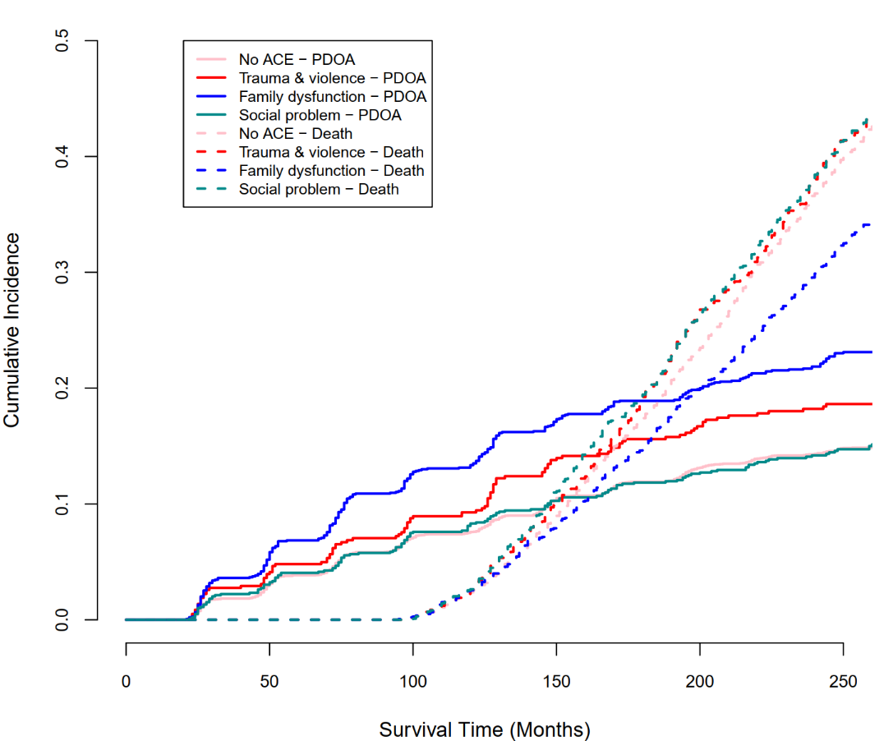
Figure S3. Cumulative incidence of PDOA and death by ACE types and number

Notes: Cumulative incidence for the psychiatric disorders in older adults (PDOA, Event 1) and death (Event 2), stratified by ACE types and number. Solid lines represent the estimated cumulative incidence for each ACE type (No ACE, Trauma & violence, Family dysfunction, and Social problem) and number of ACE (0, 1, 2, ≥3). Dashed lines represent estimated cumulative incidence for death as a competing risk.
Table S8. Number and percentage of recorded state transitions among participants with and without ACEs [n (%)]

Participants | To  From | No PC & No MS | PC | MS | PC & MS | Psychiatric disorder
With ACEs | No PC & No MS | 6430 (74.1) | 801 (9.2) | 1095(12.6) | 176 (2.0) | 178 (2.1)
With ACEs | PC | 148 (1.8) | 6421 (77.3) | 39 (0.5) | 1544 (18.6) | 150 (1.8)
With ACEs | MS | 917 (33.0) | 109 (3.9) | 1433 (51.5) | 227 (8.2) | 96 (3.5)
With ACEs | PC & MS | 22 (0.5) | 1151 (28.0) | 60 (1.5) | 2732 (66.4) | 152 (3.7)
Without ACEs | No PC & No MS | 14705 (77.9) | 1538 (8.2) | 2076 (11.0) | 324 (1.7) | 230 (1.2)
Without ACEs | PC | 241 (1.5) | 12649 (79.4) | 64 (0.4) | 2724 (17.1) | 249 (1.6)
Without ACEs | MS | 1600 (31.4) | 224 (4.4) | 2742 (53.8) | 383 (7.5) | 150 (2.9)
Without ACEs | PC & MS | 43 (0.6) | 1866 (26.4) | 123 (1.7) | 4813 (68.1) | 224 (3.2)
Note: ACEs: adverse childhood experiences; No PC & No MS: participants without physical conditions (diabetes, stroke, heart conditions and cancers) and mental symptoms (depressive symptoms and cognitive impairment); PC: participants with physical conditions; MS: participants with mental symptoms; PC & MS: participants with mental symptoms and physical conditions; Absorbing state: participants with psychiatric disorder.

Table S9. Transition intensity between different states among participants with and without ACEs

Transition categories | With ACEs |  | Without ACEs
Transition categories | Transition intensity | 95%CI | Transition intensity | 95%CI
No PC & No MS → PC | 0.067 | 0.062- 0.072 | 0.055 | 0.052- 0.058
No PC & No MS → MS | 0.130 | 0.121- 0.139 | 0.104 | 0.099- 0.109
No PC & No MS → PC & MS | 0.003 | 0.001- 0.007 | 0.004 | 0.002- 0.005
No PC & No MS → Psychiatric disorder | 0.011 | 0.009- 0.014 | 0.006 | 0.005- 0.007
PC→ No PC & No CI | 0.011 | 0.010- 0.014 | 0.010 | 0.008- 0.011
PC→ MS | 0.002 | 0.001- 0.004 | 0.001 | 0.0003-0.002
PC→ PC & MS | 0.146 | 0.138- 0.154 | 0.129 | 0.123- 0.134
PC→ Psychiatric disorder | 0.009 | 0.007- 0.011 | 0.007 | 0.006- 0.009
MS→ No PC & No CI | 0.329 | 0.306- 0.354 | 0.286 | 0.271- 0.302
MS→ PC | 0.008 | 0.003- 0.017 | 0.017 | 0.013- 0.022
MS→ PC & MS | 0.068 | 0.059- 0.078 | 0.058 | 0.052- 0.065
MS→ Psychiatric disorder | 0.021 | 0.016- 0.027 | 0.018 | 0.015- 0.022
PC & MS→ No PC & No CI | 0.002 | 0.001- 0.004 | 0.0008 | 0.0002- 0.003
PC & MS→ PC | 0.215 | 0.202- 0.228 | 0.194 | 0.185- 0.203
PC & MS→ MS | 0.011 | 0.008- 0.014 | 0.013 | 0.011- 0.016
PC & MS→ Psychiatric disorder | 0.021 | 0.017- 0.025 | 0.018 | 0.015- 0.020
Note: ACEs: adverse childhood experiences; No PC & No MS: participants without physical conditions (diabetes, stroke, heart conditions and cancers) and mental symptoms (depressive symptoms and cognitive impairment); PC: participants with physical conditions; MS: participants with mental symptoms; PC & MS: participants with mental symptoms and physical conditions; Absorbing state: participants with psychiatric disorder.

Table S10. Associations between ACEs and multi-transient states using univariate Markov model
Transient states | ACE total scores
Transient states | HR | 95%CI
No PC & No MS → PC | 1.190 | 1.086 - 1.304
No PC & No MS → MS | 1.253 | 1.153 - 1.362
No PC & No MS → PC & MS | 0. 976 | 0.417 - 2.282
No PC & No MS → Psychiatric disorder | 1.859 | 1.439 - 2.403
PC→ No PC & No CI | 1.217 | 0.970 - 1.526
PC→ MS | 1.126 | 0.241 - 5.269
PC→ PC & MS | 1.138 | 1.063 - 1.218
PC→ Psychiatric disorder | 1.123 | 0.854 - 1.477
MS→ No PC & No CI | 1.145 | 1.047 - 1.253
MS→ PC | 0.644 | 0.324 - 1.279
MS→ PC & MS | 1.126 | 0.942 - 1.347
MS→ Psychiatric disorder | 1.054 | 0.770 - 1.443
PC & MS→ No PC & No CI | 0.920 | 0.116 - 7.317
PC & MS→ PC | 1.105 | 1.021 - 1.196
PC & MS→ MS | 0.826 | 0.594 - 1.149
PC & MS→ Psychiatric disorder | 1.157 | 0.919 - 1.455
Note: Bolded values indicate statistically significant results. ACEs: adverse childhood experiences; No PC & No MS: participants without physical conditions (diabetes, stroke, heart conditions and cancers) and mental symptoms (depressive symptoms and cognitive impairment); PC: participants with physical conditions; MS: participants with mental symptoms; PC & MS: participants with mental symptoms and physical conditions; Absorbing state: participants with psychiatric disorder.

Table S11. Effects of covariates on state transitions among participants with ACEs (Univariate Markov model)
Variables | No PC & No MS→Psychiatric disorders |  | PC→Psychiatric disorders |  | MS→Psychiatric disorders |  | PC &MS→Psychiatric disorders
Variables | HR | 95%CI | HR | 95%CI | HR | 95%CI | HR | 95%CI
Older Age (≥65 years) | 0.538 | 0.362- 0.798 | 0.372 | 0.229- 0.605 | 0.308 | 0.185- 0.512 | 0.488 | 0.292- 0.816
Male | 0.536 | 0.359- 0.802 | 0.497 | 0.318- 0.777 | 0.495 | 0.294- 0.835 | 0.659 | 0.463- 0.940
Black/ African American/ Other non-White race | 0.701 | 0.343-1.434 | 0.749 | 0.336-1.667 | 0.564 | 0.282- 1.127 | 0.706 | 0.429- 1.162
Married | 1.131 | 0.730- 1.750 | 0.914 | 0.572- 1.460 | 1.581 | 0.918- 2.725 | 0.984 | 0.688- 1.406
High school education or above (≥12 years) | 0.927 | 0.634-1.356 | 1.291 | 0.831- 2.007 | 1.864 | 1.114- 3.120 | 1.472 | 1.005- 2.155
Living with others | 1.242 | 0.773- 1.996 | 0.860 | 0.537- 1.376 | 1.695 | 0.965-2 .977 | 1.038 | 0.723- 1.489
Smoking | 1.57 | 0.96-2.58 | 1.34 | 0.60-2.96 | 0.93 | 0.45-1.93 | 1.00 | 0.54-1.88
Alcohol use | 0.946 | 0.652- 1.374 | 0.482 | 0.277- 0.839 | 0.602 | 0.319- 1.136 | 0.867 | 0.566- 1.328
Vigorous physical activity | 0.620 | 0.424- 0.906 | 0.944 | 0.613- 1.455 | 1.045 | 0.629- 1.74 | 0.782 | 0.514- 1.19
Insomnia (JSS-4 score ≥5) | 1.153 | 0.739-1.800 | 1.143 | 0.679-1.924 | 1.444 | 0.669-3.117 | 2.721 | 1.244-5.952
Physical diseases
Lung diseases | 2.592 | 1.524-4.356 | 2.274 | 1.371-3.773 | 0.732 | 0.236-2.273 | 1.476 | 0.955-2.281
Arthritis | 1.530 | 1.028-2.275 | 2.846 | 1.334-6.072 | 1.268 | 0.750-2.143 | 1.118 | 0.737-1.697
Hypertension | 1.140 | 0.784- 1.659 | 1.467 | 0.878- 2.451 | 0.839 | 0.511- 1.378 | 0.731 | 0.498- 1.074
Notes: Bolded values indicate statistically significant results. ACEs: adverse childhood experiences; No PC & No MS: participants without physical conditions (diabetes, stroke, heart conditions and cancers) and mental symptoms (depressive symptoms and cognitive impairment); PC: participants with physical conditions; MS: participants with mental symptoms; PC & MS: participants with mental symptoms and physical conditions; Absorbing state: participants with psychiatric disorder. JSS-4: 4-item Jenkins Sleep Scale.

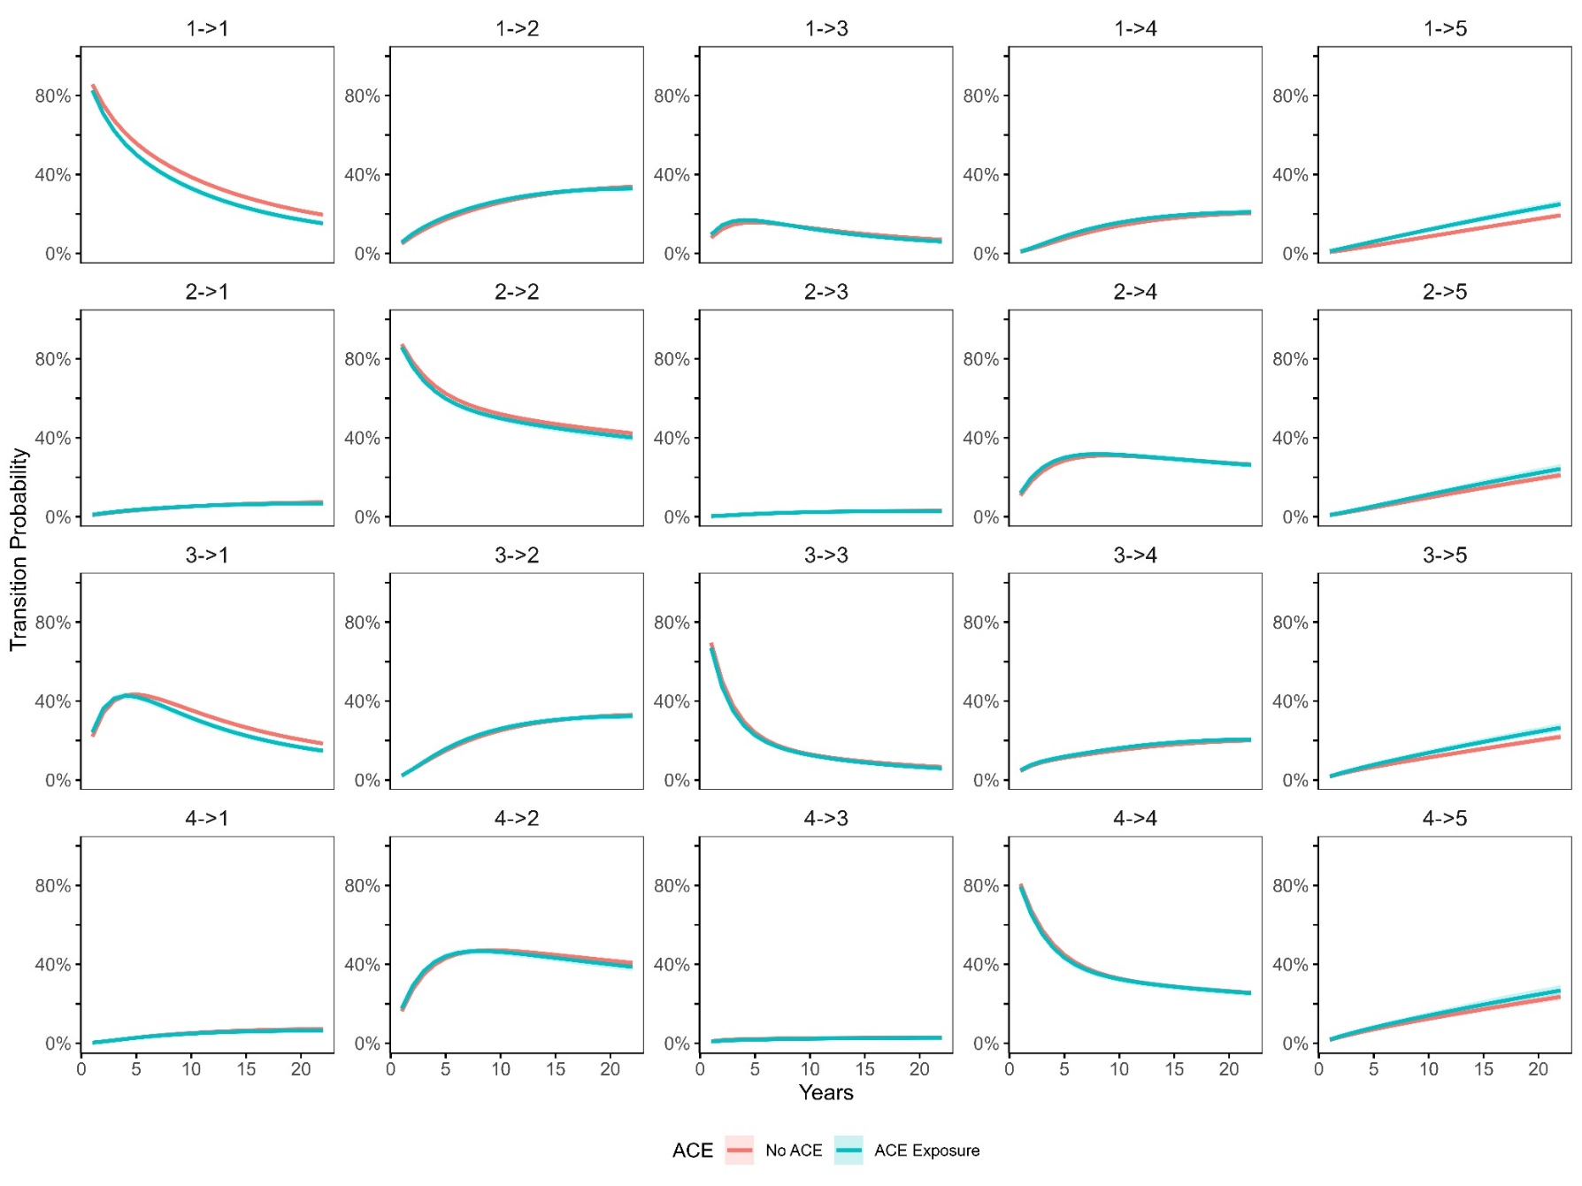
Figure S4. Transition probability curves for participants with and without ACEs over 22 years
Notes: ACEs: adverse childhood experiences Participants; State 1-5: 1. without physical conditions (diabetes, stroke, heart conditions and cancers) and mental symptoms (depressive symptoms and cognitive impairment); 2. Participants with physical conditions; 3. Participants with mental symptoms; 4. Participants with mental symptoms and physical conditions; 5. Participants suffering from psychiatric disorder.

