Supplementary Information(SI)

Application of Statistical Design of Experiment in the Screening of Carbon-Carbon Cross-Coupling Reactions

Fulufhelo Radzilaniª, Orpah Zinyembaª, and Reinout Meijboom^{a*}

ªDepartment of Chemical Science; University of Johannesburg; Auckland Park; Johannesburg 2006; South Africa.
*Corresponding author: Tel.: +27 (0)11 559 2367, fax: +27 (0)11 559 2819; *e-mail: rmeijboom@uj.ac.za

1 Experimental
1.1 Instrumentation
1.1.1 Shimadzu gas chromatography-flame ionisation detector (GC–FID) and gas chromatography-mass spectrometry (GC–MS) QP2010
The Shimadzu and GC–FID 2010 plus equipped with a Restek RTX–5 column with dimensions of 30 m × 0.25 µm × 0.25 mm film thickness with a maximum temperature of 300 ℃. Samples (1 µL) were subjected to the following column parameters: 40 ℃ and held for 2 minutes, ramped to 250 ℃ at 15 ℃/minute and held for 5 minutes. The SPL1 split/splitless injector system was used at 250 ℃ in split mode. Nitrogen gas (25 mL/min) was used as carrier gas at a pressure of 104.4 kPa, a total flow of 10.3 mL/min, column flow of 1.21 mL/min, linear velocity of 30.2 cm/sec, purge flow of 3 mL/min, and split ratio of 5:1. The flame ionisation detector was maintained at 250 ℃, with a data sampling rate of 40 msec. Hydrogen gas (40 mL/min) was used as fuel, and air (400 mL/min) was supplied as oxidant to sustain the flame.

The Shimadzu GC–MS 2010 Plus was equipped with a split/split-less inlet using an SLB-5ms capillary column with dimensions of 30 m × 0.25 µm × 0.25 mm film thickness with a maximum temperature of 300 ℃. Samples (1 µL) were subjected to the following column parameters: 40 ℃ and held for 2 minutes, ramped to 250 ℃ at 15 ℃/minute and held for 5 minutes. The SPL1 split/splitless injector system was used at 250 ℃ in split mode. Helium gas was used as a carrier gas, with a column pressure of 100 kPa, total flow of 50 mL/min, and flow rate of 1.78 mL/minute, a linear velocity of 48.1 cm/sec, purge flow of 3 mL/min, and split ratio of 24:1. Mass spectrometry (MS) parameters: an ionisation temperature of 200 ℃ and interface temperature of 250 ℃. Data were acquired in scan mode with an event time of 0.50 seconds, scan speed of 666, a mass-to-charge range (m/z) of 40- to 350, and detector voltage of 0 kV.

1.2 Method
The twelve-run Plackett-Burman design (PBD) of statistical Design of experiment (sDoE) was used for the screening of phosphine ligands, catalyst loading, bases, and solvents for the Mizoroki–Heck, Suzuki–Miyaura, and Sonogashira–Hagihara C–C cross-coupling reactions. Parameters were assigned to columns A to E. The six remaining columns were assigned to dummy parameters F to G. Each parameter was defined as high level (+1) and low level (–1). The disentangled interaction effect of each parameter was used to determine significant factors for the cross-coupling reactions mentioned above. The PBD is shown in Table SI 1.

Table SI 1: Twelve-run Plackett-Burman design (PBD) used to screen the C-C cross-coupling reactions. The following symbols represent: A to K are parameters, y_{1–12} conversions of the substrate to product, +1 is a high level, and –1 is a low level of a parameter, n is the number of factors [1].
Factors/Run | A | B | C | D | E | F | G | H | I | J | K | Conversions (y)
1 | +1 | +1 | –1 | +1 | –1 | +1 | –1 | –1 | –1 | +1 | –1 | y₁
2 | +1 | –1 | +1 | +1 | –1 | –1 | –1 | –1 | +1 | –1 | +1 | y₂
3 | –1 | +1 | +1 | +1 | +1 | –1 | –1 | +1 | –1 | +1 | +1 | y₃
4 | +1 | +1 | +1 | –1 | +1 | –1 | +1 | –1 | +1 | +1 | –1 | y4
5 | +1 | +1 | –1 | –1 | +1 | +1 | –1 | +1 | +1 | –1 | +1 | y₅
6 | +1 | –1 | –1 | –1 | –1 | –1 | +1 | +1 | –1 | +1 | +1 | y₆
7 | –1 | –1 | –1 | +1 | +1 | +1 | +1 | –1 | +1 | +1 | +1 | y₇
8 | –1 | –1 | +1 | –1 | –1 | +1 | –1 | +1 | +1 | +1 | –1 | y₈
9 | –1 | +1 | –1 | +1 | –1 | –1 | +1 | +1 | +1 | –1 | –1 | y₉
10 | +1 | –1 | +1 | +1 | +1 | +1 | +1 | +1 | –1 | –1 | –1 | y₁₀
11 | –1 | +1 | +1 | –1 | –1 | +1 | +1 | –1 | –1 | –1 | +1 | y₁₁
12 | –1 | –1 | –1 | –1 | +1 | –1 | –1 | –1 | –1 | –1 | –1 | y₁₂
 |  |  |  |  |  |  |  |  |  |  |  | ȳ
ȳ_{–1} | ȳ_{–1A} | ȳ_{–1B} | ȳ_{–1C} | ȳ_{–1D} | ȳ_{–1E} | ȳ_{–1F} | ȳ_{–1G} | ȳ_{–1H} | ȳ_{–1I} | ȳ_{–1J} | ȳ_{–1K}
ȳ₊₁ | ȳ_{+1A} | ȳ_{+1B} | ȳ_{+1C} | ȳ_{+1D} | ȳ_{+1E} | ȳ_{+1F} | ȳ_{+1G} | ȳ_{+1H} | ȳ_{+1I} | ȳ_{+1J} | ȳ_{+1K}
Contrast (Δ)  [ȳ₊₁ - ȳ_{–1}] | ȳ_{+1A} - ȳ_{–1A} | ȳ_{+1B} - ȳ_{–1B} | ȳ_{+1C} - ȳ_{–1C} | ȳ_{+1D} - ȳ_{–1D} | ȳ_{+1E} - ȳ_{–1E} | ȳ_{+1F} - ȳ_{–1F} | ȳ_{+1G} - ȳ_{–1G} | ȳ_{+1H} - ȳ_{–1H} | ȳ_{+1I} - ȳ_{–1I} | ȳ_{+1J} - ȳ_{–1J} | ȳ_{+1K} - ȳ_{–1K}
Estimated Effect  [2Δ /N] | Δ_{A} / 6 | Δ_{B} / 6 | Δ_{C} / 6 | Δ_{D} / 6 | Δ_{E} / 6 | Δ_{F} / 6 | Δ_{G} / 6 | Δ_{H} / 6 | Δ_{I} / 6 | Δ_{J} / 6 | Δ_{K} / 6
Disentangled effect* | - | - | - | - | - | - | - | - | - | - | -

Below is the detailed procedure indicating the order in which reagents were added in each reaction run based on the PBD (Table SI 2) for the three cross-coupling reactions.

1.2.1 Mizoroki–Heck coupling reactions
Mizoroki–Heck reactions were performed using iodobenzene (2 mmol), butyl acrylate (2.4 mmol), two bases, four phosphine ligands, two solvents, and Pd precursor, K₂PdCl₄. The bases were sodium hydroxide (NaOH) and Et₃N. The solvents were dimethylsulfoxide (DMSO) and acetonitrile (MeCN). The phosphine ligands used are listed in Table 1 in the manuscript. Reactions were performed in Radleys Carousel 12 plus reaction station coupled with a magnetic stirrer, see Figure SI 1.

Run 1: T1, NaOH, DMSO, and 1 mol% catalyst.
In reaction run 1, ligand T1 (0.0105 g, 0.2 mmol) and NaOH (0.1599 g, 4 mmol) were added to DMSO (5 mL). In this mixture, iodobenzene (223.82 μL, 2 mmol), butyl acrylate (345.50 μL, 2.4 mmol), and dodecane (454.54 μL, 2 mmol, internal standard), were added. Metal precursor, K₂PdCl₄ (0.0065 g, 1 mol%), was added as a catalyst. The reaction was heated at 60℃ for 24 hours. Samplings (60 μL) were done before the start of reaction (into gc-insert) and after 24 hours. The reaction mixture was subjected to a small silica column to remove inorganic species and a syringe-filter was used to remove solid particles before the 24-hour samples (60 μL) preparations and diluted (1:10) with DCM for analysis. The samples were analysed using GC-FID for quantitative purposes and GC-MS for qualitative purposes.

Run 2: T2, NaOH, DMSO, 5 mol% catalyst.
In reaction run 2, ligand T1 (5.2 μL, 0.2 mmol) and NaOH (0.1599 g, 4 mmol) were added to DMSO (5 mL). In this mixture, iodobenzene (223.82 μL, 2 mmol), butyl acrylate (345.50 μL, 2.4 mmol), and dodecane (454.54 μL, 2 mmol, internal standard), were added. Metal precursor, K₂PdCl₄ (0.0326 g, 5 mol%), was added as a catalyst. The reaction was heated at 60℃ for 24 hours. Samplings (60 μL) were done before the start of reaction (into gc-insert) and after 24 hours. The reaction mixture was subjected to a small silica column to remove inorganic species and a syringe-filter was used to remove solid particles before the 24-hour samples (60 μL) preparations and diluted (1:10) with DCM for analysis. The samples were analysed using GC-FID for quantitative purposes and GC-MS for qualitative purposes.

Run 3: T3, NaOH, MeCN, 5 mol% catalyst.
In reaction run 3, ligand T3 (0.0056 g, 0.2 mmol) and NaOH (0.1599 g, 4 mmol) were added to MeCN (5 mL). In this mixture, iodobenzene (223.82 μL, 2 mmol), butyl acrylate (345.50 μL, 2.4 mmol), and dodecane (454.54 μL, 2 mmol, internal standard), were added. Metal precursor, K₂PdCl₄ (0.0326 g, 5 mol%), was added as a catalyst. The reaction was heated at 60℃ for 24 hours. Samplings (60 μL) were done before the start of reaction (into gc-insert) and after 24 hours. The reaction mixture was subjected to a small silica column to remove inorganic species and a syringe-filter was used to remove solid particles before the 24-hour samples (60 μL) preparations and diluted (1:10) with DCM for analysis. The samples were analysed using GC-FID for quantitative purposes and GC-MS for qualitative purposes.

Run 4: T1, Et₃N, MeCN, 5 mol% catalyst.
In reaction run 4, ligand T1 (0.0105 g, 0.2 mmol) and Et₃N (557.52 μL, 4 mmol) were added to MeCN (5 mL). In this mixture, iodobenzene (223.82 μL, 2 mmol), butyl acrylate (345.50 μL, 2.4 mmol), and dodecane (454.54 μL, 2 mmol, internal standard), were added. Metal precursor, K₂PdCl₄ (0.0326 g, 5 mol%), was added as a catalyst. The reaction was heated at 60℃ for 24 hours. Samplings (60 μL) were done before the start of reaction (into gc-insert) and after 24 hours. The reaction mixture was subjected to a small silica column to remove inorganic species and a syringe-filter was used to remove solid particles before the 24-hour samples (60 μL) preparations and diluted (1:10) with DCM for analysis. The samples were analysed using GC-FID for quantitative purposes and GC-MS for qualitative purposes.

Run 5: T1, Et₃N, MeCN, 1 mol% catalyst.
In reaction run 5, ligand T1 (0.0105 g, 0.2 mmol) and Et₃N (557.52 μL, 4 mmol) were added to MeCN (5 mL). In this mixture, iodobenzene (223.82 μL, 2 mmol), butyl acrylate (345.50 μL, 2.4 mmol), and dodecane (454.54 μL, 2 mmol, internal standard), were added. Metal precursor, K₂PdCl₄ (0.0065 g, 1 mol%), was added as a catalyst. The reaction was heated at 60℃ for 24 hours. Samplings (60 μL) were done before the start of reaction (into gc-insert) and after 24 hours. The reaction mixture was subjected to a small silica column to remove inorganic species and a syringe-filter was used to remove solid particles before preparation of the 24-hour samples (60 μL) and diluted (1:10) with DCM for analysis. The samples were analysed using GC-FID for quantitative purposes and GC-MS for qualitative purposes.

Run 6: T2, Et₃N, DMSO, 1 mol% catalyst.
In reaction run 6, ligand T2 (5.2 μL, 0.2 mmol) and Et₃N (557.52 μL, 4 mmol) were added to DMSO (5 mL). In this mixture, iodobenzene (223.82 μL, 2 mmol), butyl acrylate (345.50 μL, 2.4 mmol), and dodecane (454.54 μL, 2 mmol, internal standard), were added. Metal precursor, K₂PdCl₄ (0.0065 g, 1 mol%), was added as a catalyst. The reaction was heated at 60℃ for 24 hours. Samplings (60 μL) were done before the start of reaction (into gc-insert) and after 24 hours. The reaction mixture was subjected to a small silica column to remove inorganic species and a syringe-filter was used to remove solid particles before the 24-hour samples (60 μL) preparations and diluted (1:10) with DCM for analysis. The samples were analysed using GC-FID for quantitative purposes and GC-MS for qualitative purposes.

Run 7: T4, NaOH, MeCN, 1 mol% catalyst.
In reaction run 7, ligand T4 (2.85 μL, 0.2 mmol) and NaOH (0.1599 g, 4 mmol) were added to MeCN (5 mL). In this mixture, iodobenzene (223.82 μL, 2 mmol), butyl acrylate (345.50 μL, 2.4 mmol), and dodecane (454.54 μL, 2 mmol, internal standard), were added. Metal precursor, K₂PdCl₄ (0.0065 g, 1 mol%), was added as a catalyst. The reaction was heated at 60℃ for 24 hours. Samplings (60 μL) were done before the start of reaction (into gc-insert) and after 24 hours. The reaction mixture was subjected to a small silica column to remove inorganic species and a syringe-filter was used to remove solid particles before the 24-hour samples (60 μL) preparations and diluted (1:10) with DCM for analysis. The samples were analysed using GC-FID for quantitative purposes and GC-MS for qualitative purposes.

Run 8: T4, Et₃N, DMSO, 5 mol% catalyst.
In reaction run 8, ligand T4 (2.85 μL, 0.2 mmol) and Et₃N (557.52 μL, 4 mmol) were added to DMSO (5 mL). In this mixture, iodobenzene (223.82 μL, 2 mmol), butyl acrylate (345.50 μL, 2.4 mmol), and dodecane (454.54 μL, 2 mmol, internal standard), were added. Metal precursor, K₂PdCl₄ (0.0326 g, 5 mol%), was added as a catalyst. The reaction was heated at 60℃ for 24 hours. Samplings (60 μL) were done before the start of reaction (into gc-insert) and after 24 hours. The reaction mixture was subjected to a small silica column to remove inorganic species and a syringe-filter was used to remove solid particles before the 24-hour samples (60 μL) preparations and diluted (1:10) with DCM for analysis. The samples were analysed using GC-FID for quantitative purposes and GC-MS for qualitative purposes.

Run 9: T3, NaOH, DMSO, 1 mol% catalyst.
In reaction run 9, ligand T3 (0.0056 g, 0.2 mmol) and NaOH (0.1599 g, 4 mmol) were added to DMSO (5 mL). In this mixture, iodobenzene (223.82 μL, 2 mmol), butyl acrylate (345.50 μL, 2.4 mmol), and dodecane (454.54 μL, 2 mmol, internal standard), were added. Metal precursor, K₂PdCl₄ (0.0065 g, 1 mol%), was added as a catalyst. The reaction was heated at 60℃ for 24 hours. Samplings (60 μL) were done before the start of reaction (into gc-insert) and after 24 hours. The reaction mixture was subjected to a small silica column to remove inorganic species and a syringe-filter was used to remove solid particles before the 24-hour samples (60 μL) preparations and diluted (1:10) with DCM for analysis. The samples were analysed using GC-FID for quantitative purposes and GC-MS for qualitative purposes.

Run 10: T2, NaOH, MeCN, 5 mol% catalyst.
In reaction run 10, ligand T2 (5.2 μL, 0.2 mmol) and NaOH (0.1599 g, 4 mmol) were added to MeCN (5 mL). In this mixture, iodobenzene (223.82 μL, 2 mmol), butyl acrylate (345.50 μL, 2.4 mmol), and dodecane (454.54 μL, 2 mmol, internal standard), were added. Metal precursor, K₂PdCl₄ (0.0326 g, 5 mol%), was added as a catalyst. The reaction was heated at 60℃ for 24 hours. Samplings (60 μL) were done before the start of reaction (into gc-insert) and after 24 hours. The reaction mixture was subjected to a small silica column to remove inorganic species and a syringe-filter was used to remove solid particles before the 24-hour samples (60 μL) preparations and diluted (1:10) with DCM for analysis. The samples were analysed using GC-FID for quantitative purposes and GC-MS for qualitative purposes.

Run 11: T3, Et₃N, DMSO, 5 mol% catalyst.
In reaction run 11, ligand T3 (0.0056 g, 0.2 mmol) and Et₃N (557.52 μL, 4 mmol) were added to DMSO (5 mL). In this mixture, iodobenzene (223.82 μL, 2 mmol), butyl acrylate (345.50 μL, 2.4 mmol), and dodecane (454.54 μL, 2 mmol, internal standard), were added. Metal precursor, K₂PdCl₄ (0.0326 g, 5 mol%), was added as a catalyst. The reaction was heated at 60℃ for 24 hours. Samplings (60 μL) were done before the start of reaction (into gc-insert) and after 24 hours. The reaction mixture was subjected to a small silica column to remove inorganic species and a syringe-filter was used to remove solid particles before the 24-hour samples (60 μL) preparations and diluted (1:10) with DCM for analysis. The samples were analysed using GC-FID for quantitative purposes and GC-MS for qualitative purposes.

Run 12: T4, Et₃N, MeCN, 1 mol% catalyst.
In reaction run 12, ligand T4 (2.85 μL g, 0.2 mmol) and Et₃N (557.52 μL, 4 mmol) were added to MeCN (5 mL). In this mixture, iodobenzene (223.82 μL, 2 mmol), butyl acrylate (345.50 μL, 2.4 mmol), and dodecane (454.54 μL, 2 mmol, internal standard), were added. Metal precursor, K₂PdCl₄ (0.0065 g, 1 mol%), was added as a catalyst. The reaction was heated at 60℃ for 24 hours. Samplings (60 μL) were done before the start of reaction (into gc-insert) and after 24 hours. The reaction mixture was subjected to a small silica column to remove inorganic species and a syringe-filter was used to remove any solid particles before the 24-hour samples (60 μL) preparations and diluted (1:10) with DCM for analysis. The samples were analysed using GC-FID for quantitative purposes and GC-MS for qualitative purposes.

1.2.2 Suzuki–Miyaura coupling reactions
Suzuki–Miyaura coupling reactions were performed using bromobenzene (2 mmol) and 4-fluorophenylboronic acid (2.4 mmol), two bases, four phosphine ligands, two solvents and Pd precursor, K₂PdCl₄. The bases were sodium hydroxide (NaOH) and Et₃N. The solvents were dimethylsulfoxide (DMSO) and acetonitrile (MeCN). The phosphine ligands used are listed in Table 1. Reactions were performed in Radleys Carousel 12 plus reaction station coupled with a magnetic stirrer, see Figure SI 1.

Run 1: T1, NaOH, DMSO, and 1 mol% catalyst.
In reaction run 1, ligand T1 (0.0105 g, 0.2 mmol) and NaOH (0.1599 g, 4 mmol) were added to DMSO (5 mL). In this mixture, bromobenzene (210.61 μL, 2 mmol), 4-fluorophenylboronic acid (0.3358 g, 2.4 mmol), and dodecane (454.54 μL, 2 mmol, internal standard), were added. Metal precursor, K₂PdCl₄ (0.0065 g, 1 mol%), was added as a catalyst. The reaction was heated at 60℃ for 24 hours. Samplings (60 μL) were done before the start of reaction (into gc-insert) and after 24 hours. The reaction mixture was subjected to a small silica column to remove inorganic species and a syringe-filter was used to remove solid particles before the 24-hour samples (60 μL) preparations and diluted (1:10) with DCM for analysis. The samples were analysed using GC-FID for quantitative purposes and GC-MS for qualitative purposes.

Run 2: T2, NaOH, DMSO, 5 mol% catalyst.
In reaction run 2, ligand T1 (5.2 μL, 0.2 mmol) and NaOH (0.1599 g, 4 mmol) were added to DMSO (5 mL). In this mixture, bromobenzene (210.61 μL, 2 mmol), 4-fluorophenylboronic acid (0.3358 g, 2.4 mmol), and dodecane (454.54 μL, 2 mmol, internal standard), were added. Metal precursor, K₂PdCl₄ (0.0326 g, 5 mol%), was added as a catalyst. The reaction was heated at 60℃ for 24 hours. Samplings (60 μL) were done before the start of reaction (into gc-insert) and after 24 hours. The reaction mixture was subjected to a small silica column to remove inorganic species and a syringe-filter was used to remove solid particles before the 24-hour samples (60 μL) preparations and diluted (1:10) with DCM for analysis. The samples were analysed using GC-FID for quantitative purposes and GC-MS for qualitative purposes.

Run 3: T3, NaOH, MeCN, 5 mol% catalyst.
In reaction run 3, ligand T3 (0.0056 g, 0.2 mmol) and NaOH (0.1599 g, 4 mmol) were added to MeCN (5 mL). In this mixture, bromobenzene (210.61 μL, 2 mmol), 4-fluorophenylboronic acid (0.3358 g, 2.4 mmol), and dodecane (454.54 μL, 2 mmol, internal standard), were added. Metal precursor, K₂PdCl₄ (0.0326 g, 5 mol%), was added as a catalyst. The reaction was heated at 60℃ for 24 hours. Samplings (60 μL) were done before the start of reaction (into gc-insert) and after 24 hours. The reaction mixture was subjected to a small silica column to remove inorganic species and a syringe-filter was used to remove solid particles before the 24-hour samples (60 μL) preparations and diluted (1:10) with DCM for analysis. The samples were analysed using GC-FID for quantitative purposes and GC-MS for qualitative purposes.

Run 4: T1, Et₃N, MeCN, 5 mol% catalyst.
In reaction run 4, ligand T1 (0.0105 g, 0.2 mmol) and Et₃N (557.52 μL, 4 mmol) were added to MeCN (5 mL). In this mixture, bromobenzene (210.61 μL, 2 mmol), 4-fluorophenylboronic acid (0.3358 g, 2.4 mmol), and dodecane (454.54 μL, 2 mmol, internal standard), were added. Metal precursor, K₂PdCl₄ (0.0326 g, 5 mol%), was added as a catalyst. The reaction was heated at 60℃ for 24 hours. Samplings (60 μL) were done before the start of reaction (into gc-insert) and after 24 hours. The reaction mixture was subjected to a small silica column to remove inorganic species and a syringe-filter was used to remove solid particles before the 24-hour samples (60 μL) preparations and diluted (1:10) with DCM for analysis. The samples were analysed using GC-FID for quantitative purposes and GC-MS for qualitative purposes.

Run 5: T1, Et₃N, MeCN, 1 mol% catalyst.
In reaction run 5, ligand T1 (0.0105 g, 0.2 mmol) and Et₃N (557.52 μL, 4 mmol) were added to MeCN (5 mL). In this mixture, bromobenzene (210.61 μL, 2 mmol), 4-fluorophenylboronic acid (0.3358 g, 2.4 mmol), and dodecane (454.54 μL, 2 mmol, internal standard), were added. Metal precursor, K₂PdCl₄ (0.0065 g, 1 mol%), was added as a catalyst. The reaction was heated at 60℃ for 24 hours. Samplings (60 μL) were done before the start of reaction (into gc-insert) and after 24 hours. The reaction mixture was subjected to a small silica column to remove inorganic species and a syringe-filter was used to remove any solid particles before the 24-hour samples (60 μL) preparations and diluted (1:10) with DCM for analysis. The samples were analysed using GC-FID for quantitative purposes and GC-MS for qualitative purposes.

Run 6: T2, Et₃N, DMSO, 1 mol% catalyst.
In reaction run 6, ligand T2 (5.2 μL, 0.2 mmol) and Et₃N (557.52 μL, 4 mmol) were added to DMSO (5 mL). In this mixture, iodobenzene (223.82 μL, 2 mmol), bromobenzene (210.61 μL, 2 mmol), 4-fluorophenylboronic acid (0.3358 g, 2.4 mmol), and dodecane (454.54 μL, 2 mmol, internal standard), were added. Metal precursor, K₂PdCl₄ (0.0065 g, 1 mol%), was added as a catalyst. The reaction was heated at 60℃ for 24 hours. Samplings were done at the 0-hour (before the reaction) and after 24 hours. Samples were prepared into GC-inserts for the 0-hour sample (60 uL). The reaction mixture was subjected to a small silica column to remove inorganic species. A syringe was used to remove solid particles before the 24-hour samples (60 μL) preparations and diluted (1:10) with DCM for analysis. The samples were analysed using GC-FID for quantitative purposes and GC-MS for qualitative purposes.

Run 7: T4, NaOH, MeCN, 1 mol% catalyst.
In reaction run 7, ligand T4 (2.85 μL, 0.2 mmol) and NaOH (0.1599 g, 4 mmol) were added to MeCN (5 mL). In this mixture, bromobenzene (210.61 μL, 2 mmol), 4-fluorophenylboronic acid (0.3358 g, 2.4 mmol), and dodecane (454.54 μL, 2 mmol, internal standard), were added. Metal precursor, K₂PdCl₄ (0.0065 g, 1 mol%), was added as a catalyst. The reaction was heated at 60℃ for 24 hours. Samplings (60 μL) were done before the start of reaction (into gc-insert) and after 24 hours. The reaction mixture was subjected to a small silica column to remove inorganic species and a syringe-filter was used to remove solid particles before the 24-hour samples (60 μL) preparations and diluted (1:10) with DCM for analysis. The samples were analysed using GC-FID for quantitative purposes and GC-MS for qualitative purposes.

Run 8: T4, Et₃N, DMSO, 5 mol% catalyst.
In reaction run 8, ligand T4 (2.85 μL, 0.2 mmol) and Et₃N (557.52 μL, 4 mmol) were added to DMSO (5 mL). In this mixture, bromobenzene (210.61 μL, 2 mmol), 4-fluorophenylboronic acid (0.3358 g, 2.4 mmol), and dodecane (454.54 μL, 2 mmol, internal standard), were added. Metal precursor, K₂PdCl₄ (0.0326 g, 5 mol%), was added as a catalyst. The reaction was heated at 60℃ for 24 hours. Samplings (60 μL) were done before the start of reaction (into gc-insert) and after 24 hours. The reaction mixture was subjected to a small silica column to remove inorganic species and a syringe-filter was used to remove any solid particles before the 24-hour samples (60 μL) preparations and diluted (1:10) with DCM for analysis. The samples were analysed using GC-FID for quantitative purposes and GC-MS for qualitative purposes.

Run 9: T3, NaOH, DMSO, 1 mol% catalyst.
In reaction run 9, ligand T3 (0.0056 g, 0.2 mmol) and NaOH (0.1599 g, 4 mmol) were added to DMSO (5 mL). In this mixture, bromobenzene (210.61 μL, 2 mmol), 4-fluorophenylboronic acid (0.3358 g, 2.4 mmol), and dodecane (454.54 μL, 2 mmol, internal standard), were added. Metal precursor, K₂PdCl₄ (0.0065 g, 1 mol%), was added as a catalyst. The reaction was heated at 60℃ for 24 hours. Samplings (60 μL) were done before the start of reaction (into gc-insert) and after 24 hours. The reaction mixture was subjected to a small silica column to remove inorganic species and a syringe-filter was used to remove solid particles before the 24-hour samples (60 μL) preparations and diluted (1:10) with DCM for analysis. The samples were analysed using GC-FID for quantitative purposes and GC-MS for qualitative purposes.

Run 10: T2, NaOH, MeCN, 5 mol% catalyst.
In reaction run 10, ligand T2 (5.2 μL, 0.2 mmol) and NaOH (0.1599 g, 4 mmol) were added to MeCN (5 mL). In this mixture, bromobenzene (210.61 μL, 2 mmol), 4-fluorophenylboronic acid (0.3358 g, 2.4 mmol), and dodecane (454.54 μL, 2 mmol, internal standard), were added. Metal precursor, K₂PdCl₄ (0.0326 g, 5 mol%), was added as a catalyst. The reaction was heated at 60℃ for 24 hours. Samplings (60 μL) were done before the start of reaction (into gc-insert) and after 24 hours. The reaction mixture was subjected to a small silica column to remove inorganic species and a syringe-filter was used to remove solid particles before the 24-hour samples (60 μL) preparations and diluted (1:10) with DCM for analysis. The samples were analysed using GC-FID for quantitative purposes and GC-MS for qualitative purposes.

Run 11: T3, Et₃N, DMSO, 5 mol% catalyst.
In reaction run 11, ligand T3 (0.0056 g, 0.2 mmol) and Et₃N (557.52 μL, 4 mmol) were added to DMSO (5 mL). In this mixture, bromobenzene (210.61 μL, 2 mmol), 4-fluorophenylboronic acid (0.3358 g, 2.4 mmol), and dodecane (454.54 μL, 2 mmol, internal standard), were added. Metal precursor, K₂PdCl₄ (0.0326 g, 5 mol%), was added as a catalyst. The reaction was heated at 60℃ for 24 hours. Samplings (60 μL) were done before the start of reaction (into gc-insert) and after 24 hours. The reaction mixture was subjected to a small silica column to remove inorganic species and a syringe-filter was used to remove any solid particles before the 24-hour samples (60 μL) preparations and diluted (1:10) with DCM for analysis. The samples were analysed using GC-FID for quantitative purposes and GC-MS for qualitative purposes.

Run 12: T4, Et₃N, MeCN, 1 mol% catalyst.
In reaction run 12, ligand T4 (2.85 μL g, 0.2 mmol) and Et₃N (557.52 μL, 4 mmol) were added to MeCN (5 mL). In this mixture, bromobenzene (210.61 μL, 2 mmol), 4-fluorophenylboronic acid (0.3358 g, 2.4 mmol), and dodecane (454.54 μL, 2 mmol, internal standard), were added. Metal precursor, K₂PdCl₄ (0.0065 g, 1 mol%), was added as a catalyst. The reaction was heated at 60℃ for 24 hours. Samplings were done at the 0-hour (before the reaction) and after 24 hours. Samples were prepared into GC-inserts for the 0-hour sample (60 uL). The reaction mixture was subjected to a small silica column to remove inorganic species. A syringe was used to remove solid particles before the 24-hour samples (60 μL) preparations and diluted (1:10) with DCM for analysis. The samples were analysed using GC-FID for quantitative purposes and GC-MS for qualitative purposes.

1.2.3 Sonogashira–Hagihara coupling reactions
Sonogashira–Hagihara reactions were performed using iodobenzene (1 mmol) and phenylacetylene (1.2 mmol), used two bases, four phosphine ligands, two solvents and Pd precursor, K₂PdCl₄. The bases were sodium hydroxide (NaOH) and Et₃N. The solvents were dimethylsulfoxide (DMSO) and acetonitrile (MeCN). The phosphine ligands used are listed in Table 1. Reactions were performed in Radleys Carousel 12 plus reaction station coupled with a magnetic stirrer, see Figure SI 1.

Run 1: T1, NaOH, DMSO, and 1 mol% catalyst.
In reaction run 1, ligand T1 (0.0523 g, 10 mol%) and NaOH (0.0799 g, 2 mmol) were added to DMSO (5 mL). In this mixture, iodobenzene (112 μL, 1 mmol), phenylacetylene (131.78 uL, 1.4 mmol), and dodecane (227.27 μL, 1 mmol, internal standard), were added. Metal precursor, Pd[(CH₃COO)₂] (0.0022 g, 1 mol%), was added as a catalyst. The reaction was heated at 60℃ for 24 hours. Samplings (60 μL) were done before the start of reaction (into gc-insert) and after 24 hours. The reaction mixture was subjected to a small silica column to remove inorganic species and a syringe-filter was used to remove solid particles before the 24-hour samples (60 μL) preparations and diluted (1:10) with DCM for analysis. The samples were analysed using GC-FID for quantitative purposes and GC-MS for qualitative purposes.

Run 2: T2, NaOH, DMSO, 5 mol% catalyst.
In reaction run 2, ligand T2 (26.21 μL, 10 mol%) and NaOH (0.0799 g, 2 mmol) were added to DMSO (5 mL). In this mixture, iodobenzene (112 μL, 1 mmol), phenylacetylene (131.78 μL, 1.4 mmol), and dodecane (227.27 μL, 1 mmol, internal standard), were added. Metal precursor, Pd[(CH₃COO)₂] (0.0112 g, 5 mol%), was added as a catalyst. The reaction was heated at 60℃ for 24 hours. Samplings (60 μL) were done before the start of reaction (into gc-insert) and after 24 hours. The reaction mixture was subjected to a small silica column to remove inorganic species and a syringe-filter was used to remove solid particles before the 24-hour samples (60 μL) preparations and diluted (1:10) with DCM for analysis. The samples were analysed using GC-FID for quantitative purposes and GC-MS for qualitative purposes.

Run 3: T3, NaOH, MeCN, 5 mol% catalyst.
In reaction run 3, ligand T3 (0.0280 g, 10 mol%) and NaOH (0.0799 g, 2 mmol) were added to MeCN (5 mL). In this mixture, iodobenzene (112 μL, 1 mmol), phenylacetylene (131.78 μL, 1.4 mmol), and dodecane (227.27 μL, 1 mmol, internal standard), were added. Metal precursor, Pd[(CH₃COO)₂] (0.0112 g, 5 mol%), was added as a catalyst. The reaction was heated at 60℃ for 24 hours. Samplings (60 μL) were done before the start of reaction (into gc-insert) and after 24 hours. The reaction mixture was subjected to a small silica column to remove inorganic species and a syringe-filter was used to remove solid particles before the 24-hour samples (60 μL) preparations and diluted (1:10) with DCM for analysis. The samples were analysed using GC-FID for quantitative purposes and GC-MS for qualitative purposes.

Run 4: T1, Et₃N, MeCN, 5 mol% catalyst.
In reaction run 4, ligand T1 (0.0523 g, 10 mol%) and Et₃N (278.76 μL, 2 mmol) were added to MeCN (5 mL). In this mixture, iodobenzene (112 μL, 1 mmol), phenylacetylene (131.78 μL, 1.4 mmol), and dodecane (227.27 μL, 1 mmol, internal standard), were added. Metal precursor, Pd[(CH₃COO)₂] (0.0112 g, 5 mol%), was added as a catalyst. The reaction was heated at 60℃ for 24 hours. Samplings (60 μL) were done before the start of reaction (into gc-insert) and after 24 hours. The reaction mixture was subjected to a small silica column to remove inorganic species and a syringe-filter was used to remove solid particles before the 24-hour samples (60 μL) preparations and diluted (1:10) with DCM for analysis. The samples were analysed using GC-FID for quantitative purposes and GC-MS for qualitative purposes.

Run 5: T1, Et₃N, MeCN, 1 mol% catalyst.
In reaction run 5, ligand T1 (0.0523 g, 10 mol%) and Et₃N (278.76 μL, 2 mmol) were added to MeCN (5 mL). In this mixture, iodobenzene (112 μL, 1 mmol), phenylacetylene (131.78 μL, 1.4 mmol), and dodecane (227.27 μL, 1 mmol, internal standard), were added. Metal precursor, Pd[(CH₃COO)₂] (0.0022 g, 1 mol%), was added as a catalyst. The reaction was heated at 60℃ for 24 hours. Samplings (60 μL) were done before the start of reaction (into gc-insert) and after 24 hours. The reaction mixture was subjected to a small silica column to remove inorganic species and a syringe-filter was used to remove solid particles before the 24-hour samples (60 μL) preparations and diluted (1:10) with DCM for analysis. The samples were analysed using GC-FID for quantitative purposes and GC-MS for qualitative purposes.

Run 6: T2, Et₃N, DMSO, 1 mol% catalyst.
In reaction run 6, ligand T2 (26.21 μL, 10 mol%) and Et₃N (278.76 μL, 2 mmol) were added to DMSO (5 mL). In this mixture, iodobenzene (112 μL, 1 mmol), phenylacetylene (131.78 μL, 1.4 mmol), and dodecane (227.27 μL, 1 mmol, internal standard), were added. Metal precursor, Pd[(CH₃COO)₂] (0.0022 g, 1 mol%), was added as a catalyst. The reaction was heated at 60℃ for 24 hours. Samplings (60 μL) were done before the start of reaction (into gc-insert) and after 24 hours. The reaction mixture was subjected to a small silica column to remove inorganic species and a syringe-filter was used to remove solid particles before the 24-hour samples (60 μL) preparations and diluted (1:10) with DCM for analysis. The samples were analysed using GC-FID for quantitative purposes and GC-MS for qualitative purposes.

Run 7: T4, NaOH, MeCN, 1 mol% catalyst.
In reaction run 7, ligand T4 (14.22 μL, 10 mol%) and NaOH (0.0799 g, 2 mmol) were added to MeCN (5 mL). In this mixture, iodobenzene (112 μL, 1 mmol), phenylacetylene (131.78 μL, 1.4 mmol), and dodecane (227.27 μL, 1 mmol, internal standard), were added. Metal precursor, Pd[(CH₃COO)₂] (0.0022 g, 1 mol%), was added as a catalyst. The reaction was heated at 60℃ for 24 hours. Samplings (60 μL) were done before the start of reaction (into gc-insert) and after 24 hours. The reaction mixture was subjected to a small silica column to remove inorganic species and a syringe-filter was used to remove solid particles before the 24-hour samples (60 μL) preparations and diluted (1:10) with DCM for analysis. The samples were analysed using GC-FID for quantitative purposes and GC-MS for qualitative purposes.

Run 8: T4, Et₃N, DMSO, 5 mol% catalyst.
In reaction run 8, ligand T4 (14.22 μL, 10 mol%) and Et₃N (278.76 μL, 2 mmol) were added to DMSO (5 mL). In this mixture, iodobenzene (112 μL, 1 mmol), phenylacetylene (131.78 μL, 1.4 mmol), and dodecane (227.27 μL, 1 mmol, internal standard), were added. Metal precursor, Pd[(CH₃COO)₂] (0.0112 g, 5 mol%), was added as a catalyst. The reaction was heated at 60℃ for 24 hours. Samplings (60 μL) were done before the start of reaction (into gc-insert) and after 24 hours. The reaction mixture was subjected to a small silica column to remove inorganic species and a syringe-filter was used to remove any solid particles before the 24-hour samples (60 μL) preparations and diluted (1:10) with DCM for analysis. The samples were analysed using GC-FID for quantitative purposes and GC-MS for qualitative purposes.

Run 9: T3, NaOH, DMSO, 1 mol% catalyst.
In reaction run 9, ligand T3 (0.0280 g, 10 mol%) and NaOH (0.0799 g, 2 mmol) were added to DMSO (5 mL). In this mixture, iodobenzene (112 μL, 1 mmol), phenylacetylene (131.78 μL, 1.4 mmol), and dodecane (227.27 μL, 1 mmol, internal standard), were added. Metal precursor, Pd[(CH₃COO)₂] (0.0022 g, 1 mol%), was added as a catalyst. The reaction was heated at 60℃ for 24 hours. Samplings (60 μL) were done before the start of reaction (into gc-insert) and after 24 hours. The reaction mixture was subjected to a small silica column to remove inorganic species and a syringe-filter was used to remove solid particles before the 24-hour samples (60 μL) preparations and diluted (1:10) with DCM for analysis. The samples were analysed using GC-FID for quantitative purposes and GC-MS for qualitative purposes.

Run 10: T2, NaOH, MeCN, 5 mol% catalyst.
In reaction run 10, ligand T2 (26.21 μL, 10 mol%) and NaOH (0.0799 g, 2 mmol) were added to MeCN (5 mL). In this mixture, iodobenzene (112 μL, 1 mmol), phenylacetylene (131.78 μL, 1.4 mmol), and dodecane (227.27 μL, 1 mmol, internal standard), were added. Metal precursor, Pd[(CH₃COO)₂] (0.0112 g, 5 mol%), was added as a catalyst. The reaction was heated at 60℃ for 24 hours. Samplings (60 μL) were done before the start of reaction (into gc-insert) and after 24 hours. The reaction mixture was subjected to a small silica column to remove inorganic species and a syringe-filter was used to remove solid particles before the 24-hour samples (60 μL) preparations and diluted (1:10) with DCM for analysis. The samples were analysed using GC-FID for quantitative purposes and GC-MS for qualitative purposes.

Run 11: T3, Et₃N, DMSO, 5 mol% catalyst.
In reaction run 11, ligand T3 (0.0280 g, 10 mol%) and Et₃N (278.76 μL, 2 mmol) were added to DMSO (5 mL). In this mixture, iodobenzene (112 μL, 1 mmol), phenylacetylene (131.78 μL, 1.4 mmol), and dodecane (227.27 μL, 1 mmol, internal standard), were added. Metal precursor, Pd[[CH₃COO)₂] (0.0112 g, 5 mol%), was added as a catalyst. The reaction was heated at 60℃ for 24 hours. Samplings (60 μL) were done before the start of reaction (into gc-insert) and after 24 hours. The reaction mixture was subjected to a small silica column to remove inorganic species and a syringe-filter was used to remove solid particles before the 24-hour samples (60 μL) preparations and diluted (1:10) with DCM for analysis. The samples were analysed using GC-FID for quantitative purposes and GC-MS for qualitative purposes.

Run 12: T4, Et₃N, MeCN, 1 mol% catalyst.
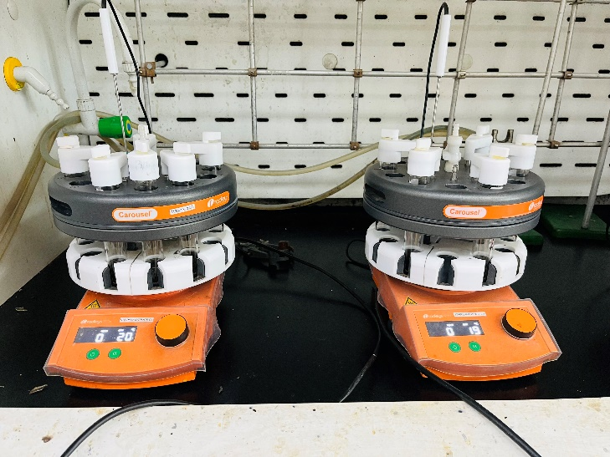
In reaction run 12, ligand T4 (14.22 μL g, 10 mol%) and Et₃N (278.76 μL, 2 mmol) were added to MeCN (5 mL). In this mixture, iodobenzene (112 μL, 1 mmol), phenylacetylene (131.78 μL, 1.4 mmol), and dodecane (227.27 μL, 1 mmol, internal standard), were added. Metal precursor, Pd[(CH₃COO)₂] (0.0022 g, 1 mol%), was added as a catalyst. The reaction was heated at 60℃ for 24 hours. Samplings (60 μL) were done before the start of reaction (into gc-insert) and after 24 hours. The reaction mixture was subjected to a small silica column to remove inorganic species and a syringe-filter was used to remove solid particles before the 24-hour samples (60 μL) preparations and diluted (1:10) with DCM for analysis. The samples were analysed using GC-FID for quantitative purposes and GC-MS for qualitative purposes.
Figure SI 1: Reaction set-up. Radleys Carousel 12 plus reaction station coupled with a magnetic stirrer.

2 Results and Discussion
After screening each parameter (ligands' electronic effect and Tolman's cone angle, catalyst loading, base strength, and solvent polarity), substrate conversions were calculated using equation 1, given in the manuscript. Other results include average conversions (ȳ), average conversions (ȳ_{–1}) for low-level (–1), and average conversions (ȳ₊₁) for high-level (+1) within a factor, Contrast (Δ), estimated effect, and disentangled effect. The absolute value of the disentangled effect indicates the magnitude of the impact of parameters on conversion. The three important parameters for each reaction were identified based on their disentangled effect.

2.1 Mizoroki-Heck coupling reactions
Table SI 2 indicates the conversions of iodobenzene to butyl-3-phenylpropionate.

Table SI 2: Complete PBD for Mizoroki-Heck reactions. Experimental results were obtained from the coupling reactions of butyl acrylate with iodobenzene using sDoE's PBD, using six dummy factors.
 | A | B | C | D | E | F | G | H | I | J | K
Factors/  Run | Electronic effect | Tolman angle | Catalyst loading | Base strength | Solvent polarity | Dummy 1 | Dummy 2 | Dummy 3 | Dummy 4 | Dummy 5 | Dummy 6 | Conversions [%]
1 | +1 | +1 | –1 | +1 | –1 | +1 | –1 | –1 | –1 | +1 | –1 | 87.68
2 | +1 | –1 | +1 | +1 | –1 | –1 | –1 | –1 | +1 | –1 | +1 | 71.89
3 | –1 | +1 | +1 | +1 | +1 | –1 | –1 | +1 | –1 | +1 | +1 | 44.57
4 | +1 | +1 | +1 | –1 | +1 | –1 | +1 | –1 | +1 | +1 | –1 | 26.70
5 | +1 | +1 | –1 | –1 | +1 | +1 | –1 | +1 | +1 | –1 | +1 | 39.70
6 | +1 | –1 | –1 | –1 | –1 | –1 | +1 | +1 | –1 | +1 | +1 | 20.93
7 | –1 | –1 | –1 | +1 | +1 | +1 | +1 | –1 | +1 | +1 | +1 | 46.16
8 | –1 | –1 | +1 | –1 | –1 | +1 | –1 | +1 | +1 | +1 | –1 | 37.18
9 | –1 | +1 | –1 | +1 | –1 | –1 | +1 | +1 | +1 | –1 | –1 | 15.73
10 | +1 | –1 | +1 | +1 | +1 | +1 | +1 | +1 | –1 | –1 | –1 | 48.07
11 | –1 | +1 | +1 | –1 | –1 | +1 | +1 | –1 | –1 | –1 | +1 | 16.06
12 | –1 | –1 | –1 | –1 | +1 | –1 | –1 | –1 | –1 | –1 | –1 | 61.92
 |  |  |  |  |  |  |  |  |  |  |  | 43.05
ȳ_{–1} | 0.37 | 0.48 | 0.45 | 0.34 | 0.42 | 0.40 | 0.57 | 0.52 | 0.47 | 0.42 | 0.46
ȳ₊₁ | 0.49 | 0.38 | 0.41 | 0.52 | 0.45 | 0.46 | 0.29 | 0.34 | 0.40 | 0.44 | 0.40
Contrast (Δ) | 0.12 | –0.09 | –0.05 | 0.19 | 0.03 | 0.06 | –0.28 | –0.17 | –0.07 | 0.02 | –0.06
Estimated effect | 0.020 | –0.015 | –0.008 | 0.031 | 0.005 | 0.009 | –0.047 | –0.029 | –0.012 | 0.003 | –0.011
Disentangled effect | 0.020 | –0.015 | –0.008 | 0.031 | 0.005 | 0.009 | –0.047 | –0.029 | –0.012 | 0.003 | –0.011

2.2 Suzuki-Miyaura coupling reactions
The conversions of bromobenzene to 4-fluoro-1,1'-biphenyl are shown in Table SI 3.

Table SI 3: Complete PBD for Suzuki-Miyaura reactions. Comparative experimental results obtained from the coupling reactions of 4-fluorophenylboronic acid with bromobenzene using sDoE's PBD, using six dummy factors.

 | A | B | C | D | E | F | G | H | I | J | K
Factors/  Run | Electronic effect | Tolman angle | Catalyst loading | Base strength | Solvent polarity | Dummy 1 | Dummy 2 | Dummy 3 | Dummy 4 | Dummy 5 | Dummy 6 | Conversions [%]
1 | +1 | +1 | –1 | +1 | –1 | +1 | –1 | –1 | –1 | +1 | –1 | 86.71
2 | +1 | –1 | +1 | +1 | –1 | –1 | –1 | –1 | +1 | –1 | +1 | 67.71
3 | –1 | +1 | +1 | +1 | +1 | –1 | –1 | +1 | –1 | +1 | +1 | 38.12
4 | +1 | +1 | +1 | –1 | +1 | –1 | +1 | –1 | +1 | +1 | –1 | 35.88
5 | +1 | +1 | –1 | –1 | +1 | +1 | –1 | +1 | +1 | –1 | +1 | 38.95
6 | +1 | –1 | –1 | –1 | –1 | –1 | +1 | +1 | –1 | +1 | +1 | 89.60
7 | –1 | –1 | –1 | +1 | +1 | +1 | +1 | –1 | +1 | +1 | +1 | 31.45
8 | –1 | –1 | +1 | –1 | –1 | +1 | –1 | +1 | +1 | +1 | –1 | 58.64
9 | –1 | +1 | –1 | +1 | –1 | –1 | +1 | +1 | +1 | –1 | –1 | 95.19
10 | +1 | –1 | +1 | +1 | +1 | +1 | +1 | +1 | –1 | –1 | –1 | 69.66
11 | –1 | +1 | +1 | –1 | –1 | +1 | +1 | –1 | –1 | –1 | +1 | 46.49
12 | –1 | –1 | –1 | –1 | +1 | –1 | –1 | –1 | –1 | –1 | –1 | 28.46
 |  |  |  |  |  |  |  |  |  |  |  | 57.24
ȳ_{–1} | 0.50 | 0.58 | 0.62 | 0.50 | 0.74 | 0.59 | 0.53 | 0.49 | 0.60 | 0.58 | 0.62
ȳ₊₁ | 0.65 | 0.57 | 0.53 | 0.65 | 0.40 | 0.55 | 0.61 | 0.65 | 0.55 | 0.57 | 0.52
Contrast (Δ) | 0.15 | –0.01 | –0.09 | 0.15 | –0.34 | –0.04 | 0.08 | 0.16 | –0.05 | –0.01 | –0.10
Estimated effect | 0.025 | –0.001 | –0.015 | 0.025 | –0.056 | –0.006 | 0.014 | 0.026 | –0.009 | –0.002 | –0.017
Disentangled effect | 0.025 | –0.001 | –0.015 | 0.025 | –0.056 | –0.006 | 0.014 | 0.026 | –0.009 | –0.002 | –0.017

2.3 Sonogashira-Hagihara coupling reactions
The conversions of iodobenzene to diphenylacetylene are shown in Table SI 4.

Table SI 4: Complete PBD for Sonogashira-Hagihara reaction. Comparative experimental results obtained from the coupling reactions of phenylacetylene with iodobenzene using sDoE's PBD, using six dummy factors.
 | A | B | C | D | E | F | G | H | I | J | K
Factors/  Run | Electronic effect | Tolman angle | Catalyst loading | Base strength | Solvent polarity | Dummy 1 | Dummy 2 | Dummy 3 | Dummy 4 | Dummy 5 | Dummy 6 | Conversions [%]
1 | +1 | +1 | –1 | +1 | –1 | +1 | –1 | –1 | –1 | +1 | –1 | 47.16
2 | +1 | –1 | +1 | +1 | –1 | –1 | –1 | –1 | +1 | –1 | +1 | 97.55
3 | –1 | +1 | +1 | +1 | +1 | –1 | –1 | +1 | –1 | +1 | +1 | 57.01
4 | +1 | +1 | +1 | –1 | +1 | –1 | +1 | –1 | +1 | +1 | –1 | 26.68
5 | +1 | +1 | –1 | –1 | +1 | +1 | –1 | +1 | +1 | –1 | +1 | 48.87
6 | +1 | –1 | –1 | –1 | –1 | –1 | +1 | +1 | –1 | +1 | +1 | 15.55
7 | –1 | –1 | –1 | +1 | +1 | +1 | +1 | –1 | +1 | +1 | +1 | 37.60
8 | –1 | –1 | +1 | –1 | –1 | +1 | –1 | +1 | +1 | +1 | –1 | 57.65
9 | –1 | +1 | –1 | +1 | –1 | –1 | +1 | +1 | +1 | –1 | –1 | 69.86
10 | +1 | –1 | +1 | +1 | +1 | +1 | +1 | +1 | –1 | –1 | –1 | 44.99
11 | –1 | +1 | +1 | –1 | –1 | +1 | +1 | –1 | –1 | –1 | +1 | 44.83
12 | –1 | –1 | –1 | –1 | +1 | –1 | –1 | –1 | –1 | –1 | –1 | 32.45
 |  |  |  |  |  |  |  |  |  |  |  | 48.35
ȳ_{–1} | 0.50 | 0.48 | 0.42 | 0.38 | 0.55 | 0.50 | 0.57 | 0.48 | 0.40 | 0.56 | 0.46
ȳ₊₁ | 0.47 | 0.49 | 0.55 | 0.59 | 0.41 | 0.47 | 0.40 | 0.49 | 0.56 | 0.40 | 0.50
Contrast (Δ) | –0.03 | 0.01 | 0.13 | 0.21 | –0.14 | –0.03 | –0.17 | 0.01 | 0.16 | –0.16 | 0.04
Estimated effect | –0.005 | 0.002 | 0.021 | 0.036 | –0.024 | –0.005 | –0.028 | 0.002 | 0.027 | –0.027 | 0.006
Disentangled effect | –0.005 | 0.002 | 0.021 | 0.036 | –0.024 | –0.005 | –0.028 | 0.002 | 0.027 | –0.027 | 0.006

3 References
[1] N.L. Bell, M., Kupper, L., Cronin, Design of Experiments for Optimization of Polyoxometalate Syntheses, Chemistry of Materials 33 (2021) 7263–7271. https://doi.org/10.1021/acs.chemmater.1c01401.

4 Appendices
4.1 Mizoroki–Heck coupling reactions
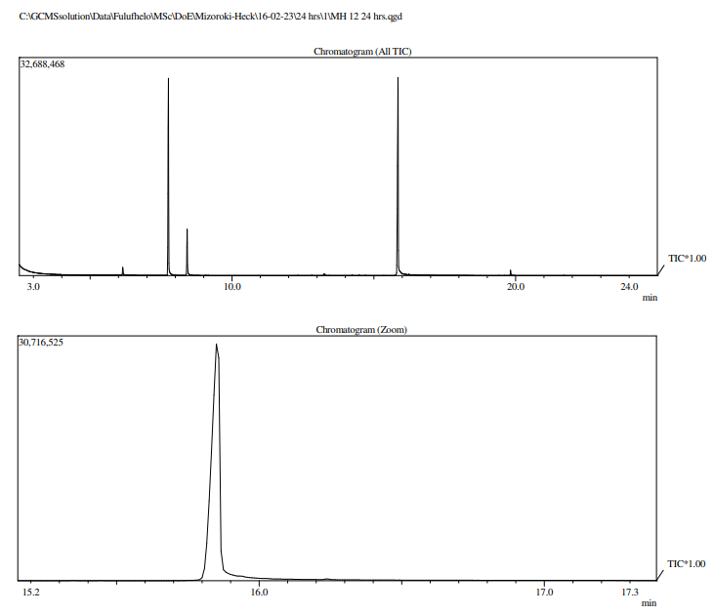
Results for the GC-MS analysis of the Mizoroki-Heck coupling reactions of iodobenzene and butyl acrylate. Figure SI 2 (chromatogram) and Figure SI 3 (mass spectrum) show the chromatogram for the 24-hour sample with a zoomed-in peak of the butyl-3-phenylpropionate product (Figure SI 4) at 15.850 min.
Figure SI 2: Chromatogram for Mizoroki–Heck reactions. A peak for the butyl-3-phenylpropionate product from coupling of iodobenzene and butyl acrylate.

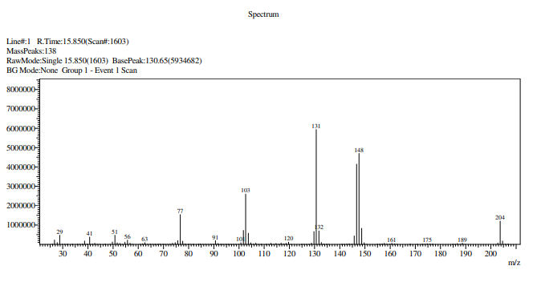
Figure SI 3: Mass spectrum for Mizoroki–Heck reactions. The Butyl-3-phenylpropionate product is identified by a molecular mass of 204 g/mol.
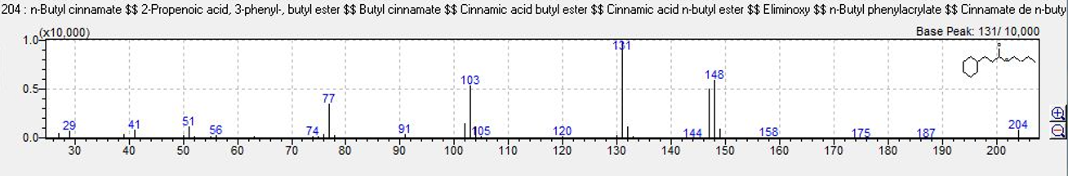
Figure SI 4: Mizoroki–Heck reaction product. Screenshot of the butyl-3-phenylpropionate product.

4.2 Suzuki–Miyaura coupling reactions
Results for the GC-MS analysis of the Suzuki-Miyaura coupling reactions of bromobenzene and 4-fluoropheylboronic acid. Figure SI 5 (chromatogram) and Figure SI 6 (mass spectrum) show the chromatogram for the 24-hour sample with a peak of the butyl-3-phenylpropionate product (Figure SI 7) at 12.800 min.
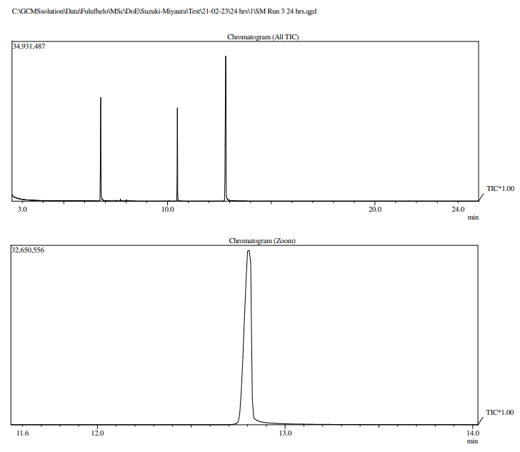
Figure SI 5: Chromatogram for Suzuki–Miyaura reactions. A peak for the 2-fluoro-1,1’-biphenyl product from coupling bromobenzene and 4-fluorophenylboronic acid.
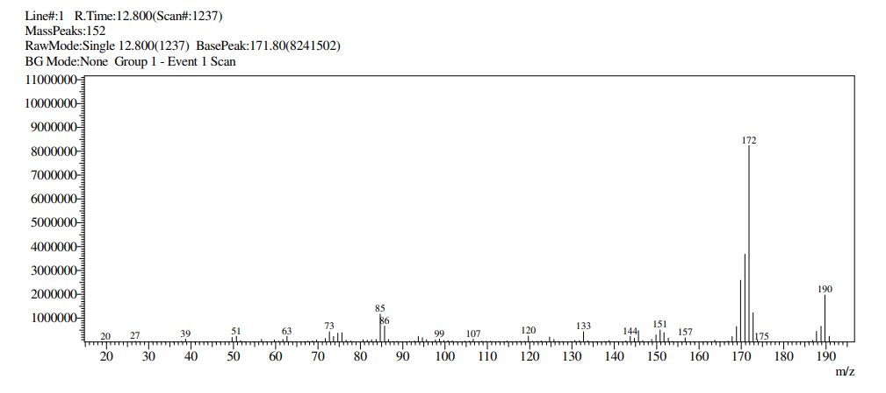
Figure SI 6: Mass spectrum for Suzuki–Miyaura reactions. The 2-fluoro-1,1’-biphenyl product is identified by a 190 g/mol molecular mass.
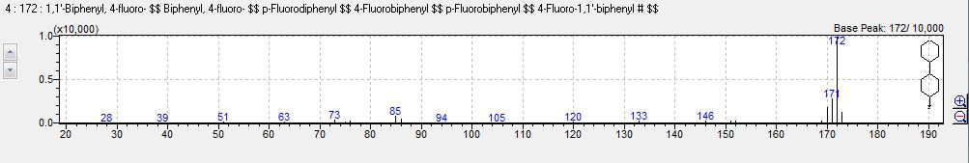

Figure SI 7: Suzuki–Miyaura reaction product. Screenshot of the 2-fluoro-1,1’-biphenyl product.

4.3 Sonogashira–Hagihara coupling reactions
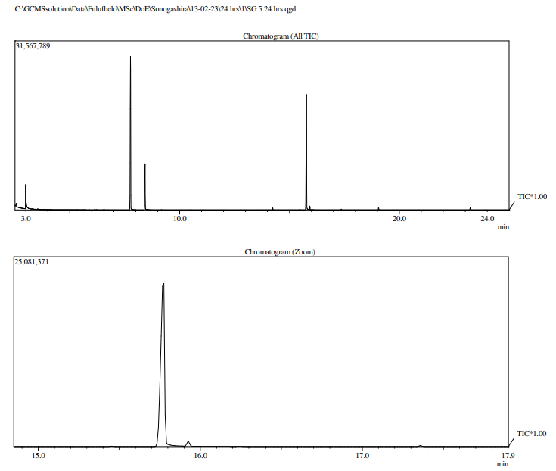
Results for the GC-MS analysis of the Sonogashira-Hagihara coupling reactions of iodobenzene and phenylacetylene. Figure SI 8 (chromatogram) and Figure SI 9 (mass spectrum) show the chromatogram for the 24-hour sample with a peak of the 1,2-diphenylacetylene (Figure SI 10) at 15.767 min.
Figure SI 8: Chromatogram for Sonogashira–Hagihara reactions. A peak for the 1,2-diphenylacetylene product from coupling of iodobenzene and phenylacetylene.
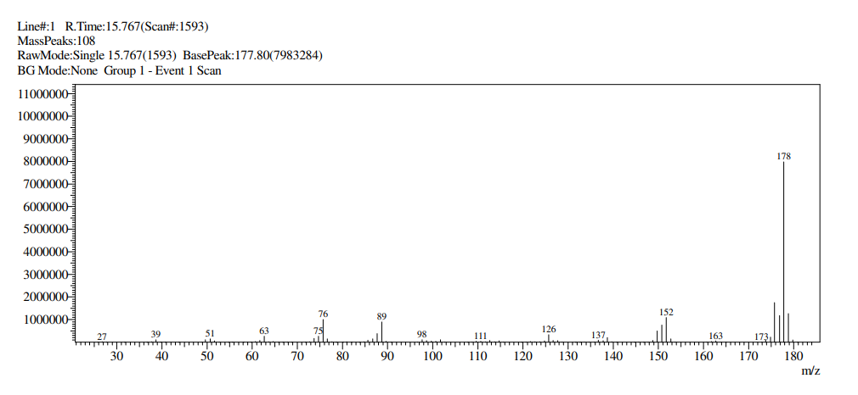
Figure SI 9: Mass spectrum for Sonogashira–Hagihara reactions. The 1,2-diphenylacetylene product is identified by a 178 g/mol molecular mass.
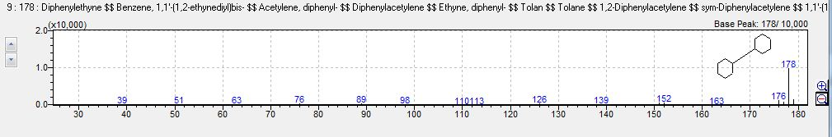
Figure SI 10: Sonogashira–Hagihara reaction product. Screenshot of the 1,2-diphenylacetylene product.

Table title and legend section
Table SI 1: Twelve-run Plackett-Burman design (PBD) ¹ used to screen the C-C cross-coupling reactions.
Legend:
The following symbols represent: A-K are parameters, y_{1–12} conversions of the substrate to product, +1 is a high level and –1 is a low level of a parameter, n is the number of factors. 4

Table SI 2: Complete PBD for Mizoroki-Heck reactions.
Legend:
Experimental results obtained from the coupling reactions of butyl acrylate with iodobenzene using sDoE's PBD, including six dummy factors. 20

Table SI 3: Complete PBD for Suzuki-Miyaura reactions.
Legend:
Comparative experimental results obtained from the coupling reactions of 4-fluorophenylboronic acid with bromobenzene using sDoE's PBD, including six dummy factors. 22

Table SI 4: Complete PBD for Sonogashira-Hagihara reaction.
Legend:
Comparative experimental results obtained from the coupling reactions of phenylacetylene with iodobenzene using sDoE's PBD, including six dummy factors. 23

Figure title and legend section
Figure SI 1: Reaction set-up.
Legend:
Radleys Carousel 12 plus reaction station coupled with a magnetic stirrer. 19

Figure SI 2: Chromatogram for Mizoroki–Heck reactions.
Legend:
The peak for butyl-3-phenylpropionate product from coupling of iodobenzene and butyl acrylate. 27

Figure SI 3: Mass spectrum for Mizoroki–Heck reactions.
Legend:
Butyl-3-phenylpropionate product as indicated by 204 g/mol molecular mass. 27

Figure SI 4: Mizoroki–Heck reaction product.
Legend:
Screenshot of butyl-3-phenylpropionate product. 27

Figure SI 5: Chromatogram for Suzuki–Miyaura reactions.
Legend:
The peak for 2-fluoro-1,1’-biphenyl product from coupling bromobenzene and 4-fluorophenylboronic acid. 28

Figure SI 6: Mass spectrum for Suzuki–Miyaura reactions.
Legend:
2-fluoro-1,1’-biphenyl product indicated by 190 g/mol molecular mass. 29

Figure SI 7: Suzuki–Miyaura reaction product.
Legend:
Screenshot of 2-fluoro-1,1’-biphenyl product. 29

Figure SI 8: Chromatogram for Sonogashira–Hagihara reactions.
Legend:
The peak for 1,2-diphenylacetylene product from coupling of iodobenzene and phenylacetylene. 30

Figure SI 9: Mass spectrum for Sonogashira–Hagihara reactions.
Legend:
1,2-diphenylacetylene product indicated by 178 g/mol molecular mass. 30

Figure SI 10: Sonogashira–Hagihara reaction product.
Legend:
Screenshot of 1,2-diphenylacetylene product. 30

