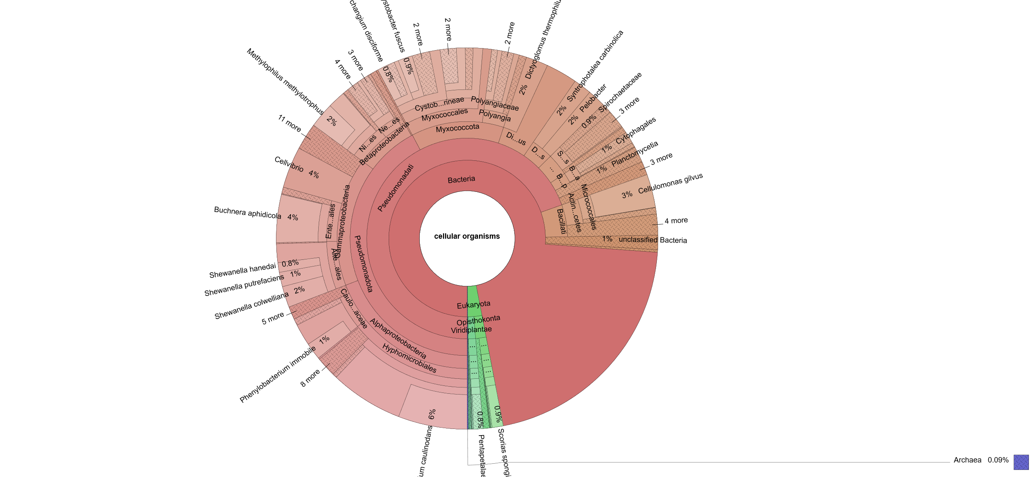

Plot1: Krona plot of S1

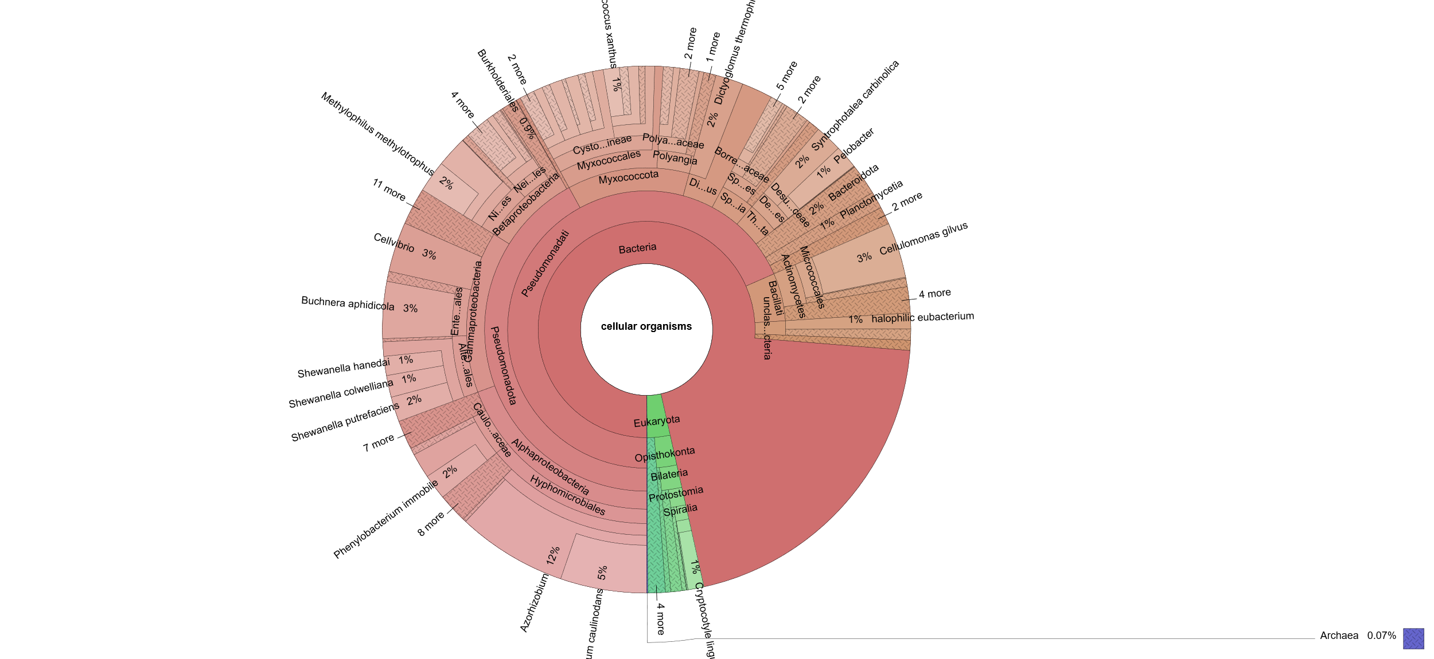

Plot 2: Krona plot of S2

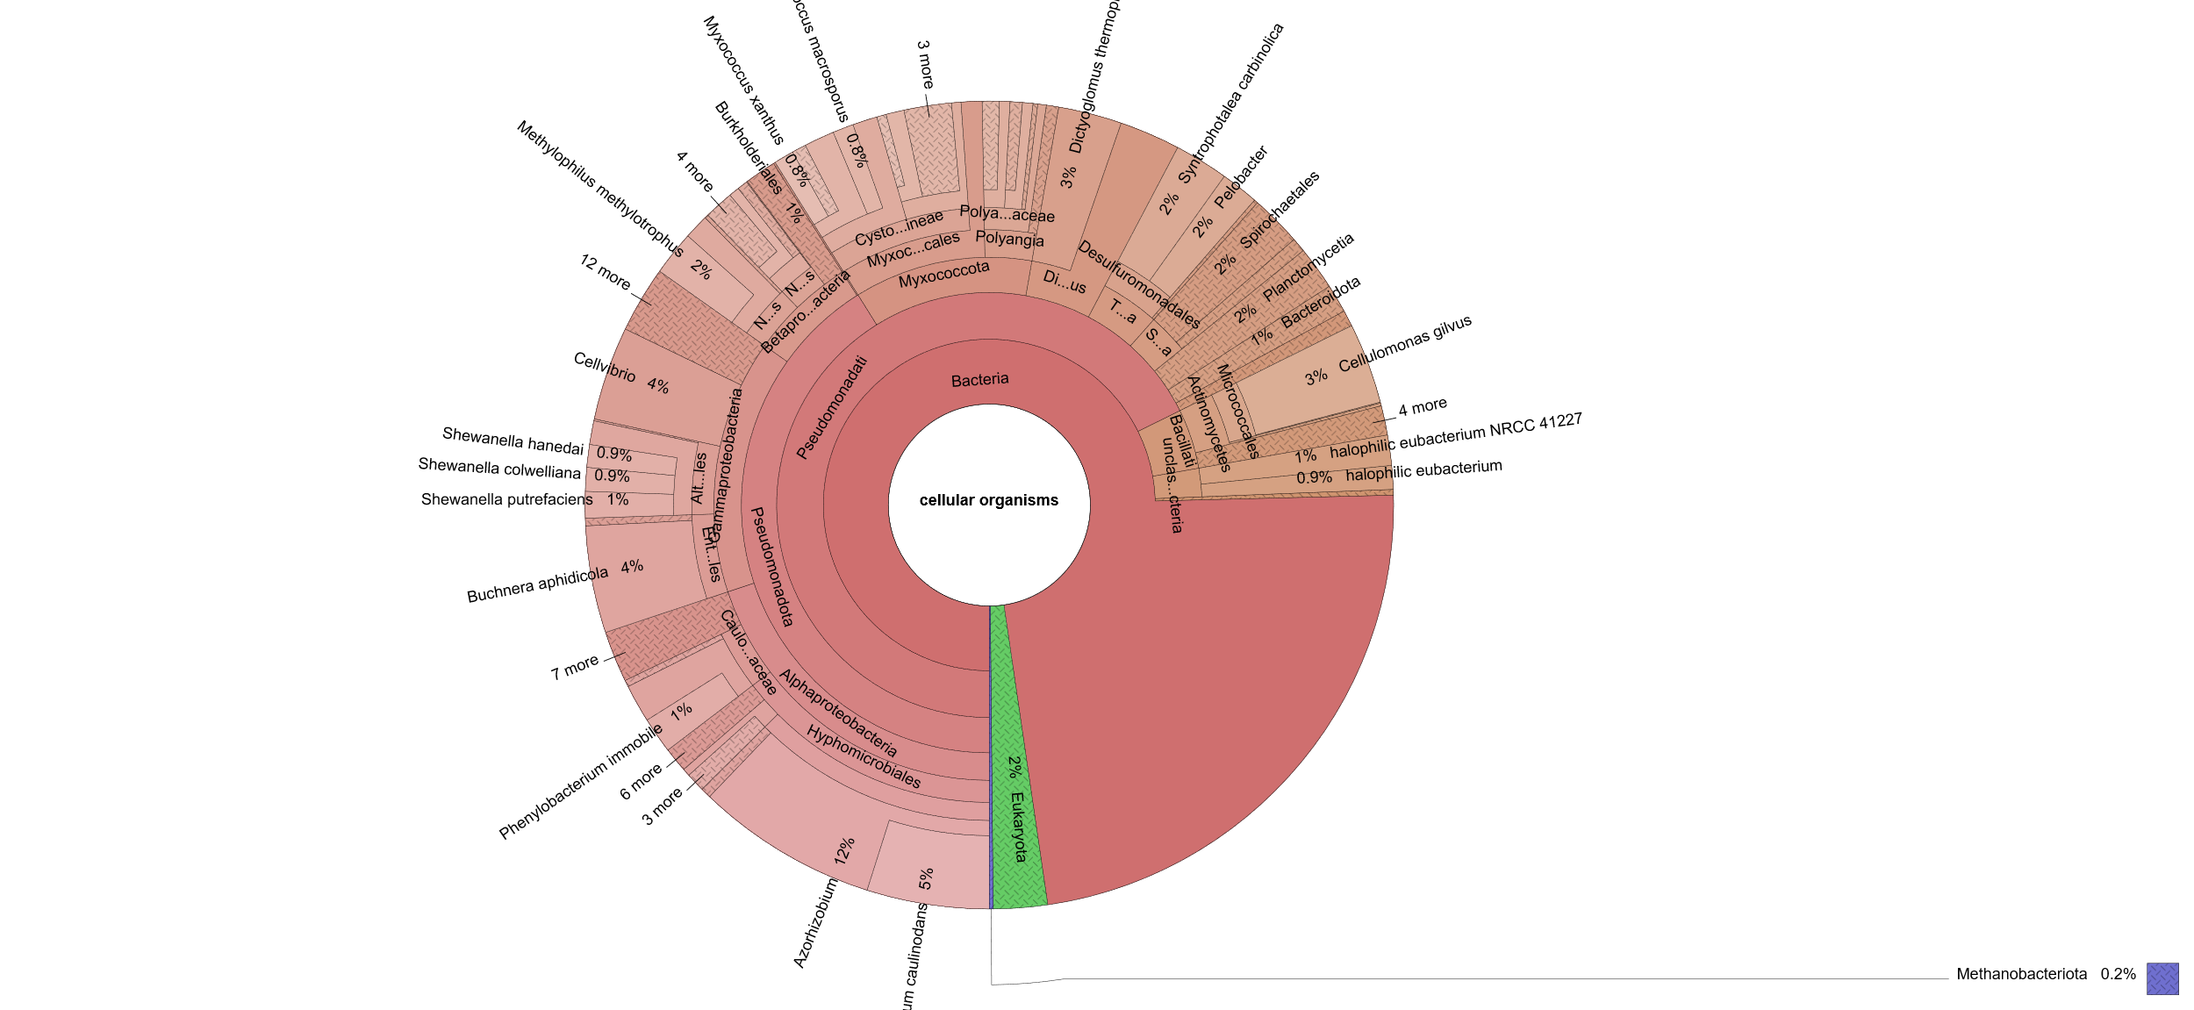

Plot 3: Krona plot of S3

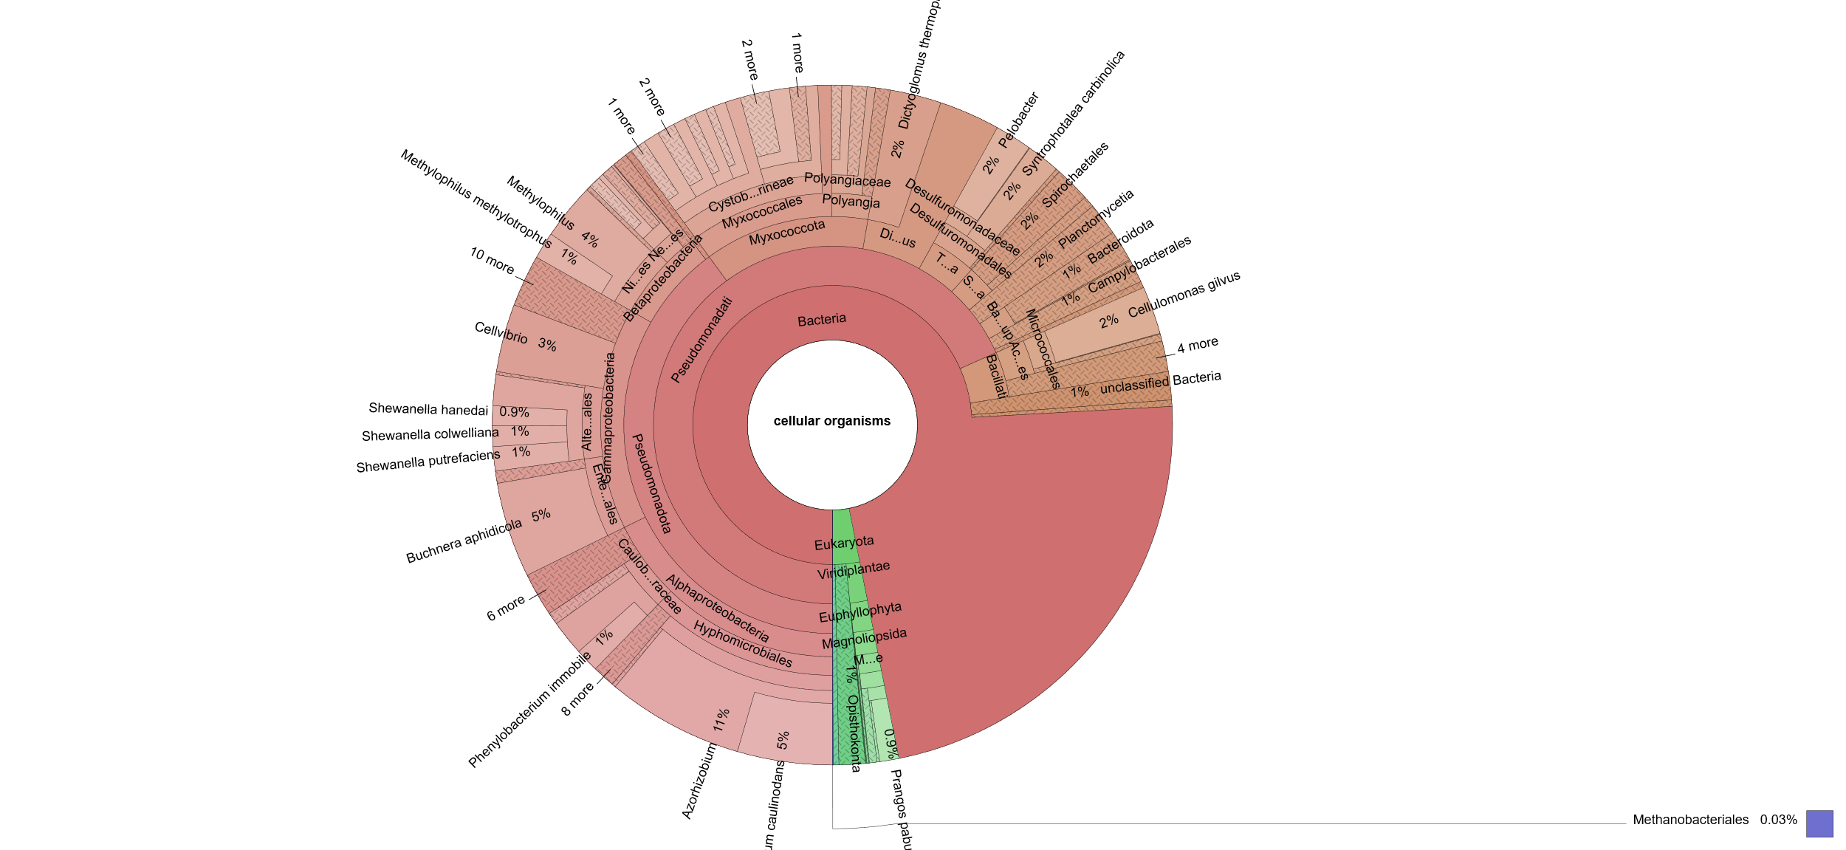

Plot 4: Krona plot of S4

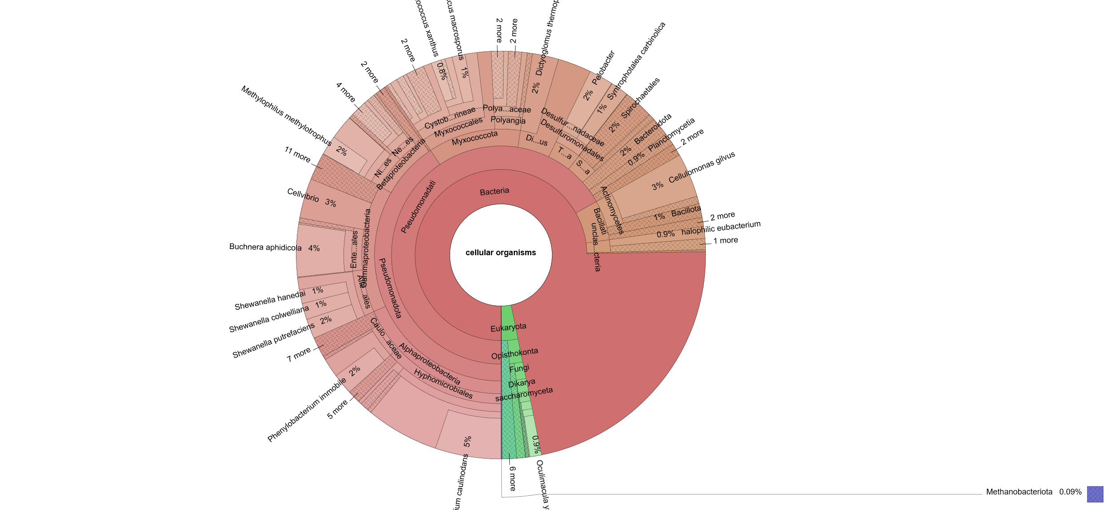

Plot 5: Krona plot of S5

