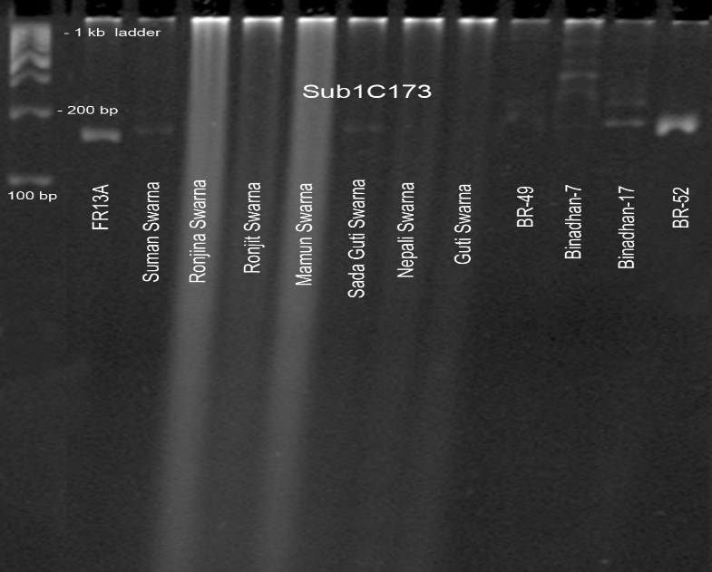
Figure S1. Germplasm screening of submergence tolerant local variety and HYV using Sub1C173 through PAGE.

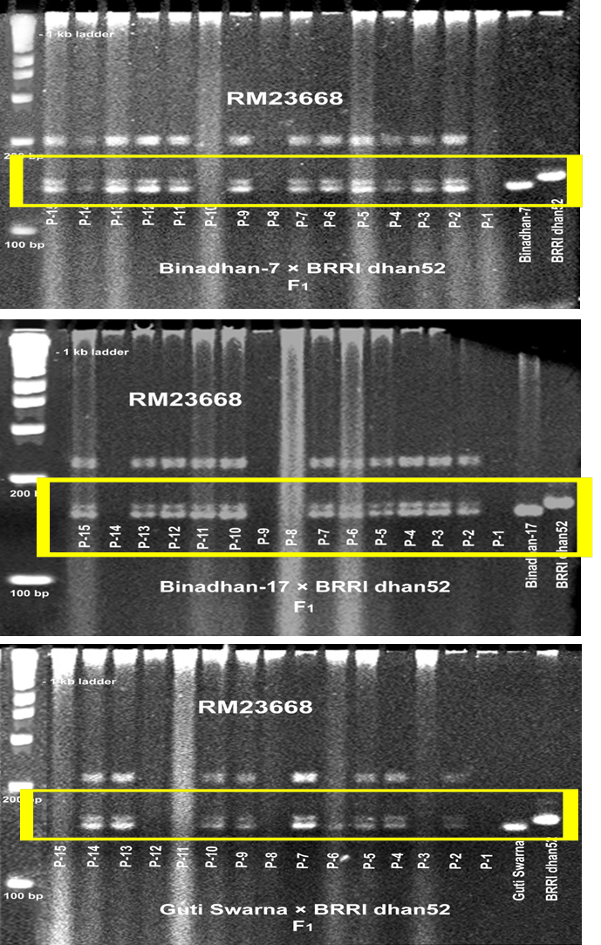
Fig. 2: Ethylene mediated physiological mechanism of submergence tolerant genotypes in rice
Figure S2: Confirmation of F₁ obtained from the crosses following PCR amplification with RM23668 primer.

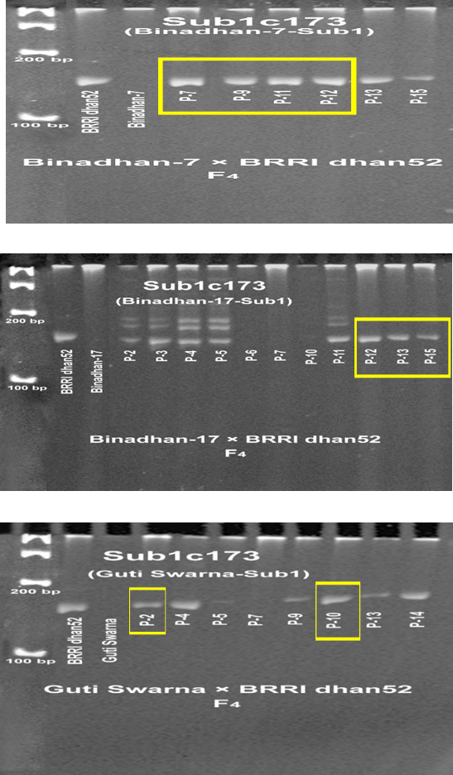
Figure S3: Confirmation of Sub1 genes in F₄ generations of three cross combinations using gene specific primer (Sub1c173) on PAGE.

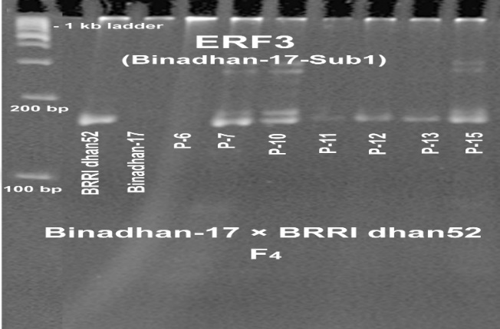
Figure S4: Sub1 gene confirmation of Binadhan-17×BRRI dhan52 (F₄) generations (7 plants) using gene specific primer (ERF3) through PAGE

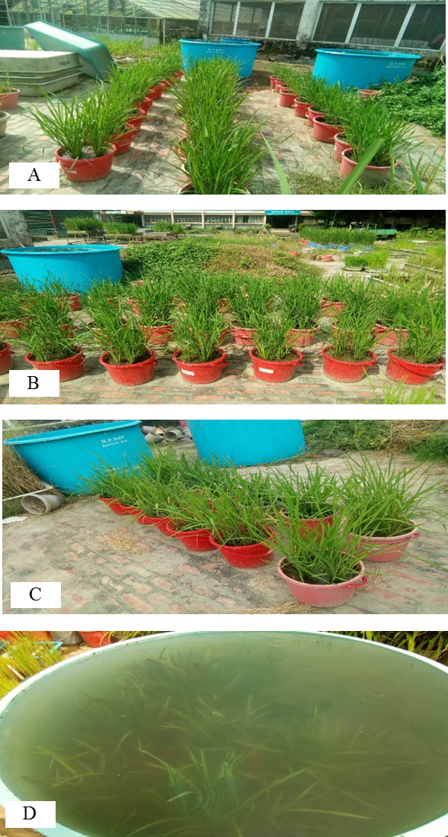

Figure S5: Populations of F₃ generation were grown for screening at vegetative stage for submergence tolerant in artificial tank at Biotechnology division, BINA; A) Binadhan-7 × BRRI dhan52, B) Binadhan-17 × BRRI dhan52, C) Guti swarna × BRRI dhan52 and D) At submerged stage.

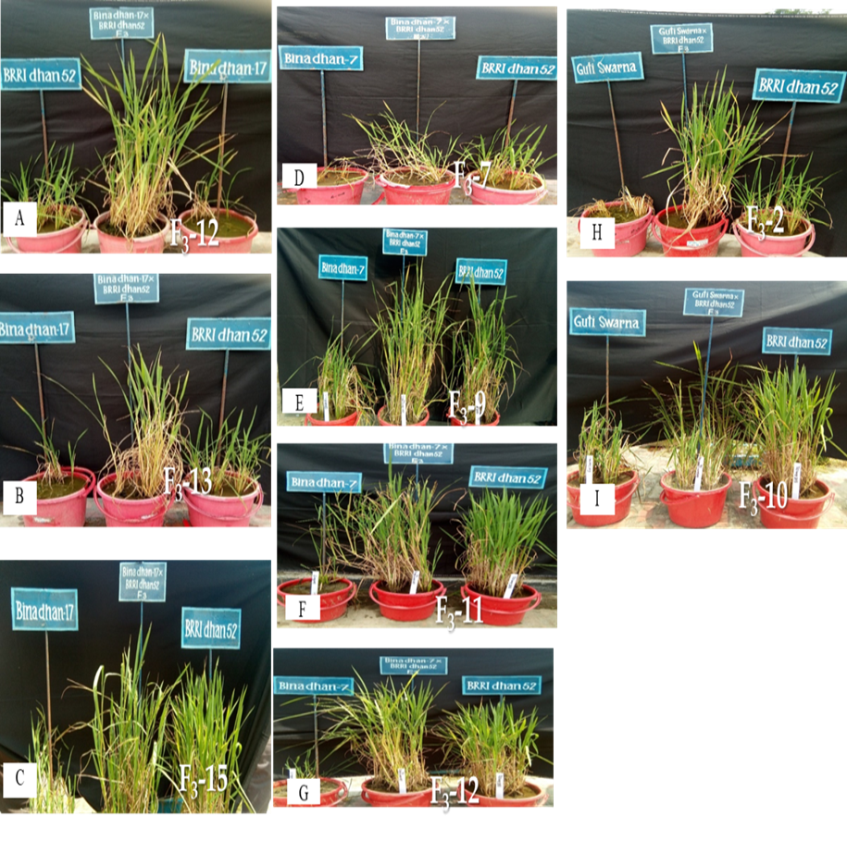
Figure S6: Phenotypic feature of the recovered plants after 21 days submergence stress in artificial tank of the cross Binadhan-17 × BRRI dhan52 at vegetative stage; A) F₃-12, B) F₃-13 and C) F₃-15. The cross combination of Binadhan-7 × BRRI dhan52 D) F₃-7, E) F₃-9, F) F₃-11 and G) F₃-12. The cross combination of Guti swarna × BRRI dhan52 H) F₃-2 and I) F₃-10.

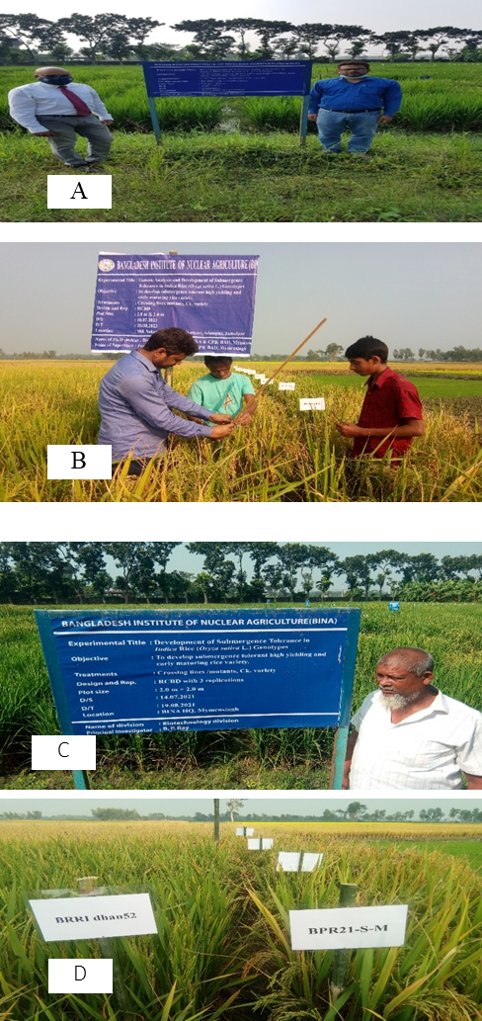

Figure S7: Adaptive performance trial of all selected lines and their checks at farmers field under submergence prone areas; A) Regional field trails at Jamalpur district, B) Rangpur district C) Kurigram district. D) Comparison for maturity of selected Sub1 lines BPR21-S-M and BRRI dhan52.

