Supplementary Information

Rational Design of Thrombin-Derived VFR12 Analogs with Enhanced Antimicrobial, Antibiofilm, and Anti-inflammatory Properties
Ishrat Jahan¹, S. Dinesh Kumar², Chelladurai Ajish¹, Chul Won Lee³, Song Yub Shin^{1,2,}* and Sungtae Yang^{1,4,}*
¹Department of Biomedical Sciences, School of Medicine, Chosun University, Gwangju 61452, Republic of Korea
²Department of Cellular & Molecular Medicine, School of Medicine, Chosun University, Gwangju, 61452, Republic of Korea
³Department of Chemistry, Chonnam National University, Gwangju, 61186, Republic of Korea
⁴ Department of Microbiology, School of Medicine and Institute of Well-Aging Medicare & CSU G-LAMP Project Group, Chosun University, Gwangju, 61452, Republic of Korea

* Corresponding authors:
Song Yub Shin (syshin@chosun.ac.kr) & Sungtae Yang (styang@chosun.ac.kr)

- Supplementary Methods

Peptide synthesis & characterization
VFR12 peptide with analogues were synthesized utilizing Fmoc solid-phase peptide synthesis (SPPS) methodology employing Rink amide MBHA resin as the solid support matrix. Coupling reactions were facilitated by dicyclohexylcarbodiimide (DCC) in conjunction with 1-hydroxybenzotriazole (HOBt) as coupling reagents. For each coupling cycle, Fmoc-protected amino acids were employed in 10-fold molar excess. Following completion of the synthesis, the peptides were subjected to standard trifluoroacetic acid-based cleavage conditions, and the resulting crude peptides were precipitated and washed with diethyl ether. Analytical assessment of peptide purity was conducted via reversed-phase high-performance liquid chromatography (RP-HPLC) utilizing an analytical Vydac C18 column. Subsequent purification was achieved through preparative RP-HPLC, and molecular mass confirmation was performed via electrospray ionization liquid chromatography-mass spectrometry (ESI-LC-MS).

Circular Dichroism Spectroscopic Analysis
Circular dichroism (CD) spectroscopic analysis was conducted to elucidate the secondary structural characteristics of the synthesized peptides. Measurements were performed on a J-715 CD spectropolarimeter (Jasco, Tokyo, Japan) equipped with a 1 mm path length quartz cell at a constant temperature of 25°C. Peptide conformational properties were investigated under multiple environmental conditions, including: (i) 10 mM sodium phosphate buffer (pH 7.4), (ii) 50% 2,2,2-trifluoroethanol (TFE) and (iii) 30 mM sodium dodecyl sulfate (SDS) micelles in sodium phosphate buffer. Spectral acquisition was conducted within the far-UV region spanning the 190-250 nm wavelength range. Three consecutive scans were recorded, averaged, and baseline-corrected for each experimental condition by subtracting the corresponding solvent spectrum. The CD data were expressed as mean residue ellipticity [θ] in units of degree square centimeter per decimole (deg·cm²/dmol).

Antimicrobial susceptibility assay
Minimum inhibitory concentrations (MICs) were determined utilizing the standardized microtiter broth dilution methodology as per the guidelines of CLSI. Bacterial isolates were initially cultured to the stationary phase via overnight incubation at 37°C in appropriate growth media. Subsequently, these cultures were subjected to a 10-fold dilution in Mueller-Hinton broth (MHB) (Difco, USA) and incubated for several hours to achieve mid-logarithmic phase growth. The resultant mid-logarithmic phase bacterial suspensions were further diluted with MHB to achieve the recommended inoculum density and subsequently dispensed into sterile 96-well microtiter plates containing two-fold serial dilutions of the test peptides and reference peptide. Following inoculation, the plates were incubated under aerobic conditions at 37°C for 18-24 hours. The MIC values were defined as the lowest peptide concentration at which no visible bacterial growth was observed. Quantitative verification of growth inhibition was performed by measuring optical density at 600 nm (OD600) using a microplate enzyme-linked immunosorbent assay (ELISA) reader (Bio-Tek Instruments EL800, USA).

Hemolysis assay
Fresh sheep red blood cells (sRBCs) were washed three times with phosphate-buffered saline (PBS), centrifuged at 2000 rpm for 5 minutes, and diluted to 4% concentration in PBS. Peptide solutions (100 μL) and 4% sRBCs (100 μL) were added to 96-well plates and incubated at 37°C for 1 hour. Following centrifugation at 1000 RCF for 5 minutes, supernatants (100 μL) were transferred to new plates and hemoglobin release was measured at 405 nm using a microplate reader. Zero and 100% hemolysis controls were determined using PBS and 0.1% Triton-X 100, respectively.

Membrane depolarization assay
S. aureus (KCTC 1621) cultures were grown at 37°C under agitation until reaching mid-logarithmic growth phase, followed by collection via centrifugation. Harvested cells underwent two washing cycles using a buffer solution comprised of 20 mM glucose and 5 mM HEPES (pH 7.4), then were reconstituted in identical buffer to achieve an optical density of 0.05 at 600 nm. The prepared cell suspension was treated with 3,3'-dipropylthiadicarbocyanine iodide [DiSC₃(5)] and incubated until fluorescence stabilization occurred, indicating complete dye integration into the bacterial cell membrane. Changes in membrane polarization status were evaluated by monitoring fluorescence intensity variations of DiSC₃(5) (excitation wavelength = 622 nm, emission wavelength = 670 nm) following exposure to peptides at 2× MIC. Melittin and buforin-2 served as reference control peptides for comparison.

SYTOX Green uptake assay
S. aureus (KCTC 1621) cultures in mid-logarithmic growth phase were harvested and subjected to three sequential washing steps using buffer containing 5 mM HEPES (pH 7.4) and 20 mM glucose. Subsequently, the pelleted bacterial cells were resuspended in buffer composed of 5 mM HEPES (pH 7.4), 20 mM glucose, and 100 mM KCl. S. aureus suspensions were prepared at a concentration of 1 × 10⁶ CFU/mL and combined with 0.5 μM SYTOX Green dye, followed by incubation for 15 minutes under dark conditions. A Shimadzu RF-5300PC fluorescence spectrophotometer (Shimadzu Scientific Instruments, Kyoto, Japan) was used to measure SYTOX Green uptake after peptides were added to a concentration equivalent to 2× MIC. Excitation and emission wavelengths were 485 nm and 520 nm, respectively.

Outer membrane permeability assay
Mid-logarithmic phase E. coli cultures were harvested and subjected to three washing cycles using buffer containing 5 mM HEPES, 20 mM glucose, and 5 mM KCN at pH 7.4. Following the washing procedure, bacterial cells were diluted to achieve an optical density of 0.05 at 600 nm. A 1 mM NPN stock solution was prepared by dissolving the probe in acetone. Subsequently, this stock solution was added to the bacterial suspension to reach a final NPN concentration of 10 μM. Fluorescence measurements were performed using excitation and emission wavelengths of 350 nm and 420 nm, respectively, and monitoring continued until stable baseline fluorescence was established. Following peptide addition at concentrations ranging from 0.5 μM to 32 μM, fluorescence intensity was monitored continuously over time, with measurements recorded until reaching equilibrium. The enhancement of fluorescence intensity indicated outer membrane permeabilization, allowing NPN partitioning into the membrane lipid environment.

FACScan
S. aureus and E. coli mid-log phase cells were diluted to OD₆₀₀ 0.5. Equal amounts of cell suspension and PBS (1 × ) were mixed, then centrifuged at 8000 rpm for 5 min. Cell pellets were resuspended in fresh PBS. For staining, PI (10 μL) was added and incubated for 15 minutes. A 15-min incubation followed the addition of peptides at 2× MICs to the suspension. Melittin and buforin-2 were used as the control for comparison. FACScan was used to assess PI fluorescence and compare it to the peptide-free samples.

Antibiofilm activity (MBIC, MBEC)
For the biofilm inhibition assay, MDRPA bacterial sub-culture (~10⁶ CFU/mL) was inoculated into a 96-well plate and incubated overnight at 37°C with or without the peptides. The highest concentration of each peptide tested was 128 μM, which was serially diluted two-fold to obtain a range of concentrations. After the incubation period, the biofilm formation was quantified by measuring the absorbance at 600 nm using a microplate reader. The MBIC value was determined as the lowest concentration of peptide that significantly reduced biofilm formation compared to the control.

For biofilm eradication assessment, MDRPA bacterial suspensions were incubated in 96-well Calgary microtiter plates containing polyethylene glycol (PEG) for 48 hours at 37°C to establish mature biofilms. The PEG lids were subsequently removed, rinsed with PBS, and transferred to sterile plates containing serially diluted peptides, followed by 24-hour incubation at 37°C with shaking. After treatment, the PEG lids were rinsed and transferred to recovery plates containing 200 μL nutrient media, then sonicated for 10-15 minutes to dislodge adherent biofilms. Biofilm eradication was quantified by measuring absorbance at 600 nm, with MBEC values defined as the lowest peptide concentration achieving significant biofilm reduction or complete eradication. Graphs were generated and statistical analysis was performed using SigmaPlot software to determine the efficacy of the peptides in inhibiting and eradicating biofilm formation.

Salt and serum stability assay
For salt stability assessment, individual salt solutions were prepared at the following concentrations: 150 mM NaCl, 4.5 mM KCl, 6 μM NH₄Cl, 1 mM MgCl₂, 2.5 mM CaCl₂, and 4 μM FeCl₃, while serum stability was evaluated using 10% human serum. The E. coli bacterial culture was grown to mid-logarithmic phase in Mueller-Hinton broth at 37°C and subsequently diluted with the respective test media containing specific salts or serum. Serial two-fold dilutions of each peptide analogue with antibiotic controls were prepared in 96-well microtiter plates, and the prepared bacterial inoculum was added to each well under the various experimental conditions. The plates were incubated at 37°C for 24 hours, after which bacterial growth was assessed by measuring optical density at 600 nm using a microplate spectrophotometer.

LPS binding assay
The binding ability of peptides to lipopolysaccharide (LPS) was assessed using a BODIPY-TR cadaverine (BC) displacement assay. In short, LPS from E. coli 0111: B4 was incubated with BC in a quartz cuvette containing 50 mM Tris buffer (pH 7.4). Peptides were added in a dose-dependent manner, with concentrations ranging up to 32 µM, over a 60-second interval. Fluorescence was measured using a spectrofluorophotometer at an excitation wavelength of 580 nm and an emission wavelength of 620 nm. The fluorescence data were expressed as %BC displacement (%∆F), calculated using the equation: %∆F = [(F_{obs} − F₀)/(F₁₀₀ − F₀)] × 100, where F_{obs} is the observed fluorescence at a given peptide concentration, F₀ is the initial fluorescence of BC with LPS in absence of peptide, and F₁₀₀ is the fluorescence of BC with LPS in presence of LL-37 which is used as a positive control.

- Supplementary Figures
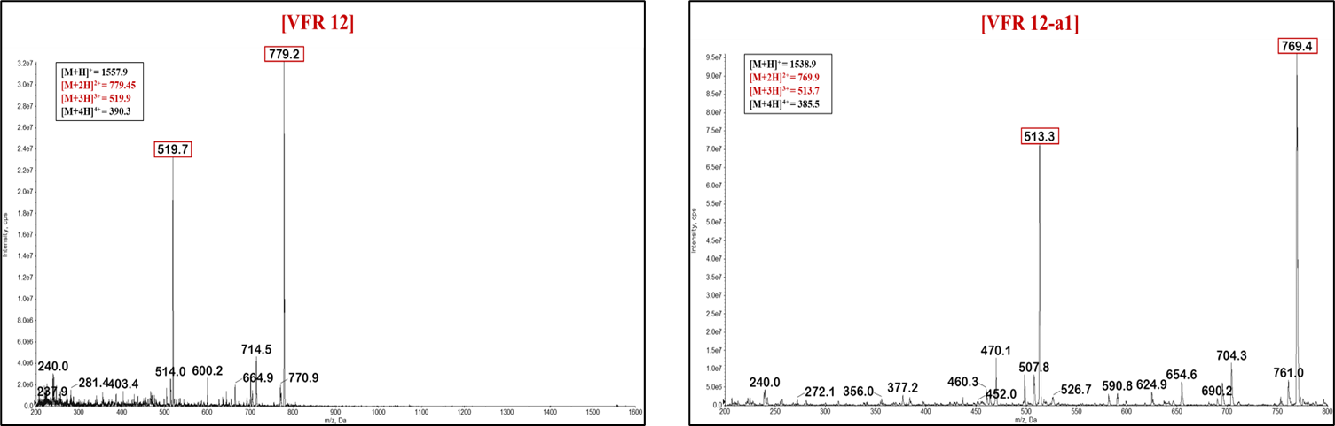
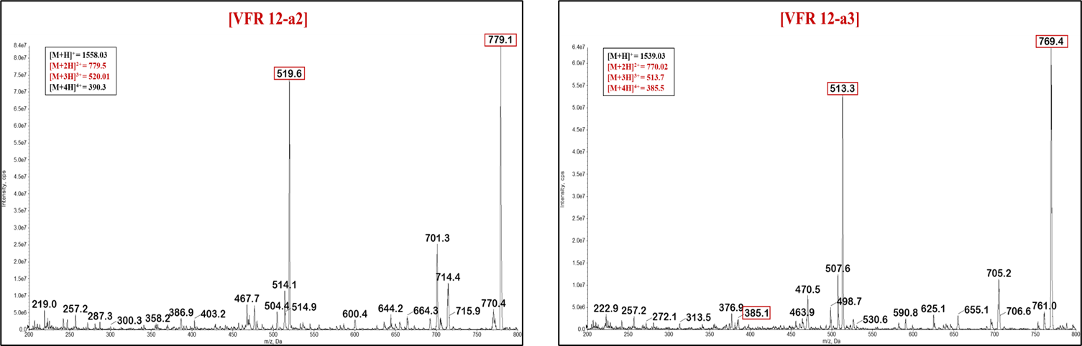
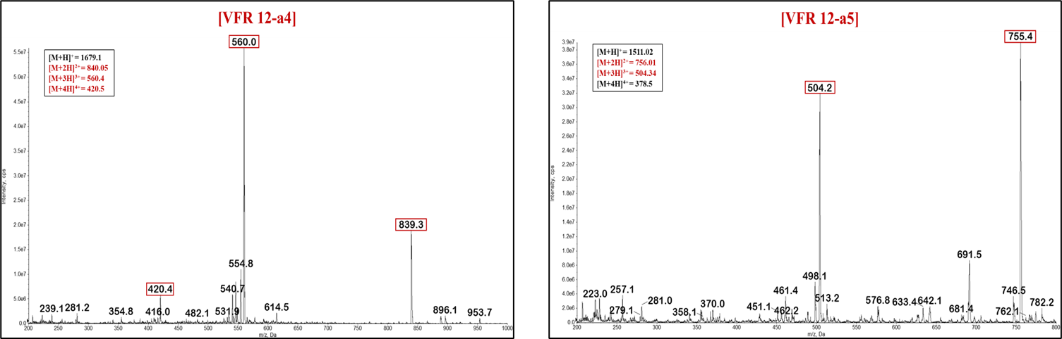

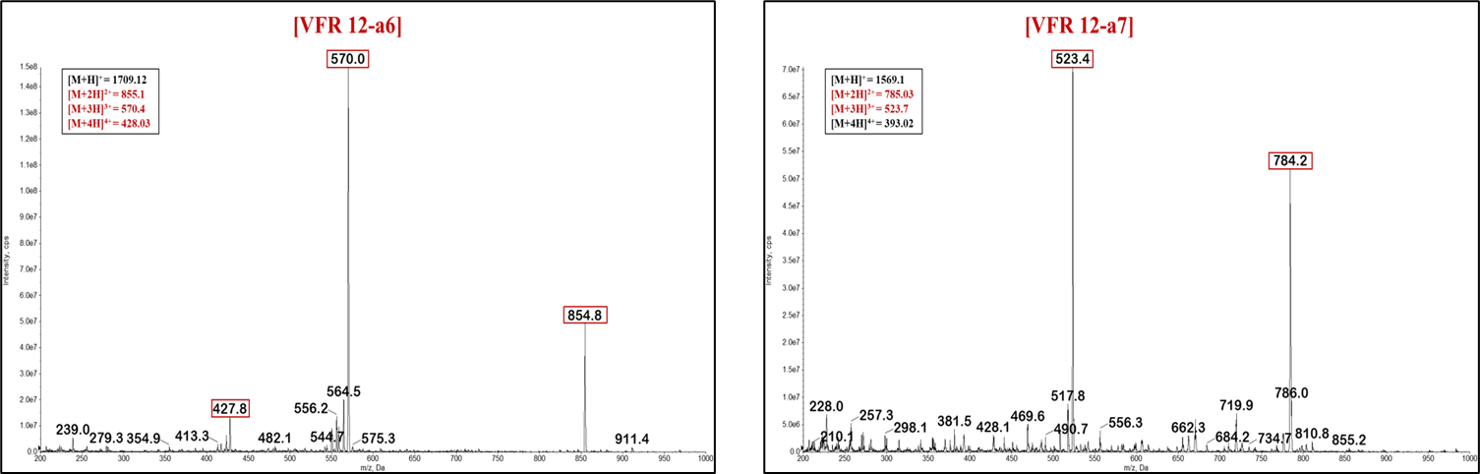
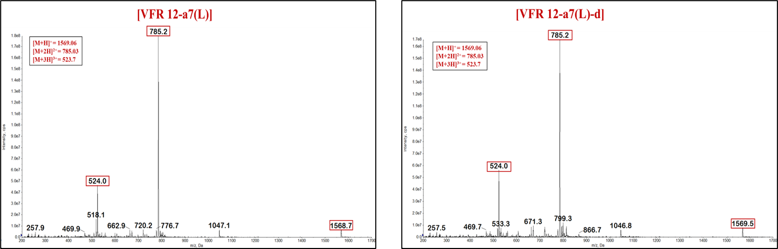
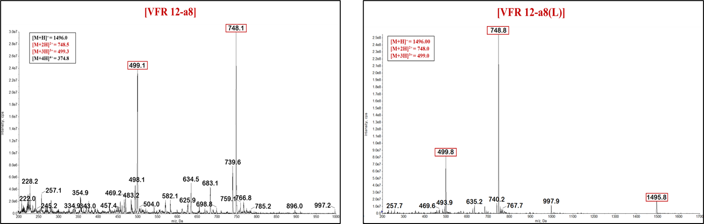
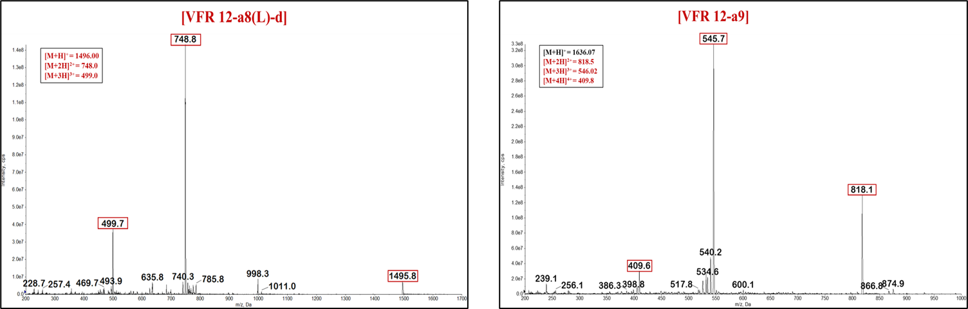
Figure S1: LC-MS data of VFR12 analogues.

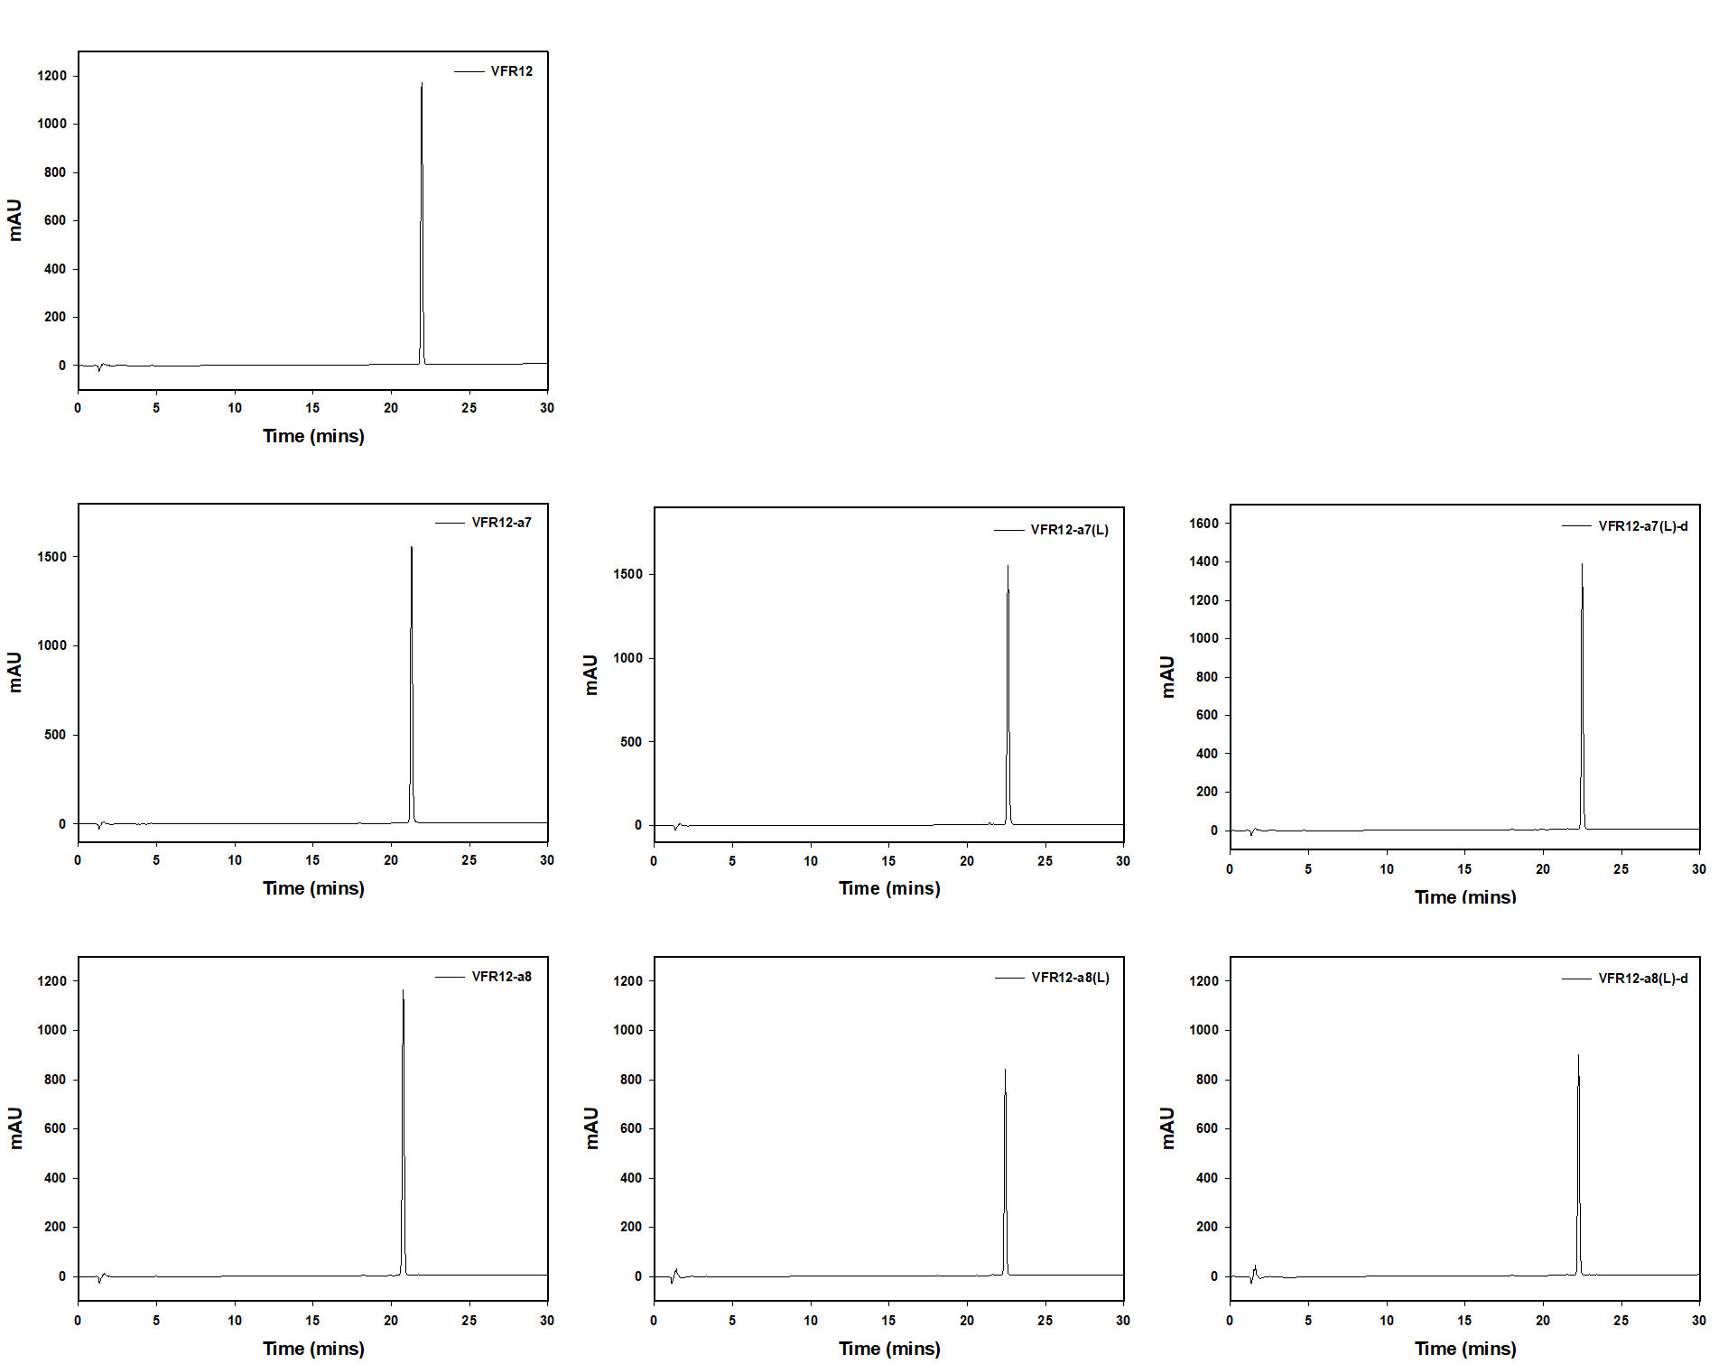
Figure S2: HPLC retention time of VFR12 and selected analogues.
Figure S3: Hemolytic activity of the VFR12 anlages, quantified as the percentage hemolysis in sheep red blood cells (sRBCs).

