Supplementary Material
S. Figure 1
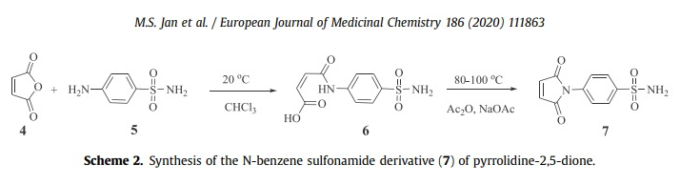
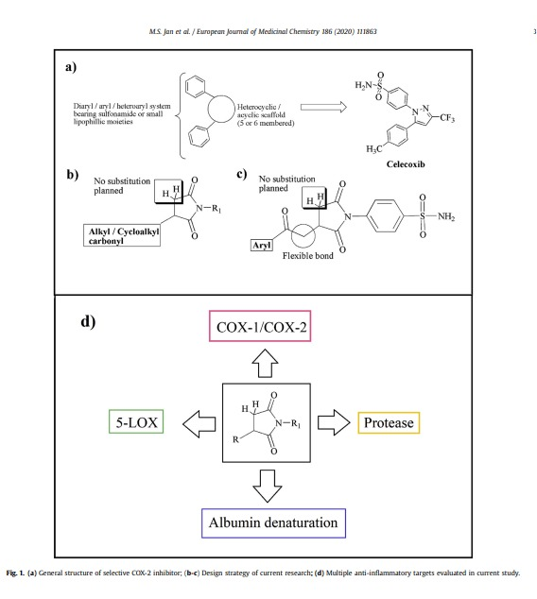
S. Figure 1: Compounds Scheme of synthesis: Adopted from our previously published article.

S. Figure 2
A
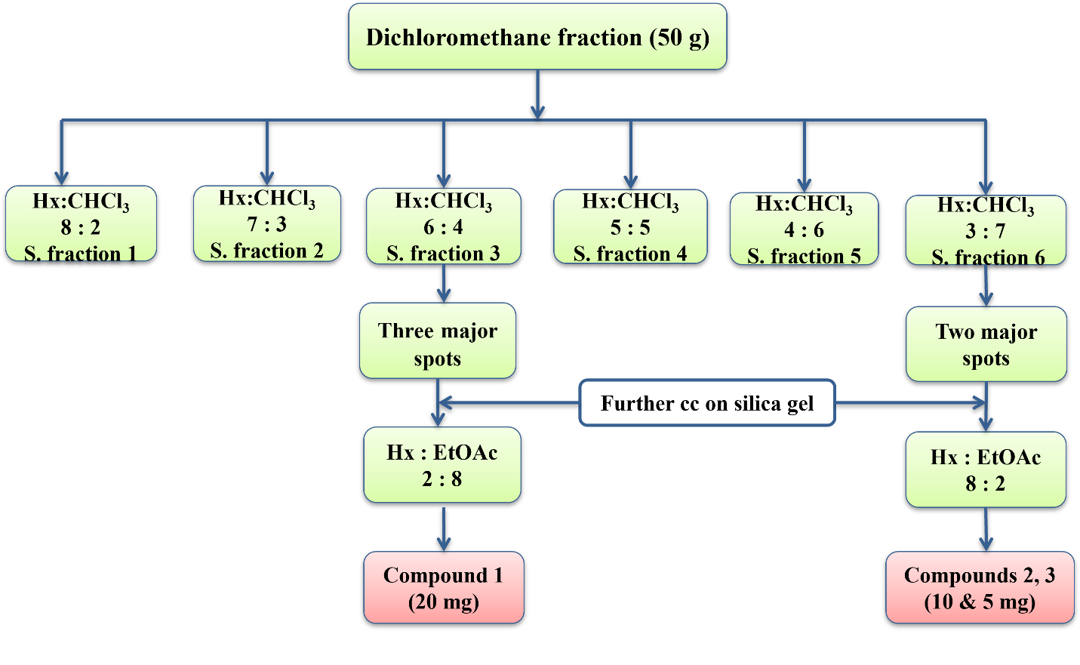
B
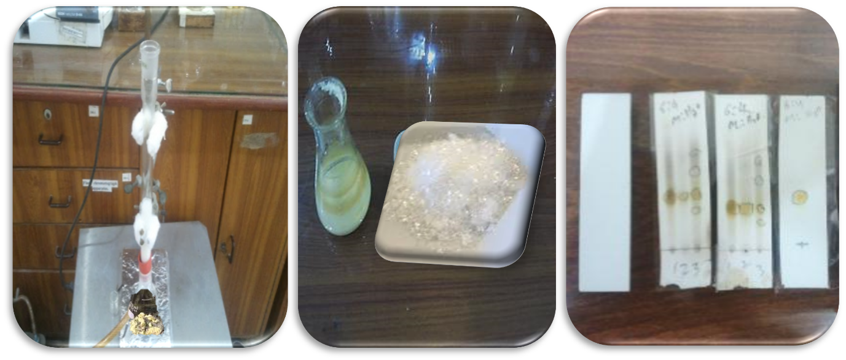
S. Figure 2: Compounds Purification. A) Shows schematic flow chart for DCM based fraction purification. B) Highlights the key steps of purification validations.

