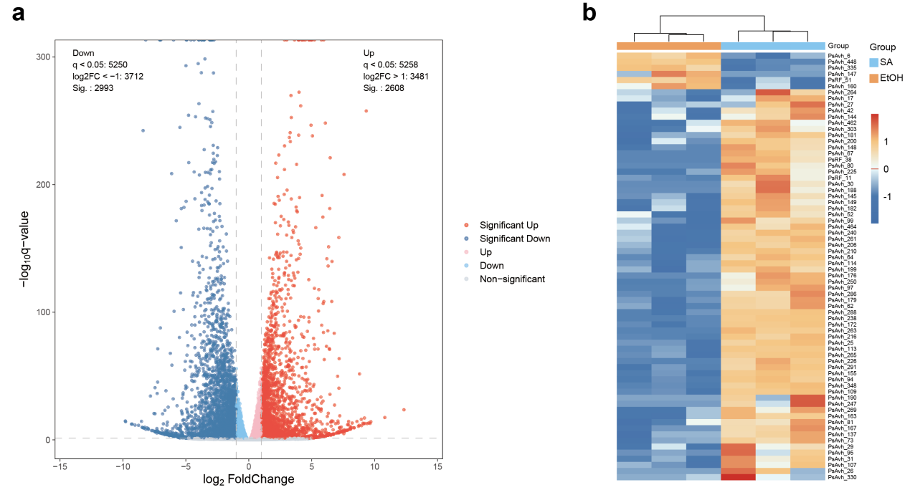

Figure S1. Effector gene expression in P. sojae is induced by salicylic acid (SA).
(a) The volcano plot illustrates differential gene expression in P. sojae in response to salicylic acid (SA) treatment. Gene expression profiles were compared between SA-treated and ethanol (EtOH) control samples at 30 minutes post-treatment. Differentially expressed genes (DEGs) were identified using DESeq2 with a false discovery rate (FDR)-adjusted q-value < 0.05 and an absolute log₂ fold change > 1. Red dots indicate upregulated genes (n = 2,608); blue dots indicate downregulated genes (n = 2,993).
(b) The heatmap displays the expression profiles of differentially expressed effector genes in P. sojae following treatment with SA or EtOH as a control. Raw FPKM values were normalized using reference genes. Expression levels are represented by a color gradient, with red indicating high expression and blue indicating low expression.

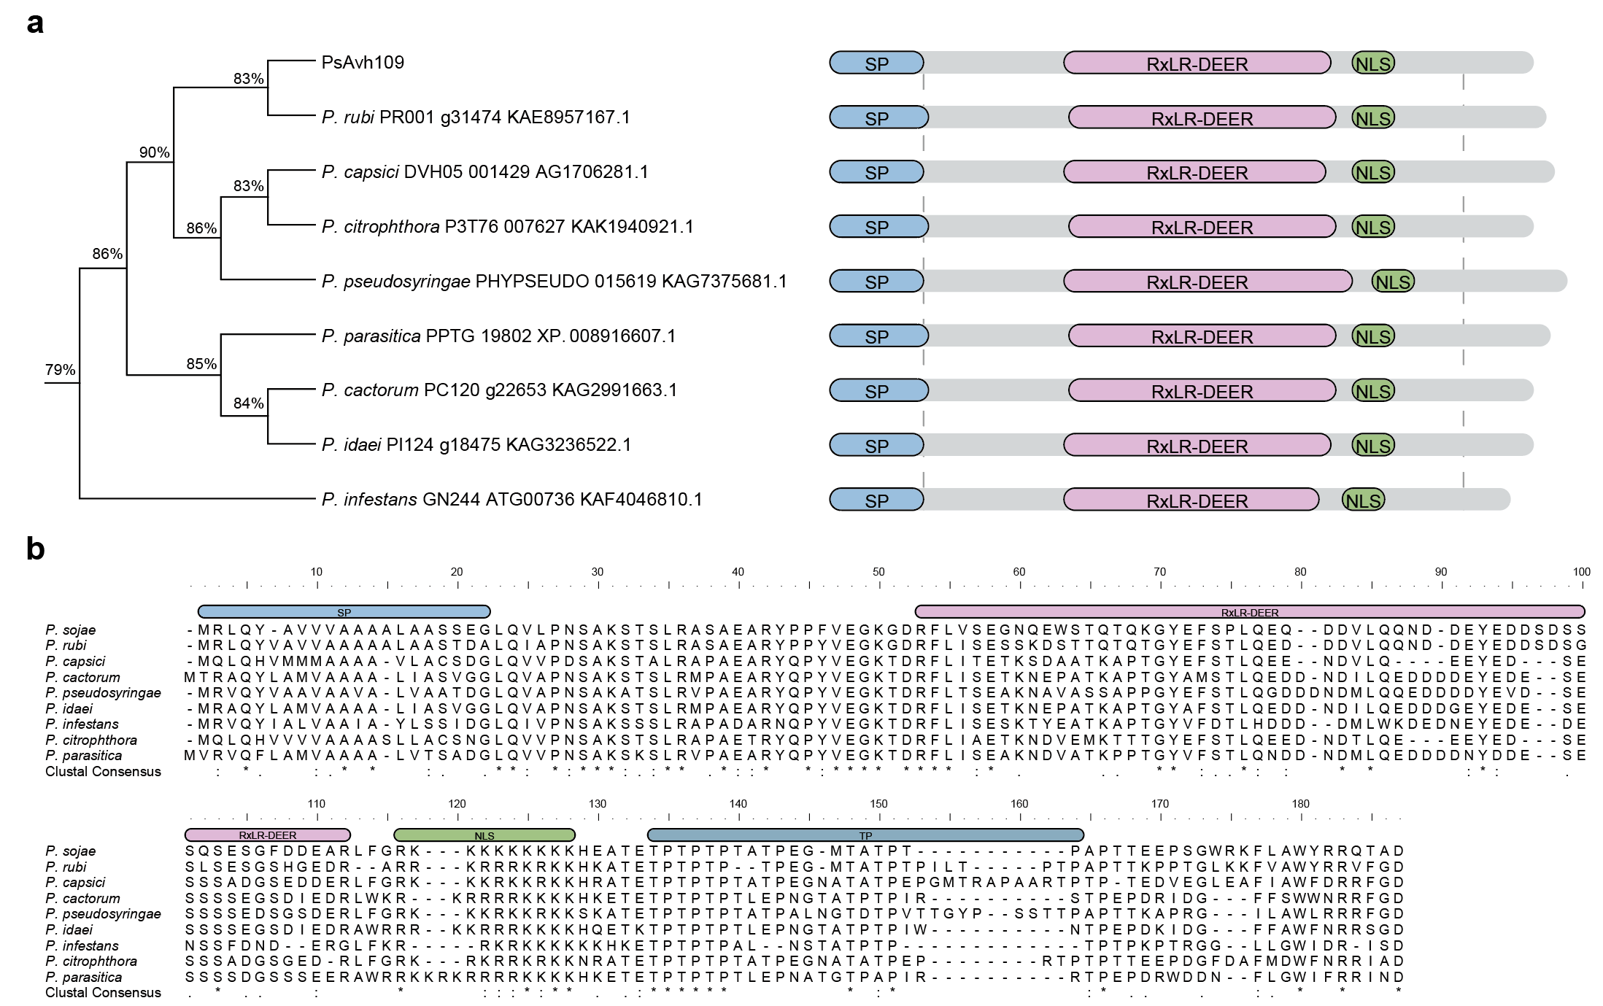

Figure S2. Structural analysis of PsAvh109 and its orthologs in Phytophthora species.
(a) PsAvh109 is a conserved effector in Phytophthora species. Phylogenetic analysis of PsAvh109 homologs from multiple Phytophthora species is shown in the figure, with percentage values indicating sequence identity relative to PsAvh109. Conserved motifs—including the signal peptide (SP), RxLR-DEER domain, and nuclear localization signal (NLS)—are depicted using distinct colors. Protein sequences were analyzed using MEGA 12 with the neighbor-joining method and 1,000 bootstrap replicates.
(b) Shown is an amino acid sequence alignment of PsAvh109 homologs from various Phytophthora species. Alignment was created using MUSCLE 3.8, available at https://www.ebi.ac.uk/jdispatcher/msa/muscle. Different colors highlight conserved motifs within PsAvh109 and its homologs, with "RxLR" representing Arg-x-Leu-Arg, and "NLS" denoting the nuclear localization signal. Protein sequences were obtained from NCBI (https://www.ncbi.nlm.nih.gov/); accession numbers are indicated. Hyphens indicate gaps introduced to maximize the alignment, * = invariant residue, : = conserved residue, . = partially conserved residue.

Figure S3. Neither knockout nor complementation of PsAvh109 affects mycelial development and sporulation of P. sojae.
(a) N. benthamiana leaves transiently expressing GFP, GFP–PsAvh109, or GFP–PsAvh109^{AAA} were inoculated with P. capsici 36 h post-Agrobacterium infiltration. Upper panels show UV fluorescence images of lesion margins (white circles). Lower panels display INF1-triggered cell death at 36 hpi. PsAvh109 suppressed INF1-induced hypersensitive response (HR), whereas GFP and PsAvh109^{AAA} had no effect.
(b) Boxplot with overlaid dotplot showing lesion diameters in (a). Data are presented as median ± SD (n=12, Student’s t-test).
(c) Relative P. capsici biomass in infected leaves, quantified by qPCR based on the ratio of P. capsici to N. benthamiana genomic DNA. Data are shown as mean ± SD (n=3, Student’s t-test).
(d, e) Analysis of mycelial growth on 10% V8 agar medium. Radial growth was measured after 6 days of incubation. Data are presented as mean ± SD (n=10). No statistically significant differences were detected (P > 0.05; one-way ANOVA with Dunnett's multiple comparisons test).
(f) Quantification of zoospore production. Zoospore density (per μL of suspension) was measured after 6 days of incubation. Data are shown as mean ± SD (n=10). No statistically significant differences were detected (P > 0.05; one-way ANOVA with Dunnett's multiple comparisons test).

Figure S4. The effector PsAvh109 specifically interacts with the mediator subunit MED21
PsAvh109 specifically interacts with the mediator subunits MED21. Yeast two-hybrid (Y2H) assays demonstrate interaction assays between PsAvh109 and GmMED6, GmMED7, GmMED10, GmMED19, GmMED21, NbMED21, or GmMED25. Yeast transformants were serially diluted 10-fold and plated on synthetic dropout (SD) media lacking tryptophan and leucine (SD - TL) or lacking tryptophan, leucine, histidine, and adenine (SD - TLHA).

Figure S5. MED21 serves as a positive regulator of plant defense
(a) Phenotypic analysis of N. benthamiana plants with NbMED21 silencing (RNAi-NbMED21) compared to control plants (RNAi-GFP). Leaves were inoculated with P. capsici and imaged at 48 hours post-inoculation (hpi). Upper panels: UV fluorescence images showing lesion boundaries (white circles). Lower panels: Cell death induced by INF1 expression at 36 hpi. INF1-triggered hypersensitive response was suppressed in RNAi-NbMED21 plants but not in RNAi-GFP controls.
(b) Boxplot with overlaid dotplot showing lesion diameters in (a). Data are presented as median ± SD (n=12, Student’s t-test).
(c) Relative P. capsici biomass in infected leaves, quantified by qPCR based on the ratio of P. capsici to N. benthamiana genomic DNA. Data are shown as mean ± SD (n=3, Student’s t-test).
(d) Functional characterization of NbMED21 during P. capsici infection. RNAi-NbMED21 leaves were agroinfiltrated with GFP or GFP-PsAvh109 and challenged with P. capsici at 36 hpi. UV fluorescence images showing lesions at 48 hpi (white circles).
(e) Quantification of lesion diameters. Data are presented as mean ± SD (n=14). No statistically significant differences were detected (P > 0.05; Student’s t-test).
(f) Relative P. capsici biomass determined by qPCR (ratio of P. capsici to N. benthamiana genomic DNA). Data are shown as mean ± SD (n=3, Student’s t-test).

Figure S6. PsAvh109 suppresses MED21/MED6-mediated transcription of defense genes.
(a) Volcano plot showing differential gene expression in response to PsAvh109. Differentially expressed genes (DEGs) in soybean root hairs overexpressing GFP–PsAvh109 compared with the GFP control at 3 h post-inoculation with the P. sojae Avh109 knockout strain (KO–PsAvh109). Differential expression was assessed using DESeq2 with a false discovery rate (FDR)-adjusted q < 0.05 and |log₂ fold change| > 1. Red dots indicate upregulated genes (n = 694); blue dots indicate downregulated genes (n = 157).
(b) Gene Ontology (GO) enrichment analysis of PsAvh109-regulated genes. Functional categories were ranked by fold enrichment, and statistical significance is expressed as –log₁₀(P-value).
(c) Transcriptional levels of GmMED21, GmMED6 (to assess silencing efficiency), GmPR1 - 1, GmPR1 - 6, and GmSABP2 genes in soybean root hairs inoculated with KO - PsAvh109 at 3 hpi were determined by RT - qPCR. RNAi - GFP transgenic plants served as the control. Relative transcriptional levels were normalized to the soybean reference gene GmCYP2. Data are presented as the mean ± SD (n=3, Student’s t-test).
(d) Cis-acting elements within the 1 kb promoter region upstream of the translation start codon of selected immune-related genes were aligned using ClustalW software. The AS-1 motif is highlighted within a black box. The consensus sequence for AS-1 was further analyzed using TBtools-Ⅱ.
(e) Occupancy of GmMED21 and GmMED6 in different promoter regions of selected immunity genes was evaluated by ChIP - qPCR in GmMED21 - FLAG and GmMED6 - FLAG transgenic hairy roots. IgG was used as a negative control. ChIP signals were normalized to the input. Data are presented as the mean ± SD (n=3, Student’s t-test). P1–P3 represent the promoter regions examined by ChIP - qPCR. The as - 1 elements in the promoters are shown as red triangles.
(f, g and h) Both RNAi - GmMED6 and RNAi - GmMED21 hairy roots enhanced soybean susceptibility to P. sojae infection.
(f) Oospore production in hairy roots infected by P. sojae strain P6497 labeled with GFP (GFP P. sojae) was observed under a microscope and counted at 48 hpi. The experiments were conducted at least three times, and similar results were obtained each time. Scale bars represent 200 μm.
(g) Quantification of the oospore count of P. sojae in the soybean hairy roots. Data are presented as mean ± SD (n=12, one-way ANOVA with Dunnett's multiple comparisons test).
(h) Relative biomass of P. sojae in hairy roots, determined by qPCR at 48 hpi through the ratio of P. sojae genome DNA to soybean genome DNA. The data are shown as means ± SD (n=3, one-way ANOVA with Dunnett's multiple comparisons test).

Figure S7. MED21 and MED6 are core subunits of the Mediator complex that play critical roles in regulating transcription of SA-responsive genes.
(a) Co-expression of GmMED21¹⁻¹⁵ or GmMED21 with cLUC-GmMED6 and GmMED21-nLUC reduced the level of reconstituted luciferase. Luminescence was observed on the N. benthamiana leaves using a plant living imaging system.
(b) Quantification of luciferase activity (integrated optical density, IOD) in treated leaves. Data presented as mean ± SD (n=6). Different letters indicate significant differences (P < 0.01; one-way ANOVA with Tukey's multiple comparisons test).
(c) Fixed amounts of GmMED21-His and GST-GmMED6 were incubated with increasing amounts of purified GmMED21¹⁻¹⁵-mCherry-3HA or purified mCherry-3HA protein (control). Proteins in the samples were then pulled down using glutathione Sepharose 4B resin, followed by western blot assays with anti-GST, anti-HA, or anti-His specific antibodies.
(d) Co-inoculation of soybean root hairs expressing mCherry, or mCherry-GmMED21¹⁻¹⁵ with a GFP-expressing P. sojae transformant (GFP P. sojae). Fluorescence microscopy images were acquired at 48 hours post-inoculation (hpi). Scale bar: 200 μm.
(e) Quantification of P. sojae oospore formation in soybean root hairs. Data are presented as mean ± standard deviation (SD) (n=12, Student’s t-test).
(f) Relative P. sojae biomass in soybean root hairs, determined by quantitative PCR (qPCR) based on the ratio of P. sojae to soybean genomic DNA. Data are presented as mean ± SD (n=3, Student’s t-test).
(g) RT-qPCR was performed to assess the transcriptional levels of GmPR1-1, GmPR1-6, and GmSABP2 in soybean root hairs overexpressing mCherry or GmMED21¹⁻¹⁵, 3 hours post-infection with the KO-PsAvh109 strain. Expression was normalized to the reference gene GmCYP2. Data are presented as mean ± SD (n=3, Student’s t-test).

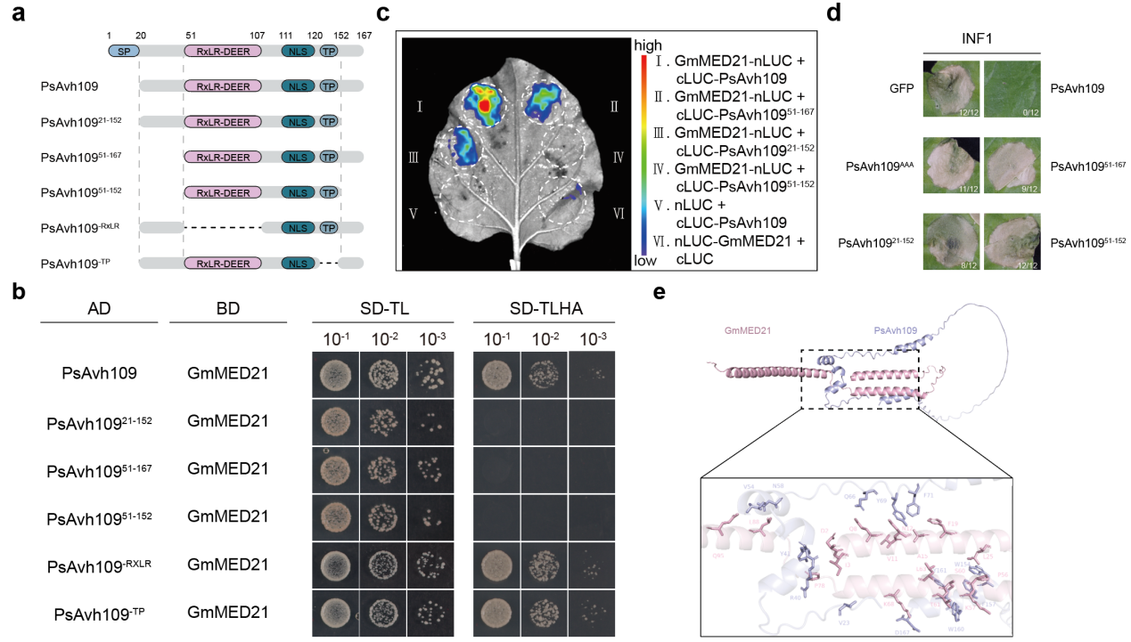

Figure S8. The N-terminus and C-terminus of PsAvh109 are required for interactions with GmMED21.
(a) Schematic of structures of PsAvh109 mutants.
(b) Interaction assays of GmMED21 with PsAvh109 or mutants in yeast. SD-TL: Synthetic defined (SD) medium without tryptophan and leucine; SD-TLHA: SD medium without tryptophan, leucine, histidine, and adenine.
(c) Luciferase complementation imaging assay of GmMED21 interactions with PsAvh109 or mutants in N. benthamiana leaves. Agrobacterium strains carrying constructs encoding the proteins were co-infiltrated into N. benthamiana leaves, followed by D-luciferin application at 2 days post-infiltration.
(d) N. benthamiana leaves transiently expressing GFP, GFP–PsAvh109, or PsAvh109 mutants were infiltrated with Agrobacterium carrying the INF1 construct. HR phenotypes were evaluated at 48 hours post-infiltration.
(e) Structural model of the PsAvh109–GmMED21 interaction predicted by AlphaFold3. Upper panel: Structural representation of the PsAvh109-GmMED21 complex as predicted by AlphaFold3. Lower panel: Detailed view of the interaction interface. The ribbon diagram highlights the overall protein structures, while stick models in distinct colors denote key interacting amino acid residues between PsAvh109 and GmMED21.

