Appendix Tables and Figures
Appendix A. Proportion of sampled facilities that do not offer PAC
 |  | N | %
Overall | (N=658) | 44 | 21.0
By level
Level 6 | (N=3) | 0 | 0.0
Level 5 | (N=59) | 0 | 0.0
Level 4 | (N=350) | 1 | 0.3
Level 3 | (N=121) | 10 | 8.6
Level 2 | (N=125) | 33 | 26.2
By region
Central and Nairobi | (N=129) | 12 | 27.7
Coast and North Eastern | (N=85) | 6 | 20.7
Eastern | (N=109) | 1 | 3.1
Nyanza and Western | (N=177) | 6 | 11.8
Rift Valley | (N=158) | 19 | 35.8
By owner
Public | (N=339) | 25 | 21.4
Private for profit | (N=239) | 17 | 23.2
Private not for profit / faith based | (N=80) | 2 | 7.5

Appendix B. Distribution of health facilities with each individual signal function
Figure 1 displays the proportion of facilities that offer each signal function according to both the availability and readiness definitions. Among referral-level facilities, almost all meet both the availability and readiness definitions for offering antibiotics, uterotonics, IV fluids, and the removal of retained products of conception and operating 24/7. For both the availability and readiness definitions, the least commonly offered services in referral-level facilities were the provision of 3+ types of short-acting contraceptive methods (availability: 64%, readiness: 49%) and surgical capacity (availability: 44%, readiness: 26%). While almost all referral-level facilities meet the availability criteria for staffing (95%), only half (49%) meet the readiness criteria for this signal function.
Most primary-level facilities are able and ready to provide antibiotics and IV fluids (88% and 81%, respectively), and approximately two-thirds are able and ready to provide uterotonics (67% and 64%, respectively). Only 58% of primary-level facilities reported providing removal of retained products of conception in the past 6 months, and this proportion drops to 48% when we consider whether the facility would be able to provide that service on the day of data collection. Finaly, there were substantial differences between availability and readiness for providing short-acting contraceptive methods (70% vs. 50%), staffing (43% vs. 14%), and referral capacity (86% vs. 66%).

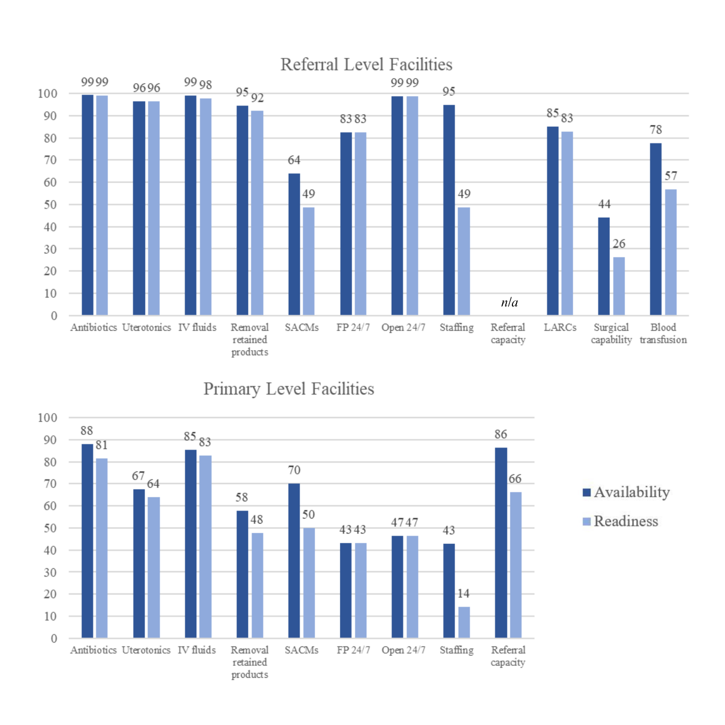
Figure B1. Proportion of referral and primary level facilities offering each signal function, by availability and readiness

Appendix C. Proportion of facilities that meet the Availability and Readiness criteria for basic and comprehensive PAC, by facility level and ownership
 |  | Availability |  |  |  |  |  | Readiness
 |  | Less than basic |  | Basic |  | Comprehensive |  | Less than basic |  | Basic |  | Comprehensive
 |  | n | % | n | % | n | % | n | % | n | % | n | %
Referral Level Facilities (n=411)
Overall |  | 203 | 50.8 | 101 | 25.1 | 107 | 24.1 | 327 | 81.5 | 47 | 11.3 | 37 | 7.2
By level
Level 6 | (N=3) | 1 | 37.5 | 0 | 0.0 | 2 | 62.5 | 1 | 37.5 | 0 | 0.0 | 2 | 62.5
Level 5 | (N=59) | 22 | 38.3 | 6 | 10.0 | 31 | 51.7 | 36 | 62.4 | 5 | 8.0 | 18 | 29.6
Level 4 | (N=349) | 180 | 51.9 | 95 | 26.6 | 74 | 21.4 | 290 | 83.4 | 42 | 11.7 | 17 | 4.9
By owner
Public | (N=207) | 84 | 42.6 | 68 | 35.3 | 55 | 22.1 | 151 | 76.3 | 27 | 13.0 | 29 | 10.7
Private | (N=204) | 119 | 58.2 | 33 | 16.0 | 52 | 25.8 | 176 | 86.1 | 20 | 9.8 | 8 | 4.1
Primary Level Facilities (n=203)
Overall |  | 155 | 81.7 | 48 | 18.3 | n/a | n/a | 193 | 96.7 | 10 | 3.3 | n/a | n/a
By level
Level 3 | (N=111) | 76 | 68.6 | 35 | 31.4 | n/a | n/a | 103 | 92.8 | 8 | 7.2 | n/a | n/a
Level 2 | (N=92) | 79 | 86.1 | 13 | 13.9 | n/a | n/a | 90 | 97.9 | 2 | 2.1 | n/a | n/a
By owner
Public | (N=107) | 84 | 86.0 | 23 | 14.0 | n/a | n/a | 105 | 98.2 | 2 | 1.8 | n/a | n/a
Private | (N=96) | 71 | 76.0 | 25 | 24.0 | n/a | n/a | 88 | 94.6 | 8 | 5.4 | n/a | n/a

Appendix D. Reasons for not meeting availability and readiness criteria for short-acting contraceptives (n=208)*

 | Total  (N=208) |  | Referral  (N=144) |  | Primary (N=64)
 | n | % | n | % | n | %
Availability criteria: reasons for not providing 3+ short-acting contraceptive methods in the last 6 months
Does not offer any postabortion family planning services | 22 | 6.6 | 17 | 12.0 | 5 | 6.0
Does not offer contraceptive methods | 47 | 15.5 | 36 | 25.8 | 11 | 14.4
Only offers 1 or 2 short-acting contraceptive methods | 139 | 77.8 | 91 | 62.2 | 48 | 79.6
Readiness indicators: frequency of contraceptive stock-outs
Never/Rarely | 65 | 36.8 | 46 | 45.2 | 19 | 36.0
Sometimes/Always | 81 | 63.3 | 52 | 54.8 | 29 | 64.1

*Unweighted N’s with weighted proportions displayed

