Supplementary Information
Fully Stretchable Reconfigurable Organic Electrochemical Transistors for Wearable Adaptive Logic Bioelectronics
Heena Kim^{1,†}, Taeheon Kim^{1,†}, Yunsu Kim¹, Huijeong Lee¹, Hyunseok Shim^{1,}*

¹School of Electrical & Electronics Engineering, Pusan National University, Busan 46241, Republic of Korea
†These authors contributed equally.

*Email: hshim@pusan.ac.kr

Supplementary Figures
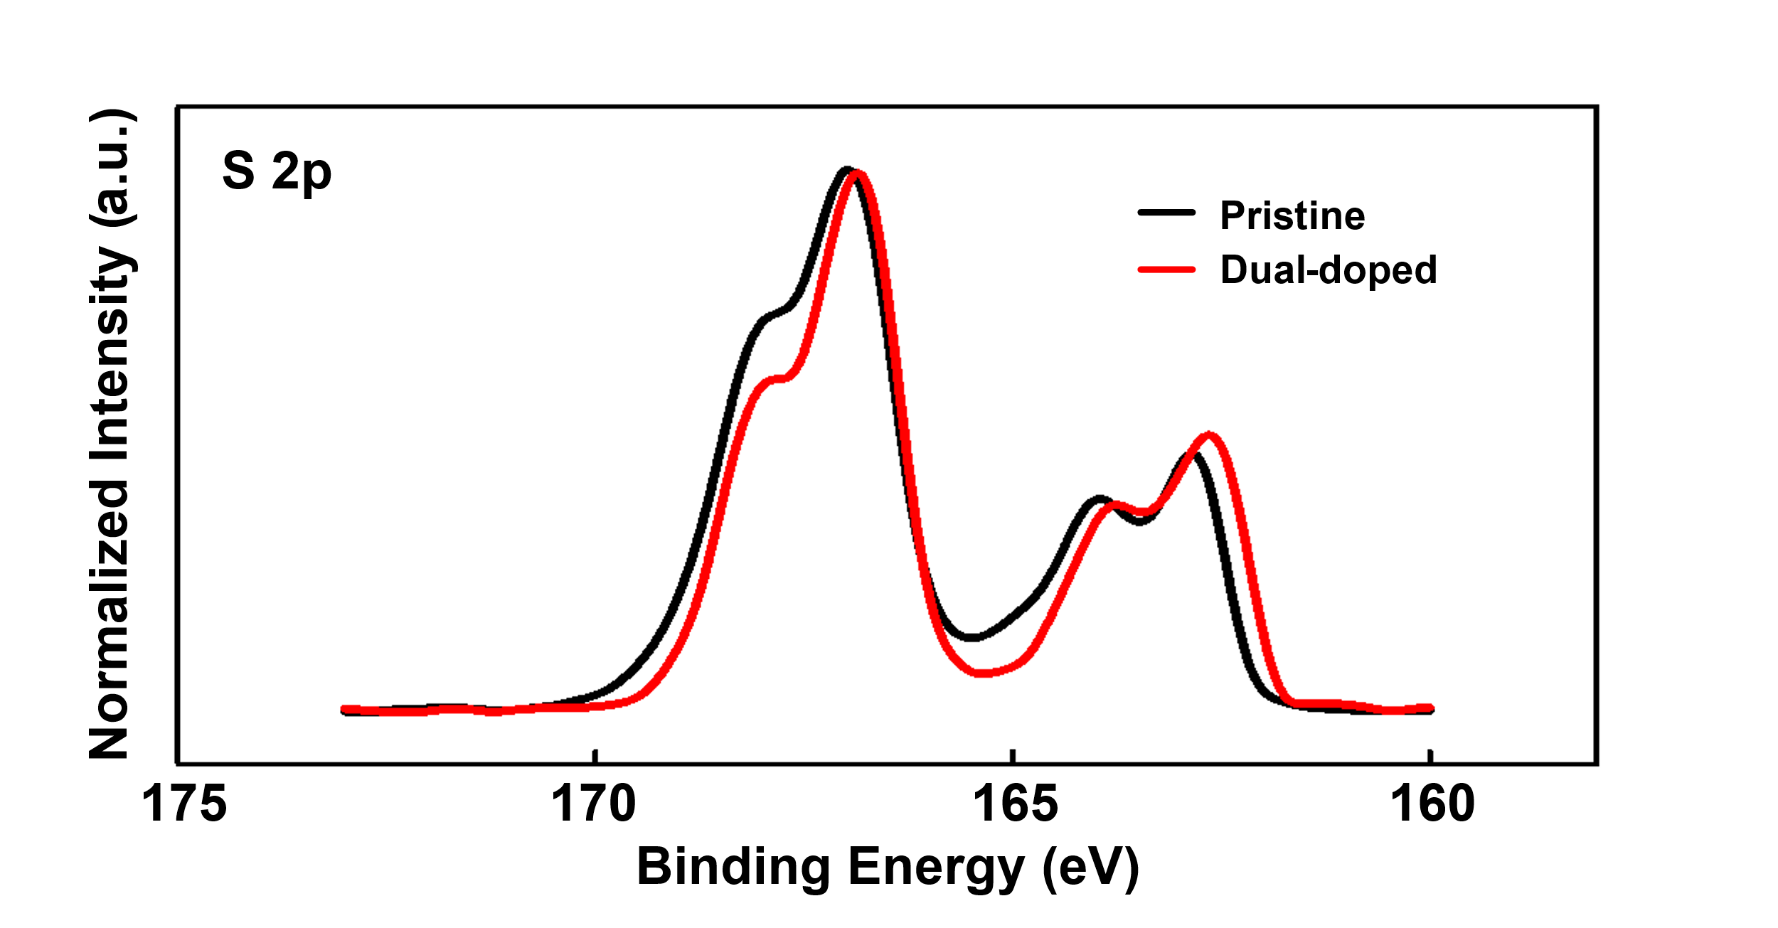
Supplementary Figure 1. XPS spectra of pristine and dual-doped PEDOT:PSS films.
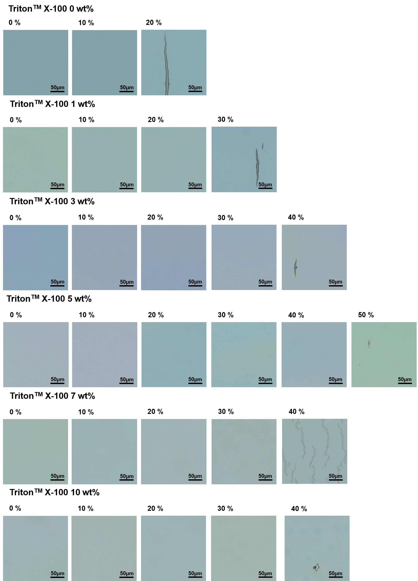
Supplementary Figure 2. OM images of PEDOT:PSS composite films doped with different TritonTM X-100 concentrations (0, 1, 3, 5, 7, 10 wt%) under increasing tensile strains.
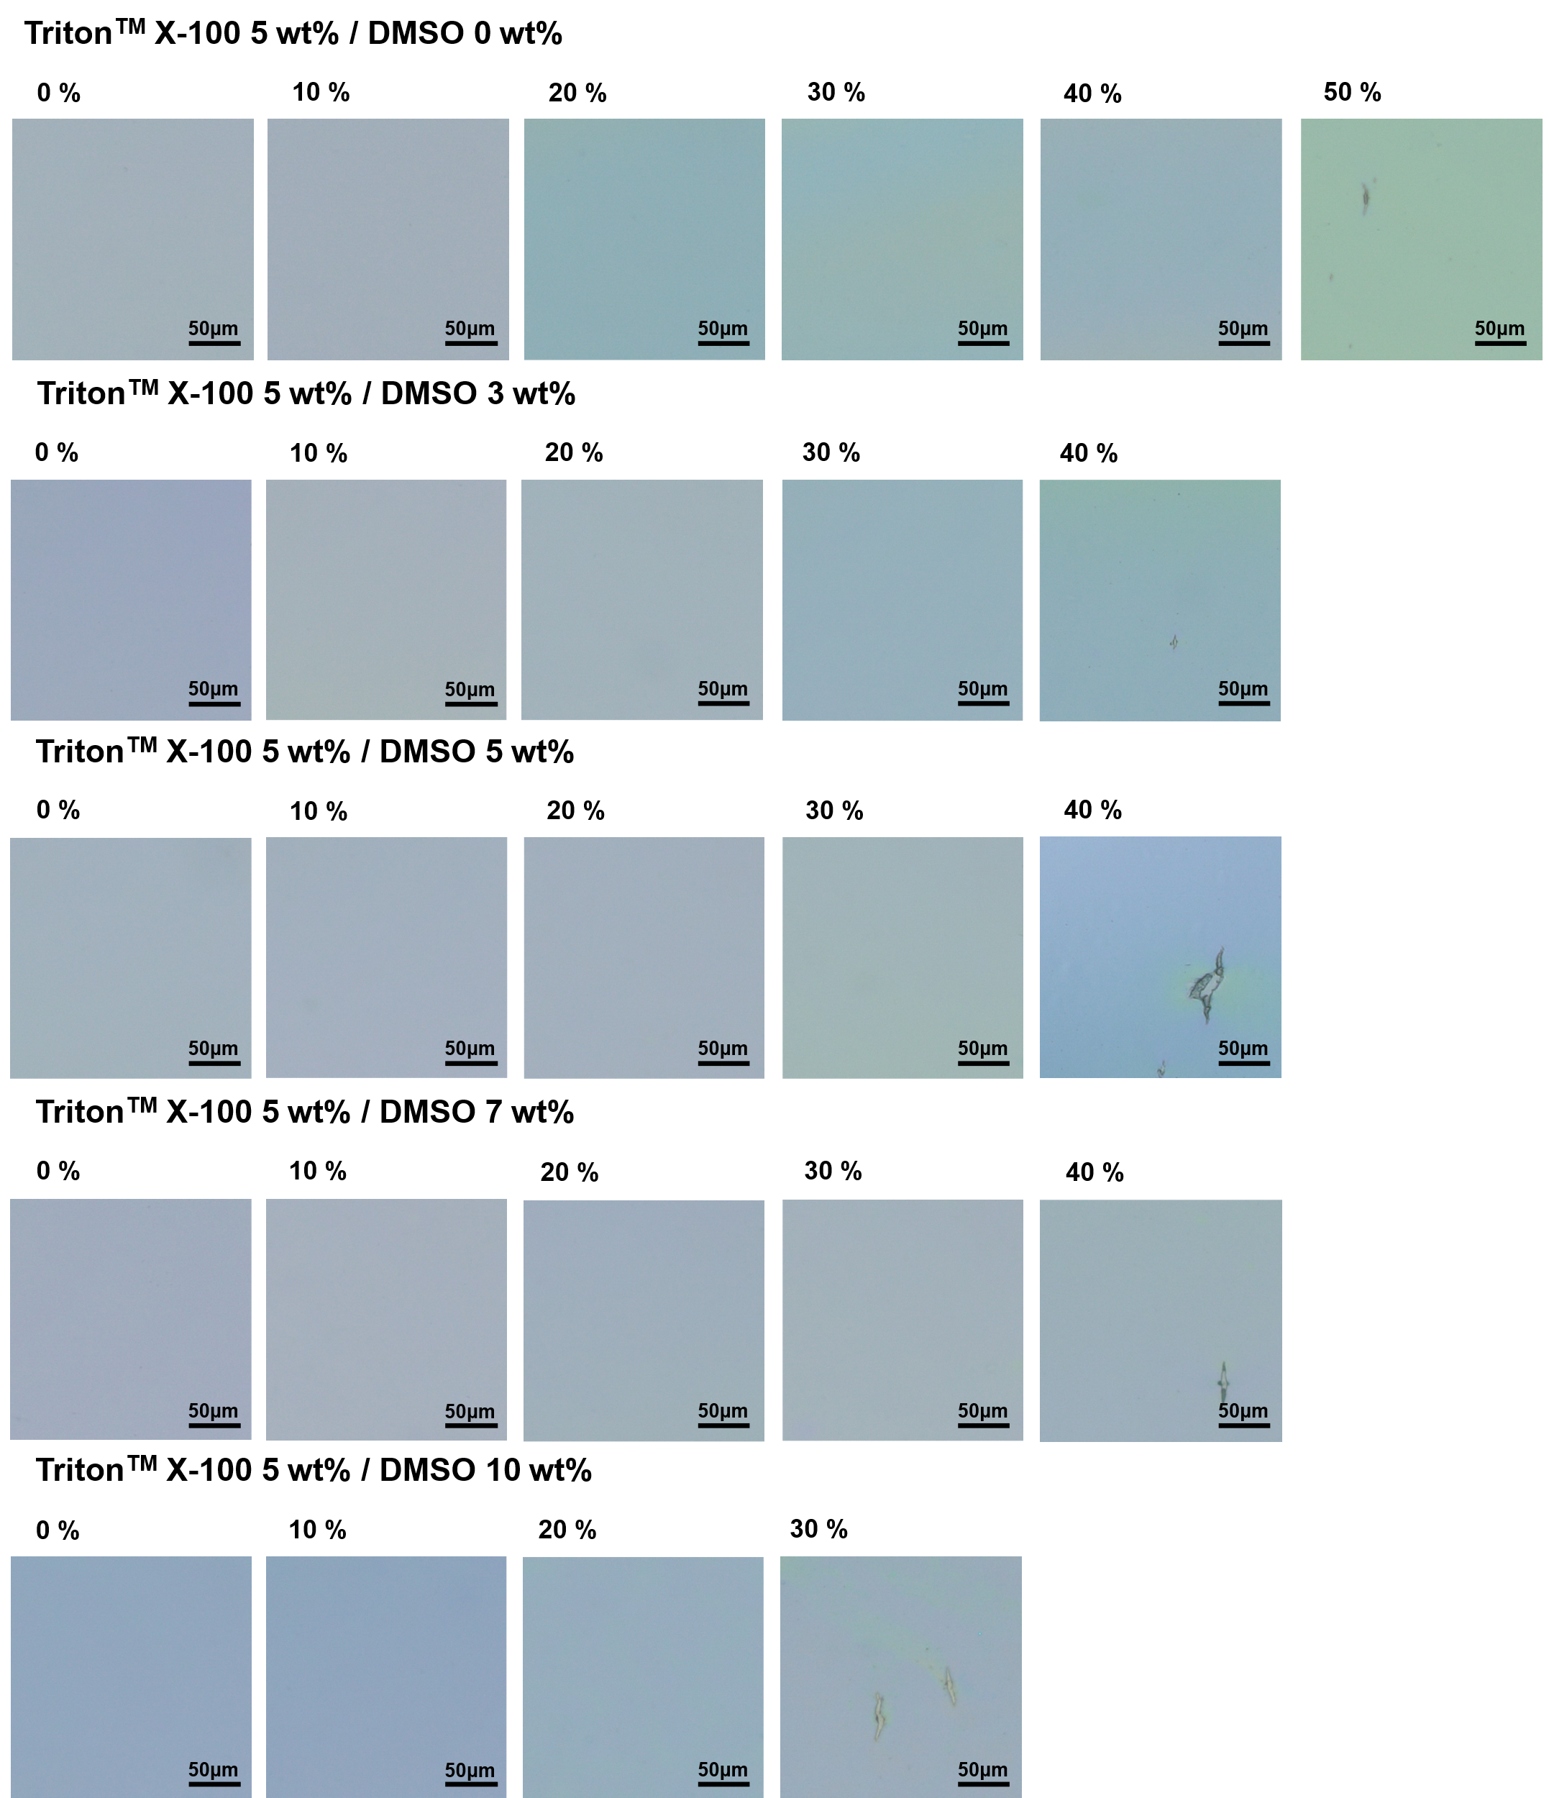
Supplementary Figure 3. OM images of PEDOT:PSS composite films doped with 5 wt% TritonTM X-100 and varying concentrations of DMSO (0, 1, 3, 5, 7, and 10 wt%) under increasing tensile strains.

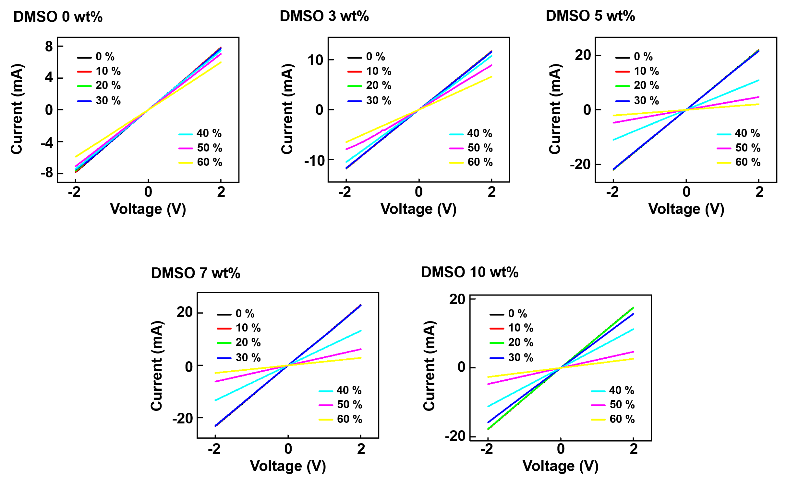
Supplementary Figure 4. The I–V characteristics of PEDOT:PSS composite films doped with the various DMSO concentrations (0, 3, 5, 7, and 10 wt%) under tensile strains ranging from 0% to 60%.

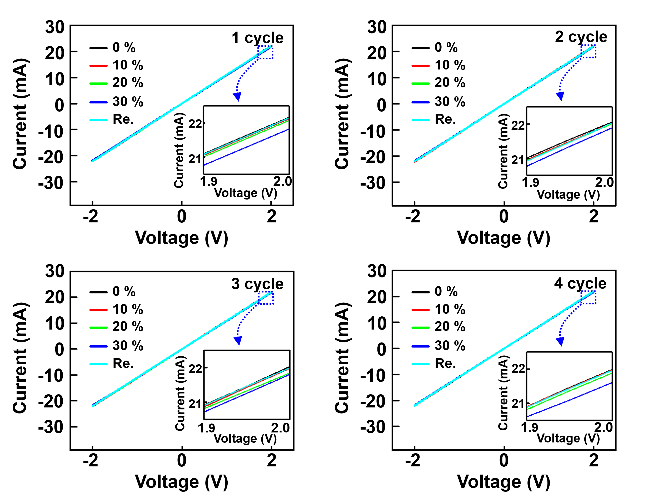
Supplementary Figure 5. The I–V characteristics of the PEDOT:PSS composite film over four stretching cycles.

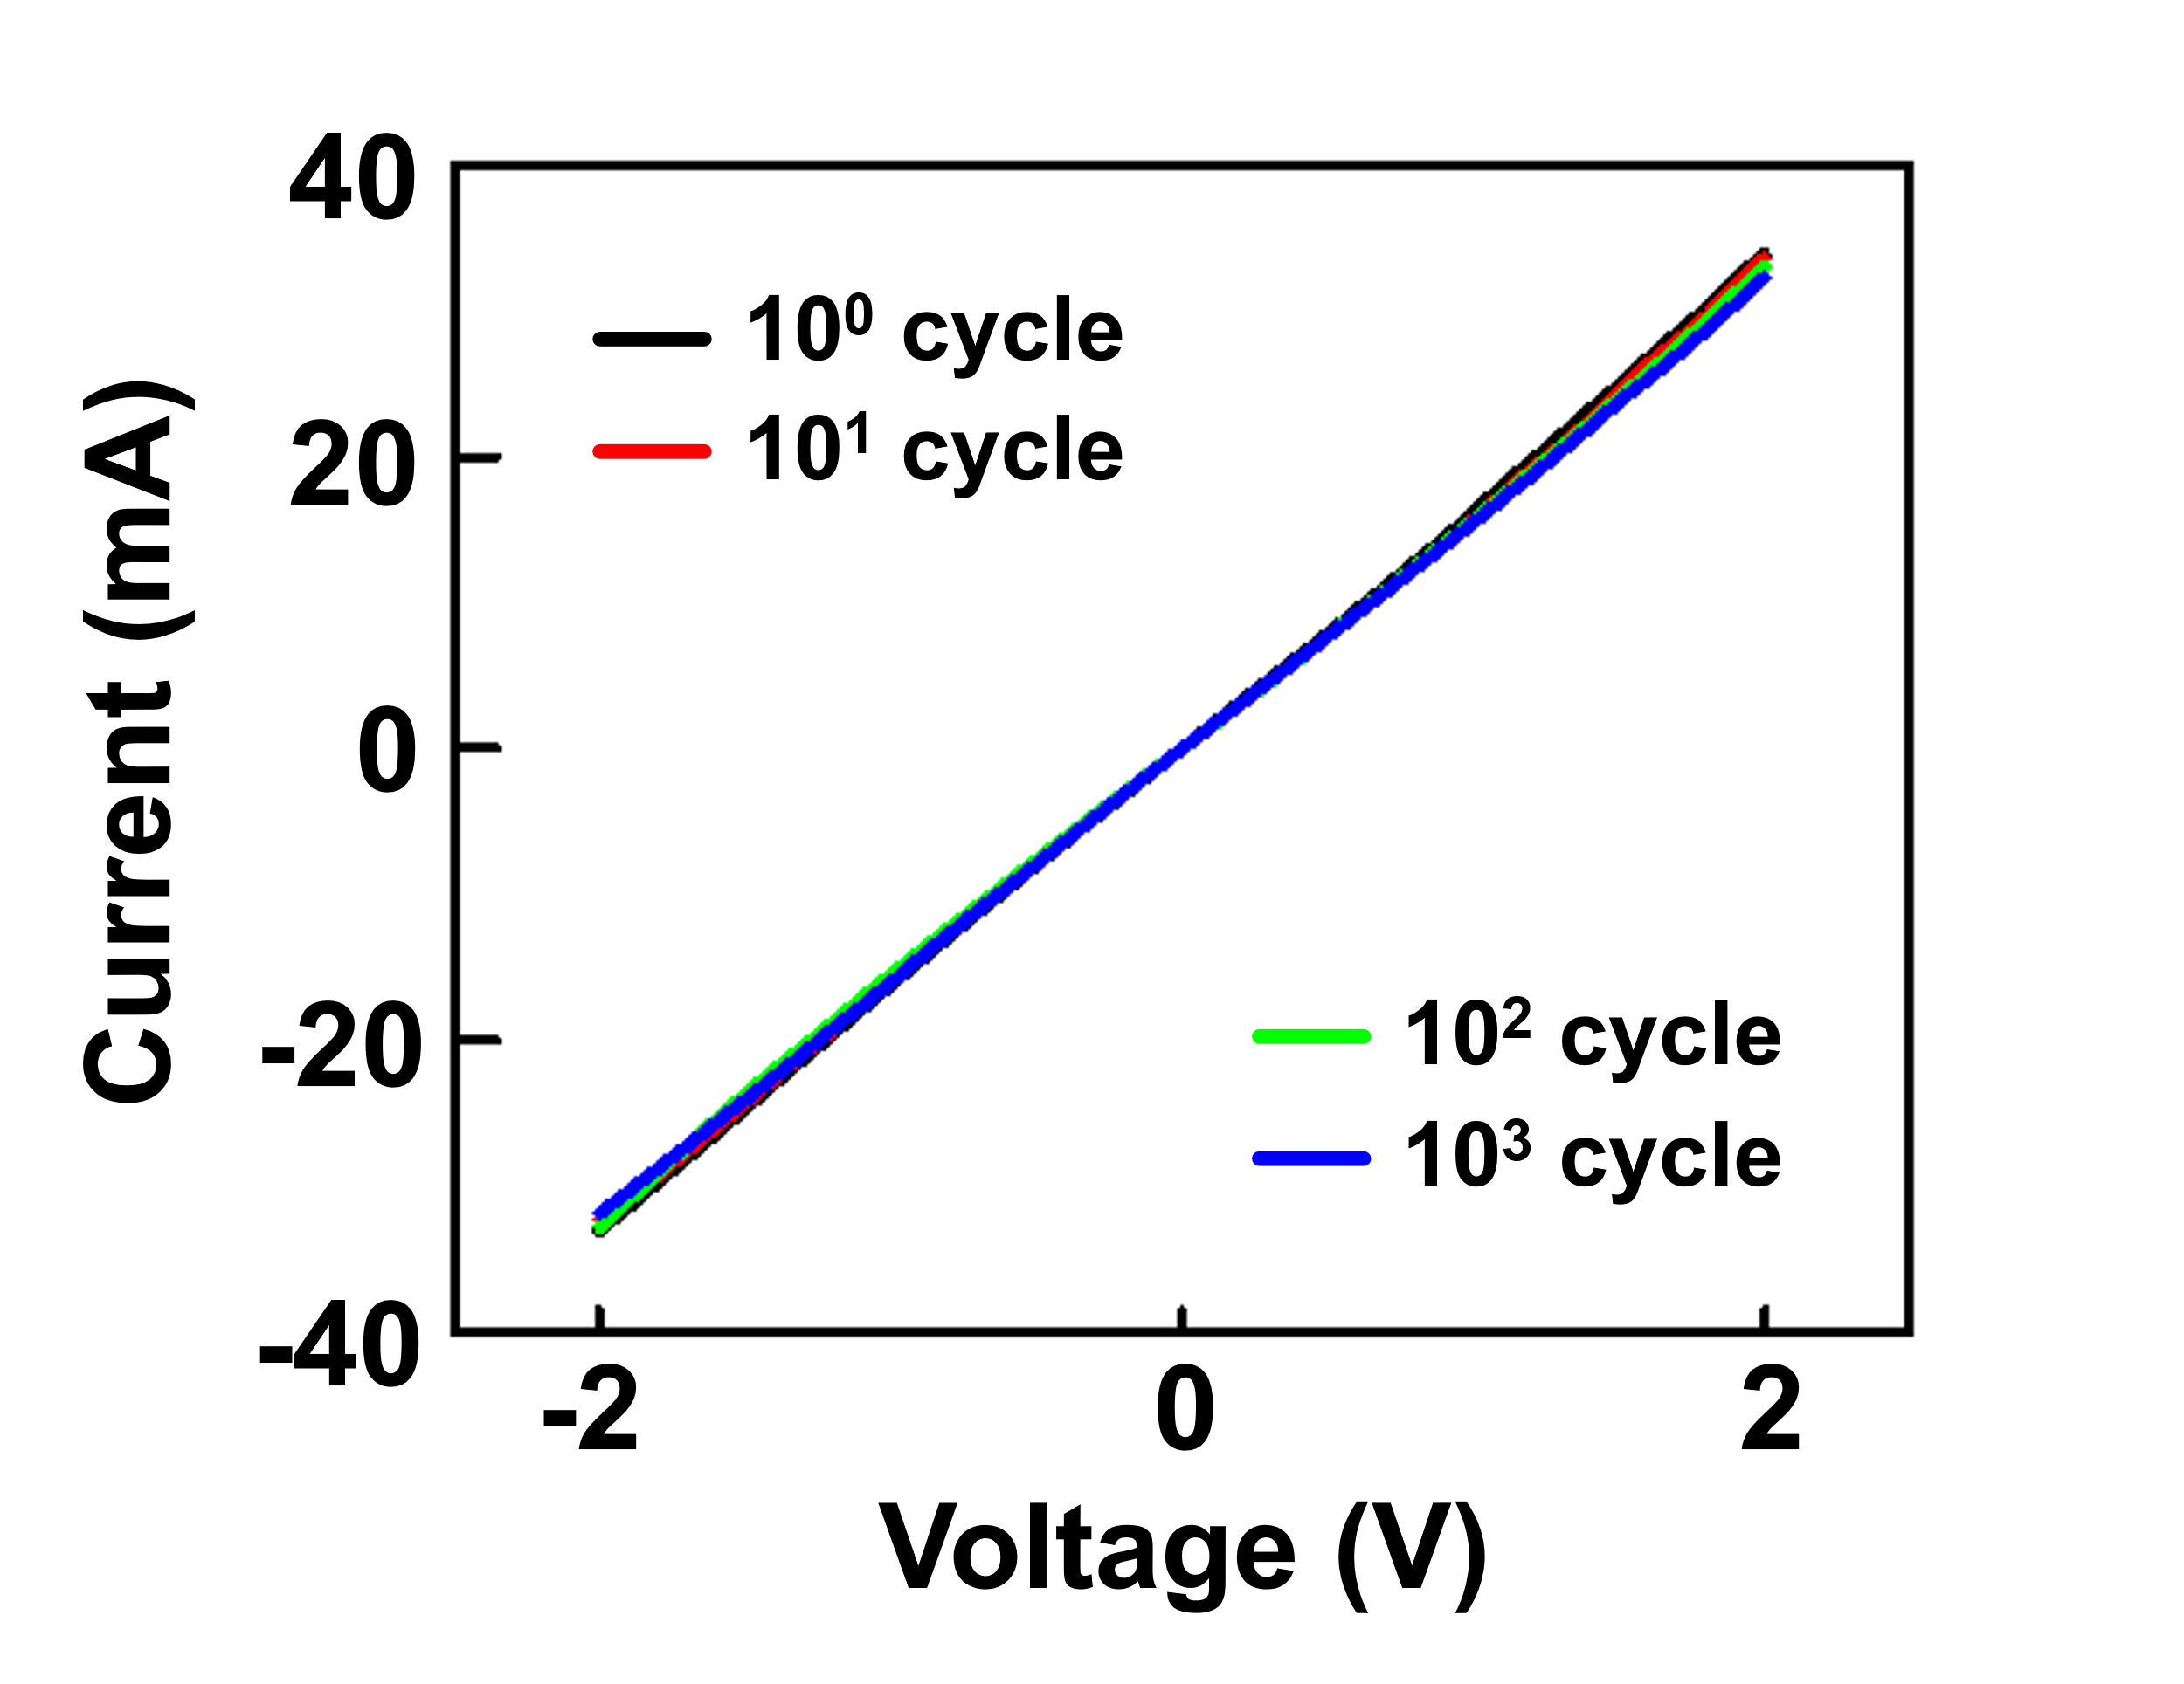
Supplementary Figure 6. The I–V characteristics of the PEDOT:PSS composite film measured after 1, 10, 100, and 1000 mechanical cycles under 30% tensile strain.

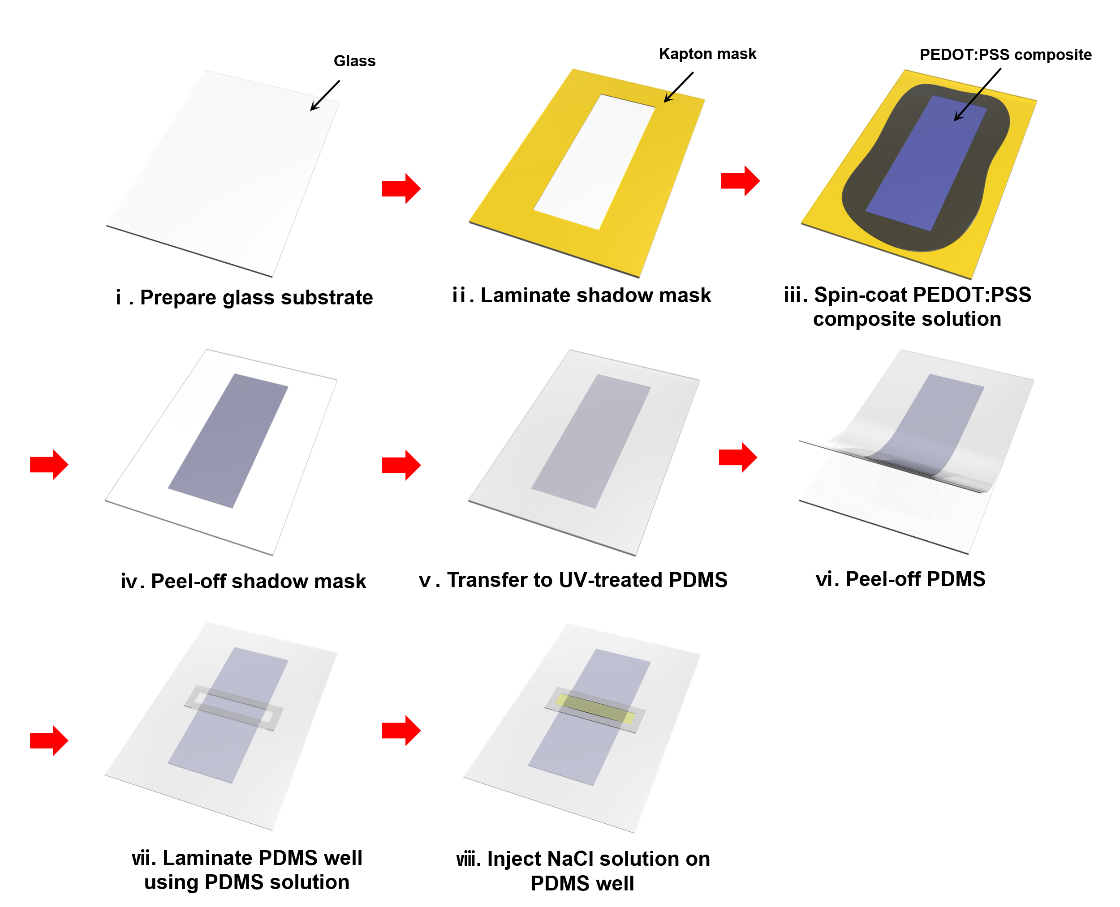
Supplementary Figure 7. Schematic fabrication process for the stretchable OECT.

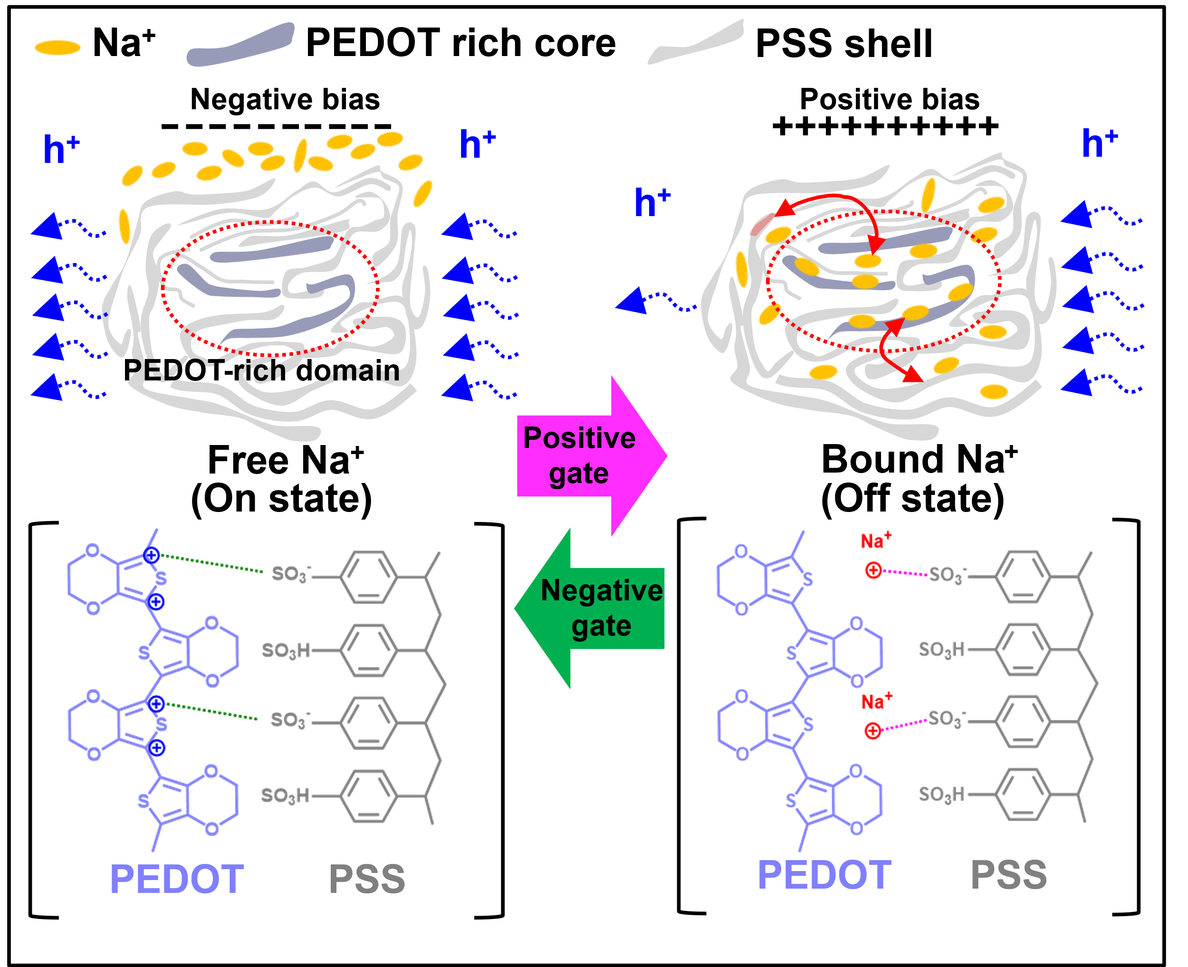
Supplementary Figure 8. Schematic illustration of the gate-voltage-induced doping and dedoping mechanism in PEDOT:PSS composite channel.
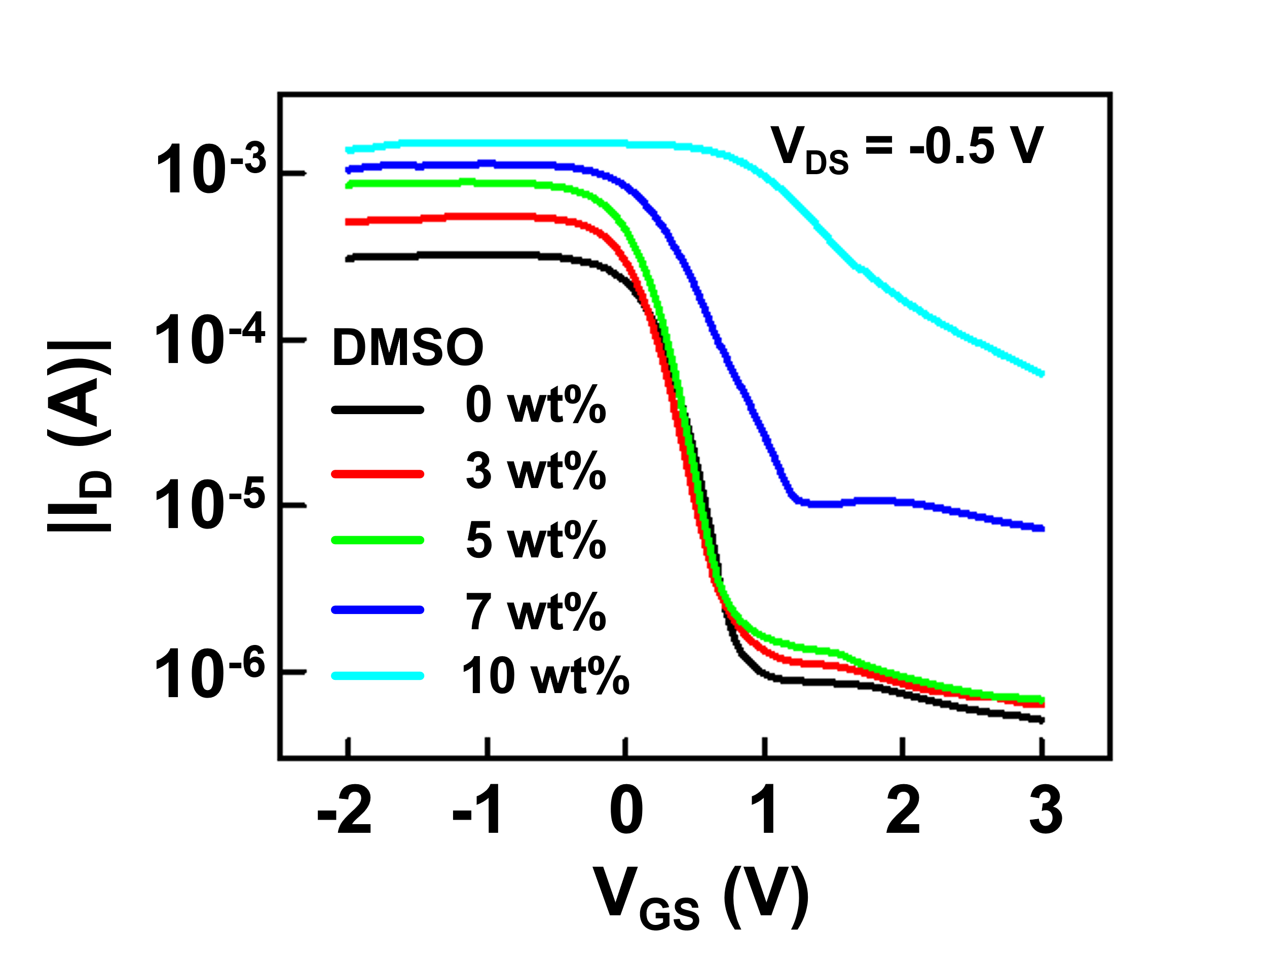
Supplementary Figure 9. Transfer characteristics of OECTs incorporating PEDOT:PSS composites with varying DMSO doping concentrations (0, 3, 5, 7, and 10 wt%).

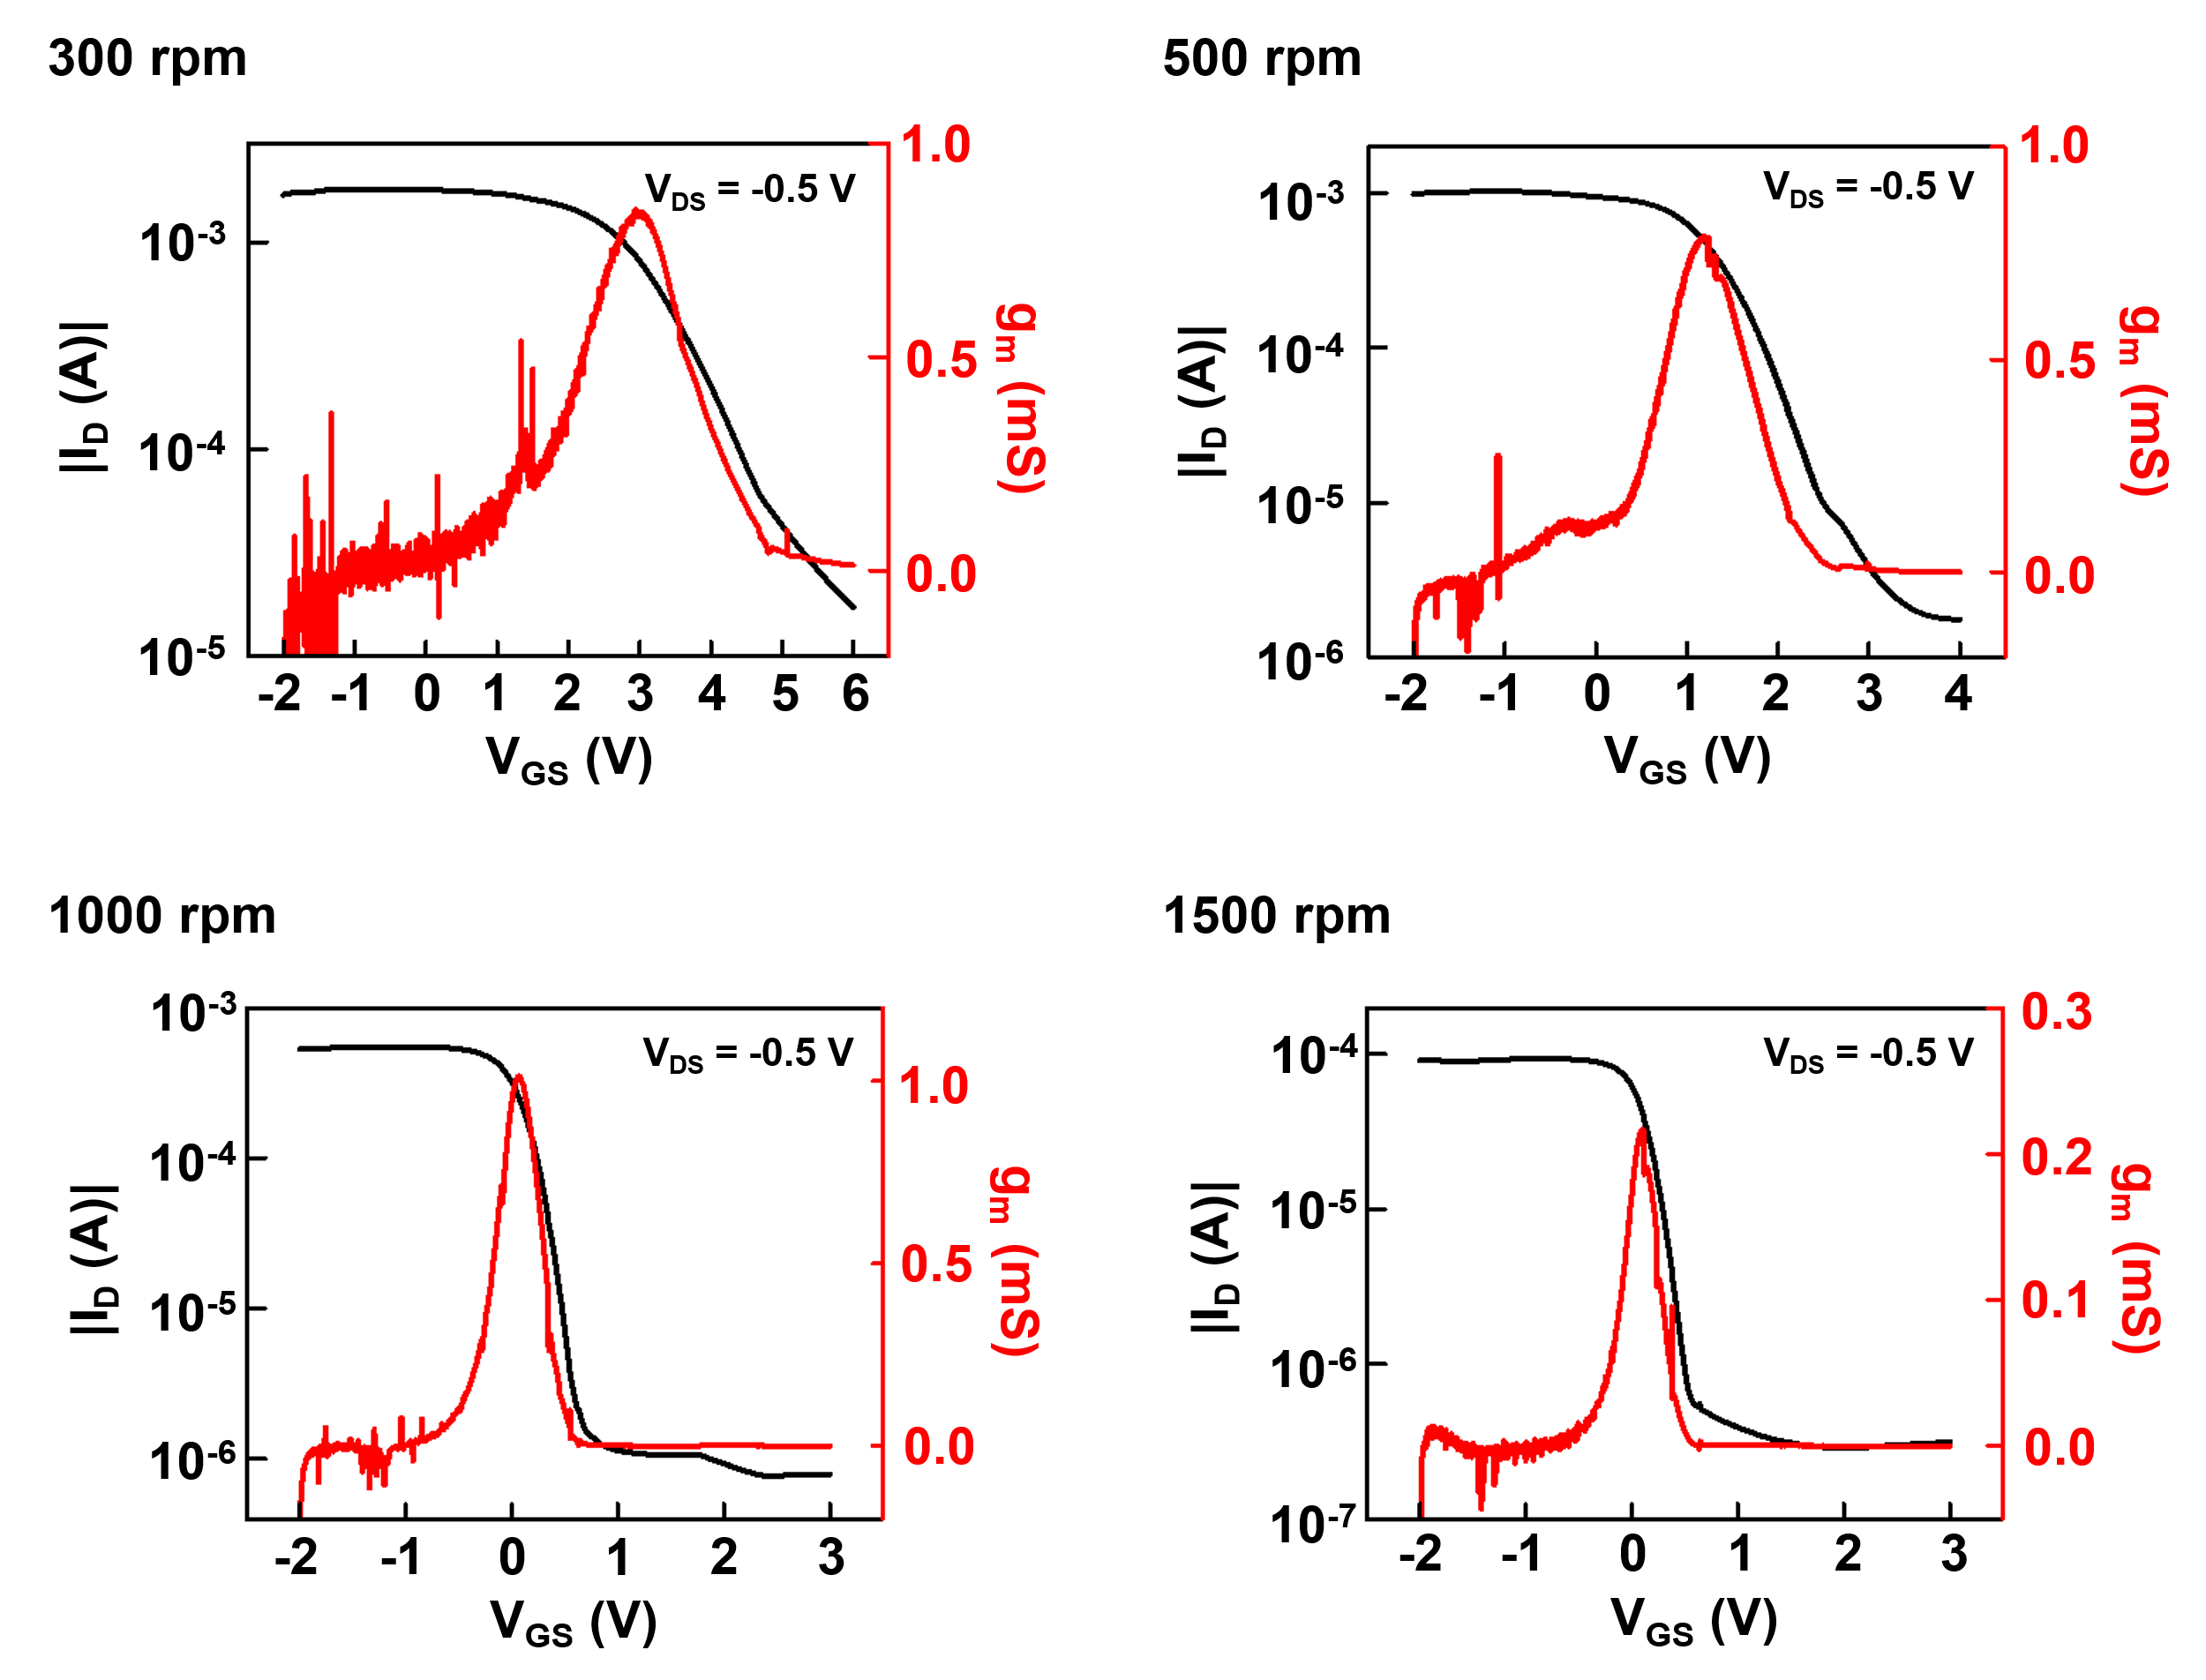
Supplementary Figure 10. Transfer characteristics and g_{m} of OECTs based on PEDOT:PSS composite films spin-coated at different speeds (300, 500, 1000, and 1500 rpm).

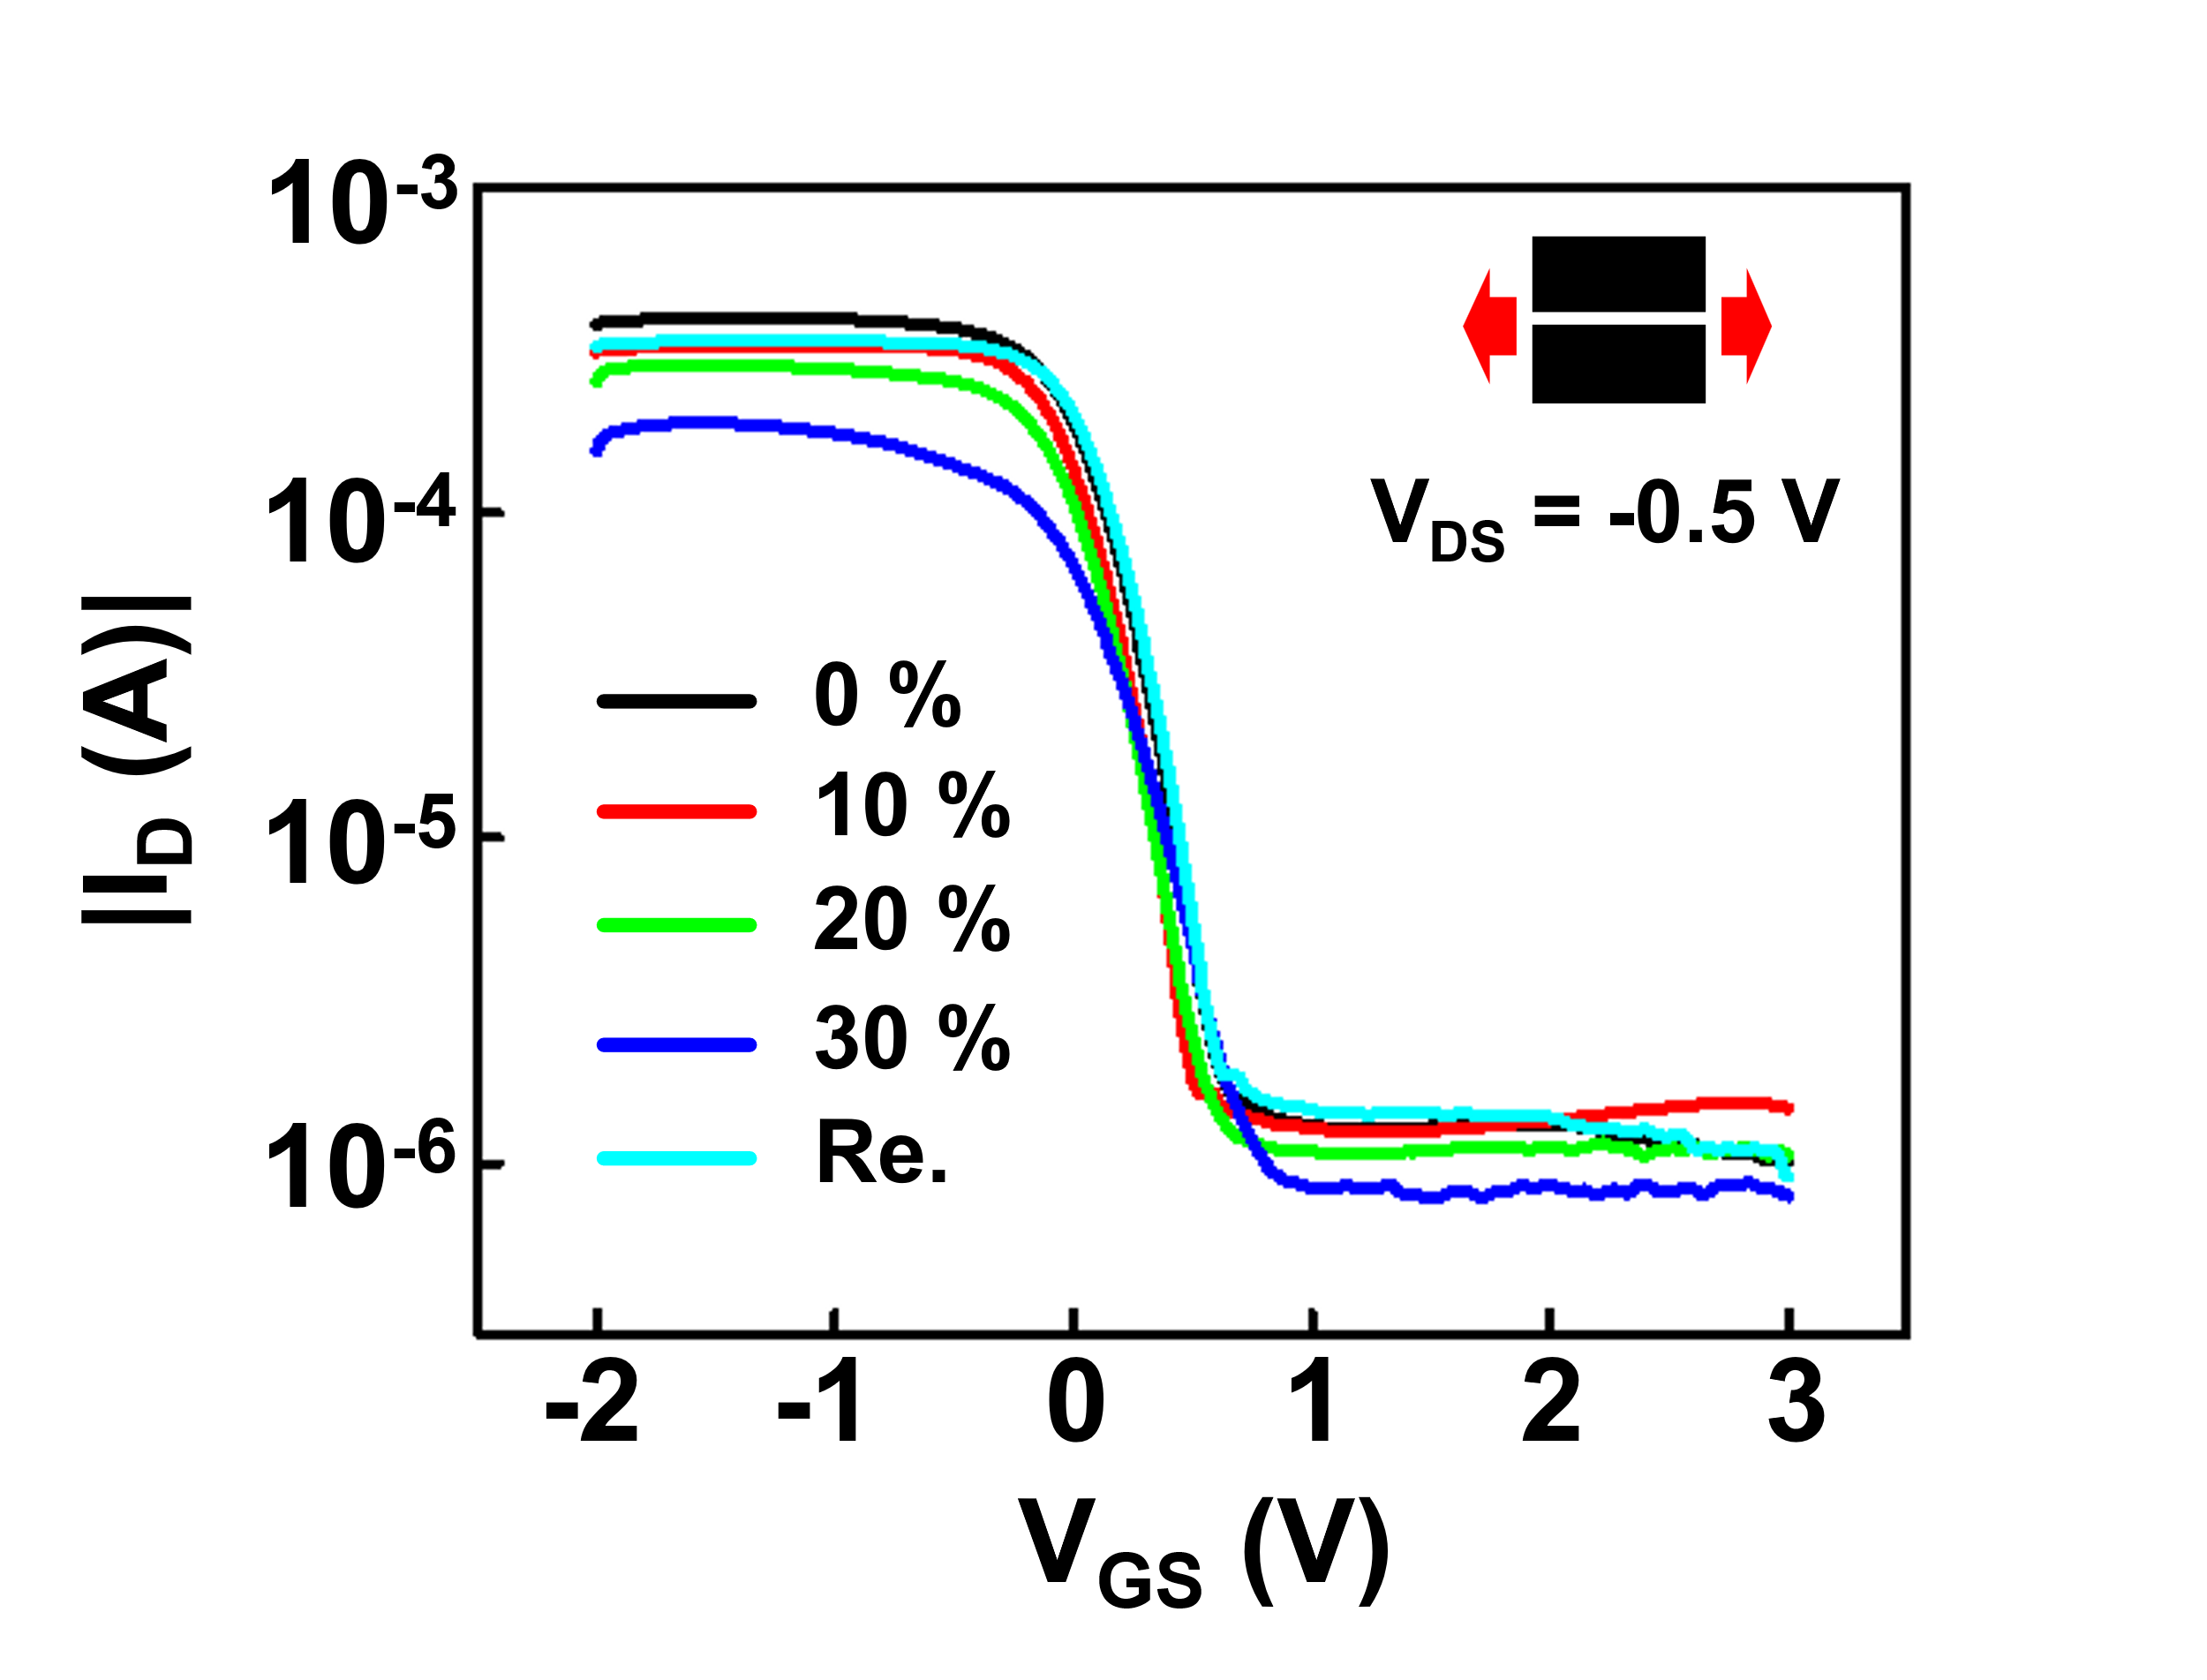
Supplementary Figure 11. Transfer characteristic of stretchable OECT under tensile strains of 0%, 10%, 20%, 30%, and after strain release (0%) applied perpendicular to the channel length direction.

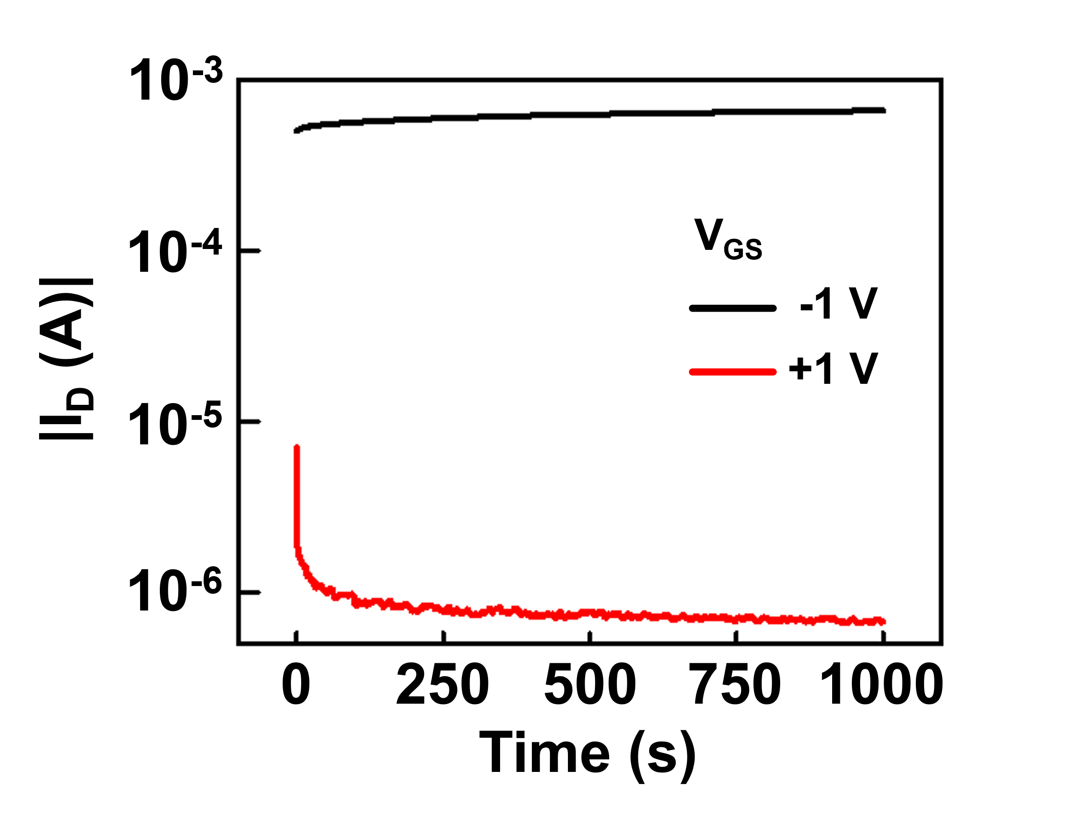
Supplementary Figure 12. I_{ON} and I_{OFF} of the device over 1000 s under a V_{DS} of −0.5 V and V_{GS} of −1 V and +1 V, respectively.

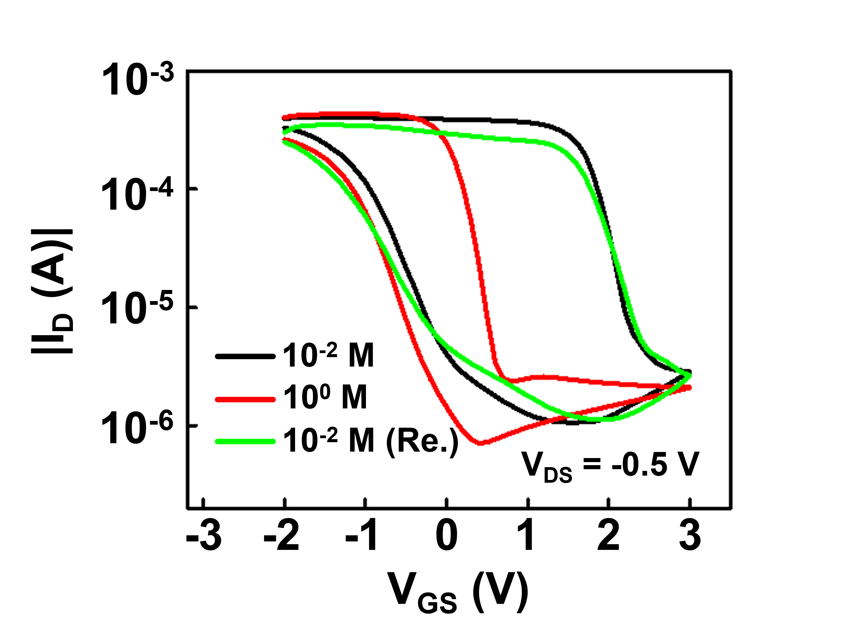

Supplementary Figure 13. Transfer characteristics under sequential NaCl switching (0.01 M → 1 M → 0.01 M) with DI rinsing.

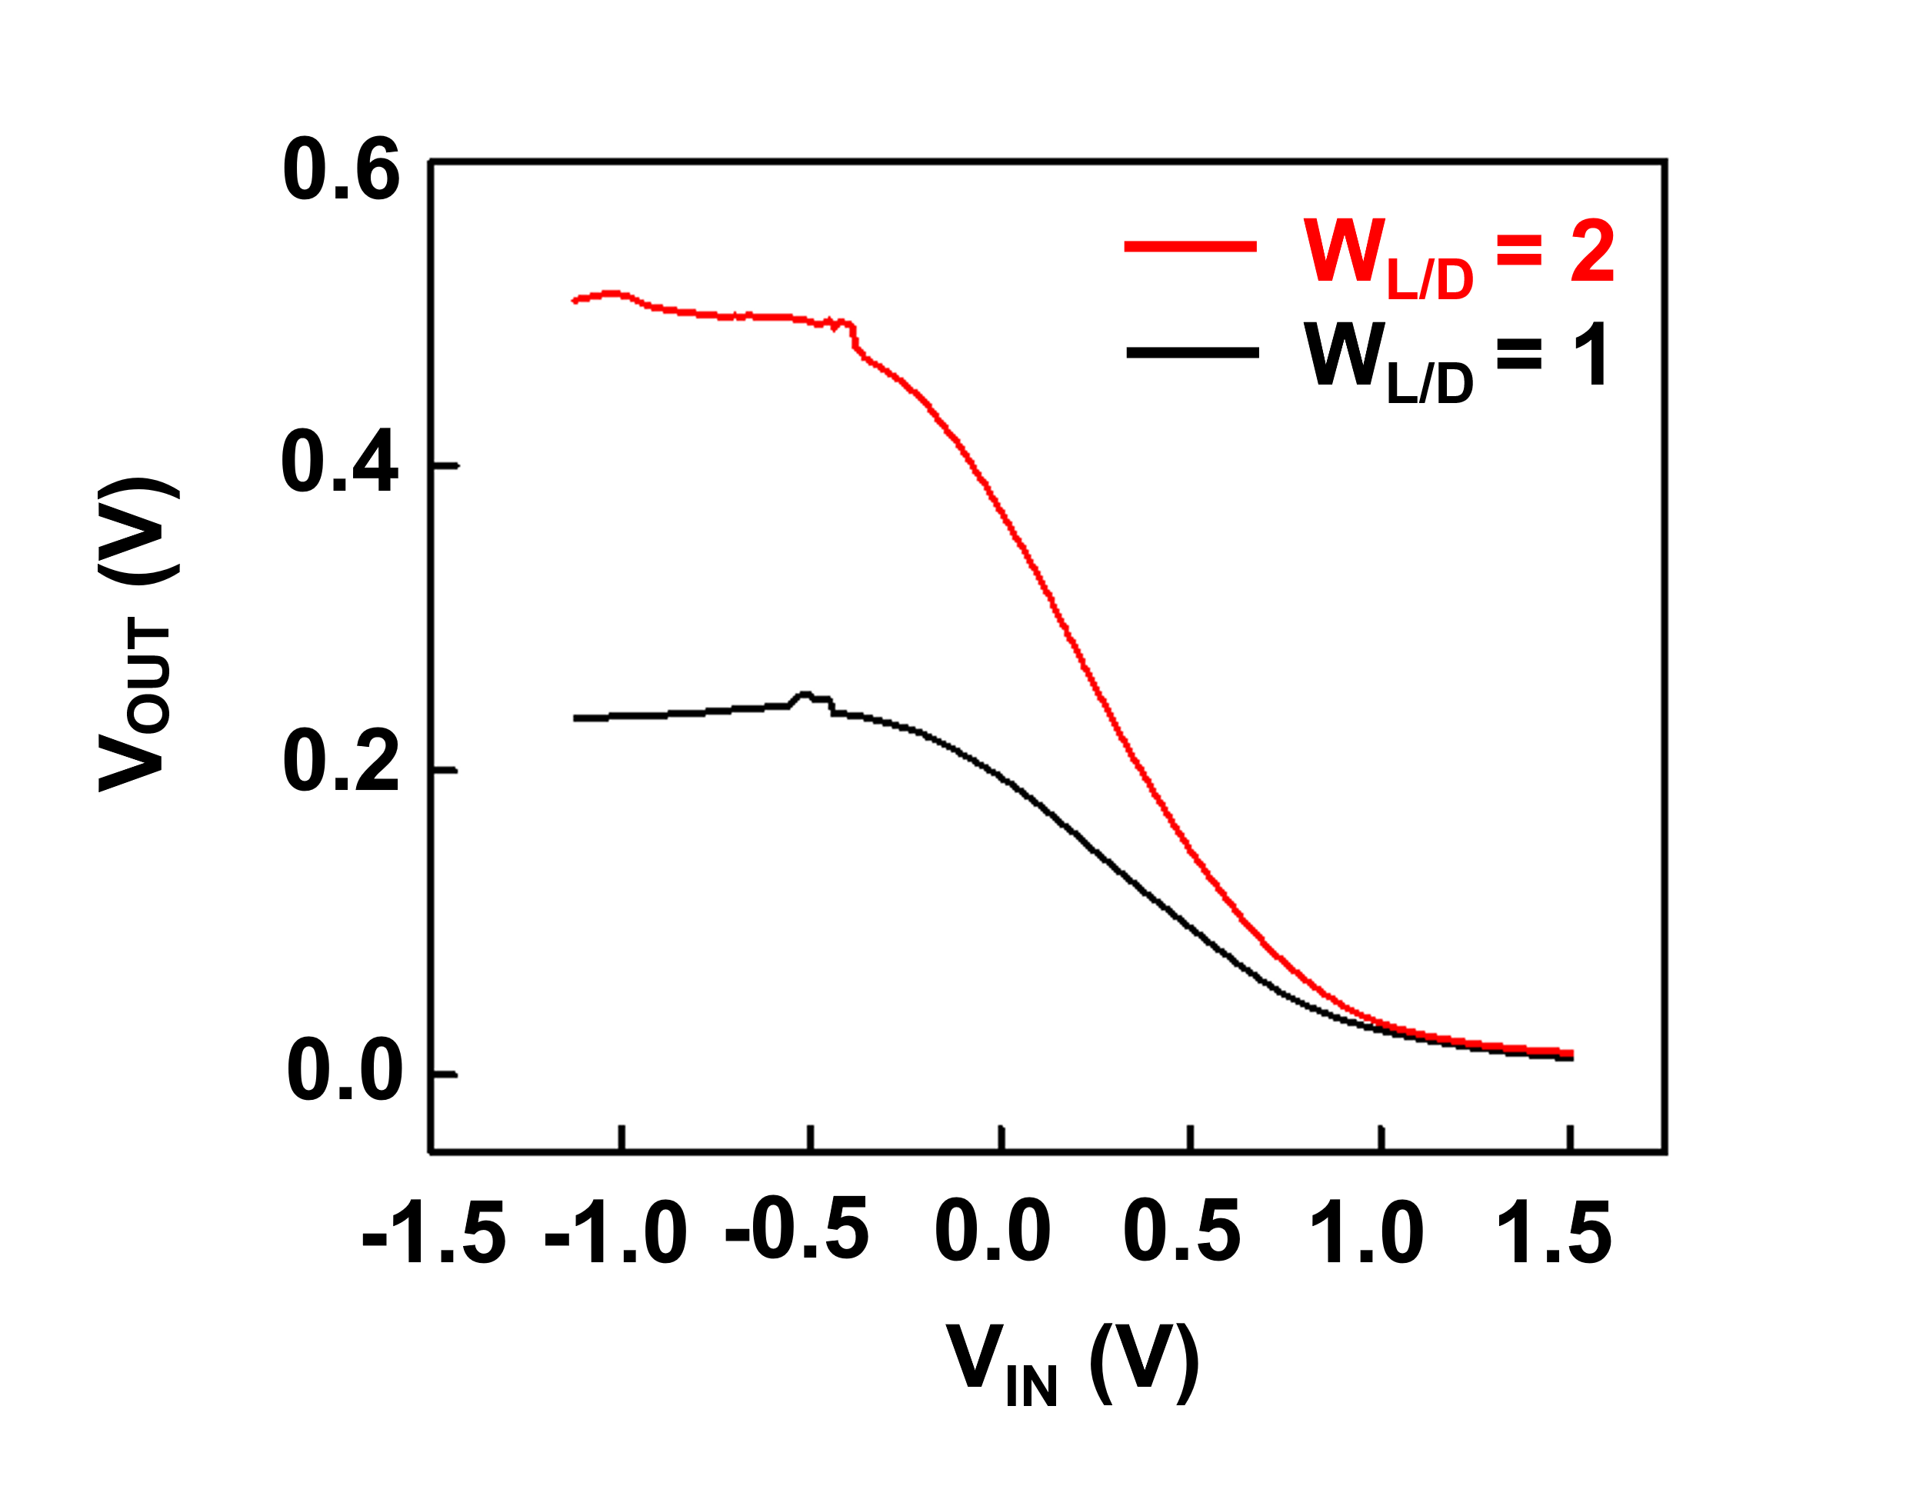
Supplementary Figure 14. VTCs of inverters as a function of the channel width ratio between the load and drive transistors (W_{L/D}).

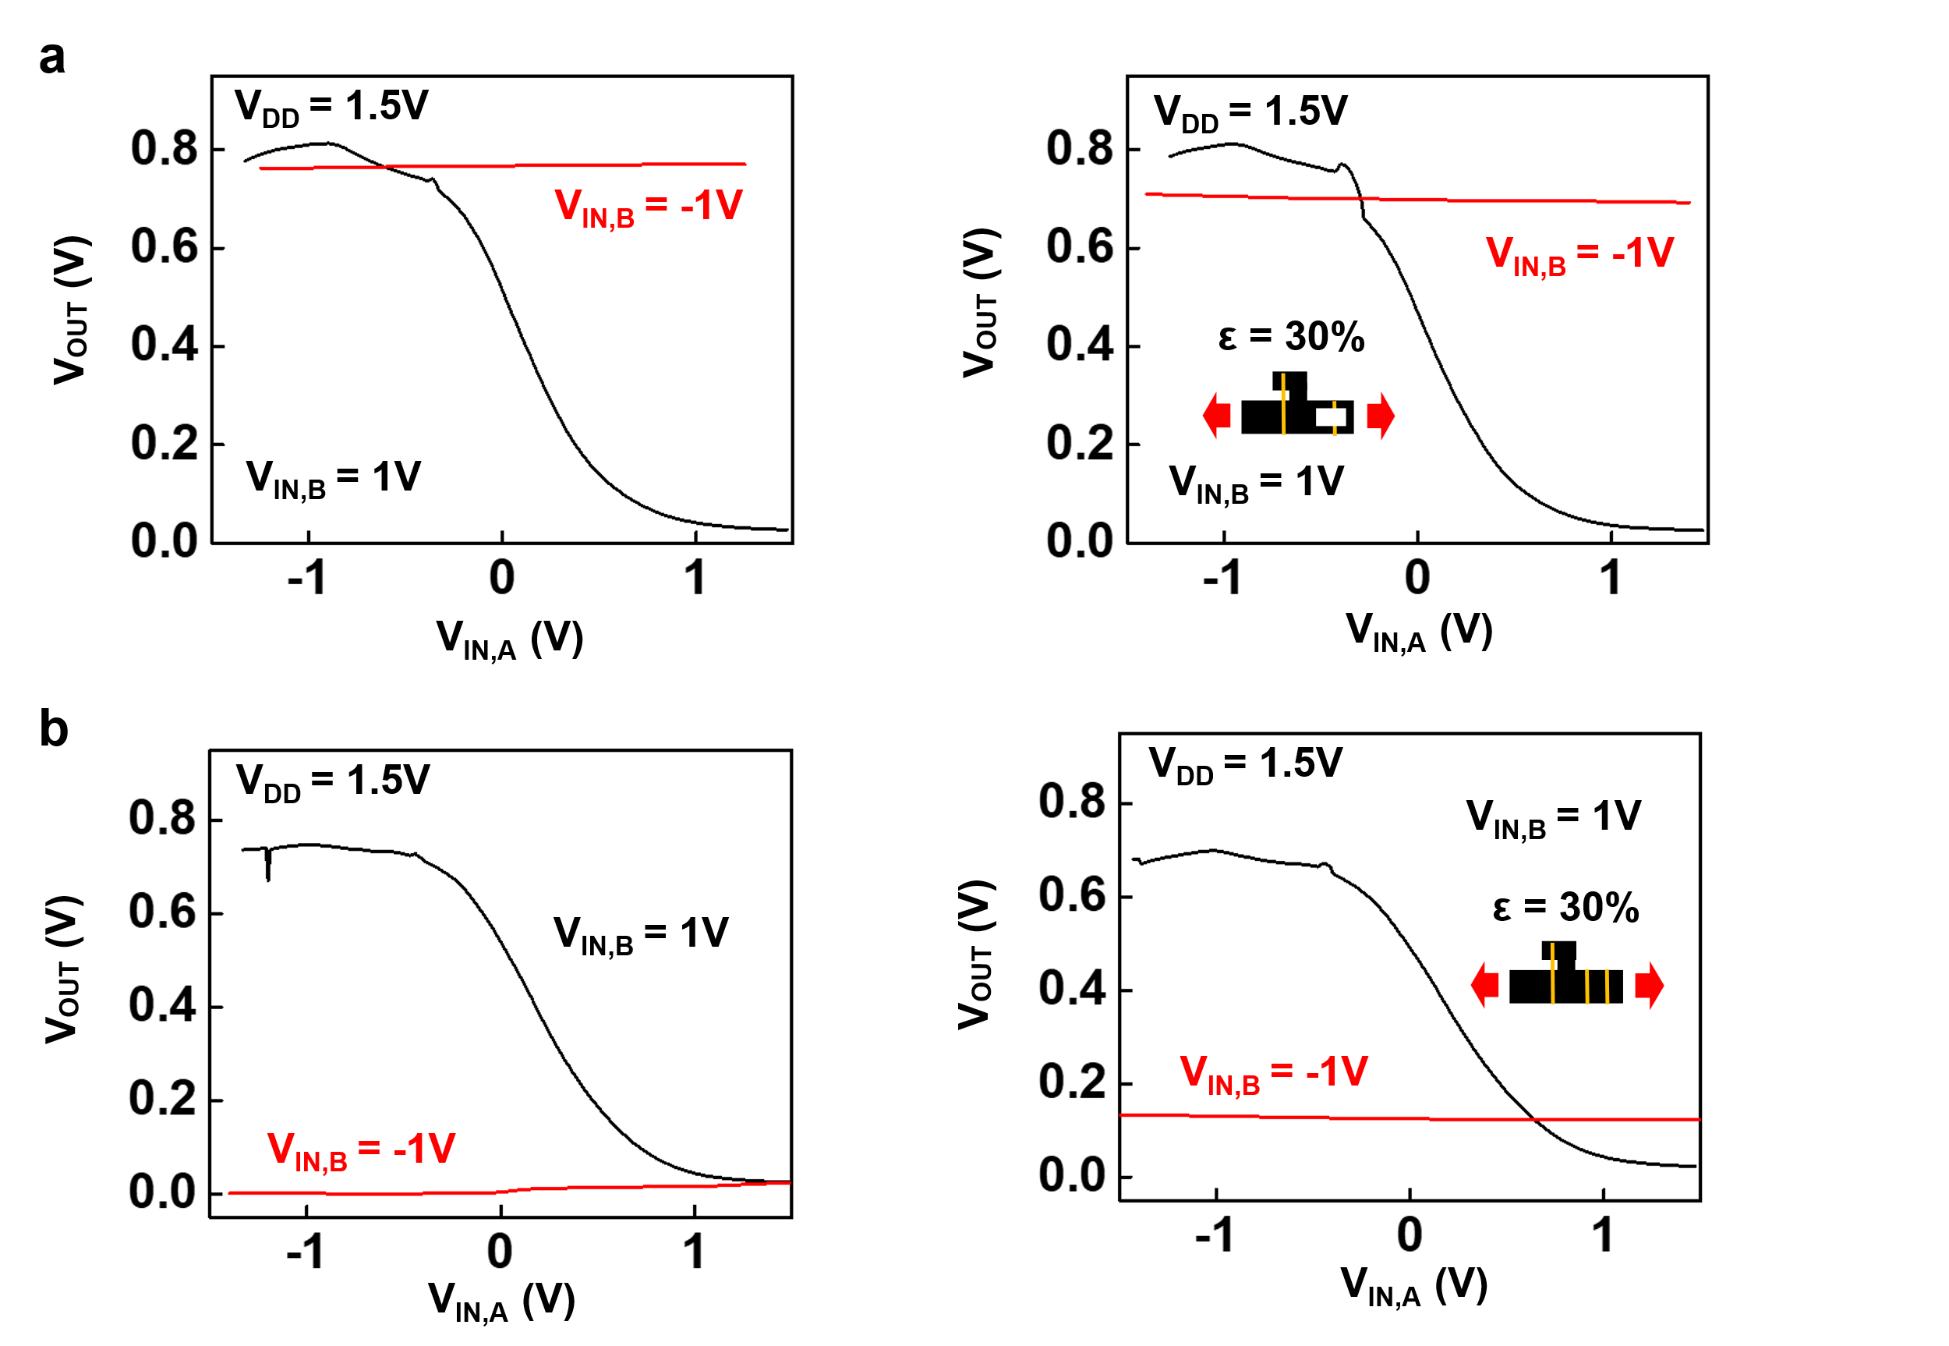
Supplementary Figure 15. The static VTCs of both NAND and NOR logic gates. a, VTC of NAND gate under tensile strain of 0% (left) and 30% (right) applied along the channel length direction. b, VTC of NOR gate under tensile strain of 0% (left) and 30% (right) applied along the channel length direction.

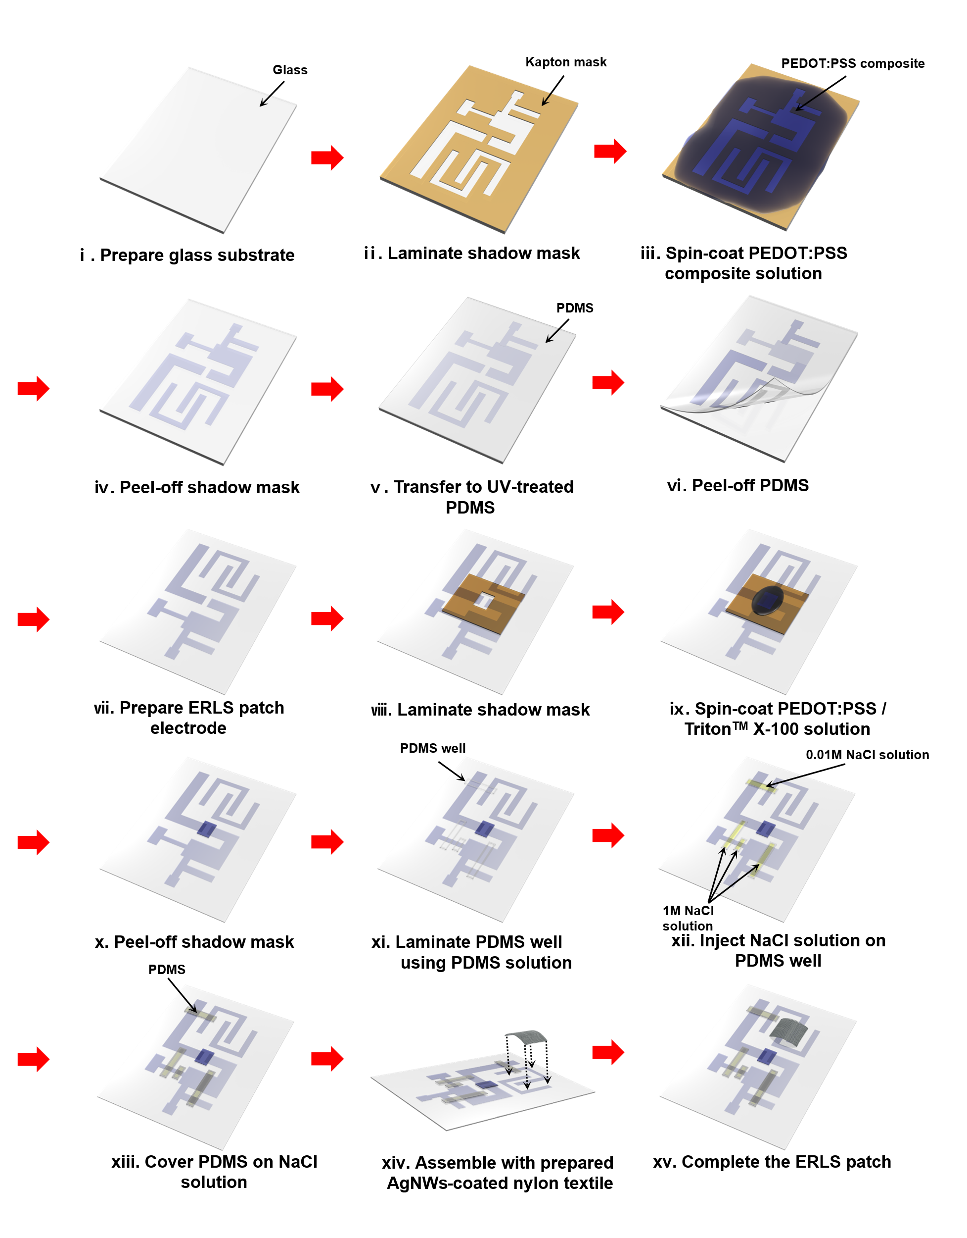
Supplementary Figure 16. The schematic fabrication process of the wearable adaptive logic system.

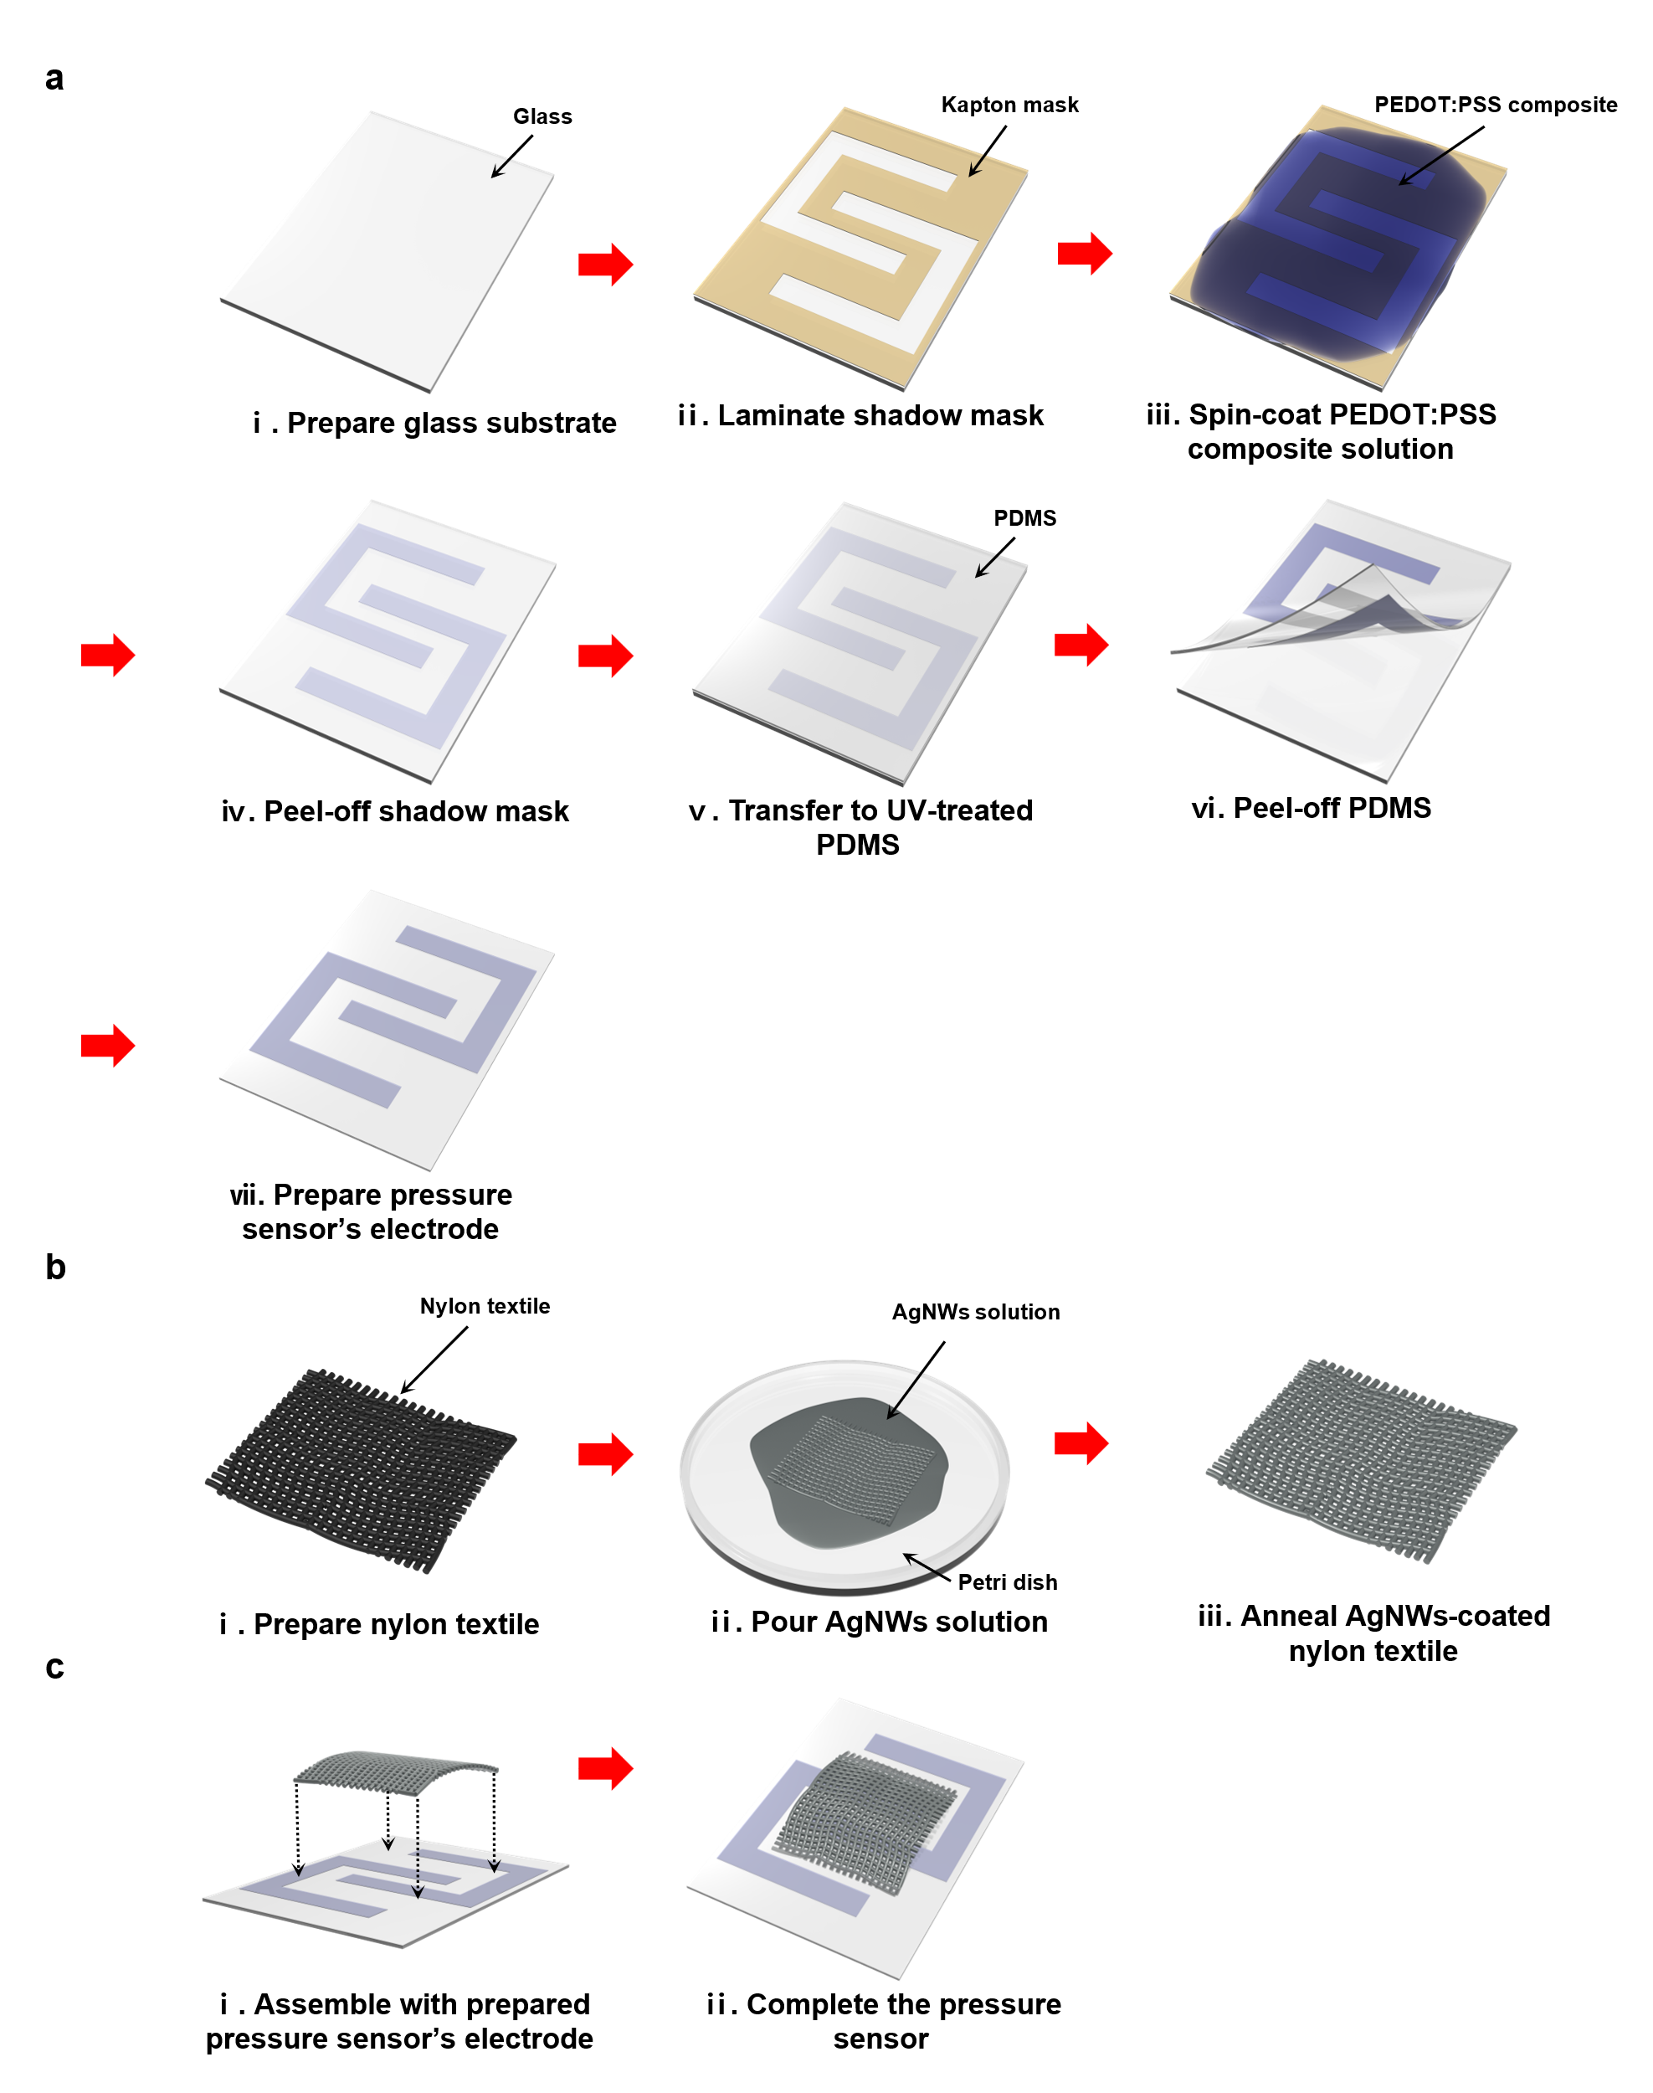
Supplementary Figure 17. The schematic fabrication process of the stretchable pressure sensor. a, The schematic fabrication process of the pressure sensor’s electrode pattern. b, Preparation of the AgNWs-coated nylon textile. c, Assembly of the pressure sensor by laminating the AgNWs-coated textile onto the patterned electrode.

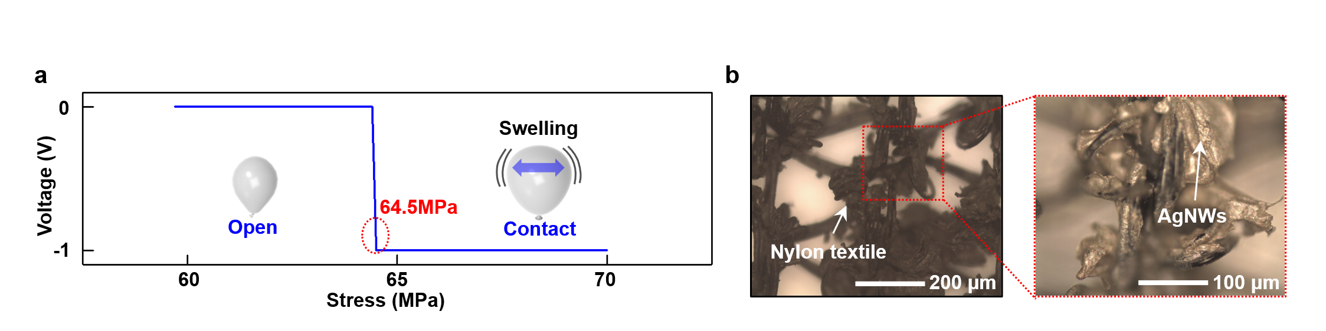
Supplementary Figure 18. Characteristic of pressure sensor and structural analysis of the AgNWs-coated nylon textile. a, Voltage responses of the pressure sensor as a function of mechanical stress. b, OM images of AgNWs-coated nylon textile confirming conductive network formation.

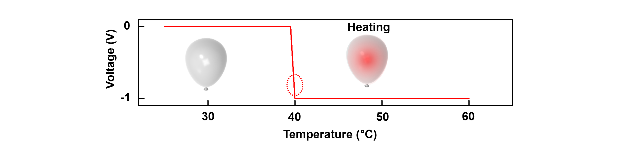
Supplementary Figure 19. Voltage responses of the temperature sensor as a function of temperature.

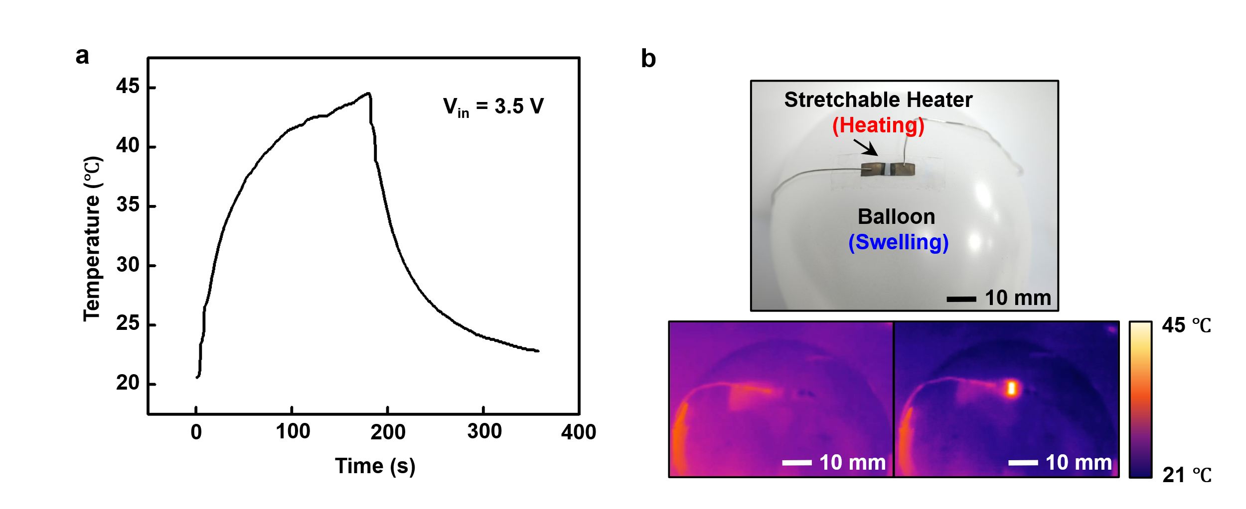
Supplementary Figure 20. Simulation of inflammatory edema using a balloon-swelling model integrated with a stretchable heater. a, Temporal temperature profile of a stretchable heater under 3.5 V bias, classification of hyperthermic condition (Temperature > 40 °C) and normothermic condition (Temperature < 40 °C, heater off). b, Optical image of a heater-integrated module mounted on a balloon model, experimental simulation of edema conditions, mimicry of hyperthermic swelling through balloon inflation.

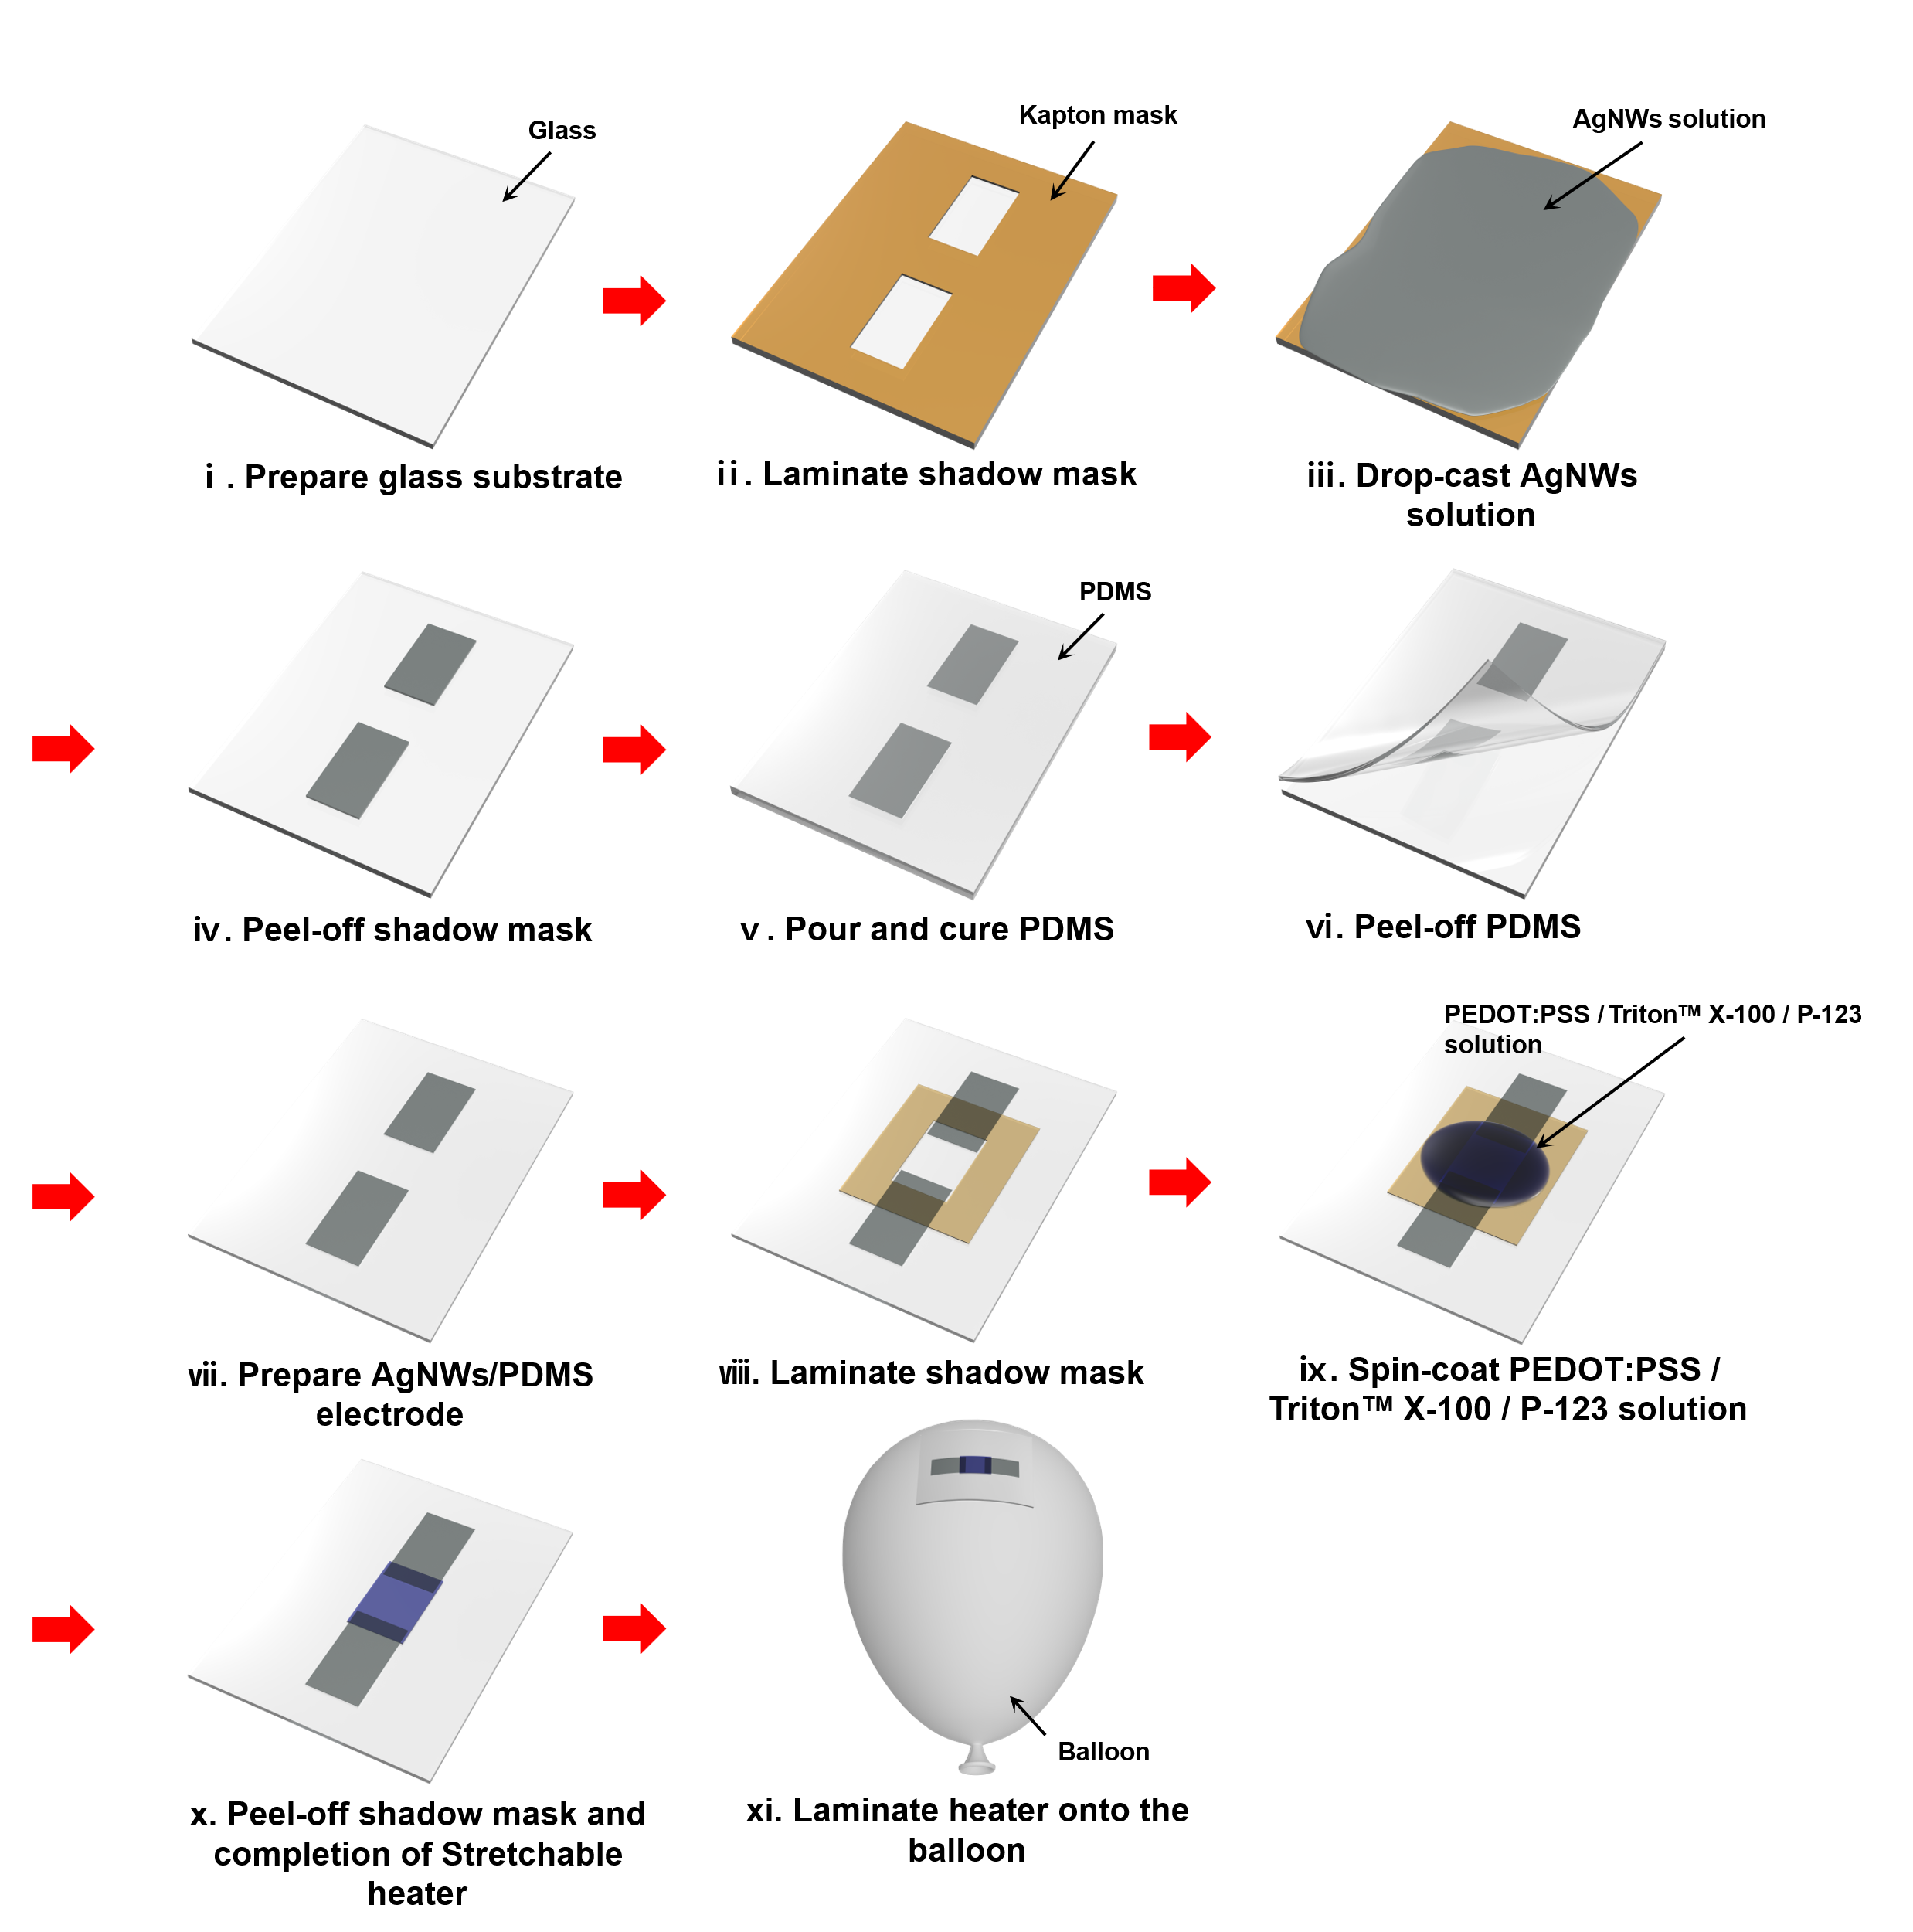
Supplementary Figure 21. Schematic fabrication process of the stretchable heater and the complete edema simulation system.

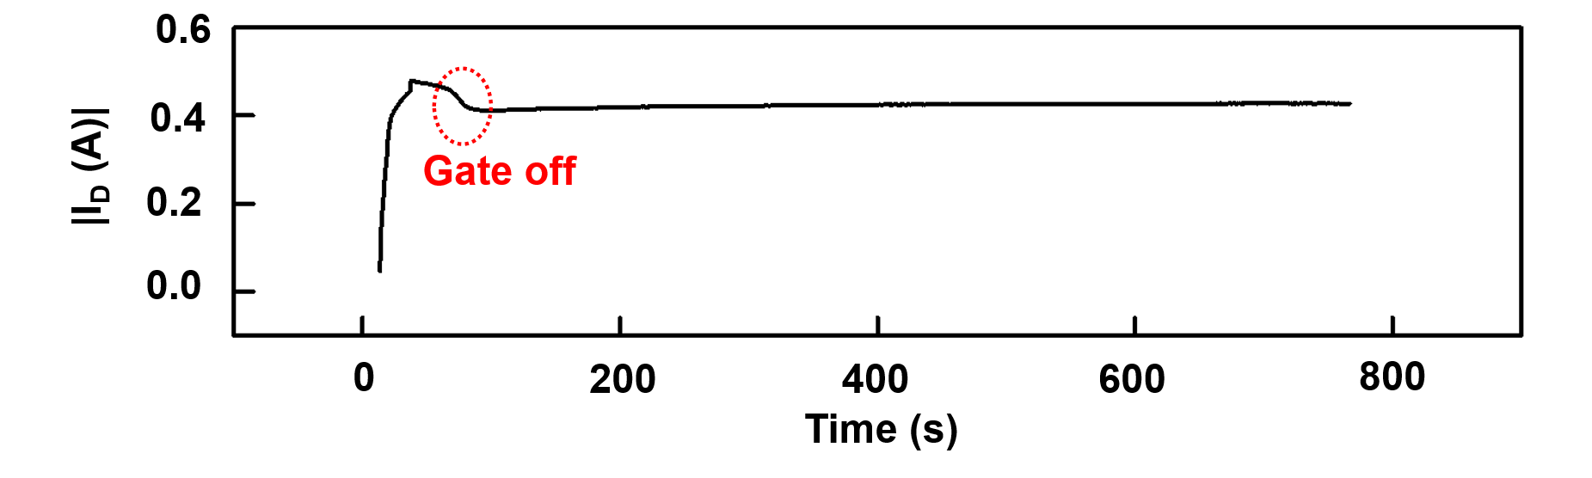
Supplementary Figure 22. The long-term memory characteristics of synaptic-mode OECT.

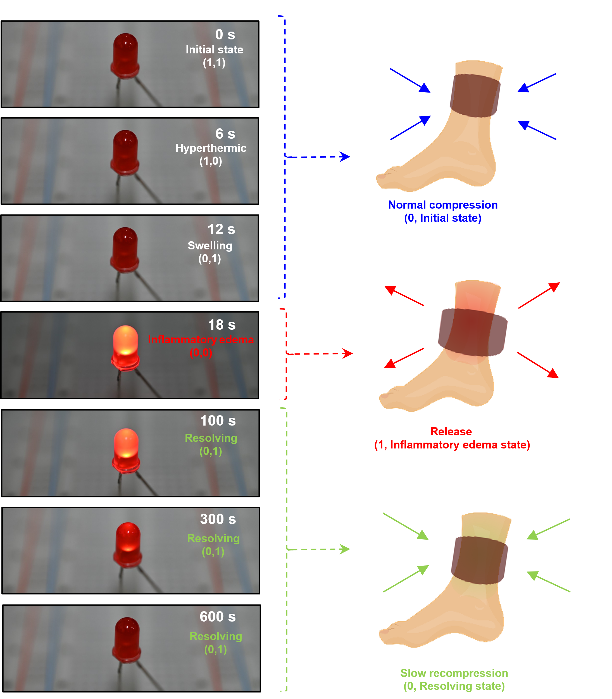
Supplementary Figure 23. Observation of LED response driven by the output signal from the adaptive logic system.

