Supplemental Figures
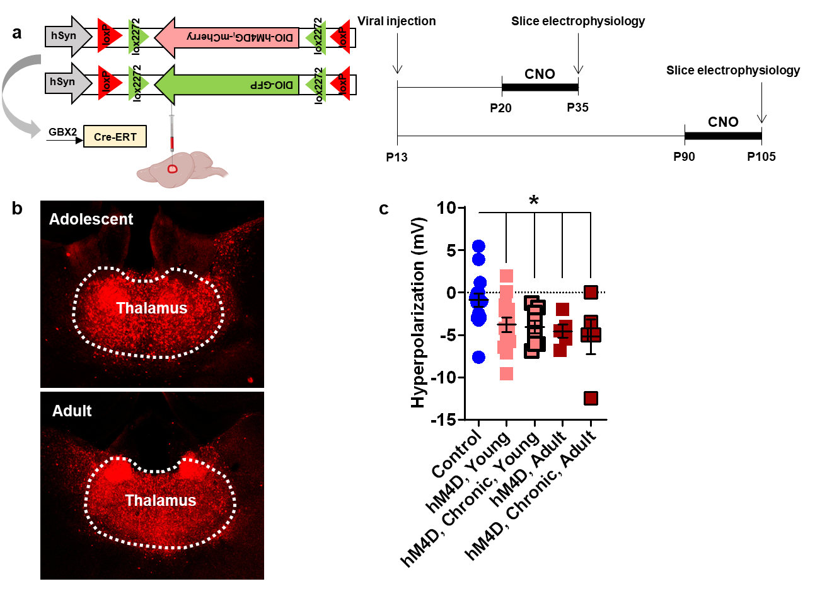
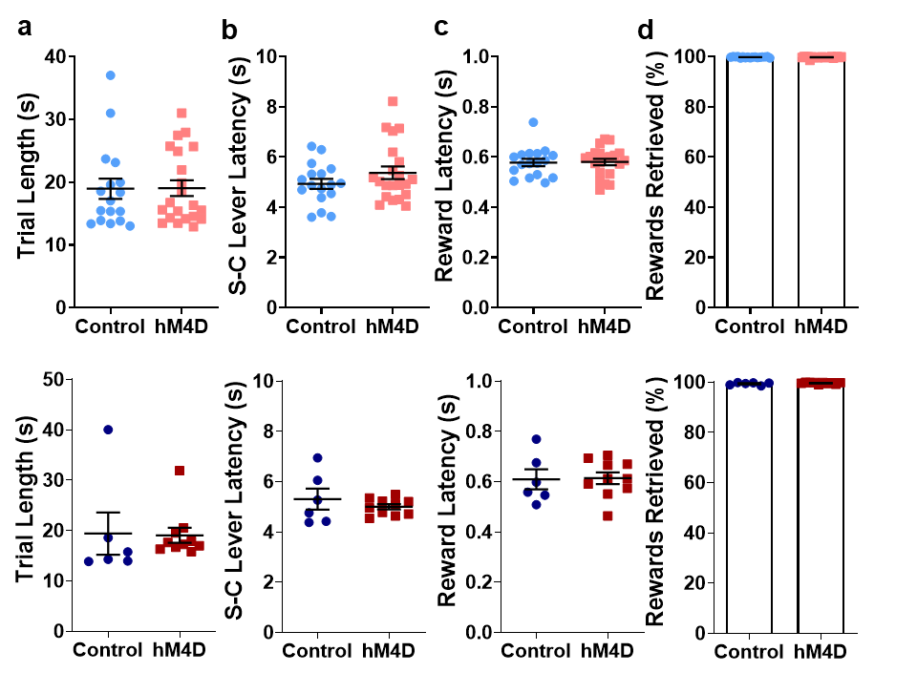
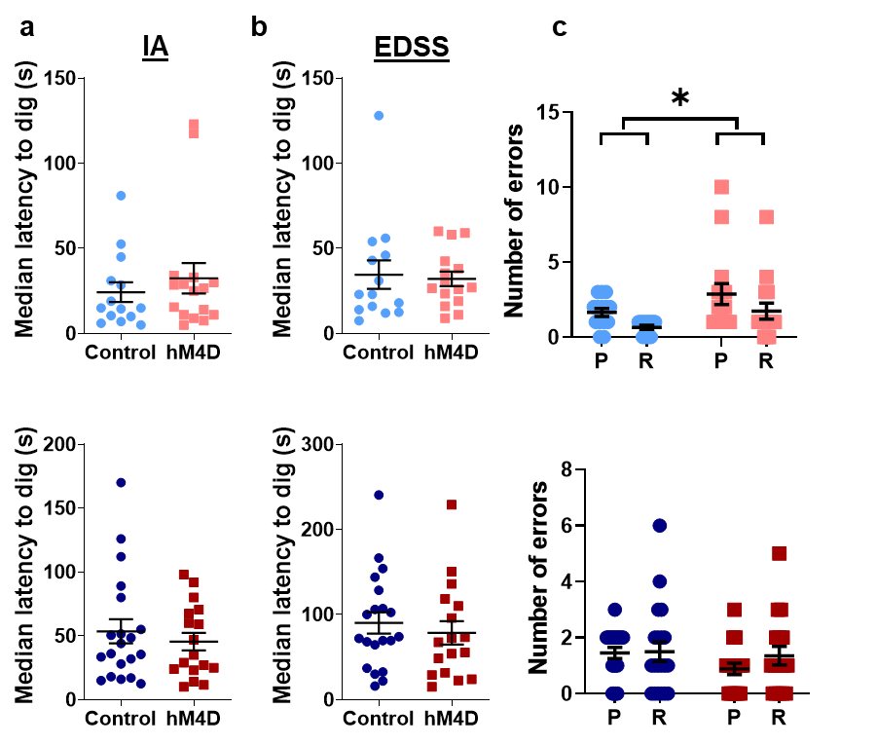
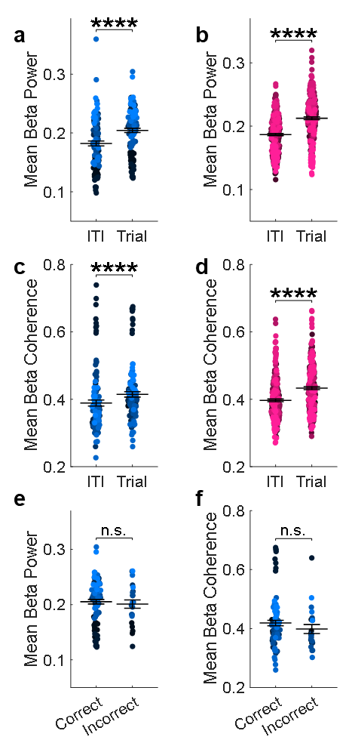
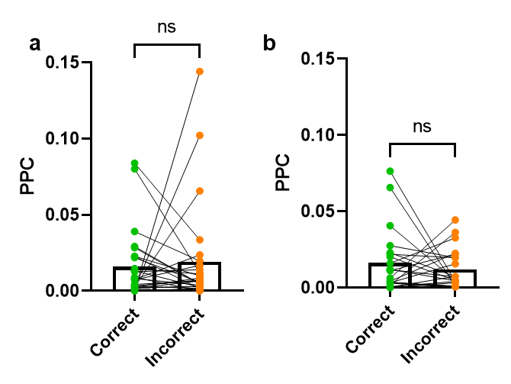
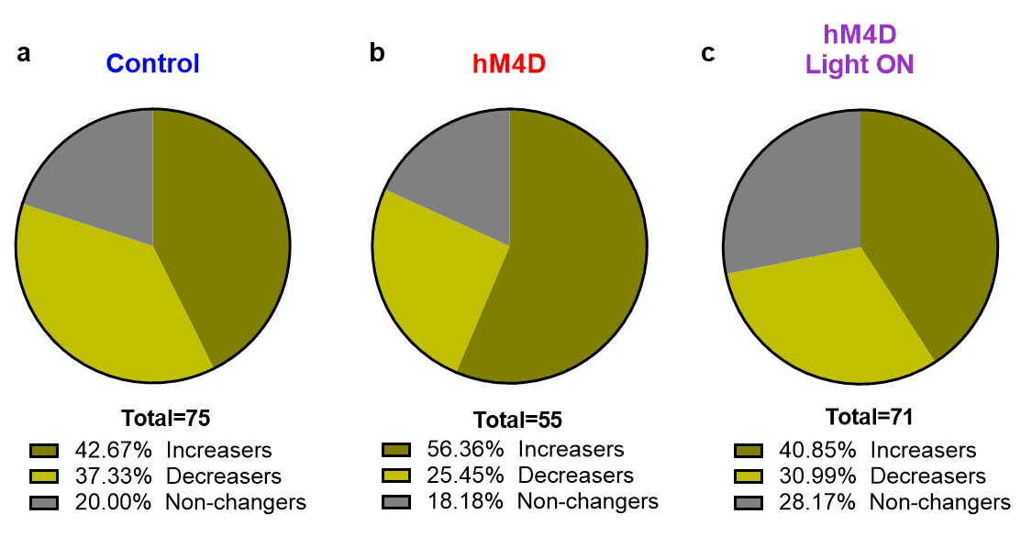
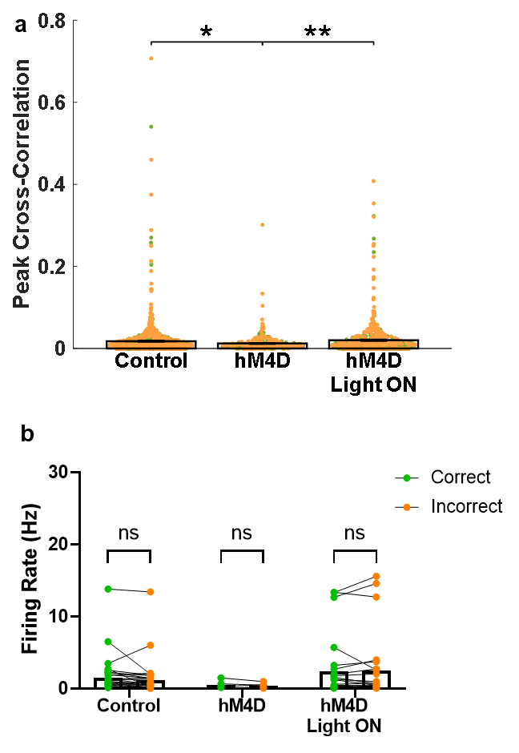
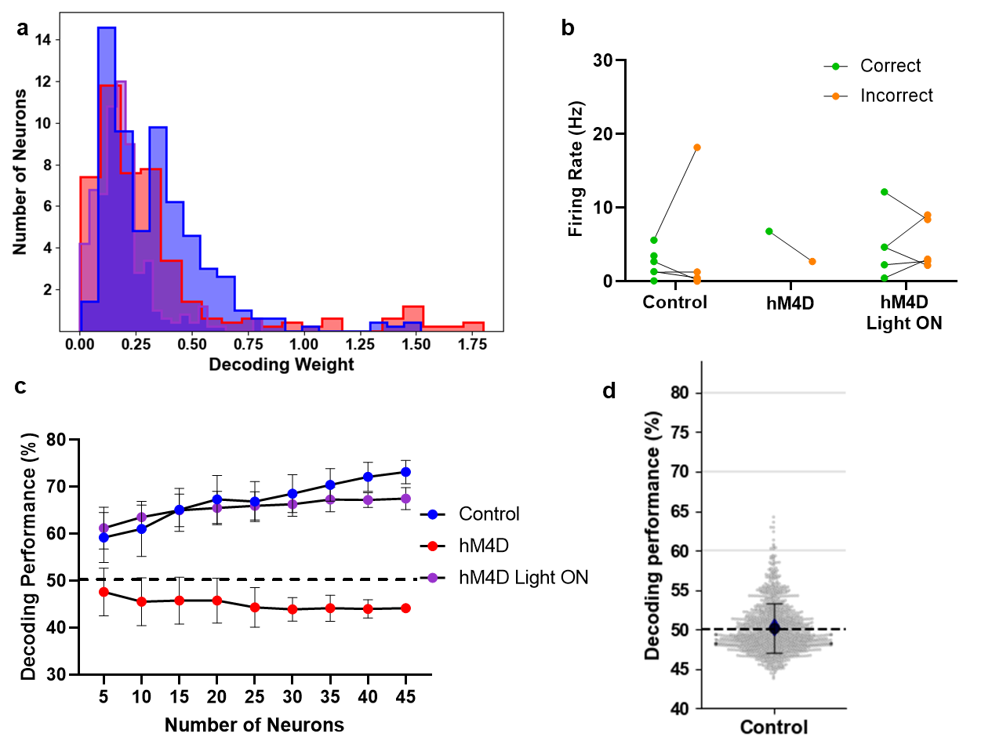
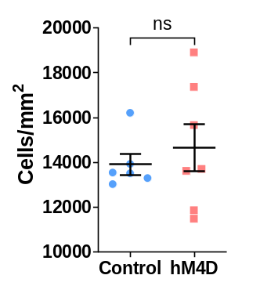
Supplemental Figure 1. A chemogenetic approach to reversibly and chronically inhibit thalamic cells during development or adulthood. (a) Experimental design and timeline. Mice were injected with virus at P13, and whole cell patch clamp recordings were made at P35 or P105 in cells expressing hM4D-mCherry or control, GFP, at baseline and in response to bath application of 10 µM. Animals were either never exposed to CNO prior to perfusion (naïve) or given twice daily 1 mg/kg CNO i.p. injections for two weeks (chronic). (b) Example images illustrating hM4D-mCherry expression in the midline thalamus in adolescent and adult animals. (c) Quantification of CNO-induced hyperpolarization. Control cells at P35 and P105 were pooled because CNO did not show an effect at either age. CNO induced a significant hyperpolarization in both P35 and P105 cells expressing hM4D relative to control cells. Dots indicate individual cell responses and bars indicate mean ± SEM. Control: n=15 cells, 5 animals; hM4D naïve young: n=13 cells, 5 animals; hM4D chronic young: n=8 cells, 3 animals; hM4D naïve adult: n=5 cells, 3 animals; hM4D chronic adult: n=5 cells, 3 animals; 1-way ANOVA, effect of treatment F(4, 41)=3.203, p=0.0223; Holm-Sidak post-hoc, P35 hM4D naïve vs. Control *p=0.0480, P35 hM4D CNO-exposed vs. Control *p=0.0480, P105 hM4D naïve vs. Control *p=0.0480, P105 hM4D CNO-exposed vs. Control *p=0.0366. *p<0.05
Supplemental Figure 2 (associated with Figure 1). In the NMS task, no metrics of mobility or motivation were affected by adolescent (top) or adult (bottom) thalamic inhibition, including (a) mean trial length, Control: 18.94±1.61 s, hM4D: 19.03±1.26 s; unpaired t-test: t=0.04228, df=36, p=0.9665, (b) mean sample lever press-choice lever press latency, Control: 4.932±0.199 s, hM4D: 5.372±0.252 s; unpaired t-test: t=1.321, df=36, p=0.1949, (c) mean latency to collect reward, Control: 0.5781±0.0143 s, hM4D: 0.5801±0.0125 s; unpaired t-test: t=0.1086, df=36, p=0.9141, and (d) percentage of rewards retrieved, Control: 99.78±0.05%, hM4D: 99.71±0.07%; unpaired t-test: t=0.7668, df=36, p=0.4482. Control: n=17; hM4D: n=21. Dots represent individual animals; lines represent mean ± SEM.
Supplemental Figure 3 (associated with Figure 1). In the ASST, no metrics of mobility or motivation were affected by adolescent (top) or adult (bottom) thalamic inhibition, including median latency to dig during (a) IA or (b) SS. (c) Similarly, the breakdown of types of errors during EDSS, perseverative (P) and random (R), was unaffected. Following adolescent inhibition (top), there was an overall effect of the manipulation, with increased numbers of both perseverative and random errors. Following adult inhibition (bottom), there was no change in either type of error. Control: n=14; hM4D: n=15 (16 for IA). Dots represent individual animals; lines represent mean ± SEM. *p<0.05
Supplemental Figure 4. Mean thalamic beta (12-30 Hz) power is specifically enhanced during the EDSS trials compared to the ITI for (a) control (ITI: 0.1822±0.0042; Trial: 0.2044±0.0036; linear mixed effects model: fixed effect (Trial), p=3.2642e-16) and (b) hM4D (hM4D: ITI: 0.1866±0.0018; Trial: 0.2124±0.0022; linear mixed effects model: fixed effect (Trial), p=2.0872e-41) animals. (c) As in (a) except for mean beta (12-30 Hz) mPFC-thalamic coherence (ITI: 0.3890±0.0090; Trial: 0.4146±0.0080; linear mixed effects model: fixed effect (Trial), p=2.0137e-07). (d) As in (b) except for mean beta mPFC-thalamic coherence (0.3968±0.0041; Trial: 0.4331±0.0044; linear mixed effects model: fixed effect (Trial), p=6.7099e-19). (e) Mean thalamic beta power (Correct: 0.2052±0.0041; Incorrect: 0.2011±0.0075; linear mixed effects model: fixed effect (Trial Type), p=0.18827) and (f) beta mPFC-thalamic coherence (Correct: 0.4188±0.0092; Incorrect: 0.3984±0.0152; linear mixed effects model: fixed effect (Trial Type), p=0.72808) are unchanged across trial types in controls. Dots represent individual trials for each animal (colors of the dots). Lines and error represent mean ± SEM. Control: n=10 animals, 88 correct trials, 23 incorrect trials; hM4D: n=15 animals, 177 correct trials, 89 incorrect trials; hM4D Light ON: n=15 animals, 137 correct trials, 41 incorrect trials. ****p<0.0001
Supplemental Figure 5. Pairwise phase consistency (PPC) values show no differences between phase-locking of mPFC cell firing and thalamic beta oscillatory activity in (a) control (Correct PPC: 0.01575±0.00420; Incorrect: 0.01904±0.00642; paired t-test: t=0.4114, df=26, p=0.6841) or (b) hM4D (Correct: 0.01623±0.00441; Incorrect: 0.01205±0.00561; paired t-test: t=0.7443, df=21, p=0.4649) animals. Dots represent individual cells, with lines connecting each cell’s correct and incorrect PPC value. Control: n=6 animals, 27 cells; hM4D: n=7 animals, 22 cells.
Supplemental Figure 6. Breakdown of cells by behavior during the trial compared to the inter-trial interval (ITI), with cells that have a significantly increased firing rate during the trial (increasers), decreased firing rate (decreasers), or unchanged firing rate compared to the ITI (non-changers). This shows a majority of cells modulated during EDSS trials, with (a) 80% modulated in control animals, (b) 81.82% modulated in adolescent-inhibited hM4D animals, and (c) 71.83% modulated in hM4D animals during EDSS thalamic activation.
Supplemental Figure 7 (associated with Figure 6). (a) Un-truncated plot with peak cross-correlations from all cell pairs for control, hM4D, and hM4D light ON groups. Statistics are as represented in the truncated version in Figure 6. Bars and error represent mean ± SEM. (b) Firing rates of cells that had a peak cross-correlation above 0.08 (the cut-off used for the graph in Figure 6). These cells do not show a particular pattern of firing across correct and incorrect trials. Each dot represents cell firing rate for each trial type, lines connecting each cell’s FR for correct and incorrect trials. Control: n=33 cells with peak cross-correlation above 0.08 from 6 animals; hM4D: n=6 cells from 3 animals; hM4D Light ON: n=26 cells from 5 animals.
Supplemental Figure 8 (associated with Figure 6). (a) Histogram of control (blue), hM4D (red), and hM4D Light ON (purple) cell decoding weights show the distribution of the contributions across cells is unchanged across groups, with few cells in each group contributing more than the general population. (b) Firing rates of cells that had a significantly elevated decoding weight relative to the shuffled data. There are very few cells (<10% for each group) that contribute significantly more than when shuffled, and further, these cells do not show a particular pattern of firing across correct and incorrect trials. Each dot represents cell firing rate for each trial type, lines connecting each cell’s FR for correct and incorrect trials. Control: n=7 cells from 3 animals; hM4D: n=1 cell from 1 animal; hM4D Light ON: n=5 cells from 2 animals. (c) The decoder performance was calculated using randomly selected subgroups of neurons, repeated 25 times for each multiple of 5 neurons. Each point represents mean performance for the 25 repetitions of random selection, with error bars representing standard deviation. Significant separation between hM4D and both Control and hM4D Light ON groups is already seen with 5 neurons. Chance performance at 50% shown with the dashed black line. 2-way rmANOVA Holm-Sidak post-hoc for each chunk, analysis with 5 neurons: Control vs. hM4D: p<0.0001, Control vs. hM4D Light ON: p=0.1557, hM4D vs. hM4D Light ON: p<0.0001. (d) Decoding performance (blue diamond) is no better than chance for control animals during the IA portion of the ASST. Black dot and lines represent mean and standard deviation of shuffled decoding performance; grey circles represent individual shuffles. n=3 animals, 47 cells, 1000 shuffles; 50.35%, shuffled data: 50.13±3.14%, p=0.9438.
Supplemental Figure 9 (associated with Figure 3). Thalamic DAPI staining shows no differences in overall cell density in the thalamus for control or hM4D animals. Dots represent individual animals; lines represent mean ± SEM. Control: n=6; hM4D: n=7; Control: 13902±474 cells/mm², hM4D: 14642±1051 cells/mm²; unpaired t-test, t=0.6050, df=11, p=0.5575.

