Additional Figures for

Shallow volcanic earthquakes in the Ōwakudani geothermal area, Hakone volcano, Japan

Ryo Kurihara, Yutaka Nagaoka, Ryou Honda and Kazuhiro Itadera
Corresponding author: Ryo Kurihara (kurihara@onken.odawara.kanagawa.jp)

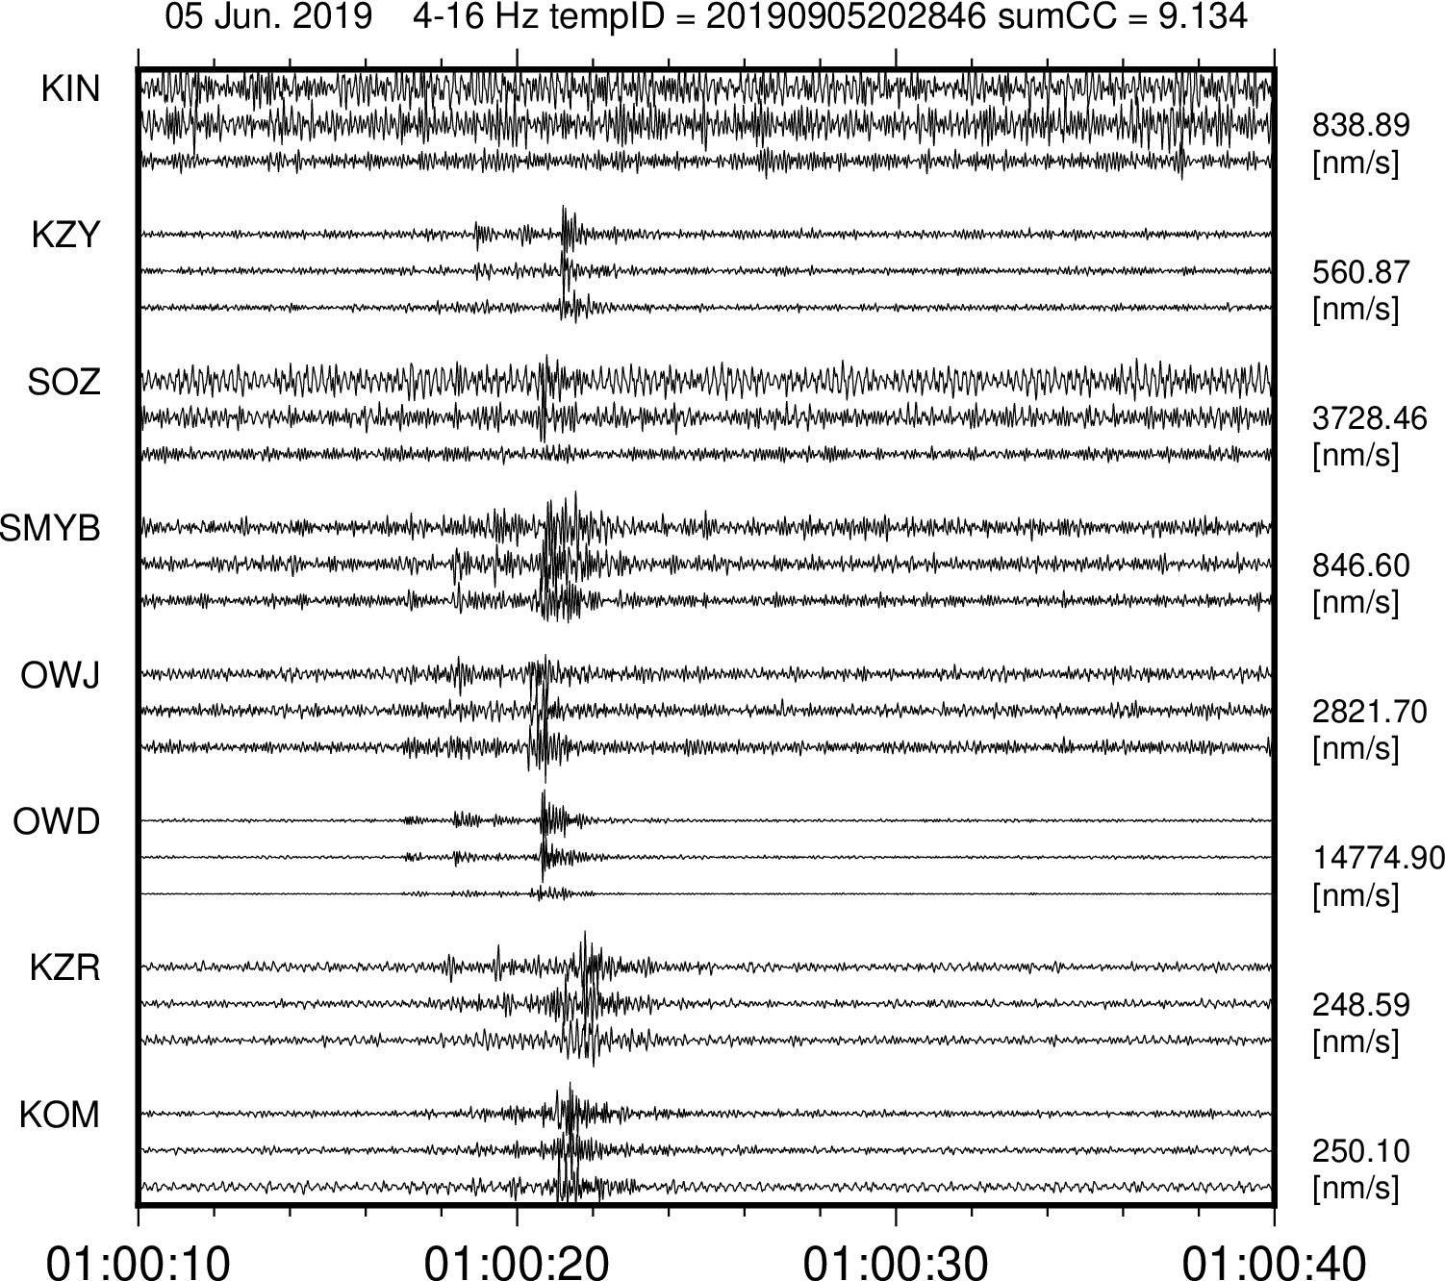

Figure S1. A sample waveform of a detected earthquake occurred in 5 June 2019. 4-16 Hz band-pass filter is applied and the waveforms were normalized by maximum value written in right.
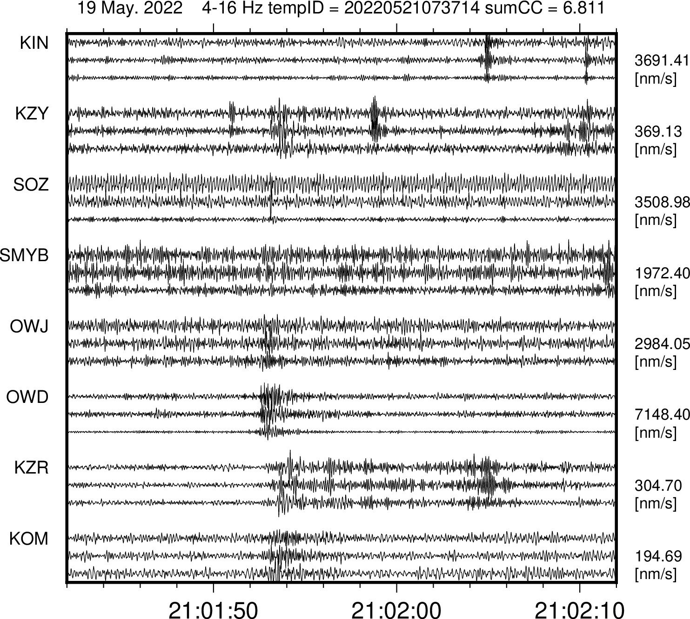
Figure S2. A sample waveform of a detected earthquake occurred in 19 June 2022.

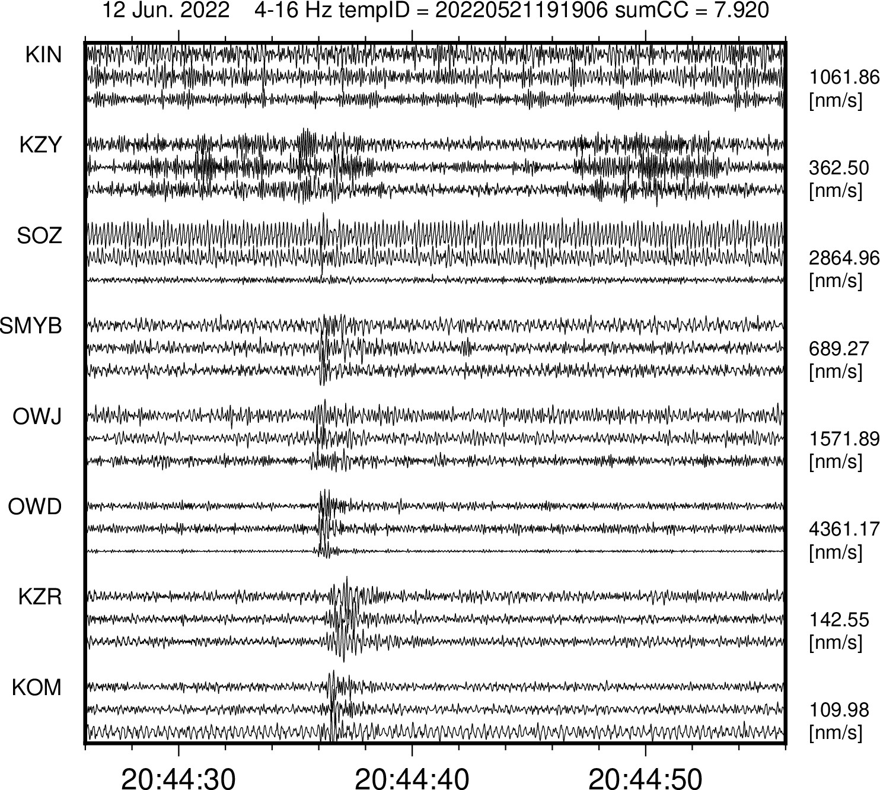
Figure S3. A sample waveform of a detected earthquake occurred in 12 June 2022.

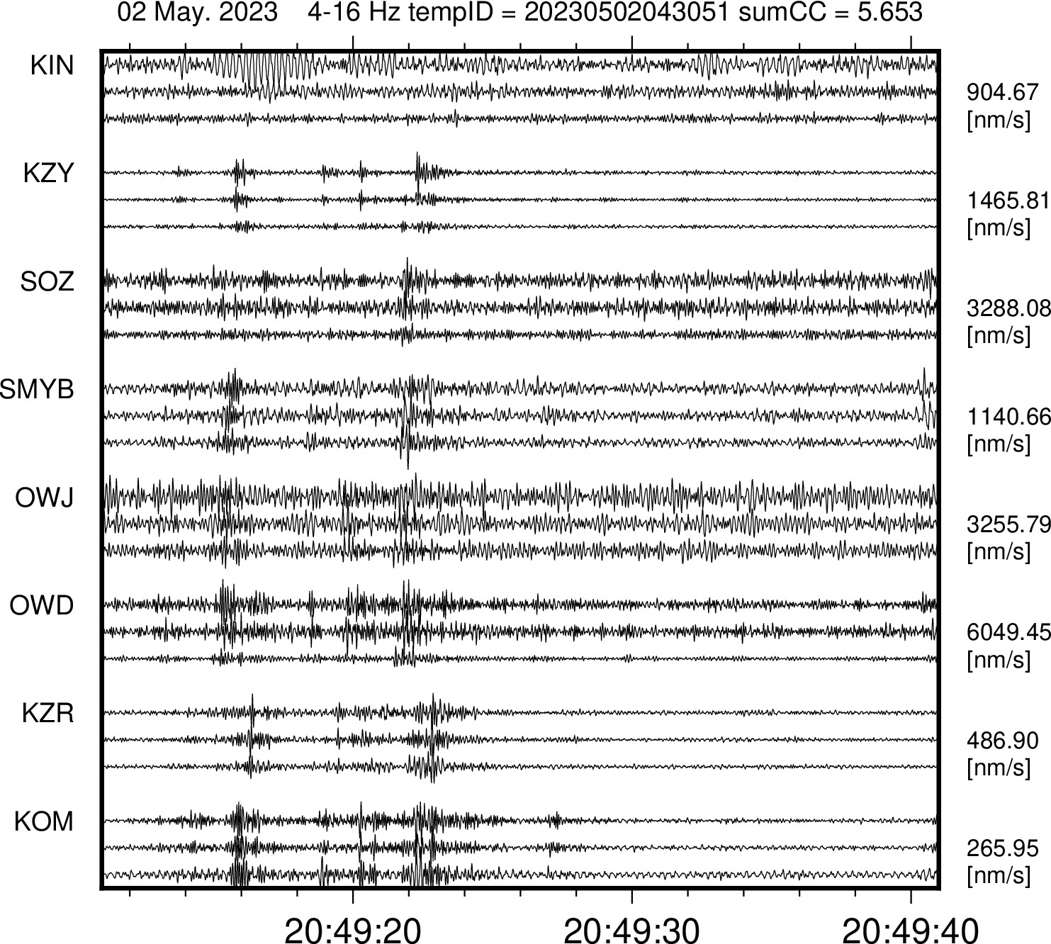
Figure S4. A sample waveform of a detected earthquake occurred in 2 May 2023.

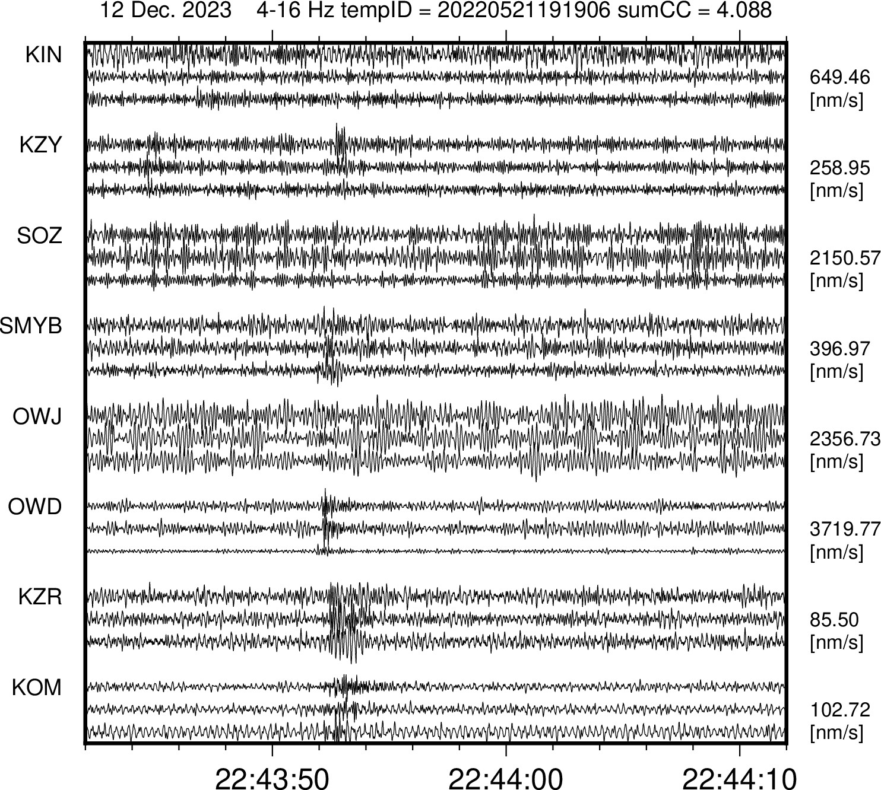
Figure S5. A sample waveform of a detected earthquake occurred in 12 Dec. 2023.

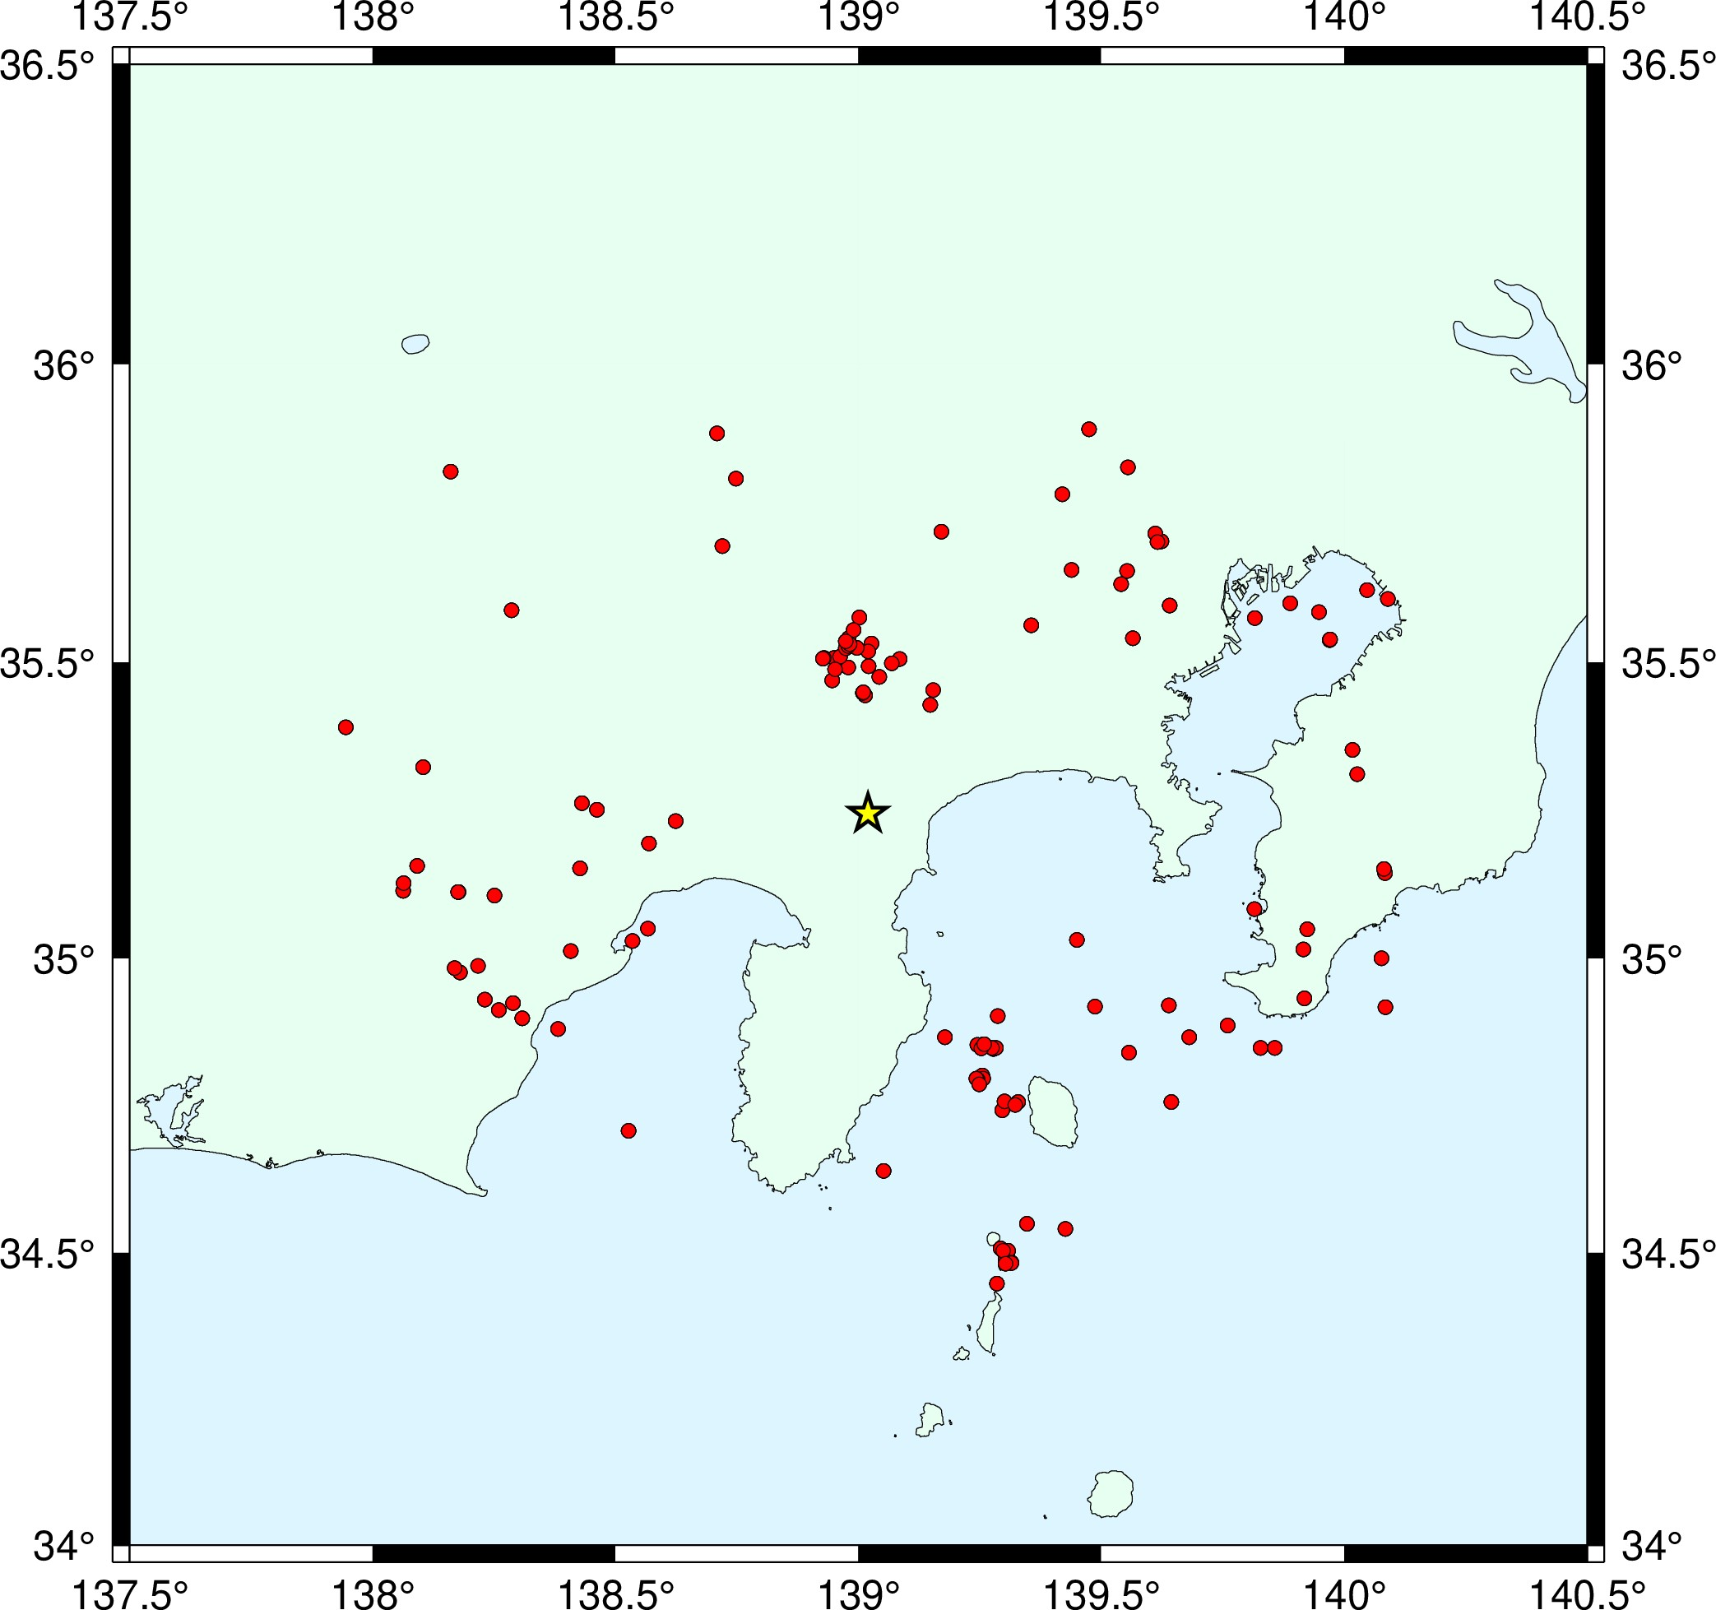
Figure S6. The distribution of the hypocenters of the earthquakes used in the estimation of site amplification factor (Red circles). The yellow star symbol shows the location of the Owakudani geothermal area in Hakone volcano.

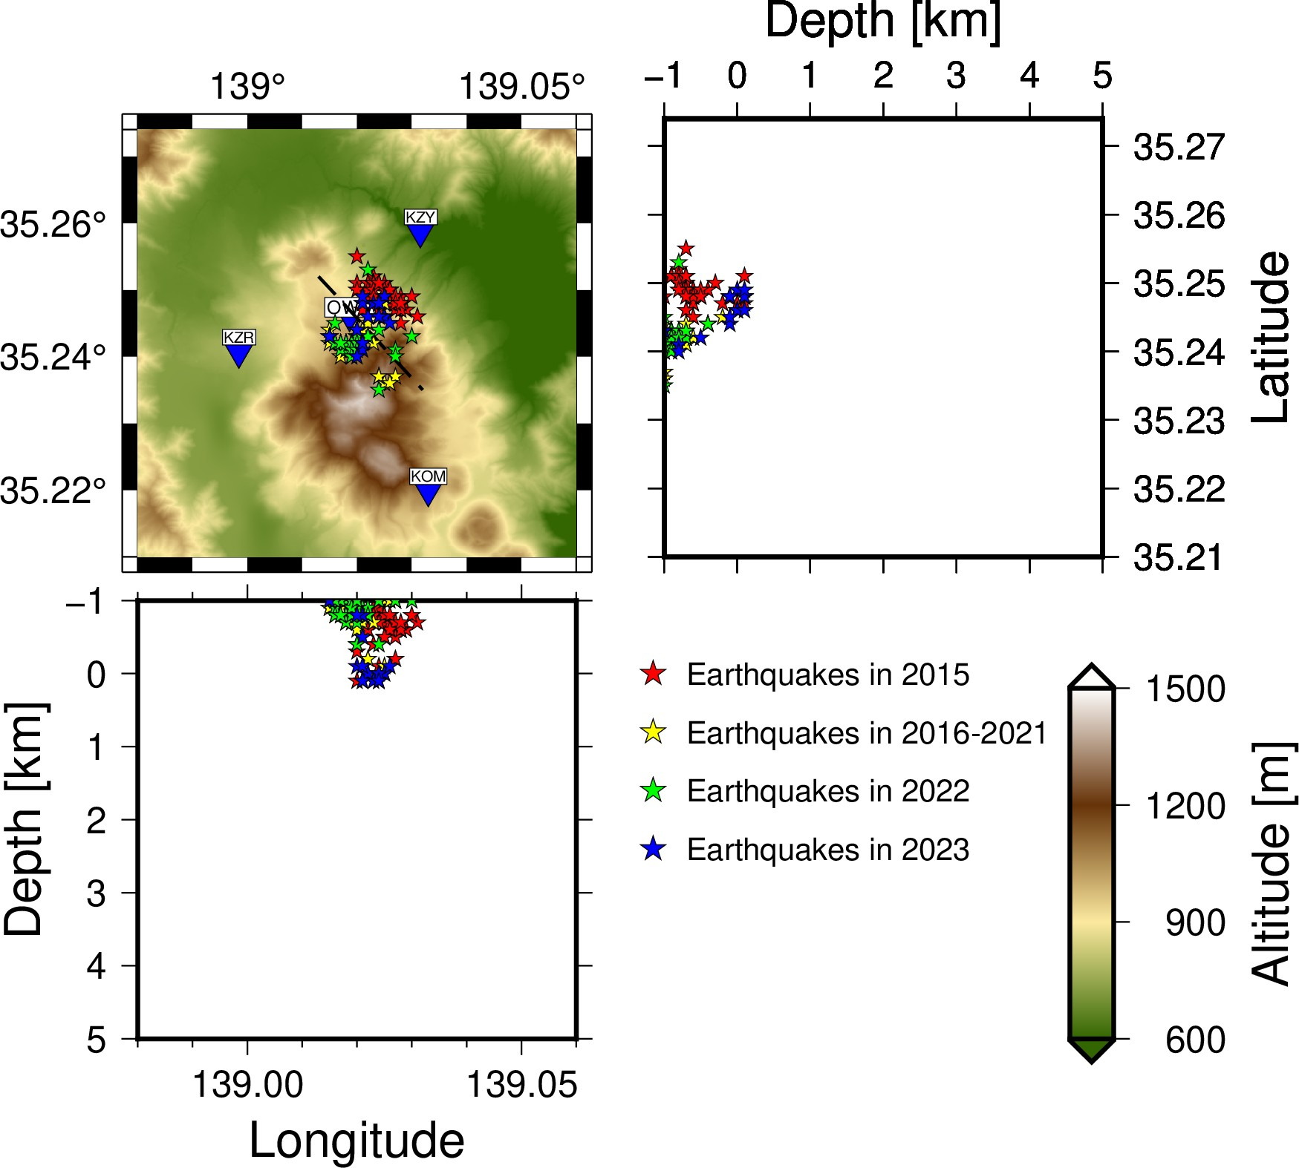
Figure S7. Locations of the hypocenters based on ASL method using only 5 seismic stations.

