Sizing blue carbon risks and benefits from bivalve aquaculture
Supplementary Information

Supplementary Table 1. Global summary statistics of the intersection of bivalve aquaculture with BCEs.
Carbon habitat | Total global extent of habitat (ha) | N countries where bivalve aqua overlaps | Total global area of overlap of modelled farm  footprint (ha) and (N of modelled aquaculture farms  with overlap)
 |  |  | High yield | Low yield | High yield | Low yield
Mangrove | 14,622,352 | 15 | 174  (n = 339) | 24,758  (n = 3,667) | 0.00% | 0.17%
Seagrass | 30,994,241 | 29 | 3,353  (n = 2,486) | 87,202  (n = 3,869) | 0.01% | 0.28%
Tidal flats | 13,203,746 | 37 | 17,449  (n = 21,145) | 304,520  (n = 43,428) | 0.13% | 2.31%
Tidal marshes | 4,459,875 | 18 | 1,118  (n = 1,622) | 30,740  (n = 7,058) | 0.03% | 0.69%
Total | 63,280,214 | 45 | 22,093  (n = 23,598) | 447,220  (n = 46,642) | 0.03% | 0.71%

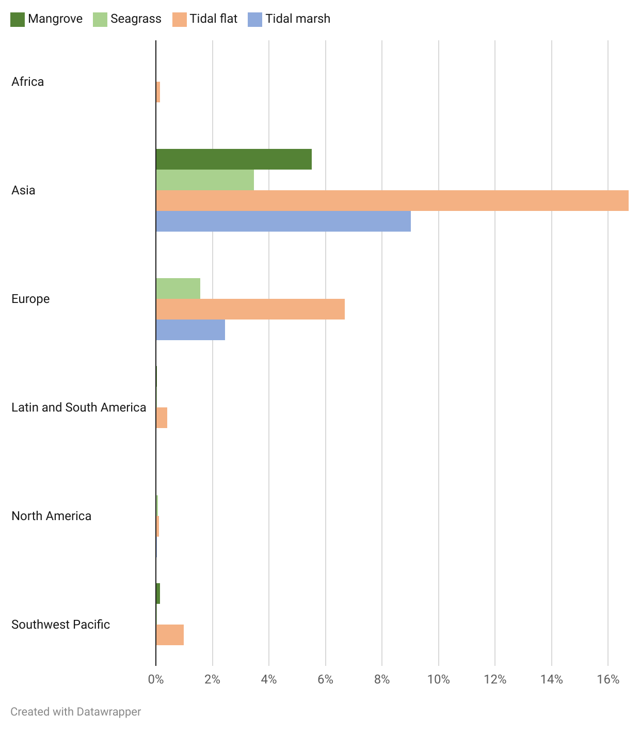
Supplementary Figure 1. Proportion of interaction of modelled farm footprint with key coastal carbon habitats, across all regions with bivalve aquaculture and carbon habitats.

Supplementary Table 2. Countries that have bivalve aquaculture overlapping with carbon habitats and the percentage of habitat this overlap represents.
Country | Mangrove | Seagrass | Tidal Flats | Tidal Marsh
Australia | 0.004% | 0.004% | 0.022% | x
Belgium | x | x | 1.350% | x
Brazil | 0.004% | x | 0.021% | x
Brunei | x | x | 0.270% | x
Cambodia | 0.057% | x | 1.727% | x
Canada | x | 0.011% | 0.014% | 0.006%
Chile | x | x | 0.195% | x
China | 4.565% | 1.372% | 5.384% | 3.063%
Croatia | x | 0.012% | x | x
Cuba | 0.006% | 0.012% | x | x
Denmark | x | 0.021% | x | x
France | x | 0.041% | 1.311% | 0.890%
Germany | x | 0.167% | 0.105% | 0.204%
Greece | x | 0.021% | x | x
India | 0.008% | 0.018% | 0.038% | 0.117%
Indonesia | 0.010% | 0.038% | 0.067% | x
Ireland | x | 0.542% | 0.688% | 0.103%
Italy | x | 0.039% | 0.074% | 0.088%
Japan | x | 0.784% | 1.059% | 0.105%
Malaysia | 0.009% | 0.047% | 0.133% | x
Mexico | 0.003% | 0.003% | 0.034% | x
Netherlands | x | x | 0.930% | 0.977%
New Zealand | 0.138% | x | 0.915% | x
North Korea | x | x | 0.691% | 2.233%
Norway | x | 0.005% | x | x
Peru | x | x | 0.225% | x
Philippines | 0.018% | 0.051% | 0.186% | x
Portugal | x | x | 0.267% | 0.004%
Russia | x | 0.018% | x | 0.003%
Singapore | x | 0.011% | x | x
South Africa | x | x | 0.128% | x
South Korea | x | x | 2.728% | 4.390%
Spain | x | 0.560% | 2.335% | 0.076%
Taiwan | 0.529% | 0.130% | 1.817% | x
Thailand | 0.132% | 0.899% | 1.596% | x
United Kingdom | x | 0.002% | 0.045% | 0.064%
United States | x | 0.030% | 0.040% | 0.026%
Vietnam | 0.166% | x | 0.794% | x

Supplementary Table 3. Indications of aquaculture development interest for countries with spatial extent of carbon habitats but no current production of bivalves.
Country | Primary development mechanism | Bivalve aquaculture development estimate | References | Data source
Saudi Arabia | National aquaculture policy | Moderate | Ministry of Environment Water and Agriculture. (2018). National Aquaculture Policies and Practices. 2nd ed. Kingdom of Saudi Arabia | https://www.mewa.gov.sa/en/InformationCenter/DocsCenter/RulesLibrary/Docs/National%20Aquaculture%20Policies%20and%20Practices.pdf#search=aquaculture
Guinea-Bissau | Strategic plan for socioeconomic development, blue economy strategy | Low | REPÚBLICA DA GUINÉ-BISSAU. (2015). Guiné-Bissau 2025 Plano Estratégico e Operacional 2015-2020 “Terra Ranka”. | https://faolex.fao.org/docs/pdf/gbs176530.pdf
Guinea-Bissau |  | Low | Ministry of Economy, Planning and Regional Integration. 2024. National Blue Economy Strategy and Investment Plan for Guinea Bissau 2024-2030. | https://www.undp.org/guinea-bissau/publications/guinea-bissaus-blue-economy-strategy
Nigeria | National aquaculture strategy, National agricultural policy | Moderate | Federal Ministry of Agriculture and Rural Development. (2008). Nigeria National Aquaculture Strategy. | https://faolex.fao.org/docs/pdf/nig189027.pdf
Nigeria | National aquaculture strategy, National agricultural policy | Moderate | Federal Ministry of Agriculture and Rural Development. (2022). National Agricultural Technology and Innovation Policy (NATIP) 2022-2027 | https://faolex.fao.org/docs/pdf/nig214137.pdf
Guinea | Aquaculture development policy | Moderate | MINISTERE DE LA PECHE ET DE L’AQUACULTURE. 2009. LETTRE DE POLITIQUE DE DEVELOPPEMENT DE LA PECHE ET DE L’AQUACULTURE (LPDPA) | https://faolex.fao.org/docs/pdf/gui158098.pdf
Papua New Guinea | Fisheries strategic plan, aquaculture roadmap | High | Fisheries Strategic Plan 2021-2030 : capitalising the fisheries sector for an inclusive and sustainable broad-based growth. - - [Port Moresby] : Papua New Guinea. National Fisheries Authority, 2021. | https://faolex.fao.org/docs/pdf/png205423.pdf
Papua New Guinea | Fisheries strategic plan, aquaculture roadmap | High | Government of Papua New Guinea. 2017. A Roadmap for coastal fisheries and marine aquaculture for Papua New Guinea: 2017–2026. | https://faolex.fao.org/docs/pdf/png205446.pdf
Myanmar | National aquaculture development plan | Moderate | Ministry of Agriculture, Livestock, and Irrigation. 2020. National Aquaculture Development Plan 2020. | http://www.dof-myanmar-fic.org/Multimedia/Books/57.%20NADP-ENG.pdf
Madagascar | Aquaculture development policies, aquaculture investment guide | High | Ministry of Fisheries and Blue Economy, Union Europeene, FishGov 2 Project, African Union Interafrican Bureau for Animal Resources. 2023. Aligning Madagascar's Fisheries and Aquaculture Development Policies on the Policy Framework and Reform Strategy for African Fisheries and Aquaculture. | https://www.mpeb.mg/wp-content/uploads/2024/03/FINAL-REPORT-OF-PFRS-MADAGASCAR-ALIGNMENT-CONSULTANCY-2023-REVISED-ok-2.pdf
Madagascar |  | High | Ministry of Fisheries and Blue Economy & Economic Development Board. 2024. Aquaculture Investment Guide in Madagascar: A Promising Investment within Reach | https://www.mpeb.mg/wp-content/uploads/2024/07/Guide-dinvestissement-Aquaculture_ANG-1.pdf
Nicaragua | Aquaculture development strategy | Moderate | Instituto Nicaraguense de la Pesca y Acuicultura. 2016. Estrategia de Desarrollo del Sector Pesquero y Acuicola en Nicaragua 2017-2021. | http://www.inpesca.gob.ni/images/Division%20de%20Planificacion/2019/ESTRATEGIA%20DE%20LA%20PESCA%20Y%20ACUICULTURA%202017-2021%20INPESCA.pdf
Bangladesh | Aquaculture development strategy | Moderate | Ministry of Fisheries and Livestock & Food and Agriculture Organization of the United Nations. 2014. National Aquaculture Development Strategy and Action Plan of Bangladesh 2013-2020. | https://faolex.fao.org/docs/pdf/bgd169471.pdf
Ukraine | National aquaculture policy | Moderate | Law No. 5293-VI "On aquaculture". 2013. | https://faolex.fao.org/docs/pdf/ukr124989.pdf

Supplementary Table 4. Global potential impact of bivalve aquaculture on C stocks and sequestration, based on areal extent of interacting bivalve aquaculture farms.
BCE or habitat | Total global habitat extent mapped (ha) | Total global area of overlap of modelled farm footprint (ha) | Storage impact of overlapping habitat (Mg C) | Sequestration impact of overlapping habitat (Mg C yr⁻¹)
Seagrasses | 30,994,241 | 17,863 | 1,975,648 | 21,324
Mangroves | 14,622,352 | 2,227 | 1,057,602 | 3,106
Tidal marshes | 4,459,875 | 6,096 | 1,618,488 | 9,892
Tidal flats | 13,203,746 | 86,555 | 7,469,697 | 113,135
Total | 63,280,214 | 112,741 | 12,121,435 | 147,456

Supplementary Table 5. Regional potential impact of bivalve aquaculture on C stocks and sequestration, based on spatial extent of interacting bivalve aquaculture farms under two scenarios of growth and aquaculture expansion to 2030.
2030 spatial extent under 10% growth scenario

Region | Mangrove |  |  | Seagrass |  |  | Tidal flat |  |  | Tidal marsh
 | Total area (ha) | Storage impact of overlapping habitat (Mg C) | Sequestration impact of overlapping habitat (Mg C yr-1) | Total area (ha) | Storage impact of overlapping habitat (Mg C) | Sequestration impact of overlapping habitat (Mg C yr-1) | Total area (ha) | Storage impact of overlapping habitat (Mg C) | Sequestration impact of overlapping habitat (Mg C yr-1) | Total area (ha) | Storage impact of overlapping habitat (Mg C) | Sequestration impact of overlapping habitat (Mg C yr-1)
AF | 0 | 0 | 0 | 0 | 0 | 0 | 30.107 | 2598.234 | 39.35246 | 0 | 0 | 0
AS | 2254.087 | 1070466 | 3143.455 | 16348.92 | 1808190 | 19516.52 | 86692.12 | 7481530 | 113314.1 | 5062.299 | 1344040 | 8214.296
EU | 0 | 0 | 0 | 2473.416 | 273559.8 | 2952.64 | 6206.409 | 535613.1 | 8112.314 | 1048.124 | 278276.9 | 1700.73
LA_CA_SA | 72.182 | 34279.23 | 100.662 | 124.751 | 13797.46 | 148.9215 | 339.922 | 29335.27 | 444.3075 | 0 | 0 | 0
NA | 37.928 | 18012.01 | 52.89279 | 532.939 | 58943.05 | 636.1959 | 484.231 | 41789.14 | 632.9319 | 594.66 | 157882.2 | 964.92
SWP | 85.866 | 40777.76 | 119.7451 | 169.411 | 18736.86 | 202.2344 | 1457.456 | 125778.5 | 1905.021 | 0 | 0 | 0
Total | 2450.063 | 1163535 | 3416.755 | 19649.43 | 2173227 | 23456.51 | 95210.24 | 8216643 | 124448 | 6705.083 | 1780200 | 10879.95
2030 spatial extent under 50% growth scenario

Region | Mangrove |  |  | Seagrass |  |  | Tidal flat |  |  | Tidal marsh
 | Total area (ha) | Storage impact of overlapping habitat (Mg C) | Sequestration impact of overlapping habitat (Mg C yr-1) | Total area (ha) | Storage impact of overlapping habitat (Mg C) | Sequestration impact of overlapping habitat (Mg C yr-1) | Total area (ha) | Storage impact of overlapping habitat (Mg C) | Sequestration impact of overlapping habitat (Mg C yr-1) | Total area (ha) | Storage impact of overlapping habitat (Mg C) | Sequestration impact of overlapping habitat (Mg C yr-1)
AF | 0 | 0 | 0 | 0 | 0 | 0 | 41.055 | 3543.047 | 53.66244 | 0 | 0 | 0
AS | 3073.755 | 1459726 | 4286.529 | 22293.98 | 2465714 | 26613.43 | 118216.5 | 10202087 | 154519.2 | 6903.135 | 1832782 | 11201.31
EU | 0 | 0 | 0 | 3372.84 | 373036.1 | 4026.328 | 8463.285 | 730381.5 | 11062.25 | 1429.26 | 379468.5 | 2319.177
LA_CA_SA | 98.43 | 46744.41 | 137.2663 | 170.115 | 18814.72 | 203.0748 | 463.53 | 40002.64 | 605.8739 | 0 | 0 | 0
NA | 51.72 | 24561.83 | 72.12653 | 726.735 | 80376.89 | 867.5399 | 660.315 | 56985.18 | 863.0889 | 810.9 | 215294 | 1315.8
SWP | 117.09 | 55606.04 | 163.2888 | 231.015 | 25550.26 | 275.7742 | 1987.44 | 171516.1 | 2597.756 | 0 | 0 | 0
Total | 3340.995 | 1586639 | 4659.211 | 26794.68 | 2963492 | 31986.15 | 129832.1 | 11204514 | 169701.9 | 9143.295 | 2427545 | 14836.29

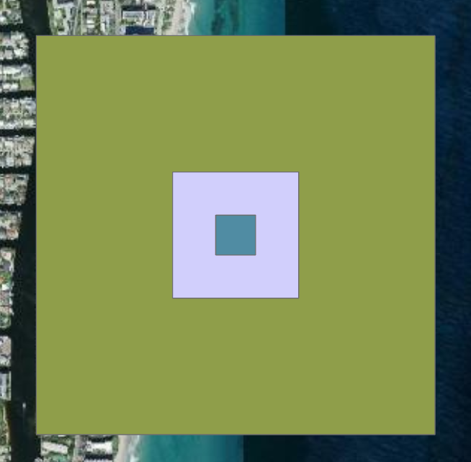
Supplementary Figure 2. Example of changes in farm footprint associated with sensitivity in yield, based on low (3.5 t ha⁻¹ yr⁻¹), mean (35 t ha⁻¹ yr⁻¹) and high yield (350 t ha⁻¹ yr⁻¹).

Supplementary Table 6. Global habitat datasets and sources utilized in the analyses.
Data Layer | Year | Reference | Data Source
Global distribution of seagrasses (version 7.1) | 2021 | UNEP-WCMC, Short FT 2021 | https://data-gis.unep-wcmc.org/portal/home/item.html?id=aaa46cd3d3d640b2916b8f0a0ffe07cb
Global Mangrove Watch (1996 - 2020) Version 3.0 Dataset | 2020 | Bunting et al. 2020 | https://zenodo.org/records/6894273
The distribution of global tidal marshes from earth observation data | 2020 | Worthington et al. 2023 | https://zenodo.org/records/8420753
High-resolution global maps of tidal flat ecosystems. Version 1.2 | 1999 - 2019 | Murray et al. 2022 | https://www.globalintertidalchange.org/data-viewer

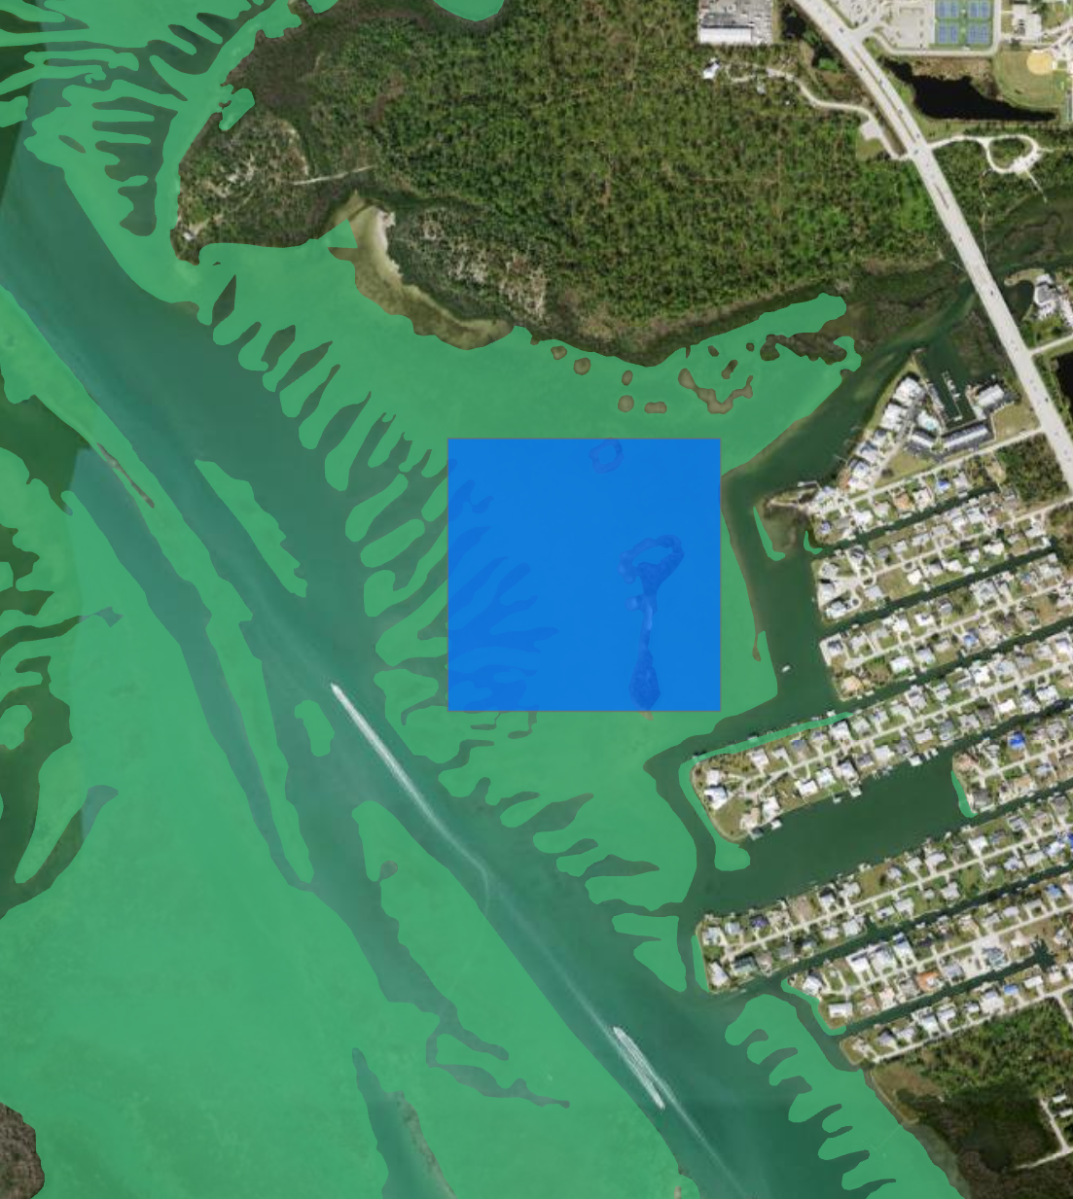
Supplementary Figure 3. Example of overlap with seagrass habitat and 4 hectare modeled farm footprint, Western Florida, USA.

