SUPPLEMENTARY INFORMATION
Additional File 1
Supplement to:
Jeannette Avila, Adrián Vásquez-Mejía, Gabriela Soto-Cabezas, Mary Reyes, Nancy Olivares, Lorena Talavera-Romero, Antonio Sanhueza, Cesar V. Munayco, Oscar J. Mujica. Neonatal mortality inequalities in Peru, 2007-2021: an ecological joinpoint trends analysis.

Table of content:

Table S1. Epidemiological characteristics of neonatal deaths, by year; Peru, 2012-2021. 2
Table S2. Neonatal mortality rate per 1,000 live births by political administrative region and year; Peru, 2007-2021. 3
Table S3. Summary measures of cross-region inequality in neonatal mortality by social stratifier and year (95% confidence interval); Peru, 2007-2021. 4
Table S4. Quartile distribution gradients and inequality gaps over time in contextual variables; Peru, 2012-2021. 5
Table S5. Quartile distribution gradients and inequality gaps over time in epidemiological characteristics variables; Peru, 2012-2021. 6
Figure S1. Neonatal mortality (rate per 1,000 live births) time trends (LOESS smoothing with span = 0.5) by political administrative region; Peru, 2007–2021 7
Figure S2. Joinpoint regression time trends of selected social determinants; Peru, 2007-2021. 8
Figure S3. Cross-regional gradients and concentration curves of inequality in neonatal mortality; Peru, 2019-2021. 9
Figure S4. Temporal correlation between neonatal mortality cross-region absolute (SII) inequality and selected social determinants; Peru, 2007-2021. 10
Figure S5. Temporal correlation between neonatal mortality cross-region relative (CIx) inequality and selected social determinants; Peru, 2007-2021. 11

Table S1. Epidemiological characteristics of neonatal deaths, by year; Peru, 2012-2021.

Epidemiological characteristics | 2012 | 2013 | 2014 | 2015 | 2016 | 2017 | 2018 | 2019 | 2020 | 2021 | χ² test of  independence | p value
Epidemiological characteristics | (n=3,599) | (n=3,692) | (n=3,588) | (n=3,275) | (n=3,295) | (n=3,153) | (n=3,229) | (n=3,037) | (n=2,975) | (n=2,965) | χ² test of  independence | p value
Cause of death |  |  |  |  |  |  |  |  |  |  | 189.252 | <0.001
Prematurity-immaturity | 26.8% | 22.0% | 23.9% | 26.4% | 26.8% | 25.2% | 25.8% | 28.8% | 28.4% | 26.5%
Prematurity-immaturity | (962) | (810) | (855) | (860) | (883) | (796) | (833) | (875) | (844) | (786)
Lethal congenital malformation | 12.4% | 14.9% | 14.9% | 13.8% | 14.1% | 16.9% | 16.8% | 15.5% | 14.4% | 16.4%
Lethal congenital malformation | (446) | (547) | (534) | (451) | (466) | (533) | (541) | (470) | (429) | (485)
Infections | 18.4% | 19.3% | 19.1% | 19.1% | 19.6% | 18.5% | 19.0% | 16.8% | 17.8% | 14.8%
Infections | (658) | (711) | (683) | (622) | (645) | (584) | (612) | (511) | (530) | (438)
Asphyxia and related causes | 21.0% | 21.9% | 19.3% | 19.8% | 18.5% | 19.1% | 17.0% | 17.8% | 16.3% | 17.7%
Asphyxia and related causes | (754) | (803) | (690) | (646) | (608) | (601) | (548) | (540) | (484) | (523)
Other causes | 21.3% | 21.9% | 22.7% | 21.0% | 21.0% | 20.3% | 21.5% | 21.1% | 23.1% | 24.7%
Other causes | (765) | (804) | (812) | (684) | (693) | (639) | (695) | (641) | (688) | (731)
Sex |  |  |  |  |  |  |  |  |  |  | 8.800 | 0.45592
Female | 42.2% | 43.1% | 42.7% | 42.2% | 43.3% | 44.1% | 43.9% | 44.0% | 44.8% | 43.8%
Female | (1,510) | (1,590) | (1,530) | (1,379) | (1,425) | (1,388) | (1,414) | (1,334) | (1,330) | (1,296)
Male | 57.8% | 56.9% | 57.3% | 57.8% | 56.7% | 55.9% | 56.1% | 56.0% | 55.2% | 56.2%
Male | (2,069) | (2,099) | (2,052) | (1,891) | (1,869) | (1,758) | (1,808) | (1,700) | (1,640) | (1,665)
Place of birth |  |  |  |  |  |  |  |  |  |  | 272.638 | <0.001
Home birth | 14.2% | 14.3% | 11.9% | 9.9% | 8.1% | 7.8% | 8.8% | 6.9% | 7.3% | 7.5%
 | (510) | (528) | (426) | (323) | (268) | (247) | (283) | (209) | (218) | (222)
Institutional birth | 85.8% | 85.7% | 88.1% | 90.1% | 91.9% | 92.2% | 91.2% | 93.1% | 92.7% | 92.5%
 | (3,089) | (3,164) | (3,162) | (2,950) | (3,022) | (2,900) | (2,945) | (2,826) | (2,751) | (2,734)
Place of death |  |  |  |  |  |  |  |  |  |  | 237.658 | <0.001
Community | 14.4% | 15.7% | 13.2% | 11.1% | 9.9% | 9.9% | 9.6% | 8.7% | 7.5% | 7.9%
Community | (517) | (578) | (473) | (362) | (325) | (312) | (311) | (263) | (224) | (233)
Institutional | 85.6% | 84.3% | 86.8% | 88.9% | 90.1% | 90.1% | 90.4% | 91.3% | 92.5% | 92.1%
Institutional | (3,082) | (3,114) | (3,115) | (2,910) | (2,964) | (2,840) | (2,916) | (2,769) | (2,745) | (2,721)
Preterm birth |  |  |  |  |  |  |  |  |  |  | 160.045 | <0.001
Not preterm [37+ weeks) | 36.2% | 36.1% | 33.9% | 32.1% | 30.4% | 31.5% | 32.1% | 29.3% | 33.0% | 31.9%
Not preterm [37+ weeks) | (1,302) | (1,332) | (1,218) | (1,052) | (1,001) | (993) | (1,036) | (891) | (982) | (945)
Late preterm [32-36 weeks) | 29.7% | 29.2% | 28.4% | 29.8% | 29.0% | 28.3% | 27.8% | 27.4% | 27.0% | 25.7%
Late preterm [32-36 weeks) | (1,068) | (1,077) | (1,019) | (975) | (954) | (892) | (899) | (831) | (803) | (763)
Very preterm [28-32 weeks) | 16.9% | 18.9% | 19.9% | 19.1% | 20.5% | 19.2% | 20.0% | 20.5% | 19.6% | 19.7%
Very preterm [28-32 weeks) | (609) | (698) | (715) | (626) | (676) | (604) | (646) | (624) | (582) | (583)
Extremely preterm (<28 weeks) | 17.2% | 15.8% | 17.7% | 19.0% | 20.2% | 21.2% | 20.2% | 22.8% | 20.4% | 22.7%
Extremely preterm (<28 weeks) | (620) | (585) | (636) | (622) | (664) | (664) | (648) | (691) | (608) | (674)
Weight at birth |  |  |  |  |  |  |  |  |  |  | 142.163 | <0.001
Normal (2,500+ grams) | 35.8% | 34.6% | 32.8% | 32.9% | 30.1% | 31.8% | 32.2% | 29.0% | 33.3% | 32.2%
Normal (2,500+ grams) | (1,287) | (1,276) | (1,176) | (1,078) | (991) | (1,004) | (1,041) | (881) | (992) | (954)
Low weight (1,500 - 2,499 grams) | 27.5% | 27.7% | 28.0% | 25.7% | 26.6% | 25.0% | 25.2% | 26.4% | 25.6% | 24.3%
Low weight (1,500 - 2,499 grams) | (988) | (1,024) | (1,004) | (843) | (876) | (789) | (815) | (801) | (763) | (720)
Very low weight (1,000 - 1,499 grams) | 17.6% | 18.1% | 18.3% | 18.2% | 19.2% | 17.9% | 17.7% | 17.9% | 17.8% | 18.3%
Very low weight (1,000 - 1,499 grams) | (632) | (670) | (657) | (597) | (631) | (563) | (571) | (545) | (531) | (542)
Extremely low weight (<1,000 grams) | 19.2% | 19.6% | 20.9% | 23.1% | 24.2% | 25.3% | 24.8% | 26.7% | 23.2% | 25.3%
Extremely low weight (<1,000 grams) | (692) | (722) | (751) | (757) | (797) | (797) | (802) | (810) | (698) | (749)

Table S2. Neonatal mortality rate per 1,000 live births by political administrative region and year; Peru, 2007-2021.

Region | 2007 | 2008 | 2009 | 2010 | 2011 | 2012 | 2013 | 2014 | 2015 | 2016 | 2017 | 2018 | 2019 | 2020 | 2021
Amazonas | 15.5 | 15.6 | 14.0 | 13.0 | 13.3 | 12.4 | 10.6 | 11.4 | 13.9 | 10.4 | 11.6 | 12.3 | 10.7 | 12.1 | 12.8
Ancash | 11.5 | 11.7 | 11.0 | 10.3 | 11.0 | 13.0 | 12.3 | 11.9 | 11.9 | 11.2 | 9.9 | 10.6 | 9.6 | 8.7 | 9.6
Apurimac | 11.2 | 11.7 | 10.6 | 8.1 | 8.9 | 9.2 | 8.7 | 11.5 | 12.4 | 11.3 | 12.7 | 13.5 | 9.8 | 12.0 | 12.5
Arequipa | 8.5 | 9.1 | 8.2 | 8.6 | 7.5 | 8.2 | 7.5 | 7.5 | 7.4 | 6.2 | 7.6 | 6.5 | 6.2 | 6.6 | 7.8
Ayacucho | 11.8 | 14.0 | 14.0 | 12.2 | 12.7 | 11.8 | 11.1 | 10.1 | 9.6 | 10.0 | 12.9 | 11.0 | 12.3 | 12.8 | 12.7
Cajamarca | 12.2 | 9.5 | 9.7 | 10.2 | 7.9 | 10.3 | 9.3 | 9.5 | 8.6 | 9.9 | 10.0 | 11.2 | 10.1 | 11.4 | 10.0
Callao | 5.8 | 6.6 | 5.0 | 6.1 | 7.0 | 5.7 | 6.6 | 6.9 | 5.6 | 5.1 | 5.9 | 6.1 | 4.4 | 5.3 | 5.1
Cusco | 13.0 | 14.5 | 15.2 | 14.9 | 13.8 | 14.2 | 12.0 | 10.6 | 13.3 | 13.3 | 13.6 | 12.3 | 12.2 | 14.5 | 12.2
Huancavelica | 13.9 | 17.9 | 16.0 | 17.8 | 14.6 | 18.0 | 17.4 | 20.8 | 20.1 | 18.0 | 17.5 | 19.8 | 20.5 | 18.3 | 21.4
Huanuco | 11.4 | 13.7 | 11.2 | 13.4 | 14.1 | 12.1 | 13.2 | 10.6 | 9.6 | 11.9 | 12.7 | 12.4 | 13.6 | 12.2 | 10.3
Ica | 5.7 | 7.9 | 7.2 | 7.7 | 5.6 | 6.6 | 6.7 | 5.1 | 4.6 | 5.1 | 5.4 | 5.7 | 4.9 | 5.3 | 4.6
Junin | 14.3 | 13.4 | 11.7 | 13.7 | 13.7 | 12.2 | 11.9 | 13.3 | 12.9 | 11.8 | 11.3 | 10.8 | 9.5 | 10.7 | 10.3
La Libertad | 7.1 | 7.6 | 9.4 | 8.4 | 8.0 | 7.1 | 7.4 | 6.8 | 7.3 | 6.7 | 6.9 | 6.2 | 6.1 | 6.4 | 7.6
Lambayeque | 9.8 | 12.0 | 11.2 | 11.2 | 10.4 | 10.0 | 8.8 | 10.1 | 8.6 | 8.5 | 10.1 | 7.9 | 9.1 | 8.6 | 8.5
Lima | 7.9 | 7.6 | 8.3 | 8.3 | 8.1 | 7.4 | 7.2 | 6.9 | 7.1 | 6.6 | 7.0 | 7.5 | 6.7 | 6.4 | 6.4
Loreto | 12.8 | 12.7 | 10.2 | 11.7 | 12.6 | 11.0 | 5.9 | 6.8 | 7.6 | 5.8 | 11.6 | 9.6 | 9.5 | 9.4 | 8.9
Madre de Dios | 18.2 | 20.4 | 14.4 | 12.9 | 15.5 | 12.9 | 14.3 | 12.2 | 11.4 | 10.6 | 9.9 | 8.8 | 12.8 | 12.3 | 11.0
Moquegua | 8.2 | 9.0 | 7.0 | 5.3 | 7.2 | 7.3 | 6.6 | 4.0 | 9.1 | 5.8 | 8.3 | 9.4 | 7.2 | 6.2 | 6.5
Pasco | 12.6 | 10.5 | 7.7 | 11.1 | 10.4 | 10.0 | 12.0 | 14.4 | 12.1 | 15.5 | 14.3 | 13.1 | 13.2 | 16.8 | 13.7
Piura | 11.7 | 11.9 | 12.8 | 11.2 | 12.7 | 11.4 | 9.4 | 9.9 | 9.6 | 7.8 | 11.4 | 10.2 | 10.2 | 9.3 | 9.3
Puno | 12.6 | 12.6 | 13.2 | 12.4 | 14.6 | 13.0 | 12.6 | 12.6 | 13.1 | 14.0 | 14.0 | 14.6 | 15.3 | 15.1 | 14.4
San Martin | 8.8 | 11.1 | 11.9 | 9.7 | 12.1 | 9.4 | 9.2 | 8.7 | 8.0 | 8.3 | 10.2 | 9.8 | 9.6 | 8.9 | 9.7
Tacna | 9.5 | 10.4 | 11.7 | 10.6 | 9.8 | 9.5 | 8.9 | 7.6 | 9.0 | 7.7 | 7.0 | 7.3 | 6.9 | 9.2 | 7.0
Tumbes | 8.1 | 8.1 | 9.2 | 9.5 | 8.7 | 7.1 | 9.4 | 8.6 | 7.7 | 7.4 | 7.8 | 5.4 | 6.9 | 6.3 | 8.5
Ucayali | 12.5 | 13.0 | 12.7 | 11.3 | 12.1 | 10.0 | 10.0 | 9.5 | 9.6 | 7.2 | 7.0 | 7.9 | 7.3 | 5.1 | 7.4

Table S3. Summary measures of cross-region inequality in neonatal mortality by social stratifier and year (95% confidence interval); Peru, 2007-2021.
Year | Monetary poverty |  |  | Unmet basic needs |  |  | Food insecurity
Year | SII | CIx |  | SII | CIx |  | SII | CIx
2007 | -6.2 | -11.5 |  | -6.9 | -11.1 |  | -6.2 | -11.0
2007 | [-8.9;-3.6] | [-14.1;-7.4] |  | [-9.3;-4.5] | [-15.1;-5.0] |  | [-8.1;-4.3] | [-13.4;-7.1]
2008 | -6.0 | -11.7 |  | -7.1 | -11.4 |  | -6.3 | -11.1
2008 | [-9.3;-2.7] | [-16.3;-7.5] |  | [-9.8;-4.4] | [-15.1;-5.1] |  | [-9.1;-3.6] | [-16;-4.5]
2009 | -5.3 | -9.5 |  | -5.0 | -7.9 |  | -3.6 | -7.2
2009 | [-8.1;-2.5] | [-13.6;-4.8] |  | [-8.2;-1.8] | [-11.8;-3.1] |  | [-6.9;-0.3] | [-13.6;-2]
2010 | -6.1 | -10.0 |  | -5.5 | -8.7 |  | -4.9 | -8.5
2010 | [-8.4;-3.8] | [-13.3;-4.6] |  | [-7.9;-3.0] | [-12.8;-3.4] |  | [-7.5;-2.4] | [-13.9;-4.5]
2011 | -4.3 | -8.6 |  | -6.1 | -10.1 |  | -3.1 | -6.4
2011 | [-8.0;-0.6] | [-13.6;-1.0] |  | [-8.2;-3.9] | [-14.2;-5.4] |  | [-6.5;0.3] | [-12;1.7]
2012 | -5.1 | -10.5 |  | -5.7 | -9.8 |  | -2.8 | -5.6
2012 | [-7.8;-2.5] | [-15.9;-5.7] |  | [-8.5;-3.0] | [-13.9;-3.0] |  | [-5.5;-0.1] | [-11;-0.9]
2013 | -3.0 | -6.4 |  | -4.3 | -7.7 |  | -2.1 | -4.8
2013 | [-6.0;-0.1] | [-13.6;-1.5] |  | [-7.9;-0.6] | [-13.2;2.2] |  | [-5.2;1.0] | [-11.1;1.3]
2014 | -4.4 | -7.7 |  | -5.8 | -9.7 |  | -4.1 | -6.4
2014 | [-7.9;-0.9] | [-13.6;-1.1] |  | [-9.7;-1.9] | [-17.2;-1.6] |  | [-8.2;0.0] | [-17.4;0.6]
2015 | -5.0 | -8.8 |  | -5.5 | -9.8 |  | -2.9 | -5.3
2015 | [-8.5;-1.6] | [-16.3;-1.6] |  | [-9.2;-1.9] | [-15.4;-2.3] |  | [-7.1;1.3] | [-14.3;2.4]
2016 | -6.2 | -11.4 |  | -4.9 | -9.4 |  | -2.2 | -3.6
2016 | [-9.3;-3.1] | [-19.1;-3.8] |  | [-8.8;-0.9] | [-18.3;1.1] |  | [-6.2;1.9] | [-12.4;3.5]
2017 | -7.1 | -12.7 |  | -6.4 | -11.6 |  | -1.2 | 3.0
2017 | [-9.5;-4.7] | [-17.9;-6.1] |  | [-9.0;-3.8] | [-15.2;-2.1] |  | [-5.4;3.1] | [-6.9;11.3]
2018 | -7.2 | -12.7 |  | -5.3 | -9.7 |  | -1.5 | -1.0
2018 | [-9.6;-4.8] | [-19.4;-8.7] |  | [-8.0;-2.6] | [-14.0;-2.1] |  | [-5.8;2.9] | [-11;5.5]
2019 | -7.5 | -14.7 |  | -6.8 | -12.5 |  | 1.2 | 5.4
2019 | [-10.4;-4.5] | [-19.9;-10.3] |  | [-9.6;-3.9] | [-18;-4.6] |  | [-3.2;5.6] | [-4.9;10.3]
2020 | -6.9 | -15.0 |  | -4.9 | -10.8 |  | 1.1 | 7.1
2020 | [-10;-3.8] | [-19.4;-11.5] |  | [-8.6;-1.1] | [-18.2;-1.2] |  | [-4.3;6.4] | [-3.4;13.9]
2021 | -4.5 | -9.0 |  | -5.0 | -9.6 |  | -2.7 | 1.7
2021 | [-7.8;-1.1] | [-17.3;-3.2] |  | [-7.9;-2.1] | [-14.7;-2.2] |  | [-7.7;2.2] | [-11.1;9.2]

Table S4. Quartile distribution gradients and inequality gaps over time in contextual variables; Peru, 2012-2021.

Study  variables | Year | 2021 NMR quartiles |  |  |  |  | Inequality gap |  |  | 2021 MP quartiles |  |  |  |  | Inequality gap |  |  | 2021 UBN quartiles |  |  |  |  | Inequality gap |  |  | 2021 FI quartiles |  |  |  |  | Inequality gap
Study  variables | Year | Q1  worst-off | Q2 | Q3 | Q4  better-off |  | Absolute  Q1-Q4 | Relative  Q1/Q4 |  | Q1  worst-off | Q2 | Q3 | Q4  better-off |  | Absolute  Q1-Q4 | Relative  Q1/Q4 |  | Q1  worst-off | Q2 | Q3 | Q4  better-off |  | Absolute  Q1-Q4 | Relative  Q1/Q4 |  | Q1  worst-off | Q2 | Q3 | Q4  better-off |  | Absolute  Q1-Q4 | Relative  Q1/Q4
Neonatal  mortality  rate  (per 1,000 lb) | 2012 | 13.1 | 11.4 | 9.5 | 7.4 |  | 5.7 | 1.8 |  | 12.0 | 8.5 | 11.7 | 8.5 |  | 3.4 | 1.4 |  | 11.2 | 12.2 | 10.3 | 7.7 |  | 3.6 | 1.5 |  | 10.4 | 8.1 | 11.4 | 10.7 |  | -0.3 | 1.0
Neonatal  mortality  rate  (per 1,000 lb) | 2013 | 12.1 | 11.1 | 7.9 | 7.4 |  | 4.8 | 1.7 |  | 10.8 | 8.1 | 10.9 | 8.0 |  | 2.8 | 1.4 |  | 9.7 | 12.1 | 9.6 | 7.4 |  | 2.3 | 1.3 |  | 10.2 | 7.6 | 10.5 | 9.6 |  | 0.6 | 1.1
Neonatal  mortality  rate  (per 1,000 lb) | 2014 | 12.4 | 10.8 | 8.2 | 6.9 |  | 5.5 | 1.8 |  | 10.9 | 8.2 | 10.1 | 7.8 |  | 3.1 | 1.4 |  | 9.9 | 11.8 | 9.4 | 7.3 |  | 2.6 | 1.4 |  | 10.2 | 7.2 | 10.7 | 9.7 |  | 0.5 | 1.1
Neonatal  mortality  rate  (per 1,000 lb) | 2015 | 13.3 | 10.2 | 8.2 | 7.0 |  | 6.3 | 1.9 |  | 10.6 | 8.3 | 10.8 | 7.3 |  | 3.3 | 1.4 |  | 9.9 | 11.6 | 9.8 | 7.2 |  | 2.6 | 1.4 |  | 10.2 | 7.3 | 10.9 | 9.4 |  | 0.8 | 1.1
Neonatal  mortality  rate  (per 1,000 lb) | 2016 | 13.1 | 10.6 | 7.0 | 6.4 |  | 6.7 | 2.1 |  | 11.0 | 7.4 | 10.2 | 6.8 |  | 4.1 | 1.6 |  | 8.7 | 12.0 | 9.7 | 6.6 |  | 2.1 | 1.3 |  | 9.9 | 6.8 | 11.0 | 8.3 |  | 1.6 | 1.2
Neonatal  mortality  rate  (per 1,000 lb) | 2017 | 13.7 | 10.7 | 9.4 | 6.8 |  | 6.9 | 2.0 |  | 12.5 | 8.3 | 10.3 | 8.0 |  | 4.6 | 1.6 |  | 11.0 | 12.1 | 9.9 | 7.3 |  | 3.7 | 1.5 |  | 10.4 | 8.0 | 11.4 | 9.5 |  | 0.8 | 1.1
Neonatal  mortality  rate  (per 1,000 lb) | 2018 | 13.5 | 10.9 | 8.0 | 7.3 |  | 6.3 | 1.9 |  | 12.4 | 8.3 | 10.1 | 6.9 |  | 5.4 | 1.8 |  | 10.3 | 11.8 | 9.9 | 7.4 |  | 2.9 | 1.4 |  | 9.9 | 8.0 | 11.3 | 9.1 |  | 0.9 | 1.1
Neonatal  mortality  rate  (per 1,000 lb) | 2019 | 13.4 | 10.4 | 8.2 | 6.4 |  | 7.0 | 2.1 |  | 12.6 | 7.4 | 9.7 | 7.1 |  | 5.5 | 1.8 |  | 10.0 | 12.3 | 9.2 | 6.7 |  | 3.3 | 1.5 |  | 10.1 | 7.4 | 10.4 | 8.8 |  | 1.3 | 1.1
Neonatal  mortality  rate  (per 1,000 lb) | 2020 | 14.4 | 10.5 | 8.0 | 6.2 |  | 8.2 | 2.3 |  | 12.6 | 7.4 | 9.8 | 7.1 |  | 5.5 | 1.8 |  | 9.6 | 12.2 | 10.1 | 6.6 |  | 3.0 | 1.5 |  | 10.3 | 7.1 | 11.6 | 8.2 |  | 2.1 | 1.3
Neonatal  mortality  rate  (per 1,000 lb) | 2021 | 13.8 | 10.0 | 8.5 | 6.2 |  | 7.5 | 2.2 |  | 11.9 | 7.6 | 9.8 | 7.3 |  | 4.6 | 1.6 |  | 9.6 | 12.0 | 9.8 | 6.7 |  | 2.9 | 1.4 |  | 10.8 | 6.9 | 10.8 | 8.5 |  | 2.2 | 1.3
Monetary  poverty  (%) | 2012 | 40.7 | 35.3 | 29.5 | 13.8 |  | 26.9 | 2.9 |  | 45.0 | 22.9 | 23.3 | 16.3 |  | 28.7 | 2.8 |  | 33.1 | 35.5 | 35.0 | 15.7 |  | 17.4 | 2.1 |  | 32.8 | 19.8 | 36.0 | 27.5 |  | 5.3 | 1.2
Monetary  poverty  (%) | 2013 | 36.8 | 32.9 | 28.4 | 12.3 |  | 24.6 | 3.0 |  | 42.2 | 21.9 | 21.2 | 12.0 |  | 30.2 | 3.5 |  | 32.9 | 31.4 | 32.4 | 13.6 |  | 19.3 | 2.4 |  | 31.0 | 18.4 | 32.3 | 25.5 |  | 5.5 | 1.2
Monetary  poverty  (%) | 2014 | 35.8 | 32.6 | 26.1 | 11.4 |  | 24.4 | 3.1 |  | 41.6 | 20.1 | 20.6 | 11.6 |  | 30.0 | 3.6 |  | 30.7 | 30.0 | 31.7 | 12.7 |  | 18.1 | 2.4 |  | 29.4 | 17.8 | 31.9 | 22.7 |  | 6.7 | 1.3
Monetary  poverty  (%) | 2015 | 34.2 | 31.8 | 24.0 | 11.0 |  | 23.1 | 3.1 |  | 40.0 | 18.7 | 20.5 | 10.9 |  | 29.2 | 3.7 |  | 28.4 | 31.2 | 29.6 | 12.1 |  | 16.3 | 2.4 |  | 28.0 | 17.0 | 29.5 | 22.2 |  | 5.8 | 1.3
Monetary  poverty  (%) | 2016 | 32.4 | 29.1 | 24.3 | 10.2 |  | 22.2 | 3.2 |  | 38.2 | 17.7 | 19.9 | 10.5 |  | 27.7 | 3.6 |  | 27.6 | 28.6 | 28.2 | 11.5 |  | 16.1 | 2.4 |  | 26.4 | 15.7 | 28.6 | 21.6 |  | 4.8 | 1.2
Monetary  poverty  (%) | 2017 | 32.3 | 31.5 | 22.6 | 12.4 |  | 19.9 | 2.6 |  | 38.0 | 18.9 | 21.7 | 10.3 |  | 27.6 | 3.7 |  | 27.3 | 29.4 | 28.3 | 13.4 |  | 14.0 | 2.0 |  | 26.6 | 17.8 | 31.0 | 18.9 |  | 7.7 | 1.4
Monetary  poverty  (%) | 2018 | 31.5 | 29.0 | 21.5 | 11.7 |  | 19.8 | 2.7 |  | 36.2 | 17.8 | 20.3 | 9.7 |  | 26.6 | 3.8 |  | 26.2 | 28.5 | 26.0 | 12.6 |  | 13.6 | 2.1 |  | 25.6 | 17.0 | 28.4 | 17.8 |  | 7.8 | 1.4
Monetary  poverty  (%) | 2019 | 31.8 | 25.7 | 21.3 | 12.3 |  | 19.5 | 2.6 |  | 34.4 | 18.1 | 18.4 | 10.5 |  | 24.0 | 3.3 |  | 25.0 | 27.0 | 24.8 | 13.3 |  | 11.7 | 1.9 |  | 26.6 | 16.7 | 27.3 | 16.0 |  | 10.6 | 1.7
Monetary  poverty  (%) | 2020 | 38.7 | 35.3 | 28.1 | 25.1 |  | 13.6 | 1.5 |  | 41.4 | 29.5 | 30.1 | 14.7 |  | 26.6 | 2.8 |  | 32.6 | 38.3 | 32.4 | 24.8 |  | 7.8 | 1.3 |  | 34.1 | 28.9 | 33.9 | 25.6 |  | 8.5 | 1.3
Monetary  poverty  (%) | 2021 | 31.3 | 28.5 | 23.7 | 23.2 |  | 8.1 | 1.4 |  | 38.8 | 25.6 | 20.9 | 10.9 |  | 27.9 | 3.6 |  | 28.2 | 30.8 | 25.5 | 22.6 |  | 5.7 | 1.3 |  | 28.3 | 27.8 | 26.5 | 18.9 |  | 9.4 | 1.5
Unmet  basic  needs  (%) | 2012 | 29.4 | 28.4 | 28.0 | 13.5 |  | 15.9 | 2.2 |  | 36.2 | 16.8 | 29.2 | 16.6 |  | 19.6 | 2.2 |  | 37.9 | 27.9 | 22.7 | 12.0 |  | 26.0 | 3.2 |  | 23.5 | 19.1 | 28.6 | 26.3 |  | -2.8 | 0.9
Unmet  basic  needs  (%) | 2013 | 28.1 | 26.4 | 25.7 | 13.4 |  | 14.7 | 2.1 |  | 34.0 | 16.0 | 28.0 | 14.6 |  | 19.5 | 2.3 |  | 37.6 | 26.0 | 19.8 | 11.1 |  | 26.5 | 3.4 |  | 21.2 | 18.3 | 27.0 | 24.9 |  | -3.6 | 0.9
Unmet  basic  needs  (%) | 2014 | 26.7 | 26.2 | 24.8 | 13.1 |  | 13.6 | 2.0 |  | 33.8 | 15.4 | 27.5 | 13.3 |  | 20.4 | 2.5 |  | 37.0 | 26.3 | 17.9 | 10.9 |  | 26.1 | 3.4 |  | 20.5 | 18.6 | 24.7 | 24.3 |  | -3.8 | 0.8
Unmet  basic  needs  (%) | 2015 | 25.5 | 27.1 | 25.1 | 12.1 |  | 13.3 | 2.1 |  | 34.0 | 14.9 | 26.6 | 13.7 |  | 20.3 | 2.5 |  | 36.7 | 26.5 | 17.9 | 10.1 |  | 26.5 | 3.6 |  | 20.9 | 17.4 | 25.3 | 23.7 |  | -2.8 | 0.9
Unmet  basic  needs  (%) | 2016 | 24.6 | 25.9 | 24.2 | 11.8 |  | 12.8 | 2.1 |  | 32.4 | 14.8 | 25.7 | 12.2 |  | 20.2 | 2.7 |  | 36.2 | 23.9 | 17.7 | 9.6 |  | 26.6 | 3.8 |  | 18.9 | 17.2 | 25.3 | 22.4 |  | -3.5 | 0.8
Unmet  basic  needs  (%) | 2017 | 22.6 | 24.4 | 24.3 | 11.4 |  | 11.2 | 2.0 |  | 30.4 | 14.7 | 24.2 | 12.2 |  | 18.2 | 2.5 |  | 35.1 | 21.3 | 16.3 | 10.0 |  | 25.1 | 3.5 |  | 17.4 | 17.0 | 23.5 | 22.1 |  | -4.6 | 0.8
Unmet  basic  needs  (%) | 2018 | 19.9 | 23.4 | 21.6 | 11.1 |  | 8.9 | 1.8 |  | 28.0 | 13.5 | 23.6 | 10.2 |  | 17.8 | 2.7 |  | 32.7 | 20.7 | 14.1 | 9.2 |  | 23.6 | 3.6 |  | 15.1 | 16.0 | 21.5 | 20.7 |  | -5.6 | 0.7
Unmet  basic  needs  (%) | 2019 | 19.1 | 21.6 | 20.7 | 11.3 |  | 7.8 | 1.7 |  | 27.3 | 12.9 | 22.2 | 10.6 |  | 16.7 | 2.6 |  | 31.4 | 20.2 | 13.0 | 9.2 |  | 22.2 | 3.4 |  | 15.0 | 15.7 | 19.4 | 20.1 |  | -5.2 | 0.7
Unmet  basic  needs  (%) | 2020 | 19.6 | 23.6 | 21.1 | 11.5 |  | 8.1 | 1.7 |  | 26.7 | 13.5 | 25.1 | 10.9 |  | 15.8 | 2.5 |  | 32.0 | 20.9 | 14.1 | 9.6 |  | 22.4 | 3.3 |  | 14.4 | 16.0 | 21.8 | 20.9 |  | -6.5 | 0.7
Unmet  basic  needs  (%) | 2021 | 17.0 | 21.3 | 21.6 | 12.2 |  | 4.8 | 1.4 |  | 26.3 | 13.4 | 22.4 | 11.3 |  | 15.0 | 2.3 |  | 32.3 | 19.1 | 12.1 | 9.9 |  | 22.4 | 3.3 |  | 13.7 | 16.7 | 18.7 | 20.5 |  | -6.8 | 0.7
Food  insecurity  (%) | 2012 | 32.9 | 33.0 | 28.9 | 20.7 |  | 12.2 | 1.6 |  | 37.0 | 25.9 | 22.3 | 23.7 |  | 13.3 | 1.6 |  | 27.6 | 33.1 | 31.3 | 23.5 |  | 4.1 | 1.2 |  | 34.0 | 24.9 | 32.2 | 22.2 |  | 11.9 | 1.5
Food  insecurity  (%) | 2013 | 33.2 | 28.9 | 28.5 | 20.7 |  | 12.5 | 1.6 |  | 36.5 | 24.3 | 22.8 | 22.6 |  | 13.9 | 1.6 |  | 25.4 | 34.1 | 29.5 | 23.4 |  | 2.0 | 1.1 |  | 35.9 | 24.0 | 27.9 | 21.3 |  | 14.6 | 1.7
Food  insecurity  (%) | 2014 | 32.1 | 31.7 | 30.2 | 19.3 |  | 12.8 | 1.7 |  | 37.6 | 23.6 | 23.9 | 25.1 |  | 12.5 | 1.5 |  | 24.7 | 35.1 | 31.8 | 23.0 |  | 1.7 | 1.1 |  | 36.9 | 22.9 | 29.1 | 22.7 |  | 14.2 | 1.6
Food  insecurity  (%) | 2015 | 30.1 | 26.9 | 24.7 | 18.5 |  | 11.6 | 1.6 |  | 34.7 | 21.3 | 18.3 | 21.8 |  | 12.8 | 1.6 |  | 21.3 | 31.8 | 26.3 | 21.6 |  | -0.4 | 1.0 |  | 33.7 | 21.4 | 25.5 | 17.5 |  | 16.2 | 1.9
Food  insecurity  (%) | 2016 | 29.2 | 26.6 | 26.2 | 21.5 |  | 7.7 | 1.4 |  | 33.0 | 23.7 | 21.1 | 21.8 |  | 11.2 | 1.5 |  | 21.8 | 31.2 | 26.6 | 24.6 |  | -2.8 | 0.9 |  | 32.5 | 24.5 | 25.5 | 18.9 |  | 13.6 | 1.7
Food  insecurity  (%) | 2017 | 27.6 | 25.5 | 25.3 | 23.7 |  | 3.9 | 1.2 |  | 31.3 | 25.3 | 20.2 | 20.5 |  | 10.8 | 1.5 |  | 21.7 | 28.2 | 25.0 | 26.7 |  | -4.9 | 0.8 |  | 31.2 | 26.6 | 24.9 | 17.3 |  | 13.8 | 1.8
Food  insecurity  (%) | 2018 | 28.3 | 24.6 | 26.0 | 23.4 |  | 4.8 | 1.2 |  | 31.5 | 25.6 | 20.0 | 19.3 |  | 12.2 | 1.6 |  | 21.3 | 31.2 | 24.5 | 26.2 |  | -4.9 | 0.8 |  | 33.4 | 26.6 | 23.4 | 16.5 |  | 16.9 | 2.0
Food  insecurity  (%) | 2019 | 26.5 | 22.5 | 28.7 | 26.4 |  | 0.0 | 1.0 |  | 28.4 | 28.6 | 21.4 | 19.6 |  | 8.8 | 1.4 |  | 22.0 | 27.7 | 25.6 | 29.0 |  | -7.0 | 0.8 |  | 34.7 | 29.4 | 23.3 | 15.4 |  | 19.3 | 2.2
Food  insecurity  (%) | 2020 | 30.4 | 26.3 | 31.7 | 35.1 |  | -4.7 | 0.9 |  | 32.5 | 35.9 | 23.3 | 24.0 |  | 8.5 | 1.4 |  | 25.8 | 31.5 | 28.6 | 37.3 |  | -11.5 | 0.7 |  | 38.0 | 37.8 | 25.8 | 19.9 |  | 18.1 | 1.9
Food  insecurity  (%) | 2021 | 33.8 | 25.2 | 31.0 | 32.9 |  | 0.9 | 1.0 |  | 36.7 | 34.6 | 20.2 | 21.4 |  | 15.3 | 1.7 |  | 24.7 | 33.5 | 28.9 | 35.6 |  | -11.0 | 0.7 |  | 42.3 | 37.1 | 25.4 | 14.7 |  | 27.6 | 2.9

Table S5. Quartile distribution gradients and inequality gaps over time in epidemiological characteristics variables; Peru, 2012-2021.

Study  variables | Year | 2021 NMR quartiles |  |  |  |  | Inequality gap |  |  | 2021 MP quartiles |  |  |  |  | Inequality gap |  |  | 2021 UBN quartiles |  |  |  |  | Inequality gap |  |  | 2021 FI quartiles |  |  |  |  | Inequality gap
Study  variables | Year | Q1  worst-off | Q2 | Q3 | Q4  better-off |  | Absolute  Q1-Q4 | Relative  Q1/Q4 |  | Q1  worst-off | Q2 | Q3 | Q4  better-off |  | Absolute  Q1-Q4 | Relative  Q1/Q4 |  | Q1  worst-off | Q2 | Q3 | Q4  better-off |  | Absolute  Q1-Q4 | Relative  Q1/Q4 |  | Q1  worst-off | Q2 | Q3 | Q4  better-off |  | Absolute  Q1-Q4 | Relative  Q1/Q4
Birth at home  (%) | 2012 | 21.9 | 22.2 | 14.1 | 2.4 |  | 19.5 | 9.2 |  | 23.1 | 9.7 | 13.0 | 8.5 |  | 14.5 | 2.7 |  | 18.7 | 19.5 | 18.1 | 4.1 |  | 14.5 | 4.5 |  | 20.5 | 6.1 | 18.2 | 13.8 |  | 6.7 | 1.5
Birth at home  (%) | 2013 | 20.6 | 22.8 | 12.9 | 3.3 |  | 17.3 | 6.2 |  | 23.3 | 10.6 | 10.9 | 6.5 |  | 16.7 | 3.6 |  | 17.0 | 16.9 | 22.7 | 3.0 |  | 14.1 | 5.8 |  | 18.2 | 5.0 | 20.7 | 14.8 |  | 3.4 | 1.2
Birth at home  (%) | 2014 | 16.8 | 20.7 | 10.2 | 1.7 |  | 15.0 | 9.8 |  | 19.7 | 8.5 | 10.4 | 2.4 |  | 17.2 | 8.1 |  | 15.6 | 15.1 | 17.1 | 1.5 |  | 14.1 | 10.6 |  | 14.1 | 4.1 | 17.5 | 11.9 |  | 2.2 | 1.2
Birth at home  (%) | 2015 | 15.0 | 15.4 | 9.3 | 3.1 |  | 11.9 | 4.9 |  | 15.9 | 7.8 | 7.4 | 6.4 |  | 9.5 | 2.5 |  | 11.6 | 12.5 | 16.1 | 2.7 |  | 9.0 | 4.4 |  | 14.5 | 3.7 | 12.7 | 11.1 |  | 3.5 | 1.3
Birth at home  (%) | 2016 | 10.4 | 15.1 | 8.5 | 2.8 |  | 7.6 | 3.8 |  | 12.7 | 6.9 | 6.6 | 7.2 |  | 5.5 | 1.8 |  | 9.9 | 8.9 | 13.8 | 3.2 |  | 6.7 | 3.1 |  | 10.3 | 3.6 | 12.9 | 9.6 |  | 0.6 | 1.1
Birth at home  (%) | 2017 | 11.2 | 12.9 | 8.5 | 1.6 |  | 9.5 | 6.8 |  | 12.6 | 6.7 | 5.7 | 3.2 |  | 9.5 | 4.0 |  | 12.1 | 8.6 | 10.8 | 1.8 |  | 10.3 | 6.9 |  | 8.4 | 3.7 | 10.3 | 10.2 |  | -1.7 | 0.8
Birth at home  (%) | 2018 | 10.9 | 15.5 | 9.0 | 2.2 |  | 8.7 | 5.0 |  | 12.3 | 7.3 | 9.2 | 3.4 |  | 8.9 | 3.6 |  | 11.8 | 6.1 | 15.2 | 2.3 |  | 9.6 | 5.2 |  | 10.3 | 3.0 | 14.3 | 9.5 |  | 0.9 | 1.1
Birth at home  (%) | 2019 | 9.4 | 13.2 | 8.0 | 1.5 |  | 7.8 | 6.1 |  | 12.3 | 6.0 | 6.7 | 1.6 |  | 10.7 | 7.6 |  | 8.7 | 6.4 | 14.5 | 1.5 |  | 7.2 | 5.7 |  | 9.5 | 2.9 | 11.3 | 7.5 |  | 2.0 | 1.3
Birth at home  (%) | 2020 | 11.5 | 12.1 | 5.8 | 1.9 |  | 9.6 | 6.0 |  | 13.2 | 4.5 | 7.3 | 2.7 |  | 10.5 | 4.9 |  | 7.4 | 7.0 | 13.2 | 2.1 |  | 5.3 | 3.6 |  | 7.4 | 3.1 | 13.1 | 6.1 |  | 1.3 | 1.2
Birth at home  (%) | 2021 | 11.7 | 10.2 | 7.1 | 2.1 |  | 9.7 | 5.7 |  | 11.4 | 5.3 | 6.4 | 4.3 |  | 7.1 | 2.6 |  | 10.4 | 7.1 | 9.9 | 2.2 |  | 8.2 | 4.8 |  | 7.1 | 3.1 | 10.2 | 9.1 |  | -2.0 | 0.8
Death at home  (%) | 2012 | 25.9 | 22.5 | 14.2 | 1.2 |  | 24.6 | 20.8 |  | 23.5 | 9.8 | 13.1 | 11.1 |  | 12.5 | 2.1 |  | 15.8 | 20.9 | 22.5 | 4.1 |  | 11.7 | 3.9 |  | 22.9 | 5.0 | 21.1 | 12.6 |  | 10.2 | 1.8
Death at home  (%) | 2013 | 31.6 | 24.1 | 10.6 | 2.0 |  | 29.6 | 15.8 |  | 28.0 | 10.1 | 13.8 | 5.6 |  | 22.5 | 5.0 |  | 14.6 | 22.3 | 28.3 | 2.5 |  | 12.0 | 5.7 |  | 22.7 | 4.5 | 26.8 | 11.4 |  | 11.3 | 2.0
Death at home  (%) | 2014 | 23.3 | 23.0 | 8.6 | 1.8 |  | 21.5 | 13.1 |  | 21.7 | 9.0 | 14.0 | 2.0 |  | 19.7 | 10.6 |  | 15.2 | 17.8 | 21.0 | 1.8 |  | 13.4 | 8.5 |  | 15.1 | 5.0 | 21.4 | 11.8 |  | 3.3 | 1.3
Death at home  (%) | 2015 | 23.2 | 16.8 | 8.4 | 1.6 |  | 21.5 | 14.2 |  | 21.3 | 7.7 | 7.4 | 4.9 |  | 16.3 | 4.3 |  | 11.4 | 14.7 | 20.7 | 1.8 |  | 9.6 | 6.2 |  | 17.3 | 3.8 | 16.5 | 9.3 |  | 8.0 | 1.9
Death at home  (%) | 2016 | 20.3 | 16.6 | 8.0 | 2.2 |  | 18.1 | 9.2 |  | 17.6 | 7.8 | 8.1 | 6.6 |  | 11.0 | 2.7 |  | 11.4 | 12.5 | 18.8 | 2.5 |  | 8.9 | 4.5 |  | 13.6 | 3.8 | 17.1 | 10.2 |  | 3.4 | 1.3
Death at home  (%) | 2017 | 19.5 | 15.9 | 7.8 | 1.5 |  | 18.0 | 13.4 |  | 18.2 | 6.9 | 9.3 | 2.4 |  | 15.8 | 7.5 |  | 11.3 | 15.0 | 16.3 | 1.5 |  | 9.8 | 7.4 |  | 11.5 | 3.9 | 15.8 | 10.2 |  | 1.3 | 1.1
Death at home  (%) | 2018 | 19.5 | 15.2 | 8.6 | 0.8 |  | 18.7 | 25.2 |  | 16.7 | 6.6 | 10.1 | 3.9 |  | 12.8 | 4.3 |  | 10.1 | 11.0 | 19.0 | 1.6 |  | 8.5 | 6.2 |  | 14.5 | 2.3 | 15.4 | 9.3 |  | 5.2 | 1.6
Death at home  (%) | 2019 | 18.4 | 15.9 | 7.2 | 1.0 |  | 17.4 | 18.3 |  | 17.6 | 6.3 | 8.9 | 2.0 |  | 15.6 | 8.9 |  | 9.3 | 12.6 | 17.6 | 1.5 |  | 7.8 | 6.1 |  | 13.1 | 3.1 | 15.9 | 7.2 |  | 5.8 | 1.8
Death at home  (%) | 2020 | 14.5 | 12.9 | 5.4 | 1.7 |  | 12.9 | 8.7 |  | 15.9 | 4.9 | 6.2 | 1.8 |  | 14.1 | 8.7 |  | 7.3 | 9.7 | 14.6 | 1.7 |  | 5.6 | 4.2 |  | 10.8 | 3.5 | 12.0 | 5.3 |  | 5.4 | 2.0
Death at home  (%) | 2021 | 16.6 | 12.2 | 6.5 | 0.9 |  | 15.7 | 17.5 |  | 14.4 | 5.5 | 7.0 | 2.4 |  | 12.0 | 6.1 |  | 10.4 | 10.7 | 11.6 | 1.6 |  | 8.8 | 6.5 |  | 10.5 | 2.7 | 11.7 | 8.0 |  | 2.5 | 1.3
Low birth weight  (<1,500 g)  (%) | 2012 | 25.0 | 30.9 | 37.9 | 46.3 |  | -21.2 | 0.5 |  | 27.8 | 42.0 | 37.0 | 34.1 |  | -6.3 | 0.8 |  | 33.7 | 28.3 | 30.5 | 46.4 |  | -12.7 | 0.7 |  | 28.1 | 46.0 | 33.0 | 33.9 |  | -5.8 | 0.8
Low birth weight  (<1,500 g)  (%) | 2013 | 26.6 | 34.6 | 38.8 | 47.0 |  | -20.4 | 0.6 |  | 30.5 | 43.3 | 39.9 | 32.7 |  | -2.1 | 0.9 |  | 38.2 | 34.2 | 31.9 | 44.3 |  | -6.1 | 0.9 |  | 32.8 | 46.0 | 31.3 | 37.9 |  | -5.1 | 0.9
Low birth weight  (<1,500 g)  (%) | 2014 | 28.5 | 34.7 | 42.4 | 47.6 |  | -19.1 | 0.6 |  | 31.5 | 44.8 | 36.9 | 41.8 |  | -10.3 | 0.8 |  | 36.1 | 33.1 | 35.6 | 48.1 |  | -12.0 | 0.8 |  | 37.3 | 45.5 | 34.9 | 38.2 |  | -0.9 | 1.0
Low birth weight  (<1,500 g)  (%) | 2015 | 27.8 | 38.3 | 46.5 | 49.1 |  | -21.3 | 0.6 |  | 31.9 | 49.4 | 36.8 | 41.6 |  | -9.8 | 0.8 |  | 41.7 | 35.4 | 35.6 | 49.5 |  | -7.7 | 0.8 |  | 36.1 | 49.3 | 37.2 | 41.5 |  | -5.4 | 0.9
Low birth weight  (<1,500 g)  (%) | 2016 | 33.2 | 35.2 | 48.9 | 49.6 |  | -16.4 | 0.7 |  | 34.8 | 47.8 | 43.7 | 42.9 |  | -8.1 | 0.8 |  | 44.7 | 35.4 | 35.7 | 50.6 |  | -5.9 | 0.9 |  | 40.1 | 49.4 | 36.8 | 43.4 |  | -3.3 | 0.9
Low birth weight  (<1,500 g)  (%) | 2017 | 36.5 | 36.5 | 45.4 | 50.4 |  | -13.9 | 0.7 |  | 34.8 | 47.4 | 44.2 | 45.3 |  | -10.4 | 0.8 |  | 40.8 | 38.1 | 41.1 | 49.4 |  | -8.6 | 0.8 |  | 41.3 | 49.0 | 37.6 | 43.0 |  | -1.7 | 1.0
Low birth weight  (<1,500 g)  (%) | 2018 | 33.3 | 38.0 | 43.5 | 48.9 |  | -15.5 | 0.7 |  | 35.9 | 45.4 | 40.8 | 45.3 |  | -9.4 | 0.8 |  | 39.6 | 35.4 | 39.0 | 49.1 |  | -9.5 | 0.8 |  | 37.2 | 47.8 | 36.9 | 43.9 |  | -6.7 | 0.8
Low birth weight  (<1,500 g)  (%) | 2019 | 33.9 | 40.9 | 48.9 | 49.7 |  | -15.8 | 0.7 |  | 37.5 | 48.0 | 44.6 | 46.8 |  | -9.3 | 0.8 |  | 41.9 | 41.7 | 40.7 | 50.9 |  | -9.0 | 0.8 |  | 42.4 | 50.5 | 38.8 | 43.8 |  | -1.4 | 1.0
Low birth weight  (<1,500 g)  (%) | 2020 | 31.4 | 38.2 | 43.4 | 47.8 |  | -16.4 | 0.7 |  | 30.7 | 46.2 | 42.5 | 43.4 |  | -12.7 | 0.7 |  | 40.2 | 37.1 | 36.7 | 47.8 |  | -7.6 | 0.8 |  | 36.4 | 45.6 | 35.1 | 46.9 |  | -10.5 | 0.8
Low birth weight  (<1,500 g)  (%) | 2021 | 35.1 | 42.1 | 43.1 | 50.0 |  | -15.0 | 0.7 |  | 35.2 | 48.1 | 43.6 | 44.1 |  | -8.9 | 0.8 |  | 40.5 | 41.4 | 39.9 | 49.8 |  | -9.4 | 0.8 |  | 38.0 | 49.3 | 40.4 | 44.3 |  | -6.3 | 0.9
Preterm birth  (<37 weeks)  (%) | 2012 | 55.5 | 60.8 | 62.2 | 70.9 |  | -15.5 | 0.8 |  | 57.6 | 66.9 | 66.0 | 59.1 |  | -1.5 | 1.0 |  | 62.6 | 58.8 | 61.8 | 67.2 |  | -4.6 | 0.9 |  | 56.3 | 68.6 | 60.7 | 65.2 |  | -8.8 | 0.9
Preterm birth  (<37 weeks)  (%) | 2013 | 53.2 | 62.4 | 64.9 | 72.2 |  | -19.1 | 0.7 |  | 57.2 | 68.1 | 66.5 | 63.3 |  | -6.1 | 0.9 |  | 64.8 | 58.9 | 61.1 | 69.1 |  | -4.3 | 0.9 |  | 59.9 | 70.1 | 58.3 | 66.2 |  | -6.3 | 0.9
Preterm birth  (<37 weeks)  (%) | 2014 | 61.9 | 58.9 | 67.9 | 73.5 |  | -11.7 | 0.8 |  | 60.6 | 71.0 | 62.7 | 67.9 |  | -7.3 | 0.9 |  | 62.8 | 60.7 | 64.2 | 73.7 |  | -10.9 | 0.9 |  | 65.8 | 71.5 | 61.3 | 65.3 |  | 0.5 | 1.0
Preterm birth  (<37 weeks)  (%) | 2015 | 59.5 | 64.8 | 70.8 | 73.6 |  | -14.1 | 0.8 |  | 62.5 | 72.5 | 65.6 | 67.8 |  | -5.3 | 0.9 |  | 68.1 | 65.9 | 62.7 | 73.3 |  | -5.2 | 0.9 |  | 64.5 | 73.3 | 64.0 | 68.4 |  | -3.9 | 0.9
Preterm birth  (<37 weeks)  (%) | 2016 | 64.3 | 64.8 | 73.7 | 73.1 |  | -8.8 | 0.9 |  | 63.6 | 72.5 | 71.7 | 69.8 |  | -6.2 | 0.9 |  | 70.9 | 67.9 | 65.9 | 72.7 |  | -1.8 | 1.0 |  | 68.6 | 72.8 | 66.7 | 69.7 |  | -1.1 | 1.0
Preterm birth  (<37 weeks)  (%) | 2017 | 63.4 | 61.9 | 70.9 | 74.2 |  | -10.8 | 0.9 |  | 60.4 | 71.5 | 69.2 | 73.9 |  | -13.5 | 0.8 |  | 65.9 | 66.0 | 65.4 | 74.2 |  | -8.3 | 0.9 |  | 68.5 | 72.0 | 63.5 | 69.1 |  | -0.6 | 1.0
Preterm birth  (<37 weeks)  (%) | 2018 | 61.2 | 64.0 | 69.4 | 72.5 |  | -11.2 | 0.8 |  | 63.0 | 69.7 | 68.2 | 69.4 |  | -6.4 | 0.9 |  | 66.1 | 66.0 | 63.9 | 72.3 |  | -6.2 | 0.9 |  | 63.0 | 71.5 | 63.8 | 70.4 |  | -7.4 | 0.9
Preterm birth  (<37 weeks)  (%) | 2019 | 63.8 | 69.6 | 72.5 | 73.7 |  | -9.8 | 0.9 |  | 63.8 | 73.1 | 72.2 | 72.5 |  | -8.7 | 0.9 |  | 70.2 | 68.4 | 66.3 | 74.9 |  | -4.7 | 0.9 |  | 68.7 | 74.1 | 68.4 | 69.6 |  | -0.9 | 1.0
Preterm birth  (<37 weeks)  (%) | 2020 | 62.7 | 64.3 | 67.9 | 70.5 |  | -7.8 | 0.9 |  | 58.6 | 68.3 | 70.6 | 73.3 |  | -14.7 | 0.8 |  | 65.7 | 64.3 | 64.8 | 70.6 |  | -4.9 | 0.9 |  | 62.9 | 68.1 | 65.3 | 71.7 |  | -8.8 | 0.9
Preterm birth  (<37 weeks)  (%) | 2021 | 66.4 | 64.3 | 68.3 | 73.6 |  | -7.2 | 0.9 |  | 62.8 | 71.3 | 70.2 | 69.6 |  | -6.8 | 0.9 |  | 65.5 | 72.1 | 65.7 | 72.5 |  | -7.0 | 0.9 |  | 67.7 | 71.9 | 63.7 | 70.4 |  | -2.7 | 1.0

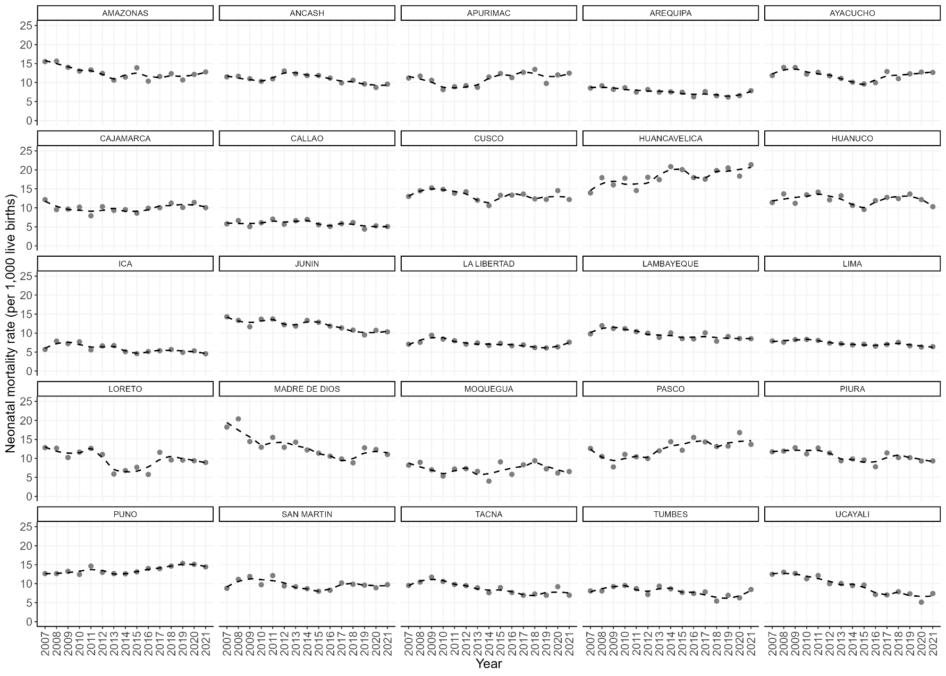
Figure S1. Neonatal mortality (rate per 1,000 live births) time trends (LOESS smoothing with span = 0.5) by political administrative region; Peru, 2007–2021.

Figure S2. Joinpoint regression time trends of selected social determinants; Peru, 2007-2021.

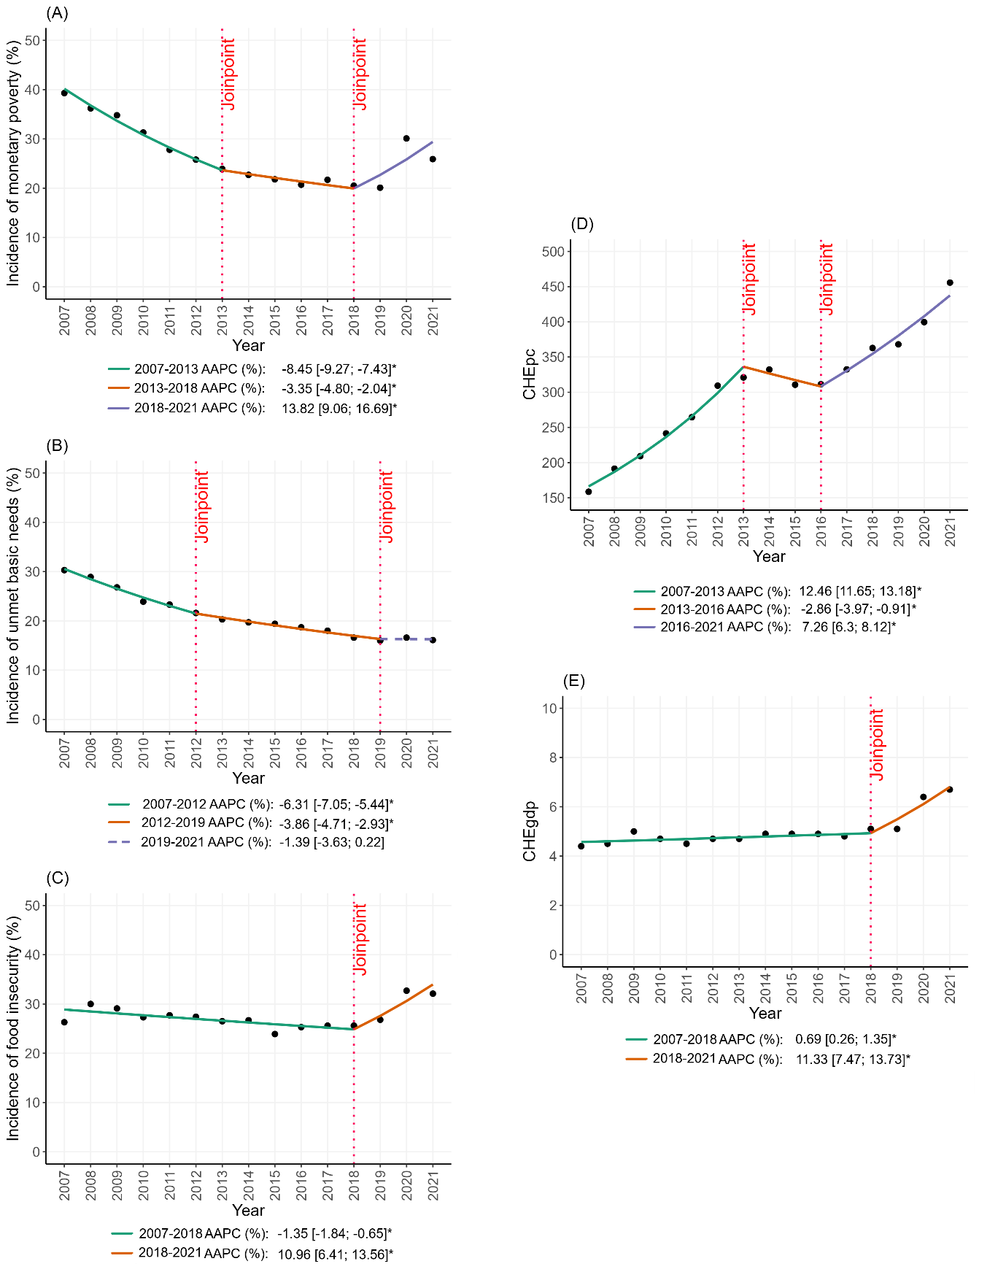

Figure S3. Cross-regional gradients and concentration curves of inequality in neonatal mortality; Peru, 2019-2021.

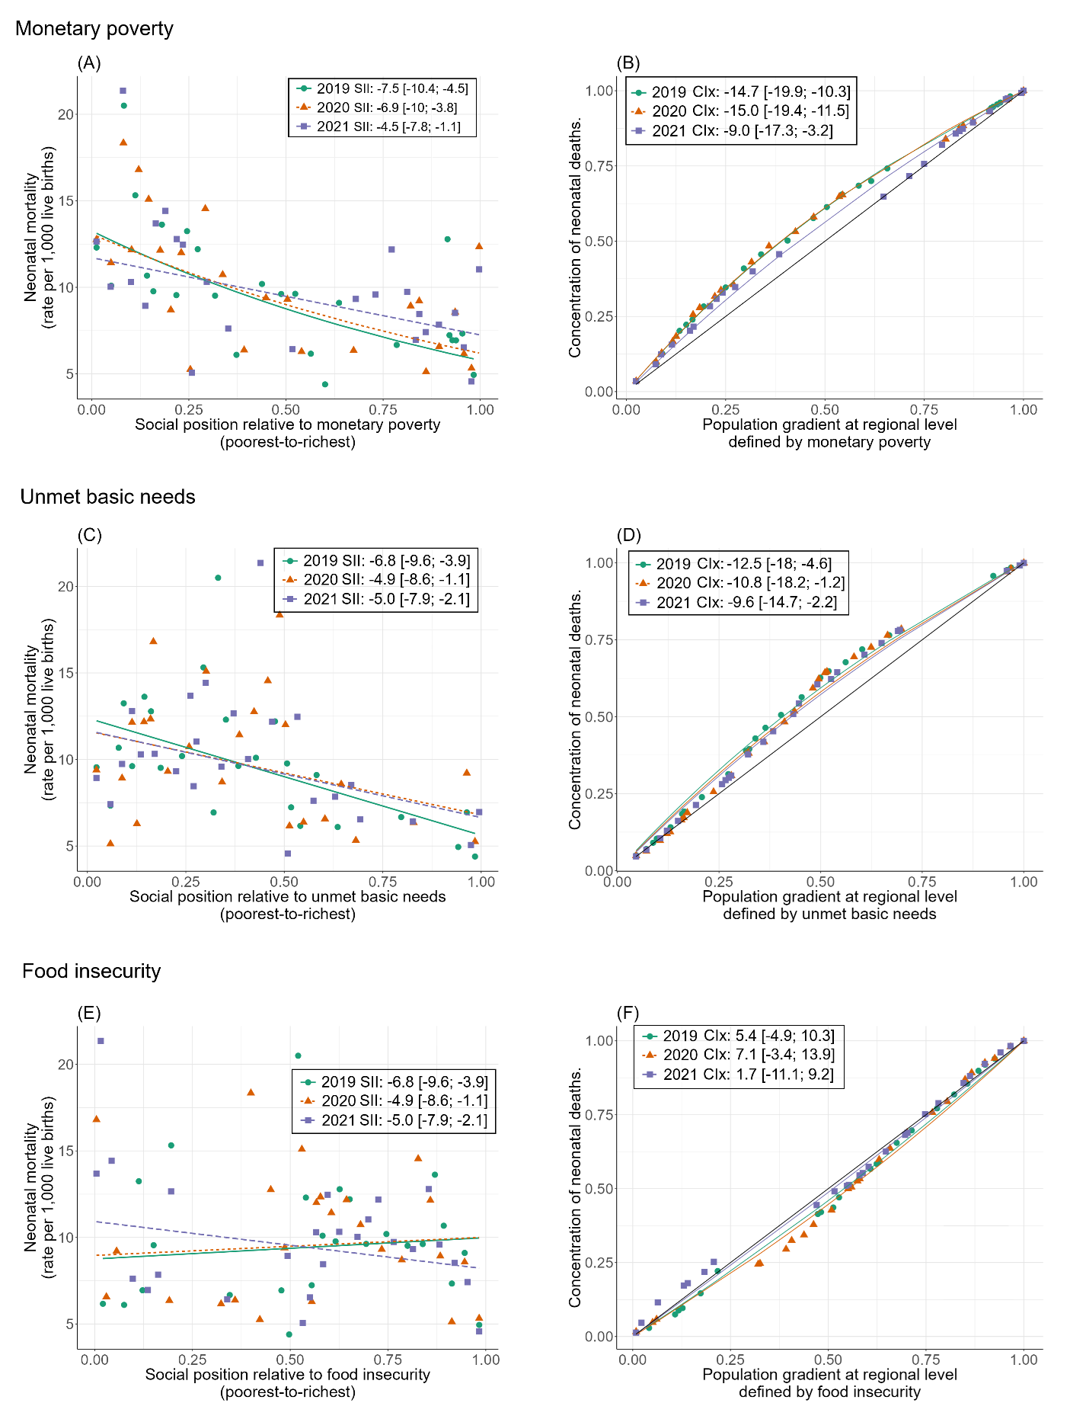

Figure S4. Temporal correlation between neonatal mortality cross-region absolute (SII) inequality and selected social determinants; Peru, 2007-2021.
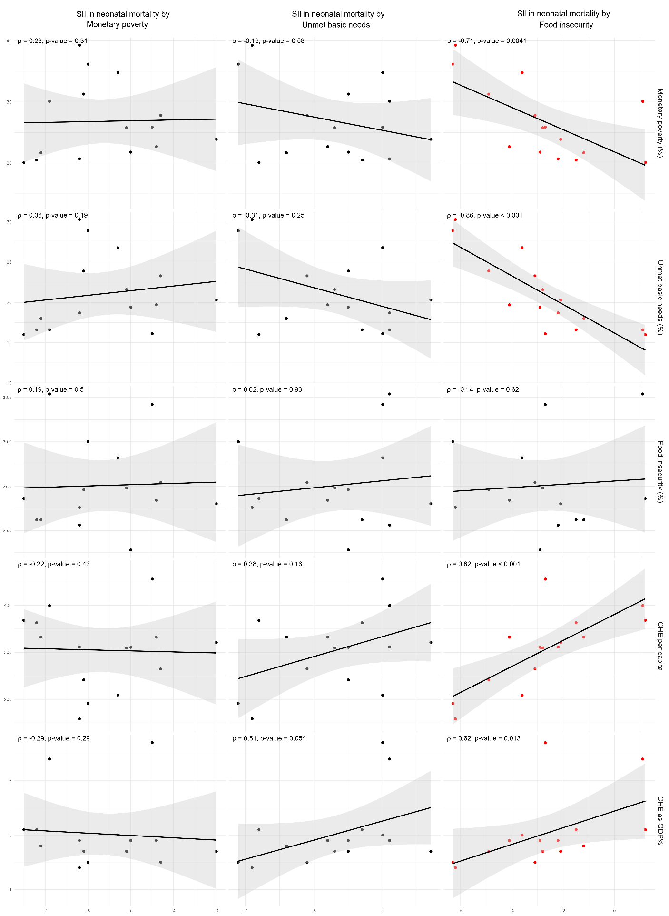

Figure S5. Temporal correlation between neonatal mortality cross-region relative (CIx) inequality and selected social determinants; Peru, 2007-2021.
