Prognostic Significance of Serum Markers in Pancreatic Ductal Adenocarcinoma: A Swiss Single-Center Experience
A. Sgries¹, M. Knufinke², R. Rosenberg³, M. Voegeli⁴, A. Angelini⁵, S. Mitrovic⁶, E. Burri⁷, K. Mertz⁸, R. Mosimann⁹, M. Vetter*⁴, E.D. Chiru*⁴

- Medical University Hamburg, Hamburg, Germany
- Department of Health and Science Technology, ETH Zürich, Switzerland
- Clinic for Surgery and Visceral Surgery, Colon Cancer Center, Cantonal Hospital Baselland, Liestal, Switzerland
- Cancer Center Baselland, Medical University Clinic, Liestal, Switzerland
- University Center for Internal Medicine, Cantonal Hospital Baselland, Liestal, Switzerland
- Central Laboratory, Cantonal Hospital Baselland, Liestal, Switzerland
- University Center for Gastroenetrology and Hepatology, Cantonal Hospital Baselland, Liestal, Switzerland
- Institute for Pathology, Cantonal Hospital Baselland, Liestal, Switzerland
- Medical University, Basel University, Basel, Switzerland

* Shared Last Authorship

Supplementary Material

I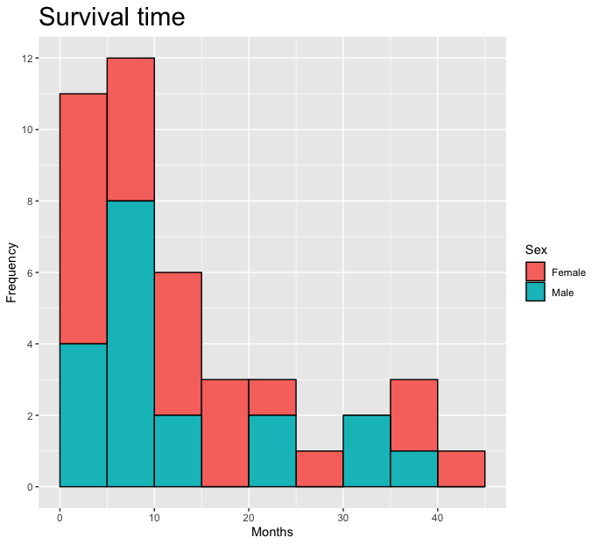.
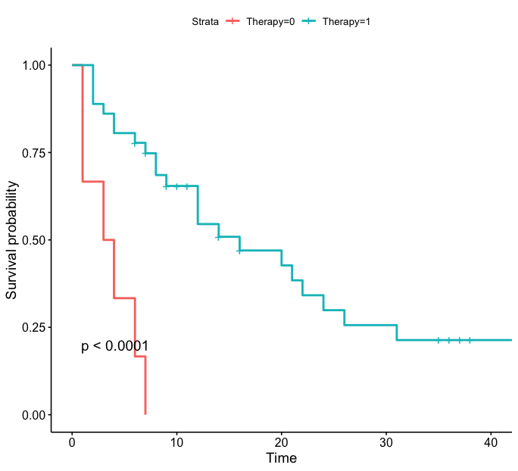
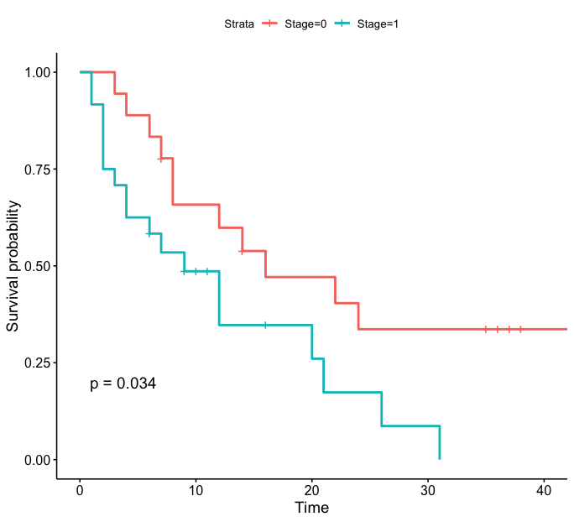
IIi.
Fig. 3A survival analysis showing improved survival with receipt of therapy (I) and localized disease (II); No therapy = 0, Receipt of therapy = 1; Stage 0 = localized disease, Stage 1 = metastatic disease.

I.
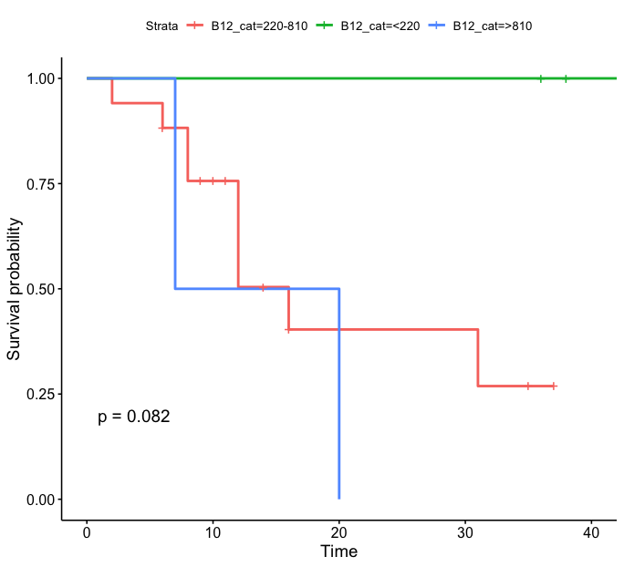
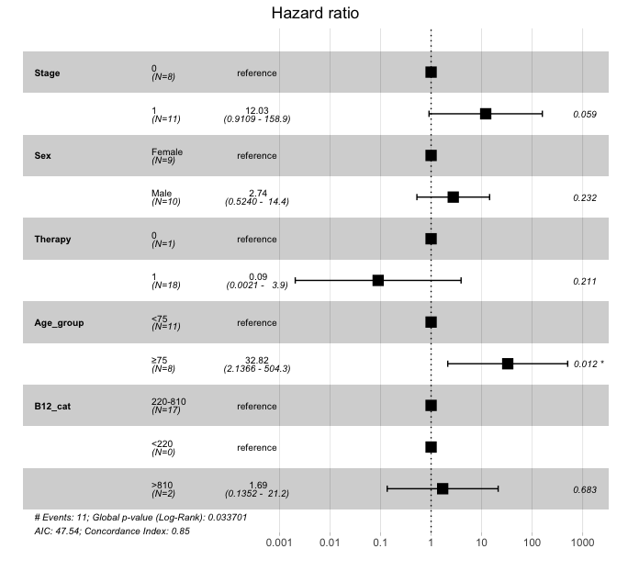
IIi.
Fig. 3A Mutlivariate Cox regression analysis showing no impact of vitamin B12, grouped in category values (<220 pmol/L, 220-810 pmol/L, >810 pmol/L) on risk of death (I) and survival analysis showing no impact of vitamin B12 on the survival curve (II)

Figure 4 B. Survival distribution according to gender

Table 3. Multivariate Regression Analysis showing impact of age and laboratory biomarkers on survival, in patients >75 and <75 years, on censored and uncensored survival data. SD = standard deviation, CI = confidence interval, CRP = C-reactive Protein, LDH = lactate dehydrogenase, NLR = neutrophiles to lymphocytes ratio.
Regression Analysis in Patients > 75 years uncensored
 | P-value | SD | CI
Age>75 | 0.233 | 0.76 | -2.97, 0.92
Albumin | 0.154 | 0.55 | -2.32, 0.49
CRP | 0.529 | -0.22 | -0.22, 0.02
LDH | 0.831 | -0.02 | -0.02, 0.02
NLR | 0.76 | -1.77 | -1.77, 1.38
Regression Analysis in Patients > 75 years censored
Age>75 | 0.612 | 1.85 | -5.48, 4.37
Albumin | 0.908 | 1.42 | -2.94, 4.63
CRP | 0.755 | 0.16 | -0.38, 0.47
LDH | 0.148 | 0.02 | -0.06, 0.06
NLR | 0.613 | 1.28 | -4.91, 1.92
Regression Analysis in Patients < 75 years uncensored
Age < 75 | 0.667 | 0.55 | -1.48, 0.99
Albumin | 0.903 | 0.79 | -1.87, 1,67
CRP | 0.308 | 0.47 | -0.55, 1.17
LDH | 0.377 | 0.1 | -0.12, 0.3
NLR | 0.382 | 2.09 | -6.57, 2.74
Regression Analysis in Patients < 75 years censored
Age < 75 | 0.856 | 0.46 | -1.06, 0.89
Albumin | 0.047 | 0.63 | 0.02, 2.68
CRP | 0.077 | 0.33 | -1.33, 0.07
LDH | 0.671 | 0.07 | -0.12, 0.19
NLR | 0.097 | 0.39 | -1.48, 0.14

